Multiphysics Geophysical Pattern Recognition for Mineral Exploration

using Spatial Principal Component Analysis:

Case Study of Carajás, Brazil Using IOCG Deposits

Introduction
Mineral exploration targeting, which involves identifying and prioritizing locations most likely to contain economically viable mineral deposits, is a decision problem characterized by high impact and high uncertainty (Carranza, 2009; Haldar, 2013; Hronsky & Groves, 2008; Nykänen et al., 2025; Partington et al., 2024, 2024; Singer, 1993; Yousefi et al., 2024). Targeting decisions can lead to actions, such as acquiring more data or drilling, that require significant capital investments. These early decisions are especially consequential because fewer than 1% to 5% of explored prospects advance to economically viable mines (McIntosh, 2016; Regueiro González-Barros & Espí, 2019). Poor targeting can lead to costly drilling or data acquisition in areas with limited economic potential. Initial targeting, therefore, represents a critical, high-leverage decision point within the mining life cycle.
Traditionally, the mineral exploration industry manages targeting risk and high uncertainty through an expert-led and multiscale workflow, gradually narrowing the search from a regional to a target scale by utilizing larger volumes of geophysical, geological, and geochemical data to detect anomalies (Carranza, 2009; Hronsky & Groves, 2008; McCuaig et al., 2010). This is then followed by testing these anomalies with increasing capital investments such as drilling. Recently, data-driven methods have been gaining popularity. They can augment expert interpretation by extracting meaningful targeting information from large, multi-source datasets. They may provide a more systematic, less biased, and more reproducible exploration workflows (Yang et al., 2024; Yousefi et al., 2021).
Current work in data-driven mineral exploration largely focuses on mineral prospectivity mapping. This approach combines multiple exploration evidence layers to predict favorable locations for mineralization (Carranza, 2009; Yousefi et al., 2021; Zuo, 2020). Prospectivity-mapping methods range from classical GIS-based evidence integration to newer machine learning and AI models (Yang et al., 2024; Zuo, 2020). Exploratory multivariate methods are widely used to summarize large geoscience datasets for mineral targeting. PCA and factor analysis are commonly used to reduce dimensionality and redundancy among correlated geochemical, geophysical, and remote-sensing variables. By transforming the original variables into a smaller set of components or latent factors, these methods reveal dominant patterns of covariation. They provide a reduced feature space in which components or latent factors, these methods reveal dominant patterns of covariation. They provide a reduced feature space in which samples or map cells with similar multivariate signatures can be compared or grouped. (Jansson et al., 2022; Sadeghi et al., 2024; J. Wang et al., 2017; L. Wang et al., 2024). Nonlinear embedding and representation-learning methods, such as t-SNE, UMAP, and autoencoders, can capture complex nonlinear relationships in high-dimensional exploration datasets that may not be well represented by linear methods such as PCA or factor analysis. They can support exploratory visualization and pattern recognition. This includes, including the identification of clusters or gradients related to lithology, alteration, or mineralization (Luo et al., 2020; McInnes et al., 2018; van der Maaten & Hinton, n.d.; Zhang et al., 2024).
Data-driven methods that support expert interpretation can be extended in , there are opportunities to extend their use in two ways.important ways. First, methods can be designed to work with fewer labeled examples. This is important because, in real exploration settings, only a few deposits may be known for a given mineral system (Chen & Wu, 2017; Xiong & Zuo, 2021). Second, known deposits can be used as spatial geophysical signatures, rather than only as labeled locations. The 2D geometry of the geophysical signal may contain important information for identifying analogous mineralization (Yu et al., 2024). Together, these opportunities motivate methods that work with few (fewer than 10) labeled examples by leveraging the geometry of the deposit, rather than simply its location as a single label.This creates a need for methods that can operate with few labeled examples and make fuller use of the spatial information contained in each known deposit, beyond its location alone.
This paper proposes a method that first learns the relationship between the geometry of a known deposit and the overlapping multivariate geophysical signal. We aim to show that this learning can be achieved by using the geometry of a single known deposit. Then the method searches, within the same mineral systems, for the same multivariate geophysical signal. As such, the method aims to rank other targets based on how closely their geometry across multi-variate datasets matches the known deposit geometry.
We intend to show that this method introduces a quantitative metric of spatial similarity based on spatial principal component analysis (sPCA). By decomposing into spatial eigenfrequencies, sPCA captures the specific geophysical geometry of the known deposit and quantifies how closely other locations reproduce that geometry. We intend to show that sPCA produces spatial components that can be visualized, weighted according to the known deposit, and used directly to rank other areas by geometric similarity.
We show this approach in a brownfield case study in the Carajás Mineral Province (Brazil). We apply it to magnetic and radiometric datasets to identify IOCG-related geometries consistent with a known copper deposit.

Real Case Introduction
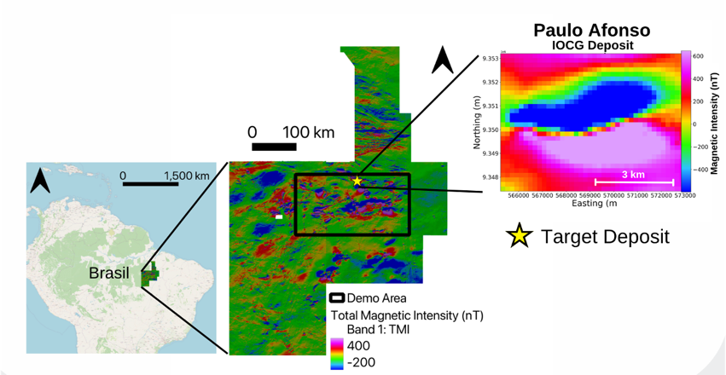
The study area lies in the Carajás Mineral Province of Pará, northern Brazil. This region hosts the Archean granite–greenstone and volcano-sedimentary terrane of the Itacaiúnas Supergroup. It contains numerous Fe-oxidend IOCG systems. We aim to detect locations within it whose geometry resembles that of a known IOCG deposit and rank them by similarity.
Figure 1. Location of study area.
The training data for Case 1 is the Total Magnetic Intensity (TMI) in the Paulo Afonso deposit area. This is an iron-oxide copper–gold (IOCG) body characterized by magnetite–hematite–rich alteration and structurally focused chalcopyrite ± Au mineralization. This body produces a well-defined dipole geometry in the TMI grid. This dipole TMI response is a diagnostic geometry that IOCG experts already use as an exploration criterion in this area. This makes it a geologically meaningful template for identifying district-scale analogs and assessing regional prospectivity. By adopting this dipole as the reference geometry, our analysis is intentionally restricted to other areas that express a similar dipole geometry.

To enable a like-for-like comparison between the deposit and the surrounding areas, we analyze the TMI grid (Figure 1) using a sliding-window approach. Here, every window has exactly the same dimensions as the deposit footprint. The resulting analysis window measures 46 × 28 pixels (1,288 pixels in total). It corresponds to a physical area of 9.20 × 5.60 km at the 200-m grid resolution. We move this window across the full 259 × 138 km demonstration area (2,485 × 3,527 pixels) using a fixed lateral and vertical stride. This extracts 13031 ospatially consistent windows from the TMI grid. Each of which can be directly compared to the deposit’s geophysical geometry.

Within this study area, several other economic IOCG and iron-ore deposits exhibit comparable magnetic dipoles (Tucuma, Pedra Branca, Salobo, etc.). These deposits provide an independent way to test whether the method identifies meaningful targets (Figure 2).

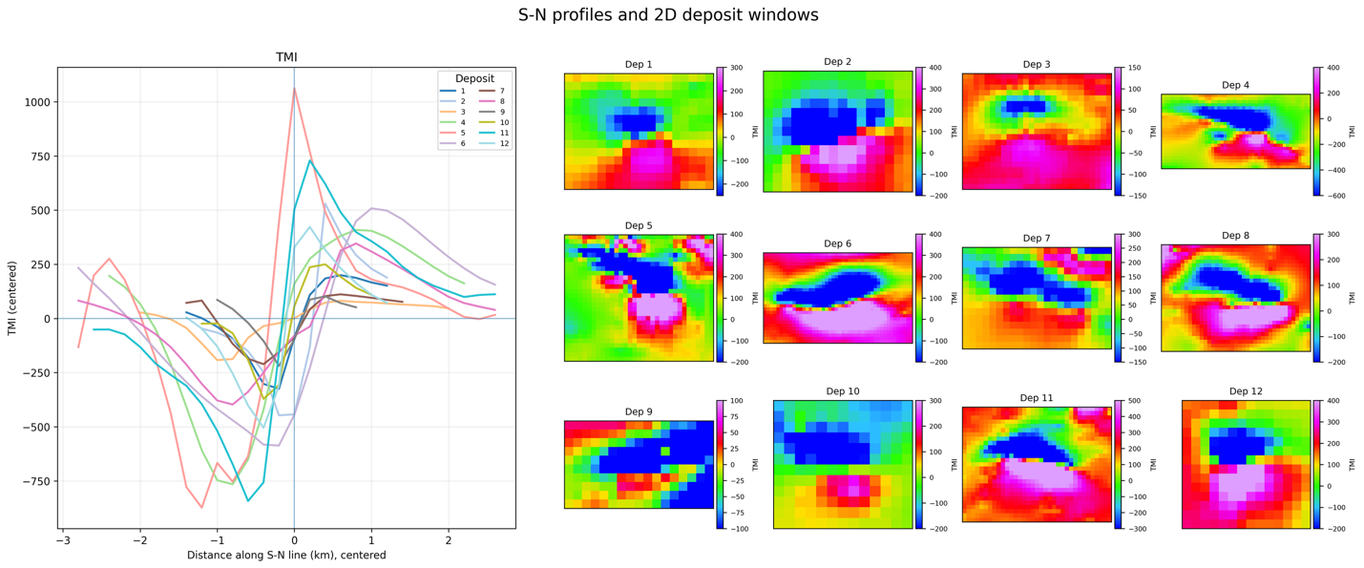
Figure 2. Centered south-north (S-N) TMI profiles and corresponding 2D deposit windows for the twelve deposits. The profiles summarize the 1D geometry, while the 2D windows show the full spatial patterns used in the spatial PCA analysis.
Case 2 focuses on Alemão (Deposit 3) as a representative multivariate example. In the Igarapé Bahia camp, IOCG mineralization also expresses a dipole geometry in the TMI grid. Alemão has been described as a Cu-Au-(U-REE) IOCG deposit containing minor uraninite. Therefore, elevated radiometric U provides a geologically meaningful complementary signal in this area. The combined presence of a magnetic dipole and high radiometric U is treated here as a district-specific IOCG exploration signature. This motivates the multivariate TMI + U analysis developed in Case 2.

Methodology

Overview

The goal of the method is to create a data-driven similarity map and target ranking that shows which areas have geophysical geometries most similar to that of the known deposit. The methodology starts by placing a window over each known deposit (known from drilling) (Figure 3). In this window, we have (one or more) geophysical data available. The goal is to look elsewhere in the domain for geophysical signatures whose geometry matches the geophysical data over the known deposit.

To achieve this, we collect windows of geophysical data by sliding the same window over the domain (study area). Each sliding window is compared with the known deposit window. Windows with the closest match are ranked highest, under the assumption that similar geophysical geometry may indicate similar ore geometry. To compare the windows, we use spatial PCA. This decomposes the sliding-window data into orthogonal spatial components. Each window is represented by its PCA scores. We then compute the distance between each window and the known deposit window. Figure 4 shows the various steps which will be explained in detail on a tutorial example in the next section.
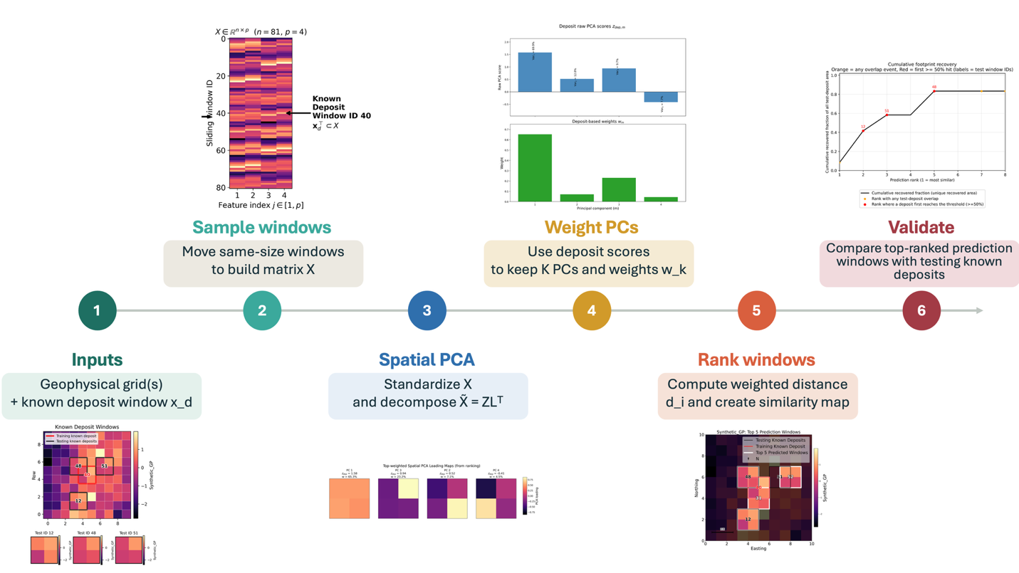
Figure 3. Spatial PCA similarity workflow. The method compares a known deposit geometry with candidate areas by first sampling the geophysical grid(s) into same-size windows. This ensures that every window is evaluated at the same spatial scale as the reference deposit. The window matrix $X$ is standardized and decomposed with spatial PCA to represent each window by its main spatial patterns. The deposit scores are used to select and weight the PCs that best describe the reference geometry. Each window is then ranked by its deposit-weighted distance $d_{i}$, producing a similarity map. The top-ranked prediction windows are finally evaluated against other known testing deposits using footprint recovery and hit metrics.

Spatial sampling using overlapping sliding windows
To compare the known deposit with the rest of the study area, the geophysical grid is sampled using overlapping sliding windows of size $w_{y}$× $w_{x}$, see Figure 4. The window dimensions $w_{y}$ and $w_{x}$ are chosen to capture the geophysical geometry of interest around the known deposit, such as a dipole. This ensures that all comparisons are made at the same spatial scale. This choice determines which part of the deposit geometry serves as the reference geometry.
Windows are extracted with vertical stride $s_{y}$ and lateral stride $s_{x}$. This produces partially overlapping samples that provide continuous spatial coverage and preserve transitions between adjacent areas (see Figure 4. Each sliding window is flattened into a feature vector, and the full set of 𝑛 windows forms the structured data matrix
$$X=\left[\begin{aligned}x_{1}^{⊤} \\ x_{2}^{⊤} \\ ⋮ \\ x_{n}^{⊤}\end{aligned}\right]∈R^{n×p}, p=w_{y}×w_{x}.$$Each row $x_{i}∈R^{p}$ corresponds to one flattened sliding window (sample). $p=w_{y}×w_{x}$ represents the number of features, with each feature corresponding to one pixel location across all windows. The known or training deposit geometry is denoted
$$x_{d}∈R^{p}$$, and in the data matrix $X$, it corresponds to one specific row (see Figure 4).
This vector represents the characteristic geophysical geometry of the known deposit at the chosen spatial scale ($w_{y},w_{x}$). It serves as the reference vector against which all other windows $x_{i}$ in $X$ are compared to quantify spatial similarity across the study area.
Up to this point, the formulation has been presented for a single geophysical variable ($r=1$ and $p=w_{y}×w_{x}$). In this case, each sliding window captures only the spatial structure of a single spatial dataset. However, most exploration settings involve multiple complementary geospatial surveys (e.g., magnetic, gravity, and resistivity), each sensitive to different subsurface petrophysical properties. To jointly analyze these datasets and identify areas whose combined geophysical geometry resembles that of the known deposit, the approach is extended to a multivariate representation.
In the multivariate case, the sliding windows are extracted simultaneously from all available geophysical grids. Each window is therefore described by the pixel values of all $r$ variables within its spatial extent. This results in feature vectors of dimension
$$p=w_{y}×w_{x}×r.$$
The resulting data matrix, $X∈R^{n×p}$thus integrates both spatial context (within each window) and cross-variable relationships (across the $r$ geospatial attributes). Sliding window dimensions may vary across variables $r$, as long as they remain spatially co-located. This maintains spatial correlation among geophysical responses.
To illustrate the sampling step, we first consider a simplified case involving a single synthetic geophysical variable ($r=1$). Figure 4 shows how the geophysical grid is sampled using overlapping sliding windows and transformed into the structured data matrix $X∈R^{n×p}$.
The single geophysical grid is divided into $2×2$ sliding windows (so $p=4$) that move across the map with partial overlap. The window dimensions $\left(w_{y},w_{x}\right)$ approximate the footprint of the known deposit. The strides $\left(s_{y},s_{x}\right)$ control the overlap between consecutive samples. In total, $n=81$ windows are extracted, each flattened into a row vector $x_{i}∈R^{p}$.
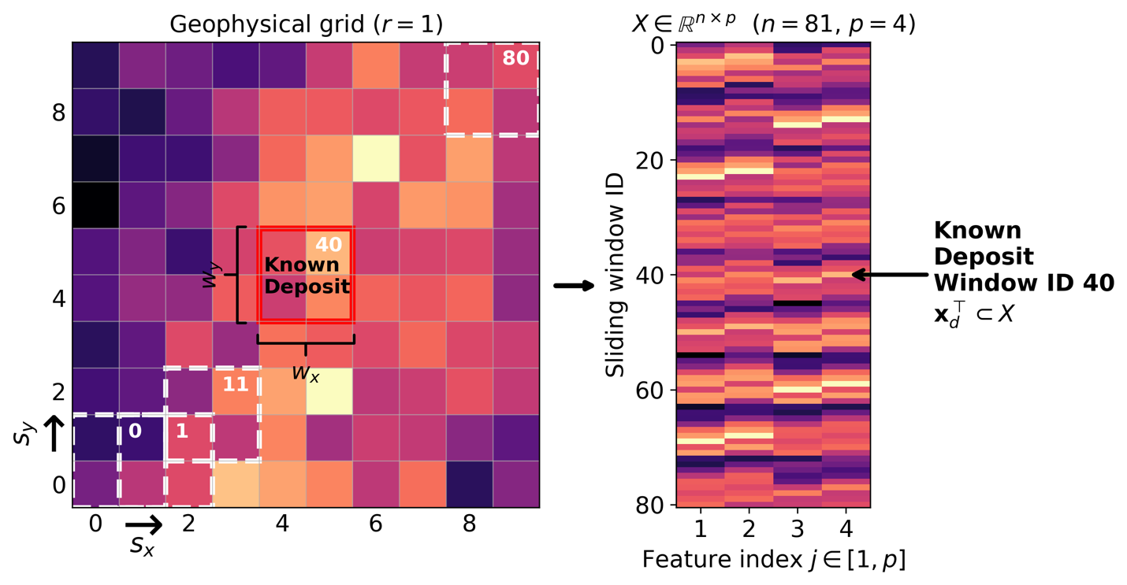
The known deposit window is outlined in black in Figure 4. In the panel to the right of Figure 4, this row appears as $x_{d}^{⊤}⊂ X$. It serves as the reference geometry against which the similarity of all other windows will be measured. This panel displays $X$, where rows index sliding windows ($n=81$) and columns index the four pixels within each window ($p=4$). In the later paragraphs, we will discuss spatial principal component analysis on $X$ and similarity analysis, and continue with the illustrative example.
Figure 4. Illustrative example of sampling of a single-variable geophysical grid ($r=1$) using overlapping 2×2 sliding windows ($w_{y},w_{x}$) with strides ($s_{y},s_{x}$). Each flattened window defines a sample in the structured data matrix $X∈R^{n×p}$ with $n=81$ and $p=4$. The known deposit window ($x_{d}^{⊤}⊂X$) is highlighted in red and used as the training geometry for similarity analysis.
Spatial Principal Component Analysis and Similarity Analysis
To measure how closely each sliding window resembles the known deposit, we require a similarity metric that quantifies geophysical geometry rather than comparing pixel values directly. To make this comparison consistent, all windows are represented in a common feature space. Spatial PCA provides this space by extracting the main spatial patterns in X and quantifying how strongly each window expresses them.

In sPCA, each feature in $X$ corresponds to a pixel within the sliding window, rather than to a distinct geophysical variable. PCA is therefore performed in pixel space to extract dominant spatial patterns. Like standard PCA, sPCA relies on the covariance matrix and singular value decomposition. The resulting eigenvectors are the PC loadings. Each principal component acts as a spatial filter that isolates a pattern of pixel-to-pixel variability contributing to the geophysical geometry expressed within each window.

The associated PC scores quantify how strongly each window expresses each pattern. This maps the deposit window and all other sliding windows into a common coordinate system defined by the same spatial components. Similarity can then be evaluated by comparing windows in terms of the patterns that define their geophysical geometry.

Not all components are equally relevant to the deposit geometry. Some are strongly expressed by the deposit, while others represent background variability or noise. We therefore compute deposit-specific weights from the deposit’s PCA scores and use them to emphasize the components that best define the reference geometry.

Finally, we compute similarity using the weighted Euclidean distance between each sliding window and the deposit in PCA score space. Windows with the smallest distances are ranked as the most similar because their geophysical geometry most closely matches that of the known deposit.
To measure how closely each sliding window resembles the geometry of the known deposit, we require a similarity metric that quantifies spatial structure, enabling us to detect windows whose geometry resemble that of the deposit rather than simply comparing pixel values directly. To compare geometries consistently, all windows must be represented in a common feature space. Spatial PCA provides this feature space by extracting the main spatial structures in the data. It also quantifies how strongly each window expresses each structure.
Not all spatial components are equally relevant to the deposit. Some components capture features that the deposit expresses strongly, while others represent background variability or noise. We therefore compute deposit-specific weights from the deposit’s PCA scores. We then use them to emphasize the components that best define the reference geometry.
In the following paragraphs, we detail the formulation of the spatial principal component analysis and the construction of the similarity metric. We use the illustrative example to visualize each step. We begin by standardizing the data matrix $X$ column by column using a z-score transform,

$${\tilde{X}}_{ij}=\frac{X_{ij}-μ_{j}}{σ_{j}},$$where $μ_{j}$ is the column-wise mean and $σ_{j}$ is the column-wise standard deviation. For constant features, $σ_{j}$ is set to 1 to avoid division by zero. This step puts all pixels on a common scale with zero mean and unit variance. Therefore, PCA captures spatial geometry rather than being dominated by absolute magnitude differences.
We then perform PCA on $X_{\text{std}}$,
$$\tilde{X}=ZL^{⊤},$$Where $L∈R^{p×M}$ is the loading matrix, and $Z∈R^{n×M}$ is the score matrix. Each loading vector defines a principal component (PC) showing how the $p$ pixels contribute to each PC (Figure 5). Each row of $Z$ gives the coordinates of one sliding window in the PCA space built from standardized features. Let
$$M=\min\left(n,p\right)$$
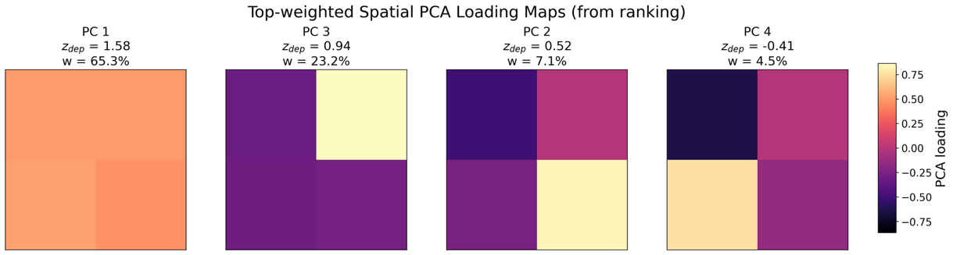
Figure 5. Loading maps. Each loading map illustrates a spatial pattern or filter extracted by sPCA. The deposit’s score $z_{d,m}$ indicates how strongly the deposit expresses that pattern. The weights $w_{m}$ quantify each component’s relative importance in the similarity metric.
denote the total number of PCs produced by the decomposition, and $λ_{1},…,λ_{M}$ the associated eigenvalues. The PCA score vector of the deposit window is the corresponding row of $Z$,
$$z_{d}=Z_{d,⋅}∈R^{M}.$$In the similarity analysis, we do not necessarily use all $M$ PCA components. Instead, we retain only $K$ components in the distance calculation. In principle, $K$ should be chosen as the smallest number of principal components that still provides an adequate representation of the deposit geometry. Choosing $K$ too small risks excluding important spatial detail. Choosing $K$ too large may introduce weakly expressed or noise-dominated components into the similarity calculation. The appropriate choice of $K$ is therefore partly a matter of expert judgment. It is informed by the deposit geometry and the intended level of detail in the comparison. Then
$$z_{d}^{K}​=\left(z_{d1}​,…,zdK​\right)$$
corresponds to the retained deposit score vector.
We then derive deposit-specific weights directly from its raw PCA scores. For a retained set of $K$ components we define
$$w_{k}=\frac{z_{dk}^{2}}{\sum_{m=1}^{K}{z_{dm}^{2}}},k=1,…,K,$$
so that the weights sum to one. Components with larger deposit-score magnitude receive higher weights, while weakly expressed components are down-weighted.
In the illustrative example, we standardize the 81 windows pixel-wise and then apply PCA. This yields four spatial loading maps (PC1–PC4) together with their associated score vectors. Figure 4 illustrates the loading maps that show the pixel-level structure captured by each principal component. It highlights the dominant pattern (e.g., smooth gradients or sharp pixel-to-pixel transitions) extracted by the decomposition.
The deposit corresponds to one row of the score matrix, denoted $z_{d}$. For the illustrative example, the training deposit position in PCA space is shown explicitly in Figure 6. The top panel displays the raw PCA scores $z_{\text{dep},k}$ alongside the eigenvalues $λ_{k}$.
It is worth noting that high variance alone is not enough to make a component important for similarity ranking. A component may explain a large amount of regional variance but be weakly expressed in the deposit. As a result, it contributes little to the deposit-guided comparison.
For the synthetic illustrative example, the deposit scores $Z_{d,k}$ are used to compute $w_{k}$. The bottom panel of Figure 6 shows the resulting deposit-based weights $w_{k}$, used to emphasize the components that contribute most significantly to the deposit’s geometry.
To compare any window $i$ to the deposit, we measure the difference between them in standardized PCA coordinates. The component-wise difference is
$Δ_{i,k}=Z_{i,k}-Z_{d,k}$
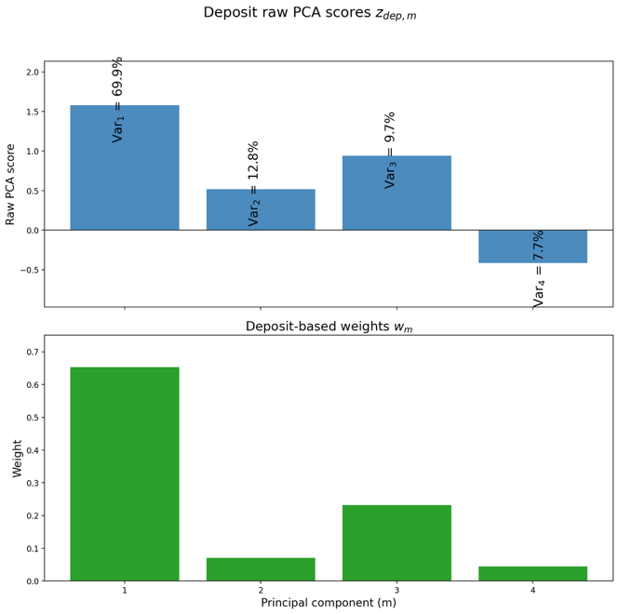
The deposit-weighted squared distance is then
Figure 6. PCA scores of the deposit (top) and the corresponding deposit-based weights $w_{m}$ used in the similarity metric (bottom). The weights emphasize the spatial components most strongly expressed by the deposit.
$$d_{i}^{ 2}=\sum_{k=1}^{K}{w_{k}} Δ_{i,k}^{ 2},$$and the dissimilarity measure is
$$d_{i}=\sqrt{d_{i}^{ 2}}.$$Windows with the smallest $d_{i}$ are those whose PCA score vectors most closely match the deposit’s geometry, after deposit-specific weighting. Windows that lie closer to the deposit in these coordinates (shown by lighter colors in Figure 7) express more similar multidimensional geometry.

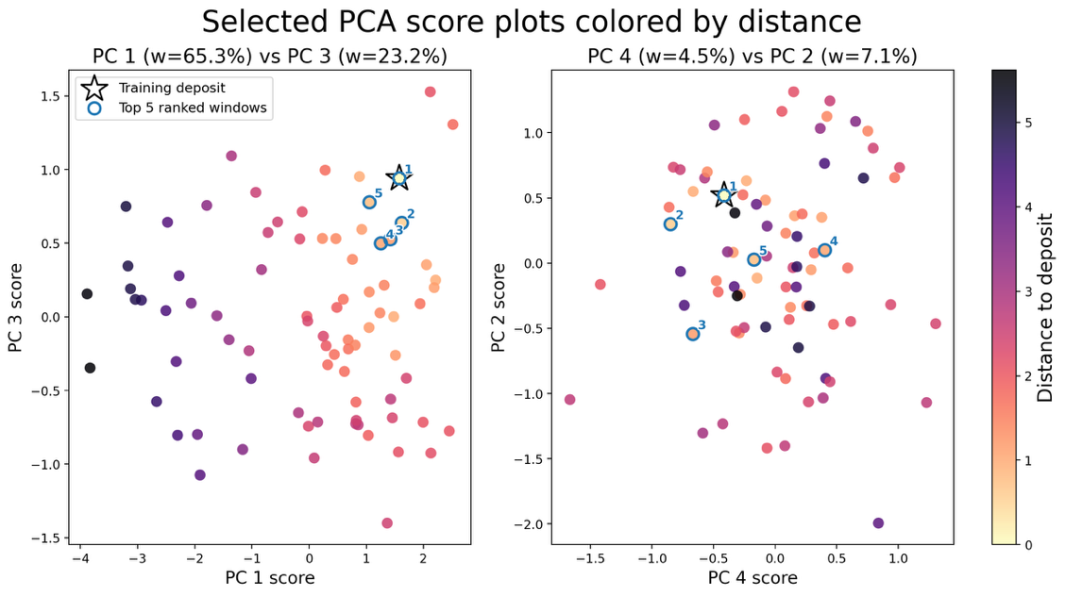
The two panels in Figure 7 illustrate the relative importance of the principal components in the distance and similarity calculations. In the (PC1, PC3) plot (left), the color gradient of the distances corresponds closely with PC1 and less with PC3. Windowsthe axes. Windows with high PC1 and PC3 scores show the smallest distances. This indicates that PC1 and PC3 jointly capture the dominant spatial patterns that define the deposit geometry (see PC scores in Figure 6). In contrast, in Figure 7, the (PC4, PC2) plot (right) exhibits a much weaker relationship between distance and the PC coordinates. The color pattern is more dispersed and lacks a clear gradient. This reflects the fact that these PCs contribute less to discriminating deposit-like geometries.
Figure 7. Pairwise scatter plots of PCA scores for principal component pairs $\left(PC1 , PC3\right)$and $\left(PC4 , PC2\right)$. Each point corresponds to a sliding window in the study area. They are colored by their deposit-weighted distance $D_{i}$, computed in variance-standardized PCA space. computed in the standard PCA space. Lighter blue colors denote windows whose spatial patterns more closely resemble the deposit geometry. The deposit window (yellow star) lies near its four top-ranked matches (red circles), illustrating how the similarity metric identifies windows with geometry similar to that of the deposit.

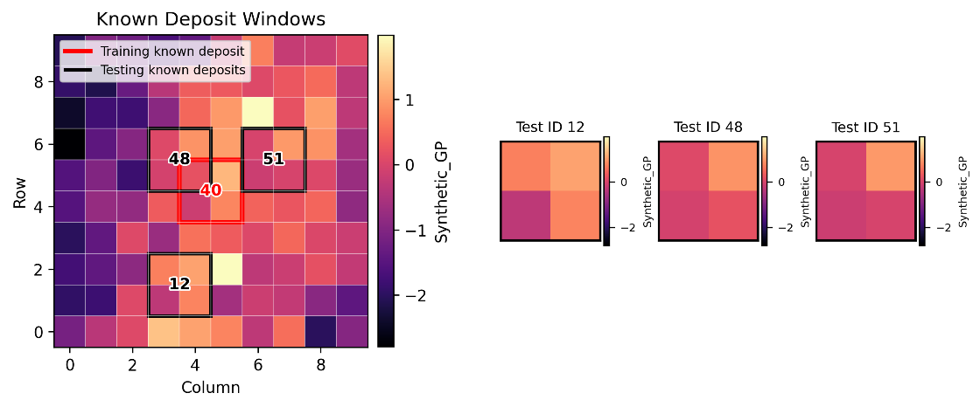
By computing $d_{i}$ for all sliding windows, we obtain a ranking from most to least similar to the known deposit. Mapping this ranking back to the grid produces the similarity map used in the regional prospectivity analysis (see Figure 9). This procedure enables the identification and ranking of windows across the study area that share the strongest multivariate spatial resemblance to the known deposit geometry.
Figure 8. Known deposit windows used for validation. The left panel shows the synthetic geophysical grid with the training deposit window in red and the testing deposit windows in black. The right panels show the extracted test windows for deposits 12, 48, and 51, which are used to evaluate whether the similarity ranking recovers deposit-like spatial patterns beyond the training example.
Validation metric using other known deposits
Other known deposits in the study area are used to validate the ranked predictions (Figure 8). These deposits are not used to define the training geometry and are therefore treated as test deposits. Let $D_{j}$, $j=1,…,J$ denote the test deposits. Let $P_{\left(t\right)}$ denote the footprint of the $t$-th ranked prediction window, with
$$t=1,…,T_{max}$$For each rank level $t$, the cumulative recovered area for the deposit $D_{j}$ is defined as
$$A_{j}\left(t\right)=Area\left(\left(\bigcup_{l=1}^{t}{P_{\left(l\right)}}\right) ∩ D_{j}\right).$$
This formulation uses the union of intersections. Overlapping prediction windows within the same testing deposit are counted only once. The corresponding recovered fraction for the testing deposit $D_{j}$ is
$$c_{j}\left(t\right)=\frac{A_{j}\left(t\right)}{\operatorname{Area}\left(D_{j}\right)}.$$
From this, we compute the cumulative recovery fraction of the total test-deposit area
$$T_{total}\left(t\right)=\frac{\sum_{j=1}^{J}{A_{j}}\left(t\right)}{\sum_{j=1}^{J}{Area⁡(}D_{j})}.$$
In addition, a test deposit is recorded as hit when its recovered fraction first exceeds a minimum coverage threshold $c_{min}$. That is, when
$$c_{j}\left(t\right)≥c_{min}.$$
Finally, these recovery and hit metrics are used to assess the ranked predictions. The left panel of Figure 9 maps the top-ranked predicted windows relative to the training and test deposits. The right panel summarizes recovery as a cumulative footprint-recovery curve. In particular, the orange marker at rank 1 shows that the first predicted window overlaps test deposit $n=48$.#48. However, it covers only about 25% of the deposit footprint. ItBecause this is countedbelow the 50% threshold, it is counted as an overlap and, not as a threshold-reaching hit because it is below the 50% covered area threshold. Beyond rank 1, additional prediction windows progressively recover more of the test-deposit footprint. For example, test deposit $n=12$ reaches the threshold at rank 2, and test deposit $n=51$ reaches it at rank 3. The flat parts of the curve indicate ranks where the added prediction window does not increase the unique recovered test deposit area.
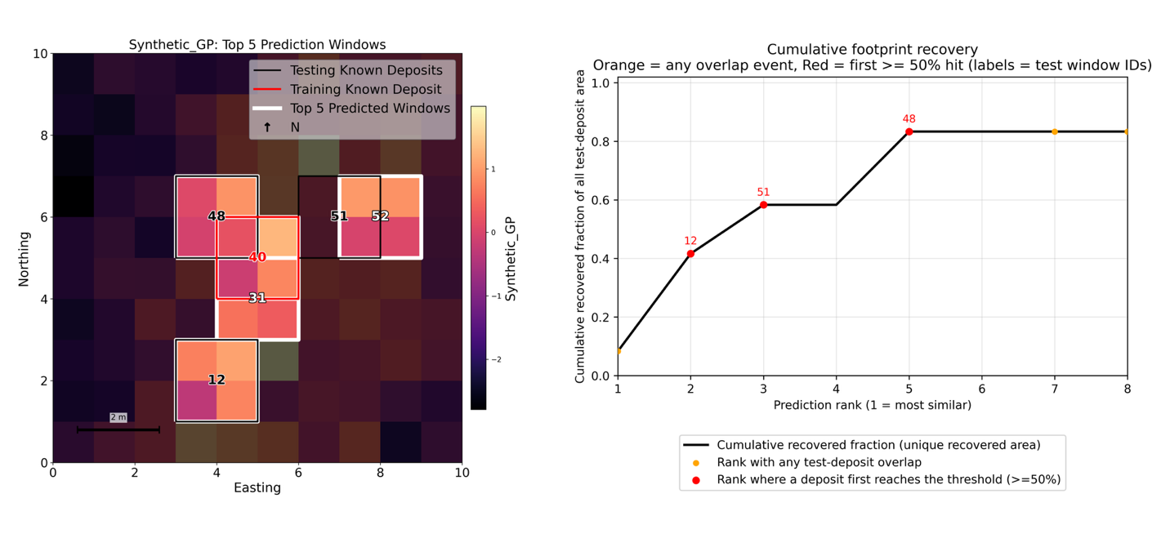
Figure 9. Similarity-based prediction and validation. Left: synthetic geophysical grid showing the training deposit window used for ranking, the known test deposits, and the top-5 predicted windows ranked by similarity. White boxes mark predicted windows, and labels indicate deposit or window IDs. Right: cumulative footprint-recovery curve showing how much of the total test-deposit area is recovered as more ranked windows are included. Orange markers indicate ranks where a predicted window has any non-zero overlap with a test deposit. RedThe red markers indicate the first rank at which a test deposit reaches the 50% area-coverage threshold. The first ranked window partially overlaps test deposit 48 but covers less than 50% of its area, so it is counted as an overlap event rather than a threshold-reaching hit. Prediction window ID=31, doesn’t overlap with any known test deposit.

Results
To illustrate the method's behavior in more detail, selected case studies are presented for both univariate and multivariate analyses. In the univariate analysis, Paulo Afonso (Deposit 6) is used as the training deposit. In the multivariate analysis, Alemao (Deposit 3) is used as the training geometry to provide a clear comparison between the single-variable and fused workflows. This case shows the effect of adding and jointly interpreting radiometric information.
Table 1. Summary of the case-study configurations used in the validation analysis. It lists, for each case, the reference (training) deposit used to construct the similarity ranking and the known testing deposits.
Case Name | Training Deposit IDs | Testing Deposits IDs
Paulo Afonso Deposit: Univariate TMI | 6 | 1, 2, 3, 4, 5, 7, 8, 9, 10, 11, 12
Alemao Deposit: Multivariate TMI + Radiometric U | 3 | 1,2,4,5

Case Study 1. Paulo Afonso Deposit: Univariate TMI
We start by sampling the TMI grid using overlapping sliding windows and extracting dominant spatial patterns via spatial PCA. Then, we compare the sliding windows and the deposit window using Euclidean distance in a learned feature space. We include a weighting scheme that emphasizes the patterns most representative of the deposit geometry. We then rank windows by similarity to the deposit (increasing distance). Finally, we compare the rank windows with the other testing known deposits using cumulative footprint recovery, counting unique overlap area, and the first rank each deposit reaches 50% coverage.

For the sampling of the Total Magnetic Intensity geophysical grid ($r=1$) we use overlapping sliding windows of size $w_{y}=28 px$ and $w_{x}=46 px.$ They approximate the TMI dipole geometry footprint of the Paulo Afonso deposit. Windows are extracted with vertical stride $s_{y}=8 px$ and lateral strides$=8 px$. After the sampling, a total of 13031 are extracted, each of them with p=1288 px (28 px by 46 px).
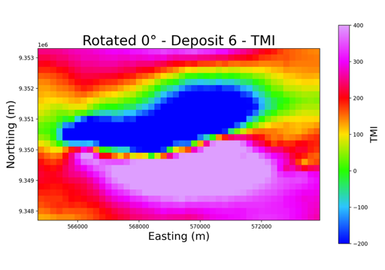
$$X∈R^{n × p}, n=13031+1, p=28×46×1$$
Figure 10. Total Magnetic Intensity (TMI) response of Deposit 6. The map highlights the well-defined dipole geometry associated with the deposit. This is the training window used for spatial PCA decomposition and similarity ranking across the study area.

Each sliding window is flattened into a feature vector. The full set of 𝑛 windows forms the structured data matrix $X$. The deposit window is added at the bottom to matrix $X$. The deposit window $n=13031$ (Figure 10) serves as the training geometry against which all other windows $x_{i}$ in $X$ are compared to quantify spatial similarity across the study area.
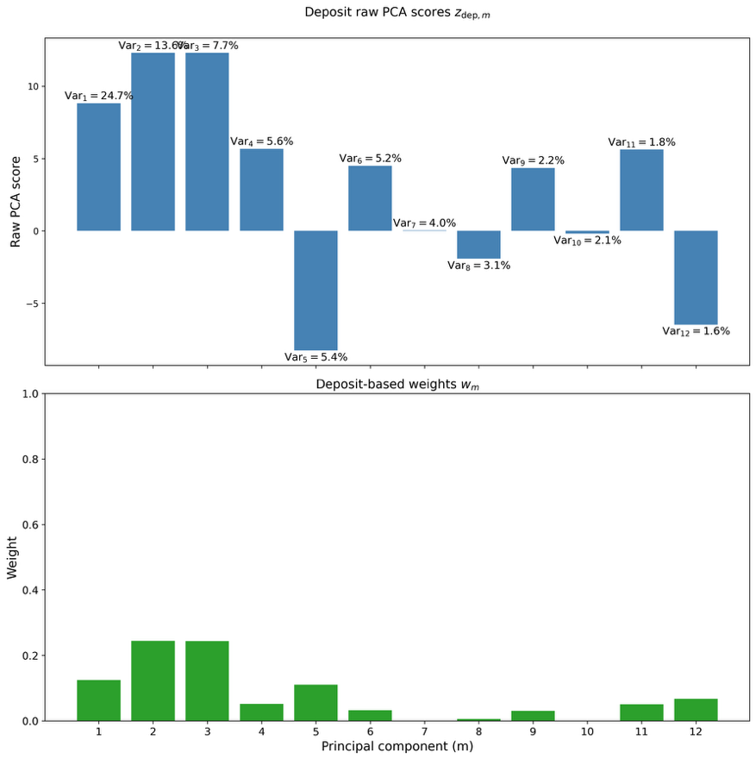
After sampling the TMI grid, we compare each sliding window with the deposit window. To do this, we first need a way to consistently extract and represent their geophysical geometries. To do that, we start by transforming both the deposit window and all other windows into a common coordinate system defined by the spatial components of PCA. Before we applied PCA, we standardized X to obtain $\tilde{X}=ZL^{⊤}$.
Figure 11. Deposit-specific PCA scores and derived component weights. Top: raw PCA score vector of the training deposit, $z_{dep,m}$, showing the signed contribution of each spatial principal component. Bottom: normalized deposit-based weights $w_{m}$, computed from the absolute deposit scores and used to emphasize the spatial components most characteristic of the deposit in the similarity metric.
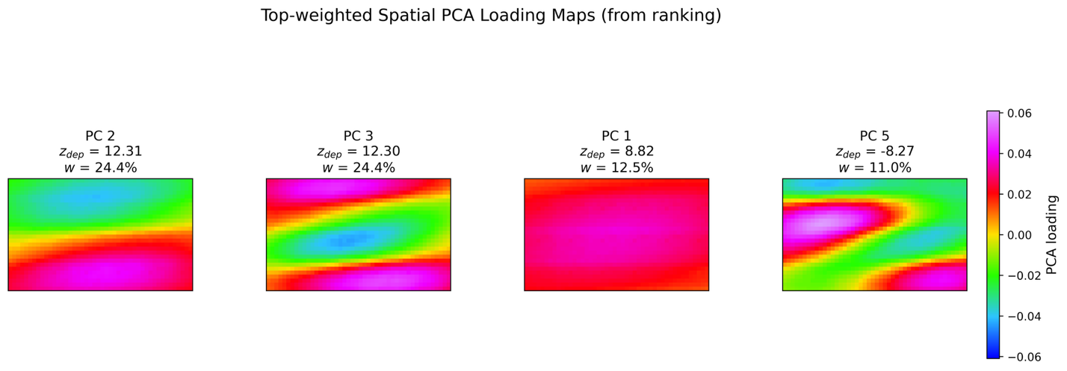
Once we apply PCA and have them in a common coordinate system, we select the best estimate of $(k)$ components to then perform the similarity analysis. To guide this choice, we progressively reconstruct the deposit geometry using an increasing number of principal components. We evaluate visually the extent to which the relevant geometry is recovered. Figure 11 shows that the dominant dipolar geometry emerges clearly with the first components. Figure 13 shows that the dominant dipole geometry emerges clearly with the first components. It becomes progressively more complete as additional components are included. By around (k=17), the reconstruction captures the main geometry of the deposit. Later components contribute only minor refinements. Later components contribute only minor refinements and noise. We therefore select (k=17) as a suitable balance between retaining the essential deposit geometry and avoiding the inclusion of weak higher-order components.
Figure 12. Dominant spatial principal components identified from the deposit-weighted similarity analysis. Each panel represents an sPCA loading map. They highlight a distinct spatial pattern expressed by the training deposit. Components are ranked by deposit-specific weights ($w_{m}$). They emphasize the spatial components that most strongly characterize the deposit geometry used in the similarity comparison.

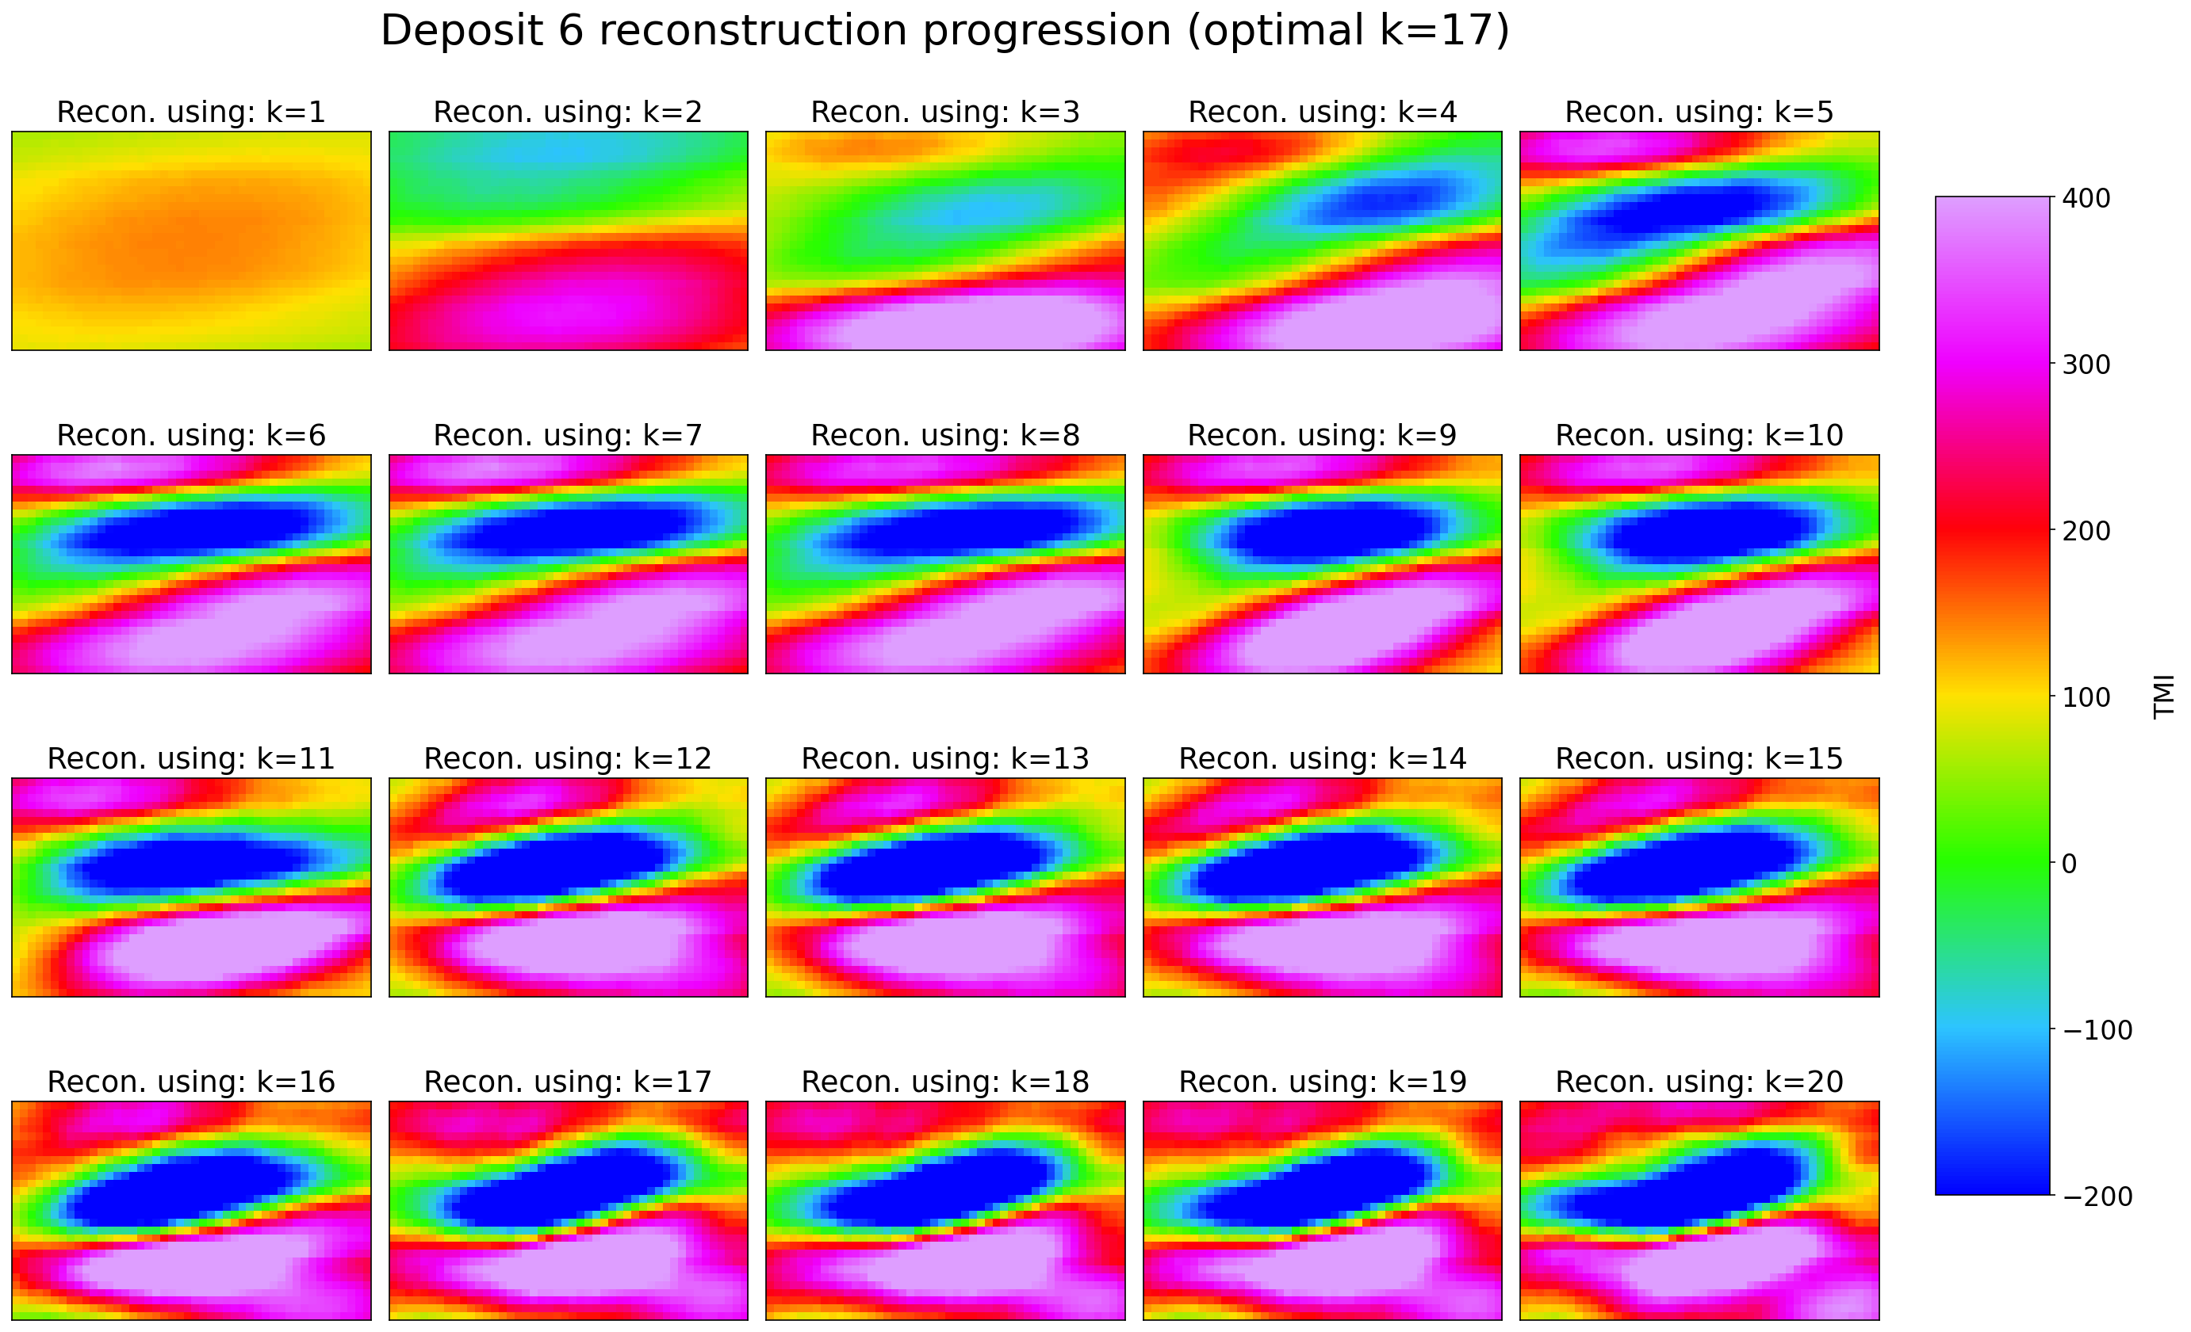
Figure 13. Reconstruction progression of Deposit 6 as increasing numbers of principal components are retained (k = 1-20). The sequence shows how the dominant TMI dipole pattern is gradually recovered as additional components are included. k = 17 is selected as the optimal amount. It is the smallest number of components that provides an adequate reconstruction of the deposit geometry, with only minor visual changes beyond this point.
The retained PCA scores $z_{\text{dep},m}, m=1…k$ indicate how strongly the deposit expresses each component (Figure 11). We can see that the PCs 2 ($z_{d,2}=12.31$) and 3 ($z_{d,3}=12.30$) have the highest score absolute value. This means that those components capture patterns that the deposit strongly expresses. Although PC1 is the component that captures the most variance in the overall data, it has an absolute smaller score value ($z_{d,1}=8.82$) than PC2 and PC3 (Figure 11). PC5 ($z_{d,5}=-8.27$) and PC12 ($z_{d,12}=-7.00$) correspond to patterns that are also strongly expressed by the deposit geometry. On the other hand, PC 7 and 10 are expressed weakly in the deposit.
Since not all spatial components are equally relevant to the deposit geometry , we derive normalized deposit-specific weights directly from the kept PCA scores $z_{d}$ (Figure 11Figure 10). We use them to perform a weighted distance for the similarity analysis.
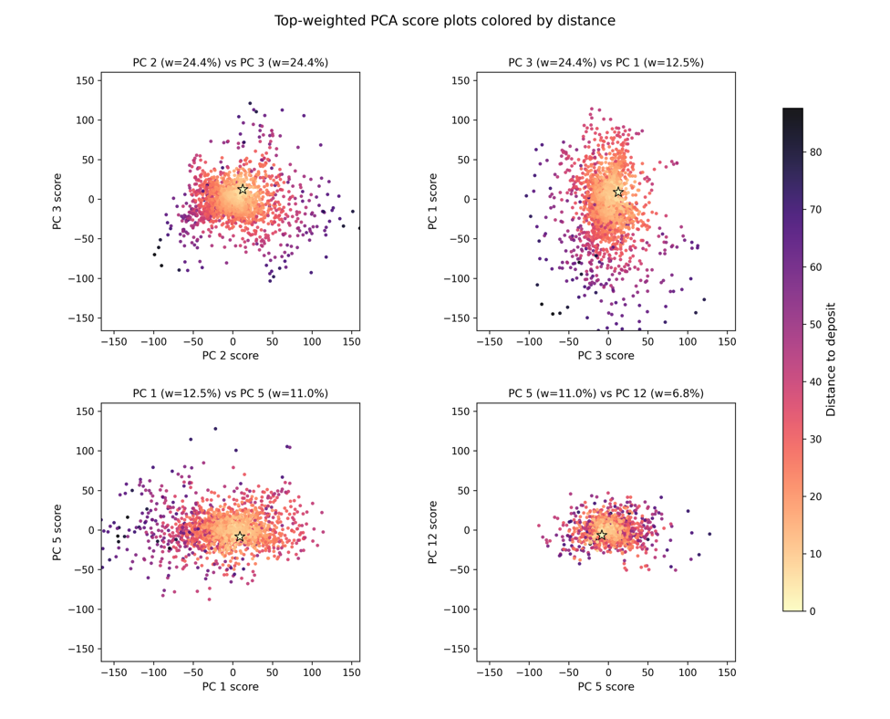
Figure 12 illustrates the spatial PCA loading maps corresponding to the highest-weighted components. PC2 and PC3. Together, they account for the largest deposit weights (≈24% each) and exhibit strong spatial gradients across the window. PC2 expresses a pronounced north–south–oriented contrast (Figure 2) and PC3 captures a SW-NE oriented pattern. These spatial components closely resemble the dominant deposit’s geometry. Therefore, they exert the strongest influence on the similarity metric. Lower-weighted components (e.g., PC1 and PC5) capture spatial variations and contribute less to the distance calculation. The reconstruction progression (Figure 11) shows how the deposit geometry emerges as additional PCA components are included. Components with larger deposit-based weights contribute more strongly to reconstructing the geometry. They more important in the similarity analysis.
Figure 14. Pairwise spatial PCA score scatter plots colored by deposit-weighted distance. Each panel shows the distribution of sliding-window scores for selected principal component pairs. Point color indicates similarity to the training deposit window. The relative importance of the components in the distance metric is reflected in the clustering structure: windows with PC2 and PC3 scores similar to those of the deposit consistently exhibit the smallest distances. Components with lower deposit weights show weaker clustering and contribute less to the similarity calculation.
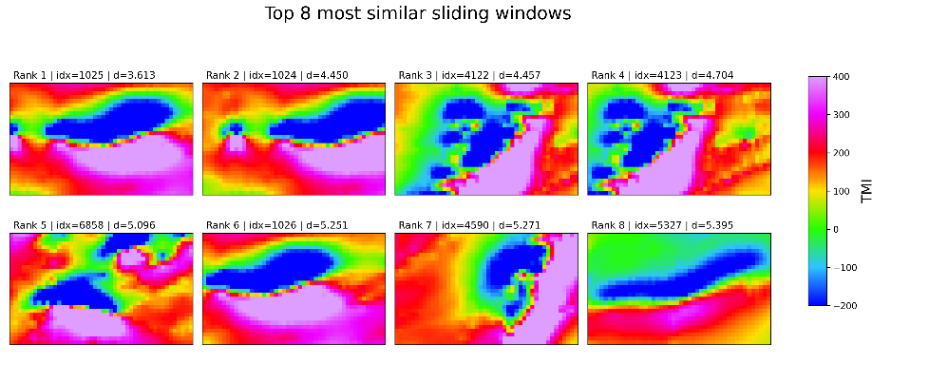
After calculating the deposit-weighted squared distance between all sliding windows and the deposit, we rank the sliding windows based on their similarity $d_{i}$. In Figure 14, we observe the relative importance of the principal components in the distance and similarity calculations. Windows with similar score values in PC2 and PC3 to the deposit window consistently show the smallest distances.
Figure 14. Top-ranked sliding windows based on the deposit-weighted similarity metric. The first panel corresponds to the sliding window overlapping the training deposit. Subsequent panels show the highest-ranked regional windows ordered by increasing distance. All displayed windows exhibit spatial patterns that closely reproduce the deposit’s internal geophysical geometry in weighted PCA space, highlighting candidate areas with analogous responses.
The top 8 prediction windows with the smallest distance are shown in Figure 15. As expected, the most similar windows are the deposit window itself and the sliding windows around it. The top 8 include multiple times the deposit, since we use a stride of 8 px in both the lateral and vertical directions. Window n=6858, Window $n=6858$ coincides spatially with the known IOCG [deposit name] and exhibits a TMI dipole geometry similar to Paolo Afonso. It is independently identified as an analogous geometry by the similarity analysis.
Figure 15. Top-ranked sliding windows based on the deposit-weighted similarity metric. The first panel corresponds to the sliding window overlapping the training deposit. Subsequent panels show the highest-ranked sliding windows ordered by increasing distance. All displayed windows exhibit spatial patterns that closely reproduce the deposit’s internal geophysical geometry in weighted PCA space, highlighting candidate areas with analogous responses.
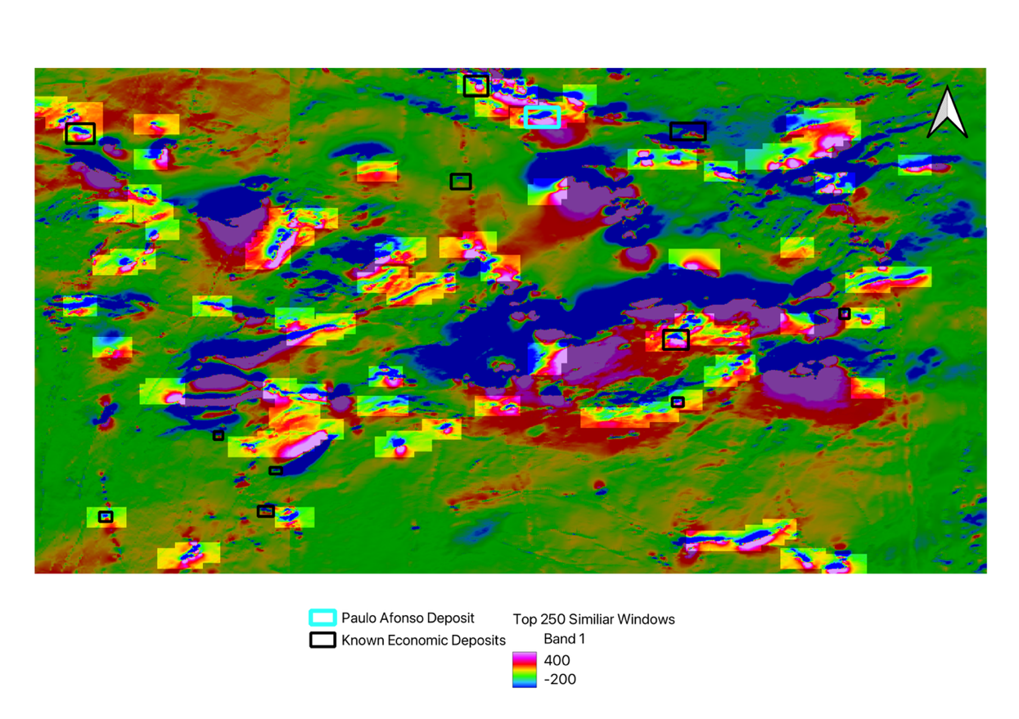
Figure 16. Study area showing the top 250 sliding windows identified by the deposit-weighted similarity analysis. Bright-colored rectangles indicate windows whose TMI spatial patterns most closely resemble the reference Paulo Afonso deposit geometry, overlain on the background TMI map. The training deposit and other known testing mineral deposits are shown for context. The prediction windows overlap with 5 testing deposits.
The top 250 prediction windows are mapped across the demonstration area (Figure 165). These windows highlight areas whose geometry most closely resembles that of the training deposit. In addition to the window overlapping the Paulo Afonso deposit, five other windows within the demonstration area coincide with known mineral occurrences Figure 16. These include Tucuma, Pedra Branca, and Salobo deposits (Figure 2). These are independently identified by the similarity analysis despite not being used as reference inputs.
To validate the ranked predictions, all known deposits, except the training deposit, are treated as test deposits (Table 1).. We then evaluate whether the ranked prediction windows overlap the areas of these test deposits (Figure 17).. For each rank level, the footprint of the predicted window is intersected with each test deposit. Overlap . The recovered area is accumulated using the union of intersections, so that overlapping prediction windows within the same deposit are counted only once. This yields both deposit-specific recovered fractions and an area-weighted cumulative recovery curve for the total test-deposit area. Overlap events are recorded whenever a predicted window intersected a test deposit. Hit events are defined as the first rank at which a deposit reached the minimum coverage threshold of 50%.
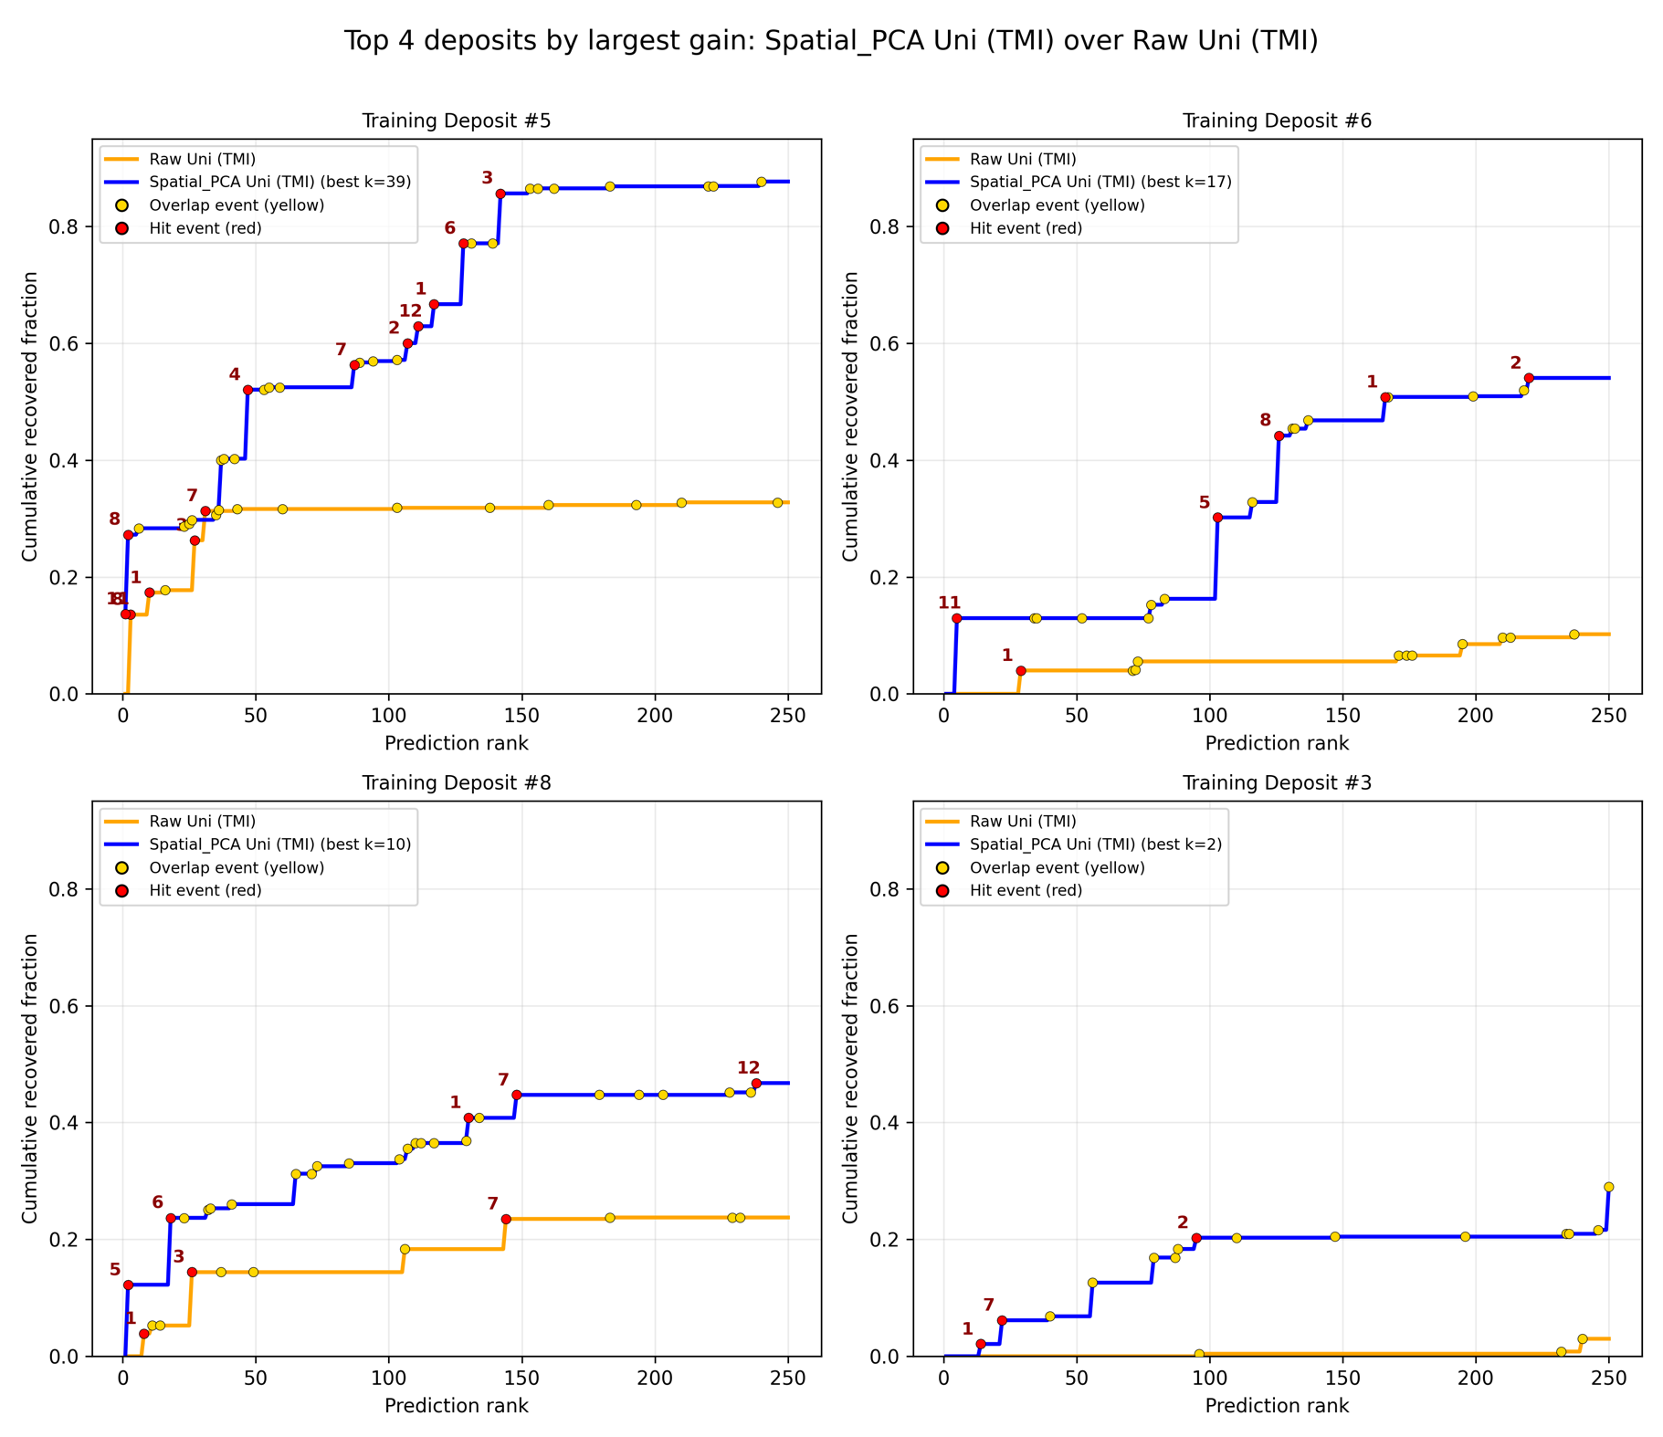
Figure 17. Cumulative recovered fraction versus prediction rank for Training Deposit #6, comparing Raw Univariate TMI and Spatial PCA Univariate TMI (k = 17). Yellow markers denote overlap events and red markers denote hit events. Labels indicate the corresponding testing deposit IDs that were hit.
To provide a transparent baseline against which the contribution of spatial PCA could be evaluated, we also consider a raw comparison method. Here, prediction windows are ranked directly by Euclidean distance to the training deposit in the original pixel-value space, without PCA decomposition, dimensionality reduction, or deposit-specific weighting. This raw ranking represents the most direct use of the geophysical data. It serves as a useful benchmark for assessing whether the additional structure introduced by spatial PCA leads to a measurable improvement in predictive performance.
Spatial PCA with $k=17$ recovers 54.1% of the total test-deposit area by rank 250, compared with 10.2% for the raw TMI baseline (Figure 17). It also produces five threshold-reaching hits, with the first occurring at rank 5 (test deposit ID=11). The raw ranking produces only one hit, first occurring at rank 29 (test deposit #1). The cumulative recovery AUC likewise increases from 14.04 to 83.15.

Case Study 2. Alemao Deposit: Multivariate TMI + Radiometric U
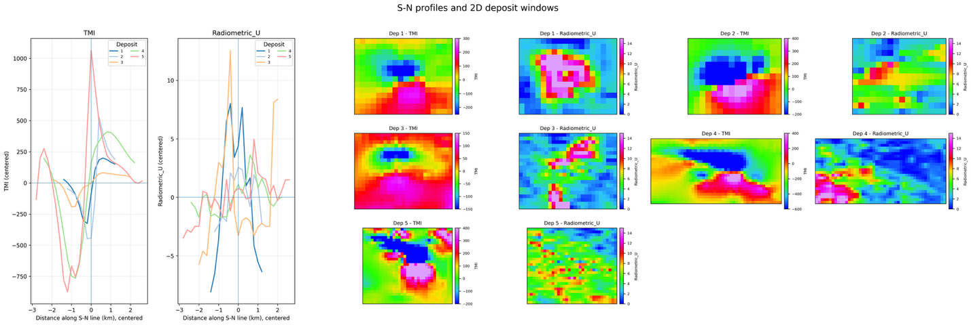
Figure 18. TMI and radiometric U centered S-N profiles and corresponding 2D deposit windows for Deposits 1-5. The figure highlights the complementary geometry used in the multivariate spatial PCA analysis.
Alemao (Deposit 3) is selected as the representative multivariate case. It provides a direct comparison between single-variable rankings and a fused workflow. In the multivariate analysis, co-located sliding windows are extracted simultaneously from the TMI and radiometric U grids (Figure 18). Only deposits containing a high uranium geometry are considered for the analysis in this case (Table 1).
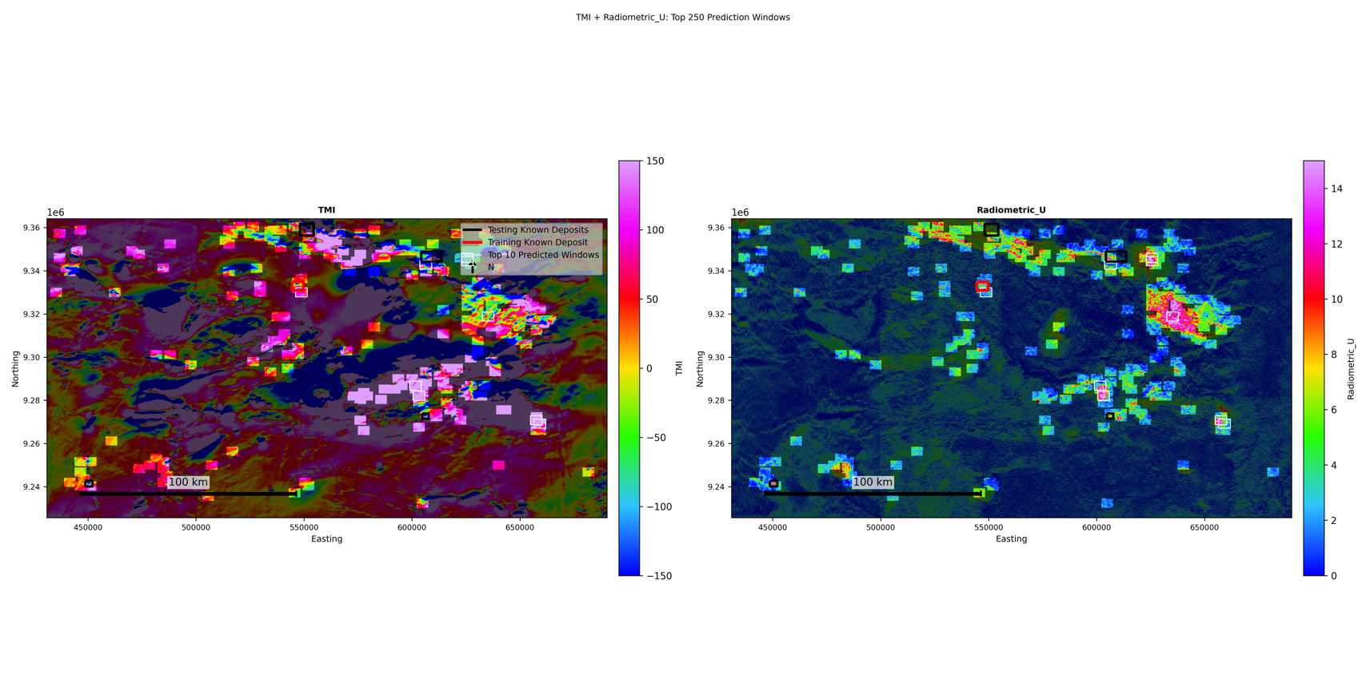
Figure 19. Map of the top 250-ranked prediction prediction windows for the multivariate Case 2 analysis. The red box marks the Alemão training deposit. The black boxes show the known test deposits. The top 250 windows are now conditioned jointly on the geometry of the TMI and the Radiometric U geometry of the training deposit. Predictions must resemble the training deposit across both geophysical layers.The top 250 similar windows identified from the combined TMI + radiometric U analysis are shown in bright colors. The fused multivariate spca analysis produces hits for all four test deposits.
sPCA is first applied separately to each variable, retaining $k_{TMI}=2$ and $k_{U}=34$ components. The retained score vectors are then concatenated, standardized, and subjected to a second PCA. Similarity is computed in this fused space using the first $k_{fused}=6$ components with deposit-based weights (Figure 198). The Raw Multi baseline ranks windows by direct Euclidean distance in the concatenated TMI+U pixel space. Using Deposit 3 as the training deposit and Deposits 1, 2, 4, and 5 as test deposits, sPCA Multi achieves the highest AUC among the tested methods (AUC = 99.22 compared with 82.22 for sPCAstrongest validation performance. It recovers 77.7% of the total test-deposit area by rank 250 AUC128.89 (Figure 19). This exceeds SPCA Uni Radiometric U, 37.15 for sPCA Uni TMI, and 0.23 for Raw Multi). This means the multivariate ranking places recovered test-deposit area earlier and more consistently through the top 250 predictions, even though the final recovered area at rank 250 is slightly higher for the univariate Radiometric U model. The advantage, therefore, comes from improved ordering of predictions, not simply from maximizing the final cumulative recovery value.
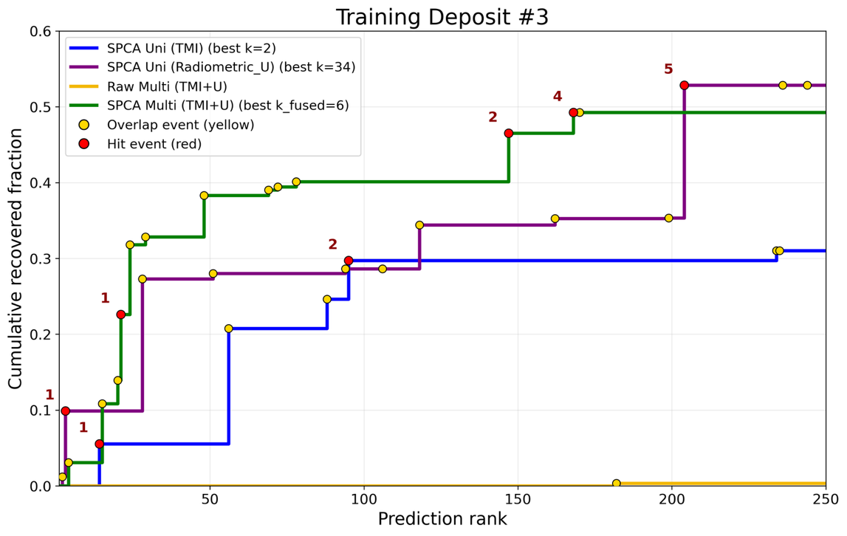
Figure 20. Cumulative recovered fraction as a function of prediction rank for Training Deposit #3. The figure compares univariate sPCA, Raw Multi, and fused multivariate sPCA rankings. sPCAand multivariate ranking methods. SPCA Multi (TMI+U) achieves the highest rank-integrated recovery, indicating that recovered test-deposit area is prioritized earlier and more consistently through the top 250 predictions. Raw Multi performs poorly, showing that the improvement comes from the fused sPCA representation rather than direct Euclidean distance in the concatenated TMI+U pixel space. Yellow. Yellow and red markers indicate overlap and hit events for the testing deposits.

Discussion
This study aimed to develop a quantitative, reproducible, and interpretable framework for geophysical prospecting based on spatial similarity to a known deposit. The results of both case studies support that objective. Rather than comparing windows only in the original pixel space, the sPCA approach decomposes the reference geometry into spatial components. It ranks candidate windows by how well they reproduce that geometry. An important outcome is that the method remains physically interpretable. The loading maps and cumulative reconstructions indicate that the most-weighted components correspond to thosethe ones that contribute most strongly to reconstructing the observed deposit geometry. In this sense, the deposit-based weights are measures of which spatial patterns are most diagnostic of the training deposit geometry. This is a useful property in brownfield exploration, where a method is more valuable if its targets can be related back to recognizable geophysical geometry rather than treated as black-box outputs.
The first case, based on Deposit 6 and univariate TMI, provides the clearest demonstration of the gain obtained by sPCA over a direct raw comparison. Spatial PCA Uni TMI substantially outperformed Raw Uni TMI. sPCA Uni TMI substantially outperformed Raw Uni TMI. It increases the total recovered test-deposit area from 10.2% to 54.1%, the hit count from one to five, and the cumulative recovery AUC from 14.04 to 83.15. These gains show that the improvement is strong, not confined to a few isolated predictions. These gains show that the improvement is strong, not confined to a few isolated prediction windows. The main implication of this case is that sPCA performs especially well when the training deposit has a well-defined geophysical geometry. In such settings, the decomposition isolates the dominant spatial components of the geometry and reduces the influence of amplitude differences, local noise, and non-diagnostic background variation. Case 1, therefore, provides strong proof of concept for the sPCA method under well-defined training geometries.
The second case, based on Alemão (Deposit 3), extends this idea to a multivariate setting. It shows why the joint use of TMI and radiometric U can be advantageous. In Case 2, Raw Multi performs poorly. It recovers only 0.3% of the test-deposit area by rank 250 and produces no threshold-reaching hits. sPCA Uni TMI recovers 31.0%, while sPCA Uni Radiometric U recovers 52.8%. The fused sPCA Multi result recovers 49.3% by rank 250. This is slightly below the univariate radiometric U endpoint, but it achieves the highest AUC and produces threshold-reaching hits for three of the four test deposits. This In Case 2, performance improved progressively from Raw Multi to SPCA Uni TMI, to SPCA Uni Radiometric U, and finally to SPCA Multi. The recovery increased from 7.9% to 31.0%, 52.8%, and 77.7%, respectively. SPCA Multi also achieved the highest AUC and is the only method to hit all four test deposits. This progression suggests two things. First, the improvement from Raw Multi to the univariate sPCA rankings confirms that feature extraction itself is important. Simply concatenating raw variables is not enough. Second, the further improvement from the best univariate result to SPCA Multi indicates that the multivariate model improves the ordering of predictions through the ranked list, rather than simply maximizing the final cumulative recovery value. The modest difference between the multivariate endpoint recovery and the univariate Radiometric U endpoint may suggest that multivariate performance may depend on how clearly each input variable expresses deposit-scale geometry; a more spatially coherent Radiometric U anomaly could potentially strengthen the fused ranking.
The gain from sPCA Multi over both univariate sPCA and Raw Multi suggests that TMI and radiometric U contribute complementary spatial information when fused in the learned sPCA score space. This is geologically reasonable in the Alemão area, where the magnetic response is related to the iron-oxide-rich footprint of the system. Radiometric U may reflect a shallower or more alteration-related hydrothermal expression. These two datasets do not need to image exactly the same physical part of the deposit to be useful together. Instead, the multivariate result suggests that, at the scale of the analysis window, they jointly describe a broader IOCG-related system geometry.
This point is important for interpretation. A potential concern in multivariate fusion is that different datasets may respond to different depths, processes, or components of a mineral system. The Case 2 results suggest that this does not necessarily weaken the method, provided the variables are genetically and spatially related at the scale of the deposit window. In other words, the multivariate framework does not require a perfect one-to-one correspondence between anomalies. Instead, it seeks recurring combinations of complementary spatial geometries. The poor Raw Multi result is especially important in this context because it shows that simply concatenating TMI and radiometric U pixels is not sufficient. The improvement comes from the fused sPCA representation, which learns the joint geometry of the two datasets before computing similarity. At the same time, this also defines a practical limitation: variable selection must remain geologically informed. If datasets are unrelated to the same mineralizing system, or if their responses operate at incompatible spatial scales, fusion could dilute rather than improve the similarity measure.

References

Carranza, E. J. M. (2009). Geochemical anomaly and mineral prospectivity mapping in GIS (1st ed). Elsevier.
Chen, Y., & Wu, W. (2017). Mapping mineral prospectivity by using one-class support vector machine to identify multivariate geological anomalies from digital geological survey data. Australian Journal of Earth Sciences, 64(5), 639–651. https://doi.org/10.1080/08120099.2017.1328705
Haldar, S. K. (2013). Mineral Exploration. Elsevier. https://doi.org/10.1016/C2011-0-05550-3
Hronsky, J. M. A., & Groves, D. I. (2008). Science of targeting: Definition, strategies, targeting and performance measurement. Australian Journal of Earth Sciences, 55(1), 3–12. https://doi.org/10.1080/08120090701581356
Jansson, N. F., Allen, R. L., Skogsmo, G., & Tavakoli, S. (2022). Principal component analysis and K-means clustering as tools during exploration for Zn skarn deposits and industrial carbonates, Sala area, Sweden. Journal of Geochemical Exploration, 233, 106909. https://doi.org/10.1016/j.gexplo.2021.106909
Luo, Z., Xiong, Y., & Zuo, R. (2020). Recognition of geochemical anomalies using a deep variational autoencoder network. Applied Geochemistry, 122, 104710. https://doi.org/10.1016/j.apgeochem.2020.104710
McCuaig, T. C., Beresford, S., & Hronsky, J. (2010). Translating the mineral systems approach into an effective exploration targeting system. Ore Geology Reviews, 38(3), 128–138. https://doi.org/10.1016/j.oregeorev.2010.05.008
McInnes, L., Healy, J., Saul, N., & Großberger, L. (2018). UMAP: Uniform Manifold Approximation and Projection. Journal of Open Source Software, 3(29), 861. https://doi.org/10.21105/joss.00861
McIntosh, S. (2016, June 27). Rio Tinto Exploration. Citi’s Mining Exploration Day. https://announcements.asx.com.au/asxpdf/20160627/pdf/4384m96mnj5msz.pdf
Nykänen, V., Yousefi, M., & Sadeghi, M. (2025). Exploration information system: Mineral systems anatomy linked to computational techniques for mineral exploration targeting. Ore Geology Reviews, 187, 106961. https://doi.org/10.1016/j.oregeorev.2025.106961
Partington, G. A., Peters, K. J., Czertowicz, T. A., Greville, P. A., Blevin, P. L., & Bahiru, E. A. (2024). Ranking mineral exploration targets in support of commercial decision making: A key component for inclusion in an exploration information system. Applied Geochemistry, 168, 106010. https://doi.org/10.1016/j.apgeochem.2024.106010
Regueiro González-Barros, M., & Espí, J. A. (2019). The returns on mining exploration investments. Boletín Geológico y Minero, 130(1), 161–180. https://doi.org/10.21701/bolgeomin.130.1.010
Sadeghi, M., Casey, P., Carranza, E. J. M., & Lynch, E. P. (2024). Principal components analysis and K-means clustering of till geochemical data: Mapping and targeting of prospective areas for lithium exploration in Västernorrland Region, Sweden. Ore Geology Reviews, 167, 106002. https://doi.org/10.1016/j.oregeorev.2024.106002
Singer, D. A. (1993). Basic concepts in three-part quantitative assessments of undiscovered mineral resources. Nonrenewable Resources, 2(2), 69–81. https://doi.org/10.1007/BF02272804
van der Maaten, L., & Hinton, G. (n.d.). Visualizing Data using t-SNE. Journal of Machine Learning Research, 9, 2579–2605.
Wang, J., Zuo, R., & Caers, J. (2017). Discovering geochemical patterns by factor-based cluster analysis. Journal of Geochemical Exploration, 181, 106–115. https://doi.org/10.1016/j.gexplo.2017.07.006
Wang, L., Yin, Z., & Caers, J. (2024). Data science for the geosciences. Cambridge University Press. https://doi.org/10.1017/9781009201391
Xiong, Y., & Zuo, R. (2021). A positive and unlabeled learning algorithm for mineral prospectivity mapping. Computers & Geosciences, 147, 104667. https://doi.org/10.1016/j.cageo.2020.104667
Yang, F., Zuo, R., & Kreuzer, O. P. (2024). Artificial intelligence for mineral exploration: A review and perspectives on future directions from data science. Earth-Science Reviews, 258, 104941. https://doi.org/10.1016/j.earscirev.2024.104941
Yousefi, M., Carranza, E. J. M., Kreuzer, O. P., Nykänen, V., Hronsky, J. M. A., & Mihalasky, M. J. (2021). Data analysis methods for prospectivity modelling as applied to mineral exploration targeting: State-of-the-art and outlook. Journal of Geochemical Exploration, 229, 106839. https://doi.org/10.1016/j.gexplo.2021.106839
Yousefi, M., Nykänen, V., Harris, J., Hronsky, J. M. A., Kreuzer, O. P., Bertrand, G., & Lindsay, M. (2024). Overcoming survival bias in targeting mineral deposits of the future: Towards null and negative tests of the exploration search space, accounting for lack of visibility. Ore Geology Reviews, 172, 106214. https://doi.org/10.1016/j.oregeorev.2024.106214
Yu, X., Yu, P., Wang, K., Cao, W., & Zhou, Y. (2024). Data-Driven Mineral Prospectivity Mapping Based on Known Deposits Using Association Rules. Natural Resources Research, 33(3), 1025–1048. https://doi.org/10.1007/s11053-024-10328-2
Zhang, Q., Liu, Y., & Fang, H. (2024). Manifold learning-based UMAP method for geochemical anomaly identification. Geochemistry, 84(4), 126157. https://doi.org/10.1016/j.chemer.2024.126157
Zuo, R. (2020). Geodata Science-Based Mineral Prospectivity Mapping: A Review. Natural Resources Research, 29(6), 3415–3424. https://doi.org/10.1007/s11053-020-09700-9

