Introduction
This project applies data mining techniques to the Bank Marketing dataset to predict whether a client will subscribe to a term deposit. The analysis is conducted from the perspective of a data scientist supporting business decision-making, with the aim of identifying patterns in customer and campaign data to improve targeting and increase campaign efficiency.
The project follows a standard data mining workflow, including data understanding, preprocessing, exploratory data analysis, predictive modelling, model evaluation, and business interpretation (Han, Kamber and Pei, 2012). This approach demonstrates appropriate technique selection, model evaluation using relevant performance metrics, and communication of findings that support business decision-making.
The analysis uses the Bank Marketing dataset, originally developed by Moro, Rita, and Cortez (Moro, Cortez and Rita, 2014). The dataset contains customer, socioeconomic, and campaign-related variables, with the target variable indicating whether a client subscribed to a term deposit.
Dataset Description
The dataset contains 41,188 records and 21 variables, combining numerical and categorical data. These variables describe customer demographics, including age, job, marital status, and education, together with campaign information such as contact type, month, number of contacts, and several macroeconomic indicators.
The target variable, y, is binary and indicates whether a customer subscribed to a term deposit. Initial inspection showed that the dataset contained no standard missing values. However, several categorical variables included the label unknown, representing incomplete information rather than true missing data. The dataset also contained 12 duplicated records.
The target variable was highly imbalanced, with 88.73% of observations labelled no and 11.27% labelled yes. This imbalance is an important consideration because a model can achieve high accuracy while still performing poorly at identifying customers who are likely to subscribe. Therefore, additional evaluation metrics such as precision, recall, F1-score, and ROC-AUC are required to assess model performance more effectively (Fawcett, 2006)
Figure 1: Target variable distribution bar chart
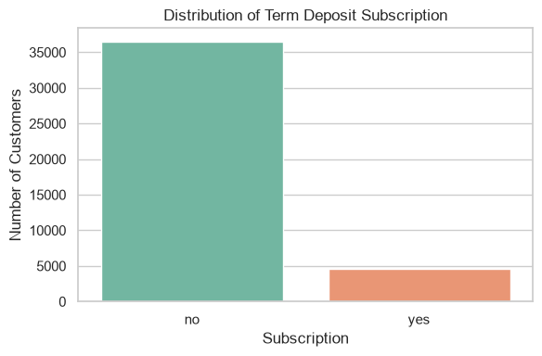
Source: notebook output

Data Preprocessing
Data preprocessing was carried out to prepare the dataset for predictive modelling and improve the reliability of the results. The target variable was converted into binary form, with no encoded as 0 and yes as 1, making it suitable for classification algorithms.
Duplicated records were removed to reduce redundancy. One of the most important preprocessing decisions was excluding the duration variable from the modelling process. Although call duration is a strong predictor of subscription, it is only known after customer contact has taken place, so including it would introduce data leakage into a model intended to support pre-call targeting decisions. Removing this variable, therefore, makes the model more realistic and suitable for business use.
Categorical variables were transformed using one-hot encoding, while numerical variables were standardized where required by the selected model. An 80:20 stratified train-test split was then applied to preserve the original class distribution in both the training and testing datasets. These preprocessing steps ensured that the models were trained consistently and could be compared fairly
Exploratory Data Analysis

To understand the distribution of customer characteristics and identify patterns that could influence subscription behavior before model development, exploratory data analysis (EDA) was implemented, confirming that the target variable was highly imbalanced and showing that occupations such as admin. and blue-collar were the most common customer groups.
The distribution of education levels indicated that university degrees and high school were the most frequent categories. These patterns provide useful context for interpreting the model results and understanding which customer characteristics are most common within the dataset.
Figure 2: Distribution of customer occupations
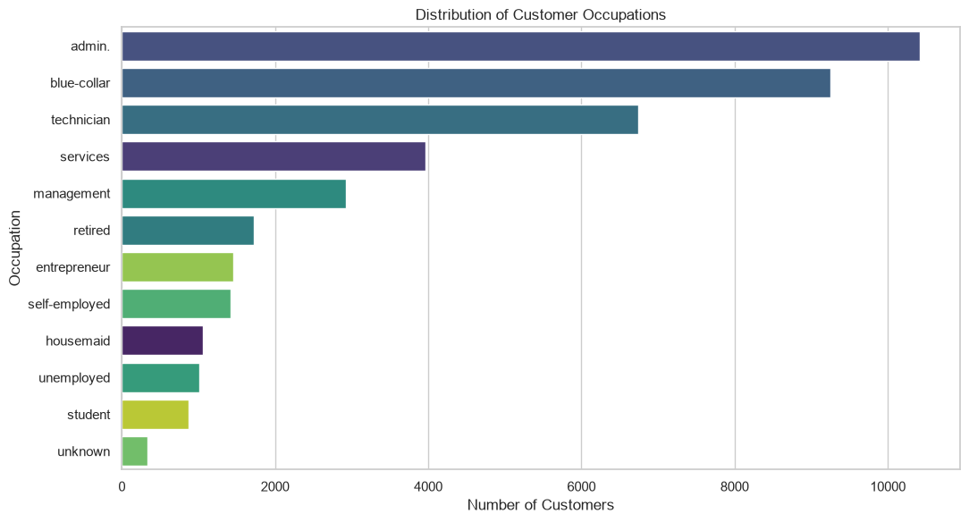
Source: Notebook output.

Figure 3: Education distribution chart
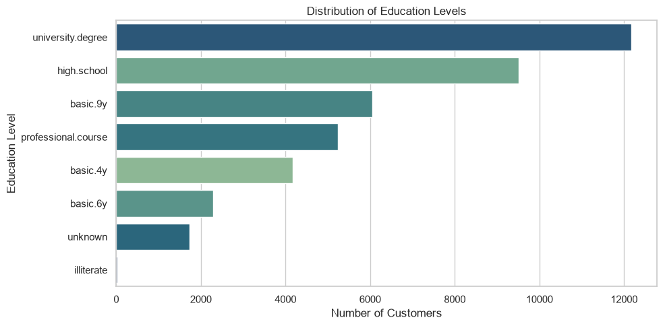
Source: Notebook output.

The analysis of numerical variables also identified skewed distributions and several outliers, particularly in variables such as campaign, duration, and previous. These findings supported the use of appropriate preprocessing techniques and reinforced the decision to compare a linear model with a tree-based approach, as the two algorithms handle numerical data differently.
Figure 4: Boxplots of numerical features
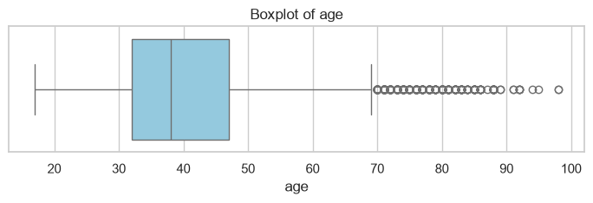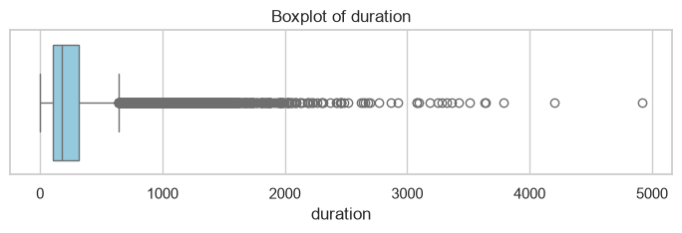
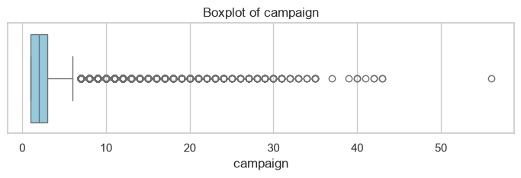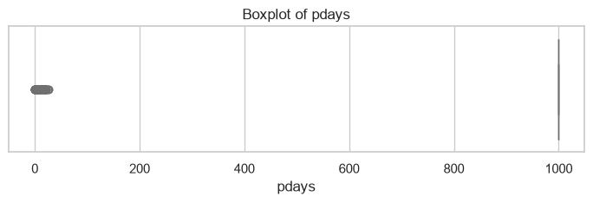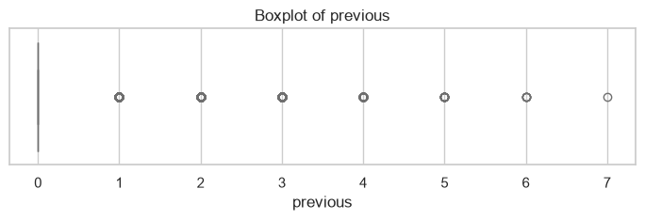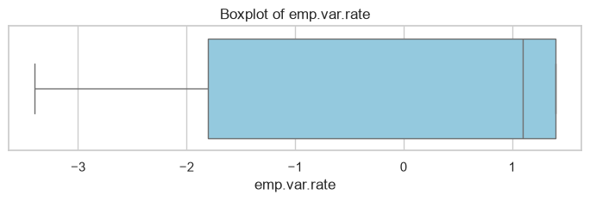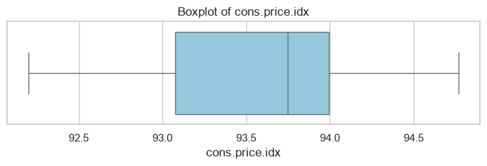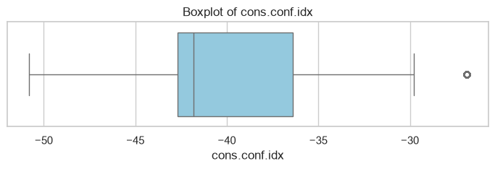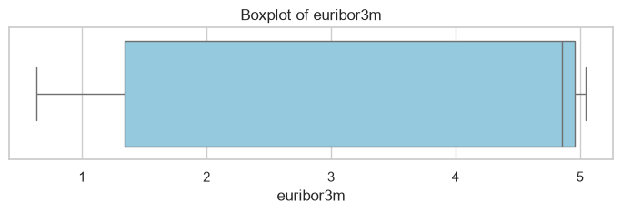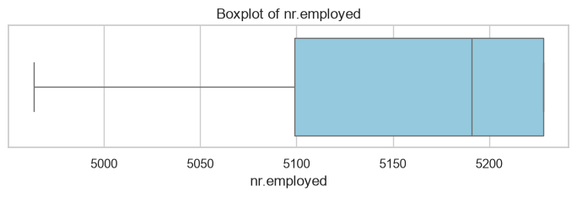
Source: Notebook output.
Model Development
Two classification models were developed for this project: Logistic Regression and Decision Tree. Logistic Regression was selected as a baseline model because it is widely used for binary classification, computationally efficient, and easy to interpret (James et al., 2021). Decision Tree was chosen as a comparison model because it can capture more complex, non-linear relationships and interactions between variables (James et al., 2021).
Selecting both models allows different modelling approaches to be compared before identifying the most suitable solution for the problem. Comparing two algorithms also strengthens the analysis by ensuring that the final recommendation is based on model performance rather than a single approach.
Both models were trained using the same preprocessed training data and evaluated on the same held-out test set. This ensured a fair comparison and allowed differences in performance to be attributed to the models rather than the data or preprocessing steps.
Evaluation and Comparison
Model performance was evaluated using accuracy, precision, recall, F1-score, confusion matrices, and ROC-AUC (Fawcett, 2006; Han, Kamber and Pei, 2012). This combination of metrics is appropriate for a binary classification problem with class imbalance because accuracy alone does not provide a reliable measure of how well the models identify potential subscribers.
Logistic Regression achieved higher accuracy (89.83%), precision (65.00%), and ROC-AUC (0.80), while the Decision Tree achieved a slightly higher recall (35.34%) and F1-score (0.33). These results indicate that Logistic Regression provides stronger overall discrimination, whereas the Decision Tree identifies more potential subscribers at the expense of a higher number of false positives.
Table 1: Performance comparison of Logistic Regression and Decision Tree
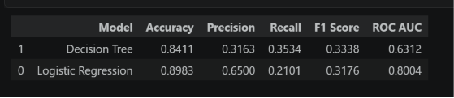
Confusion matrices were used to examine the classification results in more detail by showing the number of correct and incorrect predictions made by each model. This makes it easier to understand how well each model identifies subscribers and non-subscribers and to explain the results to non-technical stakeholders.
Figure 5: Confusion matrix comparison
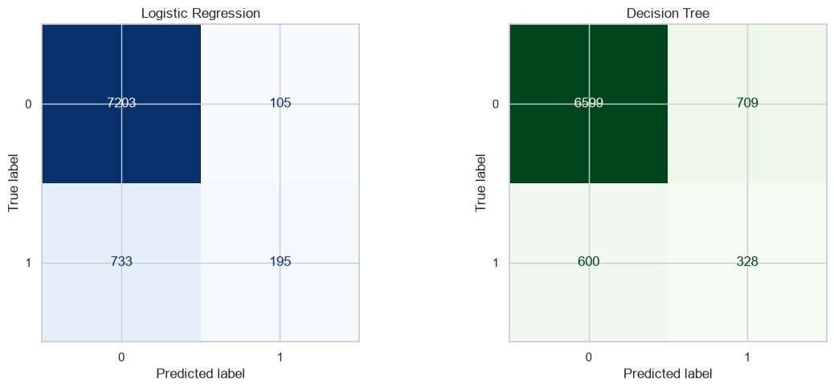
Source: Notebook output.
ROC curves were also used to compare the ability of both models to distinguish between subscribers and non-subscribers across different probability thresholds. Together with the quantitative evaluation metrics, they provide a more complete assessment of model performance.
Figure 6: ROC curve comparison
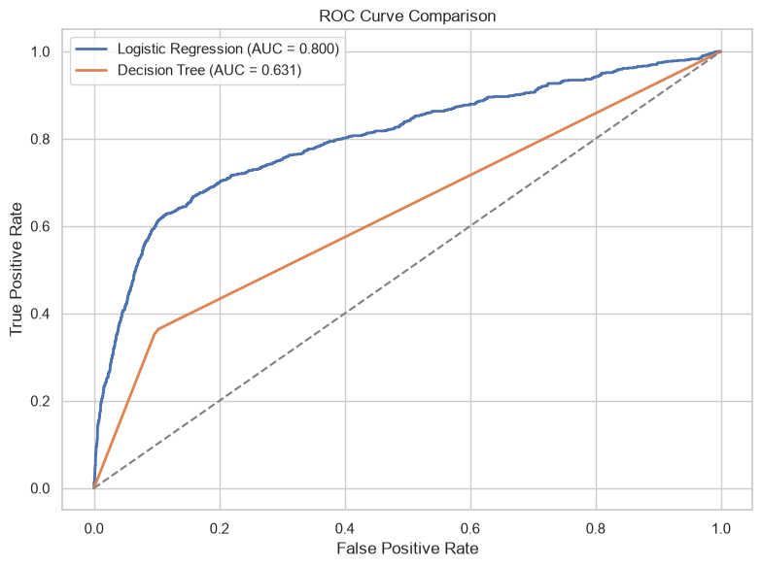
Source: Notebook output.
Overall, model selection should be based on the best balance between recall, F1-score, and ROC-AUC rather than accuracy alone. In the context of a marketing campaign, identifying potential subscribers is often more valuable than achieving the highest overall accuracy, making recall an important consideration alongside the other evaluation metrics.
Business Interpretation
The modelling results show how predictive analytics can support more effective marketing decisions by identifying customers with a higher probability of subscribing to a term deposit. Rather than applying the same marketing strategy to all customers, the bank can use the model to prioritize customers who are more likely to respond positively, improving the efficiency of future campaigns.
This has clear business value; Better targeting can reduce unnecessary customer contact, lower campaign costs, and make better use of staff time. It may also improve customer experience by reducing contact with customers who are unlikely to be interested in the product.
The exploratory analysis and model development also suggest that variables such as previous campaign outcome, contact method, customer characteristics, and macroeconomic indicators contribute to predicting subscription behavior. However, these variables should be interpreted as predictors rather than causes, as feature importance reflects relationships within the data and does not demonstrate causality.
Limitations
One limitation of this project is the imbalance in the target variable, which makes it more difficult to identify customers in the minority class. For this reason, evaluation metrics such as recall, F1-score, and ROC-AUC provide a more meaningful assessment of model performance than accuracy alone.
Another limitation is that several variables contain unknown values, which may reduce predictive quality or reflect incomplete customer information. In addition, excluding the duration variable improves the realism of the model but may reduce predictive performance compared with models that use post-call information. However, this trade-off is appropriate because the aim of the model is to support decision-making before customer contact.
Finally, the Decision Tree model may be sensitive to changes in the data and parameter settings, increasing the risk of overfitting. Future work could evaluate ensemble methods such as Random Forest or Gradient Boosting to improve predictive performance and model stability.
Conclusion
This project applied a complete data mining workflow to the Bank Marketing dataset, including data understanding, preprocessing, exploratory data analysis, model development, evaluation, and business interpretation. The objective was to predict customer subscription using information available before contact.
Among the two models evaluated, Logistic Regression was selected as the preferred model because it achieved stronger overall performance, particularly in terms of precision and ROC-AUC, while remaining easy to interpret. Although the Decision Tree identified more potential subscribers, its lower precision increased the number of false positive predictions.
Overall, the analysis shows that predictive modelling can support more effective marketing decisions by helping the bank identify customers who are more likely to subscribe. When applied appropriately, these models can improve campaign efficiency, reduce unnecessary contact costs, and support more informed, data-driven marketing decisions.

References
Dua, D. and Graff, C. (2019) UCI Machine Learning Repository. University of California, Irvine, School of Information and Computer Science. Available at: https://archive.ics.uci.edu/dataset/222/bank+marketing
Fawcett, T. (2006) 'An introduction to ROC analysis', Pattern Recognition Letters, 27(8), pp. 861–874.
Han, J., Kamber, M. and Pei, J. (2012) Data Mining: Concepts and Techniques. 3rd edn. Waltham, MA: Morgan Kaufmann.
James, G., Witten, D., Hastie, T. and Tibshirani, R. (2021) An Introduction to Statistical Learning: With Applications in R. 2nd edn. New York: Springer.
Moro, S., Cortez, P. and Rita, P. (2014) 'A data-driven approach to predict the success of bank telemarketing', Decision Support Systems, 62, pp. 22–31.

