VEERMATA JIJABAI TECHNOLOGICAL INSTITUTE
  - B.TECH COMPUTER ENGINEERING
  - OPTIMIZATION TECHNIQUES LABORATORY

LAB ASSIGNMENT 7
MULTIOBJECTIVE OPTIMIZATION
  - 37 Algorithms, Trade-offs and Applications
Student detail | Value
Name | Sofia Abidi
Registration number | 241071072
Roll suffix | 72
Course | B.Tech Computer Engineering
Assignment issued | 5 October 2026
Assigned deep dives | A35 R-NSGA-II, A10 VEGA, A22 MOPSO
AIM
To implement, verify and compare classical, evolutionary, swarm, indicator, preference and gradient-based multiobjective optimization methods on the specified P1-P14 problem bank.

OBJECTIVES
Implement all 37 assigned mechanisms; verify shared numerical utilities and constraints; study A35 R-NSGA-II, A10 VEGA and A22 MOPSO in depth; compare methods with reproducible metrics; and document suitable applications and limitations.

GitHub repository: https://github.com/sofiaabidi/OT_LAB07
This report presents tested Python implementations of all 37 catalogue mechanisms, their measured tradeoffs on the assignment problems, and the three assigned study cards. It includes Tasks A to F, raw-result references and reproducible commands. The main finding is that selection geometry, constraints and preferences determine useful choices: no algorithm leads across every problem and metric.
Ten-trial stochastic studies use a 10,000-evaluation cap, with P9 feature-selection experiments explicitly reduced to 200. Classical scalar solvers often consume fewer calls. Measured quality is separated from theoretical mechanism claims; some advantages and disadvantages needing direct experimental support still need targeted ablations.
Contents
1 Overview and completion status 2
2 Methodology and reproducibility 3
3 Problem formulations 3
4 Shared tools and verification 11
5 Tasks A and B algorithm implementations and comparison 12
6 Task C assigned study cards and hand traces 52
35. R-NSGA-II — Reference Point-Based NSGA-II 52
10. VEGA — Vector Evaluated Genetic Algorithm 53
22. MOPSO — Multi-Objective Particle Swarm Optimization 54
7 Task D head to head comparisons 62
8 Task E algorithm selection cases 70
9 Task F viva preparation 71
10 Findings and limitations 72
11 Reproducibility and repository instructions 73
12 References 73
13 Appendix evidence files and lecture alignment 74

The paginated table above is a native Word field. It remains editable and can be refreshed after later edits with Update Field.

1 Overview and completion status
The project has 37 separately named algorithm modules, 37 defining-mechanism tests and 62 passing automated tests in total. The main manifest contains 1196 optimizer experiment rows and 60 additional network learning curves. Every front figure is drawn from persisted arrays of decisions, objectives and violations, not mock data.
Roll assignment calculation for R=72: ((72-1) mod 37)+1=35; ((72+11) mod 37)+1=10; ((72+23) mod 37)+1=22.
Area | Verified outcome
Implementations | All 37 modules have core-mechanism tests
Problem bank | P1 to P14 definitions plus NumPy network
Task A | Designated problem runs, figures and consolidated algorithm/problem implementation log
Task B | Four reasoned strengths and four risks per method, with evidence-linked analysis and explicit causal boundaries
Task C | Three study cards, deterministic traces, three settings x ten trials
Task D | P3 P5 P10 M5 P8 comparisons plus ranking and gradient studies
Task E | Six cases including constraints and five objectives
Task F | Eight official questions plus focused A10/A22/A35 code walkthrough preparation
Remaining | P9 at full suggested budget and further mechanism-specific causal ablations

2 Methodology and reproducibility
Implementations use NumPy and the standard library. Matplotlib creates plots. SciPy SLSQP is used only in algorithms 1 to 7 for permitted scalar subproblems; scalarization, reference/epsilon sweeps, deviation elimination and priorities are handwritten. Scikit-learn loads only the Wisconsin dataset; five-neighbour classification and five-fold evaluation are handwritten. Neural-network forward and backward passes use NumPy without autograd.
Stochastic optimizer seeds are 720 to 729, ten independent streams. Benchmark construction and Monte Carlo metric seeds are separate fixed configuration values. Population and output archive cap are 40 except methods whose archive naturally shrinks. Candidate evaluation budgets include local-search proposals. Objective-vector evaluation counts one candidate irrespective of objective count. Finite-difference solver probes count in classical methods, including objective evaluations invoked by constraints. Reported runtime is wall-clock and should not be treated as a machine-independent algorithm complexity.
All natural maximization objectives are negated before dominance. Feasible candidates beat infeasible ones; smaller normalized positive constraint residual wins among infeasible candidates. Feasibility threshold is 1e-10, with a 1e-8 numerical verification tolerance on scalar-solver outputs. This prevents roundoff from being confused with a materially infeasible design.
Quality normalization uses fixed problem constants listed in Section 3. Two-objective HV is an exact staircase area. Higher-dimensional HV uses 8192 identical uniform samples per comparison, seed 991, in [0,1.1]^M. Its absolute Monte Carlo uncertainty is bounded by box_volume/(2*sqrt(8192)), about 0.00735 for M=3 and 0.00890 for M=5; differences smaller than that require cautious interpretation. SD across ten optimizer seeds is distinct from HV sampling error. IGD uses 301 exact-front samples where an analytic front is available; no true-front IGD is invented for P4 P8 or P9. Spacing is the sample SD of nearest L1 distances; a singleton scores zero without offering coverage.
Early nonelitist algorithms use a passive recording archive for comparable outputs. The final breeding population is saved separately in NPZ files. Thus a good recorded front does not prove that VEGA MOGA NSGA or NPGA preserved its parents. Classical algorithms use a common cap but naturally different consumed counts, so these are equal-cap rather than equal-consumed-budget studies.
The five supplied lecture decks were checked against the code. The teaching NPGA, MOSA, IBEA, RVEA and HypE conventions are stated in the appendix. Algorithms changed during that check were rerun; current figures and tables use refreshed rows.

3 Problem formulations

P1 Factory speed
Decision variables and encoding x in [1,10], one real variable

Standard form objectives in minimization convention
Formula in code notation min [(x-3)^2,(x-7)^2]
Constraints and handling Bounds only; Pareto x in [3,7].
Encoding: one-element real vector. Equal weight solution x=7-4w. Convex front; uniform weight steps are uniform x steps, not uniform arc lengths.
Numerical sanity check x=3 gives (f1,f2)=(0,16), while x=7 gives (16,0); both are Pareto endpoints.
Normalized objectives are (F-ideal)/(nadir-ideal). Fixed ideal=[0.0, 0.0]; fixed nadir=[16.0, 16.0]. Quality HV reference=[1.1, 1.1] in normalized coordinates. These are declared scaling constants; conservative lower bounds are used where the attainable ideal is unavailable.
Termination Classical scalar sweeps stop at solver tolerance under the 10,000-call cap; stochastic methods use at most 10,000 evaluations.
Evaluated methods: Benson reference improvement, Weight Metric, Weighted Sum. See the corresponding Task A pages and raw files.

P2 Fleet size
Decision variables and encoding x in [1,10], real or integer

Standard form objectives in minimization convention
Formula in code notation min [100/x,x^2]
Constraints and handling Bounds; every x is Pareto optimal.
Integer experiment has at most ten distinct objective points. VEGA runs and exact integer problem definitions retain integer repair.
Numerical sanity check x=1 gives (100,1) and x=10 gives (10,100), confirming the opposing monotone objectives.
Normalized objectives are (F-ideal)/(nadir-ideal). Fixed ideal=[10.0, 1.0]; fixed nadir=[100.0, 100.0]. Quality HV reference=[1.1, 1.1] in normalized coordinates. These are declared scaling constants; conservative lower bounds are used where the attainable ideal is unavailable.
Termination Scalar or stochastic runs use the shared 10,000-evaluation cap; integer repair is applied after variation.
Evaluated methods: Epsilon-Constraint, VEGA. See the corresponding Task A pages and raw files.

P3 Specified ZDT2
Decision variables and encoding 10 real variables in [0,1]

Standard form objectives in minimization convention
Formula in code notation g=1+sum(x2..x10); min [x1,g*(1-(x1/g)^2)]
Constraints and handling Bounds; exact front [t,1-t^2].
The factor matches the assignment at n=10; no alternate benchmark is substituted. Weighted Sum cannot select the unsupported interior with a global scalar solve.
Numerical sanity check With x2..x10=0, g=1; x1=0.5 gives (0.5,0.75) on f2=1-f1^2.
Normalized objectives are (F-ideal)/(nadir-ideal). Fixed ideal=[0.0, 0.0]; fixed nadir=[1.0, 1.0]. Quality HV reference=[1.1, 1.1] in normalized coordinates. These are declared scaling constants; conservative lower bounds are used where the attainable ideal is unavailable.
Termination Task A and Task D stochastic comparisons stop at 10,000 evaluations; scalar sweeps use the same cap.
Evaluated methods: Epsilon-Constraint, IBEA, MO-TLBO, MOABC, MOBA, MODE, MOEA/D, MOEA/D-DE, MOGA, MOSA, NPGA, NSGA-II, PESA-II, SMS-EMOA, VEGA, Weight Metric, Weighted Sum. See the corresponding Task A pages and raw files.

P4 Portfolio
Decision variables and encoding four nonnegative real weights

Standard form objectives in minimization convention
Formula in code notation min [w^T Sigma w,-mu^T w]
Constraints and handling sum(w)=1. Repair positive entries by sum; scalar solvers use equality.
mu=(.08,.12,.15,.10). Sigma rows (.010,.002,.001,.003),(.002,.040,.006,.004),(.001,.006,.090,.005),(.003,.004,.005,.020). Scaling risk lower bound 0 is conservative, not true attainable ideal. Repair/penalty investigation is a random-design ablation.
Numerical sanity check w=(0.25,0.25,0.25,0.25) sums to one, has risk 0.012625 and expected return 0.1125.
Normalized objectives are (F-ideal)/(nadir-ideal). Fixed ideal=[0.0, -0.15]; fixed nadir=[0.09, -0.08]. Quality HV reference=[1.1, 1.1] in normalized coordinates. These are declared scaling constants; conservative lower bounds are used where the attainable ideal is unavailable.
Termination Portfolio optimizers stop at 10,000 evaluations; scalar solvers stop at tolerance under that cap.
Evaluated methods: MOBA, MOPSO, SPEA2, Value Function. See the corresponding Task A pages and raw files.

P5 Cantilever beam
Decision variables and encoding b in [.01,.10]m, h in [.02,.20]m

Standard form objectives in minimization convention
Formula in code notation min [7850*b*h,4000/(200e9*b*h^3)]
Constraints and handling CV=max((2.4e-5-b*h^2)/2.4e-5,0).
P=1000N,L=1m,E=200GPa,rho=7850kg/m^3. Feasibility first. For given area A=b*h, maximize h=min(.2,A/.01) to derive true tradeoff; smallest feasible area is .01*sqrt(2.4e-5/.01).
Numerical sanity check At (b,h)=(0.10,0.02), b*h^2=4e-5 exceeds 2.4e-5, mass=15.7 kg and deflection=0.025.
Normalized objectives are (F-ideal)/(nadir-ideal). Fixed ideal=[0.0, 0.0]; fixed nadir=[157.0, 0.25]. Quality HV reference=[1.1, 1.1] in normalized coordinates. These are declared scaling constants; conservative lower bounds are used where the attainable ideal is unavailable.
Termination Constrained stochastic runs stop at 10,000 evaluations with Deb feasibility applied at every comparison.
Evaluated methods: Constrained NSGA-II, MO-TLBO, MODE, MOEA/D-DE, MOGA, MOGWO, MOMA, MOPSO, MOSA, NPGA, NSGA, NSGA-II, PESA-II, R-NSGA-II, SPEA2. See the corresponding Task A pages and raw files.

P6 Binh-Korn
Decision variables and encoding x1 in [0,5], x2 in [0,3]

Standard form objectives in minimization convention
Formula in code notation min [4*(x1^2+x2^2),(x1-5)^2+(x2-5)^2]
Constraints and handling (x1-5)^2+x2^2<=25; (x1-8)^2+(x2+3)^2>=7.7.
Residuals divided by 25 and 7.7 before summing positive parts. Second constraint inactive: minimum 18. Front x1=x2 from 0 to 3, then x2=3 and x1 from 3 to 5.
Numerical sanity check A=(0,0) gives (0,50), B=(1,1) gives (8,32), and both are feasible; the report retains the full four-point Deb-rule calculation.
Normalized objectives are (F-ideal)/(nadir-ideal). Fixed ideal=[0.0, 4.0]; fixed nadir=[136.0, 50.0]. Quality HV reference=[1.1, 1.1] in normalized coordinates. These are declared scaling constants; conservative lower bounds are used where the attainable ideal is unavailable.
Termination Stochastic runs stop at 10,000 evaluations; feasibility is checked before objective dominance.
Evaluated methods: Constrained NSGA-II, MOABC. See the corresponding Task A pages and raw files.
Point | Decision | f1 | f2 | Circle lhs | CV
A | (0,0) | 0 | 50 | 25 | 0
B | (1,1) | 8 | 32 | 17 | 0
C | (0,3) | 36 | 29 | 34 | 0.36
D | (.2,3) | 36.16 | 27.04 | 32.04 | 0.2816
Manual Deb comparison: A and B are feasible and trade off objectives; both outrank C and D. D outranks C because .2816 < .36. The layers are [A,B], [D], [C]. The second constraint is inactive for all four points; infeasible objective values do not override violation order.

P7 Water allocation
Decision variables and encoding x1 agriculture [10,70], x2 industry [20,80]

Standard form objectives in minimization convention
Formula in code notation min [-.8*x1,-1.2*x2]
Constraints and handling x1+x2<=90; CV=max((sum(x)-90)/90,0).
Natural maximized outputs preserve interpretation after sign conversion. Exact front sum=90. Output reference (40,50) requires 91.6667 units, so it is unattainable exactly.
Numerical sanity check (x1,x2)=(40,50) exactly uses the capacity 90 and gives minimized objectives (-32,-60).
Normalized objectives are (F-ideal)/(nadir-ideal). Fixed ideal=[-56.0, -96.0]; fixed nadir=[-8.0, -24.0]. Quality HV reference=[1.1, 1.1] in normalized coordinates. These are declared scaling constants; conservative lower bounds are used where the attainable ideal is unavailable.
Termination Scalar and stochastic runs use the shared 10,000-evaluation cap.
Evaluated methods: Benson reference improvement, Goal Programming, Lexicographic, NSGA. See the corresponding Task A pages and raw files.

P8 Delivery routing
Decision variables and encoding permutation of 15 city indices, closed tour

Standard form objectives in minimization convention
Formula in code notation min [sum distance edges,sum traffic-time edges]
Constraints and handling Each city once. Invalid permutations CV=1.
Legacy RandomState(7), coordinates uniform [0,100]^2; independent upper-triangle symmetric traffic multipliers uniform [.5,2]. Deposits include closing edge. OX, swap and inversion remain valid tours. The wording 15 customers/depot is resolved as the specified 15-city permutation.
Numerical sanity check Every stored decision is checked to contain each city index 0..14 exactly once; nearest-neighbour distance and time baselines are reported separately.
Normalized objectives are (F-ideal)/(nadir-ideal). Fixed ideal=[0.0, 0.0]; fixed nadir=[2200.0, 3300.0]. Quality HV reference=[1.1, 1.1] in normalized coordinates. These are declared scaling constants; conservative lower bounds are used where the attainable ideal is unavailable.
Termination Routing methods stop at 10,000 evaluated tours, always after permutation repair or construction.
Evaluated methods: MOACO, MOEA/D-ACO. See the corresponding Task A pages and raw files.
City | x | y
0 | 7.631 | 77.99
1 | 43.84 | 72.35
2 | 97.8 | 53.85
3 | 50.11 | 7.205
4 | 26.84 | 49.99
5 | 67.92 | 80.37
6 | 38.09 | 6.594
7 | 28.81 | 90.96
8 | 21.34 | 45.21
9 | 93.12 | 2.49
10 | 60.05 | 95.01
11 | 23.03 | 54.85
12 | 90.91 | 13.32
13 | 52.34 | 75.04
14 | 66.9 | 46.78

P9 Feature selection
Decision variables and encoding 30-bit mask with at least one selected feature

Standard form objectives in minimization convention
Formula in code notation min [hand-coded five-fold 5NN error,mask count]
Constraints and handling Empty mask CV=1; repair selects feature 0.
569 Wisconsin observations from sklearn dataset loader only. Fixed shuffled five folds seed 63; fold-local standardization avoids leakage. Squared distances and majority of five neighbours coded with NumPy. 200 candidate evaluations, ten trials: exploratory, full 10,000 budget incomplete.
Numerical sanity check The all-features five-fold 5NN baseline error is 0.04042; an empty mask has positive violation and is repaired before optimization.
Normalized objectives are (F-ideal)/(nadir-ideal). Fixed ideal=[0.0, 1.0]; fixed nadir=[0.2, 30.0]. Quality HV reference=[1.1, 1.1] in normalized coordinates. These are declared scaling constants; conservative lower bounds are used where the attainable ideal is unavailable.
Termination Feature-selection runs intentionally stop at 200 candidate evaluations; the suggested 10,000 budget remains incomplete.
Evaluated methods: MOGWO, MOMA. See the corresponding Task A pages and raw files.
Most frequent features in the pooled retained feature-selection fronts are listed below. Frequencies pool the two methods and ten seeds; the reduced budget does not establish globally optimal masks.
Feature | Front frequency
mean smoothness | 0.7143
mean concave points | 0.7143
fractal dimension error | 0.7143
worst radius | 0.7143
worst area | 0.7143
mean radius | 0.5714
mean texture | 0.5714
radius error | 0.5714
perimeter error | 0.5714
concave points error | 0.5714

P10 DTLZ2
Decision variables and encoding n=M+9 variables in [0,1], M=3 or 5
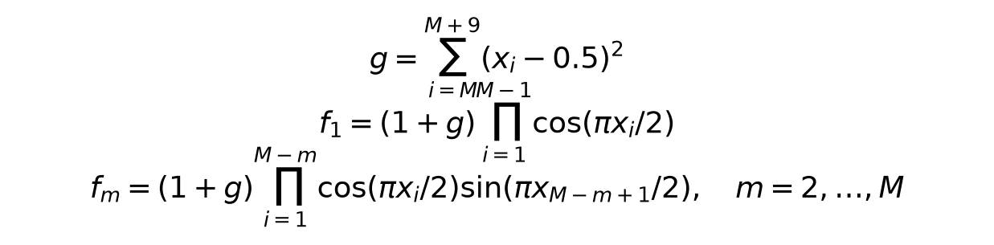
Standard form objectives in minimization convention
Formula in code notation g=sum(i=M..M+9)(xi-.5)^2; f1=(1+g)*product(i=1..M-1)cos(pi*xi/2); fm=(1+g)*product(i=1..M-m)cos(pi*xi/2)*sin(pi*x(M-m+1)/2), m=2..M
Constraints and handling Bounds; at g=0 sum(f_j^2)=1.
Python zero-based tail starts at M-1. f1 uses cos indices 0..M-2; later objectives shorten product and use sine at M-j-1. IGD reference: 301 fixed absolute Gaussian unit directions seed 100+M, an exact-front sample with finite sampling resolution.
Numerical sanity check When every tail variable is 0.5, g=0 and the implementation test confirms sum(f_j^2)=1.
Normalized objectives are (F-ideal)/(nadir-ideal). Fixed ideal=[0.0, 0.0, 0.0, 0.0, 0.0]; fixed nadir=[1.0, 1.0, 1.0, 1.0, 1.0]. Quality HV reference=[1.1, 1.1, 1.1, 1.1, 1.1] in normalized coordinates. These are declared scaling constants; conservative lower bounds are used where the attainable ideal is unavailable.
Termination Three- and five-objective runs stop at 10,000 evaluations.
Evaluated methods: HypE, MOEA/D, NSGA-III, RVEA. See the corresponding Task A pages and raw files.

P11 Production planning
Decision variables and encoding xA,xB>=0; finite bounds [0,400]^2

Standard form objectives in minimization convention
Formula in code notation min [-4*xA-6*xB,-xA-xB]
Constraints and handling 2*xA+3*xB<=1200; 4*xA+2*xB<=1600.
Corners (0,0),(400,0),(300,200),(0,400). Profit=2400 ties on an edge; units priority selects (300,200), units=500. Goals profit>=2400,units>=600 leave at least 100 units shortfall. Unit and normalized deviations both solved.
Numerical sanity check (xA,xB)=(300,200) makes both resource left sides 1200 and 1600, with profit 2400 and 500 total units.
Normalized objectives are (F-ideal)/(nadir-ideal). Fixed ideal=[-2400.0, -500.0]; fixed nadir=[0.0, 0.0]. Quality HV reference=[1.1, 1.1] in normalized coordinates. These are declared scaling constants; conservative lower bounds are used where the attainable ideal is unavailable.
Termination Goal and lexicographic scalar solves terminate at solver tolerance under the shared cap.
Evaluated methods: Goal Programming, Lexicographic. See the corresponding Task A pages and raw files.

P12 Supplier ranking
Decision variables and encoding index 0..4 or supplied finite alternatives table

Standard form objectives in minimization convention
Formula in code notation min [cost,-quality,delivery,-reliability]
Constraints and handling Five supplied alternatives; no manufactured supplier data.
S1=(120,8,10,92),S2=(100,7,14,88),S3=(140,9,7,95),S4=(90,6,18,80),S5=(130,8,9,90). Weights (.3,.3,.2,.2); shift cost +.1 and quality -.1 to preserve sum. TOPSIS vector scales; VIKOR range scales.
Numerical sanity check Supplier S1 is encoded as (120,-8,10,-92) in the common minimization convention; the supplied five-row table is not synthesized.
Normalized objectives are (F-ideal)/(nadir-ideal). Fixed ideal=[90.0, -9.0, 7.0, -95.0]; fixed nadir=[140.0, -6.0, 18.0, -80.0]. Quality HV reference=[1.1, 1.1, 1.1, 1.1] in normalized coordinates. These are declared scaling constants; conservative lower bounds are used where the attainable ideal is unavailable.
Termination TOPSIS and VIKOR terminate after scoring the five supplied alternatives or the stored NSGA-II front.
Evaluated methods: TOPSIS and VIKOR on supplier data. See the corresponding Task A pages and raw files.
All five supplied suppliers are nondominated under cost minimization and quality delivery reliability directions. Ranking imposes an additional preference order on these tradeoffs.

P13 Differentiable multi-task toy and network
Decision variables and encoding toy x in R^2, start (0,5); network 5->8 tanh->two heads

Standard form objectives in minimization convention
Formula in code notation toy min [||x-(3,3)||^2,||x-(-3,-3)||^2]; network BCE/MSE
Constraints and handling Toy unconstrained. Numerical plotting scale [0,72], no claim of bounding all R^2.
Pareto set x1=x2 in [-3,3]. MGDA minimizes norm of convex gradient combination. GradNorm balances weighted shared-body gradient norms. Synthetic 128x5 data seed 63, class sign(x0-x1), regression 3*x0+2*x2+noise. Network H=tanh(XW+b), class=sigmoid(H*wc+bc), regression=H*wr+br; 66 real parameters, 48 shared. BCE=-mean(y*log(class)+(1-y)*log(1-class)); MSE=mean((regression-target)^2). Regression scale 1 vs 10; all training derivatives handwritten.
Numerical sanity check For the toy at x=(0,0), both squared-distance losses equal 18; finite-difference tests check the network gradients.
Normalized objectives are (F-ideal)/(nadir-ideal). Fixed ideal=[0.0, 0.0]; fixed nadir=[72.0, 72.0]. Quality HV reference=[1.1, 1.1] in normalized coordinates. These are declared scaling constants; conservative lower bounds are used where the attainable ideal is unavailable.
Termination Toy gradient runs use 10,000 objective evaluations; network experiments use 1000 full-batch training steps.
Evaluated methods: GradNorm, MGDA. See the corresponding Task A pages and raw files.

P14 Laptop preference
Decision variables and encoding screen [13,17]in, battery [40,90]Wh
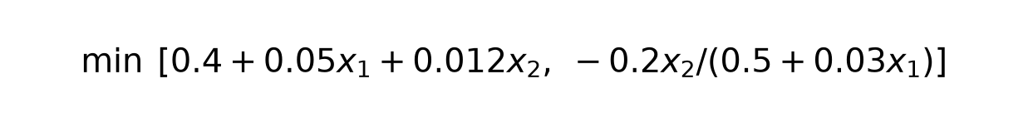
Standard form objectives in minimization convention
Formula in code notation min [.4+.05*screen+.012*battery,-.2*battery/(.5+.03*screen)]
Constraints and handling Bounds; Pareto screen=13.
Every screen increase worsens both objectives. Natural reference (1.8kg,12h) becomes (1.8,-12). At 12h front weight=1.6908kg; reference is dominated, so preference focuses near a attainable compromise rather than exact equal target.
Numerical sanity check At screen=13 and runtime=12 h, battery=53.4 Wh and weight=1.6908 kg; increasing screen size worsens both objectives.
Normalized objectives are (F-ideal)/(nadir-ideal). Fixed ideal=[1.53, -20.224719101123597]; fixed nadir=[2.33, -7.920792079207921]. Quality HV reference=[1.1, 1.1] in normalized coordinates. These are declared scaling constants; conservative lower bounds are used where the attainable ideal is unavailable.
Termination Preference and scalar runs stop at 10,000 evaluations or solver tolerance under the same cap.
Evaluated methods: IBEA, R-NSGA-II, SMS-EMOA, Value Function. See the corresponding Task A pages and raw files.

4 Shared tools and verification
moo_utils.py centralizes dominance, pairwise front sorting, crowding distance, archive filtering, normalization, positive-residual violation, exact 2D HV, Monte Carlo HV, IGD, Spacing and reproducible reference directions. Pairwise arrays expose the calculations directly and cost O(M*N^2); vectorization improves execution time without changing asymptotic work.
Check | Input | Expected
Dominance | (1,2) versus (2,3) | First dominates
Tradeoff | (1,3) versus (2,2) | Neither dominates
HV | (1,3) (2,2) (3,1); reference (4,4) | 6
IGD identical fronts | same point sets | 0
Crowding | (0,2) (1,1) (2,0) | infinity 2 infinity
Lecture car front | A B C D E F table | A B C D
Lecture Deb layers | A D feasible; B CV2; C CV5 | A,D then B then C
DTLZ2 g0 | tail variables all .5 | squared objective sum 1
Network derivatives | central finite difference +/-1e-6 | analytical match to 5 decimal places
Final automated result: 62 tests passed. Tests include seed reproducibility for all 26 stochastic modules and bounds for recorded solutions. For P8 the crossover and both mutation variants are checked across 20 seeds; cities occur exactly once. See results/roll72/test_output.txt for the named checks. Tests verify defining mechanisms, not a global-optimality guarantee.

5 Tasks A and B algorithm implementations and comparison
The consolidated Task A log below is generated from verified base summaries. Each algorithm/problem combination has its own row so budgets and metrics cannot be misaligned. Ranking methods report N/A for optimizer metrics and untimed runtime because those quantities were not recorded; no values are invented.
No. | Algorithm | Problem | Evaluations / cap | HV | IGD | Runtime s | Status
1 | Weighted Sum | P1 | 168 actual / 10,000 cap | 1.0258 ± 0 | 0.020135 ± 0 | 1.1064 ± 0 | works
1 | Weighted Sum | P3 | 847 actual / 10,000 cap | 0.21 ± 0 | 0.35379 ± 0 | 1.1766 ± 0 | works
2 | Epsilon-Constraint | P2 | 870 actual / 10,000 cap | 1.0865 ± 0 | 0.037129 ± 0 | 0.23309 ± 0 | works
2 | Epsilon-Constraint | P3 | 3488 actual / 10,000 cap | 0.52055 ± 0 | 0.02658 ± 0 | 0.59307 ± 0 | works
3 | Benson reference improvement | P1 | 714 actual / 10,000 cap | 1.0258 ± 0 | 0.020135 ± 0 | 0.17368 ± 0 | works
3 | Benson reference improvement | P7 | 3947 actual / 10,000 cap | 0.45626 ± 0 | 0.17882 ± 0 | 0.91874 ± 0 | works
4 | Weight Metric | P1 | 1857 actual / 10,000 cap | 1.0347 ± 0 | 0.012339 ± 0 | 0.64793 ± 0 | works
4 | Weight Metric | P3 | 9021 actual / 10,000 cap | 0.52368 ± 0 | 0.016164 ± 0 | 2.6382 ± 0 | works
5 | Value Function | P14 | 45 actual / 10,000 cap | 0.32905 ± 0 | 0.35302 ± 0 | 0.022336 ± 0 | works
5 | Value Function | P4 | 156 actual / 10,000 cap | 0.66617 ± 0 | N/A | 0.062954 ± 0 | works
6 | Goal Programming | P11 | 1219 actual / 10,000 cap | 1.21 ± 0 | 9.6355e-11 ± 0 | 0.52765 ± 0 | works
6 | Goal Programming | P7 | 304 actual / 10,000 cap | 0.34071 ± 0 | 0.38192 ± 0 | 0.17763 ± 0 | works
7 | Lexicographic | P11 | 219 actual / 10,000 cap | 1.21 ± 0 | 1.6309e-11 ± 0 | 0.08428 ± 0 | works
7 | Lexicographic | P7 | 47 actual / 10,000 cap | 0.11 ± 0 | 0.70711 ± 0 | 0.023686 ± 0 | works
8 | TOPSIS | P12 alternatives | ranking only | N/A | N/A | N/A (not timed) | works
8 | TOPSIS | P4 NSGA-II front | ranking only | N/A | N/A | N/A (not timed) | works
9 | VIKOR | P12 alternatives | ranking only | N/A | N/A | N/A (not timed) | works
9 | VIKOR | P4 NSGA-II front | ranking only | N/A | N/A | N/A (not timed) | works
10 | VEGA | P2 | 10,000 actual / 10,000 cap | 1.1109 ± 0.00092541 | 0.014362 ± 0.0015584 | 3.0395 ± 0.27359 | works
10 | VEGA | P3 | 10,000 actual / 10,000 cap | 0.17298 ± 0.045825 | 0.35868 ± 0.071684 | 3.0626 ± 0.22029 | works
11 | MOGA | P3 | 10,000 actual / 10,000 cap | 0.52378 ± 0.0010854 | 0.012703 ± 0.00047311 | 3.7674 ± 0.43826 | works
11 | MOGA | P5 | 10,000 actual / 10,000 cap | 1.1817 ± 0.0001344 | 0.014027 ± 0.0012597 | 3.5464 ± 0.31467 | works
12 | NSGA | P5 | 10,000 actual / 10,000 cap | 1.1818 ± 6.7066e-05 | 0.013578 ± 0.0014855 | 3.6444 ± 0.27288 | works
12 | NSGA | P7 | 10,000 actual / 10,000 cap | 0.68866 ± 0.0014876 | 0.012283 ± 0.00076085 | 3.8733 ± 0.31273 | works
13 | NPGA | P3 | 10,000 actual / 10,000 cap | 0.45723 ± 0.07144 | 0.052909 ± 0.063934 | 6.4637 ± 0.38143 | works
13 | NPGA | P5 | 10,000 actual / 10,000 cap | 1.1811 ± 0.00080777 | 0.013349 ± 0.0015902 | 6.7801 ± 0.44357 | works
14 | NSGA-II | P3 | 10,000 actual / 10,000 cap | 0.52858 ± 0.0010011 | 0.012078 ± 0.0012439 | 3.5278 ± 0.33619 | works
14 | NSGA-II | P5 | 10,000 actual / 10,000 cap | 1.1818 ± 3.9631e-05 | 0.014057 ± 0.0012871 | 3.5675 ± 0.28869 | works
15 | NSGA-III | P10 M=3 | 10,000 actual / 10,000 cap | 0.66113 ± 0.0058963 | 0.10798 ± 0.0058195 | 5.1274 ± 0.45929 | works
15 | NSGA-III | P10 M=5 | 10,000 actual / 10,000 cap | 0.98827 ± 0.018811 | 0.3083 ± 0.0065065 | 5.2657 ± 0.30871 | works
16 | SPEA2 | P4 | 10,000 actual / 10,000 cap | 0.93318 ± 0.0017067 | N/A | 6.1215 ± 0.087996 | works
16 | SPEA2 | P5 | 10,000 actual / 10,000 cap | 1.1818 ± 0.00012094 | 0.016079 ± 0.0026026 | 8.2376 ± 0.35817 | works
17 | PESA-II | P3 | 10,000 actual / 10,000 cap | 0.511 ± 0.0071042 | 0.021934 ± 0.0033027 | 5.2361 ± 0.23935 | works
17 | PESA-II | P5 | 10,000 actual / 10,000 cap | 1.1811 ± 0.0005926 | 0.016971 ± 0.0020149 | 6.3281 ± 0.45901 | works
18 | MOEA/D | P10 M=5 | 10,000 actual / 10,000 cap | 0.99538 ± 0.038577 | 0.32121 ± 0.020673 | 19.578 ± 0.88406 | works
18 | MOEA/D | P3 | 10,000 actual / 10,000 cap | 0.53179 ± 8.6192e-05 | 0.0095666 ± 0.00011134 | 14.443 ± 0.70036 | works
19 | MOEA/D-DE | P3 | 10,000 actual / 10,000 cap | 0.21242 ± 0.27423 | 1.0419 ± 0.9331 | 11.795 ± 2.1489 | works
19 | MOEA/D-DE | P5 | 10,000 actual / 10,000 cap | 1.1819 ± 3.2311e-05 | 0.0491 ± 0.031554 | 12.836 ± 0.55488 | works
20 | MOEA/D-ACO | P8 | 10,000 actual / 10,000 cap | 0.92348 ± 0.00073621 | N/A | 26.418 ± 0.90564 | works
21 | Constrained NSGA-II | P5 | 10,000 actual / 10,000 cap | 1.1818 ± 3.9631e-05 | 0.014057 ± 0.0012871 | 3.3173 ± 0.34218 | works
21 | Constrained NSGA-II | P6 | 10,000 actual / 10,000 cap | 1.0111 ± 0.0011787 | 0.013271 ± 0.00077287 | 3.3899 ± 0.30771 | works
22 | MOPSO | P4 | 10,000 actual / 10,000 cap | 0.92587 ± 0.0045498 | N/A | 2.1787 ± 0.2485 | works
22 | MOPSO | P5 | 10,000 actual / 10,000 cap | 1.1816 ± 0.00064467 | 0.014213 ± 0.0023019 | 2.0314 ± 0.3814 | works
23 | MOGWO | P5 | 10,000 actual / 10,000 cap | 1.1817 ± 0.00011936 | 0.013415 ± 0.0012894 | 4.1017 ± 0.37263 | partly works
23 | MOGWO | P9 | 200 actual / 200 cap | 0.78176 ± 0.042714 | N/A | 30.445 ± 2.0142 | partly works
24 | MOABC | P3 | 10,000 actual / 10,000 cap | 0.50853 ± 0.0089927 | 0.022472 ± 0.0044901 | 9.7198 ± 0.72292 | works
24 | MOABC | P6 | 10,000 actual / 10,000 cap | 1.0157 ± 0.00027371 | 0.011014 ± 0.00035368 | 13.04 ± 1.2447 | works
25 | MOACO | P8 | 10,000 actual / 10,000 cap | 0.92394 ± 0 | N/A | 18.135 ± 2.1703 | works
26 | MOSA | P3 | 10,000 actual / 10,000 cap | 0.51354 ± 0.0060662 | 0.020405 ± 0.0038149 | 1.4704 ± 0.13765 | works
26 | MOSA | P5 | 10,000 actual / 10,000 cap | 1.1814 ± 0.00036639 | 0.013184 ± 0.00070812 | 1.5232 ± 0.11932 | works
27 | MODE | P3 | 10,000 actual / 10,000 cap | 0.11 ± 3.0227e-10 | 0.6098 ± 1.1468e-10 | 1.7695 ± 0.068943 | works
27 | MODE | P5 | 10,000 actual / 10,000 cap | 1.1807 ± 0.0020828 | 0.013813 ± 0.0032863 | 2.1901 ± 0.27727 | works
28 | MO-TLBO | P3 | 10,000 actual / 10,000 cap | 0.53179 ± 7.0884e-05 | 0.0095087 ± 9.0745e-05 | 11.386 ± 1.2374 | works
28 | MO-TLBO | P5 | 10,000 actual / 10,000 cap | 1.1819 ± 1.6587e-05 | 0.012336 ± 0.00044219 | 11.361 ± 1.0124 | works
29 | MOBA | P3 | 10,000 actual / 10,000 cap | 0.39676 ± 0.14429 | 0.12888 ± 0.16313 | 4.6044 ± 0.22895 | works
29 | MOBA | P4 | 10,000 actual / 10,000 cap | 0.93318 ± 0.0012862 | N/A | 4.7957 ± 0.37886 | works
30 | MOMA | P5 | 10,000 actual / 10,000 cap | 1.1818 ± 5.8274e-05 | 0.01291 ± 0.0015554 | 6.3309 ± 0.65198 | partly works
30 | MOMA | P9 | 200 actual / 200 cap | 0.87363 ± 0.032115 | N/A | 39.459 ± 6.7459 | partly works
31 | RVEA | P10 M=3 | 10,000 actual / 10,000 cap | 0.64035 ± 0.011426 | 0.10879 ± 0.0032335 | 5.6417 ± 0.57606 | works
31 | RVEA | P10 M=5 | 10,000 actual / 10,000 cap | 1.0121 ± 0.030242 | 0.31113 ± 0.0085541 | 4.9951 ± 0.52206 | works
32 | IBEA | P14 | 10,000 actual / 10,000 cap | 0.81944 ± 0.012245 | 0.026183 ± 0.0076532 | 11.829 ± 0.66806 | works
32 | IBEA | P3 | 10,000 actual / 10,000 cap | 0.19276 ± 0.017015 | 0.3581 ± 0.028072 | 11.449 ± 1.0226 | works
33 | SMS-EMOA | P14 | 10,000 actual / 10,000 cap | 0.85873 ± 1.9917e-05 | 0.0075773 ± 1.8795e-05 | 30.594 ± 1.6848 | works
33 | SMS-EMOA | P3 | 10,000 actual / 10,000 cap | 0.53181 ± 0.00010904 | 0.0095649 ± 0.00012778 | 31.093 ± 1.9721 | works
34 | HypE | P10 M=3 | 10,000 actual / 10,000 cap | 0.6611 ± 0.0082237 | 0.11712 ± 0.0042523 | 20.197 ± 0.60127 | works
34 | HypE | P10 M=5 | 10,000 actual / 10,000 cap | 0.80567 ± 0.14729 | 0.43618 ± 0.075239 | 23.724 ± 1.8975 | works
35 | R-NSGA-II | P14 | 10,000 actual / 10,000 cap | 0.85563 ± 0.00087984 | 0.010043 ± 0.00082871 | 4.1524 ± 0.33328 | works
35 | R-NSGA-II | P5 | 10,000 actual / 10,000 cap | 1.1758 ± 0.014288 | 0.01448 ± 0.0031669 | 4.8108 ± 0.3217 | works
36 | MGDA | P13 | 10,000 actual / 10,000 cap | 0.28389 ± 0 | 0.62794 ± 0 | 2.3516 ± 0 | works
37 | GradNorm | P13 | 10,000 actual / 10,000 cap | 0.60519 ± 0 | 0.43296 ± 0 | 2.6674 ± 0 | works
Each following algorithm section uses the same sequence: core mechanism, implementation and parameters, verified result table, recorded plot, concise interpretation, then the four mechanism-based advantages and disadvantages required by Task B. Evidence-linked statements describe what these runs show without converting metric correlation into a causal proof.
Classical methods convert preferences or bounds into scalar solves, making their numerical accuracy depend on the scalar solver. Early GAs use objective selection, rank or sharing without parent elitism; the passive archive records discoveries but does not prevent the breeding population from losing them. Elitist methods spend quadratic comparisons to retain high-ranked parents and use crowding, density or grids for diversity. Decomposition gives each direction its own scalar pressure, although a fixed lattice may not match disconnected fronts. Swarms and local heuristics rely on archive leaders and neighbourhood moves; their schedules can exploit quickly or stagnate. Indicators replace explicit density with epsilon or hypervolume fitness but require scales and, for HV, a reference box. Reference methods remain useful when dominance loses discrimination in five dimensions. Preferences intentionally trade full-front coverage for a useful region. Gradient methods optimize differentiable tasks toward stationarity and do not produce a full front from one start. Feasibility rules are applied before Pareto comparisons, and comparisons use common normalized metric scales.

1 Weighted Sum
Core mechanism Linear scalar solve and a sweep
Implementation and parameters Module src\algorithms\weighted_sum.py; implementation status works; defining mechanism test test_01_mechanism passes. Weighted Sum: minimize dot(w,F_normalized), sweep simplex weights. Positive weights yield supported efficient points; zeros may give weak efficiency. Default SLSQP ftol=1e-10, maxiter=120; sweep=21; optimizer seed=720. Bounds and explicit constraints handled by SLSQP. Only scalar subproblems use SciPy. Local solves are not a global optimality certificate.
Problem | Trials | HV | IGD | Spacing | Runtime s | Evaluations / cap
P1 | 1 | 1.026 ± 0 | 0.02013 ± 0 | 1.535e-08 ± 0 | 1.106 ± 0 | 168 / 10,000
P3 | 1 | 0.21 ± 0 | 0.3538 ± 0 | 1.155 ± 0 | 1.177 ± 0 | 847 / 10,000
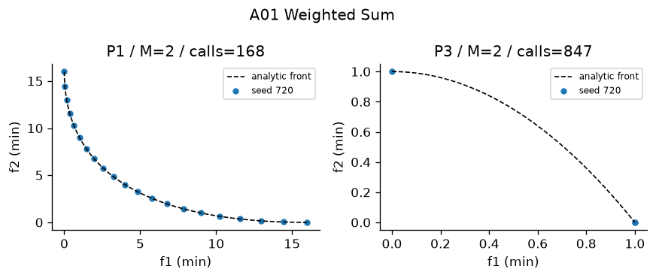
Figure A01 Recorded output on designated problems. Plotted seed and actual calls appear in the panel. The full ten-trial metrics are in the table.
Interpretation—empirical performance Weighted Sum recorded HV 1.0258 ± 0 on P1, IGD 0.020135 ± 0 (Figure A01). In the comparable P3 study with the same 10,000-evaluation cap, Weighted Sum recorded HV 0.21 ± 0; the nearest peer by mean HV was Benson reference improvement at 0.21 ± 9.8457e-12, with runtime 0.4763 ± 0.072962 s versus 1.1766 ± 0 s for Weighted Sum. A separate P3 record gives HV 0.21 ± 0 after 847 ± 0 evaluations in 1.1766 ± 0 s, so the evidence is not limited to one problem.
Interpretation—measured limitations The nonzero P1 IGD of 0.020135 ± 0 measures remaining sampled-front error. Thus the run does not support exact convergence or global optimality. Across 10 P3 trials, HV SD was 1.4261e-11 and runtime SD was 0.44449 s, which quantifies seed sensitivity at this budget.
Four advantages 1. Simple scalar objective; 2. Direct preference weights; 3. Reusable constrained scalar solver; 4. Independent solves can be distributed
Four disadvantages 1. Unsupported nonconvex points are unreachable; 2. Scaling changes weight meaning; 3. Uniform weights give nonuniform spacing; 4. Local scalar solves lack global guarantees
The measurements provide context for the claimed benefit "Simple scalar objective" and the risk "Unsupported nonconvex points are unreachable". They do not isolate either mechanism; controlled ablation would be required for causal attribution.
Best use and avoid Convex smooth two-objective design with interpretable weights. Avoid: Dented fronts and an unknown preference distribution.

2 Epsilon-Constraint
Core mechanism One objective minimized and others bounded
Implementation and parameters Module src\algorithms\epsilon_constraint.py; implementation status works; defining mechanism test test_02_mechanism passes. Epsilon-Constraint: minimize F1 with normalized F2<=epsilon. Default epsilon range=[0,1]. Extra constraint calls are explicitly counted. Default SLSQP ftol=1e-10, maxiter=120; sweep=21; optimizer seed=720. Bounds and explicit constraints handled by SLSQP. Only scalar subproblems use SciPy. Local solves are not a global optimality certificate.
Problem | Trials | HV | IGD | Spacing | Runtime s | Evaluations / cap
P2 | 1 | 1.086 ± 0 | 0.03713 ± 0 | 0.1418 ± 0 | 0.2331 ± 0 | 870 / 10,000
P3 | 1 | 0.5206 ± 0 | 0.02658 ± 0 | 0.04354 ± 0 | 0.5931 ± 0 | 3,488 / 10,000
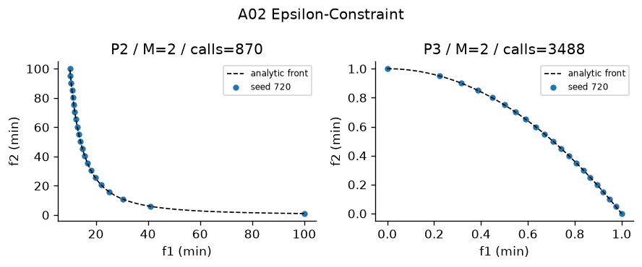
Figure A02 Recorded output on designated problems. Plotted seed and actual calls appear in the panel. The full ten-trial metrics are in the table.
Interpretation—empirical performance Epsilon-Constraint recorded HV 1.0865 ± 0 on P2, IGD 0.037129 ± 0 (Figure A02). In the comparable P3 study with the same 10,000-evaluation cap, Epsilon-Constraint recorded HV 0.52055 ± 0; the nearest peer by mean HV was Weight Metric at 0.52152 ± 0.0035033, with runtime 2.5137 ± 0.17386 s versus 0.59307 ± 0 s for Epsilon-Constraint. A separate P3 record gives HV 0.52055 ± 0 after 3488 ± 0 evaluations in 0.59307 ± 0 s, so the evidence is not limited to one problem.
Interpretation—measured limitations The nonzero P2 IGD of 0.037129 ± 0 measures remaining sampled-front error. Thus the run does not support exact convergence or global optimality. Across 10 P3 trials, HV SD was 0.0014644 and runtime SD was 0.033987 s, which quantifies seed sensitivity at this budget.
Four advantages 1. Can represent unsupported efficient points; 2. Epsilon has physical interpretation; 3. Scalar constraints remain explicit; 4. Primary objective stays recognizable
Four disadvantages 1. Infeasible epsilon values waste solves; 2. Sweeps can duplicate points; 3. Constraint solver quality matters; 4. Many objectives require multidimensional epsilon grids
The measurements provide context for the claimed benefit "Can represent unsupported efficient points" and the risk "Infeasible epsilon values waste solves". They do not isolate either mechanism; controlled ablation would be required for causal attribution.
Best use and avoid Nonconvex constrained design with hard limits. Avoid: High-dimensional objective grids.

3 Benson reference improvement
Core mechanism Weighted improvement below a reference
Implementation and parameters Module src\algorithms\benson.py; implementation status works; defining mechanism test test_03_mechanism passes. Benson reference improvement: maximize weighted nonnegative improvements from a dominated reference r=[1.1,1.1], require F<=r. This follows Foundations slide 35 reference achievement. It is the teaching form, not full polyhedral outer approximation. Default SLSQP ftol=1e-10, maxiter=120; sweep=21; optimizer seed=720. Bounds and explicit constraints handled by SLSQP. Only scalar subproblems use SciPy. Local solves are not a global optimality certificate.
Problem | Trials | HV | IGD | Spacing | Runtime s | Evaluations / cap
P1 | 1 | 1.026 ± 0 | 0.02013 ± 0 | 2.735e-08 ± 0 | 0.1737 ± 0 | 714 / 10,000
P7 | 1 | 0.4563 ± 0 | 0.1788 ± 0 | 0.5859 ± 0 | 0.9187 ± 0 | 3,947 / 10,000
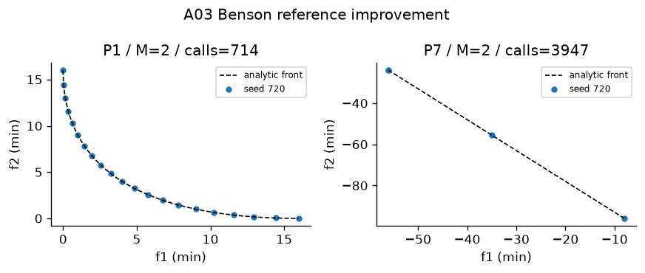
Figure A03 Recorded output on designated problems. Plotted seed and actual calls appear in the panel. The full ten-trial metrics are in the table.
Interpretation—empirical performance Benson reference improvement recorded HV 1.0258 ± 0 on P1, IGD 0.020135 ± 0 (Figure A03). In the comparable P3 study with the same 10,000-evaluation cap, Benson reference improvement recorded HV 0.21 ± 9.8457e-12; the nearest peer by mean HV was Weighted Sum at 0.21 ± 1.4261e-11, with runtime 0.40343 ± 0.44449 s versus 0.4763 ± 0.072962 s for Benson reference improvement. A separate P7 record gives HV 0.45626 ± 0 after 3947 ± 0 evaluations in 0.91874 ± 0 s, so the evidence is not limited to one problem.
Interpretation—measured limitations The nonzero P1 IGD of 0.020135 ± 0 measures remaining sampled-front error. Thus the run does not support exact convergence or global optimality. Across 10 P3 trials, HV SD was 9.8457e-12 and runtime SD was 0.072962 s, which quantifies seed sensitivity at this budget.
Four advantages 1. Reference conveys aspiration; 2. Nonnegative improvement is interpretable; 3. Explicit upper objective bounds; 4. Scalar subproblems are easy to inspect
Four disadvantages 1. This is the lecture achievement form, not outer approximation; 2. Unrestricted reference sweeps inherit weighted-sum barrier; 3. Reference coordinates require scaling; 4. Weights still encode preferences
The measurements provide context for the claimed benefit "Reference conveys aspiration" and the risk "This is the lecture achievement form, not outer approximation". They do not isolate either mechanism; controlled ablation would be required for causal attribution.
Best use and avoid Teaching reference improvement on P1/P7. Avoid: Claiming a general Benson convergence theorem.

4 Weight Metric
Core mechanism Weighted distance to fixed ideal
Implementation and parameters Module src\algorithms\weight_metric.py; implementation status works; defining mechanism test test_04_mechanism passes. Weight Metric: distance from fixed ideal, weighted p=1,2,infinity. Sweep weights for all three p values. p=infinity uses epigraph-free max. Default SLSQP ftol=1e-10, maxiter=120; sweep=21; optimizer seed=720. Bounds and explicit constraints handled by SLSQP. Only scalar subproblems use SciPy. Local solves are not a global optimality certificate.
Problem | Trials | HV | IGD | Spacing | Runtime s | Evaluations / cap
P1 | 1 | 1.035 ± 0 | 0.01234 ± 0 | 0.02381 ± 0 | 0.6479 ± 0 | 1,857 / 10,000
P3 | 1 | 0.5237 ± 0 | 0.01616 ± 0 | 0.03474 ± 0 | 2.638 ± 0 | 9,021 / 10,000
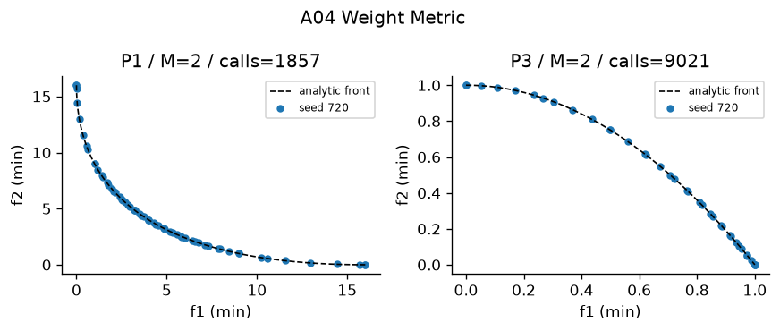
Figure A04 Recorded output on designated problems. Plotted seed and actual calls appear in the panel. The full ten-trial metrics are in the table.
Interpretation—empirical performance Weight Metric recorded HV 1.0347 ± 0 on P1, IGD 0.012339 ± 0 (Figure A04). In the comparable P3 study with the same 10,000-evaluation cap, Weight Metric recorded HV 0.52368 ± 0; the nearest peer by mean HV was MOGA at 0.52378 ± 0.0010854, with runtime 3.7374 ± 0.4774 s versus 2.6382 ± 0 s for Weight Metric. A separate P3 record gives HV 0.52368 ± 0 after 9021 ± 0 evaluations in 2.6382 ± 0 s, so the evidence is not limited to one problem.
Interpretation—measured limitations The nonzero P1 IGD of 0.012339 ± 0 measures remaining sampled-front error. Thus the run does not support exact convergence or global optimality. Across 10 P3 trials, HV SD was 0.0035033 and runtime SD was 0.17386 s, which quantifies seed sensitivity at this budget.
Four advantages 1. Infinity norm can reach unsupported tradeoffs; 2. Different p values express balance; 3. Ideal point makes distances interpretable; 4. Scalar solver is reusable
Four disadvantages 1. Ideal estimation affects solution; 2. Max norm is nonsmooth; 3. p and weights require preferences; 4. Finite weight sweep misses narrow regions
The measurements provide context for the claimed benefit "Infinity norm can reach unsupported tradeoffs" and the risk "Ideal estimation affects solution". They do not isolate either mechanism; controlled ablation would be required for causal attribution.
Best use and avoid Compromise solutions on nonconvex fronts. Avoid: Unreliable ideal estimates or many weights.

5 Value Function
Core mechanism Declared decision-maker utility
Implementation and parameters Module src\algorithms\value_function.py; implementation status works; defining mechanism test test_05_mechanism passes. Value Function: declared quadratic utility to a preferred normalized aspiration. P14 uses [1.8 kg,12 h]; P4 uses three investor risk/return targets. Utility is a decision-maker input, not a claim of universal preference. Default SLSQP ftol=1e-10, maxiter=120; sweep=21; optimizer seed=720. Bounds and explicit constraints handled by SLSQP. Only scalar subproblems use SciPy. Local solves are not a global optimality certificate.
Problem | Trials | HV | IGD | Spacing | Runtime s | Evaluations / cap
P14 | 1 | 0.329 ± 0 | 0.353 ± 0 | 0 ± 0 | 0.02234 ± 0 | 45 / 10,000
P4 | 1 | 0.6662 ± 0 | N/A | 9.678e-05 ± 0 | 0.06295 ± 0 | 156 / 10,000
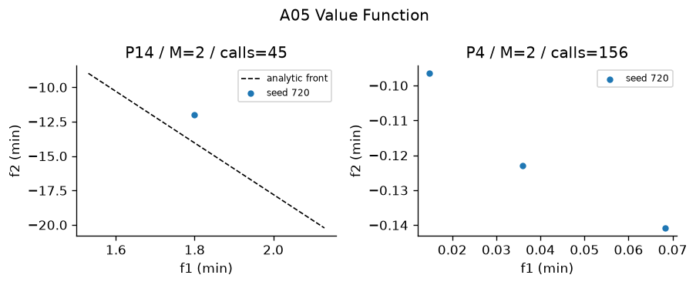
Figure A05 Recorded output on designated problems. Plotted seed and actual calls appear in the panel. The full ten-trial metrics are in the table.
Interpretation—empirical performance Value Function recorded HV 0.32905 ± 0 on P14, IGD 0.35302 ± 0 (Figure A05). The run used 45 ± 0 evaluations and took 0.022336 ± 0 s; no same-problem comparison row is used to manufacture a benchmark claim. A separate P4 record gives HV 0.66617 ± 0 after 156 ± 0 evaluations in 0.062954 ± 0 s, so the evidence is not limited to one problem.
Interpretation—measured limitations The nonzero P14 IGD of 0.35302 ± 0 measures remaining sampled-front error. Thus the run does not support exact convergence or global optimality. The P14 output retained 1 ± 0 point(s). That finite resolution limits what the plot can demonstrate; front size or zero Spacing alone is not evidence of complete coverage.
Four advantages 1. Directly encodes a preferred outcome; 2. Can express nonlinear preferences; 3. Few scalar solves are economical; 4. Natural targets communicate decisions
Four disadvantages 1. Utility must be elicited; 2. Squared target utility need not be monotone; 3. One preferred design is not a full front; 4. Misspecified preferences bias results
The measurements provide context for the claimed benefit "Directly encodes a preferred outcome" and the risk "Utility must be elicited". They do not isolate either mechanism; controlled ablation would be required for causal attribution.
Best use and avoid Laptop or portfolio profile decisions. Avoid: Exploration without known preferences.

6 Goal Programming
Core mechanism Explicit positive/negative goal deviations
Implementation and parameters Module src\algorithms\goal_programming.py; implementation status works; defining mechanism test test_06_mechanism passes. Goal Programming: goals in natural output, penalize negative deviations only (both goals are lower bounds). Explicit dminus=max(target-achieved,0), dplus=max(achieved-target,0); elimination of linear deviation variables is exact. Default SLSQP ftol=1e-10, maxiter=120; sweep=21; optimizer seed=720. Bounds and explicit constraints handled by SLSQP. Only scalar subproblems use SciPy. Local solves are not a global optimality certificate.
Problem | Trials | HV | IGD | Spacing | Runtime s | Evaluations / cap
P11 | 1 | 1.21 ± 0 | 9.636e-11 ± 0 | 0 ± 0 | 0.5277 ± 0 | 1,219 / 10,000
P7 | 1 | 0.3407 ± 0 | 0.3819 ± 0 | 0 ± 0 | 0.1776 ± 0 | 304 / 10,000
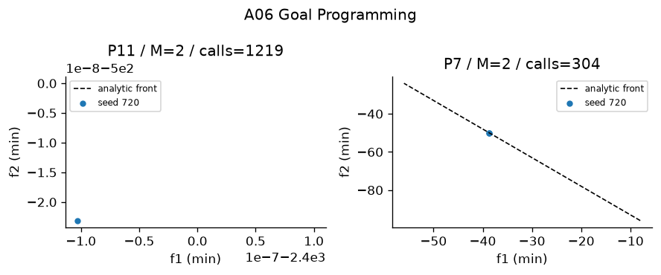
Figure A06 Recorded output on designated problems. Plotted seed and actual calls appear in the panel. The full ten-trial metrics are in the table.
Interpretation—empirical performance Goal Programming recorded HV 1.21 ± 0 on P11, IGD 9.6355e-11 ± 0 (Figure A06). The run used 1219 ± 0 evaluations and took 0.52765 ± 0 s; no same-problem comparison row is used to manufacture a benchmark claim. A separate P7 record gives HV 0.34071 ± 0 after 304 ± 0 evaluations in 0.17763 ± 0 s, so the evidence is not limited to one problem.
Interpretation—measured limitations The nonzero P11 IGD of 9.6355e-11 ± 0 measures remaining sampled-front error. Thus the run does not support exact convergence or global optimality. The P11 output retained 1 ± 0 point(s). That finite resolution limits what the plot can demonstrate; front size or zero Spacing alone is not evidence of complete coverage.
Four advantages 1. Shows unavoidable shortfall; 2. Can normalize incompatible units; 3. Soft goals remain interpretable; 4. Constraint and aspiration roles are separate
Four disadvantages 1. Goal weights control tradeoffs; 2. Infeasible goals cannot be guaranteed; 3. Units can overwhelm deviations; 4. Satisfied goals may leave efficiency ties
The measurements provide context for the claimed benefit "Shows unavoidable shortfall" and the risk "Goal weights control tradeoffs". They do not isolate either mechanism; controlled ablation would be required for causal attribution.
Best use and avoid Production targets with soft priorities. Avoid: Searching an entire front without goals.

7 Lexicographic
Core mechanism Sequential strict priorities with tolerances
Implementation and parameters Module src\algorithms\lexicographic.py; implementation status works; defining mechanism test test_07_mechanism passes. Lexicographic: sequential strict-priority scalar minimizations, preserving prior best objective within tolerance=1e-7 in normalized units. Profit first then units on P11; agricultural yield first on P7. Default SLSQP ftol=1e-10, maxiter=120; sweep=21; optimizer seed=720. Bounds and explicit constraints handled by SLSQP. Only scalar subproblems use SciPy. Local solves are not a global optimality certificate.
Problem | Trials | HV | IGD | Spacing | Runtime s | Evaluations / cap
P11 | 1 | 1.21 ± 0 | 1.631e-11 ± 0 | 0 ± 0 | 0.08428 ± 0 | 219 / 10,000
P7 | 1 | 0.11 ± 0 | 0.7071 ± 0 | 0 ± 0 | 0.02369 ± 0 | 47 / 10,000
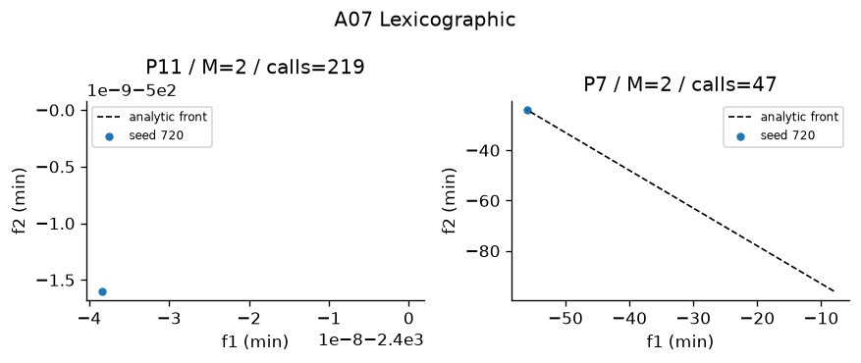
Figure A07 Recorded output on designated problems. Plotted seed and actual calls appear in the panel. The full ten-trial metrics are in the table.
Interpretation—empirical performance Lexicographic recorded HV 1.21 ± 0 on P11, IGD 1.6309e-11 ± 0 (Figure A07). The run used 219 ± 0 evaluations and took 0.08428 ± 0 s; no same-problem comparison row is used to manufacture a benchmark claim. A separate P7 record gives HV 0.11 ± 0 after 47 ± 0 evaluations in 0.023686 ± 0 s, so the evidence is not limited to one problem.
Interpretation—measured limitations The nonzero P11 IGD of 1.6309e-11 ± 0 measures remaining sampled-front error. Thus the run does not support exact convergence or global optimality. The P11 output retained 1 ± 0 point(s). That finite resolution limits what the plot can demonstrate; front size or zero Spacing alone is not evidence of complete coverage.
Four advantages 1. Priority order is transparent; 2. Breaks first-objective ties; 3. Uses scalar solvers; 4. Preserves prior objective values to declared tolerance
Four disadvantages 1. Lower objectives may have little freedom; 2. Tolerance changes strictness; 3. Priority mistakes are expensive; 4. Sequential solves add cost
The measurements provide context for the claimed benefit "Priority order is transparent" and the risk "Lower objectives may have little freedom". They do not isolate either mechanism; controlled ablation would be required for causal attribution.
Best use and avoid Profit first and units second. Avoid: Balanced objectives with no hierarchy.

8 TOPSIS
Core mechanism Closeness to weighted ideal and anti-ideal
Implementation and parameters Module src\algorithms\topsis.py; implementation status works; defining mechanism test test_08_mechanism passes. TOPSIS ranking, not an optimizer. Vector normalization, weights, benefit/cost ideal, Euclidean ideal and anti-ideal distance. Default equal weights if not supplied; P12 uses [.3,.3,.2,.2]. Zero columns protected.
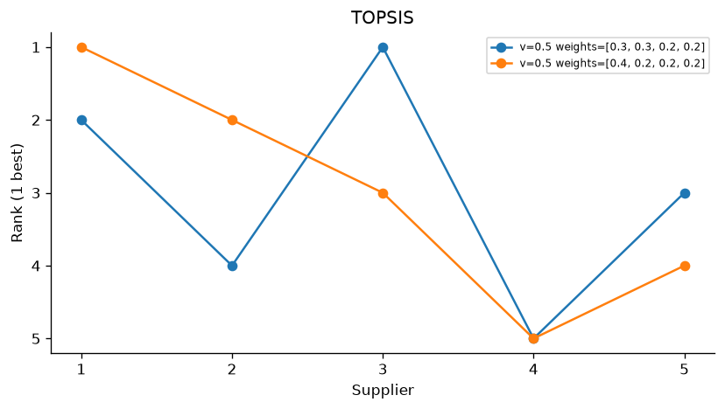
Figure A08 Recorded output on designated problems. Plotted seed and actual calls appear in the panel. The full ten-trial metrics are in the table.
Interpretation—empirical performance On the supplied alternatives, TOPSIS produced explicit top-three orders for 4 recorded preference settings; for example P12 gave [3, 1, 5]. The P12 and P4 tables therefore support its practical ability to turn stated weights into an auditable shortlist. These are ranking outcomes, not search quality.
Interpretation—measured limitations The same records contain only existing alternatives and no generated decision vector, directly confirming that TOPSIS is not an optimizer. Its orders also depend on weights; the recorded weight-shift rows quantify local sensitivity but do not establish global stability.
Four advantages 1. Fast finite-table ranking; 2. Uses all criteria; 3. Distances are explainable; 4. Works with benefit and cost columns
Four disadvantages 1. Does not generate new designs; 2. Vector normalization affects rank; 3. Compensation can hide a bad criterion; 4. Alternatives can change the ideal
The ranking evidence supports auditable preference application, while the mechanism-based benefit "Fast finite-table ranking" and risk "Does not generate new designs" remain analytical claims rather than optimizer evidence.
Best use and avoid Supplier or existing-front ranking. Avoid: Optimization without an alternatives table.

9 VIKOR
Core mechanism Compromise via group regret and worst regret
Implementation and parameters Module src\algorithms\vikor.py; implementation status works; defining mechanism test test_09_mechanism passes. VIKOR compromise ranking with S=sum weighted regret, R=max regret, Q=v*(S-Sbest)/(Sworst-Sbest)+(1-v)*(R-Rbest)/(Rworst-Rbest). Default v=.5. Report acceptable advantage 1/(N-1) and stability; never force a unique compromise when the conditions fail.
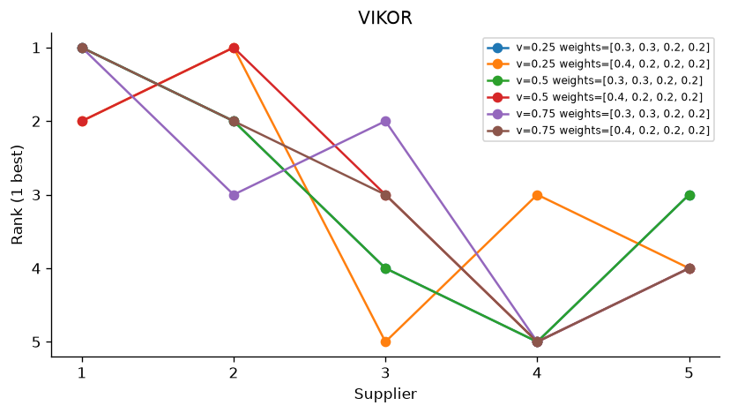
Figure A09 Recorded output on designated problems. Plotted seed and actual calls appear in the panel. The full ten-trial metrics are in the table.
Interpretation—empirical performance On the supplied alternatives, VIKOR produced explicit top-three orders for 8 recorded preference settings; for example P12 gave [1, 2, 5]. The P12 and P4 tables therefore support its practical ability to turn stated weights into an auditable shortlist. These are ranking outcomes, not search quality.
Interpretation—measured limitations The same records contain only existing alternatives and no generated decision vector, directly confirming that VIKOR is not an optimizer. Its orders also depend on weights and v; the recorded weight-shift rows quantify local sensitivity but do not establish global stability.
Four advantages 1. Worst criterion enters R; 2. v exposes group versus individual tradeoff; 3. Compromise conditions avoid forced winners; 4. Finite rankings are inexpensive
Four disadvantages 1. Requires preference weights; 2. v can change rank; 3. Range normalization changes regrets; 4. Does not generate designs
The ranking evidence supports auditable preference application, while the mechanism-based benefit "Worst criterion enters R" and risk "Requires preference weights" remain analytical claims rather than optimizer evidence.
Best use and avoid Supplier compromise with severe weak criteria. Avoid: A Pareto front generator.

10 VEGA
Core mechanism Objective-partitioned selection
Implementation and parameters Module src\algorithms\vega.py; implementation status works; defining mechanism test test_10_mechanism passes. VEGA: partition selection by objective, pool subpopulations, crossover and mutation. Tournament by one objective; no parent+child elitism. Shared defaults: population=40, budget=10,000, optimizer seed from project config. Constraints: Deb feasibility comparison unless the stated method uses scalar penalty.
Problem | Trials | HV | IGD | Spacing | Runtime s | Evaluations / cap
P2 | 10 | 1.111 ± 0.0009254 | 0.01436 ± 0.001558 | 0.017 ± 0.00279 | 3.039 ± 0.2736 | 10,000 / 10,000
P3 | 10 | 0.173 ± 0.04583 | 0.3587 ± 0.07168 | 0.0475 ± 0.02233 | 3.063 ± 0.2203 | 10,000 / 10,000
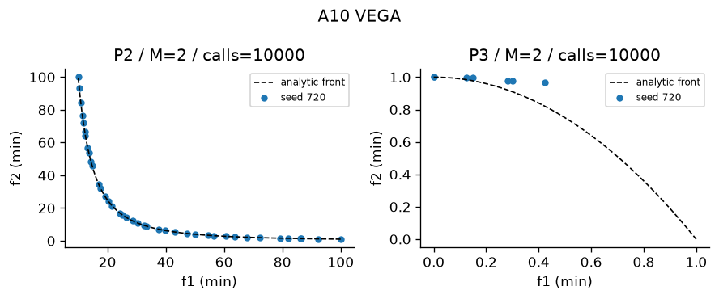
Figure A10 Recorded output on designated problems. Plotted seed and actual calls appear in the panel. The full ten-trial metrics are in the table.
Interpretation—empirical performance VEGA recorded HV 1.1109 ± 0.00092541 on P2, IGD 0.014362 ± 0.0015584 (Figure A10). In the comparable P3 study with the same 10,000-evaluation cap, VEGA recorded HV 0.17298 ± 0.045825; the nearest peer by mean HV was IBEA at 0.19276 ± 0.017015, with runtime 11.413 ± 0.95043 s versus 3.0626 ± 0.22029 s for VEGA. A separate P3 record gives HV 0.17298 ± 0.045825 after 10,000 ± 0 evaluations in 3.0626 ± 0.22029 s, so the evidence is not limited to one problem.
Interpretation—measured limitations The nonzero P2 IGD of 0.014362 ± 0.0015584 measures remaining sampled-front error. Thus the run does not support exact convergence or global optimality. Across 10 P2 trials, HV SD was 0.00092541 and runtime SD was 0.27359 s, which quantifies seed sensitivity at this budget.
Four advantages 1. Very simple selection; 2. No preference weights needed; 3. Handles several objective contests; 4. Cheap scalar tournaments
Four disadvantages 1. Extremes can dominate mating pool; 2. No parent elitism; 3. Middle tradeoffs may disappear; 4. Objective partition sizes affect pressure
The measurements provide context for the claimed benefit "Very simple selection" and the risk "Extremes can dominate mating pool". They do not isolate either mechanism; controlled ablation would be required for causal attribution.
Best use and avoid Teaching objective competition. Avoid: Reliable uniform front preservation.

11 MOGA
Core mechanism Domination-count rank and fitness sharing
Implementation and parameters Module src\algorithms\moga.py; implementation status works; defining mechanism test test_11_mechanism passes. MOGA: domination count rank, rank fitness divided by niche count. Sharing radius sigma=.3; small radius weakens sharing; no elitism. Shared defaults: population=40, budget=10,000, optimizer seed=720. Constraints: Deb feasibility comparison unless the stated method uses scalar penalty.
Problem | Trials | HV | IGD | Spacing | Runtime s | Evaluations / cap
P3 | 10 | 0.5238 ± 0.001085 | 0.0127 ± 0.0004731 | 0.01277 ± 0.002314 | 3.767 ± 0.4383 | 10,000 / 10,000
P5 | 10 | 1.182 ± 0.0001344 | 0.01403 ± 0.00126 | 0.02033 ± 0.002006 | 3.546 ± 0.3147 | 10,000 / 10,000
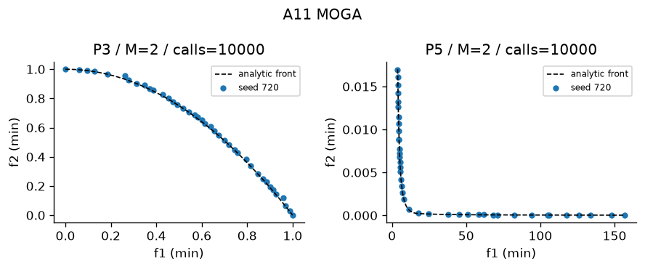
Figure A11 Recorded output on designated problems. Plotted seed and actual calls appear in the panel. The full ten-trial metrics are in the table.
Interpretation—empirical performance MOGA recorded HV 0.52378 ± 0.0010854 on P3, IGD 0.012703 ± 0.00047311 (Figure A11). In the comparable P3 study with the same 10,000-evaluation cap, MOGA recorded HV 0.52378 ± 0.0010854; the nearest peer by mean HV was NSGA at 0.52521 ± 0.001173, with runtime 3.5297 ± 0.27057 s versus 3.7674 ± 0.43826 s for MOGA. A separate P5 record gives HV 1.1817 ± 0.0001344 after 10,000 ± 0 evaluations in 3.5464 ± 0.31467 s, so the evidence is not limited to one problem.
Interpretation—measured limitations The nonzero P3 IGD of 0.012703 ± 0.00047311 measures remaining sampled-front error. Thus the run does not support exact convergence or global optimality. Across 10 P3 trials, HV SD was 0.0010854 and runtime SD was 0.43826 s, which quantifies seed sensitivity at this budget.
Four advantages 1. No scalar utility required; 2. Sharing promotes sparse niches; 3. Dominance counts are easy to inspect; 4. Can search unsupported regions
Four disadvantages 1. No elitism; 2. Sharing radius sensitive; 3. All nondominated members tie in rank; 4. Pairwise density costs quadratically
The measurements provide context for the claimed benefit "No scalar utility required" and the risk "No elitism". They do not isolate either mechanism; controlled ablation would be required for causal attribution.
Best use and avoid Small bi-objective populations. Avoid: Many objectives with sparse dominance.

12 NSGA
Core mechanism Front layers and within-front sharing
Implementation and parameters Module src\algorithms\nsga.py; implementation status works; defining mechanism test test_12_mechanism passes. NSGA: nondominated layers, dummy fitness and within-front sharing. Sharing radius sigma=.3; non-elitist generational replacement. Shared defaults: population=40, budget=10,000, optimizer seed=720. Constraints: Deb feasibility comparison unless the stated method uses scalar penalty.
Problem | Trials | HV | IGD | Spacing | Runtime s | Evaluations / cap
P5 | 10 | 1.182 ± 6.707e-05 | 0.01358 ± 0.001486 | 0.01959 ± 0.002904 | 3.644 ± 0.2729 | 10,000 / 10,000
P7 | 10 | 0.6887 ± 0.001488 | 0.01228 ± 0.0007609 | 0.01077 ± 0.001845 | 3.873 ± 0.3127 | 10,000 / 10,000
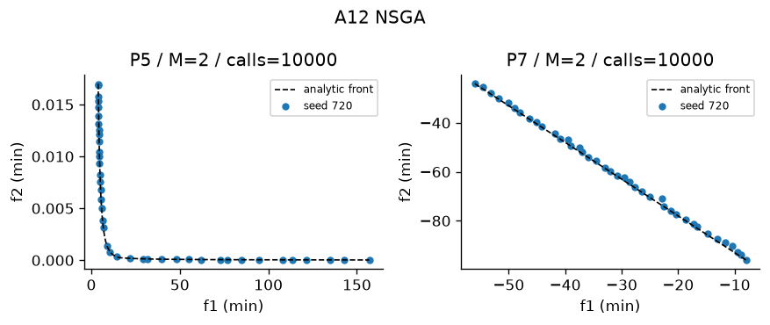
Figure A12 Recorded output on designated problems. Plotted seed and actual calls appear in the panel. The full ten-trial metrics are in the table.
Interpretation—empirical performance NSGA recorded HV 1.1818 ± 6.7066e-05 on P5, IGD 0.013578 ± 0.0014855 (Figure A12). In the comparable P5 study with the same 10,000-evaluation cap, NSGA recorded HV 1.1818 ± 6.7066e-05; the nearest peer by mean HV was SPEA2 at 1.1818 ± 0.00012094, with runtime 8.2078 ± 0.36449 s versus 3.6444 ± 0.27288 s for NSGA. A separate P7 record gives HV 0.68866 ± 0.0014876 after 10,000 ± 0 evaluations in 3.8733 ± 0.31273 s, so the evidence is not limited to one problem.
Interpretation—measured limitations The nonzero P5 IGD of 0.013578 ± 0.0014855 measures remaining sampled-front error. Thus the run does not support exact convergence or global optimality. Across 10 P5 trials, HV SD was 6.7066e-05 and runtime SD was 0.27288 s, which quantifies seed sensitivity at this budget.
Four advantages 1. Explicit Pareto hierarchy; 2. Sharing is local to fronts; 3. No objective weights required; 4. Variation supports arbitrary encodings
Four disadvantages 1. No elitism; 2. Quadratic sorting and sharing; 3. Dummy fitness spacing is arbitrary; 4. Niche radius must be tuned
The measurements provide context for the claimed benefit "Explicit Pareto hierarchy" and the risk "No elitism". They do not isolate either mechanism; controlled ablation would be required for causal attribution.
Best use and avoid Teaching early Pareto GAs. Avoid: Large fast convergence requirements.

13 NPGA
Core mechanism Direct contestant dominance then separate comparison-set quadratic niche tie
Implementation and parameters Module src\algorithms\npga.py; implementation status works; defining mechanism test test_13_mechanism passes. Niched Pareto Genetic Algorithm: direct binary tournament with comparison-set crowding. Direct dominance decides; otherwise smaller comparison-set niche count wins. Defaults: comparison_size=2, sigma=.3; objective distances normalized. Shared defaults: population=40, budget=10,000, optimizer seed=720. Constraints: Deb feasibility comparison unless the stated method uses scalar penalty.
Problem | Trials | HV | IGD | Spacing | Runtime s | Evaluations / cap
P3 | 10 | 0.4572 ± 0.07144 | 0.05291 ± 0.06393 | 0.0329 ± 0.01947 | 6.464 ± 0.3814 | 10,000 / 10,000
P5 | 10 | 1.181 ± 0.0008078 | 0.01335 ± 0.00159 | 0.01876 ± 0.001853 | 6.78 ± 0.4436 | 10,000 / 10,000
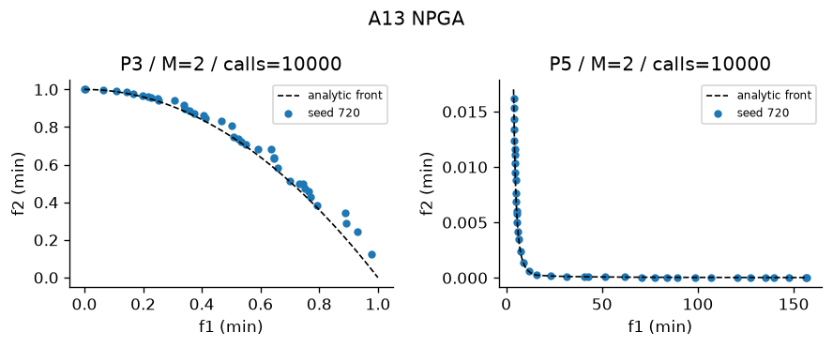
Figure A13 Recorded output on designated problems. Plotted seed and actual calls appear in the panel. The full ten-trial metrics are in the table.
Interpretation—empirical performance NPGA recorded HV 0.45723 ± 0.07144 on P3, IGD 0.052909 ± 0.063934 (Figure A13). In the comparable P3 study with the same 10,000-evaluation cap, NPGA recorded HV 0.45723 ± 0.07144; the nearest peer by mean HV was MOPSO at 0.41909 ± 0.03166, with runtime 1.8638 ± 0.12697 s versus 6.4637 ± 0.38143 s for NPGA. A separate P5 record gives HV 1.1811 ± 0.00080777 after 10,000 ± 0 evaluations in 6.7801 ± 0.44357 s, so the evidence is not limited to one problem.
Interpretation—measured limitations The nonzero P3 IGD of 0.052909 ± 0.063934 measures remaining sampled-front error. Thus the run does not support exact convergence or global optimality. Across 10 P3 trials, HV SD was 0.07144 and runtime SD was 0.38143 s, which quantifies seed sensitivity at this budget.
Four advantages 1. No fixed utility weights; 2. Niche tie-break preserves sparse points; 3. Comparison sample controls work; 4. Can visit nonconvex tradeoffs
Four disadvantages 1. Nonelitist generations lose parents; 2. Small comparison set gives noisy niche counts; 3. Sigma changes density pressure; 4. Lecture tournament differs from original publication
The measurements provide context for the claimed benefit "No fixed utility weights" and the risk "Nonelitist generations lose parents". They do not isolate either mechanism; controlled ablation would be required for causal attribution.
Best use and avoid Bi-objective diversity experiments. Avoid: Many-objective fronts where most tournaments tie.

14 NSGA-II
Core mechanism Front rank, crowding, parent-child elitism
Implementation and parameters Module src\algorithms\nsga2.py; implementation status works; defining mechanism test test_14_mechanism passes. NSGA-II: fast front sorting, crowded binary tournament, SBX and mutation, parent+offspring elitist survival. Permutations use OX and swap/inversion. Shared defaults: population=40, budget=10,000, optimizer seed=720. Constraints: Deb feasibility comparison unless the stated method uses scalar penalty.
Problem | Trials | HV | IGD | Spacing | Runtime s | Evaluations / cap
P3 | 10 | 0.5286 ± 0.001001 | 0.01208 ± 0.001244 | 0.01765 ± 0.001747 | 3.528 ± 0.3362 | 10,000 / 10,000
P5 | 10 | 1.182 ± 3.963e-05 | 0.01406 ± 0.001287 | 0.02067 ± 0.003274 | 3.568 ± 0.2887 | 10,000 / 10,000
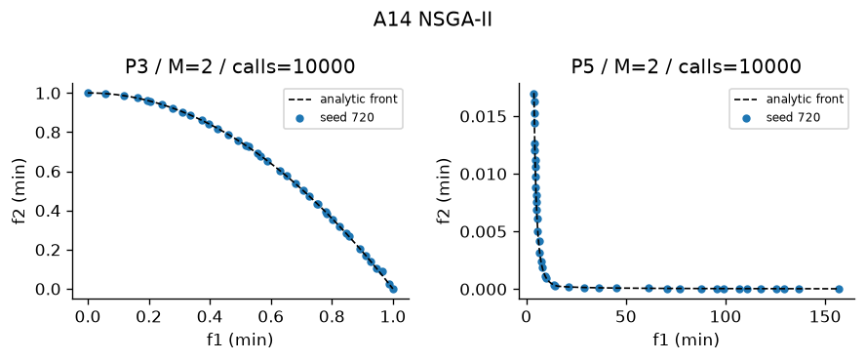
Figure A14 Recorded output on designated problems. Plotted seed and actual calls appear in the panel. The full ten-trial metrics are in the table.
Interpretation—empirical performance NSGA-II recorded HV 0.52858 ± 0.0010011 on P3, IGD 0.012078 ± 0.0012439 (Figure A14). In the comparable P3 study with the same 10,000-evaluation cap, NSGA-II recorded HV 0.52858 ± 0.0010011; the nearest peer by mean HV was Constrained NSGA-II at 0.52858 ± 0.0010011, with runtime 3.3525 ± 0.089792 s versus 3.5278 ± 0.33619 s for NSGA-II. A separate P5 record gives HV 1.1818 ± 3.9631e-05 after 10,000 ± 0 evaluations in 3.5675 ± 0.28869 s, so the evidence is not limited to one problem.
Interpretation—measured limitations The nonzero P3 IGD of 0.012078 ± 0.0012439 measures remaining sampled-front error. Thus the run does not support exact convergence or global optimality. Across 10 P3 trials, HV SD was 0.0010011 and runtime SD was 0.33619 s, which quantifies seed sensitivity at this budget.
Four advantages 1. Elitist survivor retention; 2. Boundary points receive protection; 3. No sharing radius; 4. Permutation and real variation share selection
Four disadvantages 1. Crowding weakens as objectives grow; 2. Quadratic pairwise sorting; 3. Finite population truncates front; 4. Crowding is not an explicit convergence measure
The measurements provide context for the claimed benefit "Elitist survivor retention" and the risk "Crowding weakens as objectives grow". They do not isolate either mechanism; controlled ablation would be required for causal attribution.
Best use and avoid General constrained two-objective search. Avoid: Very many objectives with weak dominance.

15 NSGA-III
Core mechanism Reference-point niching after front rank
Implementation and parameters Module src\algorithms\nsga3.py; implementation status works; defining mechanism test test_15_mechanism passes. NSGA-III: front ranking, simplex-lattice reference association and niche occupancy survival. Normalize by observed ranges (simplification of intercepts). Shared defaults: population=40, budget=10,000, optimizer seed=720. Constraints: Deb feasibility comparison unless the stated method uses scalar penalty.
Problem | Trials | HV | IGD | Spacing | Runtime s | Evaluations / cap
P10 M3 | 10 | 0.6611 ± 0.005896 | 0.108 ± 0.005819 | 0.09917 ± 0.0101 | 5.127 ± 0.4593 | 10,000 / 10,000
P10 M5 | 10 | 0.9883 ± 0.01881 | 0.3083 ± 0.006507 | 0.2831 ± 0.02087 | 5.266 ± 0.3087 | 10,000 / 10,000
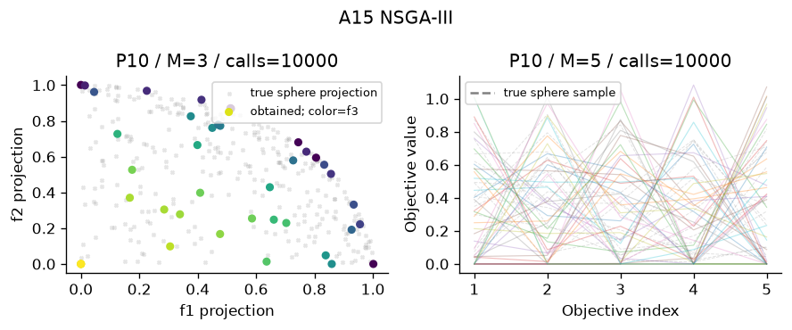
Figure A15 Recorded output on designated problems. Plotted seed and actual calls appear in the panel. The full ten-trial metrics are in the table.
Interpretation—empirical performance NSGA-III recorded HV 0.66113 ± 0.0058963 on P10, IGD 0.10798 ± 0.0058195 (Figure A15). In the comparable P10 study with the same 10,000-evaluation cap, NSGA-III recorded HV 0.98827 ± 0.018811; the nearest peer by mean HV was MOEA/D at 0.99538 ± 0.038577, with runtime 19.644 ± 0.8166 s versus 5.2657 ± 0.30871 s for NSGA-III. A separate P10 record gives HV 0.98827 ± 0.018811 after 10,000 ± 0 evaluations in 5.2657 ± 0.30871 s, so the evidence is not limited to one problem.
Interpretation—measured limitations The nonzero P10 IGD of 0.10798 ± 0.0058195 measures remaining sampled-front error. Thus the run does not support exact convergence or global optimality. Across 10 P10 trials, HV SD was 0.0058963 and runtime SD was 0.45929 s, which quantifies seed sensitivity at this budget.
Four advantages 1. Reference niches control coverage; 2. Supports many objectives; 3. Occupancy encourages unused directions; 4. Does not use a sharing radius
Four disadvantages 1. Range normalization simplifies original intercepts; 2. Reference count grows combinatorially; 3. Poor reference geometry biases coverage; 4. Dominance layers still require quadratic work
The measurements provide context for the claimed benefit "Reference niches control coverage" and the risk "Range normalization simplifies original intercepts". They do not isolate either mechanism; controlled ablation would be required for causal attribution.
Best use and avoid DTLZ2 with three or five objectives. Avoid: Irregular fronts without adapted references.

16 SPEA2
Core mechanism Strength, raw fitness and neighbour density
Implementation and parameters Module src\algorithms\spea2.py; implementation status works; defining mechanism test test_16_mechanism passes. SPEA2: strength S, raw fitness R=sum strengths of dominators; density 1/(sigma_k+2), fixed archive, lexicographic nearest-distance truncation. Shared defaults: population=40, budget=10,000, optimizer seed=720. Constraints: Deb feasibility comparison unless the stated method uses scalar penalty.
Problem | Trials | HV | IGD | Spacing | Runtime s | Evaluations / cap
P4 | 10 | 0.9332 ± 0.001707 | N/A | 0.01409 ± 0.001608 | 6.121 ± 0.088 | 10,000 / 10,000
P5 | 10 | 1.182 ± 0.0001209 | 0.01608 ± 0.002603 | 0.01923 ± 0.001586 | 8.238 ± 0.3582 | 10,000 / 10,000
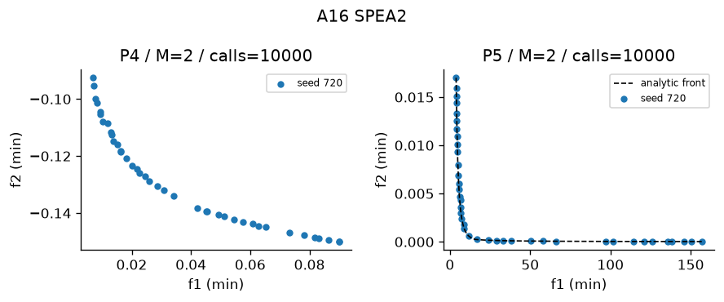
Figure A16 Recorded output on designated problems. Plotted seed and actual calls appear in the panel. The full ten-trial metrics are in the table.
Interpretation—empirical performance SPEA2 recorded HV 0.93318 ± 0.0017067 on P4, and Spacing 0.014089 ± 0.0016077 where exact-front IGD is unavailable (Figure A16). In the comparable P5 study with the same 10,000-evaluation cap, SPEA2 recorded HV 1.1818 ± 0.00012094; the nearest peer by mean HV was NSGA at 1.1818 ± 6.7066e-05, with runtime 3.6169 ± 0.17249 s versus 8.2376 ± 0.35817 s for SPEA2. A separate P5 record gives HV 1.1818 ± 0.00012094 after 10,000 ± 0 evaluations in 8.2376 ± 0.35817 s, so the evidence is not limited to one problem.
Interpretation—measured limitations No exact front is available for P4, so the run cannot experimentally establish convergence; HV 0.93318 ± 0.0017067 and Spacing 0.014089 ± 0.0016077 cover different questions. Across 10 P4 trials, HV SD was 0.0017067 and runtime SD was 0.087996 s, which quantifies seed sensitivity at this budget.
Four advantages 1. Strength combines domination information; 2. Density distinguishes ties; 3. Fixed archive bounds memory; 4. Lexicographic truncation considers nearest distances
Four disadvantages 1. Quadratic distance storage; 2. Repeated truncation adds cost; 3. k-neighbour density depends on scale; 4. Archive size limits attainable resolution
The measurements provide context for the claimed benefit "Strength combines domination information" and the risk "Quadratic distance storage". They do not isolate either mechanism; controlled ablation would be required for causal attribution.
Best use and avoid Small smooth front archives. Avoid: Large populations with tight memory.

17 PESA-II
Core mechanism Archive region occupancy selection
Implementation and parameters Module src\algorithms\pesa2.py; implementation status works; defining mechanism test test_17_mechanism passes. PESA-II: archive adaptive grid regions; region tournament selects lower occupancy region, then uniform individual. Default grid divisions=8. Shared defaults: population=40, budget=10,000, optimizer seed=720. Constraints: Deb feasibility comparison unless the stated method uses scalar penalty.
Problem | Trials | HV | IGD | Spacing | Runtime s | Evaluations / cap
P3 | 10 | 0.511 ± 0.007104 | 0.02193 ± 0.003303 | 0.0234 ± 0.007883 | 5.236 ± 0.2394 | 10,000 / 10,000
P5 | 10 | 1.181 ± 0.0005926 | 0.01697 ± 0.002015 | 0.01689 ± 0.002372 | 6.328 ± 0.459 | 10,000 / 10,000
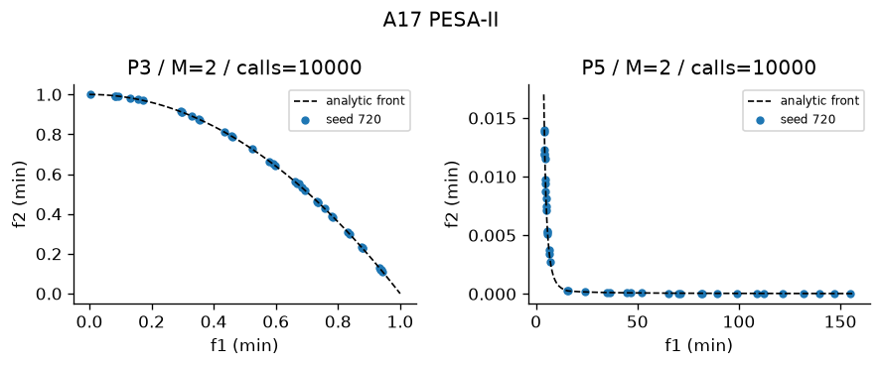
Figure A17 Recorded output on designated problems. Plotted seed and actual calls appear in the panel. The full ten-trial metrics are in the table.
Interpretation—empirical performance PESA-II recorded HV 0.511 ± 0.0071042 on P3, IGD 0.021934 ± 0.0033027 (Figure A17). In the comparable P3 study with the same 10,000-evaluation cap, PESA-II recorded HV 0.511 ± 0.0071042; the nearest peer by mean HV was MOABC at 0.50853 ± 0.0089927, with runtime 9.6225 ± 0.75254 s versus 5.2361 ± 0.23935 s for PESA-II. A separate P5 record gives HV 1.1811 ± 0.0005926 after 10,000 ± 0 evaluations in 6.3281 ± 0.45901 s, so the evidence is not limited to one problem.
Interpretation—measured limitations The nonzero P3 IGD of 0.021934 ± 0.0033027 measures remaining sampled-front error. Thus the run does not support exact convergence or global optimality. Across 10 P3 trials, HV SD was 0.0071042 and runtime SD was 0.23935 s, which quantifies seed sensitivity at this budget.
Four advantages 1. Region selection directly rewards sparsity; 2. Archive keeps observed tradeoffs; 3. Grid counts are interpretable; 4. Less dependence on precise distances
Four disadvantages 1. Grid divisions sensitive; 2. High-dimensional grids become sparse; 3. Archive can shrink to few members; 4. Grid boundaries change selection abruptly
The measurements provide context for the claimed benefit "Region selection directly rewards sparsity" and the risk "Grid divisions sensitive". They do not isolate either mechanism; controlled ablation would be required for causal attribution.
Best use and avoid Bi-objective region coverage. Avoid: Many objectives with almost unique cells.

18 MOEA/D
Core mechanism Neighbouring Tchebycheff subproblems
Implementation and parameters Module src\algorithms\moead.py; implementation status works; defining mechanism test test_18_mechanism passes. MOEA/D: reference weights, neighbourhood mating, running ideal, cooperative Tchebycheff replacement. Neighbourhood size=10. Shared defaults: population=40, budget=10,000, optimizer seed=720. Constraints: Deb feasibility comparison unless the stated method uses scalar penalty.
Problem | Trials | HV | IGD | Spacing | Runtime s | Evaluations / cap
P10 M5 | 10 | 0.9954 ± 0.03858 | 0.3212 ± 0.02067 | 0.2613 ± 0.0299 | 19.58 ± 0.8841 | 10,000 / 10,000
P3 | 10 | 0.5318 ± 8.619e-05 | 0.009567 ± 0.0001113 | 0.003944 ± 0.0007786 | 14.44 ± 0.7004 | 10,000 / 10,000
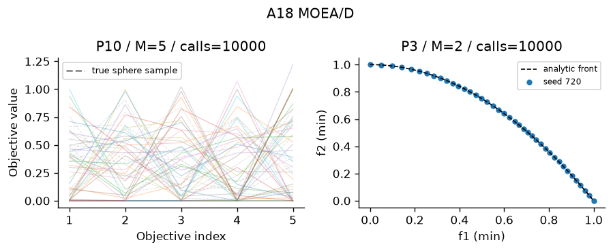
Figure A18 Recorded output on designated problems. Plotted seed and actual calls appear in the panel. The full ten-trial metrics are in the table.
Interpretation—empirical performance MOEA/D recorded HV 0.99538 ± 0.038577 on P10, IGD 0.32121 ± 0.020673 (Figure A18). In the comparable P10 study with the same 10,000-evaluation cap, MOEA/D recorded HV 0.99538 ± 0.038577; the nearest peer by mean HV was NSGA-III at 0.98827 ± 0.018811, with runtime 5.3109 ± 0.27819 s versus 19.578 ± 0.88406 s for MOEA/D. A separate P3 record gives HV 0.53179 ± 8.6192e-05 after 10,000 ± 0 evaluations in 14.443 ± 0.70036 s, so the evidence is not limited to one problem.
Interpretation—measured limitations The nonzero P10 IGD of 0.32121 ± 0.020673 measures remaining sampled-front error. Thus the run does not support exact convergence or global optimality. Across 10 P10 trials, HV SD was 0.038577 and runtime SD was 0.88406 s, which quantifies seed sensitivity at this budget.
Four advantages 1. Cooperation shares good designs; 2. Scalar subproblems retain pressure with many objectives; 3. Neighbourhood limits update work; 4. Weights provide coverage plan
Four disadvantages 1. Reference geometry biases front; 2. Neighbourhood size affects spread; 3. Shared donors can homogenize subproblems; 4. Ideal updates alter scalar values
The measurements provide context for the claimed benefit "Cooperation shares good designs" and the risk "Reference geometry biases front". They do not isolate either mechanism; controlled ablation would be required for causal attribution.
Best use and avoid Smooth continuous many-objective design. Avoid: Disconnected fronts badly matched by weights.

19 MOEA/D-DE
Core mechanism DE variation inside MOEA/D
Implementation and parameters Module src\algorithms\moead_de.py; implementation status works; defining mechanism test test_19_mechanism passes. MOEA/D-DE: neighbourhood donor x_a+F*(x_b-x_c), binomial crossover CR=.9 with forced coordinate, F=.5; cooperative scalar replacement. Shared defaults: population=40, budget=10,000, optimizer seed=720. Constraints: Deb feasibility comparison unless the stated method uses scalar penalty.
Problem | Trials | HV | IGD | Spacing | Runtime s | Evaluations / cap
P3 | 10 | 0.2124 ± 0.2742 | 1.042 ± 0.9331 | 0.001026 ± 0.001503 | 11.8 ± 2.149 | 10,000 / 10,000
P5 | 10 | 1.182 ± 3.231e-05 | 0.0491 ± 0.03155 | 0.02913 ± 0.02089 | 12.84 ± 0.5549 | 10,000 / 10,000
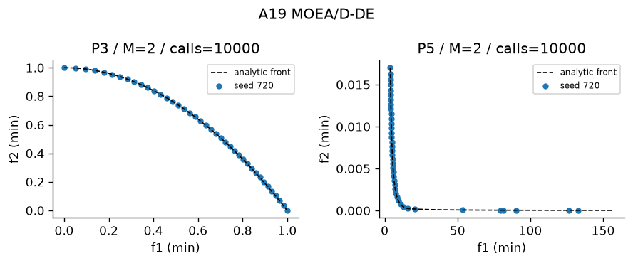
Figure A19 Recorded output on designated problems. Plotted seed and actual calls appear in the panel. The full ten-trial metrics are in the table.
Interpretation—empirical performance MOEA/D-DE recorded HV 0.21242 ± 0.27423 on P3, IGD 1.0419 ± 0.9331 (Figure A19). In the comparable P3 study with the same 10,000-evaluation cap, MOEA/D-DE recorded HV 0.21242 ± 0.27423; the nearest peer by mean HV was Weighted Sum at 0.21 ± 1.4261e-11, with runtime 0.40343 ± 0.44449 s versus 11.795 ± 2.1489 s for MOEA/D-DE. A separate P5 record gives HV 1.1819 ± 3.2311e-05 after 10,000 ± 0 evaluations in 12.836 ± 0.55488 s, so the evidence is not limited to one problem.
Interpretation—measured limitations The nonzero P3 IGD of 1.0419 ± 0.9331 measures remaining sampled-front error. Thus the run does not support exact convergence or global optimality. Across 10 P3 trials, HV SD was 0.27423 and runtime SD was 2.1489 s, which quantifies seed sensitivity at this budget.
Four advantages 1. DE exploits vector differences; 2. Neighbour cooperation; 3. Tchebycheff reaches nonconvex fronts; 4. Forced crossover guarantees a changed coordinate
Four disadvantages 1. F and CR need tuning; 2. DE requires enough distinct neighbours; 3. Boundary clipping distorts donors; 4. Weight coverage may be uneven
The measurements provide context for the claimed benefit "DE exploits vector differences" and the risk "F and CR need tuning". They do not isolate either mechanism; controlled ablation would be required for causal attribution.
Best use and avoid Continuous real-coded nonconvex design. Avoid: Permutation encodings without a new donor operator.

20 MOEA/D-ACO
Core mechanism Weight-specific ant pheromones and scalar replacement
Implementation and parameters Module src\algorithms\moead_aco.py; implementation status works; defining mechanism test test_20_mechanism passes. MOEA/D-ACO for tours: each weight has edge pheromone, weighted distance/time heuristic, neighbour Tchebycheff replacement and deposits. Defaults alpha=1 beta=2 evaporation=.1. Requires P8. Shared defaults: population=40, budget=10,000, optimizer seed=720. Constraints: Deb feasibility comparison unless the stated method uses scalar penalty.
Problem | Trials | HV | IGD | Spacing | Runtime s | Evaluations / cap
P8 | 10 | 0.9235 ± 0.0007362 | N/A | 0.003604 ± 0.001162 | 26.42 ± 0.9056 | 10,000 / 10,000
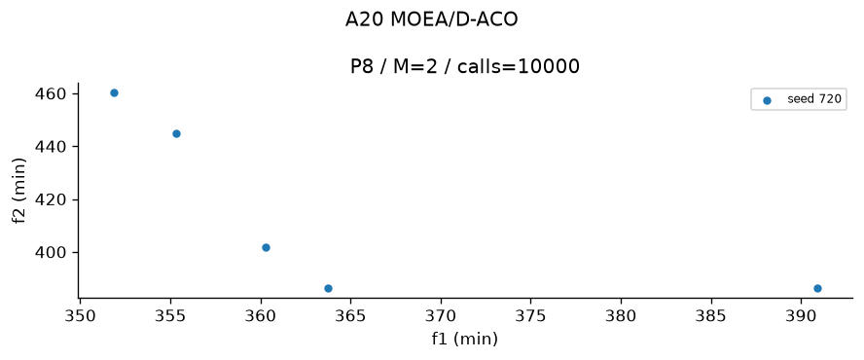
Figure A20 Recorded output on designated problems. Plotted seed and actual calls appear in the panel. The full ten-trial metrics are in the table.
Interpretation—empirical performance MOEA/D-ACO recorded HV 0.92348 ± 0.00073621 on P8, and Spacing 0.0036041 ± 0.0011622 where exact-front IGD is unavailable (Figure A20). In the comparable P8 study with the same 10,000-evaluation cap, MOEA/D-ACO recorded HV 0.92348 ± 0.00073621; the nearest peer by mean HV was MOMA at 0.92348 ± 0.0011631, with runtime 7.6185 ± 0.51051 s versus 26.418 ± 0.90564 s for MOEA/D-ACO. A separate P8 record gives HV 0.92348 ± 0.00073621 after 10,000 ± 0 evaluations in 26.149 ± 0.97718 s, so the evidence is not limited to one problem.
Interpretation—measured limitations No exact front is available for P8, so the run cannot experimentally establish convergence; HV 0.92348 ± 0.00073621 and Spacing 0.0036041 ± 0.0011622 cover different questions. Across 10 P8 trials, HV SD was 0.00073621 and runtime SD was 0.90564 s, which quantifies seed sensitivity at this budget.
Four advantages 1. Valid tours by construction; 2. Heuristic directs ant choices; 3. Separate subproblems retain tradeoffs; 4. Pheromone records good edges
Four disadvantages 1. Pheromone arrays cost N*cities^2; 2. Deposits can lock routes; 3. Alpha beta evaporation matter; 4. Continuous encodings unsupported
The measurements provide context for the claimed benefit "Valid tours by construction" and the risk "Pheromone arrays cost N*cities^2". They do not isolate either mechanism; controlled ablation would be required for causal attribution.
Best use and avoid Bi-objective routing. Avoid: Smooth gradient problems.

21 Constrained NSGA-II
Core mechanism NSGA-II with Deb feasibility
Implementation and parameters Module src\algorithms\constrained_nsga2.py; implementation status works; defining mechanism test test_21_mechanism passes. Constrained NSGA-II: feasible beats infeasible, lower violation wins among infeasible, Pareto rank then crowding among feasible. NSGA-II in this project also supports Deb rules; this module exposes the rule. Shared defaults: population=40, budget=10,000, optimizer seed=720. Constraints: Deb feasibility comparison unless the stated method uses scalar penalty.
Problem | Trials | HV | IGD | Spacing | Runtime s | Evaluations / cap
P5 | 10 | 1.182 ± 3.963e-05 | 0.01406 ± 0.001287 | 0.02067 ± 0.003274 | 3.317 ± 0.3422 | 10,000 / 10,000
P6 | 10 | 1.011 ± 0.001179 | 0.01327 ± 0.0007729 | 0.01679 ± 0.0029 | 3.39 ± 0.3077 | 10,000 / 10,000
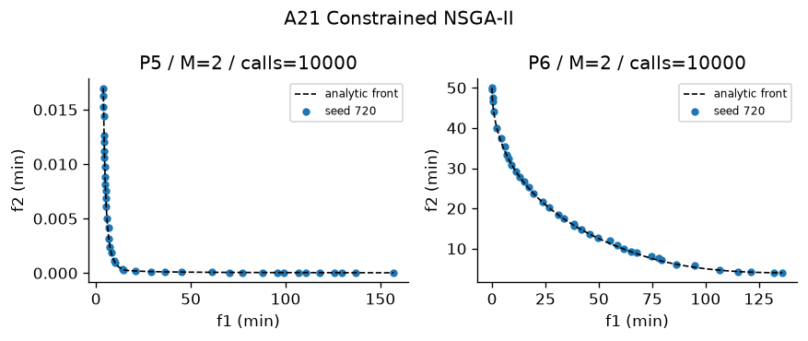
Figure A21 Recorded output on designated problems. Plotted seed and actual calls appear in the panel. The full ten-trial metrics are in the table.
Interpretation—empirical performance Constrained NSGA-II recorded HV 1.1818 ± 3.9631e-05 on P5, IGD 0.014057 ± 0.0012871 (Figure A21). In the comparable P5 study with the same 10,000-evaluation cap, Constrained NSGA-II recorded HV 1.1818 ± 3.9631e-05; the nearest peer by mean HV was NSGA-II at 1.1818 ± 3.9631e-05, with runtime 3.5601 ± 0.2764 s versus 3.3173 ± 0.34218 s for Constrained NSGA-II. A separate P6 record gives HV 1.0111 ± 0.0011787 after 10,000 ± 0 evaluations in 3.3899 ± 0.30771 s, so the evidence is not limited to one problem.
Interpretation—measured limitations The nonzero P5 IGD of 0.014057 ± 0.0012871 measures remaining sampled-front error. Thus the run does not support exact convergence or global optimality. Across 10 P5 trials, HV SD was 3.9631e-05 and runtime SD was 0.34218 s, which quantifies seed sensitivity at this budget.
Four advantages 1. Feasible beats infeasible without objective penalty; 2. Lower violation guides infeasible search; 3. Pareto ranking within feasible; 4. Crowding retains feasible diversity
Four disadvantages 1. Violation normalization affects infeasible order; 2. Feasibility boundary can trap search; 3. Quadratic ranking; 4. Finite crowding resolution
The measurements provide context for the claimed benefit "Feasible beats infeasible without objective penalty" and the risk "Violation normalization affects infeasible order". They do not isolate either mechanism; controlled ablation would be required for causal attribution.
Best use and avoid Constrained beam or Binh-Korn. Avoid: Problems needing stochastic feasibility guarantees.

22 MOPSO
Core mechanism Particle velocity with personal and archive leaders
Implementation and parameters Module src\algorithms\mopso.py; implementation status works; defining mechanism test test_22_mechanism passes. MOPSO: inertia velocity, personal best, crowding-selected archive leader, occasional mutation. Personal best changes only when a trial dominates it. Defaults inertia=.4, c1=c2=1.5. Shared defaults: population=40, budget=10,000, optimizer seed from project config. Constraints: Deb feasibility comparison unless the stated method uses scalar penalty.
Problem | Trials | HV | IGD | Spacing | Runtime s | Evaluations / cap
P4 | 10 | 0.9259 ± 0.00455 | N/A | 0.01343 ± 0.003755 | 2.179 ± 0.2485 | 10,000 / 10,000
P5 | 10 | 1.182 ± 0.0006447 | 0.01421 ± 0.002302 | 0.02041 ± 0.002691 | 2.031 ± 0.3814 | 10,000 / 10,000
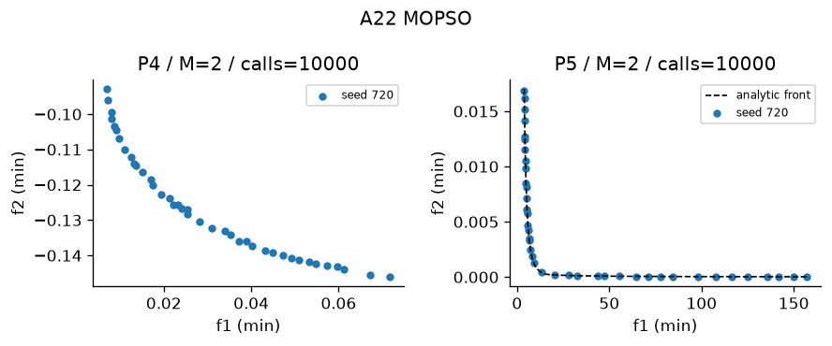
Figure A22 Recorded output on designated problems. Plotted seed and actual calls appear in the panel. The full ten-trial metrics are in the table.
Interpretation—empirical performance MOPSO recorded HV 0.92587 ± 0.0045498 on P4, and Spacing 0.013429 ± 0.0037554 where exact-front IGD is unavailable (Figure A22). In the comparable P5 study with the same 10,000-evaluation cap, MOPSO recorded HV 1.1816 ± 0.00064467; the nearest peer by mean HV was Weight Metric at 1.1817 ± 1.5148e-06, with runtime 3.4155 ± 0.29556 s versus 2.0314 ± 0.3814 s for MOPSO. A separate P5 record gives HV 1.1816 ± 0.00064467 after 10,000 ± 0 evaluations in 2.0314 ± 0.3814 s, so the evidence is not limited to one problem.
Interpretation—measured limitations No exact front is available for P4, so the run cannot experimentally establish convergence; HV 0.92587 ± 0.0045498 and Spacing 0.013429 ± 0.0037554 cover different questions. Across 10 P4 trials, HV SD was 0.0045498 and runtime SD was 0.2485 s, which quantifies seed sensitivity at this budget.
Four advantages 1. Memory of personal successes; 2. Few basic coefficients; 3. Archive leader spreads movement; 4. No crossover operator needed
Four disadvantages 1. Velocities can collapse; 2. Boundary clipping affects dynamics; 3. Leader policy controls diversity; 4. Coefficients require tuning
The measurements provide context for the claimed benefit "Memory of personal successes" and the risk "Velocities can collapse". They do not isolate either mechanism; controlled ablation would be required for causal attribution.
Best use and avoid Continuous portfolio and beam designs. Avoid: Permutation tours without discrete velocity.

23 MOGWO
Core mechanism Three archive leaders and encircling
Implementation and parameters Module src\algorithms\mogwo.py; implementation status partly works; defining mechanism test test_23_mechanism passes. MOGWO: alpha, beta, delta archive leaders; decreasing encircling coefficient a=2*(1-used/budget), average three proposed positions. Binary masks use a sigmoid transfer, then at-least-one repair. Shared defaults: population=40, budget=10,000, optimizer seed=720. Constraints: Deb feasibility comparison unless the stated method uses scalar penalty.
Problem | Trials | HV | IGD | Spacing | Runtime s | Evaluations / cap
P5 | 10 | 1.182 ± 0.0001194 | 0.01341 ± 0.001289 | 0.02077 ± 0.001969 | 4.102 ± 0.3726 | 10,000 / 10,000
P9 | 10 | 0.7818 ± 0.04271 | N/A | 0.04461 ± 0.05219 | 30.45 ± 2.014 | 200 / 200
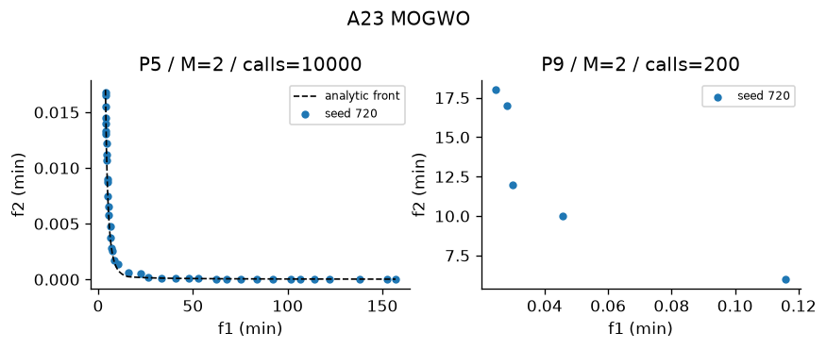
Figure A23 Recorded output on designated problems. Plotted seed and actual calls appear in the panel. The full ten-trial metrics are in the table.
Interpretation—empirical performance MOGWO recorded HV 1.1817 ± 0.00011936 on P5, IGD 0.013415 ± 0.0012894 (Figure A23). In the comparable P5 study with the same 10,000-evaluation cap, MOGWO recorded HV 1.1817 ± 0.00011936; the nearest peer by mean HV was Weight Metric at 1.1817 ± 1.5148e-06, with runtime 3.4155 ± 0.29556 s versus 4.1017 ± 0.37263 s for MOGWO. A separate P9 record gives HV 0.78176 ± 0.042714 after 200 ± 0 evaluations in 30.445 ± 2.0142 s, so the evidence is not limited to one problem.
Interpretation—measured limitations The nonzero P5 IGD of 0.013415 ± 0.0012894 measures remaining sampled-front error. Thus the run does not support exact convergence or global optimality. Across 10 P5 trials, HV SD was 0.00011936 and runtime SD was 0.37263 s, which quantifies seed sensitivity at this budget.
Four advantages 1. Multiple leaders guide movement; 2. Coefficient shrinks automatically; 3. Archive covers tradeoffs; 4. Binary transfer enables masks
Four disadvantages 1. Averaging leaders may erase diversity; 2. No strict improvement guarantee; 3. Transfer sigmoid biases masks; 4. Binary objective evaluation is costly
The measurements provide context for the claimed benefit "Multiple leaders guide movement" and the risk "Averaging leaders may erase diversity". They do not isolate either mechanism; controlled ablation would be required for causal attribution.
Best use and avoid Continuous design or exploratory feature masks. Avoid: Required stable high-accuracy feature conclusions on tiny budgets.

24 MOABC
Core mechanism Employed moves, crowding-based onlookers and abandonment scouts
Implementation and parameters Module src\algorithms\moabc.py; implementation status works; defining mechanism test test_24_mechanism passes. MOABC: employed and onlooker differential-coordinate proposals, Deb dominance greedy replacement, abandoned-source scouts. Limit=20. Shared defaults: population=40, budget=10,000, optimizer seed=720. Constraints: Deb feasibility comparison unless the stated method uses scalar penalty.
Problem | Trials | HV | IGD | Spacing | Runtime s | Evaluations / cap
P3 | 10 | 0.5085 ± 0.008993 | 0.02247 ± 0.00449 | 0.02386 ± 0.004992 | 9.72 ± 0.7229 | 10,000 / 10,000
P6 | 10 | 1.016 ± 0.0002737 | 0.01101 ± 0.0003537 | 0.006067 ± 0.001849 | 13.04 ± 1.245 | 10,000 / 10,000
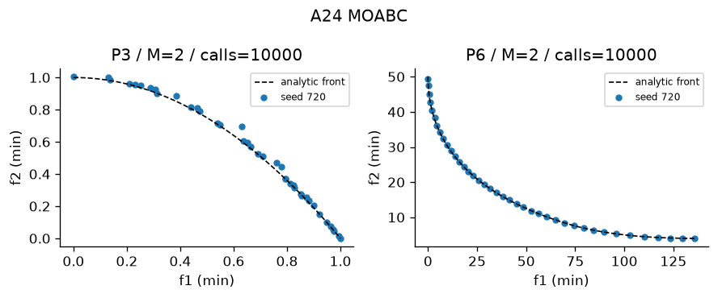
Figure A24 Recorded output on designated problems. Plotted seed and actual calls appear in the panel. The full ten-trial metrics are in the table.
Interpretation—empirical performance MOABC recorded HV 0.50853 ± 0.0089927 on P3, IGD 0.022472 ± 0.0044901 (Figure A24). In the comparable P3 study with the same 10,000-evaluation cap, MOABC recorded HV 0.50853 ± 0.0089927; the nearest peer by mean HV was PESA-II at 0.511 ± 0.0071042, with runtime 5.2138 ± 0.18371 s versus 9.7198 ± 0.72292 s for MOABC. A separate P6 record gives HV 1.0157 ± 0.00027371 after 10,000 ± 0 evaluations in 13.04 ± 1.2447 s, so the evidence is not limited to one problem.
Interpretation—measured limitations The nonzero P3 IGD of 0.022472 ± 0.0044901 measures remaining sampled-front error. Thus the run does not support exact convergence or global optimality. Across 10 P3 trials, HV SD was 0.0089927 and runtime SD was 0.72292 s, which quantifies seed sensitivity at this budget.
Four advantages 1. Scouts restart abandoned sources; 2. Onlooker pressure favours sparse regions; 3. Coordinate moves are inspectable; 4. No gradients needed
Four disadvantages 1. Dominance-only greed can reject useful tradeoffs; 2. Limit needs tuning; 3. Three phases complicate budget accounting; 4. One-coordinate changes may be slow
The measurements provide context for the claimed benefit "Scouts restart abandoned sources" and the risk "Dominance-only greed can reject useful tradeoffs". They do not isolate either mechanism; controlled ablation would be required for causal attribution.
Best use and avoid Small continuous design with restarts. Avoid: Strongly coupled high-dimensional variables.

25 MOACO
Core mechanism Two pheromone matrices and route construction
Implementation and parameters Module src\algorithms\moaco.py; implementation status works; defining mechanism test test_25_mechanism passes. MOACO: two pheromone matrices, randomized tradeoff exponent, probabilistic valid tour construction, evaporation and archive deposits. Defaults alpha=1 beta=2 evaporation=.1. P8 only. Shared defaults: population=40, budget=10,000, optimizer seed=720. Constraints: Deb feasibility comparison unless the stated method uses scalar penalty.
Problem | Trials | HV | IGD | Spacing | Runtime s | Evaluations / cap
P8 | 10 | 0.9239 ± 0 | N/A | 0.003111 ± 0.0008203 | 18.13 ± 2.17 | 10,000 / 10,000
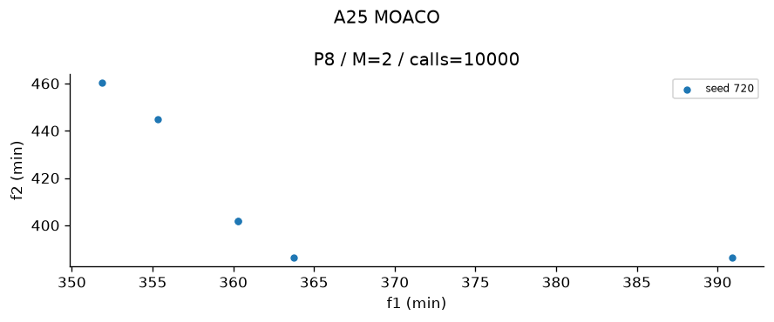
Figure A25 Recorded output on designated problems. Plotted seed and actual calls appear in the panel. The full ten-trial metrics are in the table.
Interpretation—empirical performance MOACO recorded HV 0.92394 ± 0 on P8, and Spacing 0.0031115 ± 0.00082031 where exact-front IGD is unavailable (Figure A25). In the comparable P8 study with the same 10,000-evaluation cap, MOACO recorded HV 0.92394 ± 0; the nearest peer by mean HV was NSGA-II at 0.92354 ± 0.0011666, with runtime 5.8743 ± 0.25408 s versus 18.135 ± 2.1703 s for MOACO. A separate P8 record gives HV 0.92394 ± 0 after 10,000 ± 0 evaluations in 17.956 ± 1.854 s, so the evidence is not limited to one problem.
Interpretation—measured limitations No exact front is available for P8, so the run cannot experimentally establish convergence; HV 0.92394 ± 0 and Spacing 0.0031115 ± 0.00082031 cover different questions. The P8 output retained 5.2 ± 0.42164 point(s). That finite resolution limits what the plot can demonstrate; front size or zero Spacing alone is not evidence of complete coverage.
Four advantages 1. Produces valid permutations; 2. Two objectives retain separate memories; 3. Heuristic reduces random route work; 4. Archive deposits reward tradeoffs
Four disadvantages 1. Strong evaporation forgets edges; 2. Weak evaporation stagnates; 3. Traffic/distance scales matter; 4. No exact TSP optimality guarantee
The measurements provide context for the claimed benefit "Produces valid permutations" and the risk "Strong evaporation forgets edges". They do not isolate either mechanism; controlled ablation would be required for causal attribution.
Best use and avoid Distance-time routing. Avoid: Continuous portfolio allocation.

26 MOSA
Core mechanism Incomparable neighbour acceptance and Boltzmann dominated moves
Implementation and parameters Module src\algorithms\mosa.py; implementation status works; defining mechanism test test_26_mechanism passes. Multiobjective Simulated Annealing: population of chains, normalized summed worsened-objective energy for dominated moves, Boltzmann acceptance and archive. Temperature T0=.1, cooling=.97 per population sweep, move scale=.1. Lecture Part 4 slide 41 acceptance; parallel chains are a declared extension. Incomparable neighbours always accepted. Normalized T0=.1 is not raw-unit T0=100. Shared defaults: population=40, budget=10,000, optimizer seed=720. Constraints: Deb feasibility comparison unless the stated method uses scalar penalty.
Problem | Trials | HV | IGD | Spacing | Runtime s | Evaluations / cap
P3 | 10 | 0.5135 ± 0.006066 | 0.0204 ± 0.003815 | 0.03388 ± 0.01308 | 1.47 ± 0.1377 | 10,000 / 10,000
P5 | 10 | 1.181 ± 0.0003664 | 0.01318 ± 0.0007081 | 0.01876 ± 0.001253 | 1.523 ± 0.1193 | 10,000 / 10,000
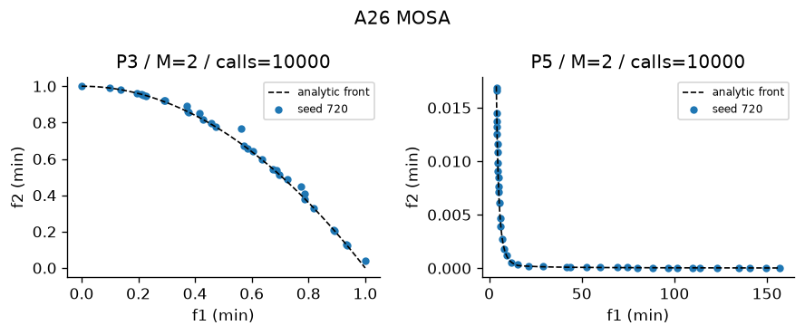
Figure A26 Recorded output on designated problems. Plotted seed and actual calls appear in the panel. The full ten-trial metrics are in the table.
Interpretation—empirical performance MOSA recorded HV 0.51354 ± 0.0060662 on P3, IGD 0.020405 ± 0.0038149 (Figure A26). In the comparable P3 study with the same 10,000-evaluation cap, MOSA recorded HV 0.51354 ± 0.0060662; the nearest peer by mean HV was PESA-II at 0.511 ± 0.0071042, with runtime 5.2138 ± 0.18371 s versus 1.4704 ± 0.13765 s for MOSA. A separate P5 record gives HV 1.1814 ± 0.00036639 after 10,000 ± 0 evaluations in 1.5232 ± 0.11932 s, so the evidence is not limited to one problem.
Interpretation—measured limitations The nonzero P3 IGD of 0.020405 ± 0.0038149 measures remaining sampled-front error. Thus the run does not support exact convergence or global optimality. Across 10 P3 trials, HV SD was 0.0060662 and runtime SD was 0.13765 s, which quantifies seed sensitivity at this budget.
Four advantages 1. May accept uphill escape moves; 2. Works without derivatives; 3. Mutation adapts to encoding; 4. Archive records tradeoffs from many chains
Four disadvantages 1. Cooling schedule sensitive; 2. Local moves can miss distant regions; 3. Incomparable moves remain random at low temperature; 4. Finite cooling gives no global guarantee
The measurements provide context for the claimed benefit "May accept uphill escape moves" and the risk "Cooling schedule sensitive". They do not isolate either mechanism; controlled ablation would be required for causal attribution.
Best use and avoid Budgeted local exploration on nonconvex fronts. Avoid: Uniform global coverage with insufficient chains.

27 MODE
Core mechanism DE dominance-only trial replacement
Implementation and parameters Module src\algorithms\mode.py; implementation status works; defining mechanism test test_27_mechanism passes. MODE: DE/rand/1 and forced binomial crossover; trial replaces target only if it dominates under Deb rules. F=.5, CR=.9. Output archive retains tradeoffs. Shared defaults: population=40, budget=10,000, optimizer seed=720. Constraints: Deb feasibility comparison unless the stated method uses scalar penalty.
Problem | Trials | HV | IGD | Spacing | Runtime s | Evaluations / cap
P3 | 10 | 0.11 ± 3.023e-10 | 0.6098 ± 1.147e-10 | 0 ± 0 | 1.77 ± 0.06894 | 10,000 / 10,000
P5 | 10 | 1.181 ± 0.002083 | 0.01381 ± 0.003286 | 0.01812 ± 0.003533 | 2.19 ± 0.2773 | 10,000 / 10,000
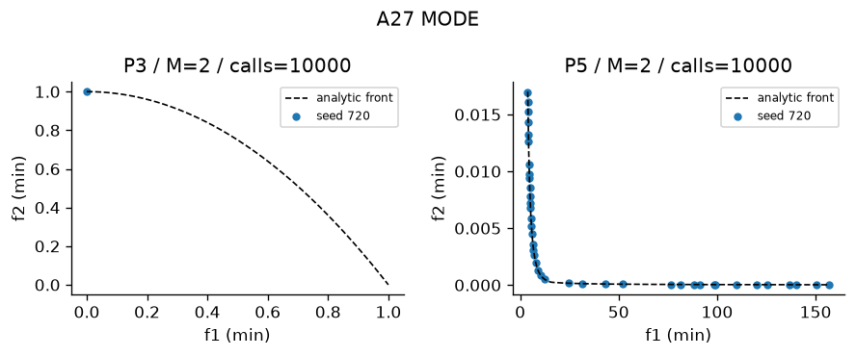
Figure A27 Recorded output on designated problems. Plotted seed and actual calls appear in the panel. The full ten-trial metrics are in the table.
Interpretation—empirical performance MODE recorded HV 0.11 ± 3.0227e-10 on P3, IGD 0.6098 ± 1.1468e-10 (Figure A27). In the comparable P3 study with the same 10,000-evaluation cap, MODE recorded HV 0.11 ± 3.0227e-10; the nearest peer by mean HV was VEGA at 0.17298 ± 0.045825, with runtime 3.0357 ± 0.21072 s versus 1.7695 ± 0.068943 s for MODE. A separate P5 record gives HV 1.1807 ± 0.0020828 after 10,000 ± 0 evaluations in 2.1901 ± 0.27727 s, so the evidence is not limited to one problem.
Interpretation—measured limitations The nonzero P3 IGD of 0.6098 ± 1.1468e-10 measures remaining sampled-front error. Thus the run does not support exact convergence or global optimality. Across 10 P3 trials, HV SD was 3.0227e-10 and runtime SD was 0.068943 s, which quantifies seed sensitivity at this budget.
Four advantages 1. Simple vector donor; 2. No utility weights; 3. CR forces one donor coordinate; 4. Dominating trials preserve target improvement
Four disadvantages 1. Incomparable trials do not replace targets; 2. F CR sensitivity; 3. Coordinate clipping can stagnate; 4. Only real encoding is implemented
The measurements provide context for the claimed benefit "Simple vector donor" and the risk "Incomparable trials do not replace targets". They do not isolate either mechanism; controlled ablation would be required for causal attribution.
Best use and avoid Continuous design with comparable improvements. Avoid: Many objectives with almost no domination.

28 MO-TLBO
Core mechanism Crowding archive teacher, shrinking TF and nondominated learner moves
Implementation and parameters Module src\algorithms\motlbo.py; implementation status works; defining mechanism test test_28_mechanism passes. MO-TLBO: teacher phase x+r*(teacher-TF*mean); learner phase towards better peer or away from worse peer. TF shrinks from 2 to 1. Nondominated replacement, archive tracks nondominated proposals. Shared defaults: population=40, budget=10,000, optimizer seed=720. Constraints: Deb feasibility comparison unless the stated method uses scalar penalty.
Problem | Trials | HV | IGD | Spacing | Runtime s | Evaluations / cap
P3 | 10 | 0.5318 ± 7.088e-05 | 0.009509 ± 9.075e-05 | 0.003671 ± 0.001287 | 11.39 ± 1.237 | 10,000 / 10,000
P5 | 10 | 1.182 ± 1.659e-05 | 0.01234 ± 0.0004422 | 0.02285 ± 0.0009418 | 11.36 ± 1.012 | 10,000 / 10,000
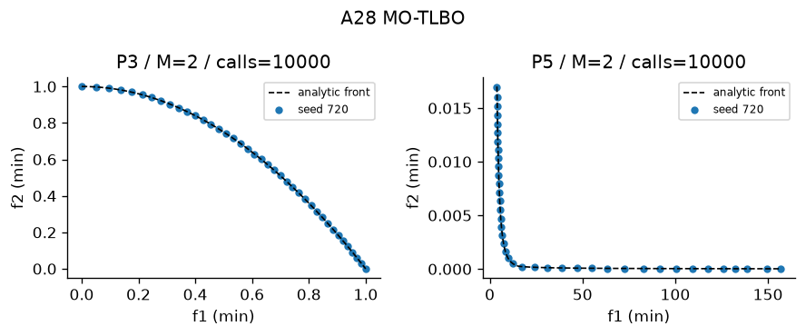
Figure A28 Recorded output on designated problems. Plotted seed and actual calls appear in the panel. The full ten-trial metrics are in the table.
Interpretation—empirical performance MO-TLBO recorded HV 0.53179 ± 7.0884e-05 on P3, IGD 0.0095087 ± 9.0745e-05 (Figure A28). In the comparable P3 study with the same 10,000-evaluation cap, MO-TLBO recorded HV 0.53179 ± 7.0884e-05; the nearest peer by mean HV was MOEA/D at 0.53179 ± 8.6192e-05, with runtime 14.525 ± 0.79452 s versus 11.386 ± 1.2374 s for MO-TLBO. A separate P5 record gives HV 1.1819 ± 1.6587e-05 after 10,000 ± 0 evaluations in 11.361 ± 1.0124 s, so the evidence is not limited to one problem.
Interpretation—measured limitations The nonzero P3 IGD of 0.0095087 ± 9.0745e-05 measures remaining sampled-front error. Thus the run does not support exact convergence or global optimality. Across 10 P3 trials, HV SD was 7.0884e-05 and runtime SD was 1.2374 s, which quantifies seed sensitivity at this budget.
Four advantages 1. No crossover design needed; 2. Teacher encourages exploitation; 3. Learners use peer information; 4. Shrinking TF changes search scale
Four disadvantages 1. Teacher choice depends on archive; 2. Incomparable moves can wander; 3. Population means blur disconnected regions; 4. TF schedule differs from conventional TLBO
The measurements provide context for the claimed benefit "No crossover design needed" and the risk "Teacher choice depends on archive". They do not isolate either mechanism; controlled ablation would be required for causal attribution.
Best use and avoid Small continuous educational examples. Avoid: Highly multimodal separated feasible regions.

29 MOBA
Core mechanism Frequency velocity, pulse and loudness
Implementation and parameters Module src\algorithms\moba.py; implementation status works; defining mechanism test test_29_mechanism passes. MOBA: frequency velocity toward archive leader, pulse-controlled local random walk, loudness acceptance. fmin=0 fmax=2, loudness*=.95, pulse=1*(1-exp(-.1*g)). Pareto archive stores all visited feasible points. Shared defaults: population=40, budget=10,000, optimizer seed=720. Constraints: Deb feasibility comparison unless the stated method uses scalar penalty.
Problem | Trials | HV | IGD | Spacing | Runtime s | Evaluations / cap
P3 | 10 | 0.3968 ± 0.1443 | 0.1289 ± 0.1631 | 0.04146 ± 0.05039 | 4.604 ± 0.229 | 10,000 / 10,000
P4 | 10 | 0.9332 ± 0.001286 | N/A | 0.01234 ± 0.002368 | 4.796 ± 0.3789 | 10,000 / 10,000
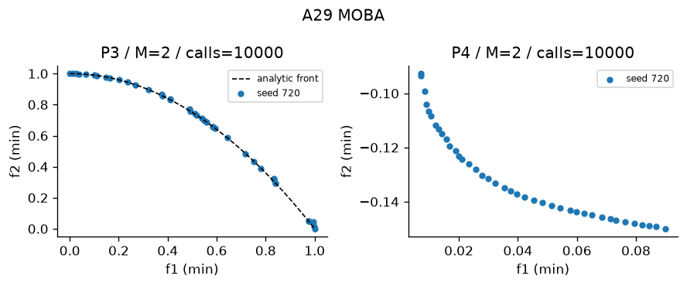
Figure A29 Recorded output on designated problems. Plotted seed and actual calls appear in the panel. The full ten-trial metrics are in the table.
Interpretation—empirical performance MOBA recorded HV 0.39676 ± 0.14429 on P3, IGD 0.12888 ± 0.16313 (Figure A29). In the comparable P3 study with the same 10,000-evaluation cap, MOBA recorded HV 0.39676 ± 0.14429; the nearest peer by mean HV was MOPSO at 0.41909 ± 0.03166, with runtime 1.8638 ± 0.12697 s versus 4.6044 ± 0.22895 s for MOBA. A separate P4 record gives HV 0.93318 ± 0.0012862 after 10,000 ± 0 evaluations in 4.7957 ± 0.37886 s, so the evidence is not limited to one problem.
Interpretation—measured limitations The nonzero P3 IGD of 0.12888 ± 0.16313 measures remaining sampled-front error. Thus the run does not support exact convergence or global optimality. Across 10 P3 trials, HV SD was 0.14429 and runtime SD was 0.22895 s, which quantifies seed sensitivity at this budget.
Four advantages 1. Few interpretable schedules; 2. Local walks exploit leaders; 3. Frequency creates long moves; 4. Archive records candidate tradeoffs
Four disadvantages 1. Loudness decay suppresses replacement; 2. Velocity can explode then clip; 3. Pulse schedule sensitive; 4. Archive quality may exceed final-chain quality
The measurements provide context for the claimed benefit "Few interpretable schedules" and the risk "Loudness decay suppresses replacement". They do not isolate either mechanism; controlled ablation would be required for causal attribution.
Best use and avoid Continuous local refinement. Avoid: Robust full-front exploration without schedule tuning.

30 MOMA
Core mechanism NSGA-II plus sparse-child combined-score hill climbing
Implementation and parameters Module src\algorithms\moma.py; implementation status partly works; defining mechanism test test_30_mechanism passes. MOMA: NSGA-II global search and normalized combined-improvement hill-climb on a subset of children. Local fraction=.25, mutation scale=.02. Local calls count in budget. Shared defaults: population=40, budget=10,000, optimizer seed=720. Constraints: Deb feasibility comparison unless the stated method uses scalar penalty.
Problem | Trials | HV | IGD | Spacing | Runtime s | Evaluations / cap
P5 | 10 | 1.182 ± 5.827e-05 | 0.01291 ± 0.001555 | 0.01836 ± 0.001705 | 6.331 ± 0.652 | 10,000 / 10,000
P9 | 10 | 0.8736 ± 0.03212 | N/A | 0.0402 ± 0.03056 | 39.46 ± 6.746 | 200 / 200
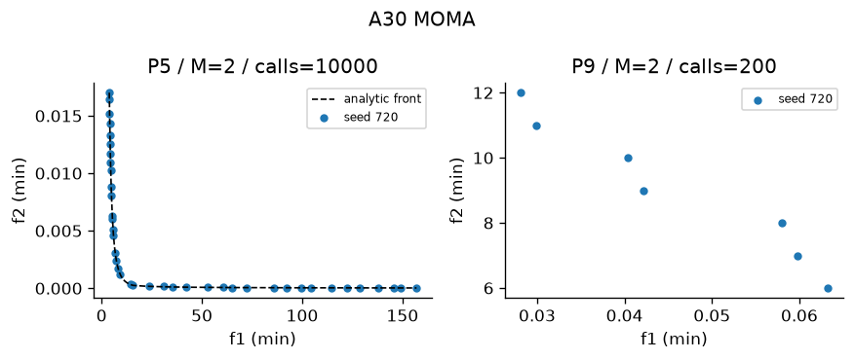
Figure A30 Recorded output on designated problems. Plotted seed and actual calls appear in the panel. The full ten-trial metrics are in the table.
Interpretation—empirical performance MOMA recorded HV 1.1818 ± 5.8274e-05 on P5, IGD 0.01291 ± 0.0015554 (Figure A30). In the comparable P5 study with the same 10,000-evaluation cap, MOMA recorded HV 1.1818 ± 5.8274e-05; the nearest peer by mean HV was MOBA at 1.1818 ± 3.4425e-05, with runtime 4.2628 ± 0.30584 s versus 6.3309 ± 0.65198 s for MOMA. A separate P9 record gives HV 0.87363 ± 0.032115 after 200 ± 0 evaluations in 39.459 ± 6.7459 s, so the evidence is not limited to one problem.
Interpretation—measured limitations The nonzero P5 IGD of 0.01291 ± 0.0015554 measures remaining sampled-front error. Thus the run does not support exact convergence or global optimality. Across 10 P5 trials, HV SD was 5.8274e-05 and runtime SD was 0.65198 s, which quantifies seed sensitivity at this budget.
Four advantages 1. Local moves refine global children; 2. Elitist survival; 3. Works with binary/tour mutation; 4. Local cost explicitly counted
Four disadvantages 1. Local calls reduce global generations; 2. Combined-score preference changes tradeoffs; 3. Mutation neighbourhood determines refinement; 4. Feature CV makes local search costly
The measurements provide context for the claimed benefit "Local moves refine global children" and the risk "Local calls reduce global generations". They do not isolate either mechanism; controlled ablation would be required for causal attribution.
Best use and avoid Beam refinement or routing. Avoid: Expensive objectives with no local structure.

31 RVEA
Core mechanism Normalized reference vectors and lecture linear-progress APD
Implementation and parameters Module src\algorithms\rvea.py; implementation status works; defining mechanism test test_31_mechanism passes. RVEA: reference-vector association and angle-penalized distance (APD), penalty strength alpha=2. Range-adapt vectors every 10 generations. One best member per vector, fill unoccupied slots by APD. Shared defaults: population=40, budget=10,000, optimizer seed=720. Constraints: Deb feasibility comparison unless the stated method uses scalar penalty.
Problem | Trials | HV | IGD | Spacing | Runtime s | Evaluations / cap
P10 M3 | 10 | 0.6403 ± 0.01143 | 0.1088 ± 0.003233 | 0.1006 ± 0.01106 | 5.642 ± 0.5761 | 10,000 / 10,000
P10 M5 | 10 | 1.012 ± 0.03024 | 0.3111 ± 0.008554 | 0.2684 ± 0.02503 | 4.995 ± 0.5221 | 10,000 / 10,000
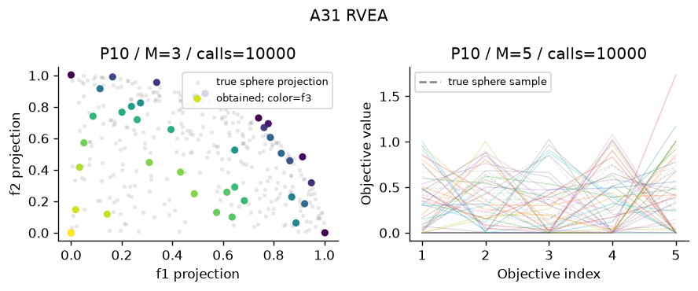
Figure A31 Recorded output on designated problems. Plotted seed and actual calls appear in the panel. The full ten-trial metrics are in the table.
Interpretation—empirical performance RVEA recorded HV 0.64035 ± 0.011426 on P10, IGD 0.10879 ± 0.0032335 (Figure A31). In the comparable P10 study with the same 10,000-evaluation cap, RVEA recorded HV 1.0121 ± 0.030242; the nearest peer by mean HV was MOEA/D at 0.99538 ± 0.038577, with runtime 19.644 ± 0.8166 s versus 4.9951 ± 0.52206 s for RVEA. A separate P10 record gives HV 1.0121 ± 0.030242 after 10,000 ± 0 evaluations in 4.9951 ± 0.52206 s, so the evidence is not limited to one problem.
Interpretation—measured limitations The nonzero P10 IGD of 0.10879 ± 0.0032335 measures remaining sampled-front error. Thus the run does not support exact convergence or global optimality. Across 10 P10 trials, HV SD was 0.011426 and runtime SD was 0.57606 s, which quantifies seed sensitivity at this budget.
Four advantages 1. Angular niches aid many objectives; 2. APD shifts toward convergence; 3. Vector adaptation tracks scales; 4. Sparse niches can retain representatives
Four disadvantages 1. Penalty strength and adaptation period matter; 2. Observed ranges can be unstable; 3. Empty niches require fill policy; 4. Reference alignment can bias coverage
The measurements provide context for the claimed benefit "Angular niches aid many objectives" and the risk "Penalty strength and adaptation period matter". They do not isolate either mechanism; controlled ablation would be required for causal attribution.
Best use and avoid Five-objective DTLZ2. Avoid: Strongly irregular disconnected fronts.

32 IBEA
Core mechanism Outgoing additive-epsilon fitness and largest-fitness deletion
Implementation and parameters Module src\algorithms\ibea.py; implementation status works; defining mechanism test test_32_mechanism passes. IBEA: additive epsilon indicator I(a,b)=max_j(a_j-b_j); outgoing fitness -sum_j exp(-I(i,j)/kappa), largest removed, iterative worst removal with recalculation. kappa=.05; normalized objective ranges; feasibility penalty before indicator. Shared defaults: population=40, budget=10,000, optimizer seed=720. Constraints: Deb feasibility comparison unless the stated method uses scalar penalty.
Problem | Trials | HV | IGD | Spacing | Runtime s | Evaluations / cap
P14 | 10 | 0.8194 ± 0.01225 | 0.02618 ± 0.007653 | 0.02763 ± 0.007352 | 11.83 ± 0.6681 | 10,000 / 10,000
P3 | 10 | 0.1928 ± 0.01702 | 0.3581 ± 0.02807 | 0.00594 ± 0.002949 | 11.45 ± 1.023 | 10,000 / 10,000
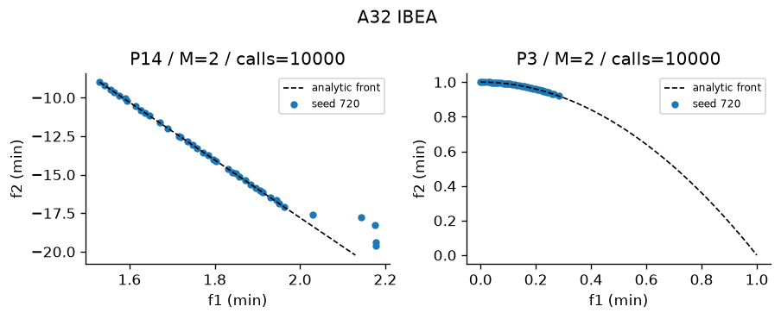
Figure A32 Recorded output on designated problems. Plotted seed and actual calls appear in the panel. The full ten-trial metrics are in the table.
Interpretation—empirical performance IBEA recorded HV 0.81944 ± 0.012245 on P14, IGD 0.026183 ± 0.0076532 (Figure A32). In the comparable P3 study with the same 10,000-evaluation cap, IBEA recorded HV 0.19276 ± 0.017015; the nearest peer by mean HV was Benson reference improvement at 0.21 ± 9.8457e-12, with runtime 0.4763 ± 0.072962 s versus 11.449 ± 1.0226 s for IBEA. A separate P3 record gives HV 0.19276 ± 0.017015 after 10,000 ± 0 evaluations in 11.449 ± 1.0226 s, so the evidence is not limited to one problem.
Interpretation—measured limitations The nonzero P14 IGD of 0.026183 ± 0.0076532 measures remaining sampled-front error. Thus the run does not support exact convergence or global optimality. Across 10 P14 trials, HV SD was 0.012245 and runtime SD was 0.66806 s, which quantifies seed sensitivity at this budget.
Four advantages 1. No separate sharing operator; 2. Indicator gives selection pressure; 3. Works on nonconvex fronts; 4. Kappa controls discrimination
Four disadvantages 1. Exponentials can saturate; 2. Kappa changes selection; 3. Recalculated deletion is costly; 4. Fitness depends strongly on scales
The measurements provide context for the claimed benefit "No separate sharing operator" and the risk "Exponentials can saturate". They do not isolate either mechanism; controlled ablation would be required for causal attribution.
Best use and avoid Small bi-objective indicator experiments. Avoid: Large populations with limited CPU.

33 SMS-EMOA
Core mechanism Steady-state smallest HV deletion
Implementation and parameters Module src\algorithms\sms_emoa.py; implementation status works; defining mechanism test test_33_mechanism passes. SMS-EMOA: one offspring, nondominated sorting, delete least HV contribution in worst front. Exact 2-D exclusive contributions. Reference is component maximum + .1 in normalized coordinates. Shared defaults: population=40, budget=10,000, optimizer seed=720. Constraints: Deb feasibility comparison unless the stated method uses scalar penalty.
Problem | Trials | HV | IGD | Spacing | Runtime s | Evaluations / cap
P14 | 10 | 0.8587 ± 1.992e-05 | 0.007577 ± 1.879e-05 | 0.002664 ± 0.0008371 | 30.59 ± 1.685 | 10,000 / 10,000
P3 | 10 | 0.5318 ± 0.000109 | 0.009565 ± 0.0001278 | 0.004121 ± 0.001085 | 31.09 ± 1.972 | 10,000 / 10,000
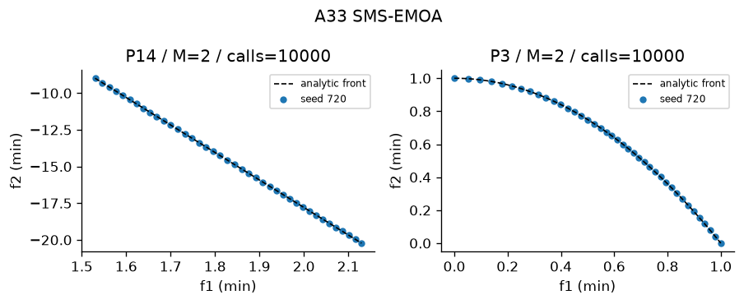
Figure A33 Recorded output on designated problems. Plotted seed and actual calls appear in the panel. The full ten-trial metrics are in the table.
Interpretation—empirical performance SMS-EMOA recorded HV 0.85873 ± 1.9917e-05 on P14, IGD 0.0075773 ± 1.8795e-05 (Figure A33). In the comparable P3 study with the same 10,000-evaluation cap, SMS-EMOA recorded HV 0.53181 ± 0.00010904; the nearest peer by mean HV was MOEA/D at 0.53179 ± 8.6192e-05, with runtime 14.525 ± 0.79452 s versus 31.093 ± 1.9721 s for SMS-EMOA. A separate P3 record gives HV 0.53181 ± 0.00010904 after 10,000 ± 0 evaluations in 31.093 ± 1.9721 s, so the evidence is not limited to one problem.
Interpretation—measured limitations The nonzero P14 IGD of 0.0075773 ± 1.8795e-05 measures remaining sampled-front error. Thus the run does not support exact convergence or global optimality. Across 10 P14 trials, HV SD was 1.9917e-05 and runtime SD was 1.6848 s, which quantifies seed sensitivity at this budget.
Four advantages 1. Direct quality indicator survival; 2. One-offspring updates are simple; 3. Exact two-objective contribution; 4. Protects coverage within the chosen reference
Four disadvantages 1. HV reference controls preferences; 2. One-at-a-time sorting costs many calls; 3. Implemented only for two objectives; 4. HV can prioritize extremes unevenly
The measurements provide context for the claimed benefit "Direct quality indicator survival" and the risk "HV reference controls preferences". They do not isolate either mechanism; controlled ablation would be required for causal attribution.
Best use and avoid Small bi-objective design. Avoid: Many objectives without an HV approximation.

34 HypE
Core mechanism Equal-share Monte Carlo HV fitness and repeated deletion
Implementation and parameters Module src\algorithms\hype.py; implementation status works; defining mechanism test test_34_mechanism passes. HypE: Monte Carlo hypervolume fitness with equal shared credits, iterative contribution deletion. Samples=256 selection, final HV uses 8192. Credits account for shared dominated samples; noisy selection is a limitation. Shared defaults: population=40, budget=10,000, optimizer seed=720. Constraints: Deb feasibility comparison unless the stated method uses scalar penalty.
Problem | Trials | HV | IGD | Spacing | Runtime s | Evaluations / cap
P10 M3 | 10 | 0.6611 ± 0.008224 | 0.1171 ± 0.004252 | 0.08613 ± 0.0114 | 20.2 ± 0.6013 | 10,000 / 10,000
P10 M5 | 10 | 0.8057 ± 0.1473 | 0.4362 ± 0.07524 | 0.3592 ± 0.07552 | 23.72 ± 1.897 | 10,000 / 10,000
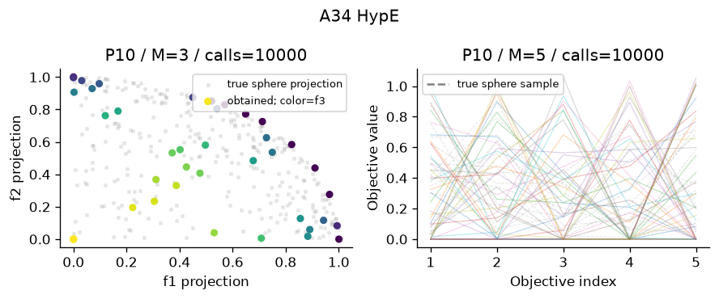
Figure A34 Recorded output on designated problems. Plotted seed and actual calls appear in the panel. The full ten-trial metrics are in the table.
Interpretation—empirical performance HypE recorded HV 0.6611 ± 0.0082237 on P10, IGD 0.11712 ± 0.0042523 (Figure A34). In the comparable P10 study with the same 10,000-evaluation cap, HypE recorded HV 0.80567 ± 0.14729; the nearest peer by mean HV was NSGA-III at 0.98827 ± 0.018811, with runtime 5.3109 ± 0.27819 s versus 23.724 ± 1.8975 s for HypE. A separate P10 record gives HV 0.80567 ± 0.14729 after 10,000 ± 0 evaluations in 23.724 ± 1.8975 s, so the evidence is not limited to one problem.
Interpretation—measured limitations The nonzero P10 IGD of 0.11712 ± 0.0042523 measures remaining sampled-front error. Thus the run does not support exact convergence or global optimality. Across 10 P10 trials, HV SD was 0.0082237 and runtime SD was 0.60127 s, which quantifies seed sensitivity at this budget.
Four advantages 1. HV sharing supports many objectives; 2. Shared samples account for overlapping domination; 3. Re-estimation updates remaining credit; 4. Final evaluation samples are identical across methods
Four disadvantages 1. Sampling noise changes survivors; 2. Selection sample count is small; 3. Repeated deletion costs CPU; 4. HV still needs a reference box
The measurements provide context for the claimed benefit "HV sharing supports many objectives" and the risk "Sampling noise changes survivors". They do not isolate either mechanism; controlled ablation would be required for causal attribution.
Best use and avoid Many-objective indicator study. Avoid: High-precision survival contribution estimates.

35 R-NSGA-II
Core mechanism Reference preference and epsilon clearing
Implementation and parameters Module src\algorithms\r_nsga2.py; implementation status works; defining mechanism test test_35_mechanism passes. R-NSGA-II: nondominated fronts, normalized distance to aspiration, epsilon clearing to spread preferred survivors. epsilon=.05; default balanced normalized aspiration [.5,.5], P14 uses natural [1.8,-12]; callers may override. Shared defaults: population=40, budget=10,000, optimizer seed from project config. Constraints: Deb feasibility comparison unless the stated method uses scalar penalty.
Problem | Trials | HV | IGD | Spacing | Runtime s | Evaluations / cap
P14 | 10 | 0.8556 ± 0.0008798 | 0.01004 ± 0.0008287 | 0.01306 ± 0.001946 | 4.152 ± 0.3333 | 10,000 / 10,000
P5 | 10 | 1.176 ± 0.01429 | 0.01448 ± 0.003167 | 0.01749 ± 0.003844 | 4.811 ± 0.3217 | 10,000 / 10,000
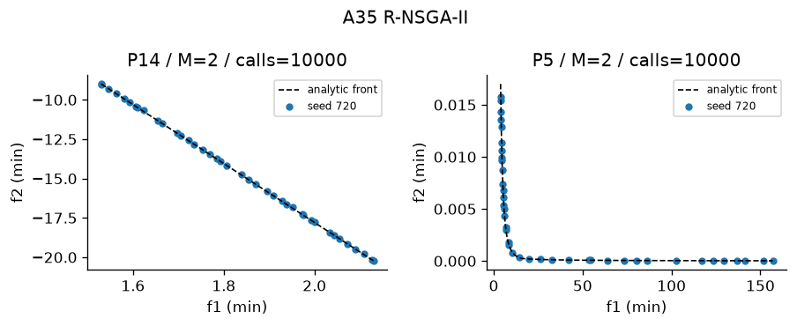
Figure A35 Recorded output on designated problems. Plotted seed and actual calls appear in the panel. The full ten-trial metrics are in the table.
Interpretation—empirical performance R-NSGA-II recorded HV 0.85563 ± 0.00087984 on P14, IGD 0.010043 ± 0.00082871 (Figure A35). In the comparable P5 study with the same 10,000-evaluation cap, R-NSGA-II recorded HV 1.1758 ± 0.014288; the nearest peer by mean HV was VEGA at 1.1805 ± 0.0012363, with runtime 3.3831 ± 0.12189 s versus 4.8108 ± 0.3217 s for R-NSGA-II. A separate P5 record gives HV 1.1758 ± 0.014288 after 10,000 ± 0 evaluations in 4.8108 ± 0.3217 s, so the evidence is not limited to one problem.
Interpretation—measured limitations The nonzero P14 IGD of 0.010043 ± 0.00082871 measures remaining sampled-front error. Thus the run does not support exact convergence or global optimality. Across 10 P14 trials, HV SD was 0.00087984 and runtime SD was 0.33328 s, which quantifies seed sensitivity at this budget.
Four advantages 1. Focuses on desired region; 2. Clearing promotes local diversity; 3. Retains nondominated hierarchy; 4. Preference is physically interpretable on P14
Four disadvantages 1. Wrong aspiration biases search; 2. Epsilon controls local spacing; 3. Full-front quality can drop; 4. Default balanced aspiration is arbitrary
The measurements provide context for the claimed benefit "Focuses on desired region" and the risk "Wrong aspiration biases search". They do not isolate either mechanism; controlled ablation would be required for causal attribution.
Best use and avoid Decision-maker laptop region. Avoid: Unknown or frequently changing preferences.

36 MGDA
Core mechanism Minimum-norm gradient combination
Implementation and parameters Module src\algorithms\mgda.py; implementation status works; defining mechanism test test_36_mechanism passes. MGDA: minimum-norm convex combination of task gradients. For two tasks solve lambda analytically; clamp to [0,1]. Learning rate=.05. Toy losses have gradients 2*(x-a),2*(x-b). No convergence theorem assumed for arbitrary nonconvex neural networks.
Problem | Trials | HV | IGD | Spacing | Runtime s | Evaluations / cap
P13 | 1 | 0.2839 ± 0 | 0.6279 ± 0 | 0 ± 0 | 2.352 ± 0 | 10,000 / 10,000
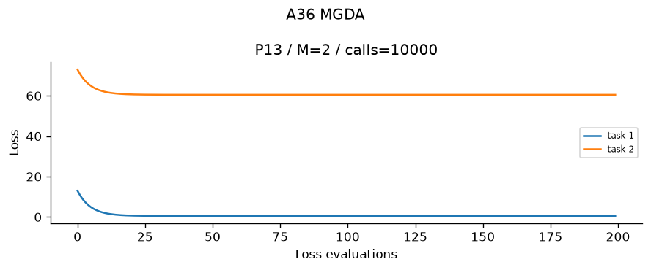
Figure A36 Recorded output on designated problems. Plotted seed and actual calls appear in the panel. The full ten-trial metrics are in the table.
Interpretation—empirical performance MGDA recorded HV 0.28389 ± 0 on P13, IGD 0.62794 ± 0 (Figure A36). The run used 10,000 ± 0 evaluations and took 2.3516 ± 0 s; no same-problem comparison row is used to manufacture a benchmark claim. The saved result supports finite-run quality and cost only, not an asymptotic efficiency claim.
Interpretation—measured limitations The nonzero P13 IGD of 0.62794 ± 0 measures remaining sampled-front error. Thus the run does not support exact convergence or global optimality. The P13 output retained 1 ± 0 point(s). That finite resolution limits what the plot can demonstrate; front size or zero Spacing alone is not evidence of complete coverage.
Four advantages 1. Common descent when norm is nonzero; 2. Analytical two-task weights; 3. No objective-scale utility required; 4. Can converge to Pareto stationarity
Four disadvantages 1. Requires gradients; 2. Stationarity is not full-front coverage; 3. May stop while each task has gradient; 4. Nonconvex network optima are local
The measurements provide context for the claimed benefit "Common descent when norm is nonzero" and the risk "Requires gradients". They do not isolate either mechanism; controlled ablation would be required for causal attribution.
Best use and avoid Differentiable conflicting tasks. Avoid: Discrete designs or a full Pareto-front sweep.

37 GradNorm
Core mechanism Gradient-norm adaptive task weights
Implementation and parameters Module src\algorithms\gradnorm.py; implementation status works; defining mechanism test test_37_mechanism passes. GradNorm: adaptive weights minimizing sum |G_i-target_i|. G_i=w_i*||gradient_i||; target=mean(G)*relative_training_rate**alpha, stop-gradient target, weights renormalized to sum(tasks). Alpha=1.5, weight_lr=.01, model_lr=.05. Hand-derived weight gradient uses sign. This supports toy objectives and the handwritten shared network.
Problem | Trials | HV | IGD | Spacing | Runtime s | Evaluations / cap
P13 | 1 | 0.6052 ± 0 | 0.433 ± 0 | 0 ± 0 | 2.667 ± 0 | 10,000 / 10,000
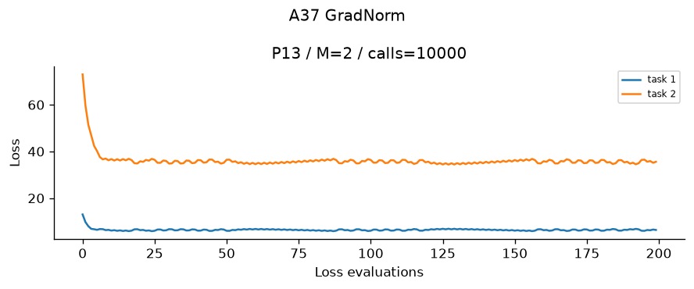
Figure A37 Recorded output on designated problems. Plotted seed and actual calls appear in the panel. The full ten-trial metrics are in the table.
Interpretation—empirical performance GradNorm recorded HV 0.60519 ± 0 on P13, IGD 0.43296 ± 0 (Figure A37). The run used 10,000 ± 0 evaluations and took 2.6674 ± 0 s; no same-problem comparison row is used to manufacture a benchmark claim. The saved result supports finite-run quality and cost only, not an asymptotic efficiency claim.
Interpretation—measured limitations The nonzero P13 IGD of 0.43296 ± 0 measures remaining sampled-front error. Thus the run does not support exact convergence or global optimality. The P13 output retained 1 ± 0 point(s). That finite resolution limits what the plot can demonstrate; front size or zero Spacing alone is not evidence of complete coverage.
Four advantages 1. Balances task gradient magnitudes; 2. Training rates influence targets; 3. Hand-derived update is inspectable; 4. Task-scale stress can be evaluated
Four disadvantages 1. Requires gradients and initial losses; 2. Alpha weight_lr matter; 3. Does not guarantee common descent; 4. Toy final point is not an entire front
The measurements provide context for the claimed benefit "Balances task gradient magnitudes" and the risk "Requires gradients and initial losses". They do not isolate either mechanism; controlled ablation would be required for causal attribution.
Best use and avoid Shared network with unequal loss gradients. Avoid: A guaranteed Pareto descent method.

6 Task C assigned study cards and hand traces
The assignment formulas produce Algorithms 35, 10 and 22. These cards describe the implemented teaching variants and do not claim original-paper equivalence.

35. R-NSGA-II — Reference Point-Based NSGA-II
Historical context: the supplied Bonus 5E lecture identifies Kalyanmoy Deb, J. Sundar, N. Udaya Bhaskara Rao and Shamik Chaudhuri (2006). The method reduces the cost of approximating an entire front when a decision-maker already knows the preferred region.
Motivation and core principle: retain NSGA-II nondominated fronts, normalize objectives, measure Euclidean distance to a decision-maker reference point, and apply ε-clearing so selected points near that reference do not collapse. If clearing leaves too few survivors, backfill in increasing reference-distance order.
Flow: parents + offspring → Deb nondominated fronts → normalized objectives and reference → splitting-front reference distances → ε-clearing → preferred survivors.
Algorithm steps and equations:
1. Combine parents and offspring and form fronts F₁, F₂, … using Deb feasibility rules before objective dominance.
2. Normalize zᵢⱼ = (fᵢⱼ − idealⱼ)/(nadirⱼ − idealⱼ) using fixed assignment scales. Normalize a natural-unit reference with the same transformation.
3. Compute dᵢ = √[Σⱼ(zᵢⱼ − rⱼ)²].
4. Copy complete fronts. In the splitting front, inspect increasing dᵢ and accept i only when min ‖zᵢ − zq‖ ≥ ε for every already accepted q.
5. Backfill deferred points by increasing reference distance until the population contains N survivors.
Parameters: a wrong reference focuses on an irrelevant region. An ε that is too small permits crowding, whereas an ε that is too large clears useful neighbours and forces distance-only backfilling. Small N gives little preferred-region resolution; large N costs more evaluations per generation. Crossover and mutation control exploration.
Convergence, diversity and constraints: nondominated rank supplies convergence pressure before preference distance is used in the splitting front. ε-clearing supplies local diversity. Deb rules handle constraints. Nondominated sorting can follow nonconvex fronts, but an unreachable reference and finite population can bias coverage. A k-dimensional reference extends beyond three objectives, although distance concentration and ε tuning become harder.
Complexity: pairwise sorting is O(MN²) for M objectives and 2N candidates; reference-distance calculation and straightforward clearing add O(MN²).
Strengths and limitations: the method directs evaluations toward a decision-relevant region while retaining Pareto ranking and explicit local spacing. Its answer depends on reference scaling and ε, and it does not provide uniform whole-front coverage when preference pressure is strong.
Sensitivity evidence: ε = 0.02, 0.05 and 0.10 on P14, using ten independent optimizer seeds 720–729. Raw rows and aggregate statistics are stored under results/roll72/; the sensitivity figure is figures/roll72/C_A35.png.

10. VEGA — Vector Evaluated Genetic Algorithm
Historical context: David Schaffer proposed VEGA in 1985. It was an early extension of genetic algorithms to several objectives, but objective-wise selection can duplicate extreme solutions and discard balanced compromises.
Motivation and core principle: evaluate all objectives, allocate equal mating-pool slots to the objectives, select each slot using only its assigned objective, merge and shuffle the subpools, then apply crossover and mutation before nonelitist replacement.
Flow: population → objective-specific tournaments and subpools → merged mating pool → crossover and mutation → nonelitist offspring replacement.
Algorithm steps and equations:
1. Evaluate every objective fⱼ(xᵢ) and the constraint violation of each candidate.
2. For mating slot i, use objective j = i mod M; compare two candidates using Deb feasibility and then scalar value fⱼ when both are feasible.
3. Pool the N winners. Each objective receives equal slots when N is divisible by M.
4. Apply the shared real, binary or permutation-safe crossover and mutation operators appropriate to the problem encoding.
5. Replace the parents with the offspring. The passive output archive records discoveries but does not make the breeding algorithm elitist.
Parameters: small N increases genetic drift; large N improves instantaneous coverage but yields fewer generations under a fixed evaluation budget. Excessive mutation destroys selected structure, whereas insufficient mutation cannot restore lost regions. Strong crossover can mix extremes but provides no diversity guarantee.
Convergence, diversity and constraints: single-objective subpools create pressure toward extremes but provide no explicit Pareto-convergence or diversity pressure. Deb feasibility is used inside every tournament. Search operators can visit nonconvex fronts, but selection does not protect their interior. With many objectives, each subpool becomes small and balanced tradeoffs receive weaker selection pressure.
Complexity: objective-wise selection requires O(N) comparisons after O(MN) evaluation; variation is O(ND) for D variables. The implementation’s passive archive adds pairwise bookkeeping but does not affect parent selection.
Strengths and limitations: VEGA is simple, inexpensive and exposes objective conflicts clearly. Its nonelitist objective partitioning can overrepresent extremes, lose compromises and make final-population coverage unstable.
Sensitivity evidence: population N = 20, 40 and 80 on P3, using ten independent optimizer seeds 720–729. At a fixed budget, this tests simultaneous coverage against the number of generations; see figures/roll72/C_A10.png.

22. MOPSO — Multi-Objective Particle Swarm Optimization
Historical context: Carlos A. Coello Coello and Maximino Salazar Lechuga proposed MOPSO in 2002. It extends scalar PSO by replacing one global best with guides selected from an external nondominated archive.
Motivation and core principle: maintain particle positions, velocities and personal bests; retain a nondominated external archive; prefer leaders from sparse archive regions; move toward the personal best and leader; mutate selected particles; and update a personal best only when the new point dominates it.
Flow: particles + archive → crowding-weighted leader → bounded velocity and position update → evaluation and mutation → dominance-based personal best → nondominated archive.
Algorithm steps and equations:
1. Initialize x, set velocity v = 0 and pbest = x, then build the nondominated archive.
2. Select an archive leader using crowding-derived probabilities.
3. Update each coordinate using v′ = wv + c₁r₁(pbest − x) + c₂r₂(leader − x).
4. In the main implementation, clip velocity to 20% of the decision-variable range, set x′ = repair(x + v′), and apply occasional mutation. The separate hand-worked teaching trace explicitly uses fixed limits [−10,10].
5. Replace pbest only if x′ dominates it under Deb rules; merge x′ into the nondominated archive and continue until the evaluation budget is exhausted.
Parameters: small inertia w can stagnate quickly, whereas large w may overshoot and weaken exploitation. Small c₁ underuses personal experience; large c₁ can cause oscillation around pbest. Small c₂ underuses the front; large c₂ can crowd particles around leaders. A small archive loses coverage; an oversized archive increases maintenance cost.
Convergence, diversity and constraints: personal bests and archive leaders supply convergence pressure, while crowding-weighted leader choice and mutation support diversity. Deb dominance handles constraints. The swarm can sample nonconvex fronts because it does not scalarize them, but its continuous velocity model is a poor natural fit for permutations. In many objectives, dominance and crowding lose discrimination and archive maintenance becomes costly.
Complexity: velocity updates cost O(ND); straightforward archive dominance and crowding cost O(MA²) for archive size A, plus problem-evaluation cost.
Strengths and limitations: MOPSO combines memory, an external Pareto archive and gradient-free movement. Performance is sensitive to inertia, acceleration coefficients, velocity limits, mutation and archive-leader pressure.
Sensitivity evidence: inertia w = 0.2, 0.4 and 0.8 on P4, using ten independent optimizer seeds 720–729; see figures/roll72/C_A22.png. IGD is unavailable because P4 has no exact reference front, and the plot states that limitation.

Flow diagram A35 R-NSGA-II
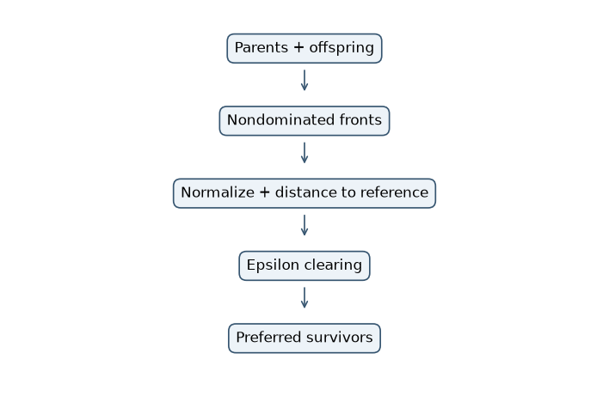
Figure C35 Current implementation control flow

Flow diagram A10 VEGA
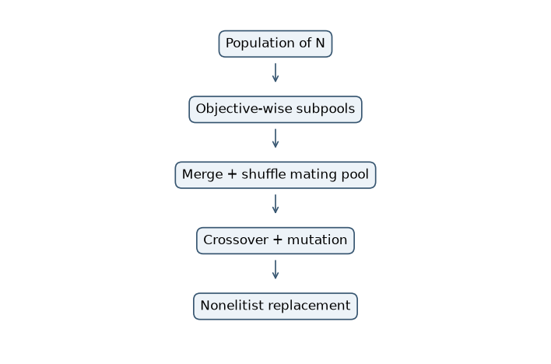
Figure C10 Current implementation control flow

Flow diagram A22 MOPSO
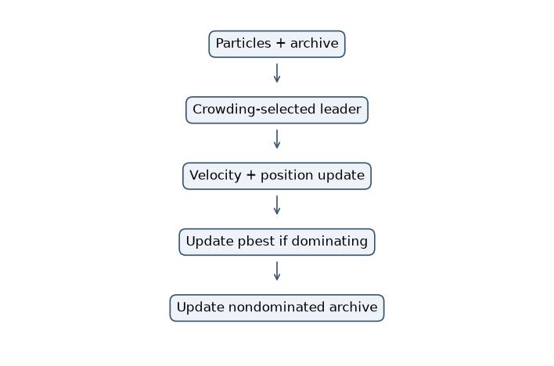
Figure C22 Current implementation control flow

R-NSGA-II two selection iterations
Tiny instance: P1 with f1=(x-3)^2 and f2=(x-7)^2, population N=4, natural-unit reference r=(4,4), fixed ideal=(0,0), nadir=(16,16), and therefore normalized reference (0.25,0.25). Epsilon=0.20. Parents and four fixed offspring form eight candidates. Deb nondominated sorting is applied first; within the splitting front, candidates are ordered by Euclidean reference distance and epsilon clearing controls local spacing.

R-NSGA-II iteration 1
Parents=[3.0, 4.0, 6.0, 7.0]; offspring=[3.5, 4.5, 5.5, 6.5]; combined indices 0-3 are parents and 4-7 are offspring.
i | Origin | x | f1 | f2 | z1 | z2 | d(i,r)
0 | P | 3 | 0 | 16 | 0 | 1 | 0.7906
1 | P | 4 | 1 | 9 | 0.0625 | 0.5625 | 0.3644
2 | P | 6 | 9 | 1 | 0.5625 | 0.0625 | 0.3644
3 | P | 7 | 16 | 0 | 1 | 0 | 0.7906
4 | O | 3.5 | 0.25 | 12.25 | 0.01562 | 0.7656 | 0.5664
5 | O | 4.5 | 2.25 | 6.25 | 0.1406 | 0.3906 | 0.1782
6 | O | 5.5 | 6.25 | 2.25 | 0.3906 | 0.1406 | 0.1782
7 | O | 6.5 | 12.25 | 0.25 | 0.7656 | 0.01562 | 0.5664
Nondominated fronts (zero-based candidate indices): [[0, 1, 2, 3, 4, 5, 6, 7]]. All eight candidates trade off f1 against f2, so the first front is also the splitting front.
Order | i | x | Reference d | Min separation | Decision
1 | 6 | 5.5 | 0.1782 | inf | accept
2 | 5 | 4.5 | 0.1782 | 0.3536 | accept
3 | 1 | 4 | 0.3644 | 0.1888 | defer
4 | 2 | 6 | 0.3644 | 0.1888 | defer
5 | 4 | 3.5 | 0.5664 | 0.3953 | accept
6 | 7 | 6.5 | 0.5664 | 0.3953 | accept
Selected survivor indices=[6, 5, 4, 7], hence x=[5.5, 4.5, 3.5, 6.5]. These four survivors become the parents shown in the next iteration.

R-NSGA-II iteration 2
Parents=[5.5, 4.5, 3.5, 6.5]; offspring=[4.25, 4.75, 5.25, 5.75]; combined indices 0-3 are parents and 4-7 are offspring.
i | Origin | x | f1 | f2 | z1 | z2 | d(i,r)
0 | P | 5.5 | 6.25 | 2.25 | 0.3906 | 0.1406 | 0.1782
1 | P | 4.5 | 2.25 | 6.25 | 0.1406 | 0.3906 | 0.1782
2 | P | 3.5 | 0.25 | 12.25 | 0.01562 | 0.7656 | 0.5664
3 | P | 6.5 | 12.25 | 0.25 | 0.7656 | 0.01562 | 0.5664
4 | O | 4.25 | 1.562 | 7.562 | 0.09766 | 0.4727 | 0.2698
5 | O | 4.75 | 3.062 | 5.062 | 0.1914 | 0.3164 | 0.08856
6 | O | 5.25 | 5.062 | 3.062 | 0.3164 | 0.1914 | 0.08856
7 | O | 5.75 | 7.562 | 1.562 | 0.4727 | 0.09766 | 0.2698
Nondominated fronts (zero-based candidate indices): [[0, 1, 2, 3, 4, 5, 6, 7]]. All eight candidates trade off f1 against f2, so the first front is also the splitting front.
Order | i | x | Reference d | Min separation | Decision
1 | 6 | 5.25 | 0.08856 | inf | accept
2 | 5 | 4.75 | 0.08856 | 0.1768 | defer
3 | 0 | 5.5 | 0.1782 | 0.08993 | defer
4 | 1 | 4.5 | 0.1782 | 0.2657 | accept
5 | 4 | 4.25 | 0.2698 | 0.0926 | defer
6 | 7 | 5.75 | 0.2698 | 0.1822 | defer
7 | 3 | 6.5 | 0.5664 | 0.4824 | accept
8 | 2 | 3.5 | 0.5664 | 0.3953 | accept
Selected survivor indices=[6, 1, 3, 2], hence x=[5.25, 4.5, 6.5, 3.5]. These four survivors become the parents shown in the next iteration.
Code verification: tests/test_traces.py recomputes normalized objectives and Euclidean reference distances, then asserts the recorded clearing decisions and survivor indices for both iterations.

VEGA two objective-wise selections
Tiny instance: the same P1 minimization problem and population N=4. Mating slots 1 and 3 use f1; slots 2 and 4 use f2. Each slot has an explicit two-candidate tournament. Variation uses the implementation's SBX equation c1=0.5[(1+beta)p1+(1-beta)p2], c2=0.5[(1-beta)p1+(1+beta)p2], with u=0.25, beta=(2u)^(1/16), positive sign, and zero mutation increment.

VEGA iteration 1
i |  | x |  | f1 min |  | f2 min
0 |  | 3 |  | 0 |  | 16
1 |  | 4 |  | 1 |  | 9
2 |  | 6 |  | 9 |  | 1
3 |  | 7 |  | 16 |  | 0
Slot | Objective |  | Tournament indices |  | Candidate x values |  | Winner | Winner x
1 | f1 |  | [0, 2] |  | ['3', '6'] |  | 0 | 3
2 | f2 |  | [1, 3] |  | ['4', '7'] |  | 3 | 7
3 | f1 |  | [1, 2] |  | ['4', '6'] |  | 1 | 4
4 | f2 |  | [0, 2] |  | ['3', '6'] |  | 2 | 6
Objective-wise mating pool=[3, 7, 4, 6]; parent pairs=[[3, 7], [4, 6]]. With u=0.25, beta=0.9576; mutation increments=[0, 0, 0, 0].
Child | x after SBX | f1 | f2 | Next population
1 | 3.085 | 0.00719 | 15.33 | 3.085
2 | 6.915 | 15.33 | 0.00719 | 6.915
3 | 4.042 | 1.087 | 8.747 | 4.042
4 | 5.958 | 8.747 | 1.087 | 5.958
The offspring replace the parents without elitist parent-plus-child survival. This explicit update produces the population used at the start of the next iteration.

VEGA iteration 2
i |  | x |  | f1 min |  | f2 min
0 |  | 3.085 |  | 0.00719 |  | 15.33
1 |  | 6.915 |  | 15.33 |  | 0.00719
2 |  | 4.042 |  | 1.087 |  | 8.747
3 |  | 5.958 |  | 8.747 |  | 1.087
Slot | Objective |  | Tournament indices |  | Candidate x values |  | Winner | Winner x
1 | f1 |  | [0, 2] |  | ['3.085', '4.042'] |  | 0 | 3.085
2 | f2 |  | [1, 3] |  | ['6.915', '5.958'] |  | 1 | 6.915
3 | f1 |  | [2, 3] |  | ['4.042', '5.958'] |  | 2 | 4.042
4 | f2 |  | [2, 3] |  | ['4.042', '5.958'] |  | 3 | 5.958
Objective-wise mating pool=[3.085, 6.915, 4.042, 5.958]; parent pairs=[[3.085, 6.915], [4.042, 5.958]]. With u=0.25, beta=0.9576; mutation increments=[0, 0, 0, 0].
Child | x after SBX | f1 | f2 | Next population
1 | 3.166 | 0.02755 | 14.7 | 3.166
2 | 6.834 | 14.7 | 0.02755 | 6.834
3 | 4.083 | 1.173 | 8.509 | 4.083
4 | 5.917 | 8.509 | 1.173 | 5.917
The offspring replace the parents without elitist parent-plus-child survival. This explicit update produces the population used at the start of the next iteration.
Code verification: tests/test_traces.py checks the objective-wise winner indices and independently recomputes every parent and offspring objective used in both population updates.

MOPSO two velocity iterations
Tiny instance: this is an independent scalar MOPSO teaching problem, not assignment P2. It uses x in [1,20], teaching velocity limits [-10,10], and objectives f1=100/x and f2=x^2, both minimized. These fixed teaching limits deliberately differ from the main implementation default, which caps each velocity component at 20% of its decision-variable range. The wider toy domain makes x=12 and x=15 valid. The update is v-new=w v+c1 r1(pbest-x)+c2 r2(leader-x), followed by clipping and x-new=x+v-new. Here w=0.7, c1=c2=1.5, and every r1=r2=0.5. Leaders are explicit archive members. A personal best changes only if the new position dominates it.

MOPSO iteration 1
Archive before update=[5.0, 10.0, 15.0, 12.0]; selected leaders=[15.0, 15.0, 5.0, 5.0]; coefficients w=0.7, c1=1.5, c2=1.5, r1=r2=0.5.
i | x |  | v | pbest |  | leader | wv | cognitive |  | social | v-new | x-new
0 | 5 |  | 0 | 5 |  | 15 | 0 | 0 |  | 7.5 | 7.5 | 12.5
1 | 10 |  | 0 | 10 |  | 15 | 0 | 0 |  | 3.75 | 3.75 | 13.75
2 | 15 |  | 0 | 15 |  | 5 | 0 | 0 |  | -7.5 | -7.5 | 7.5
3 | 12 |  | 0 | 12 |  | 5 | 0 | 0 |  | -5.25 | -5.25 | 6.75
i |  | Old objectives |  |  | New objectives |  |  |  | pbest decision |  |  |  | pbest after
0 |  | ['20', '25'] |  |  | ['8', '156.2'] |  |  |  | retain: incomparable |  |  |  | 5
1 |  | ['10', '100'] |  |  | ['7.273', '189.1'] |  |  |  | retain: incomparable |  |  |  | 10
2 |  | ['6.667', '225'] |  |  | ['13.33', '56.25'] |  |  |  | retain: incomparable |  |  |  | 15
3 |  | ['8.333', '144'] |  |  | ['14.81', '45.56'] |  |  |  | retain: incomparable |  |  |  | 12
Every move improves one objective and worsens the other, so each trial is incomparable with its pbest and the pbest values remain [5.0, 10.0, 15.0, 12.0]. The nondominated archive becomes [5.0, 10.0, 15.0, 12.0, 12.5, 13.75, 7.5, 6.75] (size 8).

MOPSO iteration 2
Archive before update=[5.0, 10.0, 15.0, 12.0, 12.5, 13.75, 7.5, 6.75]; selected leaders=[15.0, 15.0, 5.0, 5.0]; coefficients w=0.7, c1=1.5, c2=1.5, r1=r2=0.5.
i | x |  | v | pbest |  | leader | wv | cognitive |  | social | v-new | x-new
0 | 12.5 |  | 7.5 | 5 |  | 15 | 5.25 | -5.625 |  | 1.875 | 1.5 | 14
1 | 13.75 |  | 3.75 | 10 |  | 15 | 2.625 | -2.812 |  | 0.9375 | 0.75 | 14.5
2 | 7.5 |  | -7.5 | 15 |  | 5 | -5.25 | 5.625 |  | -1.875 | -1.5 | 6
3 | 6.75 |  | -5.25 | 12 |  | 5 | -3.675 | 3.938 |  | -1.312 | -1.05 | 5.7
i |  | Old objectives |  |  | New objectives |  |  |  | pbest decision |  |  |  | pbest after
0 |  | ['8', '156.2'] |  |  | ['7.143', '196'] |  |  |  | retain: incomparable |  |  |  | 5
1 |  | ['7.273', '189.1'] |  |  | ['6.897', '210.2'] |  |  |  | retain: incomparable |  |  |  | 10
2 |  | ['13.33', '56.25'] |  |  | ['16.67', '36'] |  |  |  | retain: incomparable |  |  |  | 15
3 |  | ['14.81', '45.56'] |  |  | ['17.54', '32.49'] |  |  |  | retain: incomparable |  |  |  | 12
Every move improves one objective and worsens the other, so each trial is incomparable with its pbest and the pbest values remain [5.0, 10.0, 15.0, 12.0]. The nondominated archive becomes [5.0, 10.0, 15.0, 12.0, 12.5, 13.75, 7.5, 6.75, 14.0, 14.5, 6.0, 5.7] (size 12).
Code verification: tests/test_traces.py checks each inertia, cognitive and social term; verifies x-new=x+v-new; recomputes objectives; validates pbest decisions; and confirms that each updated archive is pairwise nondominated.

Ten trial sensitivity studies

R-NSGA-II
Setting | Trials | HV | IGD | Spacing | Evaluations
Clearing ε = 0.02 | 10 | 0.8559 ± 0.0008413 | 0.00982 ± 0.000661 | 0.01451 ± 0.002032 | 10,000
Clearing ε = 0.05 | 10 | 0.8556 ± 0.0008798 | 0.01004 ± 0.0008287 | 0.01306 ± 0.001946 | 10,000
Clearing ε = 0.1 | 10 | 0.8553 ± 0.001791 | 0.01025 ± 0.001353 | 0.01444 ± 0.002119 | 10,000
Epsilon controls the minimum normalized separation near the reference: increasing it strengthens local clearing but can force distance-based backfill. Largest mean HV occurred at Clearing ε = 0.02 (0.8559 ± 0.0008413); smallest at Clearing ε = 0.1 (0.8553 ± 0.001791). These three settings and ten trials are a finite sensitivity comparison, not a claim of a globally optimal parameter. Overlapping sample SD requires caution.
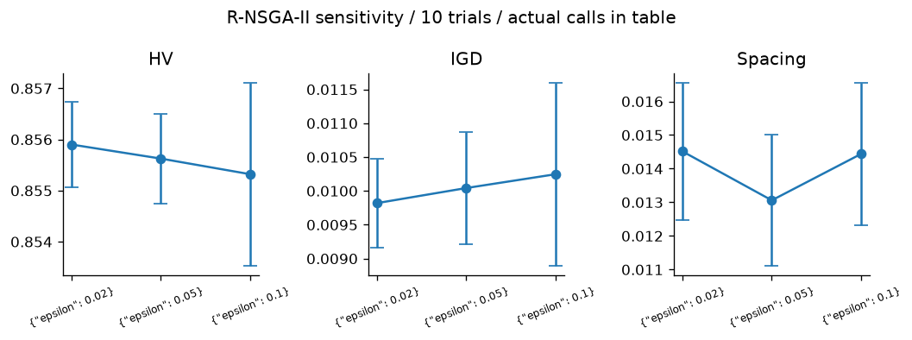
Figure S35 Sensitivity metrics with sample SD across ten seeds

VEGA
Setting | Trials | HV | IGD | Spacing | Evaluations
Population N = 20 | 10 | 0.1689 ± 0.05214 | 0.3754 ± 0.07938 | 0.0485 ± 0.02062 | 10,000
Population N = 40 | 10 | 0.173 ± 0.04583 | 0.3587 ± 0.07168 | 0.0475 ± 0.02233 | 10,000
Population N = 80 | 10 | 0.1681 ± 0.03236 | 0.3766 ± 0.05733 | 0.05438 ± 0.04213 | 10,000
Population size trades simultaneous coverage against the number of generations available under the same 10,000-evaluation budget. Largest mean HV occurred at Population N = 40 (0.173 ± 0.04583); smallest at Population N = 80 (0.1681 ± 0.03236). These three settings and ten trials are a finite sensitivity comparison, not a claim of a globally optimal parameter. Overlapping sample SD requires caution.
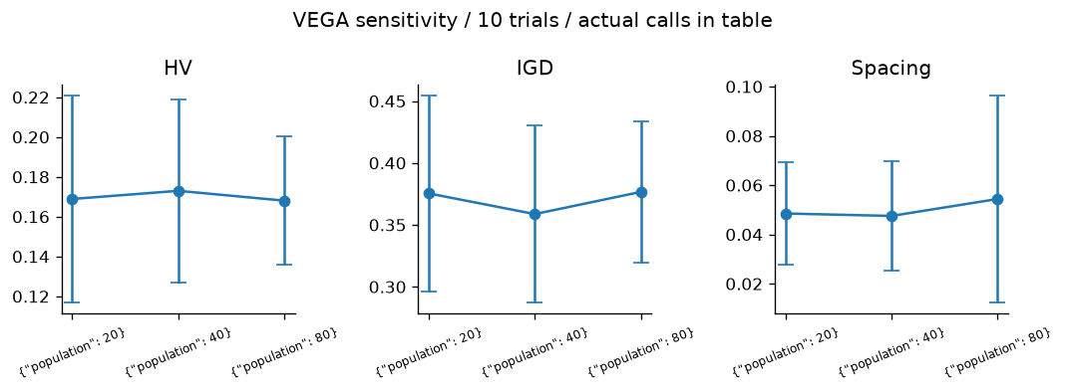
Figure S10 Sensitivity metrics with sample SD across ten seeds

MOPSO
Setting | Trials | HV | IGD | Spacing | Evaluations
Inertia w = 0.2 | 10 | 0.9156 ± 0.01095 | N/A | 0.01346 ± 0.006732 | 10,000
Inertia w = 0.4 | 10 | 0.9259 ± 0.00455 | N/A | 0.01343 ± 0.003755 | 10,000
Inertia w = 0.8 | 10 | 0.9337 ± 0.0006802 | N/A | 0.01272 ± 0.003053 | 10,000
Inertia controls retained momentum: low values emphasize current leaders, while high values explore more aggressively and may overshoot. Largest mean HV occurred at Inertia w = 0.8 (0.9337 ± 0.0006802); smallest at Inertia w = 0.2 (0.9156 ± 0.01095). P4 has no exact reference front, so IGD is intentionally unavailable and HV/Spacing carry the interpretation. These three settings and ten trials are a finite sensitivity comparison, not a claim of a globally optimal parameter. Overlapping sample SD requires caution.
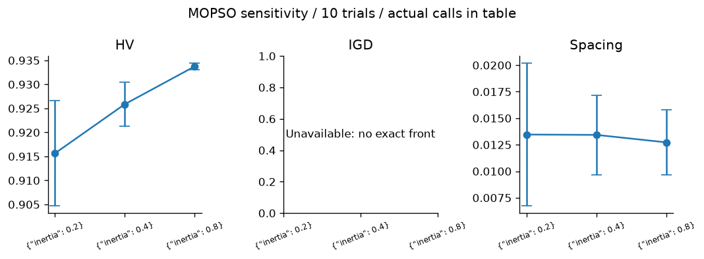
Figure S22 Sensitivity metrics with sample SD across ten seeds

7 Task D head to head comparisons
The continuous comparison includes 25 applicable two-objective optimizer mechanisms. Ranking methods are evaluated separately; ant construction requires tours, gradient methods require differentiability, and many-objective-specific methods are compared on P10. Algorithms 5 to 7 retain their designated utility goals and priorities rather than receiving invented P3/P5 goals. Algorithms 1 to 4 use at least 21 sweep settings, with metric p variants combined.

P3 comparison
Rank | Algorithm | HV | IGD | Spacing | Runtime s
1 | SMS-EMOA | 0.5318 ± 0.000109 | 0.009565 ± 0.0001278 | 0.004121 ± 0.001085 | 31 ± 2.096
2 | MOEA/D | 0.5318 ± 8.619e-05 | 0.009567 ± 0.0001113 | 0.003944 ± 0.0007786 | 14.52 ± 0.7945
3 | MO-TLBO | 0.5318 ± 7.088e-05 | 0.009509 ± 9.075e-05 | 0.003671 ± 0.001287 | 11.37 ± 1.419
4 | R-NSGA-II | 0.5296 ± 0.0007374 | 0.01162 ± 0.0005695 | 0.01701 ± 0.003134 | 4.502 ± 0.1809
5 | SPEA2 | 0.5292 ± 0.0006002 | 0.01178 ± 0.0006505 | 0.01704 ± 0.002577 | 5.418 ± 0.1784
6 | MOMA | 0.5291 ± 0.001011 | 0.01142 ± 0.0006054 | 0.0158 ± 0.002371 | 5.549 ± 0.374
7 | NSGA-II | 0.5286 ± 0.001001 | 0.01208 ± 0.001244 | 0.01765 ± 0.001747 | 3.562 ± 0.2768
8 | Constrained NSGA-II | 0.5286 ± 0.001001 | 0.01208 ± 0.001244 | 0.01765 ± 0.001747 | 3.353 ± 0.08979
9 | NSGA | 0.5252 ± 0.001173 | 0.01229 ± 0.0005384 | 0.01471 ± 0.001894 | 3.53 ± 0.2706
10 | MOGA | 0.5238 ± 0.001085 | 0.0127 ± 0.0004731 | 0.01277 ± 0.002314 | 3.737 ± 0.4774
11 | Weight Metric | 0.5215 ± 0.003503 | 0.02038 ± 0.006272 | 0.03764 ± 0.006386 | 2.514 ± 0.1739
12 | Epsilon-Constraint | 0.5201 ± 0.001464 | 0.0277 ± 0.003558 | 0.04664 ± 0.009819 | 0.5874 ± 0.03399
13 | MOSA | 0.5135 ± 0.006066 | 0.0204 ± 0.003815 | 0.03388 ± 0.01308 | 1.495 ± 0.1688
14 | PESA-II | 0.511 ± 0.007104 | 0.02193 ± 0.003303 | 0.0234 ± 0.007883 | 5.214 ± 0.1837
15 | MOABC | 0.5085 ± 0.008993 | 0.02247 ± 0.00449 | 0.02386 ± 0.004992 | 9.622 ± 0.7525
16 | NPGA | 0.4572 ± 0.07144 | 0.05291 ± 0.06393 | 0.0329 ± 0.01947 | 6.44 ± 0.3875
17 | MOPSO | 0.4191 ± 0.03166 | 0.08923 ± 0.02883 | 0.01467 ± 0.004929 | 1.864 ± 0.127
18 | MOBA | 0.3968 ± 0.1443 | 0.1289 ± 0.1631 | 0.04146 ± 0.05039 | 4.471 ± 0.2249
19 | MOGWO | 0.277 ± 0.2156 | 0.371 ± 0.3083 | 0.006815 ± 0.008808 | 3.479 ± 1.438
20 | MOEA/D-DE | 0.2124 ± 0.2742 | 1.042 ± 0.9331 | 0.001026 ± 0.001503 | 11.8 ± 2.105
21 | Weighted Sum | 0.21 ± 1.426e-11 | 0.3538 ± 2.065e-11 | 0.8971 ± 0.3252 | 0.4034 ± 0.4445
22 | Benson reference improvement | 0.21 ± 9.846e-12 | 0.3538 ± 1.133e-11 | 0.9732 ± 0.08257 | 0.4763 ± 0.07296
23 | IBEA | 0.1928 ± 0.01702 | 0.3581 ± 0.02807 | 0.00594 ± 0.002949 | 11.41 ± 0.9504
24 | VEGA | 0.173 ± 0.04583 | 0.3587 ± 0.07168 | 0.0475 ± 0.02233 | 3.036 ± 0.2107
25 | MODE | 0.11 ± 3.023e-10 | 0.6098 ± 1.147e-10 | 0 ± 0 | 1.785 ± 0.1596
Ranked by mean HV: SMS-EMOA leads at 0.5318 ± 0.000109, compared with MODE at 0.11 ± 3.023e-10. HV and IGD judge different aspects; this ranking is specific to the fixed scales and reference. All rows have ten trials. Classical actual calls differ despite the common 10,000 cap; see raw_experiments.csv.
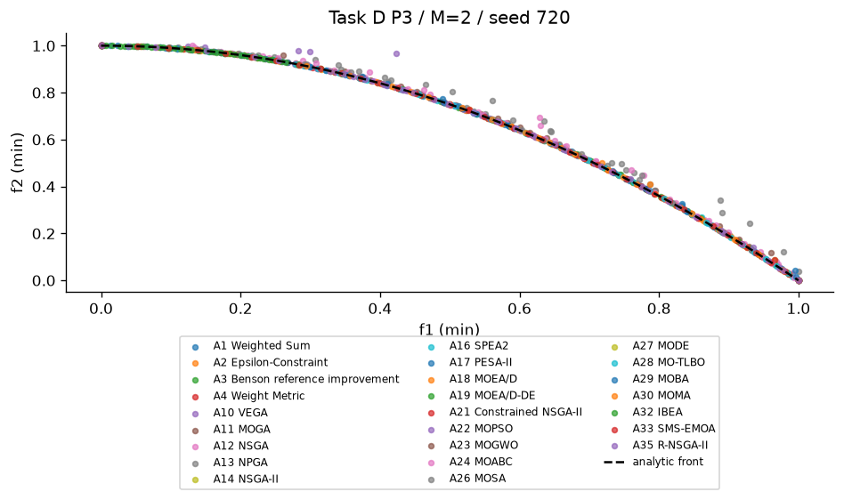
Figure DP3 Combined seed 720 results. The plot shows the recorded nondominated objective vectors for the stated problem and seed.

P5 comparison
Rank | Algorithm | HV | IGD | Spacing | Runtime s
1 | MOEA/D | 1.182 ± 7.646e-06 | 0.02074 ± 0.009097 | 0.02306 ± 0.002372 | 15.25 ± 0.9376
2 | SMS-EMOA | 1.182 ± 6.696e-06 | 0.01369 ± 0.004566 | 0.02108 ± 0.001477 | 30.43 ± 1.032
3 | MO-TLBO | 1.182 ± 1.659e-05 | 0.01234 ± 0.0004422 | 0.02285 ± 0.0009418 | 11.35 ± 0.7589
4 | MOEA/D-DE | 1.182 ± 3.231e-05 | 0.0491 ± 0.03155 | 0.02913 ± 0.02089 | 12.84 ± 0.5254
5 | MOMA | 1.182 ± 5.827e-05 | 0.01291 ± 0.001555 | 0.01836 ± 0.001705 | 6.319 ± 0.8465
6 | MOBA | 1.182 ± 3.443e-05 | 0.01329 ± 0.002086 | 0.01959 ± 0.001685 | 4.263 ± 0.3058
7 | NSGA-II | 1.182 ± 3.963e-05 | 0.01406 ± 0.001287 | 0.02067 ± 0.003274 | 3.56 ± 0.2764
8 | Constrained NSGA-II | 1.182 ± 3.963e-05 | 0.01406 ± 0.001287 | 0.02067 ± 0.003274 | 3.286 ± 0.3015
9 | SPEA2 | 1.182 ± 0.0001209 | 0.01608 ± 0.002603 | 0.01923 ± 0.001586 | 8.208 ± 0.3645
10 | NSGA | 1.182 ± 6.707e-05 | 0.01358 ± 0.001486 | 0.01959 ± 0.002904 | 3.617 ± 0.1725
11 | MOGA | 1.182 ± 0.0001344 | 0.01403 ± 0.00126 | 0.02033 ± 0.002006 | 3.602 ± 0.2128
12 | MOGWO | 1.182 ± 0.0001194 | 0.01341 ± 0.001289 | 0.02077 ± 0.001969 | 4.135 ± 0.4022
13 | Weight Metric | 1.182 ± 1.515e-06 | 0.133 ± 5.874e-06 | 0.09466 ± 0.001492 | 3.415 ± 0.2956
14 | MOPSO | 1.182 ± 0.0006447 | 0.01421 ± 0.002302 | 0.02041 ± 0.002691 | 2.027 ± 0.3936
15 | MOSA | 1.181 ± 0.0003664 | 0.01318 ± 0.0007081 | 0.01876 ± 0.001253 | 1.553 ± 0.1031
16 | MOABC | 1.181 ± 0.0004952 | 0.01087 ± 0.0008006 | 0.01898 ± 0.001757 | 12.08 ± 0.5502
17 | NPGA | 1.181 ± 0.0008078 | 0.01335 ± 0.00159 | 0.01876 ± 0.001853 | 6.839 ± 0.5114
18 | PESA-II | 1.181 ± 0.0005926 | 0.01697 ± 0.002015 | 0.01689 ± 0.002372 | 6.404 ± 0.3942
19 | Benson reference improvement | 1.181 ± 1.037e-07 | 0.2131 ± 1.002e-06 | 0.2052 ± 0.003441 | 2.257 ± 0.4278
20 | Weighted Sum | 1.181 ± 1.037e-07 | 0.2131 ± 1.003e-06 | 0.2057 ± 0.002616 | 0.6166 ± 0.08605
21 | MODE | 1.181 ± 0.002083 | 0.01381 ± 0.003286 | 0.01812 ± 0.003533 | 2.17 ± 0.224
22 | VEGA | 1.18 ± 0.001236 | 0.01266 ± 0.001117 | 0.01672 ± 0.002154 | 3.383 ± 0.1219
23 | R-NSGA-II | 1.176 ± 0.01429 | 0.01448 ± 0.003167 | 0.01749 ± 0.003844 | 4.784 ± 0.3045
24 | IBEA | 1.162 ± 0.01134 | 0.02208 ± 0.01418 | 0.01695 ± 0.01816 | 11.85 ± 0.8034
25 | Epsilon-Constraint | 1.134 ± 1.97e-08 | 0.2455 ± 1.942e-07 | 0.545 ± 0.04585 | 2.939 ± 0.1895
Ranked by mean HV: MOEA/D leads at 1.182 ± 7.646e-06, compared with Epsilon-Constraint at 1.134 ± 1.97e-08. HV and IGD judge different aspects; this ranking is specific to the fixed scales and reference. All rows have ten trials. Classical actual calls differ despite the common 10,000 cap; see raw_experiments.csv.
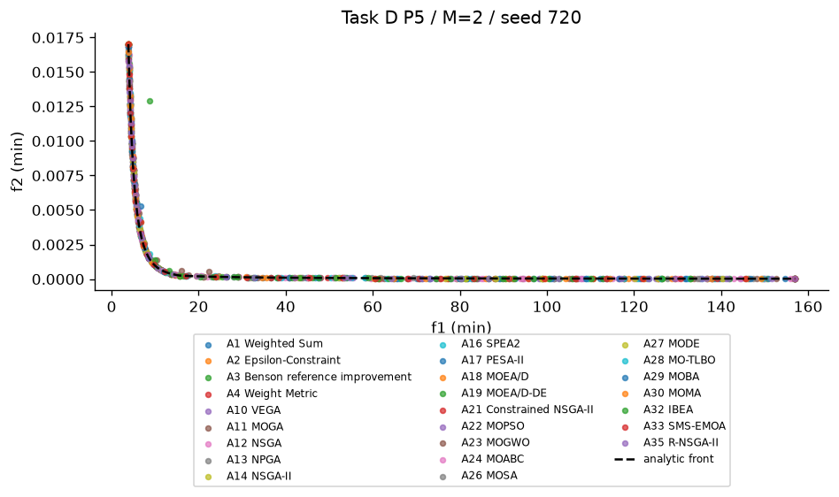
Figure DP5 Combined seed 720 results. The plot shows the recorded nondominated objective vectors for the stated problem and seed.

P10 comparison
Rank | Algorithm | HV | IGD | Spacing | Runtime s
1 | RVEA | 1.012 ± 0.03024 | 0.3111 ± 0.008554 | 0.2684 ± 0.02503 | 4.987 ± 0.3237
2 | MOEA/D | 0.9954 ± 0.03858 | 0.3212 ± 0.02067 | 0.2613 ± 0.0299 | 19.64 ± 0.8166
3 | NSGA-III | 0.9883 ± 0.01881 | 0.3083 ± 0.006507 | 0.2831 ± 0.02087 | 5.311 ± 0.2782
4 | HypE | 0.8057 ± 0.1473 | 0.4362 ± 0.07524 | 0.3592 ± 0.07552 | 23.95 ± 1.894
5 | NSGA-II | 0.2132 ± 0.1465 | 0.5167 ± 0.1017 | 0.3857 ± 0.04576 | 4.186 ± 0.2219
Ranked by mean HV: RVEA leads at 1.012 ± 0.03024, compared with NSGA-II at 0.2132 ± 0.1465. HV and IGD judge different aspects; this ranking is specific to the fixed scales and reference. All rows have ten trials. All candidate budgets are 10,000.
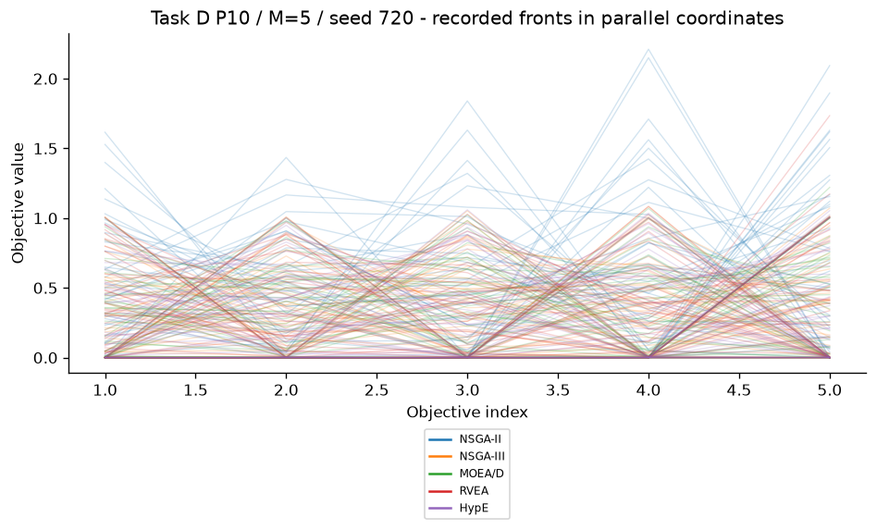
Figure DP10 Combined seed 720 results. The overlaid parallel-coordinate lines show every recorded five-objective front vector; this projection is descriptive rather than a dominance ordering.
M=3 random population nondominated fraction mean=0.318. Increasing nondomination reduces rank discrimination, while vector association adds a directional criterion.
M=5 random population nondominated fraction mean=0.588. Increasing nondomination reduces rank discrimination, while vector association adds a directional criterion.

P8 comparison
Rank | Algorithm | HV | IGD | Spacing | Runtime s
1 | MOACO | 0.9239 ± 0 | N/A | 0.003111 ± 0.0008203 | 17.96 ± 1.854
2 | NSGA-II | 0.9235 ± 0.001167 | N/A | 0.003856 ± 0.001973 | 5.874 ± 0.2541
3 | MOEA/D-ACO | 0.9235 ± 0.0007362 | N/A | 0.003604 ± 0.001162 | 26.15 ± 0.9772
4 | MOMA | 0.9235 ± 0.001163 | N/A | 0.003772 ± 0.003191 | 7.618 ± 0.5105
Ranked by mean HV: MOACO leads at 0.9239 ± 0, compared with MOMA at 0.9235 ± 0.001163. HV and IGD judge different aspects; this ranking is specific to the fixed scales and reference. All rows have ten trials. All candidate budgets are 10,000.
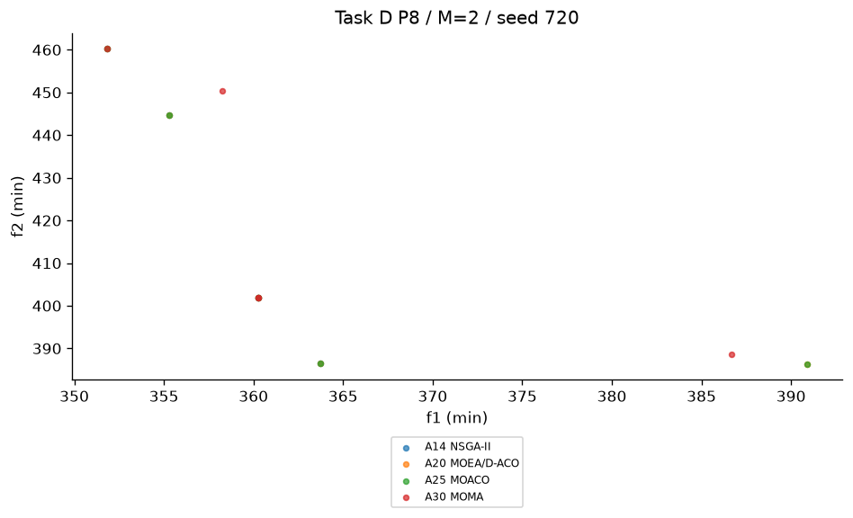
Figure DP8 Combined seed 720 results. The plot shows the recorded nondominated objective vectors for the stated problem and seed.
Nearest neighbour | Distance | Time | Tour
distance | 362 | 521.3 | [0, 7, 1, 13, 5, 10, 14, 2, 12, 9, 3, 6, 8, 4, 11]
time | 577.5 | 581.1 | [0, 1, 13, 5, 10, 11, 8, 4, 7, 9, 12, 14, 3, 6, 2]
Distance/time baselines use different edge metrics and retain valid 15-city permutations. A good optimized archive can improve one objective while worsening the other, so neither baseline should be assumed to dominate the entire tradeoff set.

P3 population and generation budget investigation
Population | Budget | Full generations | HV | IGD | Spacing
20 | 1000 | 49 | 0.442 ± 0.09599 | 0.08172 ± 0.09008 | 0.03294 ± 0.01028
20 | 5000 | 249 | 0.5127 ± 0.001579 | 0.02481 ± 0.001714 | 0.03422 ± 0.004984
20 | 10,000 | 499 | 0.5128 ± 0.002392 | 0.02502 ± 0.002066 | 0.03765 ± 0.009442
40 | 1000 | 24 | 0.3977 ± 0.1308 | 0.1217 ± 0.1353 | 0.03983 ± 0.02274
40 | 5000 | 124 | 0.5285 ± 0.0009619 | 0.01188 ± 0.0007234 | 0.01688 ± 0.002303
40 | 10,000 | 249 | 0.5286 ± 0.001001 | 0.01208 ± 0.001244 | 0.01765 ± 0.001747
80 | 1000 | 11 | 0.0888 ± 0.0843 | 0.4429 ± 0.1897 | 0.1157 ± 0.1474
80 | 5000 | 61 | 0.5358 ± 0.0002164 | 0.005863 ± 0.0001773 | 0.008493 ± 0.0009284
80 | 10,000 | 124 | 0.5362 ± 0.0002538 | 0.005832 ± 0.0001696 | 0.008031 ± 0.000386
This additional NSGA-II study uses ten seeds for each of nine population and budget settings. At fixed budget, larger populations receive fewer generations; improving population coverage can compete with convergence. More evaluations generally allow more refinement, but the measured IGD values determine the conclusion for each setting rather than an assumed universal trend. Ninety raw fronts and objective metrics are stored under results/roll72/csv/population/.

Ranking existing alternatives and preferred scalar solutions
Input | Method | Weights | v | Top three
P12 | topsis | [0.3, 0.3, 0.2, 0.2] | 0.5 | [3, 1, 5]
P12 | topsis | [0.4, 0.2, 0.2, 0.2] | 0.5 | [1, 2, 3]
P12 | vikor | [0.3, 0.3, 0.2, 0.2] | 0.25 | [1, 2, 5]
P12 | vikor | [0.4, 0.2, 0.2, 0.2] | 0.25 | [2, 1, 4]
P12 | vikor | [0.3, 0.3, 0.2, 0.2] | 0.5 | [1, 2, 5]
P12 | vikor | [0.4, 0.2, 0.2, 0.2] | 0.5 | [2, 1, 3]
P12 | vikor | [0.3, 0.3, 0.2, 0.2] | 0.75 | [1, 3, 2]
P12 | vikor | [0.4, 0.2, 0.2, 0.2] | 0.75 | [1, 2, 3]
P4 NSGA-II front | topsis | [0.5, 0.5] | 0.5 | [18, 22, 2]
P4 NSGA-II front | vikor | [0.5, 0.5] | 0.5 | [2, 38, 35]
P4 NSGA-II front | topsis | [0.6, 0.4] | 0.5 | [32, 8, 3]
P4 NSGA-II front | vikor | [0.6, 0.4] | 0.5 | [8, 32, 3]
P12 supplier identifiers are 1-based. P4 front identifiers are 0-based rows in P4_nsga2_ranking_input.csv. Moving .1 weight to the first criterion and subtracting .1 from the second preserves the simplex. VIKOR v=.25,.5,.75 and its compromise-set flags remain in rankings.csv.
TOPSIS top-three order changes under the .1 weight shift: [3, 1, 5] -> [1, 2, 3]. This measured local response is not universal preference stability.
VIKOR top-three order changes under the .1 weight shift: [1, 2, 5] -> [2, 1, 3]. This measured local response is not universal preference stability.
Value Function returns declared portfolio profiles or the laptop aspiration. Goal Programming uses production targets 2400 profit and 600 units, and normalized versus unit deviations. Lexicographic profit-first then units selects the profit tie with maximum units, approximately (300,200). Exact decisions and solver success messages are retained in the classical job JSON records; a solver failure is not silently treated as proof of optimality.

P13 gradient methods and equal weights
Method | Scale | BCE initial | BCE final | MSE initial | MSE final
equal | 1 | 0.6962 | 0.5258 ± 0.01498 | 14.92 | 0.1622 ± 0.005318
mgda | 1 | 0.6962 | 0.2795 ± 0.01688 | 14.92 | 14.08 ± 0.3358
gradnorm | 1 | 0.6962 | 0.3349 ± 0.02439 | 14.92 | 0.1584 ± 0.01261
equal | 10 | 0.6962 | 0.6382 ± 0.02039 | 1487 | 83.82 ± 1.539
mgda | 10 | 0.6962 | 0.6747 ± 0.008354 | 1487 | 1486 ± 2.45
gradnorm | 10 | 0.6962 | 0.5927 ± 0.01521 | 1487 | 1108 ± 64.26
The network has a five-input shared tanh layer of width eight and separate classification and regression heads. Ten seeds vary initialization while synthetic observations remain fixed. Regression target scale 10 creates larger gradient norms. Equal weights and MGDA sum to one; GradNorm weights sum to two by definition. Their model learning rates are explicitly recorded, so weight normalization changes effective step size and must be considered when interpreting loss differences.
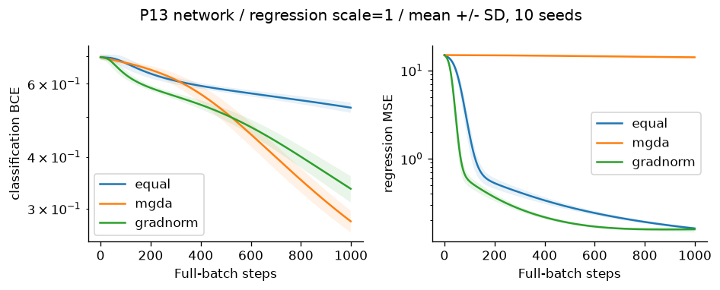
Figure N1 Network task losses with mean and SD from ten initializations
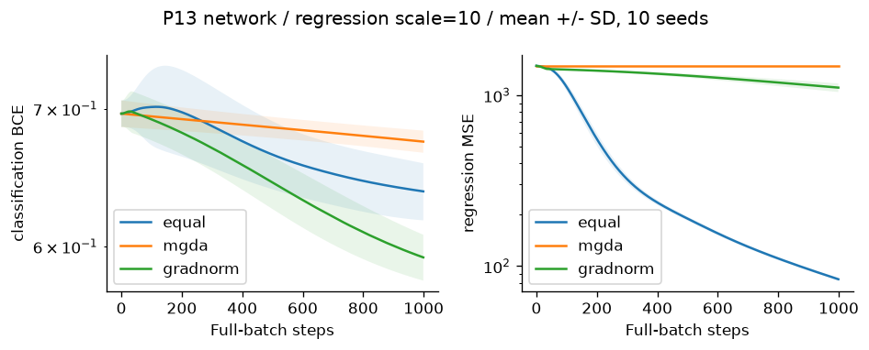
Figure N10 Network task losses with mean and SD from ten initializations
On the toy, fixed equal weights converge to (0,0), while MGDA generally stops at a different Pareto-stationary point and GradNorm changes the task weighting. Individual losses need not both approach zero: the two target points conflict. The saved 10,000-step histories and toy_equal.csv expose this trajectory rather than claiming full-front coverage from one initial point.

Toy task losses against equal weights
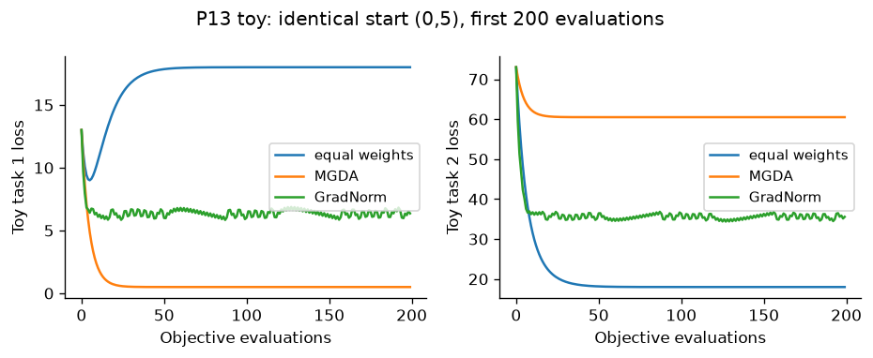
Figure T13 Hand-coded toy loss trajectories against fixed equal weights, with identical starting point and learning rate
The equal-weight toy baseline tends to x=(0,0), giving losses (18,18). MGDA tends to a different point on the Pareto segment, while GradNorm adapts its loss weights. A smaller task 1 loss can coexist with a larger task 2 loss at a Pareto-stationary tradeoff; neither method is expected to make both target distances zero.

8 Task E algorithm selection cases

P1
Suitable: Weighted Sum,Weight Metric. Poor choice: VEGA. Convex one-variable problem; scalarization offers interpretable weights and metric methods expose compromise geometry.
A1 M=2 base: HV=1.0258 ± 0, IGD=0.020135 ± 0; A4 M=2 base: HV=1.0347 ± 0, IGD=0.012339 ± 0
Recommendations combine measured finite-budget outcomes with encoding, constraints and preference reasoning; no universal winner is claimed.

P3
Suitable: SMS-EMOA,MO-TLBO. Poor choice: Weighted Sum. Nonconvex front; hypervolume survival and teacher-learner moves both cover interior tradeoffs in the recorded experiments, while linear scalarization cannot support them.
A28 M=2 D: HV=0.53179 ± 7.0884e-05, IGD=0.0095087 ± 9.0745e-05; A33 M=2 D: HV=0.53181 ± 0.00010904, IGD=0.0095649 ± 0.00012778; A28 M=2 base: HV=0.53179 ± 7.0884e-05, IGD=0.0095087 ± 9.0745e-05; A33 M=2 base: HV=0.53181 ± 0.00010904, IGD=0.0095649 ± 0.00012778
Recommendations combine measured finite-budget outcomes with encoding, constraints and preference reasoning; no universal winner is claimed.

P5
Suitable: Constrained NSGA-II,SPEA2. Poor choice: VEGA. Nonlinear feasibility makes Deb rules useful; archive strength and density support constrained tradeoffs.
A16 M=2 D: HV=1.1818 ± 0.00012094, IGD=0.016079 ± 0.0026026; A21 M=2 D: HV=1.1818 ± 3.9631e-05, IGD=0.014057 ± 0.0012871; A16 M=2 base: HV=1.1818 ± 0.00012094, IGD=0.016079 ± 0.0026026; A21 M=2 base: HV=1.1818 ± 3.9631e-05, IGD=0.014057 ± 0.0012871
Recommendations combine measured finite-budget outcomes with encoding, constraints and preference reasoning; no universal winner is claimed.

P8
Suitable: NSGA-II,MOEA/D-ACO. Poor choice: MGDA. Permutation-safe NSGA-II and ant decomposition have the leading recorded HV means and retain valid tours; gradient descent is undefined for city orders.
A14 M=2 D: HV=0.92354 ± 0.0011666, IGD=N/A; A20 M=2 D: HV=0.92348 ± 0.00073621, IGD=N/A; A20 M=2 base: HV=0.92348 ± 0.00073621, IGD=N/A
Recommendations combine measured finite-budget outcomes with encoding, constraints and preference reasoning; no universal winner is claimed.

P10
Suitable: RVEA,MOEA/D. Poor choice: VEGA. Five objectives weaken dominance; RVEA APD and MOEA/D scalar subproblems retain directional pressure and have the strongest recorded HV means at this budget.
A18 M=5 D: HV=0.99538 ± 0.038577, IGD=0.32121 ± 0.020673; A31 M=5 D: HV=1.0121 ± 0.030242, IGD=0.31113 ± 0.0085541; A18 M=5 base: HV=0.99538 ± 0.038577, IGD=0.32121 ± 0.020673; A31 M=3 base: HV=0.64035 ± 0.011426, IGD=0.10879 ± 0.0032335; A31 M=5 base: HV=1.0121 ± 0.030242, IGD=0.31113 ± 0.0085541
Recommendations combine measured finite-budget outcomes with encoding, constraints and preference reasoning; no universal winner is claimed.

P14
Suitable: R-NSGA-II,Value Function. Poor choice: VEGA. Known manager aspiration makes a preferred region useful; utility or reference clearing expresses it directly.
A5 M=2 base: HV=0.32905 ± 0, IGD=0.35302 ± 0; A35 M=2 base: HV=0.85563 ± 0.00087984, IGD=0.010043 ± 0.00082871
Recommendations combine measured finite-budget outcomes with encoding, constraints and preference reasoning; no universal winner is claimed.

9 Task F viva preparation

1 Why can Weighted Sum miss a dented front?
On P3 the true front is (t,1-t^2). A positive weighted scalar is concave in t, so its minimum occurs at an endpoint; an interior efficient point lacks a supporting linear level set. Changing the weight grid cannot fix this.

2 Why might VEGA drift to extremes?
Each mating-pool segment rewards only one objective. Extreme winners enter repeatedly, while compromise designs receive no Pareto or density protection. Check the final population as well as the passive recording archive before asserting collapse in a particular run.

3 What does elitism guarantee?
Best ranked survivors are selected from parents plus children, so beneficial parents need not disappear just because variation was poor. A finite population still truncates nondominated designs and gives no global-optimality guarantee. NSGA-II/III, SPEA2, PESA-II, decomposition and archive-guided methods retain different forms of memory.

4 Why does crowding weaken with many objectives?
Most candidates are nondominated; many receive boundary bonuses on one of many axes, while marginal nearest-neighbour gaps poorly represent high-dimensional coverage. NSGA-III reference occupancy and RVEA angles replace axis crowding. The measured random-population fractions are in dominance_pressure.csv.

5 Which methods require preferences and what if they are wrong?
Weighted Sum, metric methods and Benson need weights/reference; Value Function needs utility; Goal Programming needs targets; Lexicographic needs priorities; TOPSIS/VIKOR need criterion weights and VIKOR v; R-NSGA-II needs an aspiration. A wrong preference can select a feasible efficient design that is unsuitable for the decision-maker.

6 Explain Deb rules numerically
Lecture A=(3,6),CV=0 and D=(4,5),CV=0 beat B=(1,2),CV=2 and C=(.5,1),CV=5. A,D trade off. B beats C because 2<5. Thus front layers are [A,D],[B],[C], irrespective of the attractive infeasible objectives.

7 How can premature convergence be detected?
Track HV, IGD where exact-front samples exist, final-population spread, archive turnover and decision-variable variance across budget checkpoints and seeds. Flat HV alone may mean saturation, a poor reference box or a single-region stall; inspect more than one diagnostic.

8 Why are TOPSIS and VIKOR ranking methods rather than optimizers?
Their input is an existing alternatives matrix. They compute closeness or regret and reorder rows; they never choose new decision vectors or explore bounds.

Code Walkthrough Preparation

A10 VEGA
In src/algorithms/vega.py, change the population default from 40 to 20 while retaining the 10,000-evaluation cap. Predict twice as many approximate generations but half as many simultaneous candidates. Objective-wise tournaments remain unchanged; coverage can become less stable even if later generations improve convergence. The existing N=20,40,80 sensitivity rows test this tradeoff.

A22 MOPSO
In src/algorithms/mopso.py, change inertia from 0.4 to 0.8 in the velocity call. The retained w*v term doubles, so particles preserve momentum longer, explore farther and can overshoot leaders or hit clipping more often. Personal-best and archive dominance rules do not change. The stored w=0.2,0.4,0.8 P4 study provides the numerical comparison.

A35 R-NSGA-II
In src/algorithms/r_nsga2.py, increase epsilon in preference selection from 0.05 to 0.10. Candidates must then be farther apart in normalized objective space to survive clearing; more near-reference points are deferred and distance-ordered backfill becomes more likely. Nondominated fronts and reference distances themselves do not change. The stored epsilon=0.02,0.05,0.10 P14 study tests the effect.

10 Findings and limitations
The numerical comparison shows meaningful differences in convergence, coverage and computation across methods, but finite outputs do not establish global optima. Weighted Sum on P3 illustrates a structural unsupported-region limit. Many-objective methods preserve directional niches when ranks tie. Routing methods require valid edge/tour operations. Preference and gradient methods should be judged by their declared decision or learning task rather than by full-front HV alone.
Remaining work is explicit: P9 uses 200 evaluations per run rather than the suggested 10,000, and its smallest observed feature set is an exploratory result. The Task B table contains four argued advantages and disadvantages plus traceable measured metrics, but targeted ablations do not yet establish two experiment-supported benefits and drawbacks for every method. This report does not claim that stricter evidence requirement is fully satisfied. Student explanation and personal conclusions remain necessary for the viva.
Problem | Investigation | Measured value | Interpretation
P2 | VEGA real | 40 | distinct recorded Pareto points at 10,000 evaluations
P2 | VEGA integer | 10 | distinct recorded Pareto points at 10,000 evaluations
P5 | random infeasible fraction | 0.0255 | 10,000 independent uniform box designs; same formulas
P5 | ignore stress minimum mass | 1.791 | feasible-front minimum 4.03417; random-design ablation, not an optimizer run
P4 | raw equality feasible fraction | 0 | repair feasible fraction=1.000; penalty=z1+z2+100*violation
P9 | all-features 5NN baseline error | 0.04042 | smallest observed mask within +.01 error: 5; exploratory 200-evaluation runs, not global optimum
P14 | aspiration at 12h analytic front weight | 1.691 | at x1=13, battery=53.4Wh yields 1.6908kg; aspiration (1.8,12h) is dominated
P6 | second-constraint minimum left side | 18 | at (5,0), 9+9=18>7.7; inactive across full box
P7 | reference feasible allocation | 91.67 | 91.6667>90; exact (40,50) output unattainable
Additional limitations: fixed population 40 limits front resolution; sparse grids and reference lattices can bias irregular fronts; Monte Carlo selection noise is larger than final HV evaluation noise; runtimes measured in a process pool are environment specific; IGD depends on reference sample density; exact fronts for P4 P8 P9 remain unknown here. The shared output archive can mask nonelitist final-population losses, so saved final_f is essential for diagnosing collapse.

11 Reproducibility and repository instructions
Keep src tests results figures docs and data together. From the project root create a Python 3.10+ virtual environment, install requirements.txt, run python -m unittest discover -s tests -v, and execute python run_all.py experiments --workers 4. Jobs checkpoint per algorithm/problem/seed; an existing JSON row is reused unless --force is requested. Use python run_all.py report to rebuild figures and the Word document from saved arrays.
GitHub repository: https://github.com/sofiaabidi/OT_LAB07. The README gives individual algorithm commands and selective reruns. This editable DOCX is the requested report deliverable; no PDF or submission ZIP was generated.

12 References
1. Department of Artificial Intelligence & Data Science. Lab Assignment 7 - Multiobjective Optimization: 37 Algorithms, Trade-offs and Applications. Issued 5 October 2026. User-supplied assignment.txt; authoritative task specification. 2. Horn, J.; Nafpliotis, N.; Goldberg, D. E. (1994). A niched Pareto genetic algorithm for multiobjective optimization. Proceedings of the First IEEE Conference on Evolutionary Computation, 82-87. DOI: https://doi.org/10.1109/ICEC.1994.350037. Metadata and abstract verified using an author-uploaded primary paper copy: https://www.researchgate.net/publication/3575291_A_Niched_Pareto_Genetic_Algorithm_for_Multi-Objective_Optimization . The publisher DOI page was unavailable to the browser. 3. Serafini, P. (1994). Simulated annealing for multi objective optimization problems. In Tzeng, G. H.; Wen, U. P.; Yu, P. L. (eds.), Multiple Criteria Decision Making: Expand and Enrich the Domains of Thinking and Application. Springer, 283-292. Author paper: https://users.dimi.uniud.it/~paolo.serafini/MCDMsimann.pdf . Current author CV confirms 1994: https://users.dimi.uniud.it/~paolo.serafini/CV_Paolo_Serafini_eng.pdf . Older author bibliography says 1993: https://users.dimi.uniud.it/~paolo.serafini/ricerca.html ; discrepancy recorded, no unique first-inventor claim. 4. Zadeh, L. A. (1963). Optimality and non-scalar-valued performance criteria. IEEE Transactions on Automatic Control, 8(1), 59-60. DOI: https://doi.org/10.1109/TAC.1963.1105511 . Metadata located in scholarly records and the cited Marler-Arora review; original paper not retrieved. This is a foundational scalarization/efficiency reference, not verified invention of weighted sums. 5. Marler, R. T.; Arora, J. S. (2004). Survey of multi-objective optimization methods for engineering. Structural and Multidisciplinary Optimization, 26, 369-395. Author paper mirrored for teaching: https://paulino.princeton.edu/courses/cee307/2016/resources/papers/2004%20-%20Marler%2C%20Arora%20-%20Survey%20of%20multi-objective%20optimization%20methods%20for%20engineering.pdf . Used for historical context only; implementations are not copied. 6. Chen, Z.; Badrinarayanan, V.; Lee, C.-Y.; Rabinovich, A. (2018). GradNorm: Gradient Normalization for Adaptive Loss Balancing in Deep Multitask Networks. Proceedings of Machine Learning Research 80, 794-803. Publisher primary paper: https://proceedings.mlr.press/v80/chen18a.html . Verified metadata and adaptive gradient mechanism.
No external optimizer code or fabricated sources are used. Five supplied lecture decks define the teaching conventions; exact original-paper equivalence and global optimality are not claimed. Access checked 12 October 2026.
7. Supplied Chapter 5 course lecture sources, accessed 12 October 2026: Chapter5_MOO_Part1_Foundations_Classical_Methods.pdf (53 pages); Chapter5_Non-Elitist-MOEAs_VEGA-MOGA-NSGA-NPGA.pdf (42 pages); Elitist MOEAs.pdf (64 pages); Chapter5_Part4_Constrained_MOEAs_Multiobjective_Heuristics.pdf (98 pages); PPT-5E-Advanced-MOO.pdf (46 pages). Course author/date not identified in the provided file metadata; no author names are invented. Specific slide references are in lecture_alignment.md.

13 Appendix evidence files and lecture alignment
Evidence | Location
Raw fronts and decisions | results/roll72/csv/job_name.npz
Job metrics and scalar solver messages | results/roll72/csv/job_name.json
All raw experiment rows | results/roll72/csv/raw_experiments.csv
Mean and sample SD tables | results/roll72/tables/summary.csv
37 method comparison | results/roll72/tables/comparison.csv
Implementation log | results/roll72/implementation_log.csv
Deterministic full traces | results/roll72/csv/hand_traces.json
Feature frequencies | results/roll72/csv/feature_frequencies.csv
Network loss histories | results/roll72/csv/network_method_scale_seed.csv
Figure provenance | results/roll72/tables/figure_manifest.csv
Tests | results/roll72/test_output.txt
Requirement map | docs/requirements_checklist.md
Five supplied PDFs were parsed: Foundations/Classical (53 pages), Non-Elitist (42), Elitist (64), Part 4 (98), Bonus 5E (46). Their extracted text is retained in docs/lectures for reproducibility. The assignment takes precedence for problem constants and submission requirements. Lecture slides define teaching mechanisms; their numerical claims are independently checked.
1. Foundations slide 8 car table: A=(5,15), B=(8,22), C=(6,18), D=(10,25), E=(7,12), F=(9,20), cost minimized/mileage maximized. Correct front A,B,C,D. Exact unit test added. 2. Foundations slide 22 Deb table: A=(3,6),D=(4,5), both feasible; B=(1,2),CV=2; C=(.5,1),CV=5. Correct layers [A,D],[B],[C]. Exact unit test added. 3. Benson Foundations slide 35 is precisely weighted reference achievement with nonnegative deviations. The code matches this teaching definition; it is not the polyhedral outer-approximation algorithm. Its reference and direction weights are expressed in normalized coordinates; natural-unit targets are recovered using the fixed affine scales. This is a declared preference reparameterization. Its nonconvex-region ability requires restrictive reference bounds; sweeping only weights against an unrestricted reference still inherits a weighted-sum limitation. 4. Non-Elitist slide 6 sharing is quadratic, 1-(d/sigma)^2, not linear. MOGA, NSGA and NPGA corrected; associated runs regenerated. 5. NPGA slide 27 compares contestants directly, comparison set used only for niche count. The catalogue and original NPGA literature can suggest comparison-set dominance; we follow the explicit lecture teaching variant. Default comparison_size=2, excluding contestants. Exact two-round telecom example added with fixed lecture scales. Correct arithmetic yields NC=(.59,.78) and (.98,.39), rather than slide-rounded (.590,.778)/(.979,.389); winners remain A,D. 6. Part 4 slide 41 MOSA accepts any neighbour not dominated by the current state; only a dominated neighbour receives exp(-sum positive objective differences/T). Corrected from weighted-energy variant, results regenerated. Experiment version uses 40 parallel chains and normalized T0=.1; lecture example uses one raw-unit chain T0=100. Both are explicit; trace reproduces 100->90->81 and x=10->13->15. Part 4 slide 46 wrongly labels its line f2=5+.5*f1: eliminating x gives f2=20-.5*f1. Objective values are retained. 7. Bonus 5E slide 5 explicitly permits per-objective range normalization for NSGA-III; our normalization matches that teaching simplification. Reference simplex count is subsampled to N=40 if necessary while retaining axes, a documented resolution limit. 8. Bonus 5E slide 8 RVEA uses APD=d*(1+alpha*(t/tmax)*theta/gamma), with fixed alpha=2. Code corrected from the canonical alternative M*(t/tmax)^alpha. Per-generation range normalization and periodic vector adaptation retained; results regenerated. 9. Bonus 5E slide 17 HypE uses equal sample sharing among all dominators. Code corrected from canonical k-order exclusive-removal credits; all runs regenerated. Selection uses 256 samples vs final evaluation 8192; approximation noise is a limitation. 10. Bonus 5E slide 11 IBEA uses outgoing indicator sums and deletes the largest fitness; implemented exactly. This differs from conventional incoming-indicator sums with the smallest fitness deleted. Results regenerated and convention explicit. 11. Foundations slide 37 finite p metric places weights outside absolute deviations raised to p. Code corrected for p=2. The literal p->infinity limit of this finite-p expression loses positive weights; the catalogue explicitly names weighted Tchebycheff, so infinity uses max(w*abs(f-ideal)). This convention discrepancy is recorded instead of silently treating the formulas as identical. 12. Part 4 archive leadership uses crowding; MOGWO, MO-TLBO and MOBA aligned. MOABC onlookers favour crowding; MOMA local moves target sparse children and accept normalized combined objective improvement. Converted minimization means score=sum(old_normalized-new_normalized), with feasibility protected. All changed runs regenerated. 13. Part 4 TLBO's shrinking teaching factor is retained as TF=2-used/budget, as required by the assignment. NSGA uses efficient shared sorting rather than reproducing the historical cubic sorter; its dummy fitness keeps lower fronts below upper fronts after sharing. 14. Bonus 5E MGDA expression O(n*k) contradicts prose saying independent of n; storage/gradient work depends on n. MGDA's convex mixing subproblem depends on task count, but gradients do not. Report uses the correct dependence. 15. Bonus 5E SMS-EMOA total initial HV=9.10 is correct. After the inserted midpoints, L1's exclusive contribution is .15, not .30; ties occur with C1 and C2. The code recomputes contributions from the current population and does not reproduce stale numbers.
The 37 implementations remain educational variants. Exact original-paper equivalence is not claimed. All optimization is hand-coded except permitted scalar SLSQP solves. Lecture default numbers used in hand examples are not necessarily good experimental defaults after normalization.

Roll-72 Task C alignment
- VEGA follows the Part 2 objective-wise mating-pool mechanism. The code uses alternating objective-specific binary tournaments, which gives equal objective slot counts when the population is divisible by the objective count. This is closer to the slide's proportional-selection description than its simplified top-k hand example, but it is still a teaching variant. It is nonelitist; the passive result archive must not be described as VEGA survival. - MOPSO follows the Part 4 velocity equation with configurable w, c1 and c2, crowding-weighted archive guides and Deb dominance. Personal best is retained for incomparable trials, matching the slide's worked example; it changes only when the trial dominates it. - R-NSGA-II follows Bonus 5E's normalized reference distance and epsilon-clearing description inside NSGA-II fronts. The caller may provide a natural-unit or already-normalized reference. This is the supplied teaching mechanism, not a claim of exact reproduction of every detail in the 2006 paper.

Consolidated Task B comparison table
The required six fields are grouped by algorithm family. Advantages and disadvantages are mechanism-based arguments; the detailed algorithm pages separately connect two observed strengths and two observed limitations to stored numerical evidence wherever justified.

Classical
Algorithm | Main mechanism | Four advantages | Four disadvantages | Suitable | Avoid
1 Weighted Sum | Linear scalar solve and a sweep | 1. Simple scalar objective; 2. Direct preference weights; 3. Reusable constrained scalar solver; 4. Independent solves can be distributed | 1. Unsupported nonconvex points are unreachable; 2. Scaling changes weight meaning; 3. Uniform weights give nonuniform spacing; 4. Local scalar solves lack global guarantees | Convex smooth two-objective design with interpretable weights | Dented fronts and an unknown preference distribution
2 Epsilon-Constraint | One objective minimized and others bounded | 1. Can represent unsupported efficient points; 2. Epsilon has physical interpretation; 3. Scalar constraints remain explicit; 4. Primary objective stays recognizable | 1. Infeasible epsilon values waste solves; 2. Sweeps can duplicate points; 3. Constraint solver quality matters; 4. Many objectives require multidimensional epsilon grids | Nonconvex constrained design with hard limits | High-dimensional objective grids
3 Benson reference improvement | Weighted improvement below a reference | 1. Reference conveys aspiration; 2. Nonnegative improvement is interpretable; 3. Explicit upper objective bounds; 4. Scalar subproblems are easy to inspect | 1. This is the lecture achievement form, not outer approximation; 2. Unrestricted reference sweeps inherit weighted-sum barrier; 3. Reference coordinates require scaling; 4. Weights still encode preferences | Teaching reference improvement on P1/P7 | Claiming a general Benson convergence theorem
4 Weight Metric | Weighted distance to fixed ideal | 1. Infinity norm can reach unsupported tradeoffs; 2. Different p values express balance; 3. Ideal point makes distances interpretable; 4. Scalar solver is reusable | 1. Ideal estimation affects solution; 2. Max norm is nonsmooth; 3. p and weights require preferences; 4. Finite weight sweep misses narrow regions | Compromise solutions on nonconvex fronts | Unreliable ideal estimates or many weights
5 Value Function | Declared decision-maker utility | 1. Directly encodes a preferred outcome; 2. Can express nonlinear preferences; 3. Few scalar solves are economical; 4. Natural targets communicate decisions | 1. Utility must be elicited; 2. Squared target utility need not be monotone; 3. One preferred design is not a full front; 4. Misspecified preferences bias results | Laptop or portfolio profile decisions | Exploration without known preferences
6 Goal Programming | Explicit positive/negative goal deviations | 1. Shows unavoidable shortfall; 2. Can normalize incompatible units; 3. Soft goals remain interpretable; 4. Constraint and aspiration roles are separate | 1. Goal weights control tradeoffs; 2. Infeasible goals cannot be guaranteed; 3. Units can overwhelm deviations; 4. Satisfied goals may leave efficiency ties | Production targets with soft priorities | Searching an entire front without goals
7 Lexicographic | Sequential strict priorities with tolerances | 1. Priority order is transparent; 2. Breaks first-objective ties; 3. Uses scalar solvers; 4. Preserves prior objective values to declared tolerance | 1. Lower objectives may have little freedom; 2. Tolerance changes strictness; 3. Priority mistakes are expensive; 4. Sequential solves add cost | Profit first and units second | Balanced objectives with no hierarchy

Ranking
Algorithm | Main mechanism | Four advantages | Four disadvantages | Suitable | Avoid
8 TOPSIS | Closeness to weighted ideal and anti-ideal | 1. Fast finite-table ranking; 2. Uses all criteria; 3. Distances are explainable; 4. Works with benefit and cost columns | 1. Does not generate new designs; 2. Vector normalization affects rank; 3. Compensation can hide a bad criterion; 4. Alternatives can change the ideal | Supplier or existing-front ranking | Optimization without an alternatives table
9 VIKOR | Compromise via group regret and worst regret | 1. Worst criterion enters R; 2. v exposes group versus individual tradeoff; 3. Compromise conditions avoid forced winners; 4. Finite rankings are inexpensive | 1. Requires preference weights; 2. v can change rank; 3. Range normalization changes regrets; 4. Does not generate designs | Supplier compromise with severe weak criteria | A Pareto front generator

Early evolutionary
Algorithm | Main mechanism | Four advantages | Four disadvantages | Suitable | Avoid
10 VEGA | Objective-partitioned selection | 1. Very simple selection; 2. No preference weights needed; 3. Handles several objective contests; 4. Cheap scalar tournaments | 1. Extremes can dominate mating pool; 2. No parent elitism; 3. Middle tradeoffs may disappear; 4. Objective partition sizes affect pressure | Teaching objective competition | Reliable uniform front preservation
11 MOGA | Domination-count rank and fitness sharing | 1. No scalar utility required; 2. Sharing promotes sparse niches; 3. Dominance counts are easy to inspect; 4. Can search unsupported regions | 1. No elitism; 2. Sharing radius sensitive; 3. All nondominated members tie in rank; 4. Pairwise density costs quadratically | Small bi-objective populations | Many objectives with sparse dominance
12 NSGA | Front layers and within-front sharing | 1. Explicit Pareto hierarchy; 2. Sharing is local to fronts; 3. No objective weights required; 4. Variation supports arbitrary encodings | 1. No elitism; 2. Quadratic sorting and sharing; 3. Dummy fitness spacing is arbitrary; 4. Niche radius must be tuned | Teaching early Pareto GAs | Large fast convergence requirements
13 NPGA | Direct contestant dominance then separate comparison-set quadratic niche tie | 1. No fixed utility weights; 2. Niche tie-break preserves sparse points; 3. Comparison sample controls work; 4. Can visit nonconvex tradeoffs | 1. Nonelitist generations lose parents; 2. Small comparison set gives noisy niche counts; 3. Sigma changes density pressure; 4. Lecture tournament differs from original publication | Bi-objective diversity experiments | Many-objective fronts where most tournaments tie

Elitist
Algorithm | Main mechanism | Four advantages | Four disadvantages | Suitable | Avoid
14 NSGA-II | Front rank, crowding, parent-child elitism | 1. Elitist survivor retention; 2. Boundary points receive protection; 3. No sharing radius; 4. Permutation and real variation share selection | 1. Crowding weakens as objectives grow; 2. Quadratic pairwise sorting; 3. Finite population truncates front; 4. Crowding is not an explicit convergence measure | General constrained two-objective search | Very many objectives with weak dominance
15 NSGA-III | Reference-point niching after front rank | 1. Reference niches control coverage; 2. Supports many objectives; 3. Occupancy encourages unused directions; 4. Does not use a sharing radius | 1. Range normalization simplifies original intercepts; 2. Reference count grows combinatorially; 3. Poor reference geometry biases coverage; 4. Dominance layers still require quadratic work | DTLZ2 with three or five objectives | Irregular fronts without adapted references
16 SPEA2 | Strength, raw fitness and neighbour density | 1. Strength combines domination information; 2. Density distinguishes ties; 3. Fixed archive bounds memory; 4. Lexicographic truncation considers nearest distances | 1. Quadratic distance storage; 2. Repeated truncation adds cost; 3. k-neighbour density depends on scale; 4. Archive size limits attainable resolution | Small smooth front archives | Large populations with tight memory
17 PESA-II | Archive region occupancy selection | 1. Region selection directly rewards sparsity; 2. Archive keeps observed tradeoffs; 3. Grid counts are interpretable; 4. Less dependence on precise distances | 1. Grid divisions sensitive; 2. High-dimensional grids become sparse; 3. Archive can shrink to few members; 4. Grid boundaries change selection abruptly | Bi-objective region coverage | Many objectives with almost unique cells

Decomposition
Algorithm | Main mechanism | Four advantages | Four disadvantages | Suitable | Avoid
18 MOEA/D | Neighbouring Tchebycheff subproblems | 1. Cooperation shares good designs; 2. Scalar subproblems retain pressure with many objectives; 3. Neighbourhood limits update work; 4. Weights provide coverage plan | 1. Reference geometry biases front; 2. Neighbourhood size affects spread; 3. Shared donors can homogenize subproblems; 4. Ideal updates alter scalar values | Smooth continuous many-objective design | Disconnected fronts badly matched by weights
19 MOEA/D-DE | DE variation inside MOEA/D | 1. DE exploits vector differences; 2. Neighbour cooperation; 3. Tchebycheff reaches nonconvex fronts; 4. Forced crossover guarantees a changed coordinate | 1. F and CR need tuning; 2. DE requires enough distinct neighbours; 3. Boundary clipping distorts donors; 4. Weight coverage may be uneven | Continuous real-coded nonconvex design | Permutation encodings without a new donor operator
20 MOEA/D-ACO | Weight-specific ant pheromones and scalar replacement | 1. Valid tours by construction; 2. Heuristic directs ant choices; 3. Separate subproblems retain tradeoffs; 4. Pheromone records good edges | 1. Pheromone arrays cost N*cities^2; 2. Deposits can lock routes; 3. Alpha beta evaporation matter; 4. Continuous encodings unsupported | Bi-objective routing | Smooth gradient problems

Constrained
Algorithm | Main mechanism | Four advantages | Four disadvantages | Suitable | Avoid
21 Constrained NSGA-II | NSGA-II with Deb feasibility | 1. Feasible beats infeasible without objective penalty; 2. Lower violation guides infeasible search; 3. Pareto ranking within feasible; 4. Crowding retains feasible diversity | 1. Violation normalization affects infeasible order; 2. Feasibility boundary can trap search; 3. Quadratic ranking; 4. Finite crowding resolution | Constrained beam or Binh-Korn | Problems needing stochastic feasibility guarantees

Swarm/local
Algorithm | Main mechanism | Four advantages | Four disadvantages | Suitable | Avoid
22 MOPSO | Particle velocity with personal and archive leaders | 1. Memory of personal successes; 2. Few basic coefficients; 3. Archive leader spreads movement; 4. No crossover operator needed | 1. Velocities can collapse; 2. Boundary clipping affects dynamics; 3. Leader policy controls diversity; 4. Coefficients require tuning | Continuous portfolio and beam designs | Permutation tours without discrete velocity
23 MOGWO | Three archive leaders and encircling | 1. Multiple leaders guide movement; 2. Coefficient shrinks automatically; 3. Archive covers tradeoffs; 4. Binary transfer enables masks | 1. Averaging leaders may erase diversity; 2. No strict improvement guarantee; 3. Transfer sigmoid biases masks; 4. Binary objective evaluation is costly | Continuous design or exploratory feature masks | Required stable high-accuracy feature conclusions on tiny budgets
24 MOABC | Employed moves, crowding-based onlookers and abandonment scouts | 1. Scouts restart abandoned sources; 2. Onlooker pressure favours sparse regions; 3. Coordinate moves are inspectable; 4. No gradients needed | 1. Dominance-only greed can reject useful tradeoffs; 2. Limit needs tuning; 3. Three phases complicate budget accounting; 4. One-coordinate changes may be slow | Small continuous design with restarts | Strongly coupled high-dimensional variables
25 MOACO | Two pheromone matrices and route construction | 1. Produces valid permutations; 2. Two objectives retain separate memories; 3. Heuristic reduces random route work; 4. Archive deposits reward tradeoffs | 1. Strong evaporation forgets edges; 2. Weak evaporation stagnates; 3. Traffic/distance scales matter; 4. No exact TSP optimality guarantee | Distance-time routing | Continuous portfolio allocation
26 MOSA | Incomparable neighbour acceptance and Boltzmann dominated moves | 1. May accept uphill escape moves; 2. Works without derivatives; 3. Mutation adapts to encoding; 4. Archive records tradeoffs from many chains | 1. Cooling schedule sensitive; 2. Local moves can miss distant regions; 3. Incomparable moves remain random at low temperature; 4. Finite cooling gives no global guarantee | Budgeted local exploration on nonconvex fronts | Uniform global coverage with insufficient chains
27 MODE | DE dominance-only trial replacement | 1. Simple vector donor; 2. No utility weights; 3. CR forces one donor coordinate; 4. Dominating trials preserve target improvement | 1. Incomparable trials do not replace targets; 2. F CR sensitivity; 3. Coordinate clipping can stagnate; 4. Only real encoding is implemented | Continuous design with comparable improvements | Many objectives with almost no domination
28 MO-TLBO | Crowding archive teacher, shrinking TF and nondominated learner moves | 1. No crossover design needed; 2. Teacher encourages exploitation; 3. Learners use peer information; 4. Shrinking TF changes search scale | 1. Teacher choice depends on archive; 2. Incomparable moves can wander; 3. Population means blur disconnected regions; 4. TF schedule differs from conventional TLBO | Small continuous educational examples | Highly multimodal separated feasible regions
29 MOBA | Frequency velocity, pulse and loudness | 1. Few interpretable schedules; 2. Local walks exploit leaders; 3. Frequency creates long moves; 4. Archive records candidate tradeoffs | 1. Loudness decay suppresses replacement; 2. Velocity can explode then clip; 3. Pulse schedule sensitive; 4. Archive quality may exceed final-chain quality | Continuous local refinement | Robust full-front exploration without schedule tuning

Hybrid
Algorithm | Main mechanism | Four advantages | Four disadvantages | Suitable | Avoid
30 MOMA | NSGA-II plus sparse-child combined-score hill climbing | 1. Local moves refine global children; 2. Elitist survival; 3. Works with binary/tour mutation; 4. Local cost explicitly counted | 1. Local calls reduce global generations; 2. Combined-score preference changes tradeoffs; 3. Mutation neighbourhood determines refinement; 4. Feature CV makes local search costly | Beam refinement or routing | Expensive objectives with no local structure

Many-objective
Algorithm | Main mechanism | Four advantages | Four disadvantages | Suitable | Avoid
31 RVEA | Normalized reference vectors and lecture linear-progress APD | 1. Angular niches aid many objectives; 2. APD shifts toward convergence; 3. Vector adaptation tracks scales; 4. Sparse niches can retain representatives | 1. Penalty strength and adaptation period matter; 2. Observed ranges can be unstable; 3. Empty niches require fill policy; 4. Reference alignment can bias coverage | Five-objective DTLZ2 | Strongly irregular disconnected fronts

Indicator
Algorithm | Main mechanism | Four advantages | Four disadvantages | Suitable | Avoid
32 IBEA | Outgoing additive-epsilon fitness and largest-fitness deletion | 1. No separate sharing operator; 2. Indicator gives selection pressure; 3. Works on nonconvex fronts; 4. Kappa controls discrimination | 1. Exponentials can saturate; 2. Kappa changes selection; 3. Recalculated deletion is costly; 4. Fitness depends strongly on scales | Small bi-objective indicator experiments | Large populations with limited CPU
33 SMS-EMOA | Steady-state smallest HV deletion | 1. Direct quality indicator survival; 2. One-offspring updates are simple; 3. Exact two-objective contribution; 4. Protects coverage within the chosen reference | 1. HV reference controls preferences; 2. One-at-a-time sorting costs many calls; 3. Implemented only for two objectives; 4. HV can prioritize extremes unevenly | Small bi-objective design | Many objectives without an HV approximation
34 HypE | Equal-share Monte Carlo HV fitness and repeated deletion | 1. HV sharing supports many objectives; 2. Shared samples account for overlapping domination; 3. Re-estimation updates remaining credit; 4. Final evaluation samples are identical across methods | 1. Sampling noise changes survivors; 2. Selection sample count is small; 3. Repeated deletion costs CPU; 4. HV still needs a reference box | Many-objective indicator study | High-precision survival contribution estimates

Preference
Algorithm | Main mechanism | Four advantages | Four disadvantages | Suitable | Avoid
35 R-NSGA-II | Reference preference and epsilon clearing | 1. Focuses on desired region; 2. Clearing promotes local diversity; 3. Retains nondominated hierarchy; 4. Preference is physically interpretable on P14 | 1. Wrong aspiration biases search; 2. Epsilon controls local spacing; 3. Full-front quality can drop; 4. Default balanced aspiration is arbitrary | Decision-maker laptop region | Unknown or frequently changing preferences

Gradient
Algorithm | Main mechanism | Four advantages | Four disadvantages | Suitable | Avoid
36 MGDA | Minimum-norm gradient combination | 1. Common descent when norm is nonzero; 2. Analytical two-task weights; 3. No objective-scale utility required; 4. Can converge to Pareto stationarity | 1. Requires gradients; 2. Stationarity is not full-front coverage; 3. May stop while each task has gradient; 4. Nonconvex network optima are local | Differentiable conflicting tasks | Discrete designs or a full Pareto-front sweep
37 GradNorm | Gradient-norm adaptive task weights | 1. Balances task gradient magnitudes; 2. Training rates influence targets; 3. Hand-derived update is inspectable; 4. Task-scale stress can be evaluated | 1. Requires gradients and initial losses; 2. Alpha weight_lr matter; 3. Does not guarantee common descent; 4. Toy final point is not an entire front | Shared network with unequal loss gradients | A guaranteed Pareto descent method

