Lab Assignment 7
Multiobjective Optimization
  - Algorithms tradeoffs and applications
Optimization Techniques Lab | Department of Artificial Intelligence and Data Science | MTech
Roll number suffix 63 | Assigned deep dives 26 MOSA 1 Weighted Sum 13 NPGA
Assignment issued 5 October 2026 | Experiments and report prepared 12 October 2026
Student name and registration number: [Enter details]
GitHub repository: [Paste your GitHub repository link here after uploading]
This report presents tested Python implementations of all 37 catalogue mechanisms, their measured tradeoffs on the assignment problems, and the three assigned study cards. It includes Tasks A to F, raw-result references and reproducible commands. The main finding is that selection geometry, constraints and preferences determine useful choices: no algorithm leads across every problem and metric.
Ten-trial stochastic studies use a 10000-evaluation cap, with P9 feature-selection experiments explicitly reduced to 200. Classical scalar solvers often consume fewer calls. Measured quality is separated from theoretical mechanism claims; some advantages and disadvantages needing direct experimental support still need targeted ablations.

Contents
1 Overview and completion status
2 Methodology and reproducibility
3 Problem formulations
4 Shared tools and verification
5 Tasks A and B algorithm implementations and comparison
6 Task C assigned study cards and hand traces
7 Task D head to head comparisons
8 Task E algorithm selection cases
9 Task F viva preparation
10 Findings and limitations
11 Reproducibility and repository instructions
12 References
13 Appendix evidence files and lecture alignment
All sections and subsections use Word heading styles. Page numbers appear in the footer. Use Word References > Table of Contents to insert or refresh a paginated index after your edits.

1 Overview and completion status
The project has 37 separately named algorithm modules, 37 defining-mechanism tests and 59 passing automated tests in total. The main manifest contains 1196 optimizer experiment rows and 60 additional network learning curves. Every front figure is drawn from persisted arrays of decisions, objectives and violations, not mock data.
Roll assignment calculation: ((63-1) mod 37)+1=26; ((63+11) mod 37)+1=1; ((63+23) mod 37)+1=13.
Area | Verified outcome
Implementations | All 37 modules have core-mechanism tests
Problem bank | P1 to P14 definitions plus NumPy network
Task A | Designated problem runs and figures for all methods
Task B | Four reasoned strengths and four risks per method, measured metrics; causal evidence requirement remains partly supported
Task C | Three study cards, deterministic traces, three settings x ten trials
Task D | P3 P5 P10 M5 P8 comparisons plus ranking and gradient studies
Task E | Six cases including constraints and five objectives
Task F | Eight required questions and further code walkthrough questions
Remaining | P9 at full suggested budget and further mechanism-specific causal ablations

2 Methodology and reproducibility
Implementations use NumPy and the standard library. Matplotlib creates plots. SciPy SLSQP is used only in algorithms 1 to 7 for permitted scalar subproblems; scalarization, reference/epsilon sweeps, deviation elimination and priorities are handwritten. Scikit-learn loads only the Wisconsin dataset; five-neighbour classification and five-fold evaluation are handwritten. Neural-network forward and backward passes use NumPy without autograd.
Stochastic seeds are 630 to 639, ten independent streams. Population and output archive cap are 40 except methods whose archive naturally shrinks. Candidate evaluation budgets include local-search proposals. Objective-vector evaluation counts one candidate irrespective of objective count. Finite-difference solver probes count in classical methods, including objective evaluations invoked by constraints. Reported runtime is wall-clock per job under a six-process experiment pool and should not be treated as a machine-independent algorithm complexity.
All natural maximization objectives are negated before dominance. Feasible candidates beat infeasible ones; smaller normalized positive constraint residual wins among infeasible candidates. Feasibility threshold is 1e-10, with a 1e-8 numerical verification tolerance on scalar-solver outputs. This prevents roundoff from being confused with a materially infeasible design.
Quality normalization uses fixed problem constants listed in Section 3. Two-objective HV is an exact staircase area. Higher-dimensional HV uses 8192 identical uniform samples per comparison, seed 991, in [0,1.1]^M. Its absolute Monte Carlo uncertainty is bounded by box_volume/(2*sqrt(8192)), about 0.00735 for M=3 and 0.00890 for M=5; differences smaller than that require cautious interpretation. SD across ten optimizer seeds is distinct from HV sampling error. IGD uses 301 exact-front samples where an analytic front is available; no true-front IGD is invented for P4 P8 or P9. Spacing is the sample SD of nearest L1 distances; a singleton scores zero without offering coverage.
Early nonelitist algorithms use a passive recording archive for comparable outputs. The final breeding population is saved separately in NPZ files. Thus a good recorded front does not prove that VEGA MOGA NSGA or NPGA preserved its parents. Classical algorithms use a common cap but naturally different consumed counts, so these are equal-cap rather than equal-consumed-budget studies.
The five supplied lecture decks were checked against the code. The teaching NPGA, MOSA, IBEA, RVEA and HypE conventions are stated in the appendix. Algorithms changed during that check were rerun; current figures and tables use refreshed rows.

3 Problem formulations

P1 Factory speed
Decision variables and encoding x in [1,10], one real variable

Standard form objectives in minimization convention
Formula in code notation min [(x-3)^2,(x-7)^2]
Constraints and handling Bounds only; Pareto x in [3,7].
Encoding: one-element real vector. Equal weight solution x=7-4w. Convex front; uniform weight steps are uniform x steps, not uniform arc lengths.
Normalized objectives are (F-ideal)/(nadir-ideal). Fixed ideal=[0.0, 0.0]; fixed nadir=[16.0, 16.0]. Quality HV reference=[1.1, 1.1] in normalized coordinates. These are declared scaling constants; conservative lower bounds are used where the attainable ideal is unavailable.
Termination 10000 candidate evaluations for stochastic search, 200 on P9, scalar solver termination under shared cap, 1000 full-batch network steps. Ranking terminates after table scoring.
Evaluated methods: Benson reference improvement, Weight Metric, Weighted Sum. See the corresponding Task A pages and raw files.

P2 Fleet size
Decision variables and encoding x in [1,10], real or integer

Standard form objectives in minimization convention
Formula in code notation min [100/x,x^2]
Constraints and handling Bounds; every x is Pareto optimal.
Integer experiment has at most ten distinct objective points. VEGA runs and exact integer problem definitions retain integer repair.
Normalized objectives are (F-ideal)/(nadir-ideal). Fixed ideal=[10.0, 1.0]; fixed nadir=[100.0, 100.0]. Quality HV reference=[1.1, 1.1] in normalized coordinates. These are declared scaling constants; conservative lower bounds are used where the attainable ideal is unavailable.
Termination 10000 candidate evaluations for stochastic search, 200 on P9, scalar solver termination under shared cap, 1000 full-batch network steps. Ranking terminates after table scoring.
Evaluated methods: Epsilon-Constraint, VEGA. See the corresponding Task A pages and raw files.

P3 Specified ZDT2
Decision variables and encoding 10 real variables in [0,1]

Standard form objectives in minimization convention
Formula in code notation g=1+sum(x2..x10); min [x1,g*(1-(x1/g)^2)]
Constraints and handling Bounds; exact front [t,1-t^2].
The factor matches the assignment at n=10; no alternate benchmark is substituted. Weighted Sum cannot select the unsupported interior with a global scalar solve.
Normalized objectives are (F-ideal)/(nadir-ideal). Fixed ideal=[0.0, 0.0]; fixed nadir=[1.0, 1.0]. Quality HV reference=[1.1, 1.1] in normalized coordinates. These are declared scaling constants; conservative lower bounds are used where the attainable ideal is unavailable.
Termination 10000 candidate evaluations for stochastic search, 200 on P9, scalar solver termination under shared cap, 1000 full-batch network steps. Ranking terminates after table scoring.
Evaluated methods: Epsilon-Constraint, IBEA, MO-TLBO, MOABC, MOBA, MODE, MOEA/D, MOEA/D-DE, MOGA, MOSA, NPGA, NSGA-II, PESA-II, SMS-EMOA, VEGA, Weight Metric, Weighted Sum. See the corresponding Task A pages and raw files.

P4 Portfolio
Decision variables and encoding four nonnegative real weights

Standard form objectives in minimization convention
Formula in code notation min [w^T Sigma w,-mu^T w]
Constraints and handling sum(w)=1. Repair positive entries by sum; scalar solvers use equality.
mu=(.08,.12,.15,.10). Sigma rows (.010,.002,.001,.003),(.002,.040,.006,.004),(.001,.006,.090,.005),(.003,.004,.005,.020). Scaling risk lower bound 0 is conservative, not true attainable ideal. Repair/penalty investigation is a random-design ablation.
Normalized objectives are (F-ideal)/(nadir-ideal). Fixed ideal=[0.0, -0.15]; fixed nadir=[0.09, -0.08]. Quality HV reference=[1.1, 1.1] in normalized coordinates. These are declared scaling constants; conservative lower bounds are used where the attainable ideal is unavailable.
Termination 10000 candidate evaluations for stochastic search, 200 on P9, scalar solver termination under shared cap, 1000 full-batch network steps. Ranking terminates after table scoring.
Evaluated methods: MOBA, MOPSO, SPEA2, Value Function. See the corresponding Task A pages and raw files.

P5 Cantilever beam
Decision variables and encoding b in [.01,.10]m, h in [.02,.20]m

Standard form objectives in minimization convention
Formula in code notation min [7850*b*h,4000/(200e9*b*h^3)]
Constraints and handling CV=max((2.4e-5-b*h^2)/2.4e-5,0).
P=1000N,L=1m,E=200GPa,rho=7850kg/m^3. Feasibility first. For given area A=b*h, maximize h=min(.2,A/.01) to derive true tradeoff; smallest feasible area is .01*sqrt(2.4e-5/.01).
Normalized objectives are (F-ideal)/(nadir-ideal). Fixed ideal=[0.0, 0.0]; fixed nadir=[157.0, 0.25]. Quality HV reference=[1.1, 1.1] in normalized coordinates. These are declared scaling constants; conservative lower bounds are used where the attainable ideal is unavailable.
Termination 10000 candidate evaluations for stochastic search, 200 on P9, scalar solver termination under shared cap, 1000 full-batch network steps. Ranking terminates after table scoring.
Evaluated methods: Constrained NSGA-II, MO-TLBO, MODE, MOEA/D-DE, MOGA, MOGWO, MOMA, MOPSO, MOSA, NPGA, NSGA, NSGA-II, PESA-II, R-NSGA-II, SPEA2. See the corresponding Task A pages and raw files.

P6 Binh Korn
Decision variables and encoding x1 in [0,5], x2 in [0,3]

Standard form objectives in minimization convention
Formula in code notation min [4*(x1^2+x2^2),(x1-5)^2+(x2-5)^2]
Constraints and handling (x1-5)^2+x2^2<=25; (x1-8)^2+(x2+3)^2>=7.7.
Residuals divided by 25 and 7.7 before summing positive parts. Second constraint inactive: minimum 18. Front x1=x2 from 0 to 3, then x2=3 and x1 from 3 to 5.
Normalized objectives are (F-ideal)/(nadir-ideal). Fixed ideal=[0.0, 4.0]; fixed nadir=[136.0, 50.0]. Quality HV reference=[1.1, 1.1] in normalized coordinates. These are declared scaling constants; conservative lower bounds are used where the attainable ideal is unavailable.
Termination 10000 candidate evaluations for stochastic search, 200 on P9, scalar solver termination under shared cap, 1000 full-batch network steps. Ranking terminates after table scoring.
Evaluated methods: Constrained NSGA-II, MOABC. See the corresponding Task A pages and raw files.
Point | Decision | f1 | f2 | Circle lhs | CV
A | (0,0) | 0 | 50 | 25 | 0
B | (1,1) | 8 | 32 | 17 | 0
C | (0,3) | 36 | 29 | 34 | 0.36
D | (.2,3) | 36.16 | 27.04 | 32.04 | 0.2816

Manual Deb comparison: A and B are feasible and trade off objectives; both outrank C and D. D outranks C because .2816 < .36. The layers are [A,B], [D], [C]. The second constraint is inactive for all four points; infeasible objective values do not override violation order.

P7 Water allocation
Decision variables and encoding x1 agriculture [10,70], x2 industry [20,80]

Standard form objectives in minimization convention
Formula in code notation min [-.8*x1,-1.2*x2]
Constraints and handling x1+x2<=90; CV=max((sum(x)-90)/90,0).
Natural maximized outputs preserve interpretation after sign conversion. Exact front sum=90. Output reference (40,50) requires 91.6667 units, so it is unattainable exactly.
Normalized objectives are (F-ideal)/(nadir-ideal). Fixed ideal=[-56.0, -96.0]; fixed nadir=[-8.0, -24.0]. Quality HV reference=[1.1, 1.1] in normalized coordinates. These are declared scaling constants; conservative lower bounds are used where the attainable ideal is unavailable.
Termination 10000 candidate evaluations for stochastic search, 200 on P9, scalar solver termination under shared cap, 1000 full-batch network steps. Ranking terminates after table scoring.
Evaluated methods: Benson reference improvement, Goal Programming, Lexicographic, NSGA. See the corresponding Task A pages and raw files.

P8 Delivery routing
Decision variables and encoding permutation of 15 city indices, closed tour

Standard form objectives in minimization convention
Formula in code notation min [sum distance edges,sum traffic-time edges]
Constraints and handling Each city once. Invalid permutations CV=1.
Legacy RandomState(7), coordinates uniform [0,100]^2; independent upper-triangle symmetric traffic multipliers uniform [.5,2]. Deposits include closing edge. OX, swap and inversion remain valid tours. The wording 15 customers/depot is resolved as the specified 15-city permutation.
Normalized objectives are (F-ideal)/(nadir-ideal). Fixed ideal=[0.0, 0.0]; fixed nadir=[2200.0, 3300.0]. Quality HV reference=[1.1, 1.1] in normalized coordinates. These are declared scaling constants; conservative lower bounds are used where the attainable ideal is unavailable.
Termination 10000 candidate evaluations for stochastic search, 200 on P9, scalar solver termination under shared cap, 1000 full-batch network steps. Ranking terminates after table scoring.
Evaluated methods: MOACO, MOEA/D-ACO. See the corresponding Task A pages and raw files.
City | x | y
0 | 7.631 | 77.99
1 | 43.84 | 72.35
2 | 97.8 | 53.85
3 | 50.11 | 7.205
4 | 26.84 | 49.99
5 | 67.92 | 80.37
6 | 38.09 | 6.594
7 | 28.81 | 90.96
8 | 21.34 | 45.21
9 | 93.12 | 2.49
10 | 60.05 | 95.01
11 | 23.03 | 54.85
12 | 90.91 | 13.32
13 | 52.34 | 75.04
14 | 66.9 | 46.78

P9 Feature selection
Decision variables and encoding 30-bit mask with at least one selected feature

Standard form objectives in minimization convention
Formula in code notation min [hand-coded five-fold 5NN error,mask count]
Constraints and handling Empty mask CV=1; repair selects feature 0.
569 Wisconsin observations from sklearn dataset loader only. Fixed shuffled five folds seed 63; fold-local standardization avoids leakage. Squared distances and majority of five neighbours coded with NumPy. 200 candidate evaluations, ten trials: exploratory, full 10000 budget incomplete.
Normalized objectives are (F-ideal)/(nadir-ideal). Fixed ideal=[0.0, 1.0]; fixed nadir=[0.2, 30.0]. Quality HV reference=[1.1, 1.1] in normalized coordinates. These are declared scaling constants; conservative lower bounds are used where the attainable ideal is unavailable.
Termination 10000 candidate evaluations for stochastic search, 200 on P9, scalar solver termination under shared cap, 1000 full-batch network steps. Ranking terminates after table scoring.
Evaluated methods: MOGWO, MOMA. See the corresponding Task A pages and raw files.
Most frequent features in the pooled retained feature-selection fronts are listed below. Frequencies pool the two methods and ten seeds; the reduced budget does not establish globally optimal masks.
Feature | Front frequency
mean smoothness | 1
mean concavity | 0.75
worst texture | 0.75
mean radius | 0.625
radius error | 0.625
worst perimeter | 0.5
smoothness error | 0.375
concavity error | 0.375
concave points error | 0.375
fractal dimension error | 0.375

P10 DTLZ2
Decision variables and encoding n=M+9 variables in [0,1], M=3 or 5
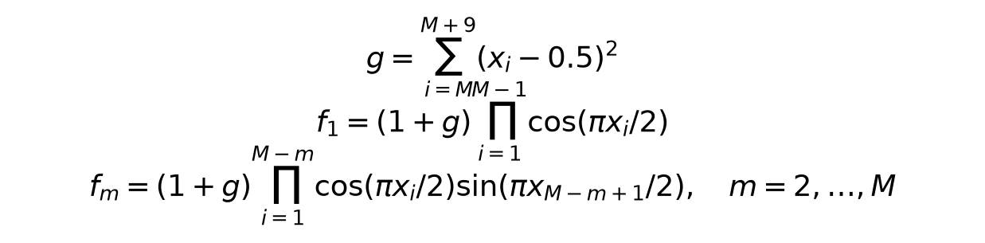
Standard form objectives in minimization convention
Formula in code notation g=sum(i=M..M+9)(xi-.5)^2; f1=(1+g)*product(i=1..M-1)cos(pi*xi/2); fm=(1+g)*product(i=1..M-m)cos(pi*xi/2)*sin(pi*x(M-m+1)/2), m=2..M
Constraints and handling Bounds; at g=0 sum(f_j^2)=1.
Python zero-based tail starts at M-1. f1 uses cos indices 0..M-2; later objectives shorten product and use sine at M-j-1. IGD reference: 301 fixed absolute Gaussian unit directions seed 100+M, an exact-front sample with finite sampling resolution.
Normalized objectives are (F-ideal)/(nadir-ideal). Fixed ideal=[0.0, 0.0, 0.0, 0.0, 0.0]; fixed nadir=[1.0, 1.0, 1.0, 1.0, 1.0]. Quality HV reference=[1.1, 1.1, 1.1, 1.1, 1.1] in normalized coordinates. These are declared scaling constants; conservative lower bounds are used where the attainable ideal is unavailable.
Termination 10000 candidate evaluations for stochastic search, 200 on P9, scalar solver termination under shared cap, 1000 full-batch network steps. Ranking terminates after table scoring.
Evaluated methods: HypE, MOEA/D, NSGA-III, RVEA. See the corresponding Task A pages and raw files.

P11 Production planning
Decision variables and encoding xA,xB>=0; finite bounds [0,400]^2

Standard form objectives in minimization convention
Formula in code notation min [-4*xA-6*xB,-xA-xB]
Constraints and handling 2*xA+3*xB<=1200; 4*xA+2*xB<=1600.
Corners (0,0),(400,0),(300,200),(0,400). Profit=2400 ties on an edge; units priority selects (300,200), units=500. Goals profit>=2400,units>=600 leave at least 100 units shortfall. Unit and normalized deviations both solved.
Normalized objectives are (F-ideal)/(nadir-ideal). Fixed ideal=[-2400.0, -500.0]; fixed nadir=[0.0, 0.0]. Quality HV reference=[1.1, 1.1] in normalized coordinates. These are declared scaling constants; conservative lower bounds are used where the attainable ideal is unavailable.
Termination 10000 candidate evaluations for stochastic search, 200 on P9, scalar solver termination under shared cap, 1000 full-batch network steps. Ranking terminates after table scoring.
Evaluated methods: Goal Programming, Lexicographic. See the corresponding Task A pages and raw files.

P12 Supplier ranking
Decision variables and encoding index 0..4 or supplied finite alternatives table

Standard form objectives in minimization convention
Formula in code notation min [cost,-quality,delivery,-reliability]
Constraints and handling Five supplied alternatives; no manufactured supplier data.
S1=(120,8,10,92),S2=(100,7,14,88),S3=(140,9,7,95),S4=(90,6,18,80),S5=(130,8,9,90). Weights (.3,.3,.2,.2); shift cost +.1 and quality -.1 to preserve sum. TOPSIS vector scales; VIKOR range scales.
Normalized objectives are (F-ideal)/(nadir-ideal). Fixed ideal=[90.0, -9.0, 7.0, -95.0]; fixed nadir=[140.0, -6.0, 18.0, -80.0]. Quality HV reference=[1.1, 1.1, 1.1, 1.1] in normalized coordinates. These are declared scaling constants; conservative lower bounds are used where the attainable ideal is unavailable.
Termination 10000 candidate evaluations for stochastic search, 200 on P9, scalar solver termination under shared cap, 1000 full-batch network steps. Ranking terminates after table scoring.
Evaluated methods: TOPSIS and VIKOR on supplier data. See the corresponding Task A pages and raw files.
All five supplied suppliers are nondominated under cost minimization and quality delivery reliability directions. Ranking imposes an additional preference order on these tradeoffs.

P13 Differentiable multi task toy and network
Decision variables and encoding toy x in R^2, start (0,5); network 5->8 tanh->two heads

Standard form objectives in minimization convention
Formula in code notation toy min [||x-(3,3)||^2,||x-(-3,-3)||^2]; network BCE/MSE
Constraints and handling Toy unconstrained. Numerical plotting scale [0,72], no claim of bounding all R^2.
Pareto set x1=x2 in [-3,3]. MGDA minimizes norm of convex gradient combination. GradNorm balances weighted shared-body gradient norms. Synthetic 128x5 data seed 63, class sign(x0-x1), regression 3*x0+2*x2+noise. Network H=tanh(XW+b), class=sigmoid(H*wc+bc), regression=H*wr+br; 66 real parameters, 48 shared. BCE=-mean(y*log(class)+(1-y)*log(1-class)); MSE=mean((regression-target)^2). Regression scale 1 vs 10; all training derivatives handwritten.
Normalized objectives are (F-ideal)/(nadir-ideal). Fixed ideal=[0.0, 0.0]; fixed nadir=[72.0, 72.0]. Quality HV reference=[1.1, 1.1] in normalized coordinates. These are declared scaling constants; conservative lower bounds are used where the attainable ideal is unavailable.
Termination 10000 candidate evaluations for stochastic search, 200 on P9, scalar solver termination under shared cap, 1000 full-batch network steps. Ranking terminates after table scoring.
Evaluated methods: GradNorm, MGDA. See the corresponding Task A pages and raw files.

P14 Laptop preference
Decision variables and encoding screen [13,17]in, battery [40,90]Wh
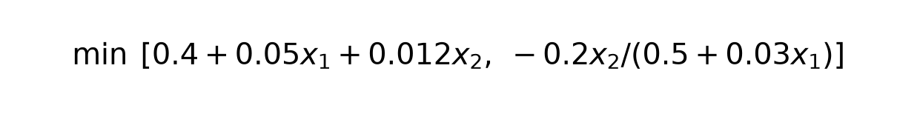
Standard form objectives in minimization convention
Formula in code notation min [.4+.05*screen+.012*battery,-.2*battery/(.5+.03*screen)]
Constraints and handling Bounds; Pareto screen=13.
Every screen increase worsens both objectives. Natural reference (1.8kg,12h) becomes (1.8,-12). At 12h front weight=1.6908kg; reference is dominated, so preference focuses near a attainable compromise rather than exact equal target.
Normalized objectives are (F-ideal)/(nadir-ideal). Fixed ideal=[1.53, -20.224719101123597]; fixed nadir=[2.33, -7.920792079207921]. Quality HV reference=[1.1, 1.1] in normalized coordinates. These are declared scaling constants; conservative lower bounds are used where the attainable ideal is unavailable.
Termination 10000 candidate evaluations for stochastic search, 200 on P9, scalar solver termination under shared cap, 1000 full-batch network steps. Ranking terminates after table scoring.
Evaluated methods: IBEA, R-NSGA-II, SMS-EMOA, Value Function. See the corresponding Task A pages and raw files.

4 Shared tools and verification
moo_utils.py centralizes dominance, pairwise front sorting, crowding distance, archive filtering, normalization, positive-residual violation, exact 2D HV, Monte Carlo HV, IGD, Spacing and reproducible reference directions. Pairwise arrays expose the calculations directly and cost O(M*N^2); vectorization improves execution time without changing asymptotic work.
Check | Input | Expected
Dominance | (1,2) versus (2,3) | First dominates
Tradeoff | (1,3) versus (2,2) | Neither dominates
HV | (1,3) (2,2) (3,1); reference (4,4) | 6
IGD identical fronts | same point sets | 0
Crowding | (0,2) (1,1) (2,0) | infinity 2 infinity
Lecture car front | A B C D E F table | A B C D
Lecture Deb layers | A D feasible; B CV2; C CV5 | A,D then B then C
DTLZ2 g0 | tail variables all .5 | squared objective sum 1
Network derivatives | central finite difference +/-1e-6 | analytical match to 5 decimal places

Final automated result: 59 tests passed. Tests include seed reproducibility for all 26 stochastic modules and bounds for recorded solutions. For P8 the crossover and both mutation variants are checked across 20 seeds; cities occur exactly once. See results/test_output.txt for the named checks. Tests verify defining mechanisms, not a global-optimality guarantee.

5 Tasks A and B algorithm implementations and comparison
Each algorithm page combines its Task A implementation and measured results with its Task B comparison. Four strengths and four weaknesses below are reasoned from the code, while the numerical evidence describes what these runs achieved. Metrics alone do not prove every causal mechanism claim; the stricter requirement for two advantages and two disadvantages per method individually supported by experimental results remains only partly met. No unsupported causal conclusion is relabelled as experimental evidence.
Classical methods convert preferences or bounds into scalar solves, making their numerical accuracy depend on the scalar solver. Early GAs use objective selection, rank or sharing without parent elitism; the passive archive records discoveries but does not prevent the breeding population from losing them. Elitist methods spend quadratic comparisons to retain high-ranked parents and use crowding, density or grids for diversity. Decomposition gives each direction its own scalar pressure, although a fixed lattice may not match disconnected fronts. Swarms and local heuristics rely on archive leaders and neighbourhood moves; their schedules can exploit quickly or stagnate. Indicators replace explicit density with epsilon or hypervolume fitness but require scales and, for HV, a reference box. Reference methods remain useful when dominance loses discrimination in five dimensions. Preferences intentionally trade full-front coverage for a useful region. Gradient methods optimize differentiable tasks toward stationarity and do not produce a full front from one start. Feasibility rules are applied before Pareto comparisons, and comparisons use common normalized metric scales.

1 Weighted Sum
Linear scalar solve and a sweep. Module src/algorithms/weighted_sum.py. Status works. Defining test test_01_mechanism passes.
Implementation and defaults Weighted Sum: minimize dot(w,F_normalized), sweep simplex weights. Positive weights yield supported efficient points; zeros may give weak efficiency. Default SLSQP ftol=1e-10, maxiter=120; sweep=21; seed=63. Bounds and explicit constraints handled by SLSQP. Only scalar subproblems use SciPy. Local solves are not a global optimality certificate.
Problem | Trials | HV | IGD | Spacing | Time s
P1 | 1 | 1.026 +/- 0 | 0.02013 +/- 0 | 9.696e-09 +/- 0 | 0.3003 +/- 0
P3 | 1 | 0.21 +/- 0 | 0.3538 +/- 0 | 0.8944 +/- 0 | 0.3115 +/- 0

Actual mean evaluations: P1 168 of cap 10000; P3 902 of cap 10000.
Advantages with mechanism reasoning 1. Simple scalar objective; 2. Direct preference weights; 3. Reusable constrained scalar solver; 4. Independent solves can be distributed
Disadvantages with mechanism reasoning 1. Unsupported nonconvex points are unreachable; 2. Scaling changes weight meaning; 3. Uniform weights give nonuniform spacing; 4. Local scalar solves lack global guarantees
Suitable use Convex smooth two-objective design with interpretable weights. Avoid: Dented fronts and an unknown preference distribution.
Measured limits Finite recorded front size=21; this is no certificate of complete coverage. Residual sampled-front IGD=0.020135; positive residual measures finite-budget approximation error.
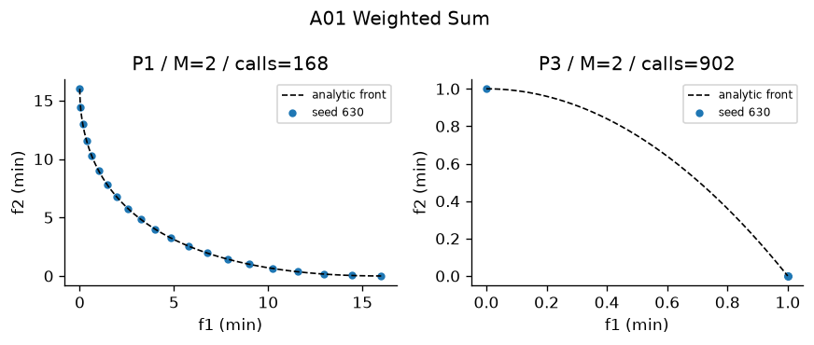
Figure A01 Recorded output on designated problems. Plotted seed and actual calls appear in the panel. The full ten-trial metrics are in the table.

2 Epsilon Constraint
One objective minimized and others bounded. Module src/algorithms/epsilon_constraint.py. Status works. Defining test test_02_mechanism passes.
Implementation and defaults Epsilon-Constraint: minimize F1 with normalized F2<=epsilon. Default epsilon range=[0,1]. Extra constraint calls are explicitly counted. Default SLSQP ftol=1e-10, maxiter=120; sweep=21; seed=63. Bounds and explicit constraints handled by SLSQP. Only scalar subproblems use SciPy. Local solves are not a global optimality certificate.
Problem | Trials | HV | IGD | Spacing | Time s
P2 | 1 | 1.086 +/- 0 | 0.03713 +/- 0 | 0.1418 +/- 0 | 0.03639 +/- 0
P3 | 1 | 0.5206 +/- 0 | 0.02658 +/- 0 | 0.04354 +/- 0 | 0.1509 +/- 0

Actual mean evaluations: P2 719 of cap 10000; P3 3635 of cap 10000.
Advantages with mechanism reasoning 1. Can represent unsupported efficient points; 2. Epsilon has physical interpretation; 3. Scalar constraints remain explicit; 4. Primary objective stays recognizable
Disadvantages with mechanism reasoning 1. Infeasible epsilon values waste solves; 2. Sweeps can duplicate points; 3. Constraint solver quality matters; 4. Many objectives require multidimensional epsilon grids
Suitable use Nonconvex constrained design with hard limits. Avoid: High-dimensional objective grids.
Measured limits Finite recorded front size=21; this is no certificate of complete coverage. Residual sampled-front IGD=0.037129; positive residual measures finite-budget approximation error.
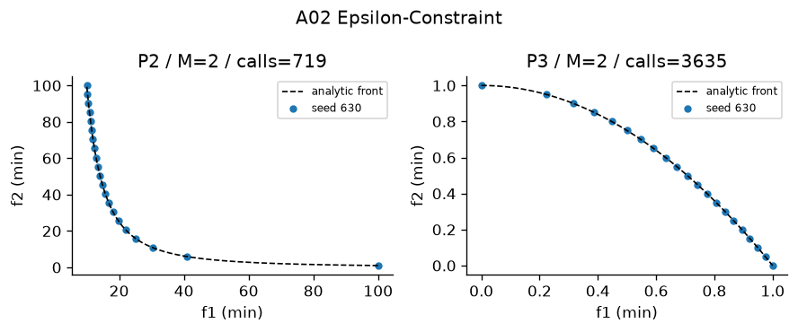
Figure A02 Recorded output on designated problems. Plotted seed and actual calls appear in the panel. The full ten-trial metrics are in the table.

3 Benson reference improvement
Weighted improvement below a reference. Module src/algorithms/benson.py. Status works. Defining test test_03_mechanism passes.
Implementation and defaults Benson reference improvement: maximize weighted nonnegative improvements from a dominated reference r=[1.1,1.1], require F<=r. This follows Foundations slide 35 reference achievement. It is the teaching form, not full polyhedral outer approximation. Default SLSQP ftol=1e-10, maxiter=120; sweep=21; seed=63. Bounds and explicit constraints handled by SLSQP. Only scalar subproblems use SciPy. Local solves are not a global optimality certificate.
Problem | Trials | HV | IGD | Spacing | Time s
P1 | 1 | 1.026 +/- 0 | 0.02013 +/- 0 | 2.726e-08 +/- 0 | 0.0498 +/- 0
P7 | 1 | 0.3824 +/- 0 | 0.2309 +/- 0 | 0.2558 +/- 0 | 0.2984 +/- 0

Actual mean evaluations: P1 714 of cap 10000; P7 4387 of cap 10000.
Advantages with mechanism reasoning 1. Reference conveys aspiration; 2. Nonnegative improvement is interpretable; 3. Explicit upper objective bounds; 4. Scalar subproblems are easy to inspect
Disadvantages with mechanism reasoning 1. This is the lecture achievement form, not outer approximation; 2. Unrestricted reference sweeps inherit weighted-sum barrier; 3. Reference coordinates require scaling; 4. Weights still encode preferences
Suitable use Teaching reference improvement on P1/P7. Avoid: Claiming a general Benson convergence theorem.
Measured limits Finite recorded front size=21; this is no certificate of complete coverage. Residual sampled-front IGD=0.020135; positive residual measures finite-budget approximation error.
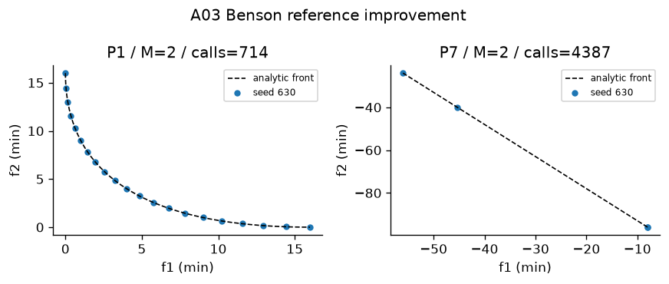
Figure A03 Recorded output on designated problems. Plotted seed and actual calls appear in the panel. The full ten-trial metrics are in the table.

4 Weight Metric
Weighted distance to fixed ideal. Module src/algorithms/weight_metric.py. Status works. Defining test test_04_mechanism passes.
Implementation and defaults Weight Metric: distance from fixed ideal, weighted p=1,2,infinity. Sweep weights for all three p values. p=infinity uses epigraph-free max. Default SLSQP ftol=1e-10, maxiter=120; sweep=21; seed=63. Bounds and explicit constraints handled by SLSQP. Only scalar subproblems use SciPy. Local solves are not a global optimality certificate.
Problem | Trials | HV | IGD | Spacing | Time s
P1 | 1 | 1.035 +/- 0 | 0.01234 +/- 0 | 0.02381 +/- 0 | 0.1819 +/- 0
P3 | 1 | 0.5198 +/- 0 | 0.02181 +/- 0 | 0.04216 +/- 0 | 0.6013 +/- 0

Actual mean evaluations: P1 1895 of cap 10000; P3 7797 of cap 10000.
Advantages with mechanism reasoning 1. Infinity norm can reach unsupported tradeoffs; 2. Different p values express balance; 3. Ideal point makes distances interpretable; 4. Scalar solver is reusable
Disadvantages with mechanism reasoning 1. Ideal estimation affects solution; 2. Max norm is nonsmooth; 3. p and weights require preferences; 4. Finite weight sweep misses narrow regions
Suitable use Compromise solutions on nonconvex fronts. Avoid: Unreliable ideal estimates or many weights.
Measured limits Finite recorded front size=63; this is no certificate of complete coverage. Residual sampled-front IGD=0.012339; positive residual measures finite-budget approximation error.
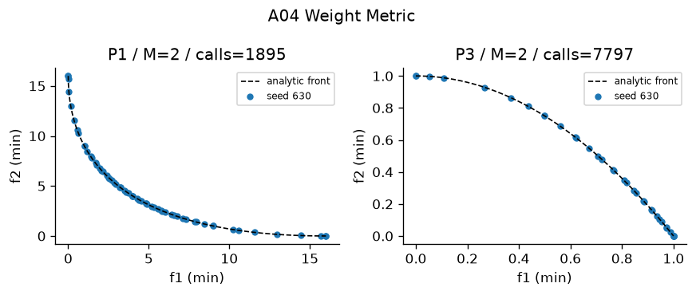
Figure A04 Recorded output on designated problems. Plotted seed and actual calls appear in the panel. The full ten-trial metrics are in the table.

5 Value Function
Declared decision-maker utility. Module src/algorithms/value_function.py. Status works. Defining test test_05_mechanism passes.
Implementation and defaults Value Function: declared quadratic utility to a preferred normalized aspiration. P14 uses [1.8 kg,12 h]; P4 uses three investor risk/return targets. Utility is a decision-maker input, not a claim of universal preference. Default SLSQP ftol=1e-10, maxiter=120; sweep=21; seed=63. Bounds and explicit constraints handled by SLSQP. Only scalar subproblems use SciPy. Local solves are not a global optimality certificate.
Problem | Trials | HV | IGD | Spacing | Time s
P14 | 1 | 0.329 +/- 0 | 0.353 +/- 0 | 0 +/- 0 | 0.005052 +/- 0
P4 | 1 | 0.6662 +/- 0 | N/A +/- N/A | 9.655e-05 +/- 0 | 0.01323 +/- 0

Actual mean evaluations: P14 45 of cap 10000; P4 142 of cap 10000.
Advantages with mechanism reasoning 1. Directly encodes a preferred outcome; 2. Can express nonlinear preferences; 3. Few scalar solves are economical; 4. Natural targets communicate decisions
Disadvantages with mechanism reasoning 1. Utility must be elicited; 2. Squared target utility need not be monotone; 3. One preferred design is not a full front; 4. Misspecified preferences bias results
Suitable use Laptop or portfolio profile decisions. Avoid: Exploration without known preferences.
Measured limits Finite recorded front size=1; this is no certificate of complete coverage. Residual sampled-front IGD=0.35302; positive residual measures finite-budget approximation error.
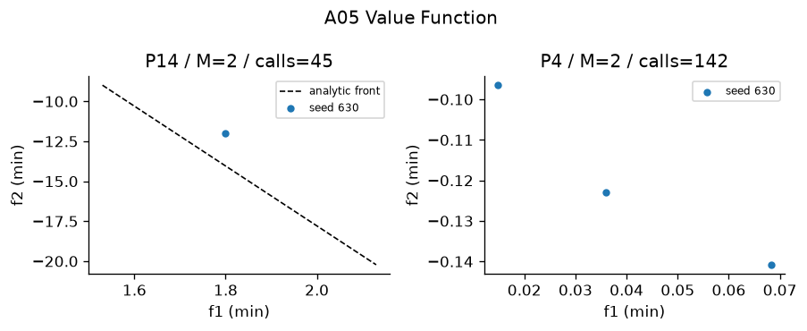
Figure A05 Recorded output on designated problems. Plotted seed and actual calls appear in the panel. The full ten-trial metrics are in the table.

6 Goal Programming
Explicit positive/negative goal deviations. Module src/algorithms/goal_programming.py. Status works. Defining test test_06_mechanism passes.
Implementation and defaults Goal Programming: goals in natural output, penalize negative deviations only (both goals are lower bounds). Explicit dminus=max(target-achieved,0), dplus=max(achieved-target,0); elimination of linear deviation variables is exact. Default SLSQP ftol=1e-10, maxiter=120; sweep=21; seed=63. Bounds and explicit constraints handled by SLSQP. Only scalar subproblems use SciPy. Local solves are not a global optimality certificate.
Problem | Trials | HV | IGD | Spacing | Time s
P11 | 1 | 1.21 +/- 0 | 4.825e-11 +/- 0 | 0 +/- 0 | 0.02595 +/- 0
P7 | 1 | 0.3407 +/- 0 | 0.3819 +/- 0 | 0 +/- 0 | 0.02809 +/- 0

Actual mean evaluations: P11 275 of cap 10000; P7 320 of cap 10000.
Advantages with mechanism reasoning 1. Shows unavoidable shortfall; 2. Can normalize incompatible units; 3. Soft goals remain interpretable; 4. Constraint and aspiration roles are separate
Disadvantages with mechanism reasoning 1. Goal weights control tradeoffs; 2. Infeasible goals cannot be guaranteed; 3. Units can overwhelm deviations; 4. Satisfied goals may leave efficiency ties
Suitable use Production targets with soft priorities. Avoid: Searching an entire front without goals.
Measured limits Finite recorded front size=1; this is no certificate of complete coverage. Residual sampled-front IGD=4.8252e-11; positive residual measures finite-budget approximation error.
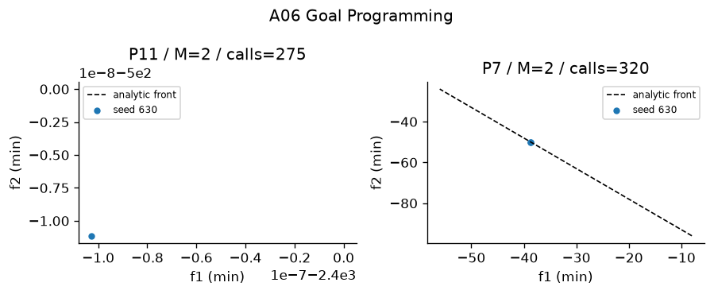
Figure A06 Recorded output on designated problems. Plotted seed and actual calls appear in the panel. The full ten-trial metrics are in the table.

7 Lexicographic
Sequential strict priorities with tolerances. Module src/algorithms/lexicographic.py. Status works. Defining test test_07_mechanism passes.
Implementation and defaults Lexicographic: sequential strict-priority scalar minimizations, preserving prior best objective within tolerance=1e-7 in normalized units. Profit first then units on P11; agricultural yield first on P7. Default SLSQP ftol=1e-10, maxiter=120; sweep=21; seed=63. Bounds and explicit constraints handled by SLSQP. Only scalar subproblems use SciPy. Local solves are not a global optimality certificate.
Problem | Trials | HV | IGD | Spacing | Time s
P11 | 1 | 1.21 +/- 0 | 6.457e-08 +/- 0 | 0 +/- 0 | 0.02934 +/- 0
P7 | 1 | 0.11 +/- 0 | 0.7071 +/- 0 | 0 +/- 0 | 0.004925 +/- 0

Actual mean evaluations: P11 424 of cap 10000; P7 38 of cap 10000.
Advantages with mechanism reasoning 1. Priority order is transparent; 2. Breaks first-objective ties; 3. Uses scalar solvers; 4. Preserves prior objective values to declared tolerance
Disadvantages with mechanism reasoning 1. Lower objectives may have little freedom; 2. Tolerance changes strictness; 3. Priority mistakes are expensive; 4. Sequential solves add cost
Suitable use Profit first and units second. Avoid: Balanced objectives with no hierarchy.
Measured limits Finite recorded front size=1; this is no certificate of complete coverage. Residual sampled-front IGD=6.457e-08; positive residual measures finite-budget approximation error.
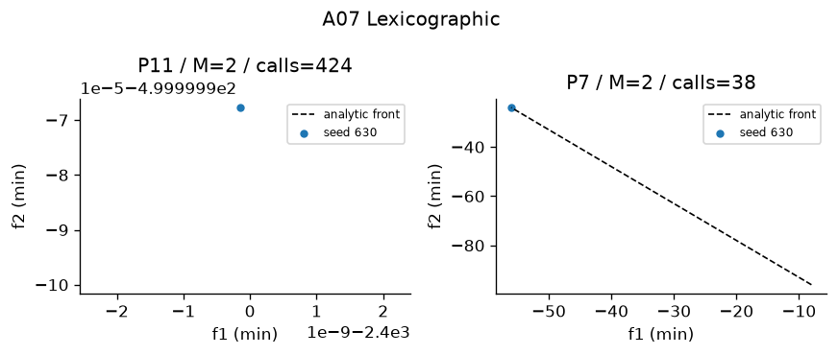
Figure A07 Recorded output on designated problems. Plotted seed and actual calls appear in the panel. The full ten-trial metrics are in the table.

8 TOPSIS
Closeness to weighted ideal and anti-ideal. Module src/algorithms/topsis.py. Status works. Defining test test_08_mechanism passes.
Implementation and defaults TOPSIS ranking, not an optimizer. Vector normalization, weights, benefit/cost ideal, Euclidean ideal and anti-ideal distance. Default equal weights if not supplied; P12 uses [.3,.3,.2,.2]. Zero columns protected.
Advantages with mechanism reasoning 1. Fast finite-table ranking; 2. Uses all criteria; 3. Distances are explainable; 4. Works with benefit and cost columns
Disadvantages with mechanism reasoning 1. Does not generate new designs; 2. Vector normalization affects rank; 3. Compensation can hide a bad criterion; 4. Alternatives can change the ideal
Suitable use Supplier or existing-front ranking. Avoid: Optimization without an alternatives table.
Measured limits Five existing suppliers are ranked; no new design is generated. Preference changes are measured in rankings.csv; ranking quality does not imply a global optimum.
Measured rankings P12 w=[0.3, 0.3, 0.2, 0.2] v=0.5: top 3 [3, 1, 5]; P12 w=[0.4, 0.2, 0.2, 0.2] v=0.5: top 3 [1, 2, 3]; P4 NSGA-II front w=[0.5, 0.5] v=0.5: top 3 [2, 14, 27]; P4 NSGA-II front w=[0.6, 0.4] v=0.5: top 3 [27, 7, 15]
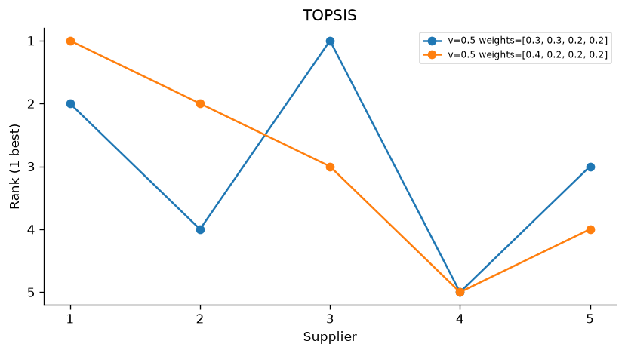
Figure A08 Recorded output on designated problems. Plotted seed and actual calls appear in the panel. The full ten-trial metrics are in the table.

9 VIKOR
Compromise via group regret and worst regret. Module src/algorithms/vikor.py. Status works. Defining test test_09_mechanism passes.
Implementation and defaults VIKOR compromise ranking with S=sum weighted regret, R=max regret, Q=v*(S-Sbest)/(Sworst-Sbest)+(1-v)*(R-Rbest)/(Rworst-Rbest). Default v=.5. Report acceptable advantage 1/(N-1) and stability; never force a unique compromise when the conditions fail.
Advantages with mechanism reasoning 1. Worst criterion enters R; 2. v exposes group versus individual tradeoff; 3. Compromise conditions avoid forced winners; 4. Finite rankings are inexpensive
Disadvantages with mechanism reasoning 1. Requires preference weights; 2. v can change rank; 3. Range normalization changes regrets; 4. Does not generate designs
Suitable use Supplier compromise with severe weak criteria. Avoid: A Pareto front generator.
Measured limits Five existing suppliers are ranked; no new design is generated. Preference changes are measured in rankings.csv; ranking quality does not imply a global optimum.
Measured rankings P12 w=[0.3, 0.3, 0.2, 0.2] v=0.25: top 3 [1, 2, 5]; P12 w=[0.4, 0.2, 0.2, 0.2] v=0.25: top 3 [2, 1, 4]; P12 w=[0.3, 0.3, 0.2, 0.2] v=0.5: top 3 [1, 2, 5]; P12 w=[0.4, 0.2, 0.2, 0.2] v=0.5: top 3 [2, 1, 3]; P12 w=[0.3, 0.3, 0.2, 0.2] v=0.75: top 3 [1, 3, 2]; P12 w=[0.4, 0.2, 0.2, 0.2] v=0.75: top 3 [1, 2, 3]; P4 NSGA-II front w=[0.5, 0.5] v=0.5: top 3 [27, 14, 2]; P4 NSGA-II front w=[0.6, 0.4] v=0.5: top 3 [7, 15, 20]
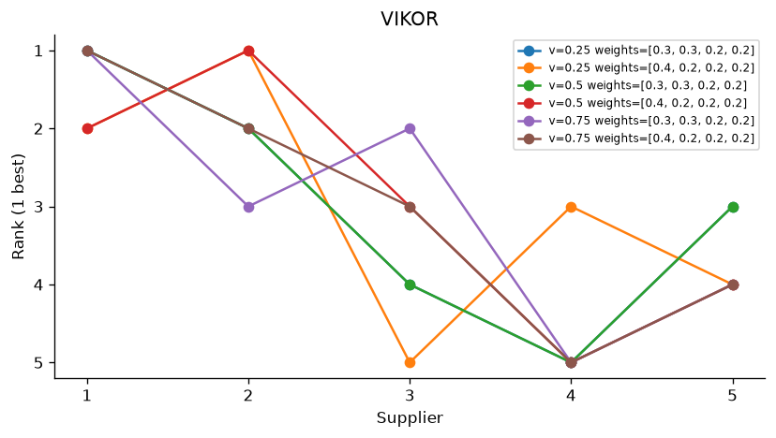
Figure A09 Recorded output on designated problems. Plotted seed and actual calls appear in the panel. The full ten-trial metrics are in the table.

10 VEGA
Objective-partitioned selection. Module src/algorithms/vega.py. Status works. Defining test test_10_mechanism passes.
Implementation and defaults VEGA: partition selection by objective, pool subpopulations, crossover and mutation. Tournament by one objective; no parent+child elitism. Shared defaults: population=40, budget=10000, seed=63. Constraints: Deb feasibility comparison unless the stated method uses scalar penalty.
Problem | Trials | HV | IGD | Spacing | Time s
P2 | 10 | 1.11 +/- 0.001796 | 0.01542 +/- 0.002203 | 0.01628 +/- 0.001243 | 0.4108 +/- 0.02133
P3 | 10 | 0.1786 +/- 0.04197 | 0.366 +/- 0.08585 | 0.04663 +/- 0.02523 | 0.3588 +/- 0.007788

Actual mean evaluations: P2 1e+04 of cap 10000; P3 1e+04 of cap 10000.
Advantages with mechanism reasoning 1. Very simple selection; 2. No preference weights needed; 3. Handles several objective contests; 4. Cheap scalar tournaments
Disadvantages with mechanism reasoning 1. Extremes can dominate mating pool; 2. No parent elitism; 3. Middle tradeoffs may disappear; 4. Objective partition sizes affect pressure
Suitable use Teaching objective competition. Avoid: Reliable uniform front preservation.
Measured limits Finite recorded front size=40; this is no certificate of complete coverage. Residual sampled-front IGD=0.015417; positive residual measures finite-budget approximation error.
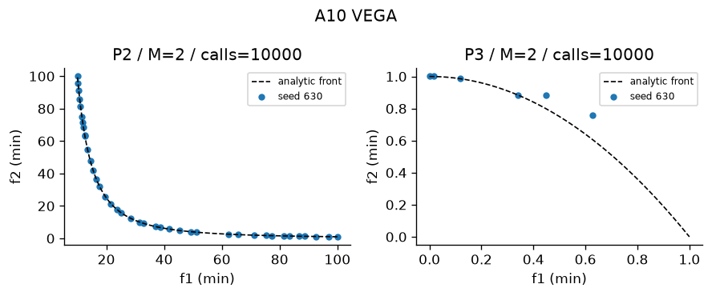
Figure A10 Recorded output on designated problems. Plotted seed and actual calls appear in the panel. The full ten-trial metrics are in the table.

11 MOGA
Domination-count rank and fitness sharing. Module src/algorithms/moga.py. Status works. Defining test test_11_mechanism passes.
Implementation and defaults MOGA: domination count rank, rank fitness divided by niche count. Sharing radius sigma=.3; small radius weakens sharing; no elitism. Shared defaults: population=40, budget=10000, seed=63. Constraints: Deb feasibility comparison unless the stated method uses scalar penalty.
Problem | Trials | HV | IGD | Spacing | Time s
P3 | 10 | 0.5244 +/- 0.0007886 | 0.01244 +/- 0.0005083 | 0.0131 +/- 0.001648 | 0.383 +/- 0.01085
P5 | 10 | 1.182 +/- 9.581e-05 | 0.01374 +/- 0.001077 | 0.01885 +/- 0.002543 | 0.3956 +/- 0.01209

Actual mean evaluations: P3 1e+04 of cap 10000; P5 1e+04 of cap 10000.
Advantages with mechanism reasoning 1. No scalar utility required; 2. Sharing promotes sparse niches; 3. Dominance counts are easy to inspect; 4. Can search unsupported regions
Disadvantages with mechanism reasoning 1. No elitism; 2. Sharing radius sensitive; 3. All nondominated members tie in rank; 4. Pairwise density costs quadratically
Suitable use Small bi-objective populations. Avoid: Many objectives with sparse dominance.
Measured limits Finite recorded front size=40; this is no certificate of complete coverage. Residual sampled-front IGD=0.012438; positive residual measures finite-budget approximation error.
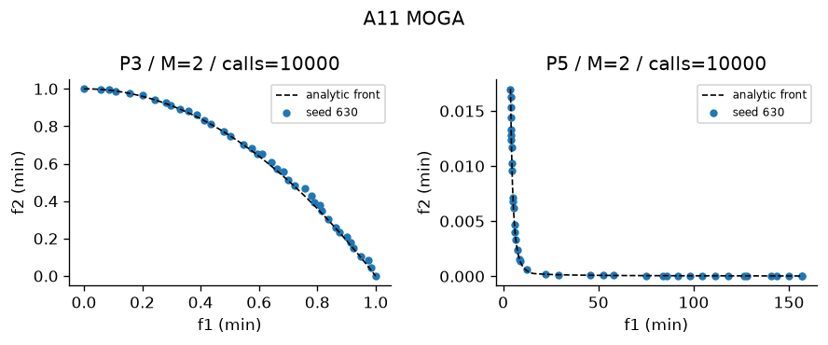
Figure A11 Recorded output on designated problems. Plotted seed and actual calls appear in the panel. The full ten-trial metrics are in the table.

12 NSGA
Front layers and within-front sharing. Module src/algorithms/nsga.py. Status works. Defining test test_12_mechanism passes.
Implementation and defaults NSGA: nondominated layers, dummy fitness and within-front sharing. Sharing radius sigma=.3; non-elitist generational replacement. Shared defaults: population=40, budget=10000, seed=63. Constraints: Deb feasibility comparison unless the stated method uses scalar penalty.
Problem | Trials | HV | IGD | Spacing | Time s
P5 | 10 | 1.182 +/- 7.723e-05 | 0.01433 +/- 0.00117 | 0.0191 +/- 0.001383 | 0.428 +/- 0.0118
P7 | 10 | 0.6878 +/- 0.001292 | 0.0127 +/- 0.0006951 | 0.009835 +/- 0.001951 | 0.4837 +/- 0.01813

Actual mean evaluations: P5 1e+04 of cap 10000; P7 1e+04 of cap 10000.
Advantages with mechanism reasoning 1. Explicit Pareto hierarchy; 2. Sharing is local to fronts; 3. No objective weights required; 4. Variation supports arbitrary encodings
Disadvantages with mechanism reasoning 1. No elitism; 2. Quadratic sorting and sharing; 3. Dummy fitness spacing is arbitrary; 4. Niche radius must be tuned
Suitable use Teaching early Pareto GAs. Avoid: Large fast convergence requirements.
Measured limits Finite recorded front size=40; this is no certificate of complete coverage. Residual sampled-front IGD=0.014333; positive residual measures finite-budget approximation error.
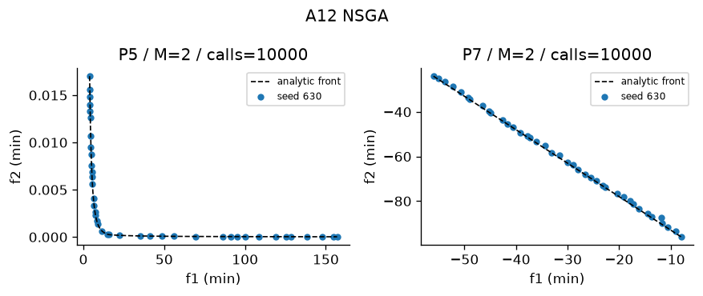
Figure A12 Recorded output on designated problems. Plotted seed and actual calls appear in the panel. The full ten-trial metrics are in the table.

13 NPGA
Direct contestant dominance then separate comparison-set quadratic niche tie. Module src/algorithms/npga.py. Status works. Defining test test_13_mechanism passes.
Implementation and defaults Niched Pareto Genetic Algorithm: direct binary tournament with comparison-set crowding. Direct dominance decides; otherwise smaller comparison-set niche count wins. Defaults: comparison_size=2, sigma=.3; objective distances normalized. Shared defaults: population=40, budget=10000, seed=63. Constraints: Deb feasibility comparison unless the stated method uses scalar penalty.
Problem | Trials | HV | IGD | Spacing | Time s
P3 | 10 | 0.4712 +/- 0.04723 | 0.0401 +/- 0.03463 | 0.02206 +/- 0.005631 | 0.731 +/- 0.02013
P5 | 10 | 1.181 +/- 0.0006727 | 0.01319 +/- 0.001771 | 0.0194 +/- 0.003436 | 0.8396 +/- 0.03424

Actual mean evaluations: P3 1e+04 of cap 10000; P5 1e+04 of cap 10000.
Advantages with mechanism reasoning 1. No fixed utility weights; 2. Niche tie-break preserves sparse points; 3. Comparison sample controls work; 4. Can visit nonconvex tradeoffs
Disadvantages with mechanism reasoning 1. Nonelitist generations lose parents; 2. Small comparison set gives noisy niche counts; 3. Sigma changes density pressure; 4. Lecture tournament differs from original publication
Suitable use Bi-objective diversity experiments. Avoid: Many-objective fronts where most tournaments tie.
Measured limits Finite recorded front size=38.3; this is no certificate of complete coverage. Residual sampled-front IGD=0.040099; positive residual measures finite-budget approximation error.
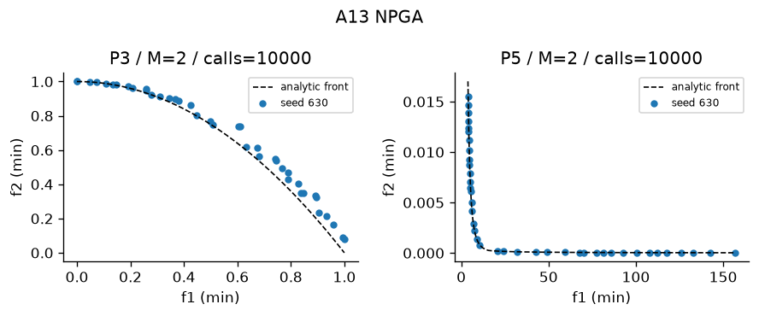
Figure A13 Recorded output on designated problems. Plotted seed and actual calls appear in the panel. The full ten-trial metrics are in the table.

14 NSGA II
Front rank, crowding, parent-child elitism. Module src/algorithms/nsga2.py. Status works. Defining test test_14_mechanism passes.
Implementation and defaults NSGA-II: fast front sorting, crowded binary tournament, SBX and mutation, parent+offspring elitist survival. Permutations use OX and swap/inversion. Shared defaults: population=40, budget=10000, seed=63. Constraints: Deb feasibility comparison unless the stated method uses scalar penalty.
Problem | Trials | HV | IGD | Spacing | Time s
P3 | 10 | 0.5284 +/- 0.0006346 | 0.01223 +/- 0.0006273 | 0.0185 +/- 0.002919 | 0.5074 +/- 0.009639
P5 | 10 | 1.182 +/- 7.219e-05 | 0.01466 +/- 0.002837 | 0.01974 +/- 0.002319 | 0.5156 +/- 0.01654

Actual mean evaluations: P3 1e+04 of cap 10000; P5 1e+04 of cap 10000.
Advantages with mechanism reasoning 1. Elitist survivor retention; 2. Boundary points receive protection; 3. No sharing radius; 4. Permutation and real variation share selection
Disadvantages with mechanism reasoning 1. Crowding weakens as objectives grow; 2. Quadratic pairwise sorting; 3. Finite population truncates front; 4. Crowding is not an explicit convergence measure
Suitable use General constrained two-objective search. Avoid: Very many objectives with weak dominance.
Measured limits Finite recorded front size=40; this is no certificate of complete coverage. Residual sampled-front IGD=0.01223; positive residual measures finite-budget approximation error.
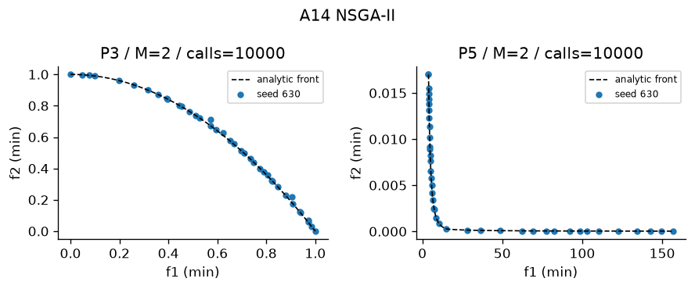
Figure A14 Recorded output on designated problems. Plotted seed and actual calls appear in the panel. The full ten-trial metrics are in the table.

15 NSGA III
Reference-point niching after front rank. Module src/algorithms/nsga3.py. Status works. Defining test test_15_mechanism passes.
Implementation and defaults NSGA-III: front ranking, simplex-lattice reference association and niche occupancy survival. Normalize by observed ranges (simplification of intercepts). Shared defaults: population=40, budget=10000, seed=63. Constraints: Deb feasibility comparison unless the stated method uses scalar penalty.
Problem | Trials | HV | IGD | Spacing | Time s
P10 M3 | 10 | 0.6578 +/- 0.01207 | 0.1095 +/- 0.005836 | 0.1022 +/- 0.01132 | 0.7215 +/- 0.01357
P10 M5 | 10 | 0.9898 +/- 0.01111 | 0.3105 +/- 0.006318 | 0.2685 +/- 0.0248 | 0.7803 +/- 0.01225

Actual mean evaluations: P10 1e+04 of cap 10000; P10 1e+04 of cap 10000.
Advantages with mechanism reasoning 1. Reference niches control coverage; 2. Supports many objectives; 3. Occupancy encourages unused directions; 4. Does not use a sharing radius
Disadvantages with mechanism reasoning 1. Range normalization simplifies original intercepts; 2. Reference count grows combinatorially; 3. Poor reference geometry biases coverage; 4. Dominance layers still require quadratic work
Suitable use DTLZ2 with three or five objectives. Avoid: Irregular fronts without adapted references.
Measured limits Finite recorded front size=40; this is no certificate of complete coverage. Residual sampled-front IGD=0.10953; positive residual measures finite-budget approximation error.
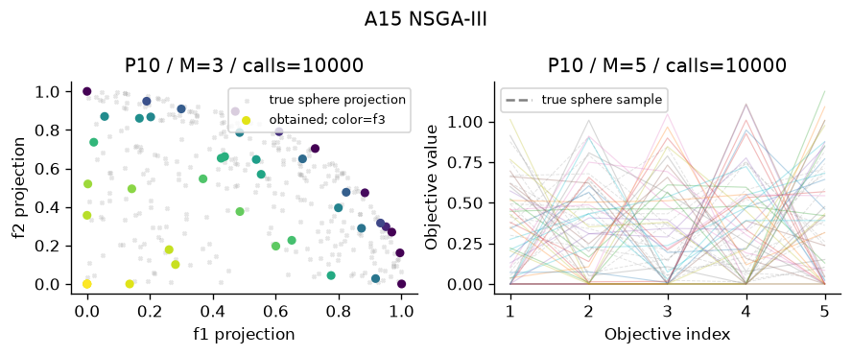
Figure A15 Recorded output on designated problems. Plotted seed and actual calls appear in the panel. The full ten-trial metrics are in the table.

16 SPEA2
Strength, raw fitness and neighbour density. Module src/algorithms/spea2.py. Status works. Defining test test_16_mechanism passes.
Implementation and defaults SPEA2: strength S, raw fitness R=sum strengths of dominators; density 1/(sigma_k+2), fixed archive, lexicographic nearest-distance truncation. Shared defaults: population=40, budget=10000, seed=63. Constraints: Deb feasibility comparison unless the stated method uses scalar penalty.
Problem | Trials | HV | IGD | Spacing | Time s
P4 | 10 | 0.9338 +/- 0.001508 | N/A +/- N/A | 0.01406 +/- 0.00335 | 1.331 +/- 0.01942
P5 | 10 | 1.182 +/- 4.595e-05 | 0.01443 +/- 0.002042 | 0.01889 +/- 0.001707 | 1.64 +/- 0.04341

Actual mean evaluations: P4 1e+04 of cap 10000; P5 1e+04 of cap 10000.
Advantages with mechanism reasoning 1. Strength combines domination information; 2. Density distinguishes ties; 3. Fixed archive bounds memory; 4. Lexicographic truncation considers nearest distances
Disadvantages with mechanism reasoning 1. Quadratic distance storage; 2. Repeated truncation adds cost; 3. k-neighbour density depends on scale; 4. Archive size limits attainable resolution
Suitable use Small smooth front archives. Avoid: Large populations with tight memory.
Measured limits Finite recorded front size=40; this is no certificate of complete coverage. Exact-front IGD is unavailable for this problem, so convergence is not certified.
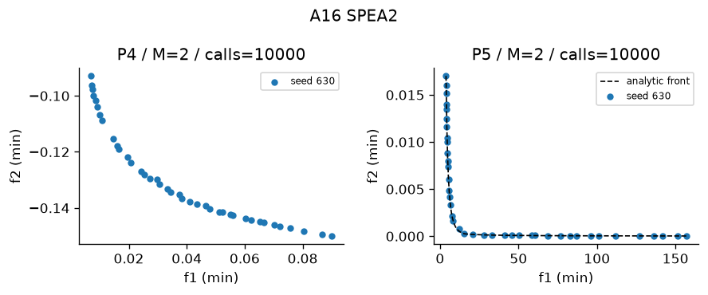
Figure A16 Recorded output on designated problems. Plotted seed and actual calls appear in the panel. The full ten-trial metrics are in the table.

17 PESA II
Archive region occupancy selection. Module src/algorithms/pesa2.py. Status works. Defining test test_17_mechanism passes.
Implementation and defaults PESA-II: archive adaptive grid regions; region tournament selects lower occupancy region, then uniform individual. Default grid divisions=8. Shared defaults: population=40, budget=10000, seed=63. Constraints: Deb feasibility comparison unless the stated method uses scalar penalty.
Problem | Trials | HV | IGD | Spacing | Time s
P3 | 10 | 0.51 +/- 0.01093 | 0.0254 +/- 0.008017 | 0.02596 +/- 0.003239 | 0.7259 +/- 0.0193
P5 | 10 | 1.181 +/- 0.0002923 | 0.0175 +/- 0.001596 | 0.01492 +/- 0.00259 | 0.791 +/- 0.01892

Actual mean evaluations: P3 1e+04 of cap 10000; P5 1e+04 of cap 10000.
Advantages with mechanism reasoning 1. Region selection directly rewards sparsity; 2. Archive keeps observed tradeoffs; 3. Grid counts are interpretable; 4. Less dependence on precise distances
Disadvantages with mechanism reasoning 1. Grid divisions sensitive; 2. High-dimensional grids become sparse; 3. Archive can shrink to few members; 4. Grid boundaries change selection abruptly
Suitable use Bi-objective region coverage. Avoid: Many objectives with almost unique cells.
Measured limits Finite recorded front size=40; this is no certificate of complete coverage. Residual sampled-front IGD=0.025403; positive residual measures finite-budget approximation error.
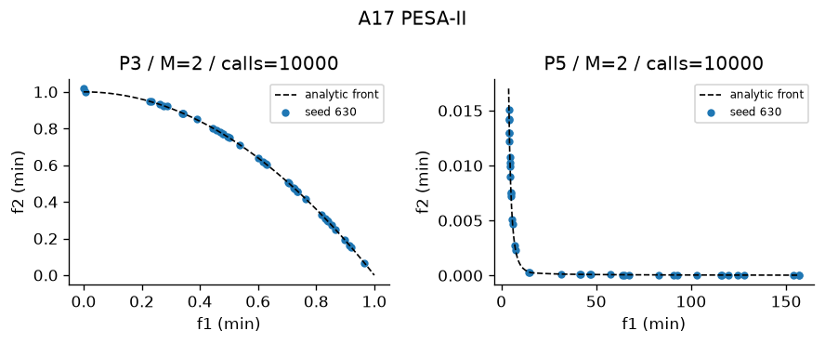
Figure A17 Recorded output on designated problems. Plotted seed and actual calls appear in the panel. The full ten-trial metrics are in the table.

18 MOEA D
Neighbouring Tchebycheff subproblems. Module src/algorithms/moead.py. Status works. Defining test test_18_mechanism passes.
Implementation and defaults MOEA/D: reference weights, neighbourhood mating, running ideal, cooperative Tchebycheff replacement. Neighbourhood size=10. Shared defaults: population=40, budget=10000, seed=63. Constraints: Deb feasibility comparison unless the stated method uses scalar penalty.
Problem | Trials | HV | IGD | Spacing | Time s
P10 M5 | 10 | 0.9999 +/- 0.03359 | 0.3293 +/- 0.02405 | 0.2709 +/- 0.0336 | 3.299 +/- 0.09405
P3 | 10 | 0.5318 +/- 5.225e-05 | 0.009563 +/- 8.205e-05 | 0.003232 +/- 0.00076 | 2.43 +/- 0.09813

Actual mean evaluations: P10 1e+04 of cap 10000; P3 1e+04 of cap 10000.
Advantages with mechanism reasoning 1. Cooperation shares good designs; 2. Scalar subproblems retain pressure with many objectives; 3. Neighbourhood limits update work; 4. Weights provide coverage plan
Disadvantages with mechanism reasoning 1. Reference geometry biases front; 2. Neighbourhood size affects spread; 3. Shared donors can homogenize subproblems; 4. Ideal updates alter scalar values
Suitable use Smooth continuous many-objective design. Avoid: Disconnected fronts badly matched by weights.
Measured limits Finite recorded front size=40; this is no certificate of complete coverage. Residual sampled-front IGD=0.32929; positive residual measures finite-budget approximation error.
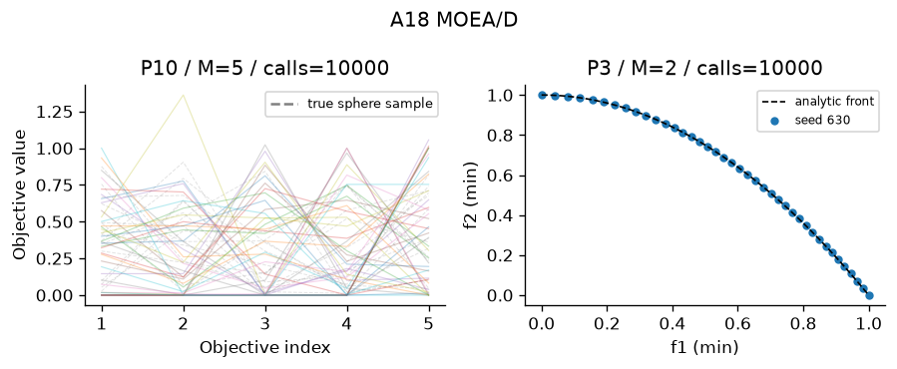
Figure A18 Recorded output on designated problems. Plotted seed and actual calls appear in the panel. The full ten-trial metrics are in the table.

19 MOEA D DE
DE variation inside MOEA/D. Module src/algorithms/moead_de.py. Status works. Defining test test_19_mechanism passes.
Implementation and defaults MOEA/D-DE: neighbourhood donor x_a+F*(x_b-x_c), binomial crossover CR=.9 with forced coordinate, F=.5; cooperative scalar replacement. Shared defaults: population=40, budget=10000, seed=63. Constraints: Deb feasibility comparison unless the stated method uses scalar penalty.
Problem | Trials | HV | IGD | Spacing | Time s
P3 | 10 | 0.08246 +/- 0.1827 | 1.257 +/- 0.8031 | 0.0007146 +/- 0.001613 | 1.672 +/- 0.2929
P5 | 10 | 1.182 +/- 3.554e-05 | 0.05253 +/- 0.01883 | 0.02536 +/- 0.01055 | 2.468 +/- 0.04699

Actual mean evaluations: P3 1e+04 of cap 10000; P5 1e+04 of cap 10000.
Advantages with mechanism reasoning 1. DE exploits vector differences; 2. Neighbour cooperation; 3. Tchebycheff reaches nonconvex fronts; 4. Forced crossover guarantees a changed coordinate
Disadvantages with mechanism reasoning 1. F and CR need tuning; 2. DE requires enough distinct neighbours; 3. Boundary clipping distorts donors; 4. Weight coverage may be uneven
Suitable use Continuous real-coded nonconvex design. Avoid: Permutation encodings without a new donor operator.
Measured limits Finite recorded front size=8.8; this is no certificate of complete coverage. Residual sampled-front IGD=1.2572; positive residual measures finite-budget approximation error.
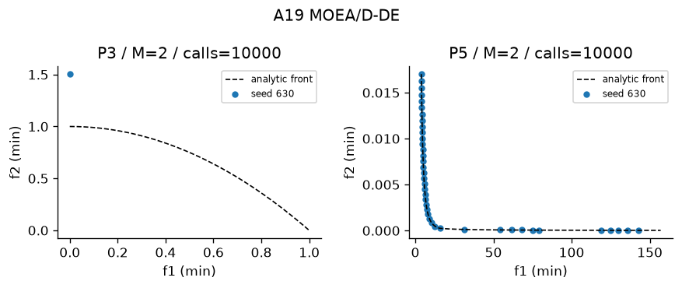
Figure A19 Recorded output on designated problems. Plotted seed and actual calls appear in the panel. The full ten-trial metrics are in the table.

20 MOEA D ACO
Weight-specific ant pheromones and scalar replacement. Module src/algorithms/moead_aco.py. Status works. Defining test test_20_mechanism passes.
Implementation and defaults MOEA/D-ACO for tours: each weight has edge pheromone, weighted distance/time heuristic, neighbour Tchebycheff replacement and deposits. Defaults alpha=1 beta=2 evaporation=.1. Requires P8. Shared defaults: population=40, budget=10000, seed=63. Constraints: Deb feasibility comparison unless the stated method uses scalar penalty.
Problem | Trials | HV | IGD | Spacing | Time s
P8 | 10 | 0.9237 +/- 0.0005056 | N/A +/- N/A | 0.00389 +/- 0.001763 | 4.13 +/- 0.02641

Actual mean evaluations: P8 1e+04 of cap 10000.
Advantages with mechanism reasoning 1. Valid tours by construction; 2. Heuristic directs ant choices; 3. Separate subproblems retain tradeoffs; 4. Pheromone records good edges
Disadvantages with mechanism reasoning 1. Pheromone arrays cost N*cities^2; 2. Deposits can lock routes; 3. Alpha beta evaporation matter; 4. Continuous encodings unsupported
Suitable use Bi-objective routing. Avoid: Smooth gradient problems.
Measured limits Finite recorded front size=5; this is no certificate of complete coverage. Exact-front IGD is unavailable for this problem, so convergence is not certified.
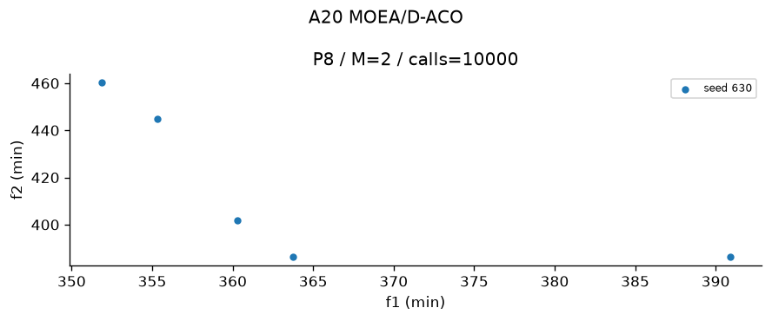
Figure A20 Recorded output on designated problems. Plotted seed and actual calls appear in the panel. The full ten-trial metrics are in the table.

21 Constrained NSGA II
NSGA-II with Deb feasibility. Module src/algorithms/constrained_nsga2.py. Status works. Defining test test_21_mechanism passes.
Implementation and defaults Constrained NSGA-II: feasible beats infeasible, lower violation wins among infeasible, Pareto rank then crowding among feasible. NSGA-II in this project also supports Deb rules; this module exposes the rule. Shared defaults: population=40, budget=10000, seed=63. Constraints: Deb feasibility comparison unless the stated method uses scalar penalty.
Problem | Trials | HV | IGD | Spacing | Time s
P5 | 10 | 1.182 +/- 7.219e-05 | 0.01466 +/- 0.002837 | 0.01974 +/- 0.002319 | 0.5638 +/- 0.007046
P6 | 10 | 1.011 +/- 0.001053 | 0.01337 +/- 0.0008598 | 0.01636 +/- 0.001703 | 0.5746 +/- 0.0121

Actual mean evaluations: P5 1e+04 of cap 10000; P6 1e+04 of cap 10000.
Advantages with mechanism reasoning 1. Feasible beats infeasible without objective penalty; 2. Lower violation guides infeasible search; 3. Pareto ranking within feasible; 4. Crowding retains feasible diversity
Disadvantages with mechanism reasoning 1. Violation normalization affects infeasible order; 2. Feasibility boundary can trap search; 3. Quadratic ranking; 4. Finite crowding resolution
Suitable use Constrained beam or Binh-Korn. Avoid: Problems needing stochastic feasibility guarantees.
Measured limits Finite recorded front size=40; this is no certificate of complete coverage. Residual sampled-front IGD=0.014663; positive residual measures finite-budget approximation error.
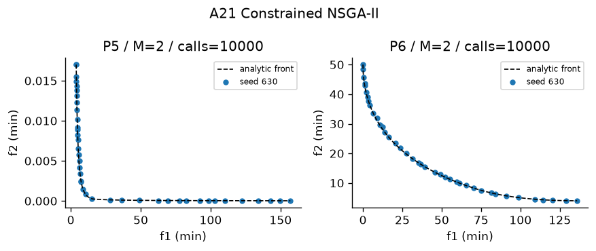
Figure A21 Recorded output on designated problems. Plotted seed and actual calls appear in the panel. The full ten-trial metrics are in the table.

22 MOPSO
Particle velocity with personal and archive leaders. Module src/algorithms/mopso.py. Status works. Defining test test_22_mechanism passes.
Implementation and defaults MOPSO: inertia velocity, personal best, crowding-selected archive leader, occasional mutation. Defaults inertia=.4, c1=c2=1.5. Shared defaults: population=40, budget=10000, seed=63. Constraints: Deb feasibility comparison unless the stated method uses scalar penalty.
Problem | Trials | HV | IGD | Spacing | Time s
P4 | 10 | 0.9325 +/- 0.001008 | N/A +/- N/A | 0.01326 +/- 0.002125 | 0.3488 +/- 0.01427
P5 | 10 | 1.182 +/- 5.901e-05 | 0.01273 +/- 0.0009179 | 0.01966 +/- 0.00158 | 0.3297 +/- 0.01865

Actual mean evaluations: P4 1e+04 of cap 10000; P5 1e+04 of cap 10000.
Advantages with mechanism reasoning 1. Memory of personal successes; 2. Few basic coefficients; 3. Archive leader spreads movement; 4. No crossover operator needed
Disadvantages with mechanism reasoning 1. Velocities can collapse; 2. Boundary clipping affects dynamics; 3. Leader policy controls diversity; 4. Coefficients require tuning
Suitable use Continuous portfolio and beam designs. Avoid: Permutation tours without discrete velocity.
Measured limits Finite recorded front size=40; this is no certificate of complete coverage. Exact-front IGD is unavailable for this problem, so convergence is not certified.
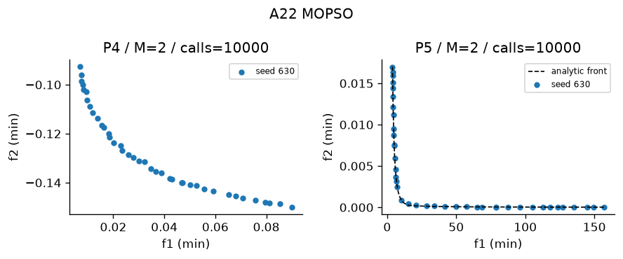
Figure A22 Recorded output on designated problems. Plotted seed and actual calls appear in the panel. The full ten-trial metrics are in the table.

23 MOGWO
Three archive leaders and encircling. Module src/algorithms/mogwo.py. Status partly works. Defining test test_23_mechanism passes.
Implementation and defaults MOGWO: alpha, beta, delta archive leaders; decreasing encircling coefficient a=2*(1-used/budget), average three proposed positions. Binary masks use a sigmoid transfer, then at-least-one repair. Shared defaults: population=40, budget=10000, seed=63. Constraints: Deb feasibility comparison unless the stated method uses scalar penalty.
Problem | Trials | HV | IGD | Spacing | Time s
P5 | 10 | 1.182 +/- 0.0001255 | 0.01314 +/- 0.0006236 | 0.01985 +/- 0.001345 | 0.5998 +/- 0.0422
P9 | 10 | 0.7932 +/- 0.04271 | N/A +/- N/A | 0.03358 +/- 0.01649 | 7.913 +/- 1.599

Actual mean evaluations: P5 1e+04 of cap 10000; P9 200 of cap 200.
Advantages with mechanism reasoning 1. Multiple leaders guide movement; 2. Coefficient shrinks automatically; 3. Archive covers tradeoffs; 4. Binary transfer enables masks
Disadvantages with mechanism reasoning 1. Averaging leaders may erase diversity; 2. No strict improvement guarantee; 3. Transfer sigmoid biases masks; 4. Binary objective evaluation is costly
Suitable use Continuous design or exploratory feature masks. Avoid: Required stable high-accuracy feature conclusions on tiny budgets.
Measured limits Finite recorded front size=40; this is no certificate of complete coverage. Residual sampled-front IGD=0.013138; positive residual measures finite-budget approximation error.
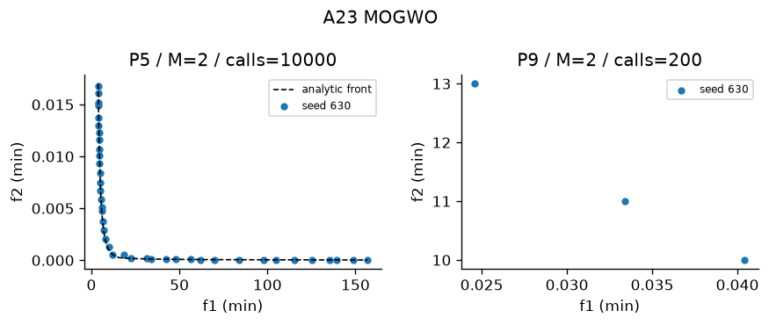
Figure A23 Recorded output on designated problems. Plotted seed and actual calls appear in the panel. The full ten-trial metrics are in the table.

24 MOABC
Employed moves, crowding-based onlookers and abandonment scouts. Module src/algorithms/moabc.py. Status works. Defining test test_24_mechanism passes.
Implementation and defaults MOABC: employed and onlooker differential-coordinate proposals, Deb dominance greedy replacement, abandoned-source scouts. Limit=20. Shared defaults: population=40, budget=10000, seed=63. Constraints: Deb feasibility comparison unless the stated method uses scalar penalty.
Problem | Trials | HV | IGD | Spacing | Time s
P3 | 10 | 0.5095 +/- 0.01272 | 0.02258 +/- 0.007054 | 0.02664 +/- 0.006989 | 0.9276 +/- 0.02662
P6 | 10 | 1.016 +/- 0.000281 | 0.01114 +/- 0.0002892 | 0.005993 +/- 0.001251 | 1.581 +/- 0.02156

Actual mean evaluations: P3 1e+04 of cap 10000; P6 1e+04 of cap 10000.
Advantages with mechanism reasoning 1. Scouts restart abandoned sources; 2. Onlooker pressure favours sparse regions; 3. Coordinate moves are inspectable; 4. No gradients needed
Disadvantages with mechanism reasoning 1. Dominance-only greed can reject useful tradeoffs; 2. Limit needs tuning; 3. Three phases complicate budget accounting; 4. One-coordinate changes may be slow
Suitable use Small continuous design with restarts. Avoid: Strongly coupled high-dimensional variables.
Measured limits Finite recorded front size=36.6; this is no certificate of complete coverage. Residual sampled-front IGD=0.022583; positive residual measures finite-budget approximation error.
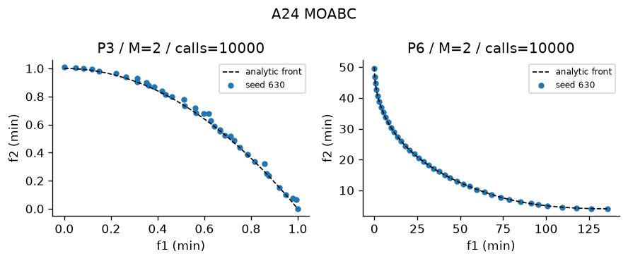
Figure A24 Recorded output on designated problems. Plotted seed and actual calls appear in the panel. The full ten-trial metrics are in the table.

25 MOACO
Two pheromone matrices and route construction. Module src/algorithms/moaco.py. Status works. Defining test test_25_mechanism passes.
Implementation and defaults MOACO: two pheromone matrices, randomized tradeoff exponent, probabilistic valid tour construction, evaporation and archive deposits. Defaults alpha=1 beta=2 evaporation=.1. P8 only. Shared defaults: population=40, budget=10000, seed=63. Constraints: Deb feasibility comparison unless the stated method uses scalar penalty.
Problem | Trials | HV | IGD | Spacing | Time s
P8 | 10 | 0.9234 +/- 0.001217 | N/A +/- N/A | 0.002724 +/- 0.001146 | 2.043 +/- 0.02242

Actual mean evaluations: P8 1e+04 of cap 10000.
Advantages with mechanism reasoning 1. Produces valid permutations; 2. Two objectives retain separate memories; 3. Heuristic reduces random route work; 4. Archive deposits reward tradeoffs
Disadvantages with mechanism reasoning 1. Strong evaporation forgets edges; 2. Weak evaporation stagnates; 3. Traffic/distance scales matter; 4. No exact TSP optimality guarantee
Suitable use Distance-time routing. Avoid: Continuous portfolio allocation.
Measured limits Finite recorded front size=4.6; this is no certificate of complete coverage. Exact-front IGD is unavailable for this problem, so convergence is not certified.
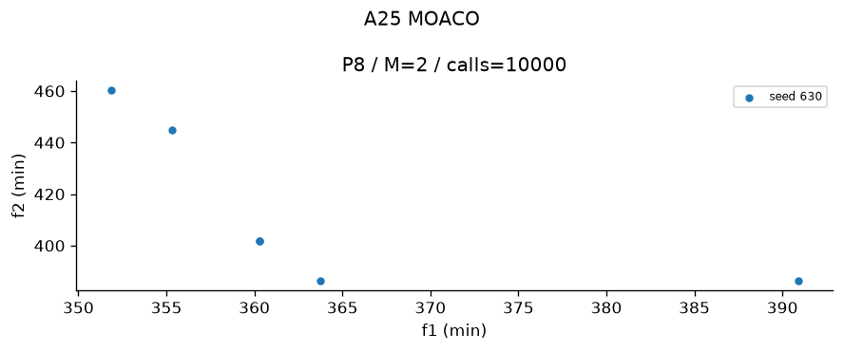
Figure A25 Recorded output on designated problems. Plotted seed and actual calls appear in the panel. The full ten-trial metrics are in the table.

26 MOSA
Incomparable neighbour acceptance and Boltzmann dominated moves. Module src/algorithms/mosa.py. Status works. Defining test test_26_mechanism passes.
Implementation and defaults Multiobjective Simulated Annealing: population of chains, normalized summed worsened-objective energy for dominated moves, Boltzmann acceptance and archive. Temperature T0=.1, cooling=.97 per population sweep, move scale=.1. Lecture Part 4 slide 41 acceptance; parallel chains are a declared extension. Incomparable neighbours always accepted. Normalized T0=.1 is not raw-unit T0=100. Shared defaults: population=40, budget=10000, seed=63. Constraints: Deb feasibility comparison unless the stated method uses scalar penalty.
Problem | Trials | HV | IGD | Spacing | Time s
P3 | 10 | 0.5048 +/- 0.01142 | 0.02343 +/- 0.006587 | 0.0405 +/- 0.01383 | 0.1936 +/- 0.01063
P5 | 10 | 1.182 +/- 0.0001516 | 0.01298 +/- 0.001509 | 0.01968 +/- 0.002269 | 0.2189 +/- 0.005545

Actual mean evaluations: P3 1e+04 of cap 10000; P5 1e+04 of cap 10000.
Advantages with mechanism reasoning 1. May accept uphill escape moves; 2. Works without derivatives; 3. Mutation adapts to encoding; 4. Archive records tradeoffs from many chains
Disadvantages with mechanism reasoning 1. Cooling schedule sensitive; 2. Local moves can miss distant regions; 3. Incomparable moves remain random at low temperature; 4. Finite cooling gives no global guarantee
Suitable use Budgeted local exploration on nonconvex fronts. Avoid: Uniform global coverage with insufficient chains.
Measured limits Finite recorded front size=35.1; this is no certificate of complete coverage. Residual sampled-front IGD=0.023434; positive residual measures finite-budget approximation error.
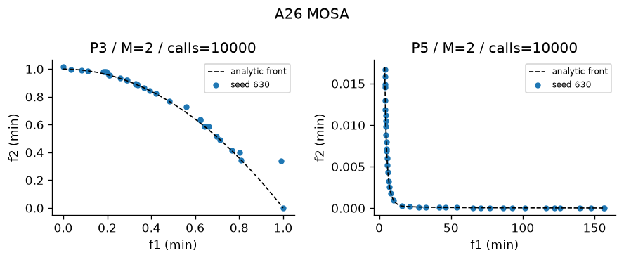
Figure A26 Recorded output on designated problems. Plotted seed and actual calls appear in the panel. The full ten-trial metrics are in the table.

27 MODE
DE dominance-only trial replacement. Module src/algorithms/mode.py. Status works. Defining test test_27_mechanism passes.
Implementation and defaults MODE: DE/rand/1 and forced binomial crossover; trial replaces target only if it dominates under Deb rules. F=.5, CR=.9. Output archive retains tradeoffs. Shared defaults: population=40, budget=10000, seed=63. Constraints: Deb feasibility comparison unless the stated method uses scalar penalty.
Problem | Trials | HV | IGD | Spacing | Time s
P3 | 10 | 0.11 +/- 3.731e-11 | 0.6098 +/- 1.416e-11 | 0 +/- 0 | 0.218 +/- 0.006621
P5 | 10 | 1.181 +/- 0.0003965 | 0.01749 +/- 0.005466 | 0.01921 +/- 0.002729 | 0.2924 +/- 0.008113

Actual mean evaluations: P3 1e+04 of cap 10000; P5 1e+04 of cap 10000.
Advantages with mechanism reasoning 1. Simple vector donor; 2. No utility weights; 3. CR forces one donor coordinate; 4. Dominating trials preserve target improvement
Disadvantages with mechanism reasoning 1. Incomparable trials do not replace targets; 2. F CR sensitivity; 3. Coordinate clipping can stagnate; 4. Only real encoding is implemented
Suitable use Continuous design with comparable improvements. Avoid: Many objectives with almost no domination.
Measured limits Finite recorded front size=1; this is no certificate of complete coverage. Residual sampled-front IGD=0.6098; positive residual measures finite-budget approximation error.
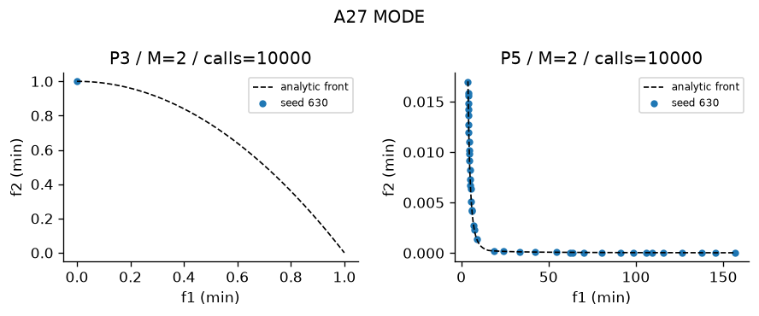
Figure A27 Recorded output on designated problems. Plotted seed and actual calls appear in the panel. The full ten-trial metrics are in the table.

28 MO TLBO
Crowding archive teacher, shrinking TF and nondominated learner moves. Module src/algorithms/motlbo.py. Status works. Defining test test_28_mechanism passes.
Implementation and defaults MO-TLBO: teacher phase x+r*(teacher-TF*mean); learner phase towards better peer or away from worse peer. TF shrinks from 2 to 1. Nondominated replacement, archive tracks nondominated proposals. Shared defaults: population=40, budget=10000, seed=63. Constraints: Deb feasibility comparison unless the stated method uses scalar penalty.
Problem | Trials | HV | IGD | Spacing | Time s
P3 | 10 | 0.5318 +/- 6.388e-05 | 0.009556 +/- 0.0001011 | 0.003339 +/- 0.001126 | 1.387 +/- 0.008201
P5 | 10 | 1.182 +/- 2.638e-05 | 0.01218 +/- 0.0003034 | 0.02268 +/- 0.0006511 | 1.439 +/- 0.02095

Actual mean evaluations: P3 1e+04 of cap 10000; P5 1e+04 of cap 10000.
Advantages with mechanism reasoning 1. No crossover design needed; 2. Teacher encourages exploitation; 3. Learners use peer information; 4. Shrinking TF changes search scale
Disadvantages with mechanism reasoning 1. Teacher choice depends on archive; 2. Incomparable moves can wander; 3. Population means blur disconnected regions; 4. TF schedule differs from conventional TLBO
Suitable use Small continuous educational examples. Avoid: Highly multimodal separated feasible regions.
Measured limits Finite recorded front size=40; this is no certificate of complete coverage. Residual sampled-front IGD=0.0095565; positive residual measures finite-budget approximation error.
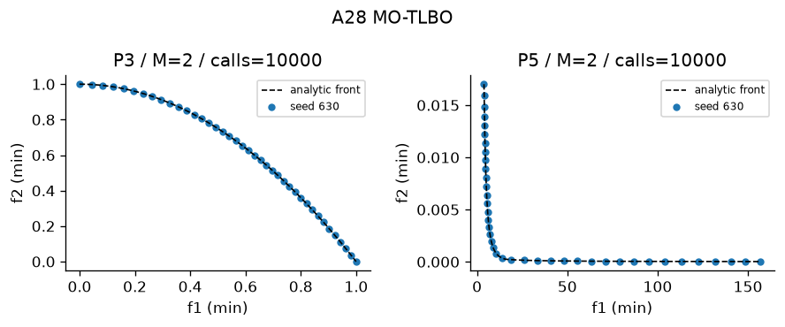
Figure A28 Recorded output on designated problems. Plotted seed and actual calls appear in the panel. The full ten-trial metrics are in the table.

29 MOBA
Frequency velocity, pulse and loudness. Module src/algorithms/moba.py. Status works. Defining test test_29_mechanism passes.
Implementation and defaults MOBA: frequency velocity toward archive leader, pulse-controlled local random walk, loudness acceptance. fmin=0 fmax=2, loudness*=.95, pulse=1*(1-exp(-.1*g)). Pareto archive stores all visited feasible points. Shared defaults: population=40, budget=10000, seed=63. Constraints: Deb feasibility comparison unless the stated method uses scalar penalty.
Problem | Trials | HV | IGD | Spacing | Time s
P3 | 10 | 0.4002 +/- 0.113 | 0.139 +/- 0.1216 | 0.0438 +/- 0.06247 | 0.482 +/- 0.0114
P4 | 10 | 0.9331 +/- 0.001591 | N/A +/- N/A | 0.01379 +/- 0.002415 | 0.5361 +/- 0.008777

Actual mean evaluations: P3 1e+04 of cap 10000; P4 1e+04 of cap 10000.
Advantages with mechanism reasoning 1. Few interpretable schedules; 2. Local walks exploit leaders; 3. Frequency creates long moves; 4. Archive records candidate tradeoffs
Disadvantages with mechanism reasoning 1. Loudness decay suppresses replacement; 2. Velocity can explode then clip; 3. Pulse schedule sensitive; 4. Archive quality may exceed final-chain quality
Suitable use Continuous local refinement. Avoid: Robust full-front exploration without schedule tuning.
Measured limits Finite recorded front size=37.1; this is no certificate of complete coverage. Residual sampled-front IGD=0.13896; positive residual measures finite-budget approximation error.
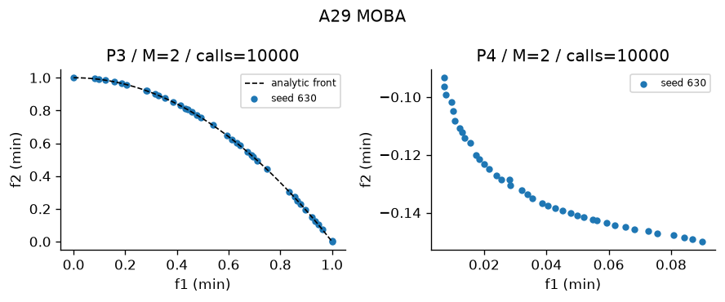
Figure A29 Recorded output on designated problems. Plotted seed and actual calls appear in the panel. The full ten-trial metrics are in the table.

30 MOMA
NSGA-II plus sparse-child combined-score hill climbing. Module src/algorithms/moma.py. Status partly works. Defining test test_30_mechanism passes.
Implementation and defaults MOMA: NSGA-II global search and normalized combined-improvement hill-climb on a subset of children. Local fraction=.25, mutation scale=.02. Local calls count in budget. Shared defaults: population=40, budget=10000, seed=63. Constraints: Deb feasibility comparison unless the stated method uses scalar penalty.
Problem | Trials | HV | IGD | Spacing | Time s
P5 | 10 | 1.182 +/- 4.265e-05 | 0.01362 +/- 0.002135 | 0.01971 +/- 0.002315 | 0.7399 +/- 0.01401
P9 | 10 | 0.8673 +/- 0.0325 | N/A +/- N/A | 0.04975 +/- 0.03517 | 5.45 +/- 0.8599

Actual mean evaluations: P5 1e+04 of cap 10000; P9 200 of cap 200.
Advantages with mechanism reasoning 1. Local moves refine global children; 2. Elitist survival; 3. Works with binary/tour mutation; 4. Local cost explicitly counted
Disadvantages with mechanism reasoning 1. Local calls reduce global generations; 2. Combined-score preference changes tradeoffs; 3. Mutation neighbourhood determines refinement; 4. Feature CV makes local search costly
Suitable use Beam refinement or routing. Avoid: Expensive objectives with no local structure.
Measured limits Finite recorded front size=40; this is no certificate of complete coverage. Residual sampled-front IGD=0.013616; positive residual measures finite-budget approximation error.
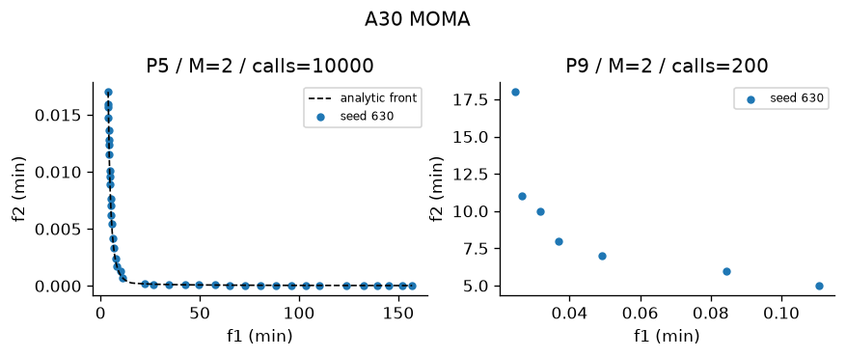
Figure A30 Recorded output on designated problems. Plotted seed and actual calls appear in the panel. The full ten-trial metrics are in the table.

31 RVEA
Normalized reference vectors and lecture linear-progress APD. Module src/algorithms/rvea.py. Status works. Defining test test_31_mechanism passes.
Implementation and defaults RVEA: reference-vector association and angle-penalized distance (APD), penalty strength alpha=2. Range-adapt vectors every 10 generations. One best member per vector, fill unoccupied slots by APD. Shared defaults: population=40, budget=10000, seed=63. Constraints: Deb feasibility comparison unless the stated method uses scalar penalty.
Problem | Trials | HV | IGD | Spacing | Time s
P10 M3 | 10 | 0.6401 +/- 0.008675 | 0.1087 +/- 0.005053 | 0.1013 +/- 0.007662 | 0.5463 +/- 0.01223
P10 M5 | 10 | 1.008 +/- 0.02081 | 0.3082 +/- 0.01173 | 0.2683 +/- 0.01688 | 0.6147 +/- 0.02021

Actual mean evaluations: P10 1e+04 of cap 10000; P10 1e+04 of cap 10000.
Advantages with mechanism reasoning 1. Angular niches aid many objectives; 2. APD shifts toward convergence; 3. Vector adaptation tracks scales; 4. Sparse niches can retain representatives
Disadvantages with mechanism reasoning 1. Penalty strength and adaptation period matter; 2. Observed ranges can be unstable; 3. Empty niches require fill policy; 4. Reference alignment can bias coverage
Suitable use Five-objective DTLZ2. Avoid: Strongly irregular disconnected fronts.
Measured limits Finite recorded front size=40; this is no certificate of complete coverage. Residual sampled-front IGD=0.10871; positive residual measures finite-budget approximation error.
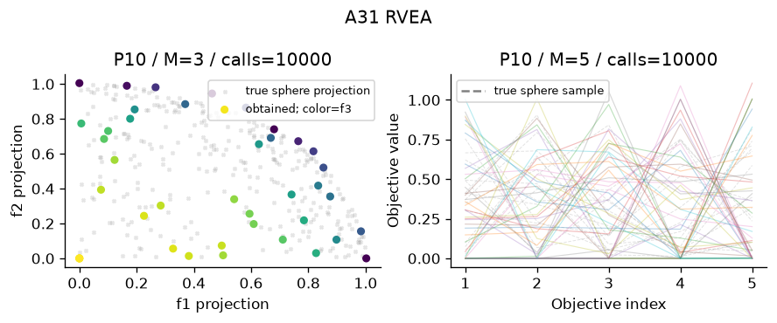
Figure A31 Recorded output on designated problems. Plotted seed and actual calls appear in the panel. The full ten-trial metrics are in the table.

32 IBEA
Outgoing additive-epsilon fitness and largest-fitness deletion. Module src/algorithms/ibea.py. Status works. Defining test test_32_mechanism passes.
Implementation and defaults IBEA: additive epsilon indicator I(a,b)=max_j(a_j-b_j); outgoing fitness -sum_j exp(-I(i,j)/kappa), largest removed, iterative worst removal with recalculation. kappa=.05; normalized objective ranges; feasibility penalty before indicator. Shared defaults: population=40, budget=10000, seed=63. Constraints: Deb feasibility comparison unless the stated method uses scalar penalty.
Problem | Trials | HV | IGD | Spacing | Time s
P14 | 10 | 0.8305 +/- 0.01035 | 0.02018 +/- 0.005315 | 0.02449 +/- 0.006615 | 1.502 +/- 0.03225
P3 | 10 | 0.1935 +/- 0.01998 | 0.3559 +/- 0.03541 | 0.007561 +/- 0.005889 | 1.547 +/- 0.03592

Actual mean evaluations: P14 1e+04 of cap 10000; P3 1e+04 of cap 10000.
Advantages with mechanism reasoning 1. No separate sharing operator; 2. Indicator gives selection pressure; 3. Works on nonconvex fronts; 4. Kappa controls discrimination
Disadvantages with mechanism reasoning 1. Exponentials can saturate; 2. Kappa changes selection; 3. Recalculated deletion is costly; 4. Fitness depends strongly on scales
Suitable use Small bi-objective indicator experiments. Avoid: Large populations with limited CPU.
Measured limits Finite recorded front size=40; this is no certificate of complete coverage. Residual sampled-front IGD=0.020185; positive residual measures finite-budget approximation error.
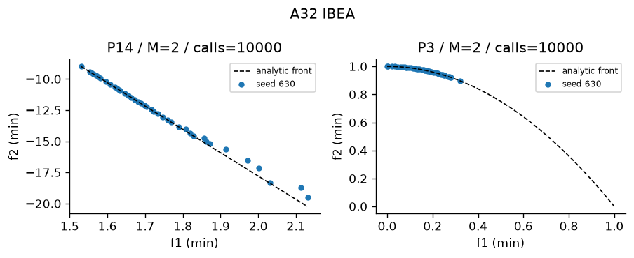
Figure A32 Recorded output on designated problems. Plotted seed and actual calls appear in the panel. The full ten-trial metrics are in the table.

33 SMS EMOA
Steady-state smallest HV deletion. Module src/algorithms/sms_emoa.py. Status works. Defining test test_33_mechanism passes.
Implementation and defaults SMS-EMOA: one offspring, nondominated sorting, delete least HV contribution in worst front. Exact 2-D exclusive contributions. Reference is component maximum + .1 in normalized coordinates. Shared defaults: population=40, budget=10000, seed=63. Constraints: Deb feasibility comparison unless the stated method uses scalar penalty.
Problem | Trials | HV | IGD | Spacing | Time s
P14 | 10 | 0.8587 +/- 1.948e-05 | 0.007575 +/- 1.648e-05 | 0.00243 +/- 0.0008177 | 5.593 +/- 0.2949
P3 | 10 | 0.5319 +/- 7.994e-05 | 0.009663 +/- 0.0001899 | 0.003307 +/- 0.001127 | 6.48 +/- 0.9188

Actual mean evaluations: P14 1e+04 of cap 10000; P3 1e+04 of cap 10000.
Advantages with mechanism reasoning 1. Direct quality indicator survival; 2. One-offspring updates are simple; 3. Exact two-objective contribution; 4. Protects coverage within the chosen reference
Disadvantages with mechanism reasoning 1. HV reference controls preferences; 2. One-at-a-time sorting costs many calls; 3. Implemented only for two objectives; 4. HV can prioritize extremes unevenly
Suitable use Small bi-objective design. Avoid: Many objectives without an HV approximation.
Measured limits Finite recorded front size=40; this is no certificate of complete coverage. Residual sampled-front IGD=0.0075754; positive residual measures finite-budget approximation error.
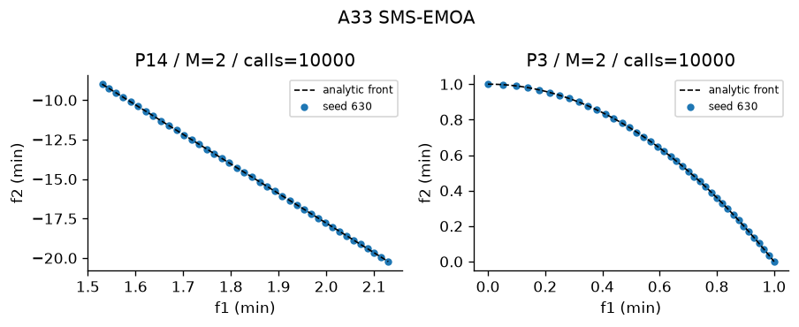
Figure A33 Recorded output on designated problems. Plotted seed and actual calls appear in the panel. The full ten-trial metrics are in the table.

34 HypE
Equal-share Monte Carlo HV fitness and repeated deletion. Module src/algorithms/hype.py. Status works. Defining test test_34_mechanism passes.
Implementation and defaults HypE: Monte Carlo hypervolume fitness with equal shared credits, iterative contribution deletion. Samples=256 selection, final HV uses 8192. Credits account for shared dominated samples; noisy selection is a limitation. Shared defaults: population=40, budget=10000, seed=63. Constraints: Deb feasibility comparison unless the stated method uses scalar penalty.
Problem | Trials | HV | IGD | Spacing | Time s
P10 M3 | 10 | 0.6614 +/- 0.02324 | 0.1218 +/- 0.01299 | 0.09629 +/- 0.01709 | 4.289 +/- 0.04698
P10 M5 | 10 | 0.77 +/- 0.1457 | 0.4398 +/- 0.07965 | 0.3217 +/- 0.06466 | 4.702 +/- 0.08547

Actual mean evaluations: P10 1e+04 of cap 10000; P10 1e+04 of cap 10000.
Advantages with mechanism reasoning 1. HV sharing supports many objectives; 2. Shared samples account for overlapping domination; 3. Re-estimation updates remaining credit; 4. Final evaluation samples are identical across methods
Disadvantages with mechanism reasoning 1. Sampling noise changes survivors; 2. Selection sample count is small; 3. Repeated deletion costs CPU; 4. HV still needs a reference box
Suitable use Many-objective indicator study. Avoid: High-precision survival contribution estimates.
Measured limits Finite recorded front size=40; this is no certificate of complete coverage. Residual sampled-front IGD=0.12184; positive residual measures finite-budget approximation error.
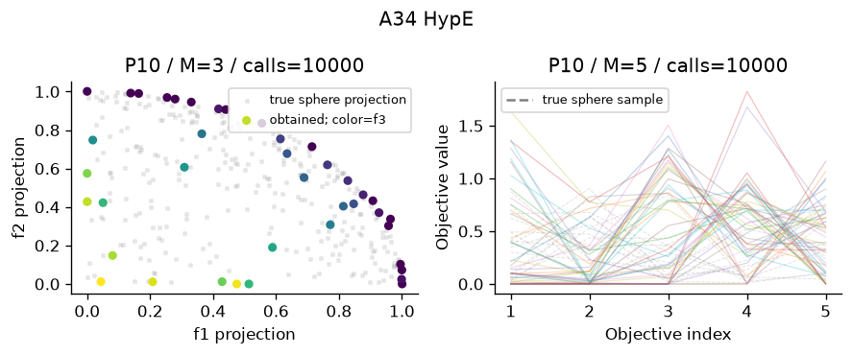
Figure A34 Recorded output on designated problems. Plotted seed and actual calls appear in the panel. The full ten-trial metrics are in the table.

35 R NSGA II
Reference preference and epsilon clearing. Module src/algorithms/r_nsga2.py. Status works. Defining test test_35_mechanism passes.
Implementation and defaults R-NSGA-II: nondominated fronts, normalized distance to aspiration, epsilon clearing to spread preferred survivors. epsilon=.05; default balanced normalized aspiration [.5,.5], P14 uses natural [1.8,-12]. Shared defaults: population=40, budget=10000, seed=63. Constraints: Deb feasibility comparison unless the stated method uses scalar penalty.
Problem | Trials | HV | IGD | Spacing | Time s
P14 | 10 | 0.8563 +/- 0.0006447 | 0.009446 +/- 0.0004959 | 0.01289 +/- 0.001826 | 0.817 +/- 0.01779
P5 | 10 | 1.177 +/- 0.00655 | 0.012 +/- 0.002219 | 0.01635 +/- 0.00387 | 0.8419 +/- 0.03731

Actual mean evaluations: P14 1e+04 of cap 10000; P5 1e+04 of cap 10000.
Advantages with mechanism reasoning 1. Focuses on desired region; 2. Clearing promotes local diversity; 3. Retains nondominated hierarchy; 4. Preference is physically interpretable on P14
Disadvantages with mechanism reasoning 1. Wrong aspiration biases search; 2. Epsilon controls local spacing; 3. Full-front quality can drop; 4. Default balanced aspiration is arbitrary
Suitable use Decision-maker laptop region. Avoid: Unknown or frequently changing preferences.
Measured limits Finite recorded front size=40; this is no certificate of complete coverage. Residual sampled-front IGD=0.0094464; positive residual measures finite-budget approximation error.
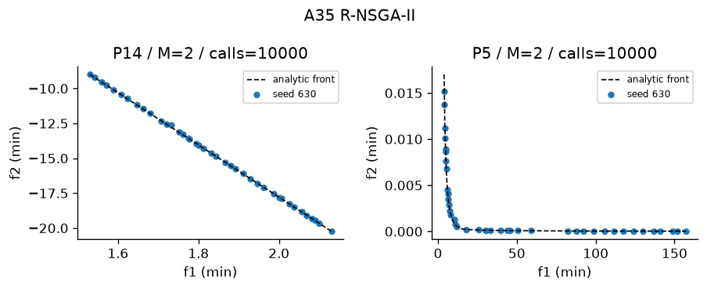
Figure A35 Recorded output on designated problems. Plotted seed and actual calls appear in the panel. The full ten-trial metrics are in the table.

36 MGDA
Minimum-norm gradient combination. Module src/algorithms/mgda.py. Status works. Defining test test_36_mechanism passes.
Implementation and defaults MGDA: minimum-norm convex combination of task gradients. For two tasks solve lambda analytically; clamp to [0,1]. Learning rate=.05. Toy losses have gradients 2*(x-a),2*(x-b). No convergence theorem assumed for arbitrary nonconvex neural networks.
Problem | Trials | HV | IGD | Spacing | Time s
P13 | 1 | 0.2839 +/- 0 | 0.6279 +/- 0 | 0 +/- 0 | 0.3109 +/- 0

Actual mean evaluations: P13 1e+04 of cap 10000.
Advantages with mechanism reasoning 1. Common descent when norm is nonzero; 2. Analytical two-task weights; 3. No objective-scale utility required; 4. Can converge to Pareto stationarity
Disadvantages with mechanism reasoning 1. Requires gradients; 2. Stationarity is not full-front coverage; 3. May stop while each task has gradient; 4. Nonconvex network optima are local
Suitable use Differentiable conflicting tasks. Avoid: Discrete designs or a full Pareto-front sweep.
Measured limits Finite recorded front size=1; this is no certificate of complete coverage. Residual sampled-front IGD=0.62794; positive residual measures finite-budget approximation error.
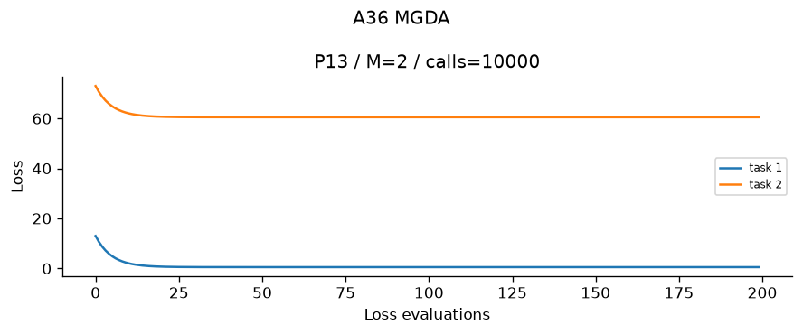
Figure A36 Recorded output on designated problems. Plotted seed and actual calls appear in the panel. The full ten-trial metrics are in the table.

37 GradNorm
Gradient-norm adaptive task weights. Module src/algorithms/gradnorm.py. Status works. Defining test test_37_mechanism passes.
Implementation and defaults GradNorm: adaptive weights minimizing sum |G_i-target_i|. G_i=w_i*||gradient_i||; target=mean(G)*relative_training_rate**alpha, stop-gradient target, weights renormalized to sum(tasks). Alpha=1.5, weight_lr=.01, model_lr=.05. Hand-derived weight gradient uses sign. This supports toy objectives and the handwritten shared network.
Problem | Trials | HV | IGD | Spacing | Time s
P13 | 1 | 0.6052 +/- 0 | 0.433 +/- 0 | 0 +/- 0 | 0.4071 +/- 0

Actual mean evaluations: P13 1e+04 of cap 10000.
Advantages with mechanism reasoning 1. Balances task gradient magnitudes; 2. Training rates influence targets; 3. Hand-derived update is inspectable; 4. Task-scale stress can be evaluated
Disadvantages with mechanism reasoning 1. Requires gradients and initial losses; 2. Alpha weight_lr matter; 3. Does not guarantee common descent; 4. Toy final point is not an entire front
Suitable use Shared network with unequal loss gradients. Avoid: A guaranteed Pareto descent method.
Measured limits Finite recorded front size=1; this is no certificate of complete coverage. Residual sampled-front IGD=0.43296; positive residual measures finite-budget approximation error.
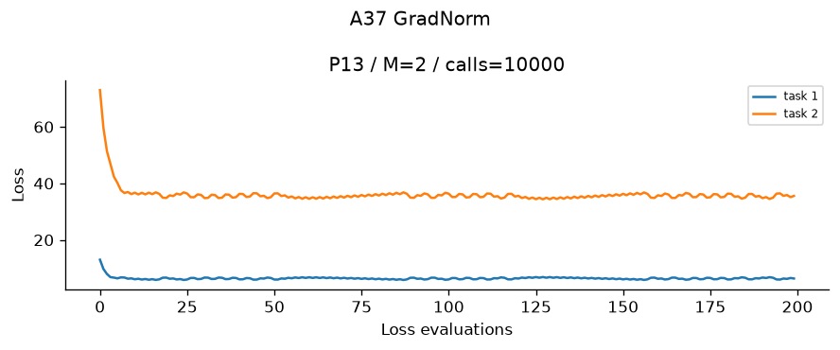
Figure A37 Recorded output on designated problems. Plotted seed and actual calls appear in the panel. The full ten-trial metrics are in the table.

6 Task C assigned study cards and hand traces

26 MOSA Multiobjective Simulated Annealing
Historical context: Paolo Serafini's 1994 chapter, "Simulated annealing for multi objective optimization problems", in Multiple Criteria Decision Making: Expand and Enrich the Domains of Thinking and Application, Springer, pp. 283-292, is an early multiobjective SA treatment. The author's older web listing says 1993; his current CV says 1994. We report 1994 as the publication year and record this discrepancy. MOSA is a family rather than one universally fixed algorithm; this implementation does not claim to reproduce all of Serafini's acceptance rules.
Core idea (five lines): keep four or more local-search chains; propose a nearby design; accept improving or incomparable neighbours; occasionally accept dominated moves with probability exp(-delta/T); cool T and record a Pareto archive.
Flow: initialize chains -> mutate -> evaluate -> Deb feasibility check -> energy/temperature acceptance -> update chain -> record nondominated proposals -> cool -> budget reached?
1. Sample population uniformly in bounds. Repair encodings and initialize recording archive.
2. Propose one mutation per chain. Real coordinate mutation: x'=clip(x+0.1*(upper-lower)*z), z normal(0,1); permutations use swap or inversion.
3. Normalize z_j=(f_j-ideal_j)/(nadir_j-ideal_j). Use the lecture sum of positive objective differences for dominated moves.
4. If proposal dominates chain under Deb's rules, accept. Feasible-to-infeasible moves are rejected. If the current solution does not dominate the feasible proposal, accept unconditionally. Otherwise delta=sum(max(z'-z,0)), p=exp(-delta/T). Between infeasible proposals use violation increase.
5. Accept if uniform u<p; record every proposal in a passive archive; cool T=T0*cooling^generation.
6. Terminate at 10000 counted candidate evaluations. Archive capped at population size by crowding.
Parameters: T0=.1; too small freezes uphill escape, too large yields random wandering. Cooling=.97; too low cools before exploration, too high prolongs random acceptance. Move scale=.1; small misses distant basins, large repeatedly hits bounds. Population=40; small limits output coverage, large uses budget on fewer sweeps. Archive cap=population; low cap loses diversity, large increases O(A^2*M) bookkeeping. Violation penalty=10 only between infeasible candidates; stronger promotes feasibility but can erase objective influence.
Convergence: cooling helps exploitation but finite-budget runs do not inherit a global SA theorem. Diversity: unconditional tradeoff moves and archive crowding, without a guaranteed uniform front. Constraints: feasibility first, then violation. Nonconvex/disconnected fronts: local moves can traverse them at sufficient temperature but may miss separated basins. Many objectives: scalar energies remain usable, yet domination becomes sparse and bounded archives lose coverage.
Cost: proposal O(d), evaluation problem dependent, chain update O(M); archive maintenance O(M*A^2) per recorded population in a straightforward implementation. This implementation records each population batch for MOSA; peak memory O(A*d+A*M+M*A^2).
Hand traces: exact Part 4 chip example x=10->13->15, F=(20,10)->(17,11.5)->(15,12.5), T=100->90->81; both moves incomparable and accepted. Additional population-four P1 fixture starts [3,4,6,7], T0=.1. Proposals [3.5,4.5,6.5,7.5] have summed positive normalized differences [.015625,.078125,.203125,.28125]; only the fourth is dominated, probability exp(-2.8125). Fixed uniforms [.1,.2,.9,.1] yield [3.5,4.5,6.5,7]. Next proposals [4,5,7,6.5] are all incomparable and accepted. Full objective tables, acceptance and mutation draws are stored in hand_traces.json and tested.
Sensitivity: cooling=.90,.97,.995, 10 seeds each on P3, fixed 10000 cap. These correspond to fast, moderate and slow cooling. Interpretation is generated from measured summary rows, not assumed.

1 Weighted Sum
Historical context: weighted sums predate modern named multiobjective optimizers, so a unique inventor/year is not asserted. Lotfi A. Zadeh's 1963 "Optimality and non-scalar-valued performance criteria", IEEE Transactions on Automatic Control 8(1), 59-60, DOI 10.1109/TAC.1963.1105511, is a foundational efficiency reference, not a claim that he invented the weighted-sum method.
Core idea: choose nonnegative weights; normalize objectives; minimize one linear combination; repeat for a sequence of weights; keep feasible nondominated solutions.
Flow: fixed scales -> simplex weight -> scalar solve -> save feasible endpoint -> next weight -> Pareto filter.
1. Declare common objective ideal/nadir constants.
2. Choose w_j>=0 with sum(w)=1. Default two-objective weights t,1-t for t in linspace(0,1,21).
3. Solve min s(x)=sum_j w_j*z_j(x), subject to the original bounds and constraints using SLSQP.
4. Record solver termination, actual objective/constraint objective calls and decision.
5. Pareto-filter successful feasible sweep candidates. Natural termination means fewer than 10000 actual calls; no unused calls are relabelled.
Parameters: weight t controls orientation; near 0 favours objective 2 and near 1 objective 1. Number of settings=21; fewer than 10 violates Task D; very many spends effort on duplicate supported solutions. Ideal/nadir scales control weight meaning; poor scales overwhelm small objectives. SLSQP tolerance=1e-10: loose leaves error, extremely tight increases work; max iterations=120: low truncates solves, high increases cost. Starting point depends on seed; a local optimizer may miss a global scalar minimum. Zero weights can produce only weak efficiency.
Guarantee: positive weights and an exact global solve imply Pareto efficiency: any dominator would reduce the weighted scalar, a contradiction. The converse holds only for supported efficient points. On P3, z2=1-z1^2; for fixed w the scalar is concave in z1 and attains its minimum at 0 or 1, so interior dented points cannot be selected by any positive weight. Finite local solves need independent convergence checks.
Diversity: controlled by sweep, not automatic. Equal weights are not equal arc lengths. Constraints: inherited from scalar solver. Many objectives: number of simplex settings grows rapidly and preferences become difficult. Discrete variants need enumeration or a discrete scalar solver; SLSQP is used only for real-valued problems here.
Cost: K scalar solves; O(K*S*C_eval) objective work, where S is calls per solve, plus O(K^2*M) Pareto filtering. Solver complexity is problem dependent, not universally O(n^3).
Hand trace P1 (raw scale is equal in both objectives): derivative 2*w*(x-3)+2*(1-w)*(x-7)=0 -> x=7-4*w. w=.25 gives x=6, F=(9,1), scalar=3. w=.75 gives x=4, F=(1,9), scalar=3. Second derivative=2>0, bounds satisfied. Both normalized scalars are 3/16.
Sensitivity: 11,21,41 settings, ten seeds on P3. Sampling density cannot overcome unsupported-front geometry; actual call counts change and this is not a strict equal-consumed-budget comparison.

13 NPGA Niched Pareto Genetic Algorithm
Jeffrey Horn, N. Nafpliotis and David E. Goldberg (1994), "A niched Pareto genetic algorithm for multiobjective optimization", Proceedings of the First IEEE Conference on Evolutionary Computation, pp. 82-87, DOI 10.1109/ICEC.1994.350037. An author-uploaded copy verifies the metadata. The method addresses maintaining a diverse tradeoff population without choosing one scalar utility. Earlier technical reports may precede the conference paper; 1994 is the cited publication.
Core idea: draw two contestants; compare them directly by dominance; otherwise measure each niche count against a separate comparison set and choose the less crowded contestant; vary winners to produce a new non-elitist generation.
Flow: population -> contestants and comparison set -> direct dominance -> comparison-set niche tie-break -> mating -> SBX/mutation -> replace population -> record output archive.
1. Initialize real vectors uniformly or valid discrete encodings.
2. Normalize the current generation by observed ranges for niche distances; this differs from fixed quality-metric scales.
3. Sample distinct contestants a,b and comparison set C of size min(2,N-2), excluding contestants. Compare a and b directly under Deb rules; this is the supplied lecture teaching variant.
4. If one contestant dominates the other, return that contestant. Otherwise use niche_i=sum_(j in C) max(0,1-(distance(i,j)/sigma)^2), sigma=.3. The comparison set excludes contestants; ties select the first within numerical tolerance 1e-12.
5. Pool tournament winners; SBX eta=15 and mutation probability 1/d create children. Permutations, when applicable, use OX plus swap/inversion.
6. Replace the generation without elitism. A passive logging archive does not participate in selection. Stop at 10000 actual candidate evaluations.
Parameters: sigma=.3; too small loses sharing except duplicates, too large averages global density and weakens local niche resolution. Comparison size=2; small gives noisy niche estimates, large costs more and approaches full-population density. Population=40; small misses niches, large reduces generations per fixed budget. Crossover eta=15; small jumps widely, large stays close to parents. Mutation scale=.1 and probability=1/d; too low stalls exploration, too high disrupts useful coordinates. Direct contestant dominance and separate comparison-set sharing follow Non-Elitist slide 27. The original publication uses a different tournament convention; the course variant is explicit.
Convergence: selection favours directly dominating contestants but provides no elitist guarantee. Diversity: sharing explicitly rewards sparse regions. Constraints: Deb-aware comparisons. Nonconvex fronts: no linear scalarization barrier. Many objectives: most contestants become incomparable and niche decisions dominate; distances also become less discriminative.
Cost: the running selector computes normalization and comparison distances per tournament, costing O(N*(N*M+|C|*M)); a cached alternative could reduce repeated normalization, crossover/mutation O(N*d), plus evaluations and output archive costs. Peak comparison-set memory O(|C|*M), plus population O(N*d+N*M) and passive archive pairwise bookkeeping. The standalone tournament helper recomputes sharing for transparent trace verification; the running selector uses the lecture comparison-set helper.
Hand traces: exact four-topology lecture table A=(10,.80),B=(15,.90),C=(12,.85),D=(18,.95). Fixed scales are (cost-10)/10 and (reliability-.8)/.2. For A vs B with C,D: distances .320156,1.096586,.390512,.390512; quadratic shares .59,0,.39,.39 give NC(A)=.59,NC(B)=.78; A wins. C vs D with A,B gives NC(C)=.98,NC(D)=.39; D wins. The displayed lecture values .778/.979 are approximate; exact arithmetic preserves both decisions. Additional full population-four generations on P1 enumerate every distance, sharing term, pair-specific comparison set, winner, fixed SBX beta=1 and Gaussian mutation draw in hand_traces.json. The second generation recomputes dominance before using density.
Sensitivity: sigma=.1,.3,.6, ten seeds on P3. The three values test local, moderate and broad sharing. Compare HV, IGD and Spacing along with final population diversity; a zero Spacing singleton is not good coverage.

Flow diagram A26 MOSA
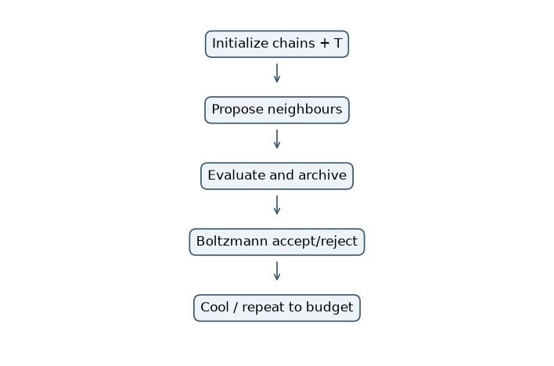
Figure C26 Current implementation control flow

Flow diagram A1 Weighted Sum
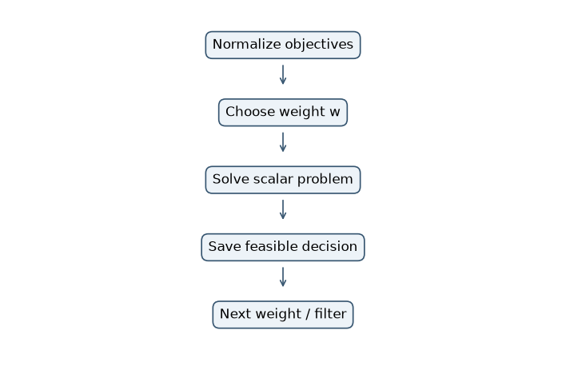
Figure C1 Current implementation control flow

Flow diagram A13 NPGA
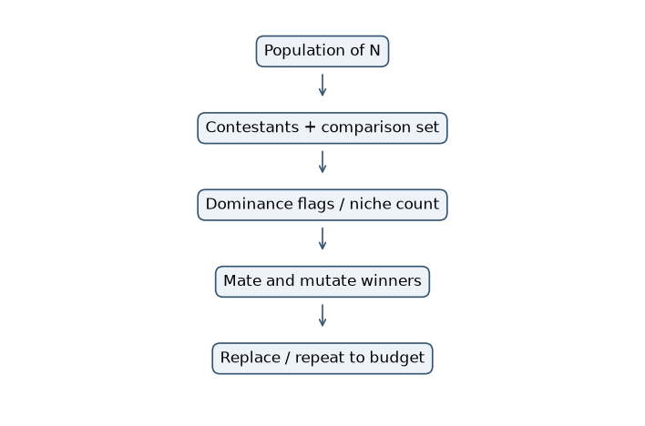
Figure C13 Current implementation control flow

Weighted Sum two settings
w1 | w2 | x | f1 | f2 | Scalar
0.25 | 0.75 | 6.0 | 9.0 | 1.0 | 3.0
0.75 | 0.25 | 4.0 | 1.0 | 9.0 | 3.0

Stationarity gives 2*w*(x-3)+2*(1-w)*(x-7)=0, hence x=7-4*w; second derivative=2. Both solutions satisfy [1,10] and lie in the Pareto set [3,7]. No random choices enter this trace.

MOSA lecture and population four trace
Step | Current x | Next x | Current F | Next F | T next | Rule
1 | 10 | 13 | (20,10) | (17,11.5) | 90 | incomparable accept
2 | 13 | 15 | (17,11.5) | (15,12.5) | 81 | incomparable accept

Raw-unit dominated example (20,10)->(23,12): deltaE=3+2=5; p=exp(-5/100)=0.951229. At T=1, p=0.006738. The displayed lecture curve is corrected to f2=20-.5*f1.

Population iteration 1
T=0.1. The draws and proposals are fixed. Normalized objectives use division by 16; no preference weights enter acceptance.
Chain | x | Proposal | Old norm F | New norm F | Delta positive | p | u | Accept
0 | 3 | 3.5 | 0,1 | 0.01562,0.7656 | 0.01562 | 1 | 0.1 | True
1 | 4 | 4.5 | 0.0625,0.5625 | 0.1406,0.3906 | 0.07812 | 1 | 0.2 | True
2 | 6 | 6.5 | 0.5625,0.0625 | 0.7656,0.01562 | 0.2031 | 1 | 0.9 | True
3 | 7 | 7.5 | 1,0 | 1.266,0.01562 | 0.2812 | 0.06005 | 0.1 | False

Next population [3.5, 4.5, 6.5, 7.0]. All proposals are recorded by the passive Pareto archive, independently of chain acceptance.

Population iteration 2
T=0.097. The draws and proposals are fixed. Normalized objectives use division by 16; no preference weights enter acceptance.
Chain | x | Proposal | Old norm F | New norm F | Delta positive | p | u | Accept
0 | 3.5 | 4 | 0.01562,0.7656 | 0.0625,0.5625 | 0.04688 | 1 | 0.2 | True
1 | 4.5 | 5 | 0.1406,0.3906 | 0.25,0.25 | 0.1094 | 1 | 0.3 | True
2 | 6.5 | 7 | 0.7656,0.01562 | 1,0 | 0.2344 | 1 | 0.7 | True
3 | 7 | 6.5 | 1,0 | 0.7656,0.01562 | 0.01562 | 1 | 0.4 | True

Next population [4.0, 5.0, 7.0, 6.5]. All proposals are recorded by the passive Pareto archive, independently of chain acceptance.

NPGA exact lecture tournament rounds
Topology | Cost | Reliability | Normalized cost | Normalized reliability
A | 10 | 0.8 | 0 | 0
B | 15 | 0.9 | 0.5 | 0.5
C | 12 | 0.85 | 0.2 | 0.25
D | 18 | 0.95 | 0.8 | 0.75

Round | Candidates | Comparison | Niche counts exact | Winner
1 | A versus B | C D | .59 versus .78 | A
2 | C versus D | A B | .98 versus .39 | D

Sharing sigma=.5 and sh(d)=max(0,1-(d/.5)^2). Distances A-C=.320156, A-D=1.096586, B-C=B-D=.390512. Shares are .59,0,.39,.39. The two contestants trade cost against reliability, so direct dominance does not decide. Exact counts differ slightly from slide-rounded figures but give identical winners.

NPGA two complete population four generations

Generation 1
Member | x | f1 | f2 | Norm f1 | Norm f2
0 | 3 | 0 | 16 | 0 | 1
1 | 4 | 1 | 9 | 0.0625 | 0.5625
2 | 6 | 9 | 1 | 0.5625 | 0.0625
3 | 7 | 16 | 0 | 1 | 0

All distances and quadratic sharing terms follow. Sigma=.8; normalization is recomputed from the four current objective rows. Pair-specific comparison sets exclude contestants.
Distance | 0 | 1 | 2 | 3
0 | 0 | 0.4419 | 1.093 | 1.414
1 | 0.4419 | 0 | 0.7071 | 1.093
2 | 1.093 | 0.7071 | 0 | 0.4419
3 | 1.414 | 1.093 | 0.4419 | 0

Share | 0 | 1 | 2 | 3
0 | 1 | 0.6948 | 0 | 0
1 | 0.6948 | 1 | 0.2187 | 0
2 | 0 | 0.2187 | 1 | 0.6948
3 | 0 | 0 | 0.6948 | 1

Pair | Compare set | NC first | NC second | Winner | Parent x | Normal z | Increment | Child x
[0, 1] | [2, 3] | 0 | 0.2187 | 0 | 3 | 0.5556 | 0.5 | 3.5
[1, 2] | [0, 3] | 0.6948 | 0.6948 | 1 | 4 | -0.2778 | -0.25 | 3.75
[2, 3] | [0, 1] | 0.2187 | 0 | 3 | 7 | 0.2778 | 0.25 | 7.25
[0, 3] | [1, 2] | 0.6948 | 0.6948 | 0 | 3 | -0.5556 | -0.5 | 2.5

Direct dominance decides pair (0,3) in generation 2: member 0 has equal f1 and smaller f2. Every other listed pair is incomparable, so its comparison-set niche totals determine the winner. Equal totals select the first contestant.
SBX u=.5 and positive beta sign imply beta=1, so each child copies its selected first parent; coordinate mutation adds .1*9*z=.9*z. Bounds are clipped to [1,10]. Offspring objectives [[0.25, 12.25], [0.5625, 10.5625], [18.0625, 0.0625], [0.25, 20.25]]. This offspring becomes the entire next nonelitist population.

Generation 2
Member | x | f1 | f2 | Norm f1 | Norm f2
0 | 3.5 | 0.25 | 12.25 | 0 | 0.6037
1 | 3.75 | 0.5625 | 10.56 | 0.01754 | 0.5201
2 | 7.25 | 18.06 | 0.0625 | 1 | 0
3 | 2.5 | 0.25 | 20.25 | 0 | 1

All distances and quadratic sharing terms follow. Sigma=.8; normalization is recomputed from the four current objective rows. Pair-specific comparison sets exclude contestants.
Distance | 0 | 1 | 2 | 3
0 | 0 | 0.08541 | 1.168 | 0.3963
1 | 0.08541 | 0 | 1.112 | 0.4802
2 | 1.168 | 1.112 | 0 | 1.414
3 | 0.3963 | 0.4802 | 1.414 | 0

Share | 0 | 1 | 2 | 3
0 | 1 | 0.9886 | 0 | 0.7546
1 | 0.9886 | 1 | 0 | 0.6397
2 | 0 | 0 | 1 | 0
3 | 0.7546 | 0.6397 | 0 | 1

Pair | Compare set | NC first | NC second | Winner | Parent x | Normal z | Increment | Child x
[0, 1] | [2, 3] | 0.7546 | 0.6397 | 1 | 3.75 | 0.2778 | 0.25 | 4
[1, 2] | [0, 3] | 1.628 | 0 | 2 | 7.25 | 0.5556 | 0.5 | 7.75
[2, 3] | [0, 1] | 0 | 1.394 | 2 | 7.25 | -0.5556 | -0.5 | 6.75
[0, 3] | [1, 2] | 0.9886 | 0.6397 | 0 | 3.5 | -0.2778 | -0.25 | 3.25

Direct dominance decides pair (0,3) in generation 2: member 0 has equal f1 and smaller f2. Every other listed pair is incomparable, so its comparison-set niche totals determine the winner. Equal totals select the first contestant.
SBX u=.5 and positive beta sign imply beta=1, so each child copies its selected first parent; coordinate mutation adds .1*9*z=.9*z. Bounds are clipped to [1,10]. Offspring objectives [[1.0, 9.0], [22.5625, 0.5625], [14.0625, 0.0625], [0.0625, 14.0625]]. This offspring becomes the entire next nonelitist population.

Ten trial sensitivity studies

MOSA
Setting | Trials | HV | IGD | Spacing | Calls
{"cooling": 0.97} | 10 | 0.5048 +/- 0.01142 | 0.02343 +/- 0.006587 | 0.0405 +/- 0.01383 | 1e+04
{"cooling": 0.995} | 10 | 0.426 +/- 0.0323 | 0.07005 +/- 0.01986 | 0.07349 +/- 0.03389 | 1e+04
{"cooling": 0.9} | 10 | 0.5088 +/- 0.009459 | 0.02092 +/- 0.004931 | 0.03383 +/- 0.0129 | 1e+04

Largest mean HV occurred at {"cooling": 0.9} (0.5088 +/- 0.009459); smallest at {"cooling": 0.995} (0.426 +/- 0.0323). These three settings and ten trials provide a finite comparison, not an optimum parameter search. Overlapping uncertainty requires caution.
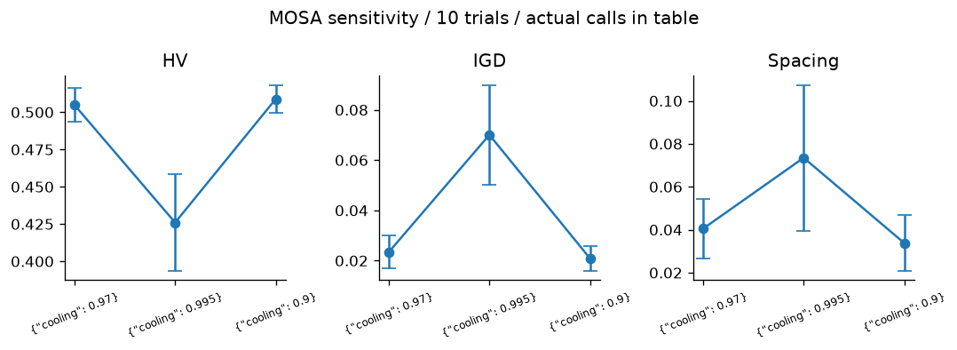
Figure S26 Sensitivity metrics with sample SD across ten seeds

Weighted Sum
Setting | Trials | HV | IGD | Spacing | Calls
{"settings": 11} | 10 | 0.21 +/- 1.008e-11 | 0.3538 +/- 1.66e-11 | 0.7619 +/- 0.5301 | 423.5
{"settings": 21} | 10 | 0.21 +/- 9.761e-12 | 0.3538 +/- 1.593e-11 | 0.7749 +/- 0.4261 | 860.2
{"settings": 41} | 10 | 0.21 +/- 9.441e-12 | 0.3538 +/- 1.521e-11 | 0.675 +/- 0.3631 | 1759

Largest mean HV occurred at {"settings": 41} (0.21 +/- 9.441e-12); smallest at {"settings": 11} (0.21 +/- 1.008e-11). These three settings and ten trials provide a finite comparison, not an optimum parameter search. Overlapping uncertainty requires caution. More scalar settings change consumed evaluations and cannot remove the P3 supporting-hyperplane barrier.
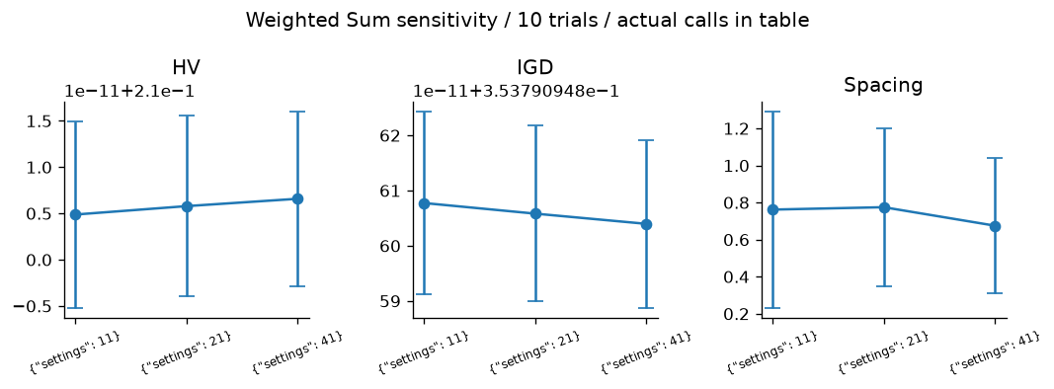
Figure S1 Sensitivity metrics with sample SD across ten seeds

NPGA
Setting | Trials | HV | IGD | Spacing | Calls
{"sigma": 0.1} | 10 | 0.3178 +/- 0.09839 | 0.1868 +/- 0.1132 | 0.02912 +/- 0.01505 | 1e+04
{"sigma": 0.3} | 10 | 0.4712 +/- 0.04723 | 0.0401 +/- 0.03463 | 0.02206 +/- 0.005631 | 1e+04
{"sigma": 0.6} | 10 | 0.4744 +/- 0.02534 | 0.03879 +/- 0.01935 | 0.02405 +/- 0.007215 | 1e+04

Largest mean HV occurred at {"sigma": 0.6} (0.4744 +/- 0.02534); smallest at {"sigma": 0.1} (0.3178 +/- 0.09839). These three settings and ten trials provide a finite comparison, not an optimum parameter search. Overlapping uncertainty requires caution.
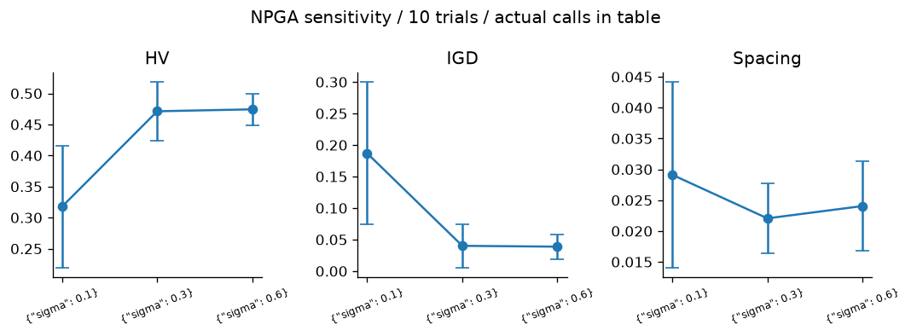
Figure S13 Sensitivity metrics with sample SD across ten seeds

7 Task D head to head comparisons
The continuous comparison includes 25 applicable two-objective optimizer mechanisms. Ranking methods are evaluated separately; ant construction requires tours, gradient methods require differentiability, and many-objective-specific methods are compared on P10. Algorithms 5 to 7 retain their designated utility goals and priorities rather than receiving invented P3/P5 goals. Algorithms 1 to 4 use at least 21 sweep settings, with metric p variants combined.

P3 comparison
Rank | Algorithm | HV | IGD | Spacing | Runtime s
1 | SMS-EMOA | 0.5319 +/- 7.994e-05 | 0.009663 +/- 0.0001899 | 0.003307 +/- 0.001127 | 6.45 +/- 0.8992
2 | MO-TLBO | 0.5318 +/- 6.388e-05 | 0.009556 +/- 0.0001011 | 0.003339 +/- 0.001126 | 1.396 +/- 0.01878
3 | MOEA/D | 0.5318 +/- 5.225e-05 | 0.009563 +/- 8.205e-05 | 0.003232 +/- 0.00076 | 2.414 +/- 0.0989
4 | SPEA2 | 0.5289 +/- 0.0006464 | 0.01168 +/- 0.0005555 | 0.01747 +/- 0.002542 | 1.151 +/- 0.01762
5 | MOMA | 0.5288 +/- 0.0005944 | 0.0114 +/- 0.0004123 | 0.01436 +/- 0.003441 | 0.6977 +/- 0.01754
6 | R-NSGA-II | 0.5286 +/- 0.0004904 | 0.01215 +/- 0.0004874 | 0.01828 +/- 0.004376 | 0.8026 +/- 0.01921
7 | NSGA-II | 0.5284 +/- 0.0006346 | 0.01223 +/- 0.0006273 | 0.0185 +/- 0.002919 | 0.5104 +/- 0.00935
8 | Constrained NSGA-II | 0.5284 +/- 0.0006346 | 0.01223 +/- 0.0006273 | 0.0185 +/- 0.002919 | 0.5653 +/- 0.01137
9 | MOPSO | 0.5282 +/- 0.0008881 | 0.01256 +/- 0.0007347 | 0.01746 +/- 0.002066 | 0.3202 +/- 0.006501
10 | NSGA | 0.5261 +/- 0.0009346 | 0.01222 +/- 0.00041 | 0.01406 +/- 0.002421 | 0.4172 +/- 0.01021
11 | MOGA | 0.5244 +/- 0.0007886 | 0.01244 +/- 0.0005083 | 0.0131 +/- 0.001648 | 0.3798 +/- 0.02214
12 | Epsilon-Constraint | 0.5203 +/- 0.0008345 | 0.02679 +/- 0.0006674 | 0.04367 +/- 0.0004236 | 0.1438 +/- 0.01934
13 | Weight Metric | 0.5199 +/- 0.00575 | 0.02053 +/- 0.005627 | 0.03622 +/- 0.002279 | 0.6553 +/- 0.05092
14 | PESA-II | 0.51 +/- 0.01093 | 0.0254 +/- 0.008017 | 0.02596 +/- 0.003239 | 0.7312 +/- 0.01224
15 | MOABC | 0.5095 +/- 0.01272 | 0.02258 +/- 0.007054 | 0.02664 +/- 0.006989 | 0.9266 +/- 0.02741
16 | MOSA | 0.5048 +/- 0.01142 | 0.02343 +/- 0.006587 | 0.0405 +/- 0.01383 | 0.1897 +/- 0.005919
17 | NPGA | 0.4712 +/- 0.04723 | 0.0401 +/- 0.03463 | 0.02206 +/- 0.005631 | 0.7341 +/- 0.01589
18 | MOGWO | 0.4015 +/- 0.2012 | 0.1924 +/- 0.288 | 0.01065 +/- 0.007508 | 0.4789 +/- 0.1546
19 | MOBA | 0.4002 +/- 0.113 | 0.139 +/- 0.1216 | 0.0438 +/- 0.06247 | 0.485 +/- 0.0144
20 | Benson reference improvement | 0.21 +/- 9.26e-12 | 0.3538 +/- 1.562e-11 | 0.8809 +/- 0.3288 | 0.1123 +/- 0.007261
21 | Weighted Sum | 0.21 +/- 9.761e-12 | 0.3538 +/- 1.593e-11 | 0.7749 +/- 0.4261 | 0.0636 +/- 0.08633
22 | IBEA | 0.1935 +/- 0.01998 | 0.3559 +/- 0.03541 | 0.007561 +/- 0.005889 | 1.54 +/- 0.03421
23 | VEGA | 0.1786 +/- 0.04197 | 0.366 +/- 0.08585 | 0.04663 +/- 0.02523 | 0.3544 +/- 0.01044
24 | MODE | 0.11 +/- 3.731e-11 | 0.6098 +/- 1.416e-11 | 0 +/- 0 | 0.2208 +/- 0.009564
25 | MOEA/D-DE | 0.08246 +/- 0.1827 | 1.257 +/- 0.8031 | 0.0007146 +/- 0.001613 | 1.669 +/- 0.289

Ranked by mean HV: SMS-EMOA leads at 0.5319 +/- 7.994e-05, compared with MOEA/D-DE at 0.08246 +/- 0.1827. HV and IGD judge different aspects; this ranking is specific to the fixed scales and reference. All rows have ten trials. Classical actual calls differ despite the common 10000 cap; see raw_experiments.csv.
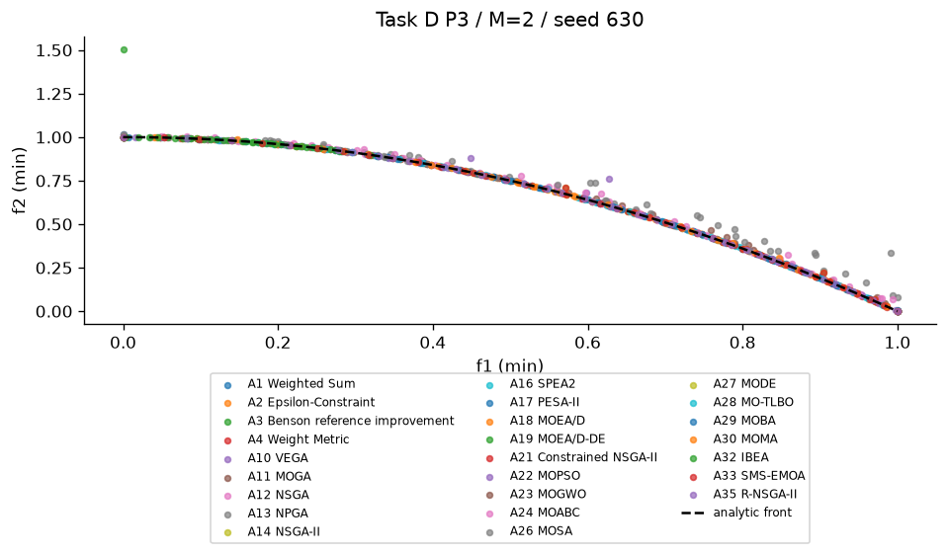
Figure DP3 Combined seed 630 results. For five objectives the overlaid parallel-coordinate lines show every recorded front vector; this projection is descriptive rather than a dominance ordering.

P5 comparison
Rank | Algorithm | HV | IGD | Spacing | Runtime s
1 | MOEA/D | 1.182 +/- 8.228e-06 | 0.01853 +/- 0.003146 | 0.02406 +/- 0.003473 | 2.449 +/- 0.04802
2 | SMS-EMOA | 1.182 +/- 7.163e-06 | 0.01324 +/- 0.004539 | 0.02103 +/- 0.001773 | 5.529 +/- 0.1789
3 | MO-TLBO | 1.182 +/- 2.638e-05 | 0.01218 +/- 0.0003034 | 0.02268 +/- 0.0006511 | 1.419 +/- 0.01454
4 | MOEA/D-DE | 1.182 +/- 3.554e-05 | 0.05253 +/- 0.01883 | 0.02536 +/- 0.01055 | 2.47 +/- 0.04966
5 | MOMA | 1.182 +/- 4.265e-05 | 0.01362 +/- 0.002135 | 0.01971 +/- 0.002315 | 0.7313 +/- 0.01026
6 | SPEA2 | 1.182 +/- 4.595e-05 | 0.01443 +/- 0.002042 | 0.01889 +/- 0.001707 | 1.642 +/- 0.05176
7 | NSGA-II | 1.182 +/- 7.219e-05 | 0.01466 +/- 0.002837 | 0.01974 +/- 0.002319 | 0.5081 +/- 0.01132
8 | Constrained NSGA-II | 1.182 +/- 7.219e-05 | 0.01466 +/- 0.002837 | 0.01974 +/- 0.002319 | 0.5599 +/- 0.006297
9 | MOBA | 1.182 +/- 0.0001708 | 0.01517 +/- 0.002272 | 0.01932 +/- 0.00142 | 0.5058 +/- 0.00827
10 | NSGA | 1.182 +/- 7.723e-05 | 0.01433 +/- 0.00117 | 0.0191 +/- 0.001383 | 0.416 +/- 0.01867
11 | MOPSO | 1.182 +/- 5.901e-05 | 0.01273 +/- 0.0009179 | 0.01966 +/- 0.00158 | 0.3289 +/- 0.01644
12 | MOGA | 1.182 +/- 9.581e-05 | 0.01374 +/- 0.001077 | 0.01885 +/- 0.002543 | 0.3856 +/- 0.01086
13 | MOGWO | 1.182 +/- 0.0001255 | 0.01314 +/- 0.0006236 | 0.01985 +/- 0.001345 | 0.5942 +/- 0.03311
14 | Weight Metric | 1.182 +/- 2.176e-06 | 0.133 +/- 7.472e-06 | 0.09488 +/- 0.002493 | 0.7468 +/- 0.07282
15 | MOSA | 1.182 +/- 0.0001516 | 0.01298 +/- 0.001509 | 0.01968 +/- 0.002269 | 0.2172 +/- 0.005155
16 | MODE | 1.181 +/- 0.0003965 | 0.01749 +/- 0.005466 | 0.01921 +/- 0.002729 | 0.2871 +/- 0.009224
17 | MOABC | 1.181 +/- 0.0005213 | 0.01107 +/- 0.0006085 | 0.0189 +/- 0.001165 | 1.442 +/- 0.02366
18 | PESA-II | 1.181 +/- 0.0002923 | 0.0175 +/- 0.001596 | 0.01492 +/- 0.00259 | 0.7956 +/- 0.01376
19 | NPGA | 1.181 +/- 0.0006727 | 0.01319 +/- 0.001771 | 0.0194 +/- 0.003436 | 0.8336 +/- 0.02343
20 | Benson reference improvement | 1.181 +/- 1.164e-07 | 0.2131 +/- 1.121e-06 | 0.2027 +/- 0.003608 | 0.3901 +/- 0.06143
21 | Weighted Sum | 1.181 +/- 1.159e-07 | 0.2131 +/- 1.121e-06 | 0.2022 +/- 0.003082 | 0.1111 +/- 0.01805
22 | VEGA | 1.18 +/- 0.001278 | 0.0113 +/- 0.0007522 | 0.0168 +/- 0.001562 | 0.3886 +/- 0.008881
23 | R-NSGA-II | 1.177 +/- 0.00655 | 0.012 +/- 0.002219 | 0.01635 +/- 0.00387 | 0.8458 +/- 0.03499
24 | IBEA | 1.162 +/- 0.0107 | 0.02821 +/- 0.02156 | 0.01427 +/- 0.009193 | 1.579 +/- 0.1092
25 | Epsilon-Constraint | 1.134 +/- 3.134e-08 | 0.2455 +/- 3.088e-07 | 0.4793 +/- 0.08327 | 0.5963 +/- 0.1482

Ranked by mean HV: MOEA/D leads at 1.182 +/- 8.228e-06, compared with Epsilon-Constraint at 1.134 +/- 3.134e-08. HV and IGD judge different aspects; this ranking is specific to the fixed scales and reference. All rows have ten trials. Classical actual calls differ despite the common 10000 cap; see raw_experiments.csv.
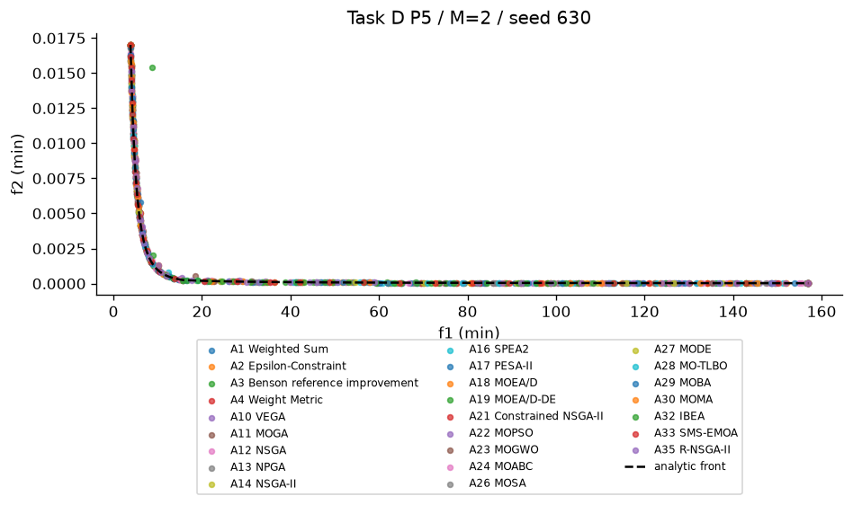
Figure DP5 Combined seed 630 results. For five objectives the overlaid parallel-coordinate lines show every recorded front vector; this projection is descriptive rather than a dominance ordering.

P10 comparison
Rank | Algorithm | HV | IGD | Spacing | Runtime s
1 | RVEA | 1.008 +/- 0.02081 | 0.3082 +/- 0.01173 | 0.2683 +/- 0.01688 | 0.6056 +/- 0.03065
2 | MOEA/D | 0.9999 +/- 0.03359 | 0.3293 +/- 0.02405 | 0.2709 +/- 0.0336 | 3.303 +/- 0.07673
3 | NSGA-III | 0.9898 +/- 0.01111 | 0.3105 +/- 0.006318 | 0.2685 +/- 0.0248 | 0.7753 +/- 0.007753
4 | HypE | 0.77 +/- 0.1457 | 0.4398 +/- 0.07965 | 0.3217 +/- 0.06466 | 4.699 +/- 0.08953
5 | NSGA-II | 0.1713 +/- 0.1749 | 0.6034 +/- 0.1898 | 0.3913 +/- 0.05419 | 0.5818 +/- 0.02024

Ranked by mean HV: RVEA leads at 1.008 +/- 0.02081, compared with NSGA-II at 0.1713 +/- 0.1749. HV and IGD judge different aspects; this ranking is specific to the fixed scales and reference. All rows have ten trials. All candidate budgets are 10000.
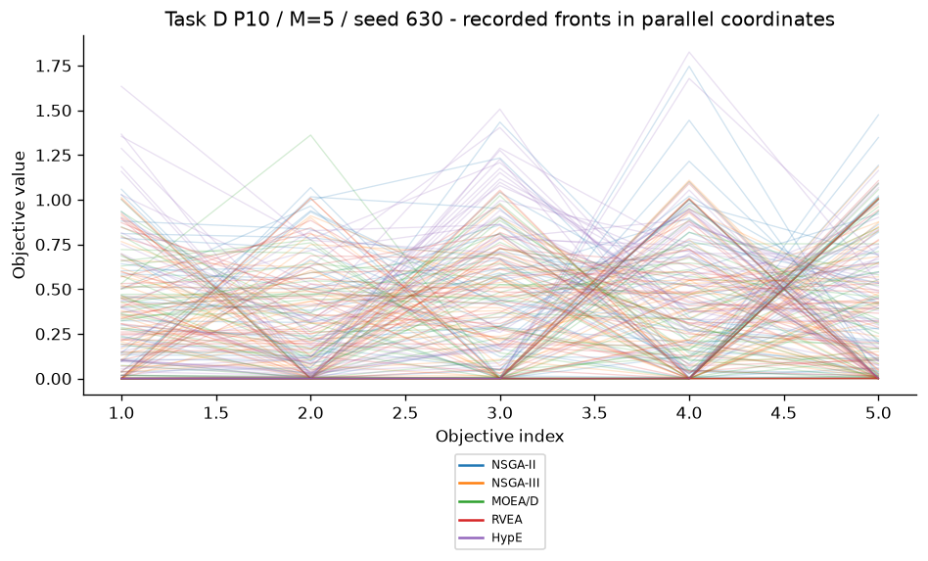
Figure DP10 Combined seed 630 results. For five objectives the overlaid parallel-coordinate lines show every recorded front vector; this projection is descriptive rather than a dominance ordering.
M=3 random population nondominated fraction mean=0.339. Increasing nondomination reduces rank discrimination, while vector association adds a directional criterion.
M=5 random population nondominated fraction mean=0.604. Increasing nondomination reduces rank discrimination, while vector association adds a directional criterion.

P8 comparison
Rank | Algorithm | HV | IGD | Spacing | Runtime s
1 | NSGA-II | 0.9238 +/- 0.0002031 | N/A +/- N/A | 0.003701 +/- 0.002802 | 0.7371 +/- 0.02493
2 | MOEA/D-ACO | 0.9237 +/- 0.0005056 | N/A +/- N/A | 0.00389 +/- 0.001763 | 4.106 +/- 0.02907
3 | MOMA | 0.9236 +/- 0.0006462 | N/A +/- N/A | 0.001274 +/- 0.00215 | 0.8282 +/- 0.01913
4 | MOACO | 0.9234 +/- 0.001217 | N/A +/- N/A | 0.002724 +/- 0.001146 | 2.042 +/- 0.02334

Ranked by mean HV: NSGA-II leads at 0.9238 +/- 0.0002031, compared with MOACO at 0.9234 +/- 0.001217. HV and IGD judge different aspects; this ranking is specific to the fixed scales and reference. All rows have ten trials. All candidate budgets are 10000.
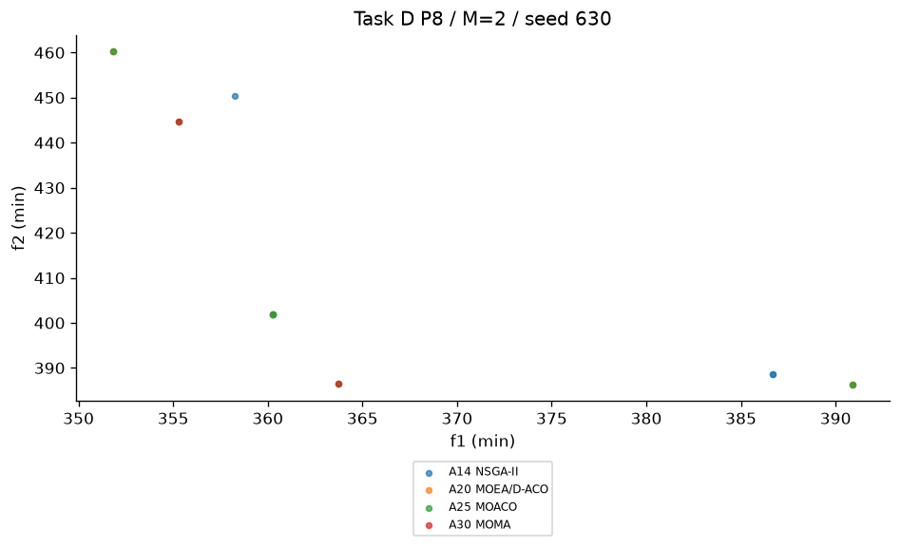
Figure DP8 Combined seed 630 results. For five objectives the overlaid parallel-coordinate lines show every recorded front vector; this projection is descriptive rather than a dominance ordering.
Nearest neighbour | Distance | Time | Tour
distance | 362 | 521.3 | [0, 7, 1, 13, 5, 10, 14, 2, 12, 9, 3, 6, 8, 4, 11]
time | 577.5 | 581.1 | [0, 1, 13, 5, 10, 11, 8, 4, 7, 9, 12, 14, 3, 6, 2]

Distance/time baselines use different edge metrics and retain valid 15-city permutations. A good optimized archive can improve one objective while worsening the other, so neither baseline should be assumed to dominate the entire tradeoff set.

P3 population and generation budget investigation
Population | Budget | Full generations | HV | IGD | Spacing
20 | 1000 | 49 | 0.3671 +/- 0.09944 | 0.1496 +/- 0.09361 | 0.02547 +/- 0.01279
20 | 5000 | 249 | 0.5133 +/- 0.002728 | 0.02507 +/- 0.002955 | 0.03691 +/- 0.01278
20 | 10000 | 499 | 0.5141 +/- 0.003762 | 0.02355 +/- 0.001744 | 0.03017 +/- 0.006758
40 | 1000 | 24 | 0.3712 +/- 0.1223 | 0.1333 +/- 0.1134 | 0.04786 +/- 0.0255
40 | 5000 | 124 | 0.5284 +/- 0.000647 | 0.01177 +/- 0.0007616 | 0.0185 +/- 0.00271
40 | 10000 | 249 | 0.5284 +/- 0.0006346 | 0.01223 +/- 0.0006273 | 0.0185 +/- 0.002919
80 | 1000 | 11 | 0.1211 +/- 0.06657 | 0.3451 +/- 0.06945 | 0.08471 +/- 0.04864
80 | 5000 | 61 | 0.5355 +/- 0.0004119 | 0.005979 +/- 0.0002967 | 0.008668 +/- 0.00116
80 | 10000 | 124 | 0.5359 +/- 0.0003097 | 0.006043 +/- 0.0003615 | 0.009051 +/- 0.0009312

This additional NSGA-II study uses ten seeds for each of nine population and budget settings. At fixed budget, larger populations receive fewer generations; improving population coverage can compete with convergence. More evaluations generally allow more refinement, but the measured IGD values determine the conclusion for each setting rather than an assumed universal trend. Ninety raw fronts and objective metrics are stored under results/csv/population/.

Ranking existing alternatives and preferred scalar solutions
Input | Method | Weights | v | Top three
P12 | topsis | [0.3, 0.3, 0.2, 0.2] | 0.5 | [3, 1, 5]
P12 | topsis | [0.4, 0.2, 0.2, 0.2] | 0.5 | [1, 2, 3]
P12 | vikor | [0.3, 0.3, 0.2, 0.2] | 0.25 | [1, 2, 5]
P12 | vikor | [0.4, 0.2, 0.2, 0.2] | 0.25 | [2, 1, 4]
P12 | vikor | [0.3, 0.3, 0.2, 0.2] | 0.5 | [1, 2, 5]
P12 | vikor | [0.4, 0.2, 0.2, 0.2] | 0.5 | [2, 1, 3]
P12 | vikor | [0.3, 0.3, 0.2, 0.2] | 0.75 | [1, 3, 2]
P12 | vikor | [0.4, 0.2, 0.2, 0.2] | 0.75 | [1, 2, 3]
P4 NSGA-II front | topsis | [0.5, 0.5] | 0.5 | [2, 14, 27]
P4 NSGA-II front | vikor | [0.5, 0.5] | 0.5 | [27, 14, 2]
P4 NSGA-II front | topsis | [0.6, 0.4] | 0.5 | [27, 7, 15]
P4 NSGA-II front | vikor | [0.6, 0.4] | 0.5 | [7, 15, 20]

P12 supplier identifiers are 1-based. P4 front identifiers are 0-based rows in P4_nsga2_ranking_input.csv. Moving .1 weight to the first criterion and subtracting .1 from the second preserves the simplex. VIKOR v=.25,.5,.75 and its compromise-set flags remain in rankings.csv.
TOPSIS top-three order changes under the .1 weight shift: [3, 1, 5] -> [1, 2, 3]. This measured local response is not universal preference stability.
VIKOR top-three order changes under the .1 weight shift: [1, 2, 5] -> [2, 1, 3]. This measured local response is not universal preference stability.
Value Function returns declared portfolio profiles or the laptop aspiration. Goal Programming uses production targets 2400 profit and 600 units, and normalized versus unit deviations. Lexicographic profit-first then units selects the profit tie with maximum units, approximately (300,200). Exact decisions and solver success messages are retained in the classical job JSON records; a solver failure is not silently treated as proof of optimality.

P13 gradient methods and equal weights
Method | Scale | BCE initial | BCE final | MSE initial | MSE final
equal | 1 | 0.6945 | 0.537 +/- 0.01881 | 15.01 | 0.164 +/- 0.01046
mgda | 1 | 0.6945 | 0.2919 +/- 0.03236 | 15.01 | 14.08 +/- 0.4983
gradnorm | 1 | 0.6945 | 0.3503 +/- 0.02601 | 15.01 | 0.1573 +/- 0.01473
equal | 10 | 0.6945 | 0.6452 +/- 0.0288 | 1488 | 84.14 +/- 1.58
mgda | 10 | 0.6945 | 0.6753 +/- 0.02113 | 1488 | 1487 +/- 2.078
gradnorm | 10 | 0.6945 | 0.5999 +/- 0.01847 | 1488 | 1136 +/- 62.65

The network has a five-input shared tanh layer of width eight and separate classification and regression heads. Ten seeds vary initialization while synthetic observations remain fixed. Regression target scale 10 creates larger gradient norms. Equal weights and MGDA sum to one; GradNorm weights sum to two by definition. Their model learning rates are explicitly recorded, so weight normalization changes effective step size and must be considered when interpreting loss differences.
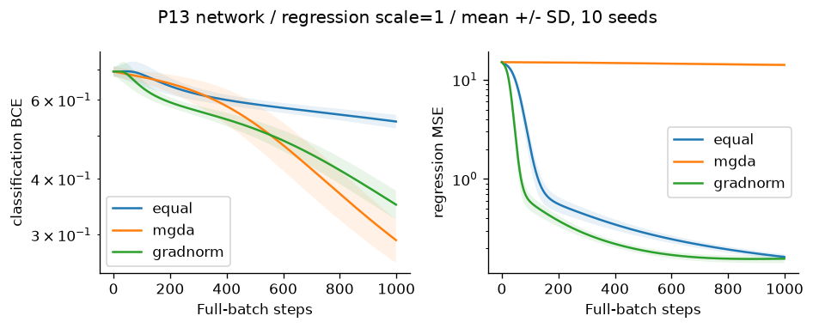
Figure N1 Network task losses with mean and SD from ten initializations
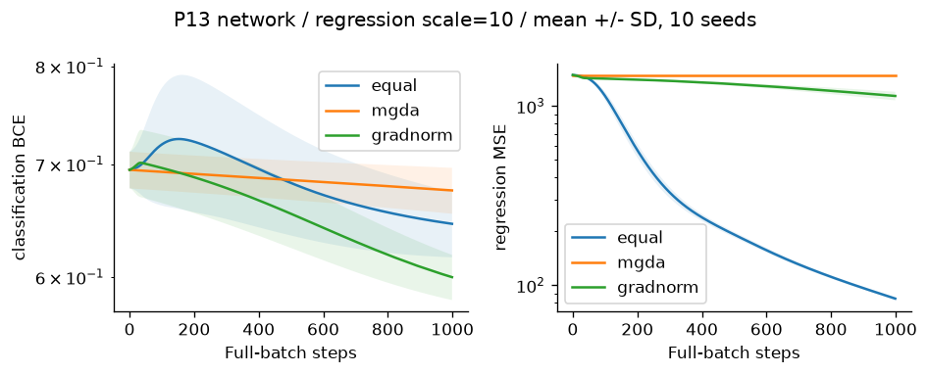
Figure N10 Network task losses with mean and SD from ten initializations
On the toy, fixed equal weights converge to (0,0), while MGDA generally stops at a different Pareto-stationary point and GradNorm changes the task weighting. Individual losses need not both approach zero: the two target points conflict. The saved 10000-step histories and toy_equal.csv expose this trajectory rather than claiming full-front coverage from one initial point.

Toy task losses against equal weights
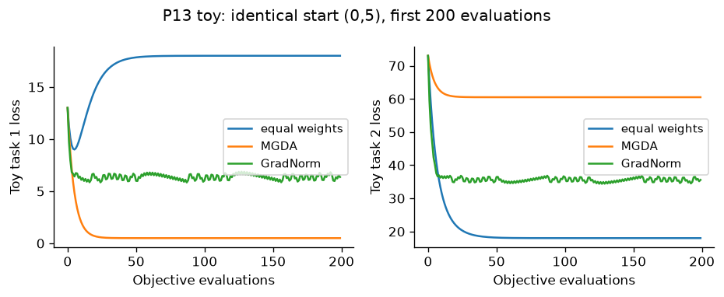
Figure T13 Hand-coded toy loss trajectories against fixed equal weights, with identical starting point and learning rate
The equal-weight toy baseline tends to x=(0,0), giving losses (18,18). MGDA tends to a different point on the Pareto segment, while GradNorm adapts its loss weights. A smaller task 1 loss can coexist with a larger task 2 loss at a Pareto-stationary tradeoff; neither method is expected to make both target distances zero.

8 Task E algorithm selection cases

P1
Suitable: Weighted Sum,Weight Metric. Poor choice: VEGA. Convex one-variable problem; scalarization offers interpretable weights and metric methods expose compromise geometry.
A1 M=2 base: HV=1.0258 +/- 0, IGD=0.020135 +/- 0; A4 M=2 base: HV=1.0347 +/- 0, IGD=0.012339 +/- 0
Recommendations combine measured finite-budget outcomes with encoding, constraints and preference reasoning; no universal winner is claimed.

P3
Suitable: SMS-EMOA,MO-TLBO. Poor choice: Weighted Sum. Nonconvex front; hypervolume survival and teacher-learner moves both cover interior tradeoffs in the recorded experiments, while linear scalarization cannot support them.
A28 M=2 D: HV=0.53182 +/- 6.3878e-05, IGD=0.0095565 +/- 0.00010113; A33 M=2 D: HV=0.53187 +/- 7.9941e-05, IGD=0.0096626 +/- 0.00018987; A28 M=2 base: HV=0.53182 +/- 6.3878e-05, IGD=0.0095565 +/- 0.00010113; A33 M=2 base: HV=0.53187 +/- 7.9941e-05, IGD=0.0096626 +/- 0.00018987
Recommendations combine measured finite-budget outcomes with encoding, constraints and preference reasoning; no universal winner is claimed.

P5
Suitable: Constrained NSGA-II,SPEA2. Poor choice: VEGA. Nonlinear feasibility makes Deb rules useful; archive strength and density support constrained tradeoffs.
A16 M=2 D: HV=1.1818 +/- 4.5953e-05, IGD=0.014428 +/- 0.0020419; A21 M=2 D: HV=1.1818 +/- 7.2189e-05, IGD=0.014663 +/- 0.002837; A16 M=2 base: HV=1.1818 +/- 4.5953e-05, IGD=0.014428 +/- 0.0020419; A21 M=2 base: HV=1.1818 +/- 7.2189e-05, IGD=0.014663 +/- 0.002837
Recommendations combine measured finite-budget outcomes with encoding, constraints and preference reasoning; no universal winner is claimed.

P8
Suitable: NSGA-II,MOEA/D-ACO. Poor choice: MGDA. Permutation-safe NSGA-II and ant decomposition have the leading recorded HV means and retain valid tours; gradient descent is undefined for city orders.
A14 M=2 D: HV=0.92385 +/- 0.00020309, IGD=N/A +/- N/A; A20 M=2 D: HV=0.92372 +/- 0.00050562, IGD=N/A +/- N/A; A20 M=2 base: HV=0.92372 +/- 0.00050562, IGD=N/A +/- N/A
Recommendations combine measured finite-budget outcomes with encoding, constraints and preference reasoning; no universal winner is claimed.

P10
Suitable: RVEA,MOEA/D. Poor choice: VEGA. Five objectives weaken dominance; RVEA APD and MOEA/D scalar subproblems retain directional pressure and have the strongest recorded HV means at this budget.
A18 M=5 D: HV=0.99988 +/- 0.033592, IGD=0.32929 +/- 0.024052; A31 M=5 D: HV=1.0076 +/- 0.020813, IGD=0.30822 +/- 0.011729; A18 M=5 base: HV=0.99988 +/- 0.033592, IGD=0.32929 +/- 0.024052; A31 M=3 base: HV=0.64011 +/- 0.0086752, IGD=0.10871 +/- 0.0050531; A31 M=5 base: HV=1.0076 +/- 0.020813, IGD=0.30822 +/- 0.011729
Recommendations combine measured finite-budget outcomes with encoding, constraints and preference reasoning; no universal winner is claimed.

P14
Suitable: R-NSGA-II,Value Function. Poor choice: VEGA. Known manager aspiration makes a preferred region useful; utility or reference clearing expresses it directly.
A5 M=2 base: HV=0.32905 +/- 0, IGD=0.35302 +/- 0; A35 M=2 base: HV=0.85628 +/- 0.00064468, IGD=0.0094464 +/- 0.00049587
Recommendations combine measured finite-budget outcomes with encoding, constraints and preference reasoning; no universal winner is claimed.

9 Task F viva preparation

1 Why can Weighted Sum miss a dented front
On P3 the true front is (t,1-t^2). A positive weighted scalar is concave in t, so its minimum occurs at an endpoint; an interior efficient point lacks a supporting linear level set. Changing the weight grid cannot fix this.

2 Why might VEGA drift to extremes
Each mating-pool segment rewards only one objective. Extreme winners enter repeatedly, while compromise designs receive no Pareto or density protection. Check the final population as well as the passive recording archive before asserting collapse in a particular run.

3 What does elitism guarantee
Best ranked survivors are selected from parents plus children, so beneficial parents need not disappear just because variation was poor. A finite population still truncates nondominated designs and gives no global-optimality guarantee. NSGA-II/III, SPEA2, PESA-II, decomposition and archive-guided methods retain different forms of memory.

4 Why does crowding weaken with many objectives
Most candidates are nondominated; many receive boundary bonuses on one of many axes, while marginal nearest-neighbour gaps poorly represent high-dimensional coverage. NSGA-III reference occupancy and RVEA angles replace axis crowding. The measured random-population fractions are in dominance_pressure.csv.

5 Which methods require preferences and what if they are wrong
Weighted Sum, metric methods and Benson need weights/reference; Value Function needs utility; Goal Programming needs targets; Lexicographic needs priorities; TOPSIS/VIKOR need criterion weights and VIKOR v; R-NSGA-II needs an aspiration. A wrong preference can select a feasible efficient design that is unsuitable for the decision-maker.

6 Explain Deb rules numerically
Lecture A=(3,6),CV=0 and D=(4,5),CV=0 beat B=(1,2),CV=2 and C=(.5,1),CV=5. A,D trade off. B beats C because 2<5. Thus front layers are [A,D],[B],[C], irrespective of the attractive infeasible objectives.

7 How can premature convergence be detected
Track HV, IGD where exact-front samples exist, final-population spread, archive turnover and decision-variable variance across budget checkpoints and seeds. Flat HV alone may mean saturation, a poor reference box or a single-region stall; inspect more than one diagnostic.

8 Why are TOPSIS and VIKOR ranking methods rather than optimizers
Their input is an existing alternatives matrix. They compute closeness or regret and reorder rows; they never choose new decision vectors or explore bounds.

9 What do HV IGD and Spacing measure
HV is dominated volume within one fixed reference; for (1,3),(2,2),(3,1) and r=(4,4), HV=6. IGD averages true-front sample distance to the approximation. Spacing is sample SD of nearest L1 distances. A singleton has Spacing=0 but poor coverage. Normalize using the same constants across algorithms.

10 Why keep decisions as well as objective arrays
Objectives rank tradeoffs, while decisions verify bounds, repair, feature masks and tours. NPZ files retain both and constraint residuals. Dense pairwise arrays permit vectorized dominance at O(M*N^2) storage/work; they do not remove quadratic complexity.

11 What does the hand trace prove
Weighted Sum reproduces analytical x=6 and 4. Lecture MOSA accepts x=13 and 15 as incomparable. Lecture NPGA chooses A and D from exact comparison-set niche counts. Additional four-chain and four-member generations show all fixed variation draws. These are mechanism checks, not proofs of global convergence.

12 How does changing a parameter affect behaviour
Raise sigma to include more comparison neighbours in NPGA; increase cooling toward 1 to preserve MOSA uphill acceptance longer; raise Weighted Sum settings to sample more directions but not unsupported P3 interior. Inspect the three-value, ten-trial sensitivity rows before predicting numerical improvements.

13 Why does MGDA sometimes stop while task gradients remain nonzero
At Pareto stationarity the minimum-norm convex combination is zero; individual gradients may oppose one another. For [1,0] and [-1,0], weights .5,.5 cancel. GradNorm instead controls magnitudes and need not choose a common descent direction.

14 How is network correctness verified
Forward and backward BCE/MSE derivatives are handwritten. Tests perturb shared weights, biases and both heads by +/-1e-6 and compare finite differences to analytical task gradients. Standardization in feature selection is fitted only to training observations.

15 Explain A1 Weighted Sum and predict one change
Linear scalar solve and a sweep. Weighted Sum: minimize dot(w,F_normalized), sweep simplex weights.
Positive weights yield supported efficient points; zeros may give weak efficiency.
Default SLSQP ftol=1e-10, maxiter=120; sweep=21; seed=63.
Bounds and explicit constraints handled by SLSQP. Only scalar subproblems use SciPy.
Local solves are not a global optimality certificate. Inspect Weighted Sum in src/algorithms/weighted_sum.py and identify the test_01_mechanism assertion before editing.

16 Explain A2 Epsilon Constraint and predict one change
One objective minimized and others bounded. Epsilon-Constraint: minimize F1 with normalized F2<=epsilon.
Default epsilon range=[0,1]. Extra constraint calls are explicitly counted.
Default SLSQP ftol=1e-10, maxiter=120; sweep=21; seed=63.
Bounds and explicit constraints handled by SLSQP. Only scalar subproblems use SciPy.
Local solves are not a global optimality certificate. Inspect Epsilon-Constraint in src/algorithms/epsilon_constraint.py and identify the test_02_mechanism assertion before editing.

17 Explain A3 Benson reference improvement and predict one change
Weighted improvement below a reference. Benson reference improvement: maximize weighted nonnegative improvements
from a dominated reference r=[1.1,1.1], require F<=r. This follows Foundations slide 35 reference achievement.
It is the teaching form, not full polyhedral outer approximation.
Default SLSQP ftol=1e-10, maxiter=120; sweep=21; seed=63.
Bounds and explicit constraints handled by SLSQP. Only scalar subproblems use SciPy.
Local solves are not a global optimality certificate. Inspect Benson reference improvement in src/algorithms/benson.py and identify the test_03_mechanism assertion before editing.

18 Explain A4 Weight Metric and predict one change
Weighted distance to fixed ideal. Weight Metric: distance from fixed ideal, weighted p=1,2,infinity.
Sweep weights for all three p values. p=infinity uses epigraph-free max.
Default SLSQP ftol=1e-10, maxiter=120; sweep=21; seed=63.
Bounds and explicit constraints handled by SLSQP. Only scalar subproblems use SciPy.
Local solves are not a global optimality certificate. Inspect Weight Metric in src/algorithms/weight_metric.py and identify the test_04_mechanism assertion before editing.

19 Explain A5 Value Function and predict one change
Declared decision-maker utility. Value Function: declared quadratic utility to a preferred normalized
aspiration. P14 uses [1.8 kg,12 h]; P4 uses three investor risk/return targets.
Utility is a decision-maker input, not a claim of universal preference.
Default SLSQP ftol=1e-10, maxiter=120; sweep=21; seed=63.
Bounds and explicit constraints handled by SLSQP. Only scalar subproblems use SciPy.
Local solves are not a global optimality certificate. Inspect Value Function in src/algorithms/value_function.py and identify the test_05_mechanism assertion before editing.

20 Explain A6 Goal Programming and predict one change
Explicit positive/negative goal deviations. Goal Programming: goals in natural output, penalize negative deviations
only (both goals are lower bounds). Explicit dminus=max(target-achieved,0),
dplus=max(achieved-target,0); elimination of linear deviation variables is exact.
Default SLSQP ftol=1e-10, maxiter=120; sweep=21; seed=63.
Bounds and explicit constraints handled by SLSQP. Only scalar subproblems use SciPy.
Local solves are not a global optimality certificate. Inspect Goal Programming in src/algorithms/goal_programming.py and identify the test_06_mechanism assertion before editing.

21 Explain A7 Lexicographic and predict one change
Sequential strict priorities with tolerances. Lexicographic: sequential strict-priority scalar minimizations, preserving
prior best objective within tolerance=1e-7 in normalized units. Profit first
then units on P11; agricultural yield first on P7.
Default SLSQP ftol=1e-10, maxiter=120; sweep=21; seed=63.
Bounds and explicit constraints handled by SLSQP. Only scalar subproblems use SciPy.
Local solves are not a global optimality certificate. Inspect Lexicographic in src/algorithms/lexicographic.py and identify the test_07_mechanism assertion before editing.

22 Explain A8 TOPSIS and predict one change
Closeness to weighted ideal and anti-ideal. TOPSIS ranking, not an optimizer. Vector normalization, weights,
benefit/cost ideal, Euclidean ideal and anti-ideal distance. Default equal
weights if not supplied; P12 uses [.3,.3,.2,.2]. Zero columns protected. Inspect TOPSIS in src/algorithms/topsis.py and identify the test_08_mechanism assertion before editing.

23 Explain A9 VIKOR and predict one change
Compromise via group regret and worst regret. VIKOR compromise ranking with S=sum weighted regret, R=max regret,
Q=v*(S-Sbest)/(Sworst-Sbest)+(1-v)*(R-Rbest)/(Rworst-Rbest).
Default v=.5. Report acceptable advantage 1/(N-1) and stability; never
force a unique compromise when the conditions fail. Inspect VIKOR in src/algorithms/vikor.py and identify the test_09_mechanism assertion before editing.

24 Explain A10 VEGA and predict one change
Objective-partitioned selection. VEGA: partition selection by objective, pool subpopulations, crossover and mutation.
Tournament by one objective; no parent+child elitism.
Shared defaults: population=40, budget=10000, seed=63.
Constraints: Deb feasibility comparison unless the stated method uses scalar penalty.
Lecture decks supplied on 12 October 2026; teaching variants documented in docs/lecture_alignment.md. Inspect VEGA in src/algorithms/vega.py and identify the test_10_mechanism assertion before editing.

25 Explain A11 MOGA and predict one change
Domination-count rank and fitness sharing. MOGA: domination count rank, rank fitness divided by niche count.
Sharing radius sigma=.3; small radius weakens sharing; no elitism.
Shared defaults: population=40, budget=10000, seed=63.
Constraints: Deb feasibility comparison unless the stated method uses scalar penalty.
Lecture decks supplied on 12 October 2026; teaching variants documented in docs/lecture_alignment.md. Inspect MOGA in src/algorithms/moga.py and identify the test_11_mechanism assertion before editing.

26 Explain A12 NSGA and predict one change
Front layers and within-front sharing. NSGA: nondominated layers, dummy fitness and within-front sharing.
Sharing radius sigma=.3; non-elitist generational replacement.
Shared defaults: population=40, budget=10000, seed=63.
Constraints: Deb feasibility comparison unless the stated method uses scalar penalty.
Lecture decks supplied on 12 October 2026; teaching variants documented in docs/lecture_alignment.md. Inspect NSGA in src/algorithms/nsga.py and identify the test_12_mechanism assertion before editing.

27 Explain A13 NPGA and predict one change
Direct contestant dominance then separate comparison-set quadratic niche tie. Niched Pareto Genetic Algorithm: direct binary tournament with comparison-set crowding.
Direct dominance decides; otherwise smaller comparison-set niche count wins.
Defaults: comparison_size=2, sigma=.3; objective distances normalized.
Shared defaults: population=40, budget=10000, seed=63.
Constraints: Deb feasibility comparison unless the stated method uses scalar penalty.
Lecture decks supplied on 12 October 2026; teaching variants documented in docs/lecture_alignment.md. Inspect NPGA in src/algorithms/npga.py and identify the test_13_mechanism assertion before editing.

28 Explain A14 NSGA II and predict one change
Front rank, crowding, parent-child elitism. NSGA-II: fast front sorting, crowded binary tournament, SBX and mutation,
parent+offspring elitist survival. Permutations use OX and swap/inversion.
Shared defaults: population=40, budget=10000, seed=63.
Constraints: Deb feasibility comparison unless the stated method uses scalar penalty.
Lecture decks supplied on 12 October 2026; teaching variants documented in docs/lecture_alignment.md. Inspect NSGA-II in src/algorithms/nsga2.py and identify the test_14_mechanism assertion before editing.

29 Explain A15 NSGA III and predict one change
Reference-point niching after front rank. NSGA-III: front ranking, simplex-lattice reference association and niche
occupancy survival. Normalize by observed ranges (simplification of intercepts).
Shared defaults: population=40, budget=10000, seed=63.
Constraints: Deb feasibility comparison unless the stated method uses scalar penalty.
Lecture decks supplied on 12 October 2026; teaching variants documented in docs/lecture_alignment.md. Inspect NSGA-III in src/algorithms/nsga3.py and identify the test_15_mechanism assertion before editing.

30 Explain A16 SPEA2 and predict one change
Strength, raw fitness and neighbour density. SPEA2: strength S, raw fitness R=sum strengths of dominators;
density 1/(sigma_k+2), fixed archive, lexicographic nearest-distance truncation.
Shared defaults: population=40, budget=10000, seed=63.
Constraints: Deb feasibility comparison unless the stated method uses scalar penalty.
Lecture decks supplied on 12 October 2026; teaching variants documented in docs/lecture_alignment.md. Inspect SPEA2 in src/algorithms/spea2.py and identify the test_16_mechanism assertion before editing.

31 Explain A17 PESA II and predict one change
Archive region occupancy selection. PESA-II: archive adaptive grid regions; region tournament selects lower
occupancy region, then uniform individual. Default grid divisions=8.
Shared defaults: population=40, budget=10000, seed=63.
Constraints: Deb feasibility comparison unless the stated method uses scalar penalty.
Lecture decks supplied on 12 October 2026; teaching variants documented in docs/lecture_alignment.md. Inspect PESA-II in src/algorithms/pesa2.py and identify the test_17_mechanism assertion before editing.

32 Explain A18 MOEA D and predict one change
Neighbouring Tchebycheff subproblems. MOEA/D: reference weights, neighbourhood mating, running ideal,
cooperative Tchebycheff replacement. Neighbourhood size=10.
Shared defaults: population=40, budget=10000, seed=63.
Constraints: Deb feasibility comparison unless the stated method uses scalar penalty.
Lecture decks supplied on 12 October 2026; teaching variants documented in docs/lecture_alignment.md. Inspect MOEA/D in src/algorithms/moead.py and identify the test_18_mechanism assertion before editing.

33 Explain A19 MOEA D DE and predict one change
DE variation inside MOEA/D. MOEA/D-DE: neighbourhood donor x_a+F*(x_b-x_c), binomial
crossover CR=.9 with forced coordinate, F=.5; cooperative scalar replacement.
Shared defaults: population=40, budget=10000, seed=63.
Constraints: Deb feasibility comparison unless the stated method uses scalar penalty.
Lecture decks supplied on 12 October 2026; teaching variants documented in docs/lecture_alignment.md. Inspect MOEA/D-DE in src/algorithms/moead_de.py and identify the test_19_mechanism assertion before editing.

34 Explain A20 MOEA D ACO and predict one change
Weight-specific ant pheromones and scalar replacement. MOEA/D-ACO for tours: each weight has edge pheromone, weighted
distance/time heuristic, neighbour Tchebycheff replacement and deposits.
Defaults alpha=1 beta=2 evaporation=.1. Requires P8.
Shared defaults: population=40, budget=10000, seed=63.
Constraints: Deb feasibility comparison unless the stated method uses scalar penalty.
Lecture decks supplied on 12 October 2026; teaching variants documented in docs/lecture_alignment.md. Inspect MOEA/D-ACO in src/algorithms/moead_aco.py and identify the test_20_mechanism assertion before editing.

35 Explain A21 Constrained NSGA II and predict one change
NSGA-II with Deb feasibility. Constrained NSGA-II: feasible beats infeasible, lower violation wins
among infeasible, Pareto rank then crowding among feasible.
NSGA-II in this project also supports Deb rules; this module exposes the rule.
Shared defaults: population=40, budget=10000, seed=63.
Constraints: Deb feasibility comparison unless the stated method uses scalar penalty.
Lecture decks supplied on 12 October 2026; teaching variants documented in docs/lecture_alignment.md. Inspect Constrained NSGA-II in src/algorithms/constrained_nsga2.py and identify the test_21_mechanism assertion before editing.

36 Explain A22 MOPSO and predict one change
Particle velocity with personal and archive leaders. MOPSO: inertia velocity, personal best, crowding-selected archive
leader, occasional mutation. Defaults inertia=.4, c1=c2=1.5.
Shared defaults: population=40, budget=10000, seed=63.
Constraints: Deb feasibility comparison unless the stated method uses scalar penalty.
Lecture decks supplied on 12 October 2026; teaching variants documented in docs/lecture_alignment.md. Inspect MOPSO in src/algorithms/mopso.py and identify the test_22_mechanism assertion before editing.

37 Explain A23 MOGWO and predict one change
Three archive leaders and encircling. MOGWO: alpha, beta, delta archive leaders; decreasing encircling
coefficient a=2*(1-used/budget), average three proposed positions.
Binary masks use a sigmoid transfer, then at-least-one repair.
Shared defaults: population=40, budget=10000, seed=63.
Constraints: Deb feasibility comparison unless the stated method uses scalar penalty.
Lecture decks supplied on 12 October 2026; teaching variants documented in docs/lecture_alignment.md. Inspect MOGWO in src/algorithms/mogwo.py and identify the test_23_mechanism assertion before editing.

38 Explain A24 MOABC and predict one change
Employed moves, crowding-based onlookers and abandonment scouts. MOABC: employed and onlooker differential-coordinate proposals,
Deb dominance greedy replacement, abandoned-source scouts. Limit=20.
Shared defaults: population=40, budget=10000, seed=63.
Constraints: Deb feasibility comparison unless the stated method uses scalar penalty.
Lecture decks supplied on 12 October 2026; teaching variants documented in docs/lecture_alignment.md. Inspect MOABC in src/algorithms/moabc.py and identify the test_24_mechanism assertion before editing.

39 Explain A25 MOACO and predict one change
Two pheromone matrices and route construction. MOACO: two pheromone matrices, randomized tradeoff exponent,
probabilistic valid tour construction, evaporation and archive deposits.
Defaults alpha=1 beta=2 evaporation=.1. P8 only.
Shared defaults: population=40, budget=10000, seed=63.
Constraints: Deb feasibility comparison unless the stated method uses scalar penalty.
Lecture decks supplied on 12 October 2026; teaching variants documented in docs/lecture_alignment.md. Inspect MOACO in src/algorithms/moaco.py and identify the test_25_mechanism assertion before editing.

40 Explain A26 MOSA and predict one change
Incomparable neighbour acceptance and Boltzmann dominated moves. Multiobjective Simulated Annealing: population of chains, normalized
summed worsened-objective energy for dominated moves, Boltzmann acceptance and archive.
Temperature T0=.1, cooling=.97 per population sweep, move scale=.1.
Lecture Part 4 slide 41 acceptance; parallel chains are a declared extension.
Incomparable neighbours always accepted. Normalized T0=.1 is not raw-unit T0=100.
Shared defaults: population=40, budget=10000, seed=63.
Constraints: Deb feasibility comparison unless the stated method uses scalar penalty.
Lecture decks supplied on 12 October 2026; teaching variants documented in docs/lecture_alignment.md. Inspect MOSA in src/algorithms/mosa.py and identify the test_26_mechanism assertion before editing.

41 Explain A27 MODE and predict one change
DE dominance-only trial replacement. MODE: DE/rand/1 and forced binomial crossover; trial replaces target
only if it dominates under Deb rules. F=.5, CR=.9. Output archive retains tradeoffs.
Shared defaults: population=40, budget=10000, seed=63.
Constraints: Deb feasibility comparison unless the stated method uses scalar penalty.
Lecture decks supplied on 12 October 2026; teaching variants documented in docs/lecture_alignment.md. Inspect MODE in src/algorithms/mode.py and identify the test_27_mechanism assertion before editing.

42 Explain A28 MO TLBO and predict one change
Crowding archive teacher, shrinking TF and nondominated learner moves. MO-TLBO: teacher phase x+r*(teacher-TF*mean); learner phase
towards better peer or away from worse peer. TF shrinks from 2 to 1.
Nondominated replacement, archive tracks nondominated proposals.
Shared defaults: population=40, budget=10000, seed=63.
Constraints: Deb feasibility comparison unless the stated method uses scalar penalty.
Lecture decks supplied on 12 October 2026; teaching variants documented in docs/lecture_alignment.md. Inspect MO-TLBO in src/algorithms/motlbo.py and identify the test_28_mechanism assertion before editing.

43 Explain A29 MOBA and predict one change
Frequency velocity, pulse and loudness. MOBA: frequency velocity toward archive leader, pulse-controlled local
random walk, loudness acceptance. fmin=0 fmax=2, loudness*=.95,
pulse=1*(1-exp(-.1*g)). Pareto archive stores all visited feasible points.
Shared defaults: population=40, budget=10000, seed=63.
Constraints: Deb feasibility comparison unless the stated method uses scalar penalty.
Lecture decks supplied on 12 October 2026; teaching variants documented in docs/lecture_alignment.md. Inspect MOBA in src/algorithms/moba.py and identify the test_29_mechanism assertion before editing.

44 Explain A30 MOMA and predict one change
NSGA-II plus sparse-child combined-score hill climbing. MOMA: NSGA-II global search and normalized combined-improvement hill-climb on a subset
of children. Local fraction=.25, mutation scale=.02. Local calls count in budget.
Shared defaults: population=40, budget=10000, seed=63.
Constraints: Deb feasibility comparison unless the stated method uses scalar penalty.
Lecture decks supplied on 12 October 2026; teaching variants documented in docs/lecture_alignment.md. Inspect MOMA in src/algorithms/moma.py and identify the test_30_mechanism assertion before editing.

45 Explain A31 RVEA and predict one change
Normalized reference vectors and lecture linear-progress APD. RVEA: reference-vector association and angle-penalized distance (APD),
penalty strength alpha=2. Range-adapt vectors every 10 generations.
One best member per vector, fill unoccupied slots by APD.
Shared defaults: population=40, budget=10000, seed=63.
Constraints: Deb feasibility comparison unless the stated method uses scalar penalty.
Lecture decks supplied on 12 October 2026; teaching variants documented in docs/lecture_alignment.md. Inspect RVEA in src/algorithms/rvea.py and identify the test_31_mechanism assertion before editing.

46 Explain A32 IBEA and predict one change
Outgoing additive-epsilon fitness and largest-fitness deletion. IBEA: additive epsilon indicator I(a,b)=max_j(a_j-b_j);
outgoing fitness -sum_j exp(-I(i,j)/kappa), largest removed, iterative worst removal with recalculation.
kappa=.05; normalized objective ranges; feasibility penalty before indicator.
Shared defaults: population=40, budget=10000, seed=63.
Constraints: Deb feasibility comparison unless the stated method uses scalar penalty.
Lecture decks supplied on 12 October 2026; teaching variants documented in docs/lecture_alignment.md. Inspect IBEA in src/algorithms/ibea.py and identify the test_32_mechanism assertion before editing.

47 Explain A33 SMS EMOA and predict one change
Steady-state smallest HV deletion. SMS-EMOA: one offspring, nondominated sorting, delete least HV
contribution in worst front. Exact 2-D exclusive contributions.
Reference is component maximum + .1 in normalized coordinates.
Shared defaults: population=40, budget=10000, seed=63.
Constraints: Deb feasibility comparison unless the stated method uses scalar penalty.
Lecture decks supplied on 12 October 2026; teaching variants documented in docs/lecture_alignment.md. Inspect SMS-EMOA in src/algorithms/sms_emoa.py and identify the test_33_mechanism assertion before editing.

48 Explain A34 HypE and predict one change
Equal-share Monte Carlo HV fitness and repeated deletion. HypE: Monte Carlo hypervolume fitness with equal shared credits,
iterative contribution deletion. Samples=256 selection, final HV uses 8192.
Credits account for shared dominated samples; noisy selection is a limitation.
Shared defaults: population=40, budget=10000, seed=63.
Constraints: Deb feasibility comparison unless the stated method uses scalar penalty.
Lecture decks supplied on 12 October 2026; teaching variants documented in docs/lecture_alignment.md. Inspect HypE in src/algorithms/hype.py and identify the test_34_mechanism assertion before editing.

49 Explain A35 R NSGA II and predict one change
Reference preference and epsilon clearing. R-NSGA-II: nondominated fronts, normalized distance to aspiration,
epsilon clearing to spread preferred survivors. epsilon=.05; default balanced
normalized aspiration [.5,.5], P14 uses natural [1.8,-12].
Shared defaults: population=40, budget=10000, seed=63.
Constraints: Deb feasibility comparison unless the stated method uses scalar penalty.
Lecture decks supplied on 12 October 2026; teaching variants documented in docs/lecture_alignment.md. Inspect R-NSGA-II in src/algorithms/r_nsga2.py and identify the test_35_mechanism assertion before editing.

50 Explain A36 MGDA and predict one change
Minimum-norm gradient combination. MGDA: minimum-norm convex combination of task gradients.
For two tasks solve lambda analytically; clamp to [0,1]. Learning rate=.05.
Toy losses have gradients 2*(x-a),2*(x-b). No convergence theorem assumed
for arbitrary nonconvex neural networks. Inspect MGDA in src/algorithms/mgda.py and identify the test_36_mechanism assertion before editing.

51 Explain A37 GradNorm and predict one change
Gradient-norm adaptive task weights. GradNorm: adaptive weights minimizing sum |G_i-target_i|.
G_i=w_i*||gradient_i||; target=mean(G)*relative_training_rate**alpha,
stop-gradient target, weights renormalized to sum(tasks). Alpha=1.5,
weight_lr=.01, model_lr=.05. Hand-derived weight gradient uses sign.
This supports toy objectives and the handwritten shared network. Inspect GradNorm in src/algorithms/gradnorm.py and identify the test_37_mechanism assertion before editing.

10 Findings and limitations
The numerical comparison shows meaningful differences in convergence, coverage and computation across methods, but finite outputs do not establish global optima. Weighted Sum on P3 illustrates a structural unsupported-region limit. Many-objective methods preserve directional niches when ranks tie. Routing methods require valid edge/tour operations. Preference and gradient methods should be judged by their declared decision or learning task rather than by full-front HV alone.
Remaining work is explicit: P9 uses 200 evaluations per run rather than the suggested 10000, and its smallest observed feature set is an exploratory result. The Task B table contains four argued advantages and disadvantages plus traceable measured metrics, but targeted ablations do not yet establish two experiment-supported benefits and drawbacks for every method. This report does not claim that stricter evidence requirement is fully satisfied. Student explanation and personal conclusions remain necessary for the viva.
Problem | Investigation | Measured value | Interpretation
P2 | VEGA real | 40 | distinct recorded Pareto points at 10000 evaluations
P2 | VEGA integer | 10 | distinct recorded Pareto points at 10000 evaluations
P5 | random infeasible fraction | 0.0262 | 10000 independent uniform box designs; same formulas
P5 | ignore stress minimum mass | 1.9 | feasible-front minimum 4.05801; random-design ablation, not an optimizer run
P4 | raw equality feasible fraction | 0 | repair feasible fraction=1.000; penalty=z1+z2+100*violation
P9 | all-features 5NN baseline error | 0.04042 | smallest observed mask within +.01 error: 7; exploratory 200-evaluation runs, not global optimum
P14 | aspiration at 12h analytic front weight | 1.691 | at x1=13, battery=53.4Wh yields 1.6908kg; aspiration (1.8,12h) is dominated
P6 | second-constraint minimum left side | 18 | at (5,0), 9+9=18>7.7; inactive across full box
P7 | reference feasible allocation | 91.67 | 91.6667>90; exact (40,50) output unattainable

Additional limitations: fixed population 40 limits front resolution; sparse grids and reference lattices can bias irregular fronts; Monte Carlo selection noise is larger than final HV evaluation noise; runtimes measured in a process pool are environment specific; IGD depends on reference sample density; exact fronts for P4 P8 P9 remain unknown here. The shared output archive can mask nonelitist final-population losses, so saved final_f is essential for diagnosing collapse.

11 Reproducibility and repository instructions
Keep src tests results figures docs and data together. From the project root create a Python 3.10+ virtual environment, install requirements.txt, run python -m unittest discover -s tests -v, and execute python run_all.py experiments --workers 4. Jobs checkpoint per algorithm/problem/seed; an existing JSON row is reused unless --force is requested. Use python run_all.py report to rebuild figures and the Word document from saved arrays.
GitHub repository: [Paste your GitHub repository link here after uploading]. No GitHub credentials or publication actions were used. The README gives individual algorithm commands and selective reruns. No submission ZIP is required, as requested. You can edit this DOCX and export it to PDF in Word after inserting your details and repository link.

12 References
1. Department of Artificial Intelligence & Data Science. Lab Assignment 7 - Multiobjective Optimization: 37 Algorithms, Trade-offs and Applications. Issued 5 October 2026. User-supplied assignment.txt; authoritative task specification.
2. Horn, J.; Nafpliotis, N.; Goldberg, D. E. (1994). A niched Pareto genetic algorithm for multiobjective optimization. Proceedings of the First IEEE Conference on Evolutionary Computation, 82-87. DOI: https://doi.org/10.1109/ICEC.1994.350037. Metadata and abstract verified using an author-uploaded primary paper copy: https://www.researchgate.net/publication/3575291_A_Niched_Pareto_Genetic_Algorithm_for_Multi-Objective_Optimization . The publisher DOI page was unavailable to the browser.
3. Serafini, P. (1994). Simulated annealing for multi objective optimization problems. In Tzeng, G. H.; Wen, U. P.; Yu, P. L. (eds.), Multiple Criteria Decision Making: Expand and Enrich the Domains of Thinking and Application. Springer, 283-292. Author paper: https://users.dimi.uniud.it/~paolo.serafini/MCDMsimann.pdf . Current author CV confirms 1994: https://users.dimi.uniud.it/~paolo.serafini/CV_Paolo_Serafini_eng.pdf . Older author bibliography says 1993: https://users.dimi.uniud.it/~paolo.serafini/ricerca.html ; discrepancy recorded, no unique first-inventor claim.
4. Zadeh, L. A. (1963). Optimality and non-scalar-valued performance criteria. IEEE Transactions on Automatic Control, 8(1), 59-60. DOI: https://doi.org/10.1109/TAC.1963.1105511 . Metadata located in scholarly records and the cited Marler-Arora review; original paper not retrieved. This is a foundational scalarization/efficiency reference, not verified invention of weighted sums.
5. Marler, R. T.; Arora, J. S. (2004). Survey of multi-objective optimization methods for engineering. Structural and Multidisciplinary Optimization, 26, 369-395. Author paper mirrored for teaching: https://paulino.princeton.edu/courses/cee307/2016/resources/papers/2004%20-%20Marler%2C%20Arora%20-%20Survey%20of%20multi-objective%20optimization%20methods%20for%20engineering.pdf . Used for historical context only; implementations are not copied.
6. Chen, Z.; Badrinarayanan, V.; Lee, C.-Y.; Rabinovich, A. (2018). GradNorm: Gradient Normalization for Adaptive Loss Balancing in Deep Multitask Networks. Proceedings of Machine Learning Research 80, 794-803. Publisher primary paper: https://proceedings.mlr.press/v80/chen18a.html . Verified metadata and adaptive gradient mechanism.
No external optimizer code or fabricated sources are used. Five supplied lecture decks define the teaching conventions; exact original-paper equivalence and global optimality are not claimed. Access checked 12 October 2026.
7. Supplied Chapter 5 course lecture sources, accessed 12 October 2026: Chapter5_MOO_Part1_Foundations_Classical_Methods.pdf (53 pages); Chapter5_Non-Elitist-MOEAs_VEGA-MOGA-NSGA-NPGA.pdf (42 pages); Elitist MOEAs.pdf (64 pages); Chapter5_Part4_Constrained_MOEAs_Multiobjective_Heuristics.pdf (98 pages); PPT-5E-Advanced-MOO.pdf (46 pages). Course author/date not identified in the provided file metadata; no author names are invented. Specific slide references are in lecture_alignment.md.

13 Appendix evidence files and lecture alignment
Evidence | Location
Raw fronts and decisions | results/csv/job_name.npz
Job metrics and scalar solver messages | results/csv/job_name.json
All raw experiment rows | results/csv/raw_experiments.csv
Mean and sample SD tables | results/tables/summary.csv
37 method comparison | results/tables/comparison.csv
Implementation log | results/implementation_log.csv
Deterministic full traces | results/csv/hand_traces.json
Feature frequencies | results/csv/feature_frequencies.csv
Network loss histories | results/csv/network_method_scale_seed.csv
Figure provenance | results/tables/figure_manifest.csv
Tests | results/test_output.txt
Requirement map | docs/requirements_checklist.md

Five supplied PDFs were parsed: Foundations/Classical (53 pages), Non-Elitist (42), Elitist (64), Part 4 (98), Bonus 5E (46). Their extracted text is retained in docs/lectures for reproducibility. The assignment takes precedence for problem constants and submission requirements. Lecture slides define teaching mechanisms; their numerical claims are independently checked.
1. Foundations slide 8 car table: A=(5,15), B=(8,22), C=(6,18), D=(10,25), E=(7,12), F=(9,20), cost minimized/mileage maximized. Correct front A,B,C,D. Exact unit test added.
2. Foundations slide 22 Deb table: A=(3,6),D=(4,5), both feasible; B=(1,2),CV=2; C=(.5,1),CV=5. Correct layers [A,D],[B],[C]. Exact unit test added.
3. Benson Foundations slide 35 is precisely weighted reference achievement with nonnegative deviations. The code matches this teaching definition; it is not the polyhedral outer-approximation algorithm. Its reference and direction weights are expressed in normalized coordinates; natural-unit targets are recovered using the fixed affine scales. This is a declared preference reparameterization. Its nonconvex-region ability requires restrictive reference bounds; sweeping only weights against an unrestricted reference still inherits a weighted-sum limitation.
4. Non-Elitist slide 6 sharing is quadratic, 1-(d/sigma)^2, not linear. MOGA, NSGA and NPGA corrected; associated runs regenerated.
5. NPGA slide 27 compares contestants directly, comparison set used only for niche count. The catalogue and original NPGA literature can suggest comparison-set dominance; we follow the explicit lecture teaching variant. Default comparison_size=2, excluding contestants. Exact two-round telecom example added with fixed lecture scales. Correct arithmetic yields NC=(.59,.78) and (.98,.39), rather than slide-rounded (.590,.778)/(.979,.389); winners remain A,D.
6. Part 4 slide 41 MOSA accepts any neighbour not dominated by the current state; only a dominated neighbour receives exp(-sum positive objective differences/T). Corrected from weighted-energy variant, results regenerated. Experiment version uses 40 parallel chains and normalized T0=.1; lecture example uses one raw-unit chain T0=100. Both are explicit; trace reproduces 100->90->81 and x=10->13->15. Part 4 slide 46 wrongly labels its line f2=5+.5*f1: eliminating x gives f2=20-.5*f1. Objective values are retained.
7. Bonus 5E slide 5 explicitly permits per-objective range normalization for NSGA-III; our normalization matches that teaching simplification. Reference simplex count is subsampled to N=40 if necessary while retaining axes, a documented resolution limit.
8. Bonus 5E slide 8 RVEA uses APD=d*(1+alpha*(t/tmax)*theta/gamma), with fixed alpha=2. Code corrected from the canonical alternative M*(t/tmax)^alpha. Per-generation range normalization and periodic vector adaptation retained; results regenerated.
9. Bonus 5E slide 17 HypE uses equal sample sharing among all dominators. Code corrected from canonical k-order exclusive-removal credits; all runs regenerated. Selection uses 256 samples vs final evaluation 8192; approximation noise is a limitation.
10. Bonus 5E slide 11 IBEA uses outgoing indicator sums and deletes the largest fitness; implemented exactly. This differs from conventional incoming-indicator sums with the smallest fitness deleted. Results regenerated and convention explicit.
11. Foundations slide 37 finite p metric places weights outside absolute deviations raised to p. Code corrected for p=2. The literal p->infinity limit of this finite-p expression loses positive weights; the catalogue explicitly names weighted Tchebycheff, so infinity uses max(w*abs(f-ideal)). This convention discrepancy is recorded instead of silently treating the formulas as identical.
12. Part 4 archive leadership uses crowding; MOGWO, MO-TLBO and MOBA aligned. MOABC onlookers favour crowding; MOMA local moves target sparse children and accept normalized combined objective improvement. Converted minimization means score=sum(old_normalized-new_normalized), with feasibility protected. All changed runs regenerated.
13. Part 4 TLBO's shrinking teaching factor is retained as TF=2-used/budget, as required by the assignment. NSGA uses efficient shared sorting rather than reproducing the historical cubic sorter; its dummy fitness keeps lower fronts below upper fronts after sharing.
14. Bonus 5E MGDA expression O(n*k) contradicts prose saying independent of n; storage/gradient work depends on n. MGDA's convex mixing subproblem depends on task count, but gradients do not. Report uses the correct dependence.
15. Bonus 5E SMS-EMOA total initial HV=9.10 is correct. After the inserted midpoints, L1's exclusive contribution is .15, not .30; ties occur with C1 and C2. The code recomputes contributions from the current population and does not reproduce stale numbers.
The 37 implementations remain educational variants. Exact original-paper equivalence is not claimed. All optimization is hand-coded except permitted scalar SLSQP solves. Lecture default numbers used in hand examples are not necessarily good experimental defaults after normalization.

Consolidated Task B comparison table
This table provides the required six comparison fields for all 37 methods. Advantages and disadvantages are numbered mechanism-based arguments; the detailed method pages provide measured metrics and recorded limitations. The remaining experimental evidence gap remains explicit in Sections 1 and 10.
Algorithm | Main mechanism | Four advantages | Four disadvantages | Suitable | Avoid
1 Weighted Sum | Linear scalar solve and a sweep | 1. Simple scalar objective; 2. Direct preference weights; 3. Reusable constrained scalar solver; 4. Independent solves can be distributed | 1. Unsupported nonconvex points are unreachable; 2. Scaling changes weight meaning; 3. Uniform weights give nonuniform spacing; 4. Local scalar solves lack global guarantees | Convex smooth two-objective design with interpretable weights | Dented fronts and an unknown preference distribution
2 Epsilon-Constraint | One objective minimized and others bounded | 1. Can represent unsupported efficient points; 2. Epsilon has physical interpretation; 3. Scalar constraints remain explicit; 4. Primary objective stays recognizable | 1. Infeasible epsilon values waste solves; 2. Sweeps can duplicate points; 3. Constraint solver quality matters; 4. Many objectives require multidimensional epsilon grids | Nonconvex constrained design with hard limits | High-dimensional objective grids
3 Benson reference improvement | Weighted improvement below a reference | 1. Reference conveys aspiration; 2. Nonnegative improvement is interpretable; 3. Explicit upper objective bounds; 4. Scalar subproblems are easy to inspect | 1. This is the lecture achievement form, not outer approximation; 2. Unrestricted reference sweeps inherit weighted-sum barrier; 3. Reference coordinates require scaling; 4. Weights still encode preferences | Teaching reference improvement on P1/P7 | Claiming a general Benson convergence theorem
4 Weight Metric | Weighted distance to fixed ideal | 1. Infinity norm can reach unsupported tradeoffs; 2. Different p values express balance; 3. Ideal point makes distances interpretable; 4. Scalar solver is reusable | 1. Ideal estimation affects solution; 2. Max norm is nonsmooth; 3. p and weights require preferences; 4. Finite weight sweep misses narrow regions | Compromise solutions on nonconvex fronts | Unreliable ideal estimates or many weights
5 Value Function | Declared decision-maker utility | 1. Directly encodes a preferred outcome; 2. Can express nonlinear preferences; 3. Few scalar solves are economical; 4. Natural targets communicate decisions | 1. Utility must be elicited; 2. Squared target utility need not be monotone; 3. One preferred design is not a full front; 4. Misspecified preferences bias results | Laptop or portfolio profile decisions | Exploration without known preferences
6 Goal Programming | Explicit positive/negative goal deviations | 1. Shows unavoidable shortfall; 2. Can normalize incompatible units; 3. Soft goals remain interpretable; 4. Constraint and aspiration roles are separate | 1. Goal weights control tradeoffs; 2. Infeasible goals cannot be guaranteed; 3. Units can overwhelm deviations; 4. Satisfied goals may leave efficiency ties | Production targets with soft priorities | Searching an entire front without goals
7 Lexicographic | Sequential strict priorities with tolerances | 1. Priority order is transparent; 2. Breaks first-objective ties; 3. Uses scalar solvers; 4. Preserves prior objective values to declared tolerance | 1. Lower objectives may have little freedom; 2. Tolerance changes strictness; 3. Priority mistakes are expensive; 4. Sequential solves add cost | Profit first and units second | Balanced objectives with no hierarchy
8 TOPSIS | Closeness to weighted ideal and anti-ideal | 1. Fast finite-table ranking; 2. Uses all criteria; 3. Distances are explainable; 4. Works with benefit and cost columns | 1. Does not generate new designs; 2. Vector normalization affects rank; 3. Compensation can hide a bad criterion; 4. Alternatives can change the ideal | Supplier or existing-front ranking | Optimization without an alternatives table
9 VIKOR | Compromise via group regret and worst regret | 1. Worst criterion enters R; 2. v exposes group versus individual tradeoff; 3. Compromise conditions avoid forced winners; 4. Finite rankings are inexpensive | 1. Requires preference weights; 2. v can change rank; 3. Range normalization changes regrets; 4. Does not generate designs | Supplier compromise with severe weak criteria | A Pareto front generator
10 VEGA | Objective-partitioned selection | 1. Very simple selection; 2. No preference weights needed; 3. Handles several objective contests; 4. Cheap scalar tournaments | 1. Extremes can dominate mating pool; 2. No parent elitism; 3. Middle tradeoffs may disappear; 4. Objective partition sizes affect pressure | Teaching objective competition | Reliable uniform front preservation
11 MOGA | Domination-count rank and fitness sharing | 1. No scalar utility required; 2. Sharing promotes sparse niches; 3. Dominance counts are easy to inspect; 4. Can search unsupported regions | 1. No elitism; 2. Sharing radius sensitive; 3. All nondominated members tie in rank; 4. Pairwise density costs quadratically | Small bi-objective populations | Many objectives with sparse dominance
12 NSGA | Front layers and within-front sharing | 1. Explicit Pareto hierarchy; 2. Sharing is local to fronts; 3. No objective weights required; 4. Variation supports arbitrary encodings | 1. No elitism; 2. Quadratic sorting and sharing; 3. Dummy fitness spacing is arbitrary; 4. Niche radius must be tuned | Teaching early Pareto GAs | Large fast convergence requirements
13 NPGA | Direct contestant dominance then separate comparison-set quadratic niche tie | 1. No fixed utility weights; 2. Niche tie-break preserves sparse points; 3. Comparison sample controls work; 4. Can visit nonconvex tradeoffs | 1. Nonelitist generations lose parents; 2. Small comparison set gives noisy niche counts; 3. Sigma changes density pressure; 4. Lecture tournament differs from original publication | Bi-objective diversity experiments | Many-objective fronts where most tournaments tie
14 NSGA-II | Front rank, crowding, parent-child elitism | 1. Elitist survivor retention; 2. Boundary points receive protection; 3. No sharing radius; 4. Permutation and real variation share selection | 1. Crowding weakens as objectives grow; 2. Quadratic pairwise sorting; 3. Finite population truncates front; 4. Crowding is not an explicit convergence measure | General constrained two-objective search | Very many objectives with weak dominance
15 NSGA-III | Reference-point niching after front rank | 1. Reference niches control coverage; 2. Supports many objectives; 3. Occupancy encourages unused directions; 4. Does not use a sharing radius | 1. Range normalization simplifies original intercepts; 2. Reference count grows combinatorially; 3. Poor reference geometry biases coverage; 4. Dominance layers still require quadratic work | DTLZ2 with three or five objectives | Irregular fronts without adapted references
16 SPEA2 | Strength, raw fitness and neighbour density | 1. Strength combines domination information; 2. Density distinguishes ties; 3. Fixed archive bounds memory; 4. Lexicographic truncation considers nearest distances | 1. Quadratic distance storage; 2. Repeated truncation adds cost; 3. k-neighbour density depends on scale; 4. Archive size limits attainable resolution | Small smooth front archives | Large populations with tight memory
17 PESA-II | Archive region occupancy selection | 1. Region selection directly rewards sparsity; 2. Archive keeps observed tradeoffs; 3. Grid counts are interpretable; 4. Less dependence on precise distances | 1. Grid divisions sensitive; 2. High-dimensional grids become sparse; 3. Archive can shrink to few members; 4. Grid boundaries change selection abruptly | Bi-objective region coverage | Many objectives with almost unique cells
18 MOEA/D | Neighbouring Tchebycheff subproblems | 1. Cooperation shares good designs; 2. Scalar subproblems retain pressure with many objectives; 3. Neighbourhood limits update work; 4. Weights provide coverage plan | 1. Reference geometry biases front; 2. Neighbourhood size affects spread; 3. Shared donors can homogenize subproblems; 4. Ideal updates alter scalar values | Smooth continuous many-objective design | Disconnected fronts badly matched by weights
19 MOEA/D-DE | DE variation inside MOEA/D | 1. DE exploits vector differences; 2. Neighbour cooperation; 3. Tchebycheff reaches nonconvex fronts; 4. Forced crossover guarantees a changed coordinate | 1. F and CR need tuning; 2. DE requires enough distinct neighbours; 3. Boundary clipping distorts donors; 4. Weight coverage may be uneven | Continuous real-coded nonconvex design | Permutation encodings without a new donor operator
20 MOEA/D-ACO | Weight-specific ant pheromones and scalar replacement | 1. Valid tours by construction; 2. Heuristic directs ant choices; 3. Separate subproblems retain tradeoffs; 4. Pheromone records good edges | 1. Pheromone arrays cost N*cities^2; 2. Deposits can lock routes; 3. Alpha beta evaporation matter; 4. Continuous encodings unsupported | Bi-objective routing | Smooth gradient problems
21 Constrained NSGA-II | NSGA-II with Deb feasibility | 1. Feasible beats infeasible without objective penalty; 2. Lower violation guides infeasible search; 3. Pareto ranking within feasible; 4. Crowding retains feasible diversity | 1. Violation normalization affects infeasible order; 2. Feasibility boundary can trap search; 3. Quadratic ranking; 4. Finite crowding resolution | Constrained beam or Binh-Korn | Problems needing stochastic feasibility guarantees
22 MOPSO | Particle velocity with personal and archive leaders | 1. Memory of personal successes; 2. Few basic coefficients; 3. Archive leader spreads movement; 4. No crossover operator needed | 1. Velocities can collapse; 2. Boundary clipping affects dynamics; 3. Leader policy controls diversity; 4. Coefficients require tuning | Continuous portfolio and beam designs | Permutation tours without discrete velocity
23 MOGWO | Three archive leaders and encircling | 1. Multiple leaders guide movement; 2. Coefficient shrinks automatically; 3. Archive covers tradeoffs; 4. Binary transfer enables masks | 1. Averaging leaders may erase diversity; 2. No strict improvement guarantee; 3. Transfer sigmoid biases masks; 4. Binary objective evaluation is costly | Continuous design or exploratory feature masks | Required stable high-accuracy feature conclusions on tiny budgets
24 MOABC | Employed moves, crowding-based onlookers and abandonment scouts | 1. Scouts restart abandoned sources; 2. Onlooker pressure favours sparse regions; 3. Coordinate moves are inspectable; 4. No gradients needed | 1. Dominance-only greed can reject useful tradeoffs; 2. Limit needs tuning; 3. Three phases complicate budget accounting; 4. One-coordinate changes may be slow | Small continuous design with restarts | Strongly coupled high-dimensional variables
25 MOACO | Two pheromone matrices and route construction | 1. Produces valid permutations; 2. Two objectives retain separate memories; 3. Heuristic reduces random route work; 4. Archive deposits reward tradeoffs | 1. Strong evaporation forgets edges; 2. Weak evaporation stagnates; 3. Traffic/distance scales matter; 4. No exact TSP optimality guarantee | Distance-time routing | Continuous portfolio allocation
26 MOSA | Incomparable neighbour acceptance and Boltzmann dominated moves | 1. May accept uphill escape moves; 2. Works without derivatives; 3. Mutation adapts to encoding; 4. Archive records tradeoffs from many chains | 1. Cooling schedule sensitive; 2. Local moves can miss distant regions; 3. Incomparable moves remain random at low temperature; 4. Finite cooling gives no global guarantee | Budgeted local exploration on nonconvex fronts | Uniform global coverage with insufficient chains
27 MODE | DE dominance-only trial replacement | 1. Simple vector donor; 2. No utility weights; 3. CR forces one donor coordinate; 4. Dominating trials preserve target improvement | 1. Incomparable trials do not replace targets; 2. F CR sensitivity; 3. Coordinate clipping can stagnate; 4. Only real encoding is implemented | Continuous design with comparable improvements | Many objectives with almost no domination
28 MO-TLBO | Crowding archive teacher, shrinking TF and nondominated learner moves | 1. No crossover design needed; 2. Teacher encourages exploitation; 3. Learners use peer information; 4. Shrinking TF changes search scale | 1. Teacher choice depends on archive; 2. Incomparable moves can wander; 3. Population means blur disconnected regions; 4. TF schedule differs from conventional TLBO | Small continuous educational examples | Highly multimodal separated feasible regions
29 MOBA | Frequency velocity, pulse and loudness | 1. Few interpretable schedules; 2. Local walks exploit leaders; 3. Frequency creates long moves; 4. Archive records candidate tradeoffs | 1. Loudness decay suppresses replacement; 2. Velocity can explode then clip; 3. Pulse schedule sensitive; 4. Archive quality may exceed final-chain quality | Continuous local refinement | Robust full-front exploration without schedule tuning
30 MOMA | NSGA-II plus sparse-child combined-score hill climbing | 1. Local moves refine global children; 2. Elitist survival; 3. Works with binary/tour mutation; 4. Local cost explicitly counted | 1. Local calls reduce global generations; 2. Combined-score preference changes tradeoffs; 3. Mutation neighbourhood determines refinement; 4. Feature CV makes local search costly | Beam refinement or routing | Expensive objectives with no local structure
31 RVEA | Normalized reference vectors and lecture linear-progress APD | 1. Angular niches aid many objectives; 2. APD shifts toward convergence; 3. Vector adaptation tracks scales; 4. Sparse niches can retain representatives | 1. Penalty strength and adaptation period matter; 2. Observed ranges can be unstable; 3. Empty niches require fill policy; 4. Reference alignment can bias coverage | Five-objective DTLZ2 | Strongly irregular disconnected fronts
32 IBEA | Outgoing additive-epsilon fitness and largest-fitness deletion | 1. No separate sharing operator; 2. Indicator gives selection pressure; 3. Works on nonconvex fronts; 4. Kappa controls discrimination | 1. Exponentials can saturate; 2. Kappa changes selection; 3. Recalculated deletion is costly; 4. Fitness depends strongly on scales | Small bi-objective indicator experiments | Large populations with limited CPU
33 SMS-EMOA | Steady-state smallest HV deletion | 1. Direct quality indicator survival; 2. One-offspring updates are simple; 3. Exact two-objective contribution; 4. Protects coverage within the chosen reference | 1. HV reference controls preferences; 2. One-at-a-time sorting costs many calls; 3. Implemented only for two objectives; 4. HV can prioritize extremes unevenly | Small bi-objective design | Many objectives without an HV approximation
34 HypE | Equal-share Monte Carlo HV fitness and repeated deletion | 1. HV sharing supports many objectives; 2. Shared samples account for overlapping domination; 3. Re-estimation updates remaining credit; 4. Final evaluation samples are identical across methods | 1. Sampling noise changes survivors; 2. Selection sample count is small; 3. Repeated deletion costs CPU; 4. HV still needs a reference box | Many-objective indicator study | High-precision survival contribution estimates
35 R-NSGA-II | Reference preference and epsilon clearing | 1. Focuses on desired region; 2. Clearing promotes local diversity; 3. Retains nondominated hierarchy; 4. Preference is physically interpretable on P14 | 1. Wrong aspiration biases search; 2. Epsilon controls local spacing; 3. Full-front quality can drop; 4. Default balanced aspiration is arbitrary | Decision-maker laptop region | Unknown or frequently changing preferences
36 MGDA | Minimum-norm gradient combination | 1. Common descent when norm is nonzero; 2. Analytical two-task weights; 3. No objective-scale utility required; 4. Can converge to Pareto stationarity | 1. Requires gradients; 2. Stationarity is not full-front coverage; 3. May stop while each task has gradient; 4. Nonconvex network optima are local | Differentiable conflicting tasks | Discrete designs or a full Pareto-front sweep
37 GradNorm | Gradient-norm adaptive task weights | 1. Balances task gradient magnitudes; 2. Training rates influence targets; 3. Hand-derived update is inspectable; 4. Task-scale stress can be evaluated | 1. Requires gradients and initial losses; 2. Alpha weight_lr matter; 3. Does not guarantee common descent; 4. Toy final point is not an entire front | Shared network with unequal loss gradients | A guaranteed Pareto descent method

