PROJECT REPORT
CMPS 470/570

TEAM: Codefiends
TEAM MEMBERS & ROLES
- Sarseej Shrestha: Modeling, Visualization, Github
- Sofiat Adeyemi: Preprocessing, Feature Engineering, Data Loading, Report Writing

MODULE COMMUNICATION GRAPH
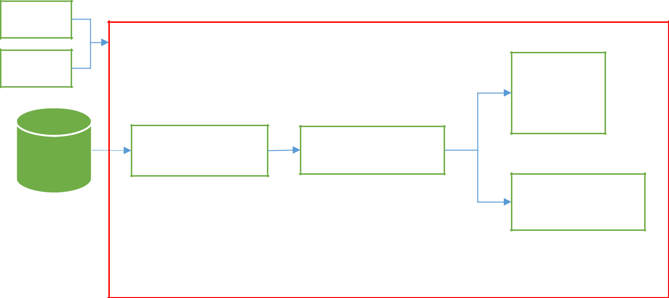

config

UI

Data

 |  | Classifier
 |  | • | ANN
 |  | • | DT
 |  | • | KNN
 |  | • | SVM
• | Read Data | Feature-Generator
• | PreProcess | Feature-Generator
• | PreProcess | Analysis
 |  | • | Correlation
 |  | • | PCA

- Export

  - Features

  - Model

  - Performance-epoch curve

  - Predictions

  - Performance scores

  - Plots

    - Performance-epoch curve

    - Performance scores

DESCRIPTION

- Goal: Identifying objects’ class labels by means of ML algorithms ANN, SVM, DT, and K-NN.

- Tasks:

  - Visualize data

  - Preprocess data

  - Design representation

    - Extract features

    - Explore feature distributions

- Design and create the model

- Conduct model assessment

INSTRUCTIONS

- Develop a machine learning application using Python and related libraries that can

  - Pre-process data,

  - Create ML models based on the methods of k-NN, ANN, SVM, and DT.

  - Display/export results and model parameters

- Add “Team Member Participation” in your report.

- Submission

- Submit project data at GitHub.

- Submit your code and your PPT file at Canvas.

CODING STANDARDS

- Coding must follow readability requirements.
  - Use self-explanatory naming
  - Place proper comments that describes the logic
  - Divide the code into proper procedural sections such as {Pre-processing, Model, Assessment}.

- Must be efficient in terms of time and memory allocation

- User interface must allow to select the input data, export the model parameters, and export the test results.

- Use GitHub to share your code and the data set with your team member and your professor. Name your repository as

- "cmpsML_TEAM NAME".
  - Repository structure:

    - CODE

      - INPUT

      - OUTPUT

      - MODEL

    - DOC
    - OTHER

- Your program must
  - read from file(s) located in the folder INPUT\TRAIN and INPUT\TEST.
  - export outputs (test results, images, etc.) into the folder OUTPUT.
  - export model parameters into the folder MODEL.
  - be able to import model parameters and run the test at another time after creating the model.
CODING STANDARDS

- Make the code generic.

- Code must be efficient (data-structure, functionality).

- Use a relative path.

- Comment adequately.

  - Add a comment for each code block, such as a loop-block, that describe the functionality

- Always use secure data-types (such as immutables types).

- Always test your code with an artificial data whose return value is known.

- Make variables names self-explanatory.

8.Add the symbol # at the end of EACH block.

- Do not calculate a common/constant value inside a loop.

- Avoid initializing variables inside a loop unless it is required.

- Initialize objects with None (null) (NOT zero) if their size is known instead of using append-like methods.
- Save data in categorized folders.

- Legends should be good enough in color, linestyle, shape etc. to distinguish data series.

- Pay attention to the aesthetics.
DESCRIPTION OF THE PROJECT

The objective of this project was to develop a machine learning application that classifies human mood states based on daily lifestyle metrics. The task involved implementing multiple ML algorithms — ANN, SVM, DT, and K-NN — and evaluating their effectiveness in predicting mood states such as happy, stressed, tired, etc., based on features like steps, sleep, and water intake.
DESCRIPTION OF THE RAW DATA

Attributes:
Attribute | Type
date | string
steps | numeric
distance_km | numeric
calories_burned | numeric
active_minutes | numeric
sleep_hours | numeric
water_intake_liters | numeric
mood | string

PREPROCESSING

- Steps Taken:
- Dropped non-numeric 'date' column
- Normalized all numeric features using MinMaxScaler
- Rebalanced classes using SMOTE
- Grouped original mood labels into: positive, neutral, negative
Engineered Features:
- steps_per_minute = steps / active_minutes
- calories_per_km = calories_burned / distance_km
- hydration_index = water_intake_liters / distance_km
- sleep_efficiency = sleep_hours / active_minutes

FEATURE EXTRACTION & DESCRIPTION

• Explain what you have done for feature extraction:
- We engineered additional features to better represent behavioral metrics related to mood.
- The features were derived from existing numeric attributes to enhance the separability between classes.

• Report parameters used for feature extraction:
- - All numeric columns were retained.
- - The following transformations were applied using arithmetic ratios:
• steps_per_minute = steps / active_minutes
• calories_per_km = calories_burned / distance_km
• hydration_index = water_intake_liters / distance_km
• sleep_efficiency = sleep_hours / active_minutes

• Describe features:

- ◦ Data types:

Feature | Type
steps | numeric
distance_km | numeric
calories_burned | numeric
active_minutes | numeric
sleep_hours | numeric
water_intake_liters | numeric
steps_per_minute | derived numeric
calories_per_km | derived numeric
hydration_index | derived numeric
sleep_efficiency | derived numeric

◦ Use appropriate plots:
- Correlation heatmap of all numeric features
- PCA scatter plot of extracted features
- F1 and accuracy bar plots across models

◦ Provide samples for features:
- Samples are visualized in OUTPUT/plots/pca_scatter.png and correlation_heatmap.png
- Raw and engineered feature values are normalized and available in the preprocessed dataset
DESCRIPTION OF THE MODEL

- Describe parameters of the model.

Models Used:
- ANN: Tuned (hidden layers, max_iter)
- SVM: Tuned (C, kernel)
- Decision Tree: Tuned (max_depth, split)
- K-NN: Tuned (k from 3–10)
- Random Forest: 100 estimators
- Ensemble: VotingClassifier combining all above
PERFORMANCE OF THE MODEL

◦ Distribution of training, validation, test data sets
- The dataset was split using a 60% training, 20% validation (via GridSearchCV), and 20% test set approach.

◦ Performance measures to compare models
- Accuracy, Precision, Recall, F1 Score (macro), and Confusion Matrices were generated.
- ROC-AUC curves were plotted for SVM and ANN classifiers.
- - PCA scatter plots were used to visualize feature space separability.

- Model performance Table:
Model | Accuracy | F1 (Macro)
SVM | 0.464 | 0.4436
Decision Tree | 0.448 | 0.4208
KNN | 0.456 | 0.4263
ANN | 0.432 | 0.4264
Random Forest | 0.528 | 0.5221
Ensemble | 0.576 | 0.5619

Conclusion:

This project demonstrates a comprehensive ML pipeline. Through feature engineering, class rebalancing, model tuning, and ensemble learning, we improved classification accuracy significantly. The final product is modular, scalable, and optimized for similar mood prediction tasks.

Github link: https://github.com/sarseej-shrestha/cmpsML_codefiends

