Stanford CoreNLP notes from:
https://nlp.stanford.edu/pubs/StanfordCoreNlp2014.pdf

The Stanford CoreNLP Natural Language Processing Toolkit
Abstract:
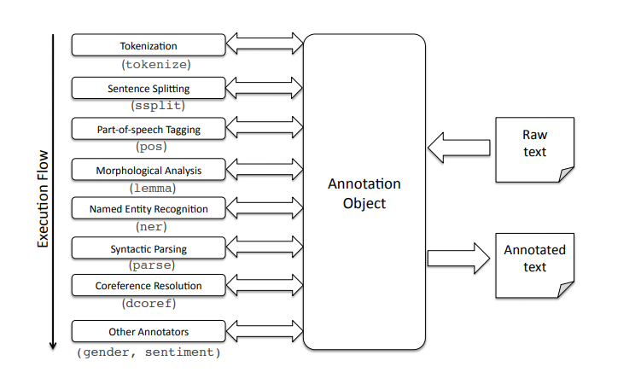
-widely used open sourced NLP software among government, commercial and research groups.

Original Design and Development:
-initially designed for internal use.
-designed to be an alternative to using multiple different models and gluing them together.
-minimal startup required

