Tree growth and carbon increment analysis
  - Analysis notes for paper drafting | Updated 20 October 2026
This note describes growth and aboveground carbon accumulation through time in the four poplar hybrids. PAIC measures recent growth over an observed interval; MAIC measures average accumulation since planting. The current figures are descriptive, and the measurement gaps require explicit interpretation.

Methods
The trees were planted in 1992. The dataset contains 180 measured trees: Beaupre, Gibecq, Robusta and Trichobel, with 45 trees per hybrid across three experimental blocks. Measurements cover the even-numbered tree rows. The recorded series spans 1993 to 2023; there are no visits in 1999, 2000, 2003 or 2004.
The main preparation retains supplied tree-level carbon stocks, PAIC and MAIC. Separate audit columns reconstruct biomass using the supplied diameter allometry, convert biomass to carbon using a fraction of 0.5, and scale to area using the configured density of 166 trees per hectare. This scaling is an assumption, not a measured whole-system carbon balance.
PAIC is the change in aboveground carbon stock divided by elapsed years between successive visits. MAIC is carbon stock divided by years since planting. Annual plots show hybrid medians and interquartile ranges across trees. These ranges describe variability and are not confidence intervals for independent experimental replicates.

Main results
Hybrid | PAIC | MAIC | Carbon stock
Beaupre | 0.70 | 1.29 | 40.08
Gibecq | 0.42 | 1.09 | 33.77
Robusta | 0.86 | 1.23 | 38.73
Trichobel | 2.33 | 2.13 | 65.99

The table gives 2023 medians. PAIC and MAIC are in Mg C per hectare per year; stock is in Mg C per hectare. Trichobel has the highest median values at the final visit. This descriptive ranking does not substitute for a longitudinal statistical comparison.

Measurement gaps and interpretation
The 2001 PAIC averages the 1998 to 2001 measurement interval, corresponding to growth years 1998 to 2000 under the adopted convention. Missing visits do not mechanically lower annualised PAIC: dividing by elapsed time already accounts for duration. The gap prevents identification of which individual years contributed to the low average and can smooth annual extremes. The 2005 PAIC similarly covers growth years 2002 to 2004.
Recalculation confirms the dip: mean PAIC across available tree records is approximately 2.65 at the 1998 visit, 0.89 at the 2001 visit and 1.77 at the 2002 visit. The supplied and stock-derived values agree closely at these visits. The cause of the slowdown remains unresolved.
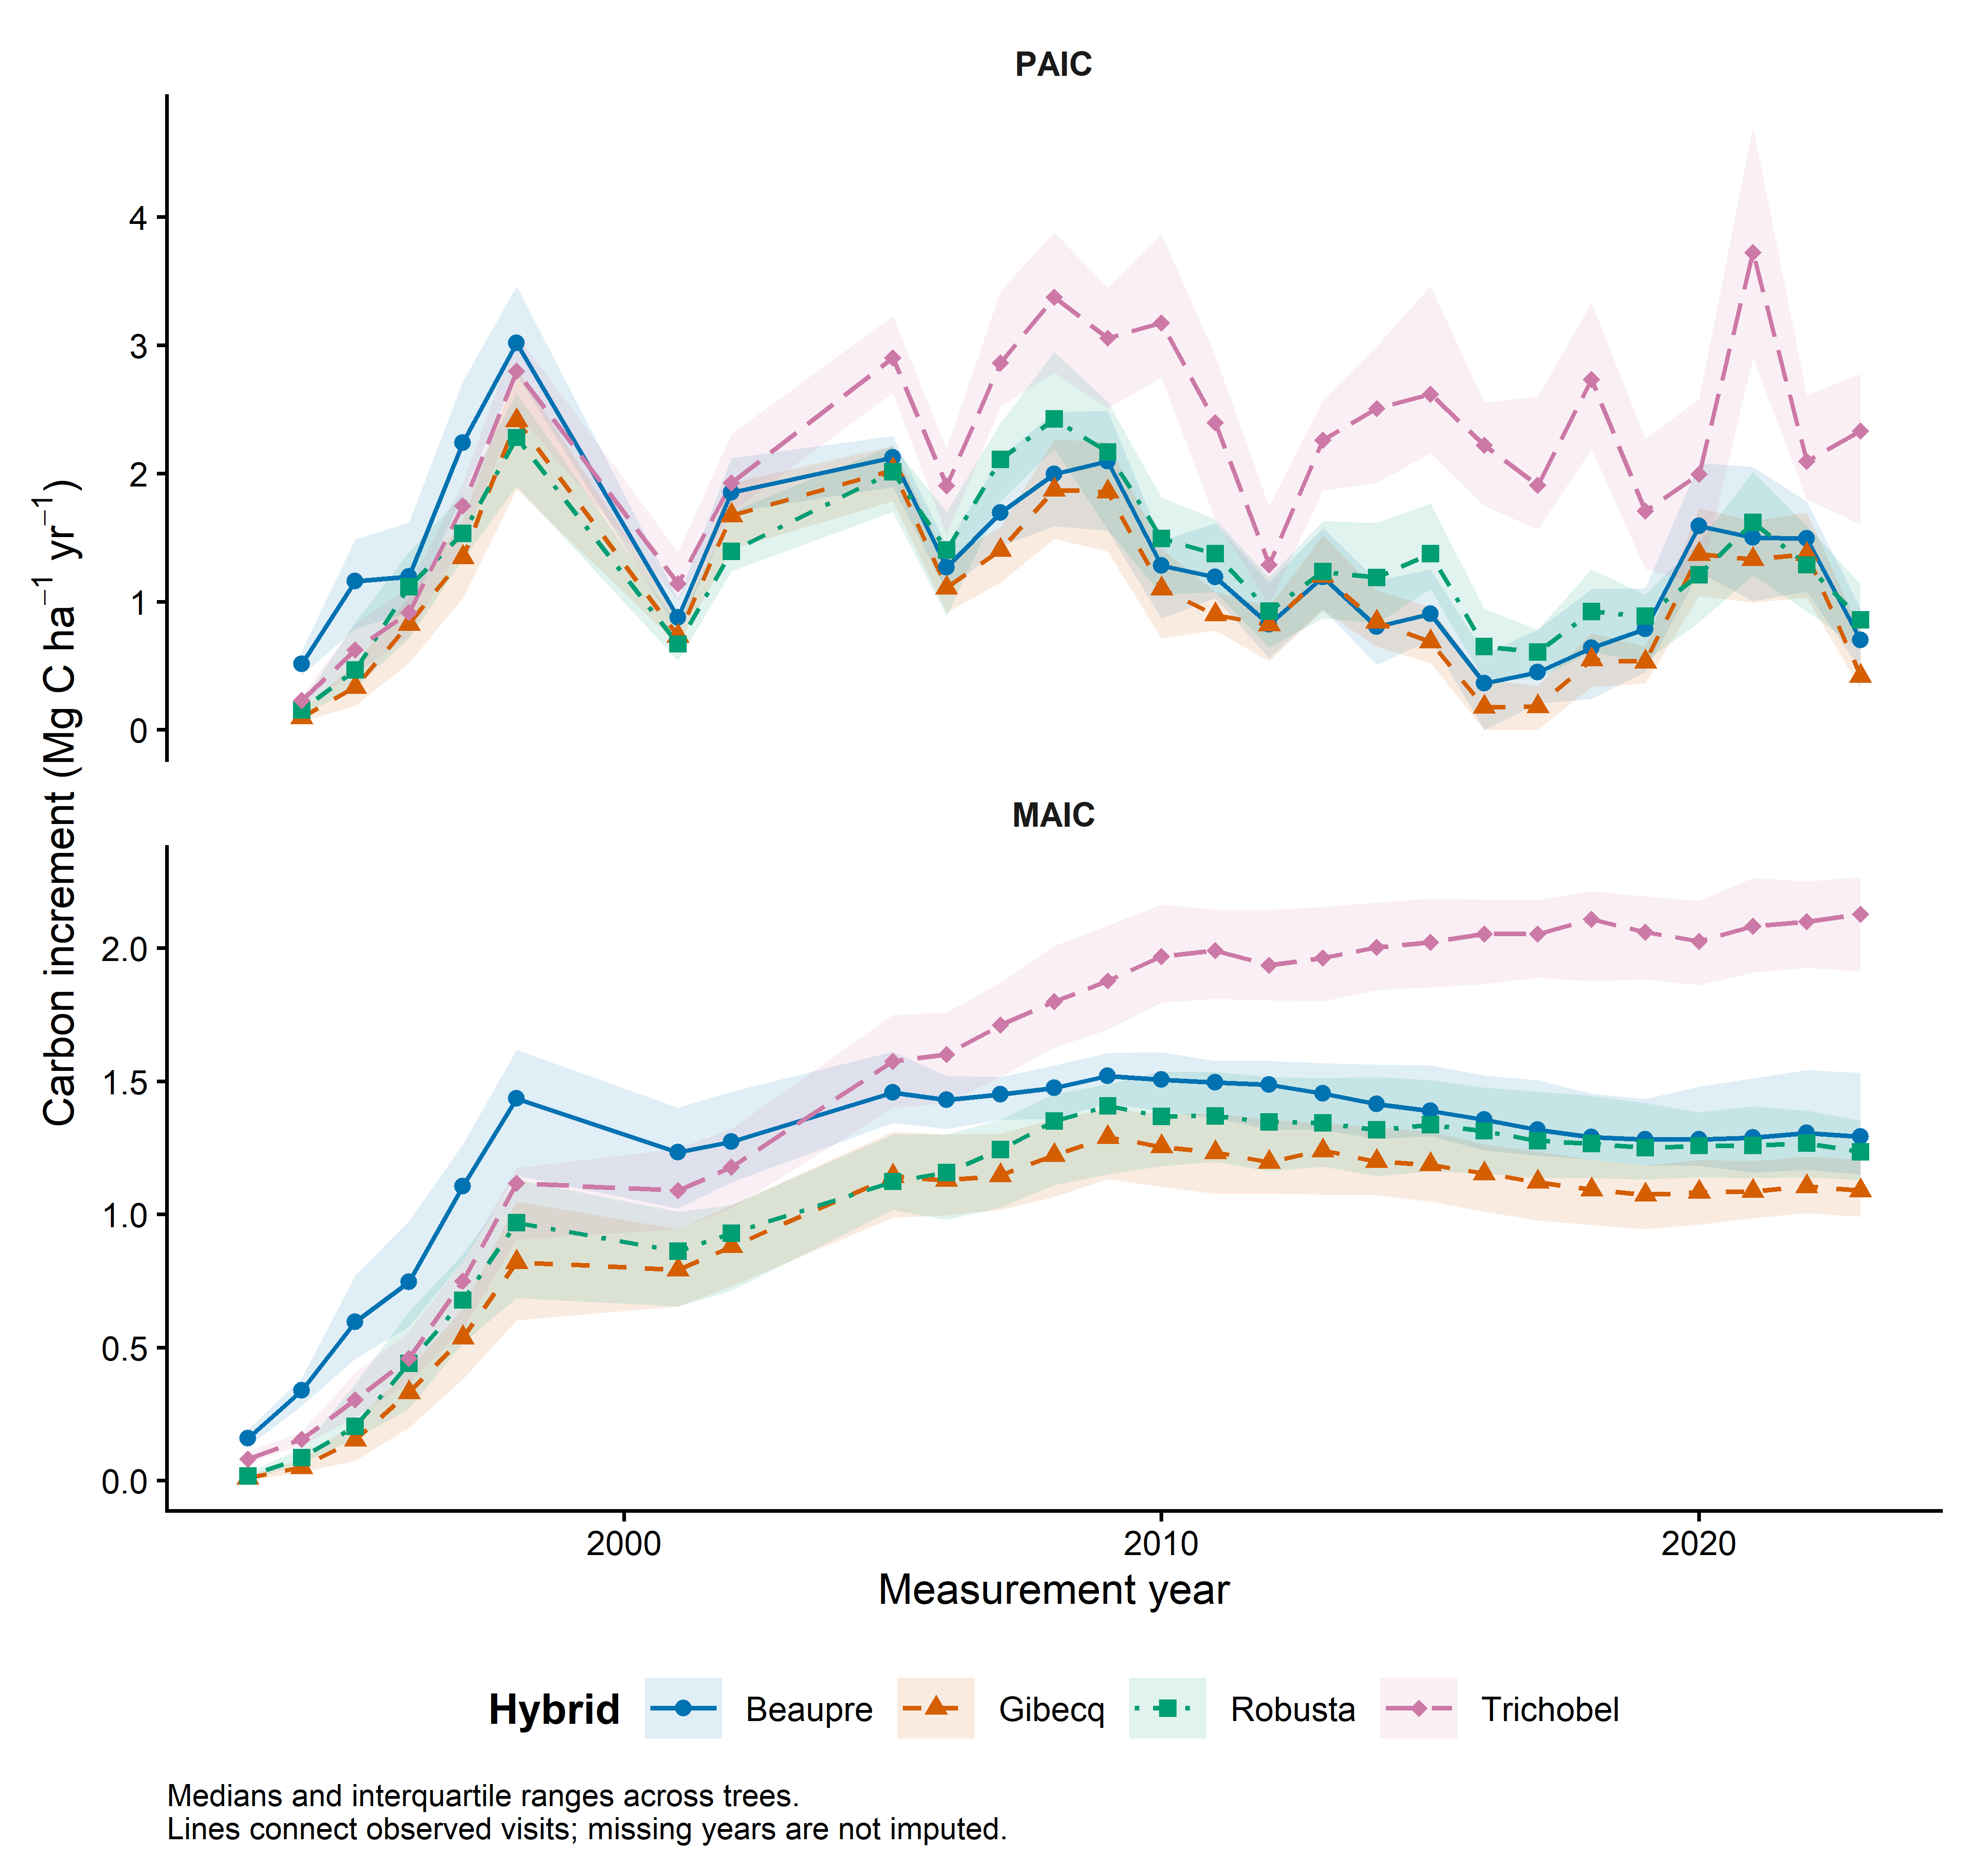
Figure 1 Hybrid medians and interquartile ranges across measured trees. Lines connect visits without reconstructing unobserved annual growth.

Discussion and decisions still needed
Use PAIC to discuss changes in growth rate, and MAIC or stocks to discuss accumulated carbon. Resolve the remaining Robusta response-summary discrepancy, the treatment of missing or nonpositive observations, and allometric uncertainty before final inference. Do not interpret continued stock differences as evidence that current growth rates remain different.

Files supporting this note
analysis/01_growth_descriptive.R
results/tables/growth_by_year_hybrid.csv
results/checks/tree_response_audit.csv
results/checks/response_comparison.csv

