Weather relationships with tree growth
  - Analysis notes for paper drafting | Updated 20 October 2026
This note records the current hybrid-specific weather models for PAIC and the limitations that matter for paper drafting. The baseline models identify statistical associations with multivariate weather gradients; they do not yet explain the low growth recorded at the 2001 visit.

Methods
The baseline analysis uses the legacy hybrid PAIC summaries for continuity with the earlier weather analysis. These have been compared with tree-level hybrid medians. Beaupre, Gibecq and Trichobel agree closely; a remaining Robusta discrepancy needs resolution. Only positive, observed PAIC values enter the Gamma models.
A measurement in year t is paired with weather for growth year t minus 1. Seasons are winter December to February, spring March to May, summer June to August and autumn September to November; half-years are October to March and April to September. Winter windows cross the calendar-year boundary.
Temperature, soil temperature and wind speed are averaged; rainfall, sunshine, frost-day counts, growing-day counts, growing degree days and windy-day counts are summed within windows. Variable coverage is exported. Partial variable records currently use available days; a final coverage policy has not been fixed.
Six separate principal component analyses describe the seasonal or half-year weather. Each is shared across hybrids, uses standardised weather variables on its complete-case basis, and retains enough axes to explain at least 80 percent of weather variance. For each hybrid and period, PAIC is modelled with a Gamma distribution and log link using retained component scores.

Current model results
Hybrid | Summer observations | Summer PCs | Deviance reduction
Beaupre | 23 | 4 | 44.2%
Gibecq | 23 | 4 | 35.0%
Robusta | 23 | 4 | 30.5%
Trichobel | 23 | 4 | 53.6%

All exported baseline fits converged. Deviance reduction is an in-sample measure, not predictive validation or the fraction of growth causally explained by weather. Models fitted to different observation sets must not be ranked directly by AIC.

The unresolved slowdown around the 2001 visit
PAIC at the 2001 visit averages growth over 1998 to 2000, but the current weather join supplies weather for 2000 only. This mismatch matters when interpreting that point. No interval-aware weather analysis has yet been completed, and the existing model should not be used to attribute the three-year average to weather in one year.
Growth year | Summer half rainfall mm | Summer half sunshine hours
1997 | 345.3 | 967.1
1998 | 335.9 | 797.8
1999 | 333.5 | 943.6
2000 | 451.4 | 906.9
2001 | 295.2 | 873.6

The local records show relatively low summer-half sunshine in 1998 and higher summer-half rainfall in 2000. These are observations for investigation, not established explanations of the growth decline. They do not resolve which years within the measurement gap were most influential.

Discussion points
Interpret each component using its loadings, rather than assigning a physical meaning from its sign or number. Component signs are arbitrary, and a one-unit score is not a one-degree temperature or one-millimetre rainfall change. Any quoted association should name the hybrid, weather period, component interpretation and uncertainty.
The treatment analysis absorbs shared temporal conditions with categorical interval effects. Its interval coefficient cannot distinguish weather from stand development, management changes or other shared causes. Separate weather modelling can investigate associations, while treatment by weather interactions would be a distinct, more demanding question.

Next analysis decisions
Compare annual-interval models with an interval-aware sensitivity analysis. A candidate approach is to predict annual growth using annual weather and then average predictions over each observed growth interval; this is not generally identical to predicting from averaged weather under a nonlinear link. Assess age or time trends, residual dependence, influential observations and fair temporal validation before describing forecasts as reliable.

Files supporting this note
analysis/02_weather_paic.R
scripts/prep/02_weather.R
scripts/prep/04_join_and_pca.R
results/tables/baseline_weather_model_summary.csv
results/tables/baseline_weather_model_coefficients.csv
data/processed/weather_pca_loadings.csv
results/checks/weather_coverage.csv

Shared fluctuations and weather model update
Update 20 October 2026. PAIC fluctuations are strongly shared across hybrids after broad trajectories are removed. The simple temperature and rainfall model did not improve held-out prediction. Earlier sections retain the original seasonal PCA record; the current decisions and results follow below.

Methods
For the synchrony analysis, use the same tree-level hybrid medians as the PAIC and MAIC descriptive figure, restricted to 26 measurement years with positive PAIC for all four hybrids. Fit a separate quadratic age trend to log PAIC for each hybrid, without a shared year effect. Divide each hybrid residual series by its own standard deviation to compare departures. Calculate descriptive Pearson and Spearman correlations; repeat with linear detrending and the legacy weather-response summaries. No missing years are imputed. The last ten observations, 2014 to 2023, form an exploratory descriptive subset, not an estimated change point.
The separate weather comparison uses 104 legacy hybrid summaries over 26 years. Gamma log-link mixed models include hybrid-specific quadratic age trends and a random measurement-year intercept. Compare the baseline with shared April to September mean temperature and rainfall effects. Leave out all four hybrids from one year together, refit, and predict the unseen year by integrating over the random intercept. This assesses interpolation, not future forecasting.

Calculated results
After quadratic detrending, correlations among Beaupre, Gibecq and Robusta range from 0.91 to 0.96. Trichobel correlations are 0.73 with Beaupre, 0.72 with Gibecq and 0.89 with Robusta. Linear detrending also shows strong positive synchrony. Trichobel correlation with the mean standardised departure of the other hybrids is 0.95 in 1994 to 2013 and 0.61 in 2014 to 2023. Its median raw PAIC ratio to the geometric mean of the others is 1.50 and 2.73, respectively. These comparisons have no inferential uncertainty assessment.
Held-out RMSE is 1.696 for the age baseline and 1.703 after adding temperature and rainfall. Mean Gamma deviance is 0.607 and 0.612, respectively. Both weather coefficient intervals include zero. Hybrid-specific weather slopes and winter extensions were not fitted because the shared-weather model did not improve either metric. Final full and fold fits have no recorded convergence or singularity warnings.

Discussion hypotheses
Shared departures are consistent with a common environmental driver but do not identify weather as its cause. Trichobel maintains higher relative growth in later observations, especially when other hybrids have low PAIC. This is not proof of greater drought tolerance or a distinct weather response; ratios can increase because their denominator declines.

Open decisions and confirmed interval convention
Retain weather from year t minus 1, including multi-year PAIC intervals, as confirmed by the user. Annualising PAIC accounts for interval duration, but growth timing within unsampled years remains unknown. State this in Methods and Discussion. Revisit age-curve sensitivity, temporal dependence, weather exposure summaries and coverage, the Robusta response discrepancy, and validation. The PCA retention caveat remains open: weather variance is not PAIC relevance. See references/WEATHER_PCA_REVIEW.md for the saved Wicklin blog and methodological reference.

Shared PAIC fluctuations
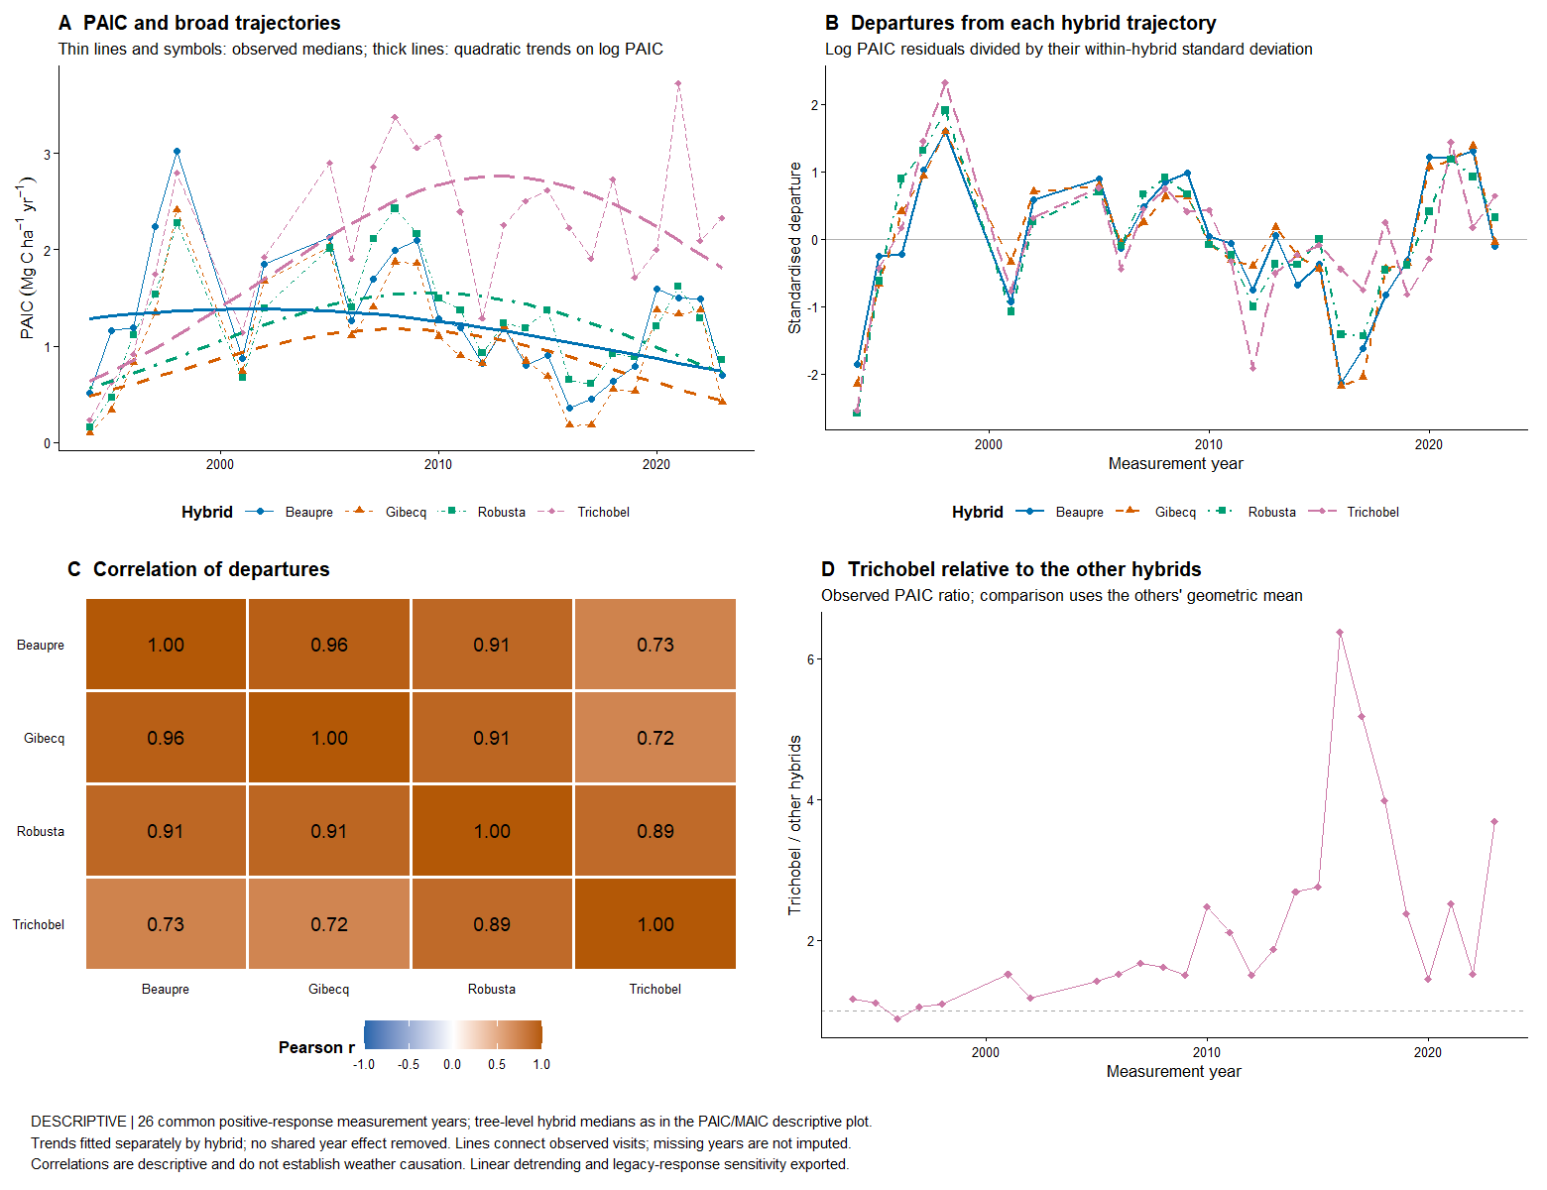
Descriptive comparisons use tree medians. Correlations do not establish causation, and quadratic trends are provisional. The Trichobel ratio compares observed PAIC with the geometric mean of Beaupre, Gibecq and Robusta.

Reproducible sources for this update
analysis/07_weather_temperature_rainfall.R and analysis/08_check_weather_temperature_rainfall.R; analysis/09_paic_shared_fluctuations.R; results/tables/paic_synchrony_*.csv; results/tables/weather_temperature_rainfall_*.csv; references/WEATHER_MODEL_NOTES.md and references/WEATHER_PCA_REVIEW.md.

Exploratory weather screen of shared departures
Update 20 October 2026. The screen suggests modest positive associations with summer rainfall and temperature. No clear dominant weather driver has emerged, and no selected predictor has been validated as a PAIC model.

Methods
Average the four within-hybrid standardised log PAIC departures from their separate quadratic age trajectories, giving hybrids equal weight. Screen nine predefined candidates: spring and summer rainfall, sunshine and mean air temperature; spring air and ground frost-day counts; and the longest dry spell during April to September. Spring is March to May and summer is June to August of growth year t minus 1. Dry days have rainfall below 1 mm; the dry-spell measure is the longest consecutive run, with no missing days allowed. Frost means daily minimum temperature below zero. Retain the confirmed t minus 1 alignment for annualised multi-year PAIC intervals.
Require complete daily coverage for the particular predictor. The primary comparison uses 24 years complete for all nine measures, omitting measurement 2001 because spring temperature lacks one day and 2019 because spring ground frost lacks two days. Predictor-specific available-year results retain 25 or 26 years. Report Pearson and Spearman correlations, the range of Pearson correlations obtained by omitting each year, correlations after adjusting both series for quadratic age on the matched sample, and sensitivity to linear rather than quadratic PAIC detrending. Omission ranges are influence diagnostics, not confidence intervals. Detrending is fitted to all observed years, so these summaries are not predictive validation.

Calculated results
Summer rainfall (mm): Pearson r 0.30, Spearman r 0.33; single-year omission range 0.26 to 0.37. Linear PAIC detrending gives r 0.47; quadratic age adjustment of both matched series gives r 0.35.
Summer air temperature (degrees C): Pearson r 0.37, Spearman r 0.23; single-year omission range 0.18 to 0.43. Linear PAIC detrending gives r 0.26; quadratic age adjustment of both matched series gives r 0.42.
Spring rainfall (mm): Pearson r -0.20, Spearman r -0.14; single-year omission range -0.30 to -0.07. Linear PAIC detrending gives r -0.12; quadratic age adjustment of both matched series gives r -0.20.
Other Pearson correlations range from approximately -0.05 to 0.17 on the common basis. Summer rainfall has a positive association within each hybrid, r 0.23 to 0.38; summer temperature also has a positive association in each, r 0.28 to 0.44. Predictor-specific available years give r 0.32 for summer rainfall and 0.33 for summer temperature. Dry spell association is weak and positive rather than the hypothesised negative association; it is not evidence of improved growth under drought.

Discussion hypotheses
Summer rainfall is a candidate for follow-up because its direction is consistent across hybrids, ranks and omission checks. The summer temperature association is influenced by the earliest observation, 1994, and is weaker using ranks. Both associations may reflect unmeasured conditions, growth-trajectory misspecification or chance among the nine screened candidates. Seasonal aggregation may capture relationships lost in the earlier half-year model, but this has not yet been tested in a validated model. Shared fluctuations remain substantially unexplained.

Open decisions
Next assess a small summer-weather model against the age baseline, with all detrending and any predictor selection inside training folds. Keep year groups together and consider temporal blocks. Check sensitivity to establishment-age observations without deleting them from the primary analysis; retain multi-year intervals and disclose their limitation. Do not interpret the screen as an independent validation set or convert individual unadjusted correlations into confirmatory claims. Weather coverage and the Robusta legacy discrepancy remain open.

Weather screen overview
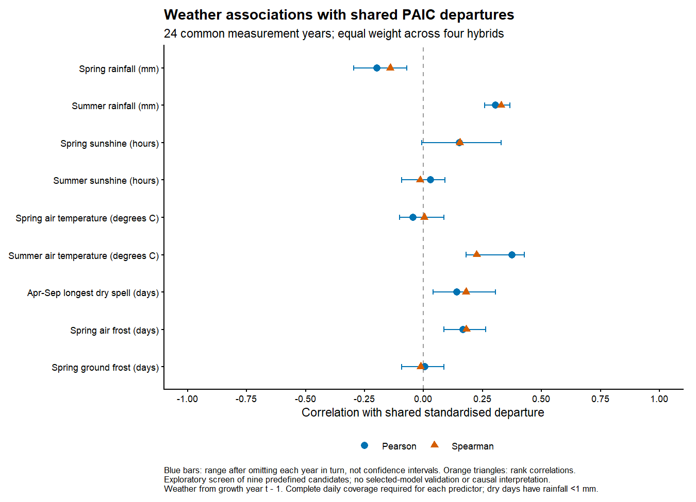
Blue points show Pearson correlations; orange triangles show Spearman rank correlations. Blue ranges show sensitivity to omitting one year at a time and are not confidence intervals.

Reproducible sources
analysis/10_weather_departure_screen.R; results/tables/weather_departure_screen_common_years.csv; weather_departure_screen_available_years.csv; weather_departure_screen_data.csv; weather_departure_hybrid_correlations.csv. The nine scatterplots are saved separately as results/figures/weather_departure_scatterplots.pdf and PNG.

Weather models of shared PAIC departures
Update 20 October 2026. Combined June to August rainfall and temperature improve prediction of shared standardised PAIC departures relative to no weather in this exploratory comparison. This is a different response and weather window from the earlier raw PAIC mixed model, and it is not an independent confirmation after screening.

Methods
Use 26 common measurement years with positive tree-level median PAIC for all four hybrids and complete summer rainfall and temperature coverage. In each training fold, fit a separate quadratic age trajectory to log PAIC for each hybrid. Divide training residuals by their within-hybrid training residual standard deviation. Calculate held-out departures from the training-fitted age trajectory and the same training standard deviation. Average the four departures with equal hybrid weights. No held-out PAIC enters the fitted trajectories or scales.
Fit linear models of shared departures using no weather, rainfall only, temperature only, or both. Age is not added to the second-stage regression. Rainfall is in 100 mm units and temperature in degrees C. Compare leave-one-year-out and five contiguous blocks of observed measurement years, keeping all hybrids from each year together. Repeat using linear rather than quadratic age detrending as a sensitivity. No automated predictor selection is performed inside this comparison; prior full-data screening remains a source of selection optimism. All multi-year increments retain the confirmed t minus 1 weather assignment.

Calculated results
Leave one year out, quadratic detrending: no-weather RMSE 1.198; rainfall only 1.158; temperature only 1.166; both 1.032. The combined model reduces RMSE by 13.9 percent relative to no weather within this scheme. Units are fold-standardised shared departures.
Five contiguous blocks, quadratic detrending: no-weather RMSE 3.001; rainfall only 2.840; temperature only 2.847; both 2.459. The combined model reduces RMSE by 18.1 percent relative to no weather within this scheme. Units are fold-standardised shared departures.
With linear detrending, the combined model reduces leave-one-year-out RMSE by 15.8 percent and block RMSE by 22.5 percent. Full-data combined-model slopes are 0.675 shared-departure units per 100 mm summer rainfall and 0.582 units per degree C. Its in-sample R squared is 0.305; this is not the proportion of raw PAIC causally explained by weather. Omitting 1994 from scoring only reduces the leave-one-year-out advantage: no-weather RMSE 0.957 versus combined-model 0.899, about 6 percent improvement; this is an influence check, not a refit excluding that year.

Discussion hypotheses
Warmer and wetter summer conditions are associated with more positive shared departures in the fitted range. The joint model performs better than either single predictor, suggesting potentially complementary information. These associations do not establish causation or imply that warming benefits growth outside observed conditions. The earlier failure of the half-year raw PAIC model and this result are not directly comparable: exposure window, response scale, data source and model structure differ.

Open decisions and limitations
Block errors are much larger than leave-one-year-out errors. The earliest block includes a held-out shared departure of about minus 9 training standard deviations, revealing poor extrapolation of the quadratic age trajectory. Do not interpret relative block improvement as reliable long-range weather forecasting. Full-data confidence bands condition on detrending and omit trend and predictor-selection uncertainty. The response is a shared standardised log-scale departure, not an individual hybrid PAIC forecast. Before inference, assess a less fragile growth trajectory, nested screening or independent data, residual temporal dependence, weather coverage and the legacy Robusta discrepancy. Keep sampling-gap and PCA-retention caveats open.

Summer weather models of shared departures
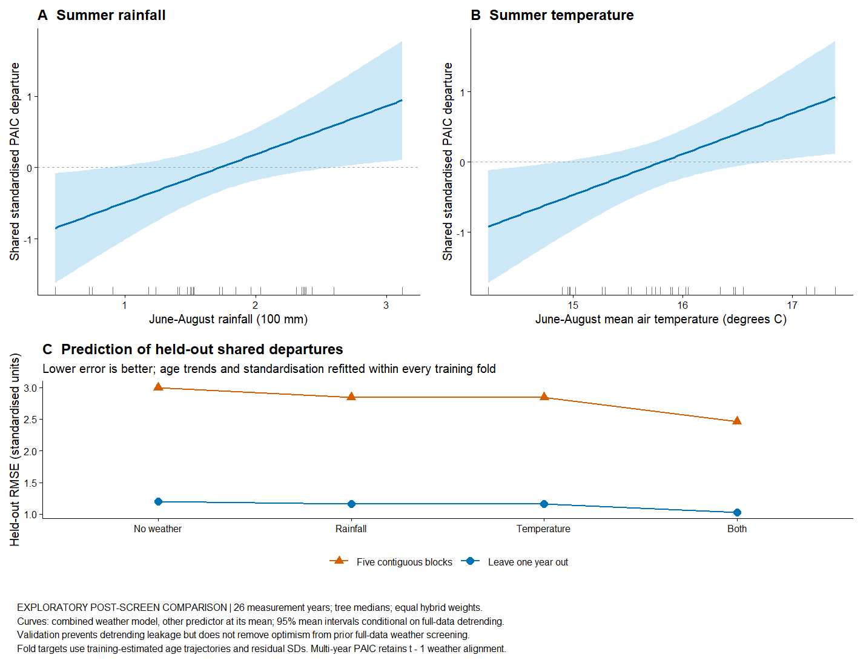
Curves show the combined model at the mean of the other predictor. Shading gives approximate 95 percent mean confidence intervals conditional on full-data detrending. Validation refits age trends and standardisation in each training fold; it does not undo prior full-data screening.

Reproducible sources
analysis/11_weather_departure_models.R; results/tables/weather_departure_model_validation.csv; weather_departure_model_held_out_predictions.csv; weather_departure_model_fold_audit.csv; weather_departure_model_coefficients.csv; results/models/weather_departure_models.rds.

Hybrid specific summer weather associations
Update 20 October 2026. Summer rainfall and temperature have positive fitted associations with growth departures in all four hybrids. Trichobel does not have a clearly larger temperature association after removing broad growth trajectories. These exploratory results do not establish equal responses or causal weather effects.

Methods
Use the same 26 common measurement years and tree-level hybrid medians as the shared-departure models. Remove a separate quadratic age trajectory from log PAIC for each hybrid and standardise residuals by their within-hybrid standard deviation. Fit hybrid-specific intercepts and summer rainfall and temperature slopes, equivalently a fully interacting joint linear model. Directly compare paired slopes rather than comparing significance within hybrids. Standardised slopes describe sensitivity relative to each hybrid variability, not absolute differences in carbon increment.
For uncertainty, take 1000 paired circular moving-block bootstrap samples, each built from blocks of three ordered measurement visits. All four hybrids and their weather stay together. Refit age trends, residual scales and weather slopes in every sample. Blocks follow observed visits and can span missing-year gaps; the block length is provisional. Plot pointwise percentile intervals for slopes and calculate simultaneous approximate intervals over all 12 pairwise slope contrasts using the maximum centred, standardised bootstrap deviation. This is exploratory after full-data weather screening, not confirmatory testing.

Calculated results
Beaupre: rainfall slope 0.79 standardised units per 100 mm; temperature slope 0.56 per degree C; in-sample R squared 0.31.
Gibecq: rainfall slope 0.68 standardised units per 100 mm; temperature slope 0.54 per degree C; in-sample R squared 0.25.
Robusta: rainfall slope 0.62 standardised units per 100 mm; temperature slope 0.69 per degree C; in-sample R squared 0.31.
Trichobel: rainfall slope 0.61 standardised units per 100 mm; temperature slope 0.55 per degree C; in-sample R squared 0.23.
Of the 12 paired rainfall and temperature slope differences, 0 have simultaneous bootstrap intervals excluding zero. These are direct slope comparisons, not comparisons of separate p values. Linear detrending also gives positive slopes in every hybrid and does not place Trichobel highest for temperature. Unstandardised log-departure slopes likewise do not show a larger Trichobel temperature coefficient.

Discussion hypotheses
The later relative advantage of Trichobel is visible in observed PAIC, but it does not translate into a clearly steeper summer temperature slope in the detrended analysis. The broad hybrid trajectories can absorb a gradual divergence that coincides with warming, so this result concerns fluctuations around those trajectories. It cannot determine whether warming contributed to the longer-term divergence. Age, time and cultivation history remain entangled in this planting cohort.

Open decisions and residual diagnostics
Weather models leave substantial temporal structure. Correlations between residuals in consecutive observed calendar years are about 0.59 for Beaupre, 0.68 for Gibecq, 0.59 for Robusta and 0.30 for Trichobel. Block-bootstrap uncertainty addresses some short dependence but does not model its cause. Assess block-length and age-trend sensitivity and unresolved shared conditions before paper inference. Omit-one-year slopes are exported as influence checks. The weather variable screening, multi-year interval, coverage, Robusta legacy discrepancy and PCA-retention caveats remain open. No forecast claim is intended.

Observed and fitted departures by hybrid
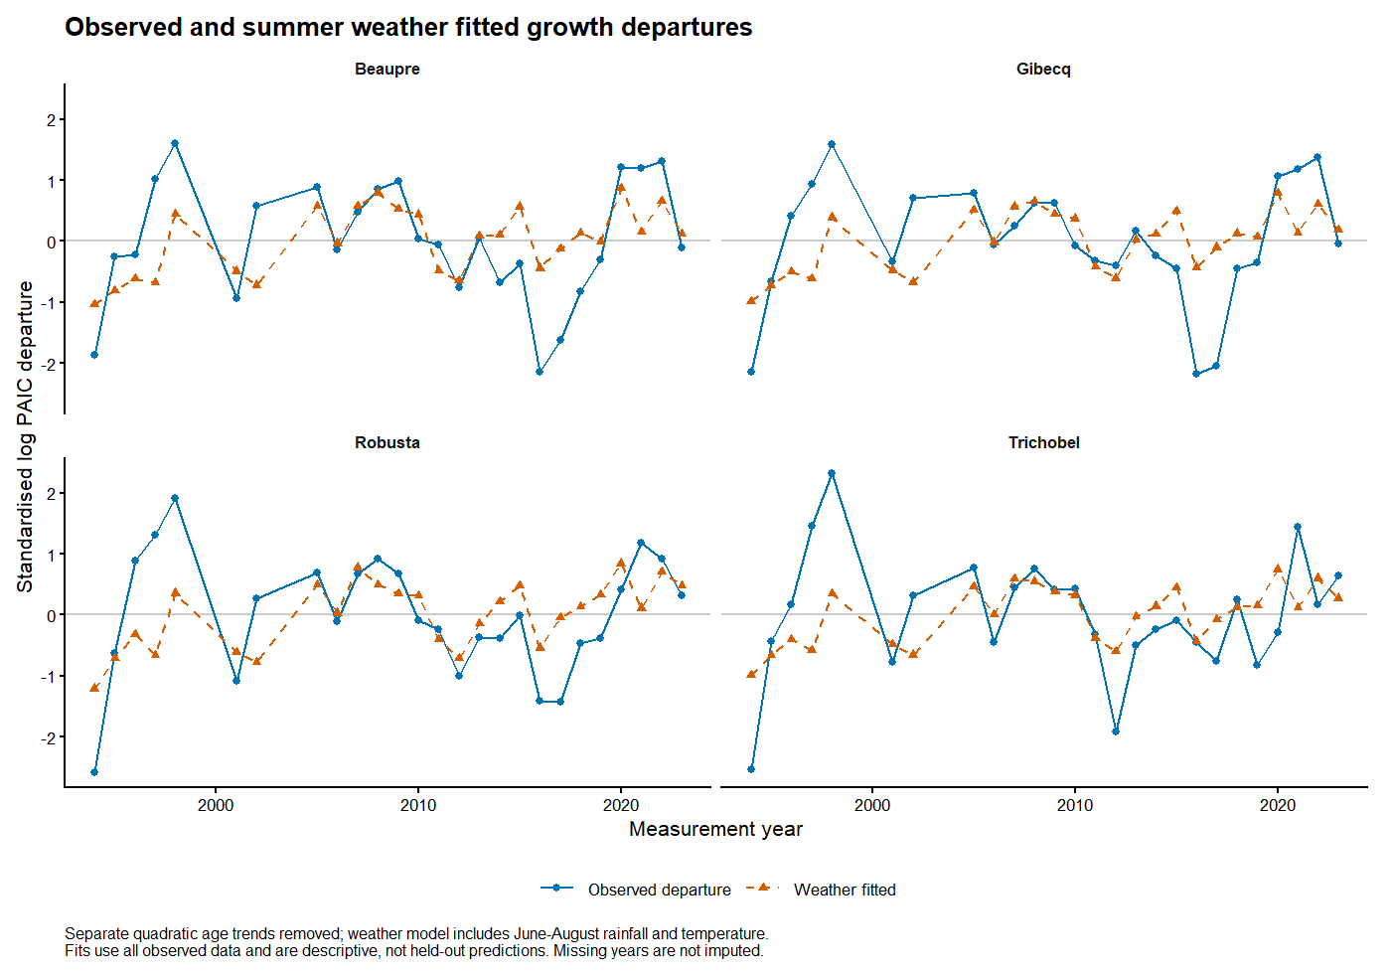
Observed departures and full-data weather fits show which peaks and troughs are captured. These are in-sample fits after removing age trajectories. The separate slope figure reports block-bootstrap intervals.

Reproducible sources
analysis/12_hybrid_weather_departures.R; results/tables/hybrid_weather_slopes.csv; hybrid_weather_paired_slope_differences.csv; hybrid_weather_sensitivity_slopes.csv; hybrid_weather_omit_year_slopes.csv; hybrid_weather_residual_summary.csv; results/models/hybrid_weather_departures.rds. Figures: hybrid_weather_time_series and hybrid_weather_slopes, PNG and PDF.

Weather associations in absolute carbon increment units
Update 20 October 2026. Retain the same June to August mean air temperature and rainfall predictors, without further screening. This analysis expresses adjusted associations directly in Mg C per hectare per year and in percentages, complementing the standardised departure analysis.

Methods
Fit original positive PAIC with Gamma log-link models, allowing each hybrid its own intercept, quadratic age trajectory and rainfall and temperature slopes. This is equivalent in fitted means to a fully interacting joint model, verified numerically. No response standardisation or preliminary detrending is used. Use the same 26 years and tree-level hybrid medians. Retain the confirmed measurement-year t to growth-year t minus 1 alignment, including annualised multi-year increments.
Average adjusted predictions over the same 26 observed ages for all hybrids. Temperature contrasts compare 15.31 with 16.31 degrees C, holding rainfall at its observed mean. Rainfall contrasts compare 122.4 with 222.4 mm, holding temperature at its mean. These are 1 degree C and 100 mm differences centred within the observed range, not extrapolated warming scenarios. They are model-adjusted comparisons across a common age distribution, not changes observed in a particular pair of years.
Use 1000 paired circular block-bootstrap samples of three observed visits, retaining all hybrids within each visit and refitting the full models. Report pointwise percentile intervals for effects and direct pairwise differences. These are exploratory intervals without multiplicity adjustment; none of the pairwise intervals exclude zero. Rare bootstrap fits give extreme absolute contrasts when age ranges are poorly represented; tail diagnostics are exported and no replicates are discarded. Percentile intervals avoid treating those tails as approximately normal, but do not resolve age-extrapolation instability. Blocks may span sampling gaps. Percent differences need not rank hybrids like absolute differences.

Calculated results
Beaupre: temperature contrast +0.44 Mg C per hectare per year (+40.5 percent); rainfall contrast +0.69 (+68.9 percent). The exported figure and tables include uncertainty intervals.
Gibecq: temperature contrast +0.39 Mg C per hectare per year (+47.6 percent); rainfall contrast +0.66 (+91.9 percent). The exported figure and tables include uncertainty intervals.
Robusta: temperature contrast +0.53 Mg C per hectare per year (+53.6 percent); rainfall contrast +0.56 (+57.5 percent). The exported figure and tables include uncertainty intervals.
Trichobel: temperature contrast +0.58 Mg C per hectare per year (+32.2 percent); rainfall contrast +0.77 (+44.3 percent). The exported figure and tables include uncertainty intervals.
Of the 12 direct pairwise absolute-effect comparisons, 0 have pointwise paired bootstrap intervals excluding zero. This is an exploratory post-screen comparison, not confirmation of causal differences. Linear age-trend results are exported as a separate sensitivity and should be considered before selecting a final specification.

Discussion and open decisions
Absolute responses combine baseline carbon increment with the proportional weather association. A faster-growing hybrid can therefore have a larger absolute response without a larger percentage or standardised response. Neither metric establishes heat tolerance. Associations are adjusted for the chosen age trajectory; this cannot separate age from calendar-time trends or cultivation history in one planting cohort. Previously detected residual temporal structure remains relevant. Variable selection uncertainty, block length, age specification, weather coverage and sampling-gap limitations remain open; the response now matches original PAIC units, not a forecasting objective.

Adjusted carbon increment differences
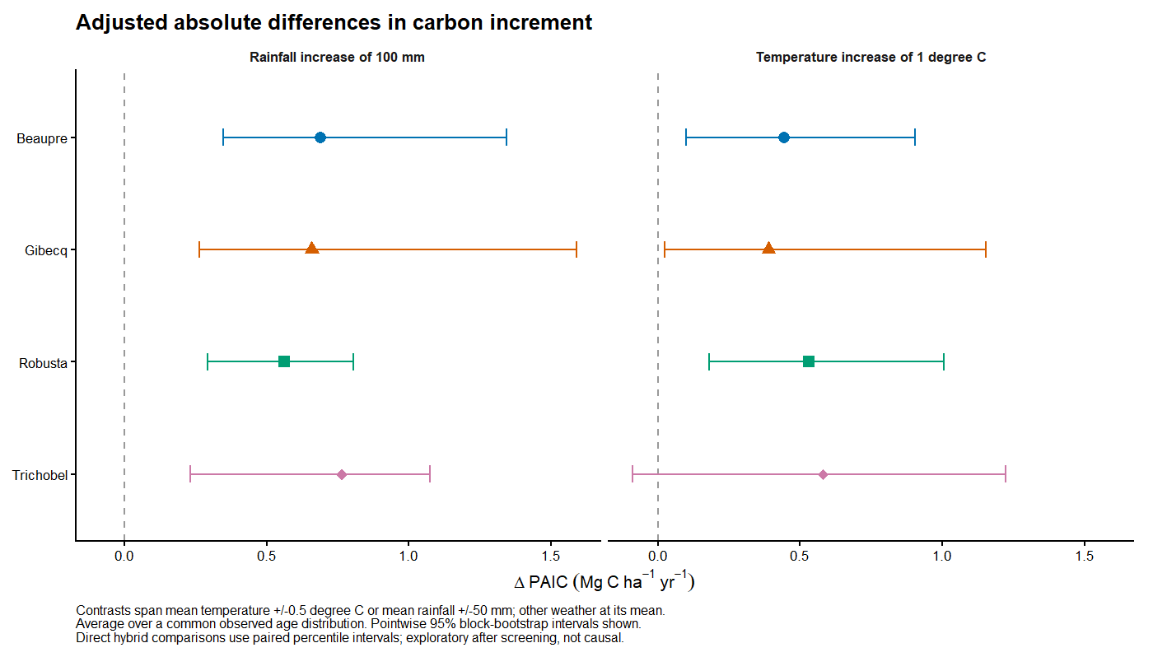
Pointwise block-bootstrap intervals for absolute contrasts averaged over the same observed age distribution. Direct hybrid comparisons use paired percentile intervals in the accompanying table. Curves in original PAIC units are saved separately.

Reproducible sources
analysis/13_absolute_weather_paic.R; results/tables/absolute_weather_adjusted_differences.csv; absolute_weather_paired_differences.csv; absolute_weather_linear_age_sensitivity.csv; absolute_weather_coefficients.csv; absolute_weather_diagnostics.csv; results/models/absolute_weather_paic.rds. Figures: absolute_weather_curves and absolute_weather_differences, PNG and PDF.

Weather associations with annual carbon increment
Paper analysis summary | 21 October 2026. Focus on absolute and percentage PAIC associations; retain standardised analyses as exploratory background only.

Weather variable selection
Nine candidates represented hypotheses about warmth, water supply, light and stress: spring and summer mean air temperature, rainfall totals and sunshine hours (six variables); spring air and ground frost-day counts (two); and the longest April-September dry spell (one). Spring was March-May and summer June-August; frost meant minimum air/grass temperature below 0 degrees C and dry days had rainfall below 1 mm. For screening, we removed a separate quadratic age trend from log PAIC for each hybrid, divided departures by each hybrid residual standard deviation, and averaged them equally. We examined Pearson and Spearman correlations on 24 years with complete coverage for all nine candidates, checking single-year influence and alternative detrending. Summer rainfall (Pearson r = 0.30) and temperature (r = 0.37) showed the clearest positive associations; sunshine, frost and dry-spell measures were weaker. Both summer predictors were retained without further screening. This hypothesis-guided selection used the same data as model fitting and remains exploratory. The final two-predictor model has 26 complete years because it needs fewer weather records.

Response and previous year weather
The analysis uses positive tree-level median PAIC for each of four hybrids in 26 measurement years (104 summaries). PAIC is carbon increment divided by years between measurements, in Mg C ha-1 yr-1. Each measurement in year t is paired with June-August mean air temperature and total rainfall in year t minus 1. For example, 2002 PAIC uses summer 2001 weather. For multi-year intervals, annualisation accounts for duration but cannot reveal growth timing in the missing years; weather still describes only the final growth year.

Statistical approach and uncertainty
Gamma models with a log link were fitted to original PAIC, allowing each hybrid its own baseline, curved age trajectory (age and age squared), and temperature and rainfall associations. Absolute differences average predictions over the same observed ages, holding the other weather variable at its mean. We compare 15.31 with 16.31 degrees C, and 122.4 with 222.4 mm rainfall. Percentage differences express the same comparisons relative to the lower-weather prediction.
To assess uncertainty, we repeatedly resampled blocks of three neighbouring visits, keeping all hybrids together, and refitted the complete model 1,000 times. Some visits were repeated and others omitted. The middle 95% of estimates gives the reported intervals. This preserves some shared and temporal variation, but blocks span sampling gaps and wrap from the record end to its start. Rare samples produced extreme age-related estimates; intervals remain provisional.

Model results
Adjusted differences below are in Mg C ha-1 yr-1, with percentage differences in brackets. They describe fitted associations within observed weather conditions, not causal warming or rainfall scenarios.
Hybrid | Temperature difference of 1 degree C | Rainfall difference of 100 mm
Beaupre | +0.44 (+40.5%) | +0.69 (+68.9%)
Gibecq | +0.39 (+47.6%) | +0.66 (+91.9%)
Robusta | +0.53 (+53.6%) | +0.56 (+57.5%)
Trichobel | +0.58 (+32.2%) | +0.77 (+44.3%)
Percentage difference = absolute difference divided by predicted PAIC at the lower weather value, times 100. For temperature, Trichobel rises from 1.80 to 2.39 (+0.58, 32%), whereas Beaupre rises from 1.10 to 1.54 (+0.44, 41%). Trichobel therefore has a larger carbon increment difference but a smaller proportional difference. All 12 direct hybrid-difference intervals include zero; Trichobel temperature association is uncertain (95% interval -0.09 to +1.22).

Discussion and limits
The positive associations offer a possible contribution to the observed growth patterns and are compatible with the biological expectation that Trichobel copes well with changing conditions. Its larger absolute estimate partly reflects higher growth, rather than a larger proportional response. All trees belong to one planting cohort: age, calendar time, management history and changing weather cannot be cleanly separated. Residual temporal patterns and bootstrap instability also remain. Present this as a supporting, exploratory explanation of Trichobel performance, without attributing its study-period advantage to climate change or claiming superior heat tolerance.
Source: analysis/13_absolute_weather_paic.R; full results and intervals in preceding pages.

