Weather relationships with tree growth
  - Analysis notes for paper drafting | Updated 20 October 2026
This note records the current hybrid-specific weather models for PAIC and the limitations that matter for paper drafting. The baseline models identify statistical associations with multivariate weather gradients; they do not yet explain the low growth recorded at the 2001 visit.

Methods
The baseline analysis uses the legacy hybrid PAIC summaries for continuity with the earlier weather analysis. These have been compared with tree-level hybrid medians. Beaupre, Gibecq and Trichobel agree closely; a remaining Robusta discrepancy needs resolution. Only positive, observed PAIC values enter the Gamma models.
A measurement in year t is paired with weather for growth year t minus 1. Seasons are winter December to February, spring March to May, summer June to August and autumn September to November; half-years are October to March and April to September. Winter windows cross the calendar-year boundary.
Temperature, soil temperature and wind speed are averaged; rainfall, sunshine, frost-day counts, growing-day counts, growing degree days and windy-day counts are summed within windows. Variable coverage is exported. Partial variable records currently use available days; a final coverage policy has not been fixed.
Six separate principal component analyses describe the seasonal or half-year weather. Each is shared across hybrids, uses standardised weather variables on its complete-case basis, and retains enough axes to explain at least 80 percent of weather variance. For each hybrid and period, PAIC is modelled with a Gamma distribution and log link using retained component scores.

Current model results
Hybrid | Summer observations | Summer PCs | Deviance reduction
Beaupre | 23 | 4 | 44.2%
Gibecq | 23 | 4 | 35.0%
Robusta | 23 | 4 | 30.5%
Trichobel | 23 | 4 | 53.6%

All exported baseline fits converged. Deviance reduction is an in-sample measure, not predictive validation or the fraction of growth causally explained by weather. Models fitted to different observation sets must not be ranked directly by AIC.

The unresolved slowdown around the 2001 visit
PAIC at the 2001 visit averages growth over 1998 to 2000, but the current weather join supplies weather for 2000 only. This mismatch matters when interpreting that point. No interval-aware weather analysis has yet been completed, and the existing model should not be used to attribute the three-year average to weather in one year.
Growth year | Summer half rainfall mm | Summer half sunshine hours
1997 | 345.3 | 967.1
1998 | 335.9 | 797.8
1999 | 333.5 | 943.6
2000 | 451.4 | 906.9
2001 | 295.2 | 873.6

The local records show relatively low summer-half sunshine in 1998 and higher summer-half rainfall in 2000. These are observations for investigation, not established explanations of the growth decline. They do not resolve which years within the measurement gap were most influential.

Discussion points
Interpret each component using its loadings, rather than assigning a physical meaning from its sign or number. Component signs are arbitrary, and a one-unit score is not a one-degree temperature or one-millimetre rainfall change. Any quoted association should name the hybrid, weather period, component interpretation and uncertainty.
The treatment analysis absorbs shared temporal conditions with categorical interval effects. Its interval coefficient cannot distinguish weather from stand development, management changes or other shared causes. Separate weather modelling can investigate associations, while treatment by weather interactions would be a distinct, more demanding question.

Next analysis decisions
Compare annual-interval models with an interval-aware sensitivity analysis. A candidate approach is to predict annual growth using annual weather and then average predictions over each observed growth interval; this is not generally identical to predicting from averaged weather under a nonlinear link. Assess age or time trends, residual dependence, influential observations and fair temporal validation before describing forecasts as reliable.

Files supporting this note
analysis/02_weather_paic.R
scripts/prep/02_weather.R
scripts/prep/04_join_and_pca.R
results/tables/baseline_weather_model_summary.csv
results/tables/baseline_weather_model_coefficients.csv
data/processed/weather_pca_loadings.csv
results/checks/weather_coverage.csv

Shared fluctuations and weather model update
Update 20 October 2026. PAIC fluctuations are strongly shared across hybrids after broad trajectories are removed. The simple temperature and rainfall model did not improve held-out prediction. Earlier sections retain the original seasonal PCA record; the current decisions and results follow below.

Methods
For the synchrony analysis, use the same tree-level hybrid medians as the PAIC and MAIC descriptive figure, restricted to 26 measurement years with positive PAIC for all four hybrids. Fit a separate quadratic age trend to log PAIC for each hybrid, without a shared year effect. Divide each hybrid residual series by its own standard deviation to compare departures. Calculate descriptive Pearson and Spearman correlations; repeat with linear detrending and the legacy weather-response summaries. No missing years are imputed. The last ten observations, 2014 to 2023, form an exploratory descriptive subset, not an estimated change point.
The separate weather comparison uses 104 legacy hybrid summaries over 26 years. Gamma log-link mixed models include hybrid-specific quadratic age trends and a random measurement-year intercept. Compare the baseline with shared April to September mean temperature and rainfall effects. Leave out all four hybrids from one year together, refit, and predict the unseen year by integrating over the random intercept. This assesses interpolation, not future forecasting.

Calculated results
After quadratic detrending, correlations among Beaupre, Gibecq and Robusta range from 0.91 to 0.96. Trichobel correlations are 0.73 with Beaupre, 0.72 with Gibecq and 0.89 with Robusta. Linear detrending also shows strong positive synchrony. Trichobel correlation with the mean standardised departure of the other hybrids is 0.95 in 1994 to 2013 and 0.61 in 2014 to 2023. Its median raw PAIC ratio to the geometric mean of the others is 1.50 and 2.73, respectively. These comparisons have no inferential uncertainty assessment.
Held-out RMSE is 1.696 for the age baseline and 1.703 after adding temperature and rainfall. Mean Gamma deviance is 0.607 and 0.612, respectively. Both weather coefficient intervals include zero. Hybrid-specific weather slopes and winter extensions were not fitted because the shared-weather model did not improve either metric. Final full and fold fits have no recorded convergence or singularity warnings.

Discussion hypotheses
Shared departures are consistent with a common environmental driver but do not identify weather as its cause. Trichobel maintains higher relative growth in later observations, especially when other hybrids have low PAIC. This is not proof of greater drought tolerance or a distinct weather response; ratios can increase because their denominator declines.

Open decisions and confirmed interval convention
Retain weather from year t minus 1, including multi-year PAIC intervals, as confirmed by the user. Annualising PAIC accounts for interval duration, but growth timing within unsampled years remains unknown. State this in Methods and Discussion. Revisit age-curve sensitivity, temporal dependence, weather exposure summaries and coverage, the Robusta response discrepancy, and validation. The PCA retention caveat remains open: weather variance is not PAIC relevance. See references/WEATHER_PCA_REVIEW.md for the saved Wicklin blog and methodological reference.

Shared PAIC fluctuations
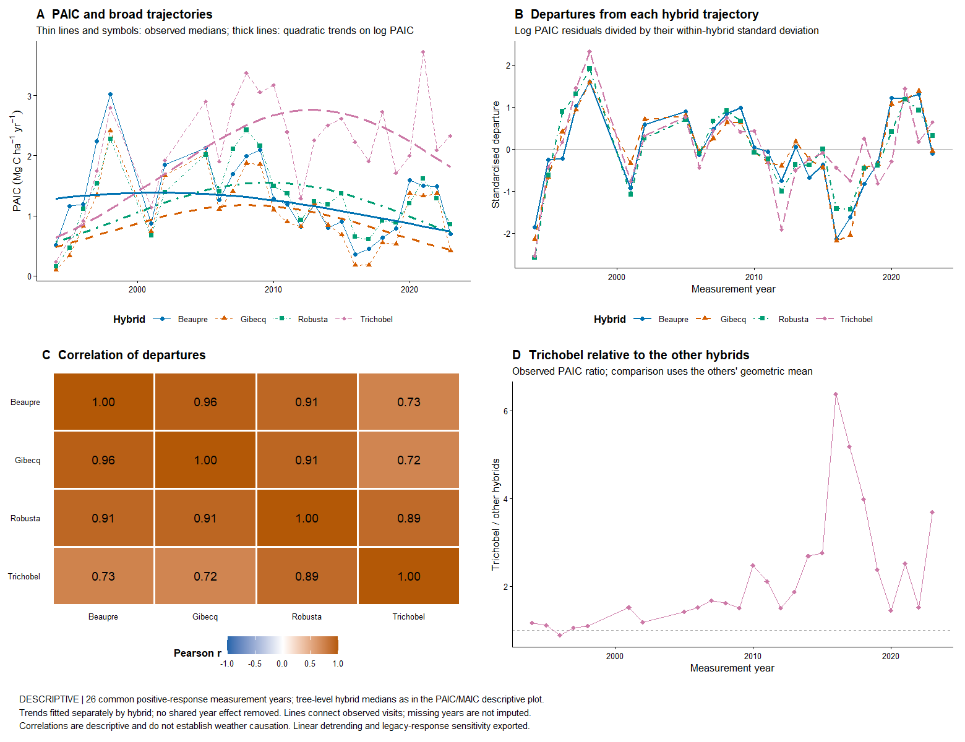
Descriptive comparisons use tree medians. Correlations do not establish causation, and quadratic trends are provisional. The Trichobel ratio compares observed PAIC with the geometric mean of Beaupre, Gibecq and Robusta.

Reproducible sources for this update
analysis/07_weather_temperature_rainfall.R and analysis/08_check_weather_temperature_rainfall.R; analysis/09_paic_shared_fluctuations.R; results/tables/paic_synchrony_*.csv; results/tables/weather_temperature_rainfall_*.csv; references/WEATHER_MODEL_NOTES.md and references/WEATHER_PCA_REVIEW.md.

Exploratory weather screen of shared departures
Update 20 October 2026. The screen suggests modest positive associations with summer rainfall and temperature. No clear dominant weather driver has emerged, and no selected predictor has been validated as a PAIC model.

Methods
Average the four within-hybrid standardised log PAIC departures from their separate quadratic age trajectories, giving hybrids equal weight. Screen nine predefined candidates: spring and summer rainfall, sunshine and mean air temperature; spring air and ground frost-day counts; and the longest dry spell during April to September. Spring is March to May and summer is June to August of growth year t minus 1. Dry days have rainfall below 1 mm; the dry-spell measure is the longest consecutive run, with no missing days allowed. Frost means daily minimum temperature below zero. Retain the confirmed t minus 1 alignment for annualised multi-year PAIC intervals.
Require complete daily coverage for the particular predictor. The primary comparison uses 24 years complete for all nine measures, omitting measurement 2001 because spring temperature lacks one day and 2019 because spring ground frost lacks two days. Predictor-specific available-year results retain 25 or 26 years. Report Pearson and Spearman correlations, the range of Pearson correlations obtained by omitting each year, correlations after adjusting both series for quadratic age on the matched sample, and sensitivity to linear rather than quadratic PAIC detrending. Omission ranges are influence diagnostics, not confidence intervals. Detrending is fitted to all observed years, so these summaries are not predictive validation.

Calculated results
Summer rainfall (mm): Pearson r 0.30, Spearman r 0.33; single-year omission range 0.26 to 0.37. Linear PAIC detrending gives r 0.47; quadratic age adjustment of both matched series gives r 0.35.
Summer air temperature (degrees C): Pearson r 0.37, Spearman r 0.23; single-year omission range 0.18 to 0.43. Linear PAIC detrending gives r 0.26; quadratic age adjustment of both matched series gives r 0.42.
Spring rainfall (mm): Pearson r -0.20, Spearman r -0.14; single-year omission range -0.30 to -0.07. Linear PAIC detrending gives r -0.12; quadratic age adjustment of both matched series gives r -0.20.
Other Pearson correlations range from approximately -0.05 to 0.17 on the common basis. Summer rainfall has a positive association within each hybrid, r 0.23 to 0.38; summer temperature also has a positive association in each, r 0.28 to 0.44. Predictor-specific available years give r 0.32 for summer rainfall and 0.33 for summer temperature. Dry spell association is weak and positive rather than the hypothesised negative association; it is not evidence of improved growth under drought.

Discussion hypotheses
Summer rainfall is a candidate for follow-up because its direction is consistent across hybrids, ranks and omission checks. The summer temperature association is influenced by the earliest observation, 1994, and is weaker using ranks. Both associations may reflect unmeasured conditions, growth-trajectory misspecification or chance among the nine screened candidates. Seasonal aggregation may capture relationships lost in the earlier half-year model, but this has not yet been tested in a validated model. Shared fluctuations remain substantially unexplained.

Open decisions
Next assess a small summer-weather model against the age baseline, with all detrending and any predictor selection inside training folds. Keep year groups together and consider temporal blocks. Check sensitivity to establishment-age observations without deleting them from the primary analysis; retain multi-year intervals and disclose their limitation. Do not interpret the screen as an independent validation set or convert individual unadjusted correlations into confirmatory claims. Weather coverage and the Robusta legacy discrepancy remain open.

Weather screen overview
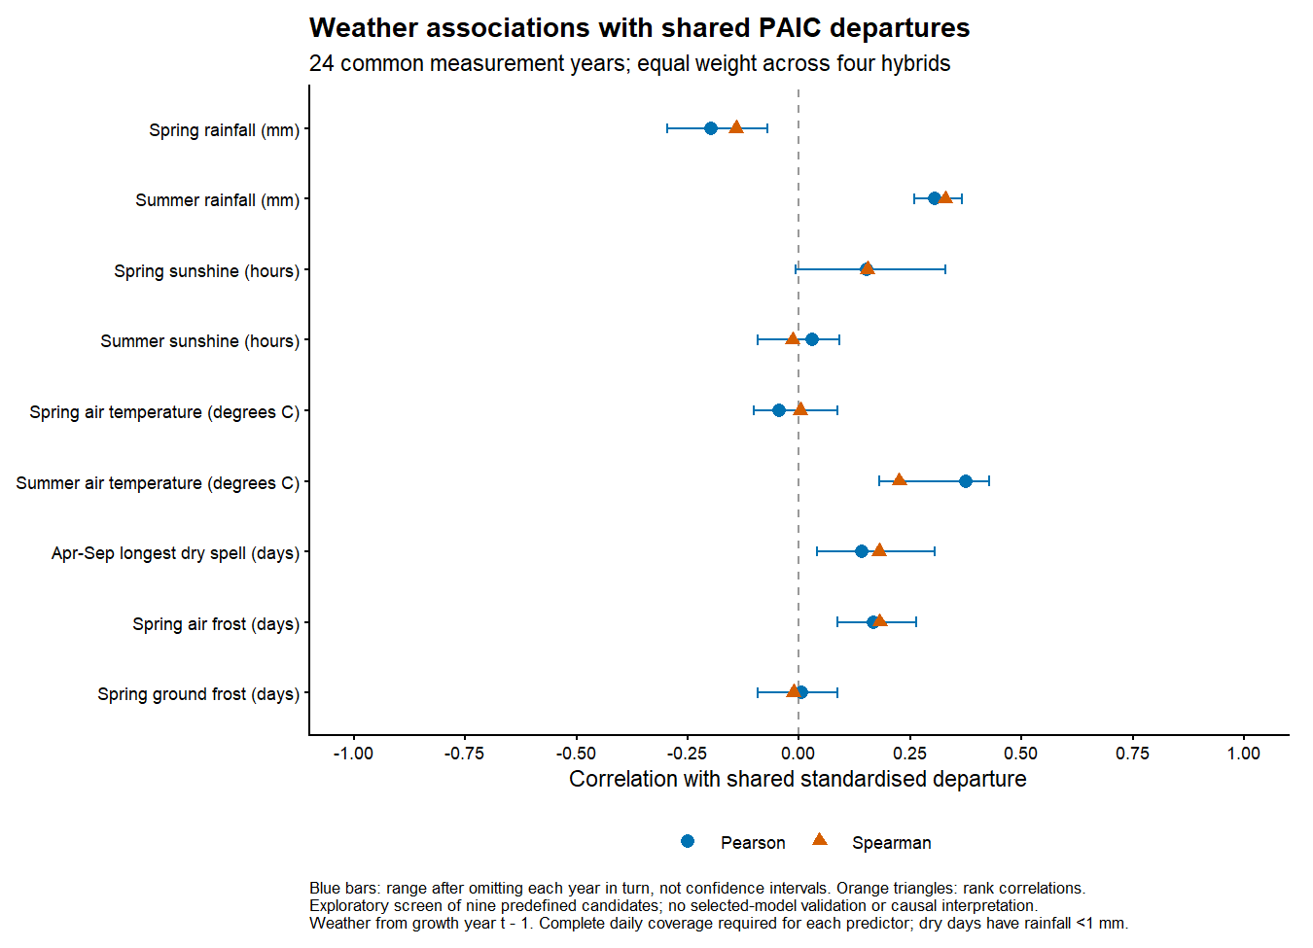
Blue points show Pearson correlations; orange triangles show Spearman rank correlations. Blue ranges show sensitivity to omitting one year at a time and are not confidence intervals.

Reproducible sources
analysis/10_weather_departure_screen.R; results/tables/weather_departure_screen_common_years.csv; weather_departure_screen_available_years.csv; weather_departure_screen_data.csv; weather_departure_hybrid_correlations.csv. The nine scatterplots are saved separately as results/figures/weather_departure_scatterplots.pdf and PNG.

Weather models of shared PAIC departures
Update 20 October 2026. Combined June to August rainfall and temperature improve prediction of shared standardised PAIC departures relative to no weather in this exploratory comparison. This is a different response and weather window from the earlier raw PAIC mixed model, and it is not an independent confirmation after screening.

Methods
Use 26 common measurement years with positive tree-level median PAIC for all four hybrids and complete summer rainfall and temperature coverage. In each training fold, fit a separate quadratic age trajectory to log PAIC for each hybrid. Divide training residuals by their within-hybrid training residual standard deviation. Calculate held-out departures from the training-fitted age trajectory and the same training standard deviation. Average the four departures with equal hybrid weights. No held-out PAIC enters the fitted trajectories or scales.
Fit linear models of shared departures using no weather, rainfall only, temperature only, or both. Age is not added to the second-stage regression. Rainfall is in 100 mm units and temperature in degrees C. Compare leave-one-year-out and five contiguous blocks of observed measurement years, keeping all hybrids from each year together. Repeat using linear rather than quadratic age detrending as a sensitivity. No automated predictor selection is performed inside this comparison; prior full-data screening remains a source of selection optimism. All multi-year increments retain the confirmed t minus 1 weather assignment.

Calculated results
Leave one year out, quadratic detrending: no-weather RMSE 1.198; rainfall only 1.158; temperature only 1.166; both 1.032. The combined model reduces RMSE by 13.9 percent relative to no weather within this scheme. Units are fold-standardised shared departures.
Five contiguous blocks, quadratic detrending: no-weather RMSE 3.001; rainfall only 2.840; temperature only 2.847; both 2.459. The combined model reduces RMSE by 18.1 percent relative to no weather within this scheme. Units are fold-standardised shared departures.
With linear detrending, the combined model reduces leave-one-year-out RMSE by 15.8 percent and block RMSE by 22.5 percent. Full-data combined-model slopes are 0.675 shared-departure units per 100 mm summer rainfall and 0.582 units per degree C. Its in-sample R squared is 0.305; this is not the proportion of raw PAIC causally explained by weather. Omitting 1994 from scoring only reduces the leave-one-year-out advantage: no-weather RMSE 0.957 versus combined-model 0.899, about 6 percent improvement; this is an influence check, not a refit excluding that year.

Discussion hypotheses
Warmer and wetter summer conditions are associated with more positive shared departures in the fitted range. The joint model performs better than either single predictor, suggesting potentially complementary information. These associations do not establish causation or imply that warming benefits growth outside observed conditions. The earlier failure of the half-year raw PAIC model and this result are not directly comparable: exposure window, response scale, data source and model structure differ.

Open decisions and limitations
Block errors are much larger than leave-one-year-out errors. The earliest block includes a held-out shared departure of about minus 9 training standard deviations, revealing poor extrapolation of the quadratic age trajectory. Do not interpret relative block improvement as reliable long-range weather forecasting. Full-data confidence bands condition on detrending and omit trend and predictor-selection uncertainty. The response is a shared standardised log-scale departure, not an individual hybrid PAIC forecast. Before inference, assess a less fragile growth trajectory, nested screening or independent data, residual temporal dependence, weather coverage and the legacy Robusta discrepancy. Keep sampling-gap and PCA-retention caveats open.

Summer weather models of shared departures
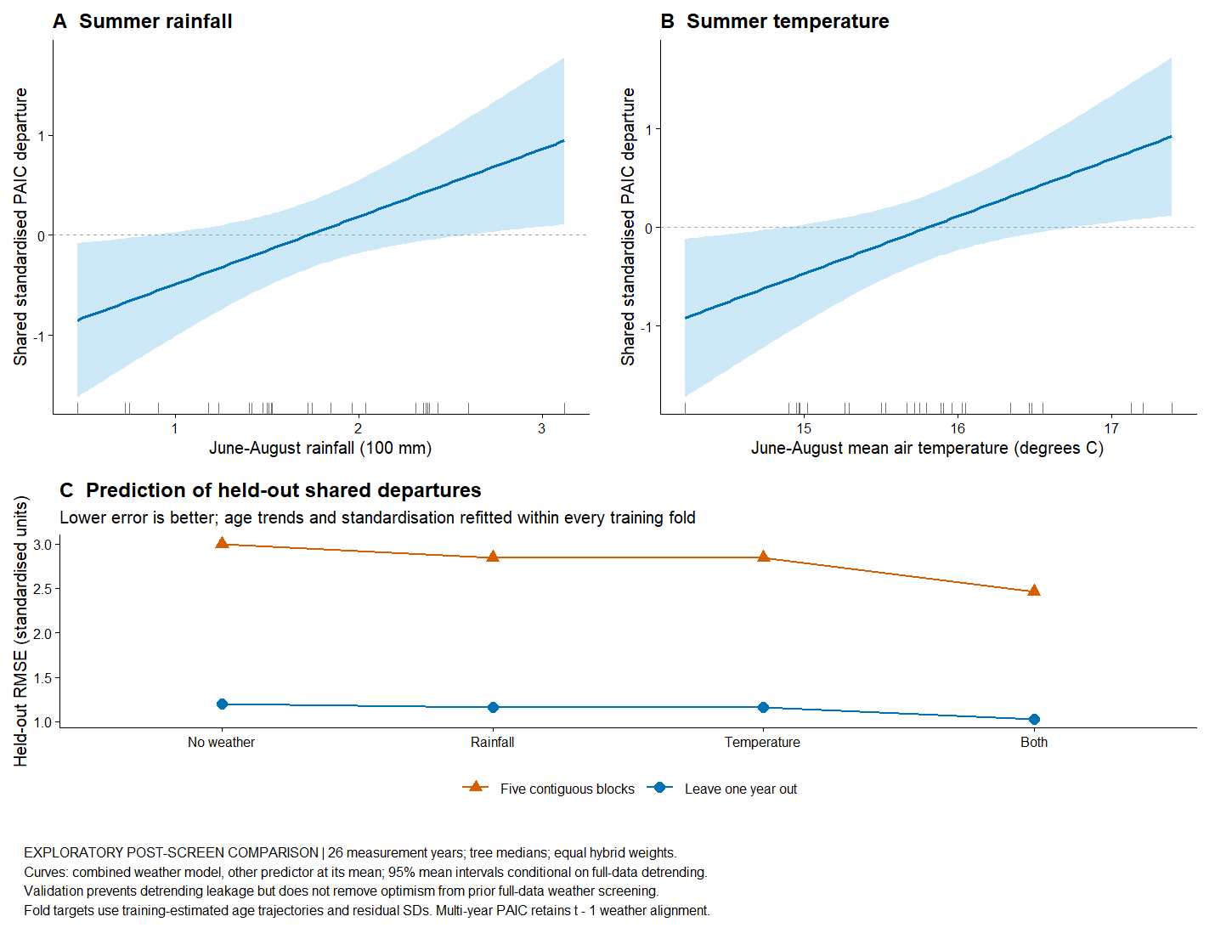
Curves show the combined model at the mean of the other predictor. Shading gives approximate 95 percent mean confidence intervals conditional on full-data detrending. Validation refits age trends and standardisation in each training fold; it does not undo prior full-data screening.

Reproducible sources
analysis/11_weather_departure_models.R; results/tables/weather_departure_model_validation.csv; weather_departure_model_held_out_predictions.csv; weather_departure_model_fold_audit.csv; weather_departure_model_coefficients.csv; results/models/weather_departure_models.rds.

