Weather associations with observed PAIC
  - Current analysis for paper drafting | 21 October 2026
Summer rainfall is positively associated with PAIC in all four hybrids. Temperature associations and differences between hybrids depend more strongly on age adjustment. This analysis describes possible weather contributions to the observed growth patterns; it cannot separate weather from all other changes during the study.

Methods and data alignment
The response is original PAIC, in Mg C ha⁻¹ yr⁻¹: the median of the available tree values within each hybrid and measurement year. Beaupre, Gibecq, Robusta and Trichobel are analysed separately. These summaries pool the sampled cropping treatments; the weather analysis does not estimate treatment effects. PAIC is neither standardised nor detrended before screening or modelling.
The model dataset contains 26 measurement years from 1994 to 2023, giving 104 hybrid summaries. All candidate models use these same years, with complete summer temperature and rainfall. Weather is assigned from the growth year preceding measurement: a measurement in year t receives weather from year t − 1. There are 26 shared weather occasions, not 104 independent weather replicates.
PAIC is divided by the years between successive measurements. This accounts for interval duration, but we do not know how growth was distributed among missing years. A multi-year PAIC value is still paired with the final growth year’s weather, following the agreed convention. For example, the 2001 PAIC averages growth years 1998–2000 and is paired with weather in 2000. This limits attribution of individual fluctuations to a particular year’s weather.

Weather variables and biological hypotheses
Candidate group | Variables examined | Biological question
Water supply | Spring and summer rainfall totals (mm) | Does water availability coincide with greater growth?
Warmth | Spring and summer mean air temperature (°C) | Does seasonal warmth coincide with greater growth?
Light | Spring and summer sunshine totals (hours) | Does light availability coincide with greater growth?
Dry conditions | Longest April–September dry spell (days) | Does sustained low rainfall coincide with reduced growth?
Frost | Spring air and ground frost days | Does frost coincide with reduced growth?

Spring means March–May and summer means June–August. A dry day has rainfall <1 mm; the dry spell is the longest consecutive run. Air and ground frost are days with minimum air and grass temperature below 0 °C, respectively. A candidate seasonal value is used only when all expected daily observations for that variable are available. No missing daily weather is imputed.

Calculated results from the weather screen
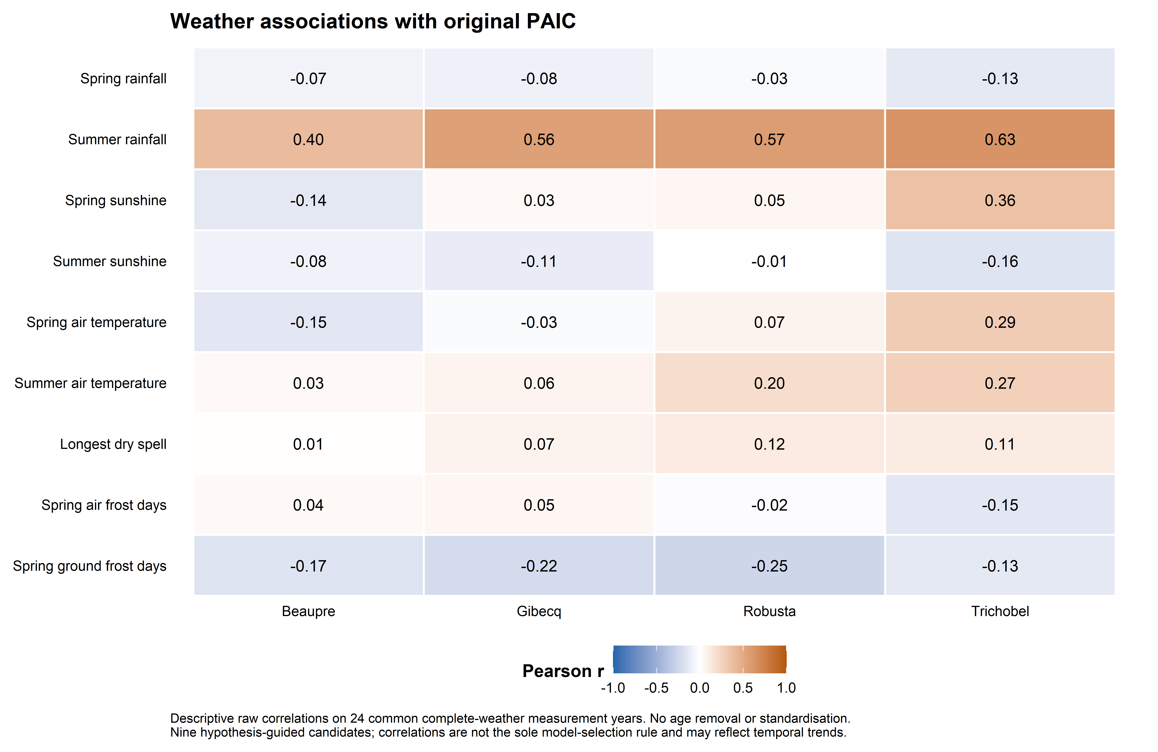
Figure 1. Pearson correlations between each candidate and original PAIC, by hybrid, using 24 common complete-weather measurement years. The colour scale is centred on zero. These are descriptive associations and include shared temporal patterns.
We inspected scatterplots for all nine variables within each hybrid and calculated Pearson correlations for linear association and Spearman correlations for rank association. The common 24-year comparison excludes measurement years 2001 and 2019 because of incomplete spring temperature or ground-frost records. Predictor-specific complete records (25 or 26 years) and omission of individual years were also checked; the final summer models use all 26 complete summer years.
Summer rainfall has the clearest consistent positive raw association: Pearson r = 0.40, 0.56, 0.57 and 0.63 for Beaupre, Gibecq, Robusta and Trichobel. The corresponding Spearman values are 0.36, 0.48, 0.50 and 0.63. Every leave-one-year-out Pearson value remains positive. Summer temperature has weaker raw correlations: 0.03, 0.06, 0.20 and 0.27; Trichobel also has positive spring temperature and sunshine associations.

How the model variables were chosen
We retained summer rainfall as the clearest common water-supply signal and summer temperature as a biologically motivated warmth hypothesis, including the question of Trichobel’s response. The candidate family contains no weather, rainfall alone, temperature alone, and both together. This tests the added contribution of temperature rather than assuming it is needed. Spring, sunshine, frost and dry-spell variables remain contextual screening results; they were not added through stepwise searches.
This is hypothesis-guided exploratory selection, informed by earlier examination of the dataset. It was not independently prespecified. Correlation strength alone did not determine inclusion, and the reported intervals do not account for this selection process.

Statistical approach

Models fitted directly to original PAIC
Positive hybrid medians are fitted with a Gamma generalised linear model and a log link. This allows variability to increase with the fitted mean and keeps fitted PAIC positive. The outcome supplied to the model is original PAIC; the log link describes the mean and does not require a preliminary log transformation or removal of an age trend.
For hybrid h and measurement year t, the most complete mean model is:
PAICₕₜ ~ Gamma with mean μₕₜ
log(μₕₜ) = αₕ + βT,ₕ Tₜ + βR,ₕ Rₜ + γ₁,ₕ Aₜ + γ₂,ₕ Aₜ²
T = summer mean temperature − 16 °C; R = (summer rainfall − 200 mm)/100; A = (age in years − 15)/10. Centring improves numerical stability and does not remove trends from the response. Intercepts, weather slopes and age terms may differ among hybrids. Separate fits are equivalent to a fully interacting joint mean model; each hybrid has its own dispersion estimate.
Each of the four weather candidates is fitted with no age term, a linear age term, and linear plus quadratic age terms: 12 candidates per hybrid, 48 fits in total. The unadjusted models describe weather associations across the observed record. The age models ask how these associations change after allowing simple longer-term trajectories. We retain the same age specifications for all hybrids when comparing sensitivities; we do not choose a different adjustment solely to obtain a preferred response.

Absolute comparisons and model fit
The combined temperature–rainfall models provide comparable absolute effects. Temperature is contrasted from 15.31 to 16.31 °C, holding rainfall at 172.44 mm. Rainfall is contrasted from 122.44 to 222.44 mm, holding temperature at 15.81 °C. These contrasts are centred on observed means. For age-adjusted models, predictions are averaged equally over the same 26 observed ages. Each effect is the higher-weather prediction minus the lower-weather prediction, in original PAIC units; it is not the change between the first and final study years.
AICc compares fit with a penalty for model complexity. Deviance reduction compares a weather model with the no-weather model having the same age terms. This is improvement in fitted Gamma deviance, not a causal fraction of temporal variation explained. AICc assumes independent model errors and is treated descriptively because temporal dependence remains. The aim is explanation of this record, so these are full-data fits rather than claims of forecasting performance.

Uncertainty explained simply
We generated 1,000 alternative datasets by resampling blocks of three successive observed visits. All four hybrids and their weather values move together, preserving their shared annual conditions and some local temporal dependence. Models are refitted to each dataset and the absolute effects recalculated. The middle 95% of effects gives a pointwise percentile interval. Hybrid differences are calculated within each resample, so we compare their effects directly rather than compare separate significance labels.
Blocks wrap from the record end to its beginning and span three visits, not necessarily three calendar years. This is an approximate exploratory uncertainty method. Intervals are not simultaneous across predictors, hybrids or age choices and omit allometric, weather measurement and variable-selection uncertainty. Further diagnostic limitations are stated on the final page.

Absolute weather associations and age sensitivity
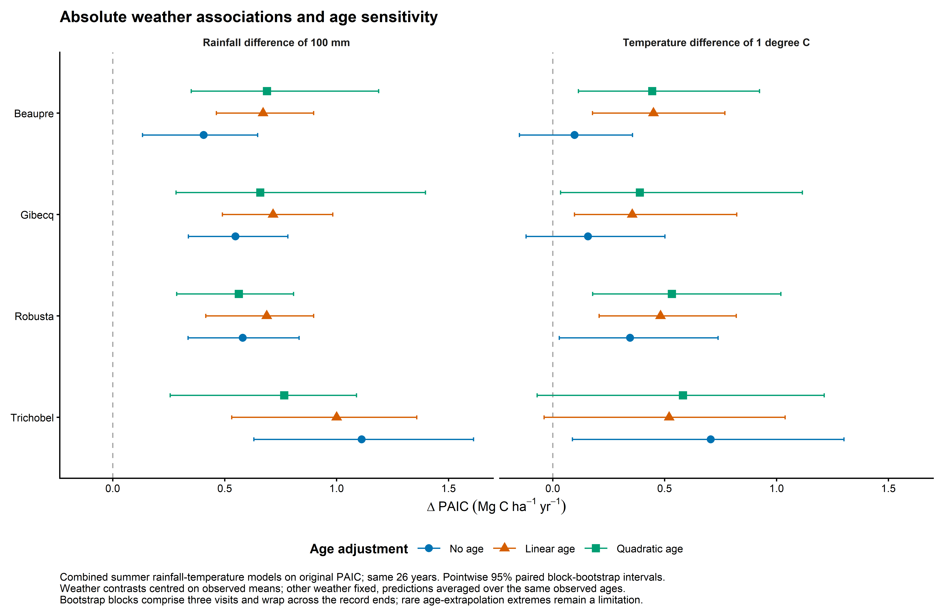
Figure 2. Estimated absolute PAIC differences for the same summer-weather contrasts under three age specifications. Symbols show estimates; bars show pointwise 95% paired block-bootstrap intervals. All models include rainfall and temperature together. Age adjustment is shown explicitly rather than removed before analysis.

Unadjusted associations in original units
Hybrid | 100 mm more rainfall | 1 °C higher temperature
Beaupre | 0.41 (0.13, 0.65) | 0.10 (-0.15, 0.36)
Gibecq | 0.55 (0.34, 0.78) | 0.16 (-0.12, 0.50)
Robusta | 0.58 (0.34, 0.83) | 0.35 (0.03, 0.74)
Trichobel | 1.11 (0.63, 1.61) | 0.71 (0.09, 1.30)

Table 1. Absolute PAIC differences (Mg C ha⁻¹ yr⁻¹), with pointwise 95% intervals, from models without age terms. Contrasts are defined on the preceding page. A negative lower limit indicates that the interval includes a negative association, not that fitted PAIC becomes negative.
Rainfall estimates remain positive under all three age specifications and all their intervals are above zero. Trichobel has the largest absolute estimate in each specification, but its rainfall estimate falls from 1.11 without age to 1.00 with linear age and 0.77 with quadratic age. Temperature estimates are also positive throughout; their magnitude and uncertainty are more sensitive to age adjustment, particularly in Beaupre and Gibecq.

How the models describe the observed record
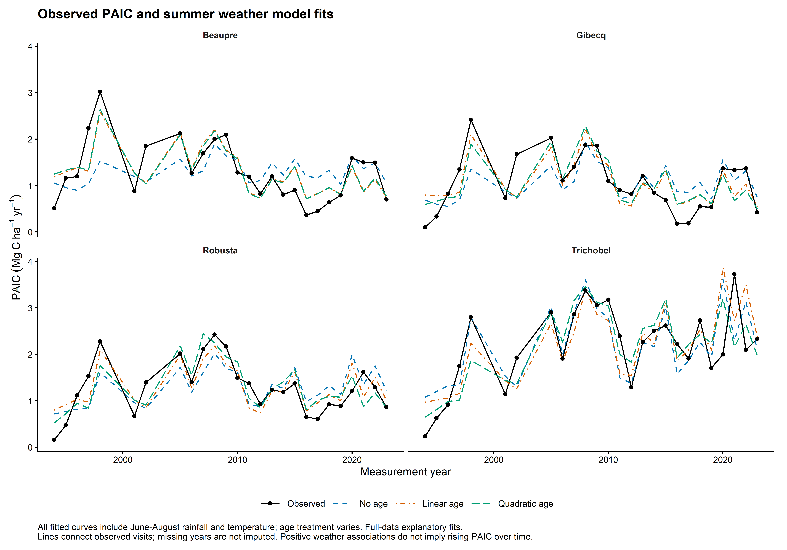
Figure 3. Observed hybrid median PAIC and fitted means from models containing both summer-weather variables. Black points are observations; coloured line types distinguish age specifications. Lines connect observed visits; no growth values are imputed between visits. These are fitted explanatory trajectories, not independent validation predictions.

Comparing fit across the candidate family
Hybrid | Lowest descriptive AICc | Deviance reduction with both weather terms
Beaupre | Linear age; Both | 16 / 43 / 42%
Gibecq | No age; Rainfall | 25 / 35 / 32%
Robusta | Quadratic age; Both | 36 / 43 / 42%
Trichobel | Quadratic age; Both | 44 / 39 / 32%

Table 2. Lowest AICc among 12 candidates per hybrid, and deviance reductions from adding both weather variables to the matching no-weather model. Percentages are in the order no age / linear age / quadratic age. They describe in-sample fit; AICc rankings are approximate in the presence of serial dependence.
There is no single clearly preferred age specification for every hybrid. Gibecq’s no-age rainfall-only model has the lowest AICc, but adding linear age and both weather terms is close (ΔAICc = 0.31). Robusta’s three combined-weather models are also close (ΔAICc ≤ 1.67). This supports showing age sensitivity rather than treating quadratic adjustment as established. Weather captures some shared peaks and troughs but leaves substantial departures unexplained.

Discussion and limits of interpretation

Biological interpretation
The most consistent result is greater PAIC in wetter summers across all four hybrids. This is compatible with a role for summer water availability in growth. Warmth may contribute as well, especially in Trichobel’s unadjusted record, but raw temperature correlations are modest and its model association changes when longer-term trajectories are included. These are associations with the preceding growth year’s weather, including the reduced temporal precision of multi-year PAIC values.
Trichobel has the largest unadjusted absolute temperature and rainfall estimates. Its unadjusted rainfall contrasts exceed those of the other hybrids in the pointwise paired intervals. After linear age adjustment, only its rainfall difference from Robusta has an interval wholly above zero; under quadratic age adjustment none of its paired differences does. Its temperature difference from Gibecq only narrowly excludes zero without age adjustment and does not persist after age adjustment. These exploratory comparisons have no multiplicity correction.
A larger absolute change can partly reflect Trichobel’s higher underlying PAIC. With a log link, the same proportional association produces more additional carbon at a higher baseline. Absolute results answer how much carbon increment differs; they do not alone establish greater physiological sensitivity or resistance. The results are compatible with the proposed role of weather in Trichobel’s performance, but do not demonstrate a distinct climate-resilience mechanism.
Positive weather associations also do not imply that PAIC must rise over time. Actual growth reflects the observed combination of rainfall, temperature, age, stand development and management. A hybrid can benefit from a warmer or wetter year relative to a comparable year while its overall PAIC declines. We have not apportioned Trichobel’s net advantage over the study period into a causal contribution from climate change.

Diagnostic limitations and remaining decisions
Age and calendar year advance together in this single cohort; management and stand development also change through time. Raw associations retain these influences. Linear and quadratic age terms provide sensitivity checks, not a complete solution to confounding. They can absorb real weather-related trends as well as unrelated development.
Residual correlations between consecutive calendar years remain substantial for some hybrids: approximately 0.47–0.65 without age for Beaupre, Gibecq and Robusta, compared with 0.10 for Trichobel. Even after age adjustment, Gibecq remains around 0.54–0.56. Three-visit blocks allow some dependence but their length is not established as sufficient. Treat the interval endpoints as exploratory; stronger significance claims would require a defensible serial-error analysis or block-length sensitivity assessment.
All 12,000 bootstrap model fits converged. Nevertheless, some quadratic-age resamples produced extreme effects when their sampled ages did not support prediction over the full reference age range. Depending on hybrid and predictor, 1–8 of 1,000 resamples exceeded an absolute difference of 10 Mg C ha⁻¹ yr⁻¹ for Beaupre, Gibecq or Robusta. These values were retained. The reported central percentile intervals are finite, but the tails show that quadratic-age uncertainty is unstable; no-age and linear-age resamples did not have these extremes. Individual-year omission results are saved alongside the model outputs.

Scope for the paper
Use Figure 2 to present absolute associations with age sensitivity, with Figure 3 available to show their relationship to the observed trajectories. Keep the interpretation exploratory and concise. Figure 1 documents the variable-selection context and may be supplementary. The substantive result is a consistent rainfall association and a possible weather contribution to hybrid performance, with uncertainty about age and other temporal effects.
Reproducibility: analysis/14_raw_paic_weather_final.R and analysis/14_raw_paic_weather_checks.R; results/models/final_raw_paic_weather.rds; tables and figures prefixed final_weather_. The raw candidate values come from weather_departure_screen_data.csv, but no departures or standardised responses from that file are used here. Figures are exported as 600 dpi PNG and vector PDF. This note contains the current analysis only; the previous Word version is preserved separately.

