Weather associations with observed PAIC
  - Current analysis for paper drafting | 21 October 2026
Summer rainfall is positively associated with PAIC in all four hybrids. Temperature associations and differences between hybrids depend more strongly on age adjustment. This analysis describes possible weather contributions to the observed growth patterns; it cannot separate weather from all other changes during the study.

Methods and data alignment
The response is original PAIC, in Mg C ha⁻¹ yr⁻¹: the median of the available tree values within each hybrid and measurement year. Beaupre, Gibecq, Robusta and Trichobel are analysed separately. These summaries pool the sampled cropping treatments; the weather analysis does not estimate treatment effects. PAIC is neither standardised nor detrended before screening or modelling.
The model dataset contains 26 measurement years from 1994 to 2023, giving 104 hybrid summaries. All candidate models use these same years, with complete summer temperature and rainfall. Weather is assigned from the growth year preceding measurement: a measurement in year t receives weather from year t − 1. There are 26 shared weather occasions, not 104 independent weather replicates.
PAIC is divided by the years between successive measurements. This accounts for interval duration, but we do not know how growth was distributed among missing years. A multi-year PAIC value is still paired with the final growth year’s weather, following the agreed convention. For example, the 2001 PAIC averages growth years 1998–2000 and is paired with weather in 2000. This limits attribution of individual fluctuations to a particular year’s weather.

Weather variables and biological hypotheses
Candidate group | Variables examined | Biological question
Water supply | Spring and summer rainfall totals (mm) | Does water availability coincide with greater growth?
Warmth | Spring and summer mean air temperature (°C) | Does seasonal warmth coincide with greater growth?
Light | Spring and summer sunshine totals (hours) | Does light availability coincide with greater growth?
Dry conditions | Longest April–September dry spell (days) | Does sustained low rainfall coincide with reduced growth?
Frost | Spring air and ground frost days | Does frost coincide with reduced growth?

Spring means March–May and summer means June–August. A dry day has rainfall <1 mm; the dry spell is the longest consecutive run. Air and ground frost are days with minimum air and grass temperature below 0 °C, respectively. A candidate seasonal value is used only when all expected daily observations for that variable are available. No missing daily weather is imputed.

Calculated results from the weather screen
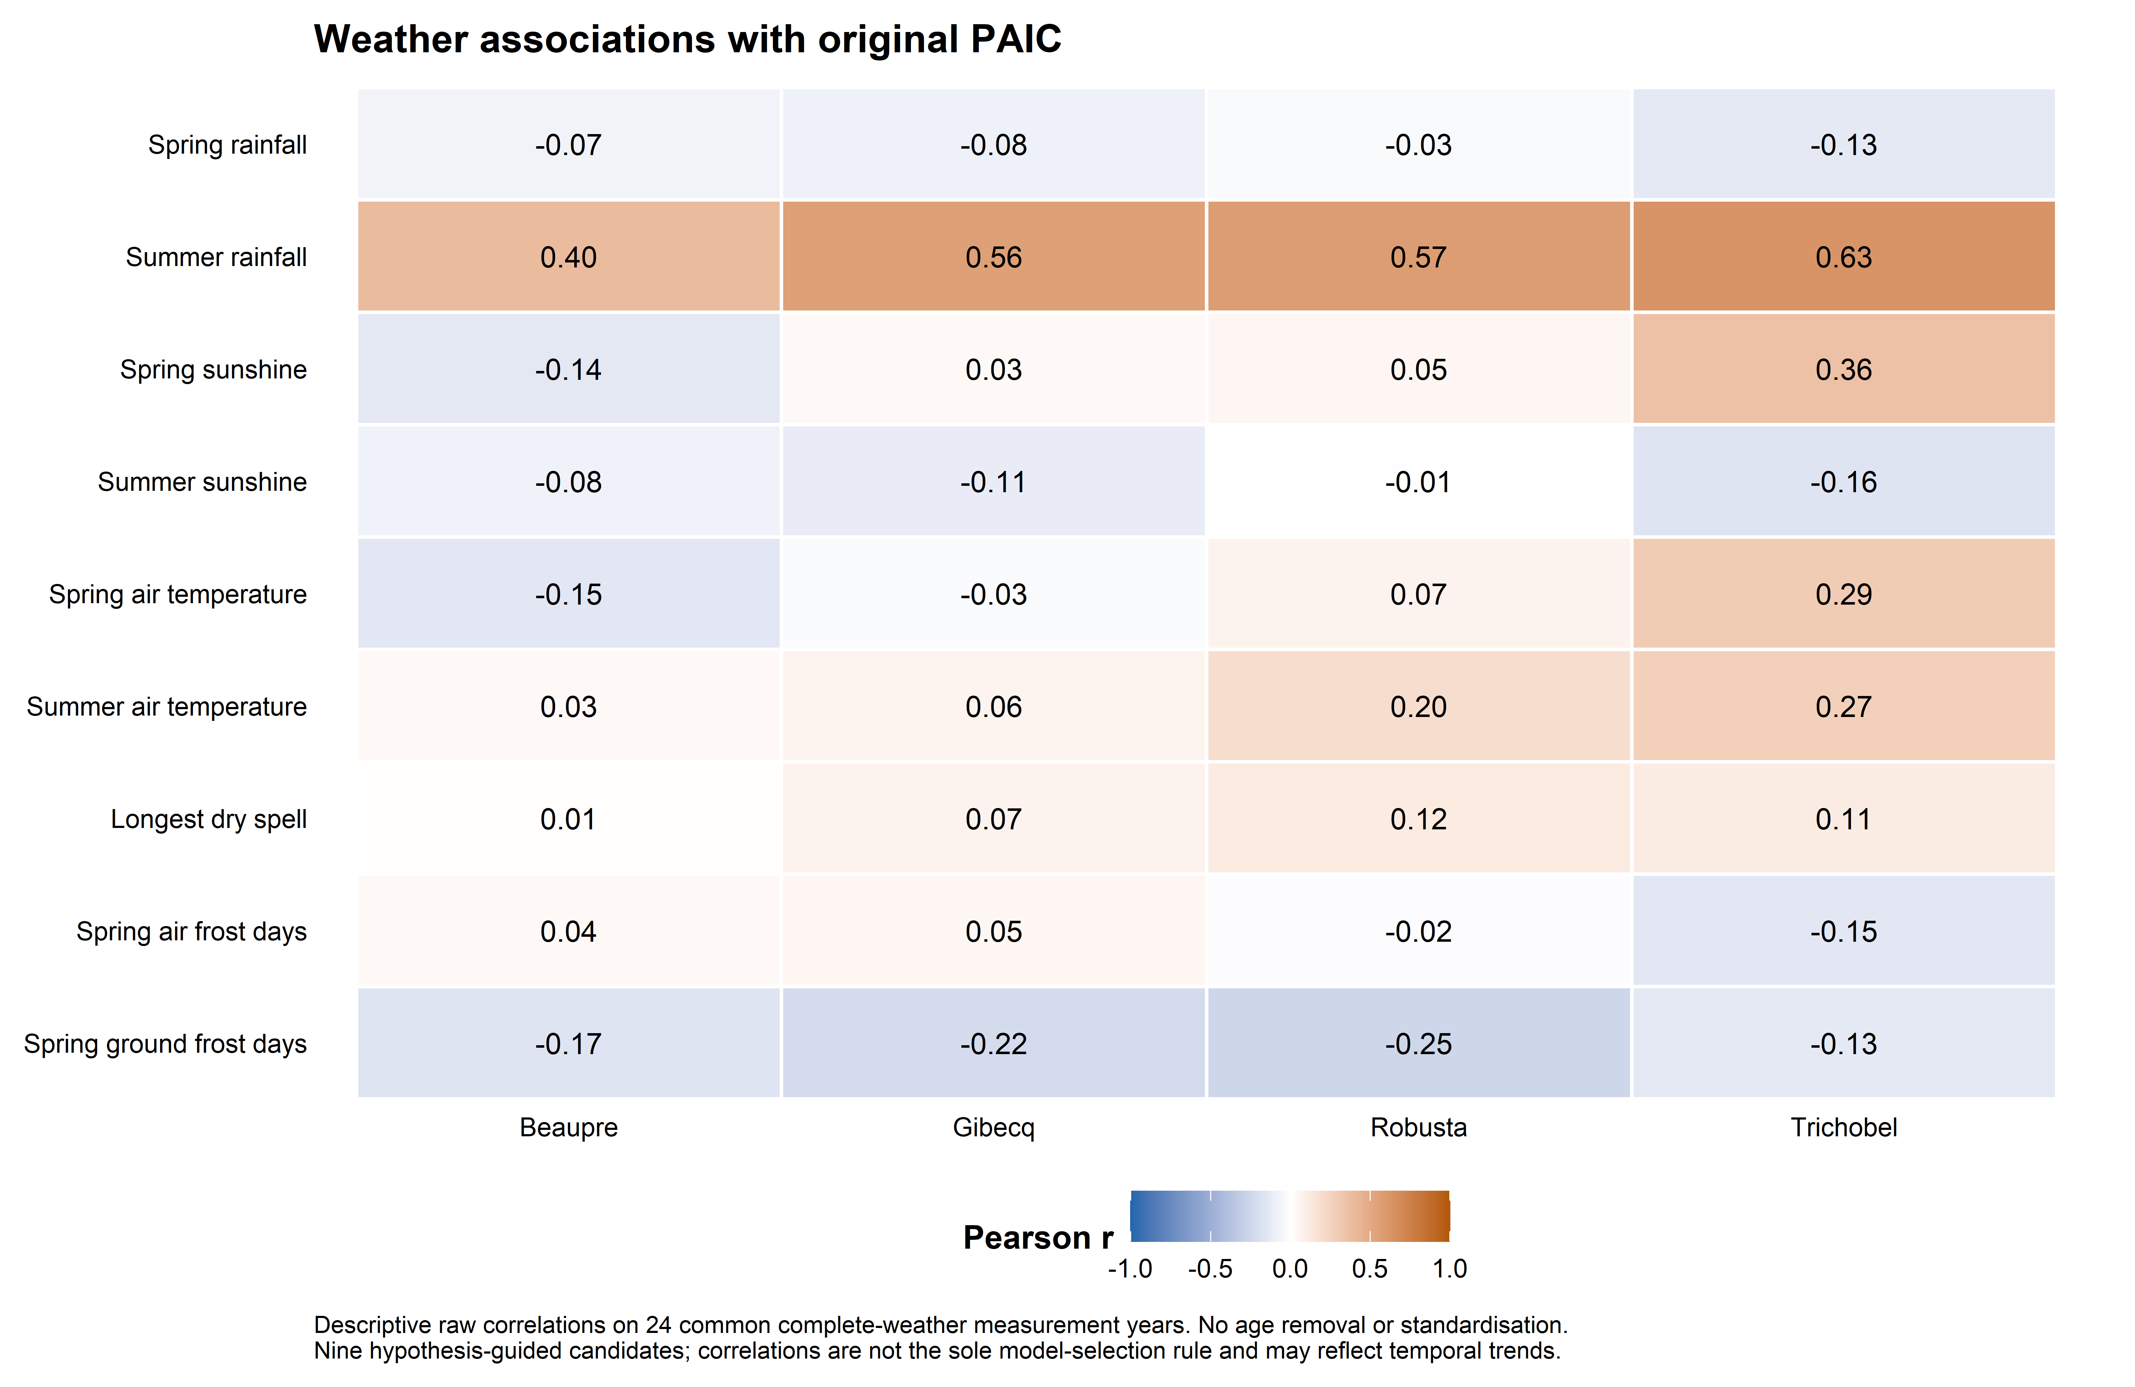
Figure 1. Pearson correlations between each candidate and original PAIC, by hybrid, using 24 common complete-weather measurement years. The colour scale is centred on zero. These are descriptive associations and include shared temporal patterns.
We inspected scatterplots for all nine variables within each hybrid and calculated Pearson correlations for linear association and Spearman correlations for rank association. The common 24-year comparison excludes measurement years 2001 and 2019 because of incomplete spring temperature or ground-frost records. Predictor-specific complete records (25 or 26 years) and omission of individual years were also checked; the final summer models use all 26 complete summer years.
Summer rainfall has the clearest consistent positive raw association: Pearson r = 0.40, 0.56, 0.57 and 0.63 for Beaupre, Gibecq, Robusta and Trichobel. The corresponding Spearman values are 0.36, 0.48, 0.50 and 0.63. Every leave-one-year-out Pearson value remains positive. Summer temperature has weaker raw correlations: 0.03, 0.06, 0.20 and 0.27; Trichobel also has positive spring temperature and sunshine associations.

How the model variables were chosen
We retained summer rainfall as the clearest common water-supply signal and summer temperature as a biologically motivated warmth hypothesis, including the question of Trichobel’s response. The candidate family contains no weather, rainfall alone, temperature alone, and both together. This tests the added contribution of temperature rather than assuming it is needed. Spring, sunshine, frost and dry-spell variables remain contextual screening results; they were not added through stepwise searches.
This is hypothesis-guided exploratory selection, informed by earlier examination of the dataset. It was not independently prespecified. Correlation strength alone did not determine inclusion, and the reported intervals do not account for this selection process.

Statistical approach

Models fitted directly to original PAIC
Positive hybrid medians are fitted with a Gamma generalised linear model and a log link. This allows variability to increase with the fitted mean and keeps fitted PAIC positive. The outcome supplied to the model is original PAIC; the log link describes the mean and does not require a preliminary log transformation or removal of an age trend.
For hybrid h and measurement year t, the most complete mean model is:
PAICₕₜ ~ Gamma with mean μₕₜ
log(μₕₜ) = αₕ + βT,ₕ Tₜ + βR,ₕ Rₜ + γₕ Aₜ
T = summer mean temperature − 16 °C; R = (summer rainfall − 200 mm)/100; A = (age in years − 15)/10. Centring improves numerical stability and does not remove trends from the response. Intercepts, weather slopes and age terms may differ among hybrids. Separate fits are equivalent to a fully interacting joint mean model; each hybrid has its own dispersion estimate.
Each of the four weather candidates is fitted without age and with a linear age term: eight candidates per hybrid, 32 fits in total. The unadjusted models describe weather associations across the observed record. The linear-age models ask how these change after allowing an age contribution to the log mean; γ is set to zero in the no-age models. Age adjustment is a sensitivity comparison, not a mandatory correction or an independently identified biological age effect.

Absolute comparisons and model fit
The combined temperature–rainfall models provide comparable absolute effects. Temperature is contrasted from 15.31 to 16.31 °C, holding rainfall at 172.44 mm. Rainfall is contrasted from 122.44 to 222.44 mm, holding temperature at 15.81 °C. These contrasts are centred on observed means. For age-adjusted models, predictions are averaged equally over the same 26 observed ages. Each effect is the higher-weather prediction minus the lower-weather prediction, in original PAIC units; it is not the change between the first and final study years.
For these Gamma models, we report deviance-based pseudo-R² = 1 − model deviance / intercept-only deviance. The reference is the same no-age, no-weather model within each hybrid. This permits direct comparison of the weather-only and weather-plus-age fits. It is not ordinary least-squares R² or a percentage of raw PAIC variance explained. The age-model value describes age and weather together, not weather alone.
Adding age generally improves fitted pseudo-R², so we also compare AICc, which penalises complexity. AICc assumes independent errors and is descriptive here because serial dependence remains. Separately exported deviance reductions against a matching age baseline answer a different question: the contribution of adding weather to that baseline. All comparisons describe fitted associations, not causal attribution or forecasting performance.

Uncertainty explained simply
We generated 1,000 alternative datasets by resampling blocks of three successive observed visits. All four hybrids and their weather values move together, preserving their shared annual conditions and some local temporal dependence. Models are refitted to each dataset and the absolute effects recalculated. The middle 95% of effects gives a pointwise percentile interval. Hybrid differences are calculated within each resample, so we compare their effects directly rather than compare separate significance labels.
Blocks wrap from the record end to its beginning and span three visits, not necessarily three calendar years. This is an approximate exploratory uncertainty method. Intervals are not simultaneous across predictors, hybrids or age choices and omit allometric, weather measurement and variable-selection uncertainty. Further diagnostic limitations are stated on the final page.

Absolute weather associations and age sensitivity
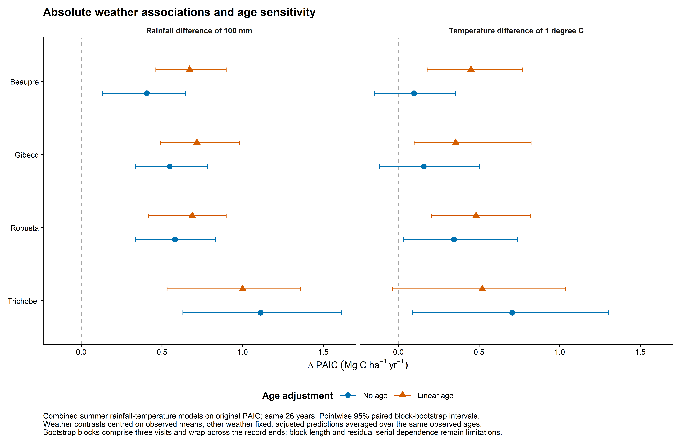
Figure 2. Estimated absolute PAIC differences for the same summer-weather contrasts, without age and with linear age. Symbols show estimates; bars show pointwise 95% paired block-bootstrap intervals. All models include rainfall and temperature together. Age adjustment is shown explicitly rather than removed before analysis.

Unadjusted associations in original units
Hybrid | 100 mm more rainfall | 1 °C higher temperature
Beaupre | 0.41 (0.13, 0.65) | 0.10 (-0.15, 0.36)
Gibecq | 0.55 (0.34, 0.78) | 0.16 (-0.12, 0.50)
Robusta | 0.58 (0.34, 0.83) | 0.35 (0.03, 0.74)
Trichobel | 1.11 (0.63, 1.61) | 0.71 (0.09, 1.30)

Table 1. Absolute PAIC differences (Mg C ha⁻¹ yr⁻¹), with pointwise 95% intervals, from models without age terms. Contrasts are defined on the preceding page. A negative lower limit indicates that the interval includes a negative association, not that fitted PAIC becomes negative.
Rainfall estimates remain positive with and without age, and all their intervals are above zero. Trichobel has the largest absolute rainfall estimate in both cases: 1.11 without age and 1.00 with linear age. Its temperature estimate changes from 0.71 (0.09, 1.30) to 0.52 (−0.04, 1.04). Beaupre’s and Gibecq’s temperature estimates increase after age adjustment, illustrating how the same temporal record can support different conditional associations.

How the models describe the observed record
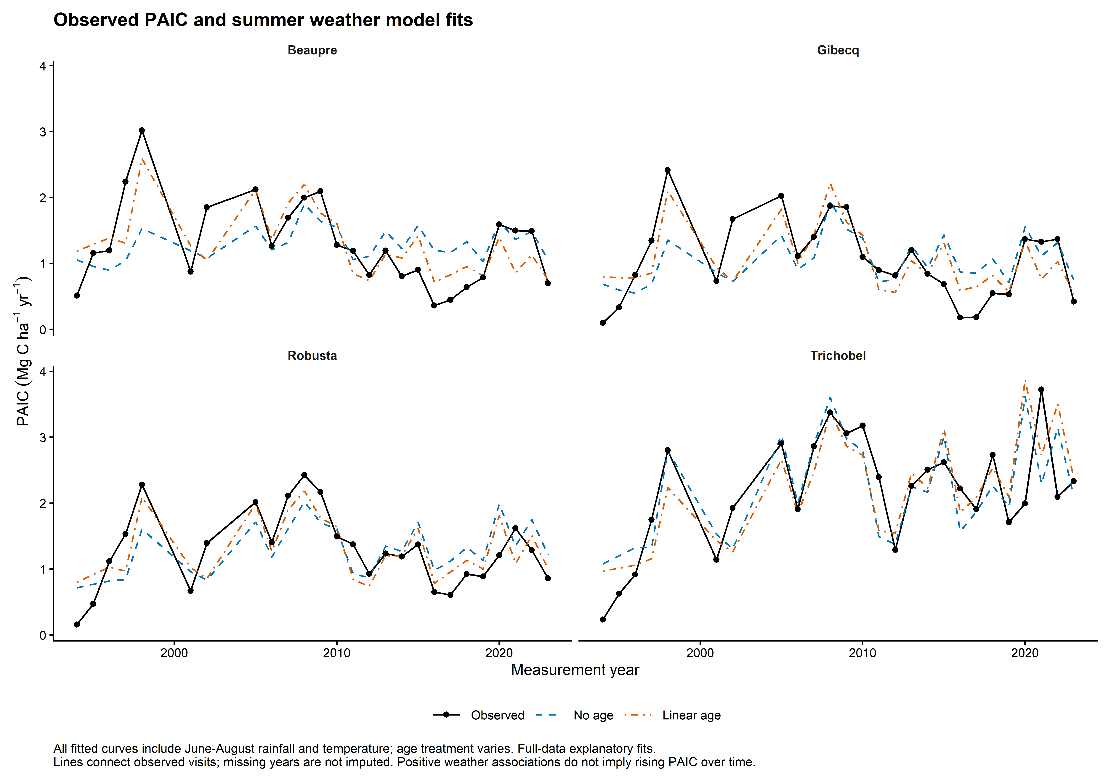
Figure 3. Observed hybrid median PAIC and fitted means from models containing both summer-weather variables. Black points are observations; coloured line types distinguish age specifications. Lines connect observed visits; no growth values are imputed between visits. These are fitted explanatory trajectories, not independent validation predictions.

Comparing weather models with and without age
Hybrid | Pseudo R²  No age | Pseudo R²  Linear age | AICc difference  Linear minus no age
Beaupre | 0.165 | 0.499 | -10.56
Gibecq | 0.247 | 0.366 | -1.64
Robusta | 0.356 | 0.436 | -0.45
Trichobel | 0.436 | 0.494 | +0.22

Table 2. Both models contain summer rainfall and temperature and use the same 26 years. Pseudo-R² uses the same intercept-only reference within each hybrid. A negative AICc difference favours adding age; a positive value favours no age. Values describe in-sample fit and AICc assumes independent errors.
Pseudo-R² increases for every hybrid, most strongly for Beaupre (0.165 to 0.499). AICc supports the added age term most clearly for Beaupre (difference −10.56). The changes for Gibecq (−1.64), Robusta (−0.45) and Trichobel (+0.22) are small after penalising complexity. Thus higher fitted pseudo-R² does not establish that an age term is needed for every hybrid. Keep the two specifications visible; weather captures some peaks and troughs but leaves substantial variation unexplained.

Discussion and limits of interpretation

Biological interpretation
Greater PAIC in wetter summers across all hybrids is compatible with a role for summer water availability. Warmth may contribute, especially in Trichobel’s unadjusted record, but raw temperature correlations are modest and model associations change with age adjustment. Attribution to a particular growth year remains less precise for multi-year PAIC values.
Trichobel’s unadjusted rainfall effects exceed the other hybrids in the pointwise paired intervals. After linear age adjustment, only its rainfall difference from Robusta has an interval wholly above zero. Its temperature difference from Gibecq narrowly excludes zero without age, but not after adjustment. These exploratory comparisons have no multiplicity correction.
A larger absolute change partly reflects Trichobel’s higher baseline PAIC: with a log link, the same proportional association produces more carbon at a higher baseline. Absolute results describe carbon differences; they do not establish greater physiological sensitivity or resistance. Weather is a possible contributor to Trichobel’s performance, but these results do not demonstrate a climate-resilience mechanism.
A positive weather association can coexist with declining PAIC over time. Growth reflects the observed combination of weather, age, stand development and management. We have not apportioned Trichobel’s net advantage into a causal contribution from climate change.

Diagnostic limitations and remaining decisions
Age and calendar year advance together in this cohort; management and stand development also change. Raw associations retain these influences. Age terms provide sensitivity checks, not a complete solution to confounding, and can absorb weather-related trends as well as unrelated development.
Residual correlations between consecutive calendar years are 0.47–0.65 without age for Beaupre, Gibecq and Robusta, versus 0.10 for Trichobel. With linear age these are approximately 0.37, 0.54, 0.31 and 0.10, respectively. Three-visit blocks accommodate some dependence but their length is not established as sufficient. Stronger significance claims would require a defensible serial-error analysis or block-length sensitivity check.
All 8,000 bootstrap fits converged, and no resampled absolute effects exceeded 10 Mg C ha⁻¹ yr⁻¹. Individual-year omission results and bootstrap tail checks are saved with the model outputs. These diagnostics do not eliminate temporal confounding or establish that the intervals fully capture uncertainty.

Scope for the paper
Figure 2 presents absolute associations with age sensitivity; Figure 3 relates them to observed trajectories. Figure 1 can document variable selection in supplementary material. Keep the interpretation concise and exploratory: consistent rainfall associations, with a possible weather contribution to hybrid performance and unresolved temporal confounding.
Reproducibility: analysis/14_raw_paic_weather_final.R and its companion 14_raw_paic_weather_checks.R; results/models/final_raw_paic_weather.rds; final_weather_ tables and figures. Raw candidate values are reused from weather_departure_screen_data.csv; no departures from that file enter the models. Figures have 600 dpi PNG and vector PDF exports. The previous Word version is preserved separately.

