Weather relationships with tree growth
  - Analysis notes for paper drafting | Updated 20 October 2026
This note records the current hybrid-specific weather models for PAIC and the limitations that matter for paper drafting. The baseline models identify statistical associations with multivariate weather gradients; they do not yet explain the low growth recorded at the 2001 visit.

Methods
The baseline analysis uses the legacy hybrid PAIC summaries for continuity with the earlier weather analysis. These have been compared with tree-level hybrid medians. Beaupre, Gibecq and Trichobel agree closely; a remaining Robusta discrepancy needs resolution. Only positive, observed PAIC values enter the Gamma models.
A measurement in year t is paired with weather for growth year t minus 1. Seasons are winter December to February, spring March to May, summer June to August and autumn September to November; half-years are October to March and April to September. Winter windows cross the calendar-year boundary.
Temperature, soil temperature and wind speed are averaged; rainfall, sunshine, frost-day counts, growing-day counts, growing degree days and windy-day counts are summed within windows. Variable coverage is exported. Partial variable records currently use available days; a final coverage policy has not been fixed.
Six separate principal component analyses describe the seasonal or half-year weather. Each is shared across hybrids, uses standardised weather variables on its complete-case basis, and retains enough axes to explain at least 80 percent of weather variance. For each hybrid and period, PAIC is modelled with a Gamma distribution and log link using retained component scores.

Current model results
Hybrid | Summer observations | Summer PCs | Deviance reduction
Beaupre | 23 | 4 | 44.2%
Gibecq | 23 | 4 | 35.0%
Robusta | 23 | 4 | 30.5%
Trichobel | 23 | 4 | 53.6%

All exported baseline fits converged. Deviance reduction is an in-sample measure, not predictive validation or the fraction of growth causally explained by weather. Models fitted to different observation sets must not be ranked directly by AIC.

The unresolved slowdown around the 2001 visit
PAIC at the 2001 visit averages growth over 1998 to 2000, but the current weather join supplies weather for 2000 only. This mismatch matters when interpreting that point. No interval-aware weather analysis has yet been completed, and the existing model should not be used to attribute the three-year average to weather in one year.
Growth year | Summer half rainfall mm | Summer half sunshine hours
1997 | 345.3 | 967.1
1998 | 335.9 | 797.8
1999 | 333.5 | 943.6
2000 | 451.4 | 906.9
2001 | 295.2 | 873.6

The local records show relatively low summer-half sunshine in 1998 and higher summer-half rainfall in 2000. These are observations for investigation, not established explanations of the growth decline. They do not resolve which years within the measurement gap were most influential.

Discussion points
Interpret each component using its loadings, rather than assigning a physical meaning from its sign or number. Component signs are arbitrary, and a one-unit score is not a one-degree temperature or one-millimetre rainfall change. Any quoted association should name the hybrid, weather period, component interpretation and uncertainty.
The treatment analysis absorbs shared temporal conditions with categorical interval effects. Its interval coefficient cannot distinguish weather from stand development, management changes or other shared causes. Separate weather modelling can investigate associations, while treatment by weather interactions would be a distinct, more demanding question.

Next analysis decisions
Compare annual-interval models with an interval-aware sensitivity analysis. A candidate approach is to predict annual growth using annual weather and then average predictions over each observed growth interval; this is not generally identical to predicting from averaged weather under a nonlinear link. Assess age or time trends, residual dependence, influential observations and fair temporal validation before describing forecasts as reliable.

Files supporting this note
analysis/02_weather_paic.R
scripts/prep/02_weather.R
scripts/prep/04_join_and_pca.R
results/tables/baseline_weather_model_summary.csv
results/tables/baseline_weather_model_coefficients.csv
data/processed/weather_pca_loadings.csv
results/checks/weather_coverage.csv

Shared fluctuations and weather model update
Update 20 October 2026. PAIC fluctuations are strongly shared across hybrids after broad trajectories are removed. The simple temperature and rainfall model did not improve held-out prediction. Earlier sections retain the original seasonal PCA record; the current decisions and results follow below.

Methods
For the synchrony analysis, use the same tree-level hybrid medians as the PAIC and MAIC descriptive figure, restricted to 26 measurement years with positive PAIC for all four hybrids. Fit a separate quadratic age trend to log PAIC for each hybrid, without a shared year effect. Divide each hybrid residual series by its own standard deviation to compare departures. Calculate descriptive Pearson and Spearman correlations; repeat with linear detrending and the legacy weather-response summaries. No missing years are imputed. The last ten observations, 2014 to 2023, form an exploratory descriptive subset, not an estimated change point.
The separate weather comparison uses 104 legacy hybrid summaries over 26 years. Gamma log-link mixed models include hybrid-specific quadratic age trends and a random measurement-year intercept. Compare the baseline with shared April to September mean temperature and rainfall effects. Leave out all four hybrids from one year together, refit, and predict the unseen year by integrating over the random intercept. This assesses interpolation, not future forecasting.

Calculated results
After quadratic detrending, correlations among Beaupre, Gibecq and Robusta range from 0.91 to 0.96. Trichobel correlations are 0.73 with Beaupre, 0.72 with Gibecq and 0.89 with Robusta. Linear detrending also shows strong positive synchrony. Trichobel correlation with the mean standardised departure of the other hybrids is 0.95 in 1994 to 2013 and 0.61 in 2014 to 2023. Its median raw PAIC ratio to the geometric mean of the others is 1.50 and 2.73, respectively. These comparisons have no inferential uncertainty assessment.
Held-out RMSE is 1.696 for the age baseline and 1.703 after adding temperature and rainfall. Mean Gamma deviance is 0.607 and 0.612, respectively. Both weather coefficient intervals include zero. Hybrid-specific weather slopes and winter extensions were not fitted because the shared-weather model did not improve either metric. Final full and fold fits have no recorded convergence or singularity warnings.

Discussion hypotheses
Shared departures are consistent with a common environmental driver but do not identify weather as its cause. Trichobel maintains higher relative growth in later observations, especially when other hybrids have low PAIC. This is not proof of greater drought tolerance or a distinct weather response; ratios can increase because their denominator declines.

Open decisions and confirmed interval convention
Retain weather from year t minus 1, including multi-year PAIC intervals, as confirmed by the user. Annualising PAIC accounts for interval duration, but growth timing within unsampled years remains unknown. State this in Methods and Discussion. Revisit age-curve sensitivity, temporal dependence, weather exposure summaries and coverage, the Robusta response discrepancy, and validation. The PCA retention caveat remains open: weather variance is not PAIC relevance. See references/WEATHER_PCA_REVIEW.md for the saved Wicklin blog and methodological reference.

Shared PAIC fluctuations
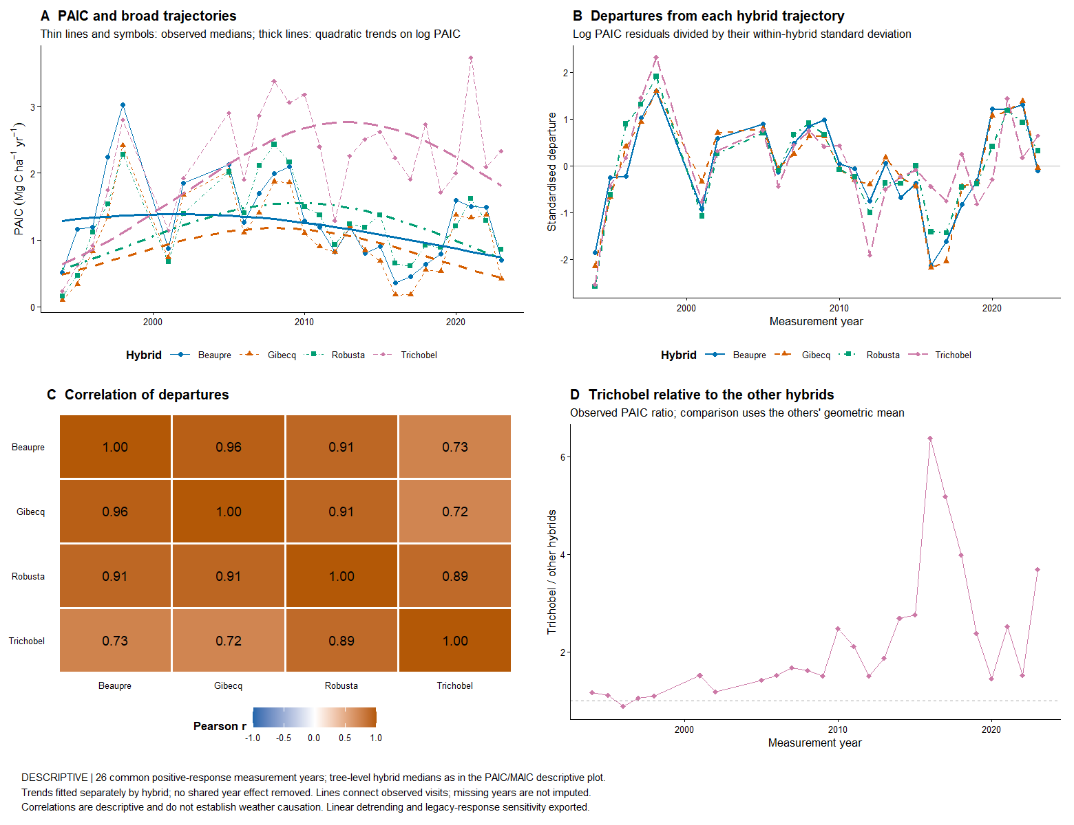
Descriptive comparisons use tree medians. Correlations do not establish causation, and quadratic trends are provisional. The Trichobel ratio compares observed PAIC with the geometric mean of Beaupre, Gibecq and Robusta.

Reproducible sources for this update
analysis/07_weather_temperature_rainfall.R and analysis/08_check_weather_temperature_rainfall.R; analysis/09_paic_shared_fluctuations.R; results/tables/paic_synchrony_*.csv; results/tables/weather_temperature_rainfall_*.csv; references/WEATHER_MODEL_NOTES.md and references/WEATHER_PCA_REVIEW.md.

