Soil organic carbon stocks and supplementary soil properties
  - Analysis notes for paper drafting | Updated 21 October 2026
SOC stocks differ among sampled locations in the 0 to 15 cm layer. No pairwise location difference is detected at 15 to 30 cm after adjustment. Complete 0 to 30 cm stocks remain the basis for tabular reporting and subsequent area scaling.

Methods
Source data are the rawdataSofia sheet of soil_and_legacy_scenarios.xlsx. Arable reference, Alley and Tree row identify sampling locations, not the cropping treatments in the tree experiment. Location codes remain in exported tables for reproducibility.
Layer SOC stock (Mg C per hectare) = fine bulk density (g per cubic centimetre) multiplied by layer thickness (cm) and SOC content (%). Complete 0 to 30 cm stock is the sum of the 0 to 15 and 15 to 30 cm layers. The data contain 188 depth records and 92 complete profiles; incomplete profiles contribute to depth comparisons but not to 0 to 30 cm summaries.
For supplementary BD, first calculate a soil-mass-weighted value within each complete profile: sum(BD squared multiplied by thickness) divided by sum(BD multiplied by thickness). Layer mass per unit area is BD multiplied by thickness. This weighting is not an equivalent-soil-mass correction of the SOC stocks. SOC content is the arithmetic mean of the two layer percentages within each complete profile, without mass weighting. Location summaries are then calculated across profile values.
Depth-specific comparisons use Kruskal-Wallis tests and two-sided, tie-corrected Dunn tests, with Benjamini-Hochberg adjustment across the three location pairs separately within each depth, following the legacy analysis. Letters use adjusted p < 0.05. Shared letters indicate no detected difference, not equivalence. Tests assume independent sampled profiles and remain exploratory until spatial clustering is resolved. Depth observations from one profile are paired; no between-depth test is implied by the letters.

Calculated results
Location | Profiles | Mean stock | SD | Median
Arable reference | 46 | 59.39 | 8.40 | 59.93
Alley | 24 | 75.71 | 8.64 | 76.35
Tree row | 22 | 71.42 | 9.37 | 72.41

Stocks are Mg C per hectare at 0 to 30 cm. SD describes variation among profiles, not uncertainty from independent experimental replication. These fixed-depth stocks are retained for upscaling and comparison with aboveground carbon on a consistent area basis.
Depth cm | Comparison | BH adjusted p
0-15 | Arable reference versus Alley | 6.13e-10
0-15 | Arable reference versus Tree row | 1.64e-08
0-15 | Alley versus Tree row | 0.528
15-30 | Arable reference versus Alley | 0.0627
15-30 | Arable reference versus Tree row | 0.98
15-30 | Alley versus Tree row | 0.0695

Discussion hypotheses
The surface-layer pattern is consistent with spatial differences in organic inputs and soil conditions, but baseline differences and management history remain alternative explanations. A nonsignificant deeper comparison does not demonstrate disappearance of an effect or equivalence among locations. Cross-sectional stock contrasts are not measured sequestration rates or causal cropping-treatment effects.

Open decisions
Confirm the sampling map, possible spatial clustering, reference comparability and whether coarse-fragment or equivalent-soil-mass treatment is required for final inference. Upscaling needs tree-row and alley area fractions: do not add two full-hectare location stocks. Comparison with aboveground biomass must use compatible area units and carbon units; biomass and carbon mass cannot be directly equated. A stock difference requires a justified baseline and timescale before interpretation as an annual rate.
Reproducible analysis: analysis/04_soc_stocks.R. Outputs: results/tables/soc_profile_summary.csv; supplement_BD_0_30.csv; supplement_SOC_content_0_30.csv; soc_stock_depth_dunn_BH.csv; soc_tables_README.txt. The original note is preserved in the analysis_notes/_history directory.

Depth specific SOC stock distributions
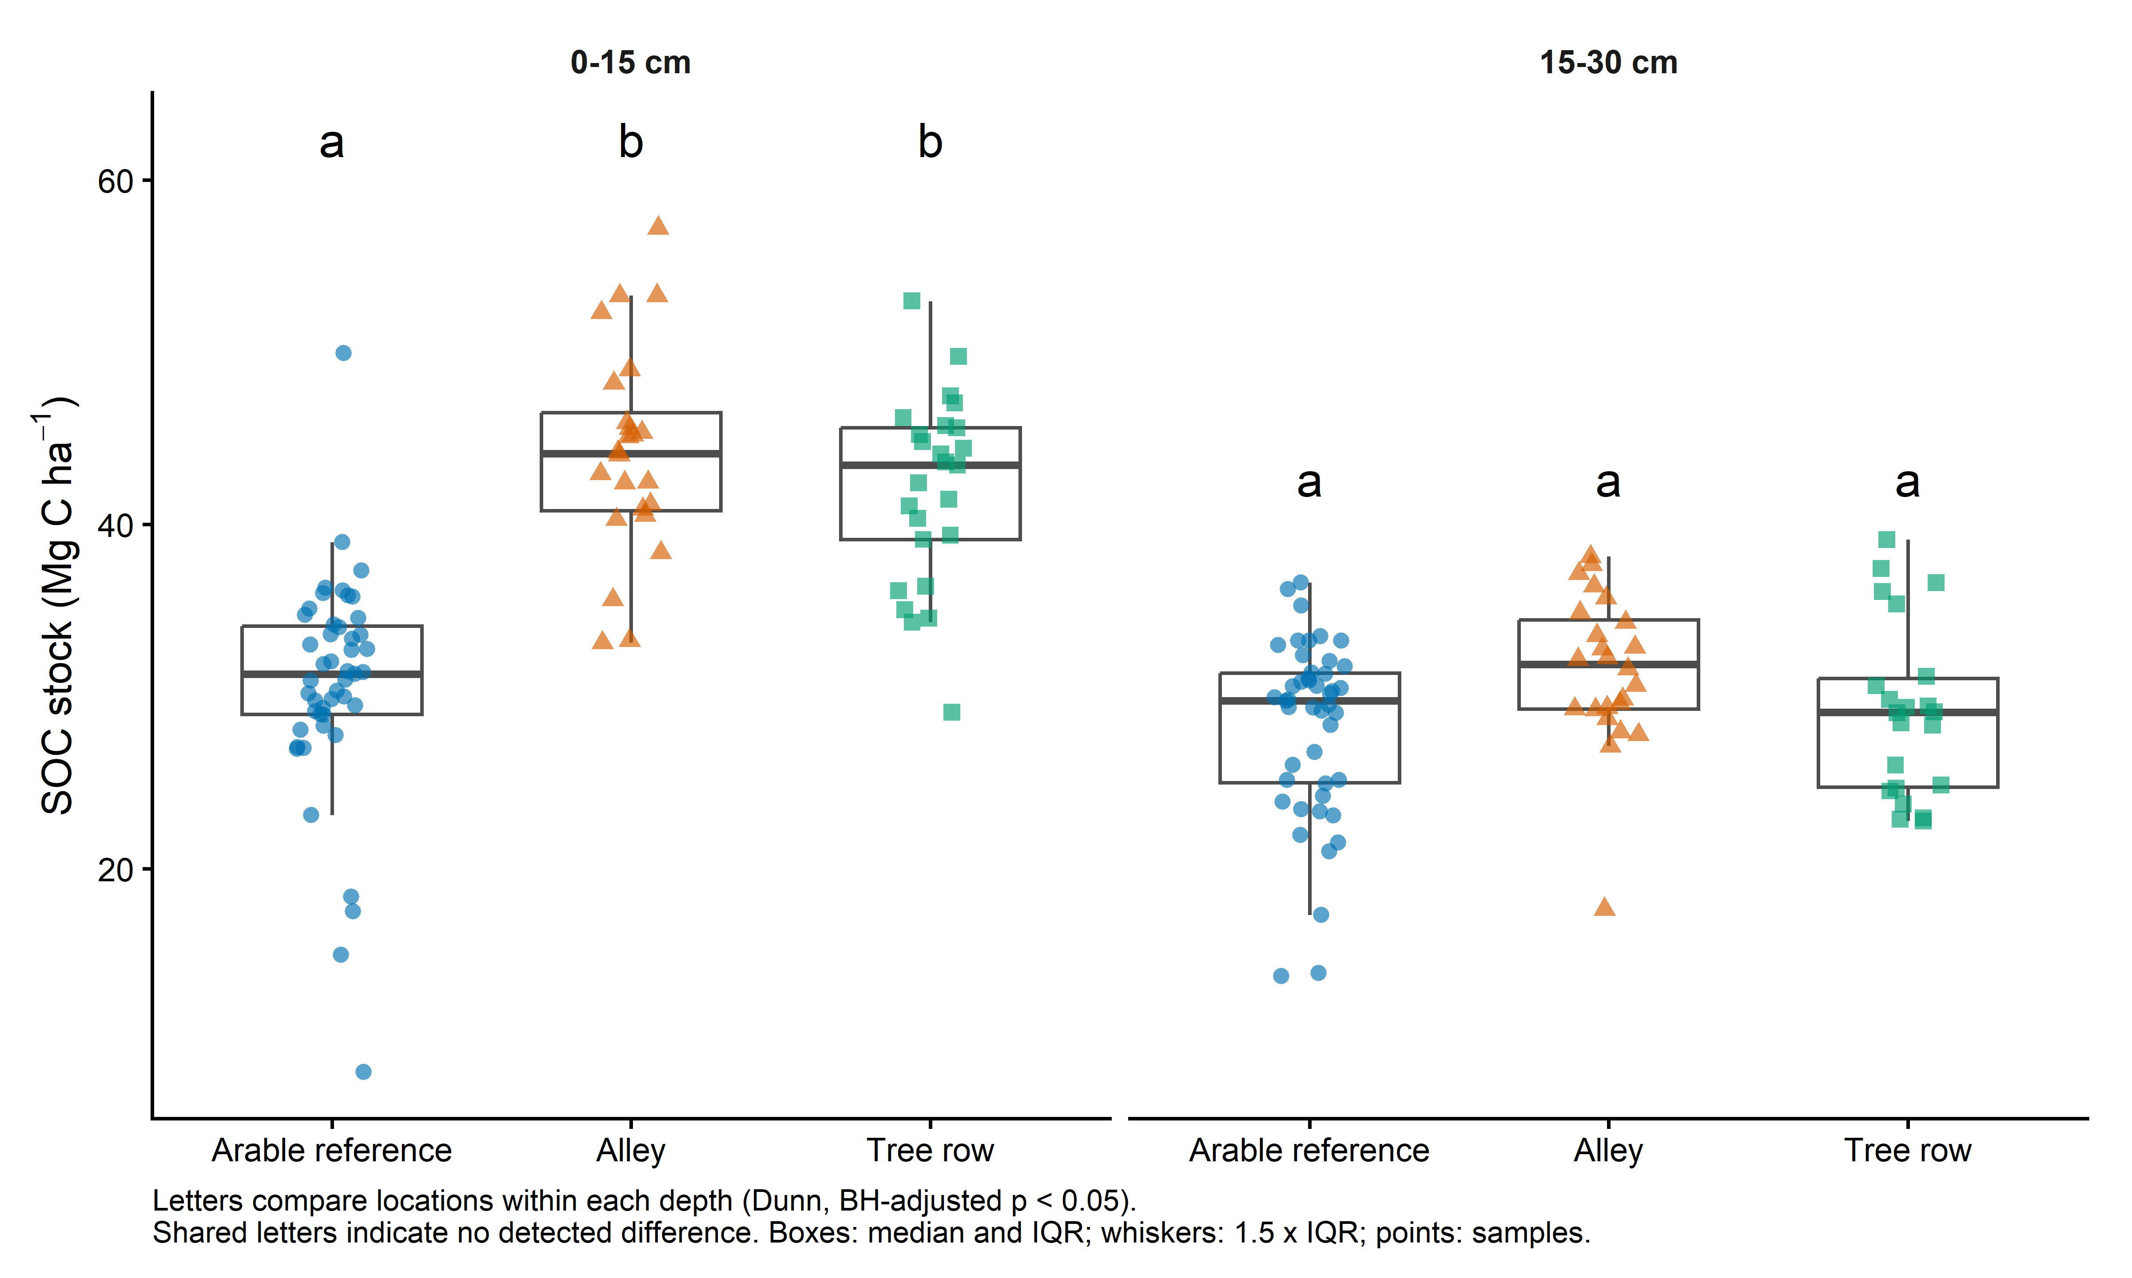
Figure 1 SOC stock by sampling location and depth. Boxes show medians and interquartile ranges; whiskers extend to observations within 1.5 times the interquartile range. Points show individual samples. Letters compare locations only within the same depth.

Supplementary soil properties at 0 to 30 cm
Location | Profiles | BD g/cm3 | SOC content %
Arable reference | 46 | 1.265 (0.129) | 1.591 (0.151)
Alley | 24 | 1.251 (0.167) | 2.111 (0.196)
Tree row | 22 | 1.108 (0.155) | 2.241 (0.315)

Entries are mean (SD) across complete profiles. BD uses soil-mass weighting within profiles; SOC content uses a simple average of the two layer percentages. Machine-readable supplementary CSV tables also contain SE, median and quartiles. SE is SD divided by the square root of the number of profiles.

