Soil organic carbon stock analysis
  - Analysis notes for paper drafting | Updated 20 October 2026
This note summarises soil organic carbon stocks in tree rows, alleys and an arable reference. Complete-profile stocks are higher on average in tree rows and alleys than in the reference samples. These are descriptive spatial comparisons, not measured sequestration rates or effects of the cropping treatment factor.

Methods
The soil preparation uses the rawdataSofia sheet in soil_and_legacy_scenarios.xlsx. Location codes identify tree row, alley and arable reference; they are distinct from Continuous fallow, Continuous cropping and Alternate cropping in the tree experiment.
For each depth, soil organic carbon stock in Mg C per hectare is calculated as fine bulk density in g per cubic centimetre multiplied by depth thickness in centimetres and SOC concentration expressed as percent. This assumes the supplied fine bulk density is the intended basis; confirm any required coarse-fragment or equivalent-soil-mass treatment before final methods.
A 0 to 30 cm profile is included only when both the 0 to 15 and 15 to 30 cm layers have observed stocks. Available-depth sums are retained separately and never labelled complete 0 to 30 cm stocks. The dataset contains 188 depth records and 92 complete profiles. The current preparation does not invent block, tree-row or geographic coordinates absent from the source.

Main results
Location | Profiles | Mean stock | Median stock
Tree row | 22 | 71.42 | 72.41
Alley | 24 | 75.71 | 76.35
Arable reference | 46 | 59.39 | 59.93

Stocks are Mg C per hectare for 0 to 30 cm. Relative to the arable-reference mean of 59.39, tree-row and alley means are approximately 20 and 27 percent higher, respectively. These percentages describe the sampled locations and are not an area-weighted estimate of whole-system enrichment.

Interpretation limits
The current paper module provides descriptive summaries and a figure, rather than a final design-aware test of location effects. Sampling profiles should not automatically be treated as independent experimental replicates until the spatial design and clustering are clarified. Depth observations within a profile are paired.

Discussion and paper use
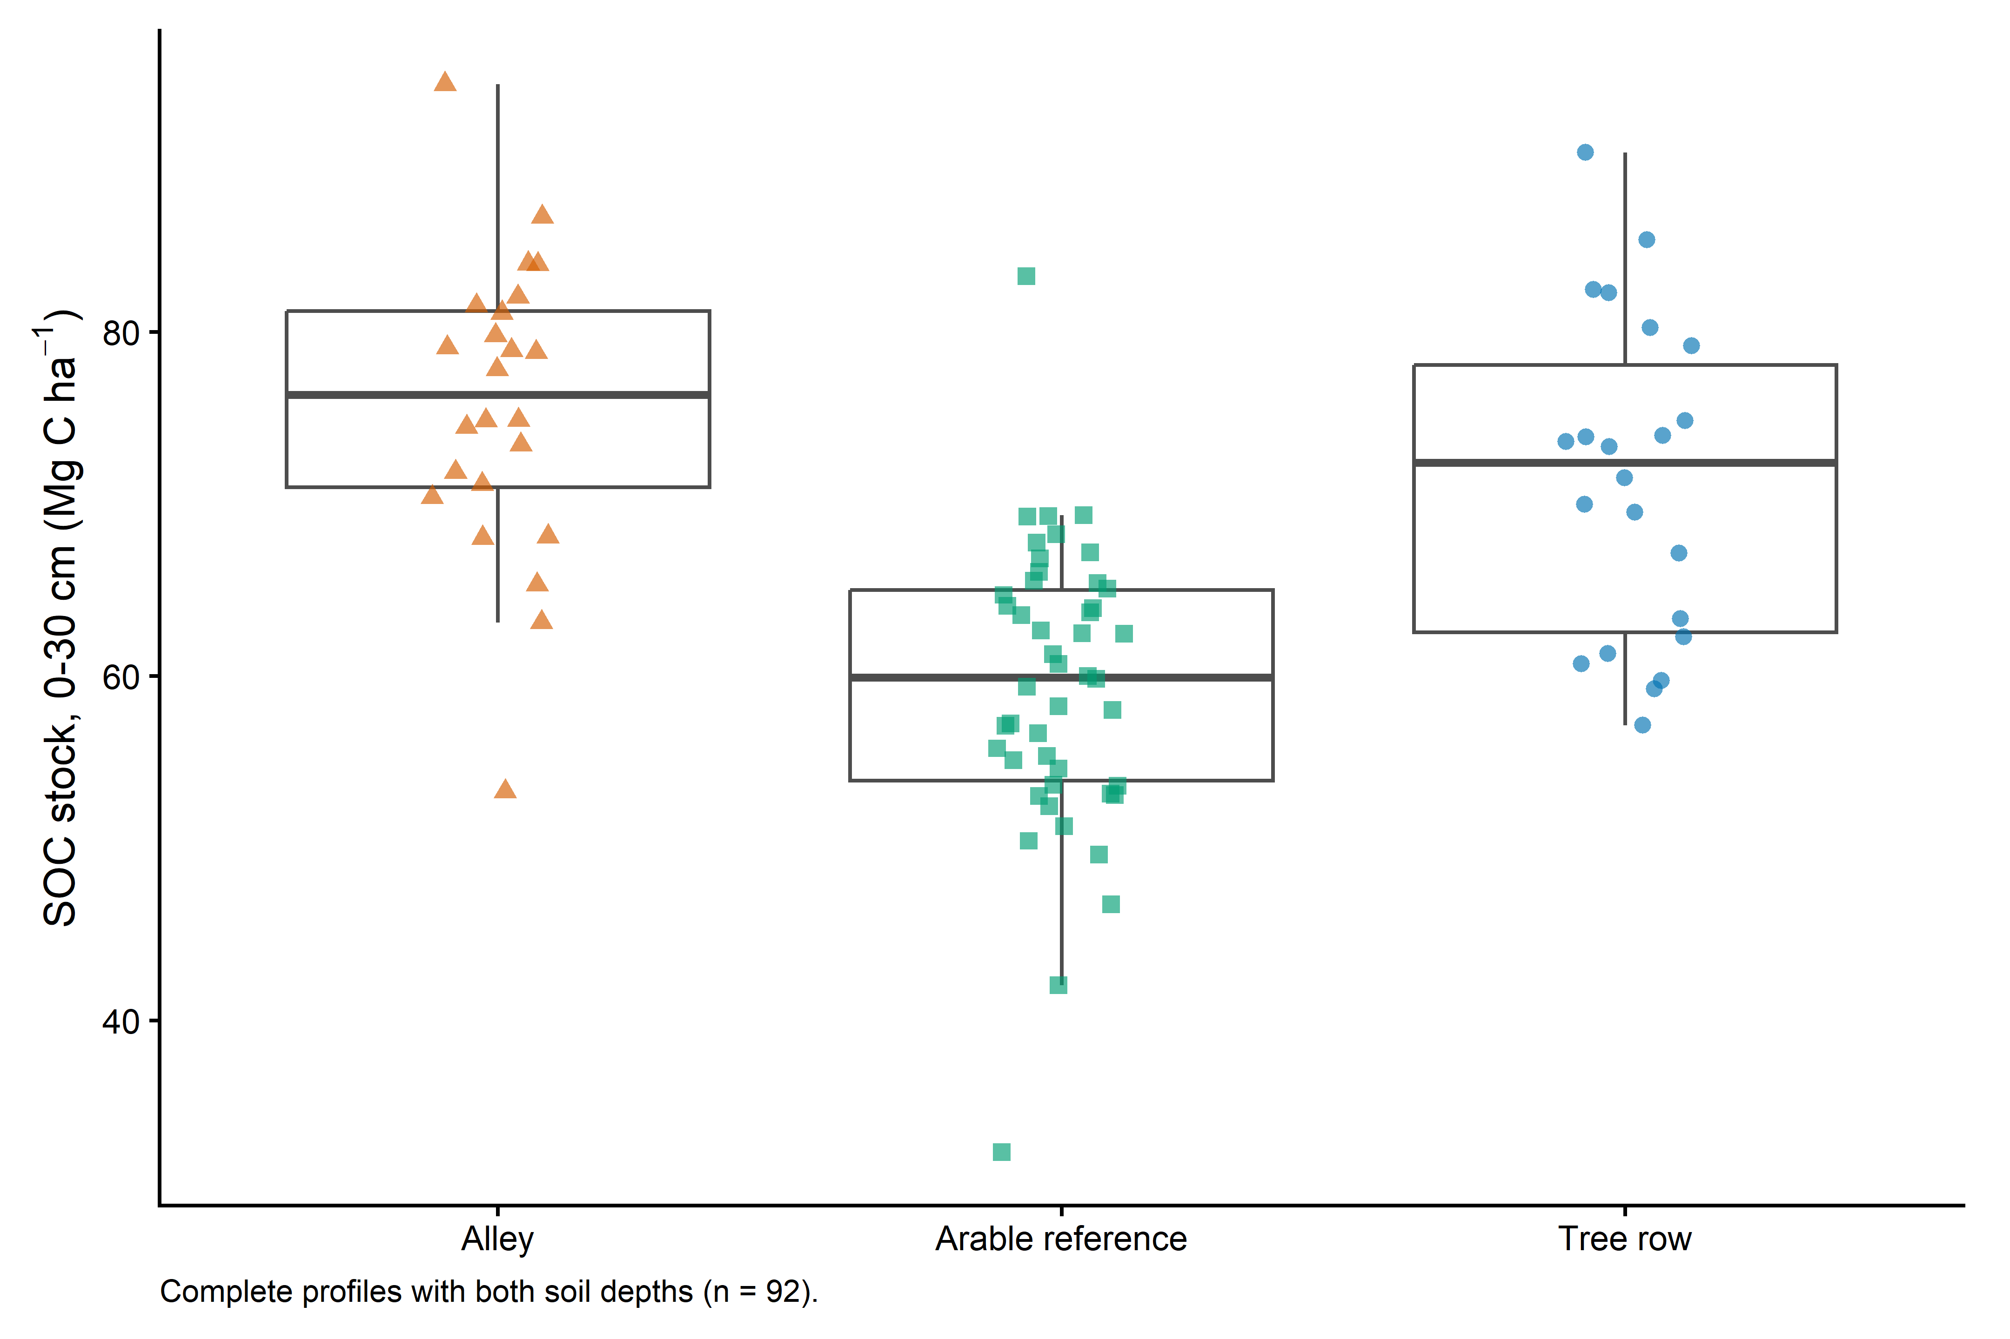
Figure 1 Complete-profile stocks by sampling location. Points represent sampled profiles; boxes describe their distributions. Locations are not cropping-treatment categories.
Discuss the location pattern as consistent with spatial differences in organic inputs and soil conditions, while retaining uncertainty about baseline differences, management history and sampling structure. The current data do not establish a causal treatment effect or a measured change through time.
Present complete-profile SOC stocks in the main paper if they address the primary question. Bulk density, SOC percent and depth-specific stocks can support supplementary interpretation. Higher concentration alone does not establish higher stock, because bulk density and depth enter the stock calculation.

Decisions before final inference and scenarios
Confirm the sampling map, possible clustering, reference comparability, and whether coarse fragments or equivalent-soil-mass correction matter. Establish any statistical model from that design. To extrapolate, specify tree-row and alley area fractions; do not sum two full-hectare location stocks. A stock contrast is not an annual sequestration rate without a justified baseline and timescale.

Files supporting this note
scripts/prep/03_soc.R
analysis/04_soc_stocks.R
results/tables/soc_profile_summary.csv
results/tables/supplement_soil_depth_summary.csv
results/checks/incomplete_soil_profiles.csv

