Soil organic carbon stocks and equivalent soil mass correction
  - Analysis notes for paper drafting | Updated 22 October 2026
Provenance update 22 October 2026: all 188 measured records have been traced to AgricARBON sample IDs. Tree row profile 25 matches reference-field core 016. Earlier numerical summaries and tests below retain the original workbook labels and require revision before scenario use. See the provenance addendum at the end.
Linear equivalent soil mass correction uses the arable mean soil masses as common reference coordinates. Corrected mean stocks are higher in alleys and tree rows than in the arable reference. Fixed-depth estimates remain available separately; corrected stocks are labelled by equivalent mass rather than physical depth.

Methods
The source is rawdataSofia in soil_and_legacy_scenarios.xlsx. Arable reference, Alley and Tree row identify sampling locations, not cropping treatments. Coded identifiers remain in exported profile and summary tables. There are 188 depth records, 96 profiles and 92 profiles with both measured layers.
Layer soil mass (Mg soil per hectare) = supplied fine bulk density (g/cm3) times thickness (cm) times 100. Layer SOC stock (Mg C per hectare) = layer soil mass times SOC content (%) divided by 100. No additional organic-matter subtraction or coarse-fragment correction is applied to the supplied fine bulk density.
The reference upper soil mass is 1775.11 Mg soil per hectare, the mean of 47 arable 0 to 15 cm samples. The mean lower-layer mass is 1959.13 Mg soil per hectare from 46 samples. Their sum, 3734.24, defines the total reference mass corresponding to arable 0 to 30 cm. All available arable observations are used within each layer; one arable profile lacks the lower layer.
For each profile, join the origin and measured cumulative mass versus cumulative SOC endpoints with straight segments. Evaluate SOC at the two reference masses using linear interpolation, without splines. Their difference is the lower reference-mass increment. Complete profiles can extend beyond their measured total mass along the final segment, assuming the measured 15 to 30 cm SOC concentration continues below 30 cm. Record the extrapolated mass, carbon and implied physical depth for every complete profile.
Profiles with only the upper layer were limited by shallow bedrock. Retain an ESM-corrected 0 to 15 cm reference-mass stock by evaluating the measured upper-layer slope at the upper arable reference mass. In these four profiles that reference exceeds the measured mass, so this is a linear extension for mass standardisation, not an observation of soil below bedrock. Do not estimate the 15 to 30 cm reference-mass increment or the 0 to 30 cm total for these profiles. Individual arable profiles are evaluated at the same reference masses as alley and tree-row profiles for comparable distributions.
For supplementary measured 0 to 30 cm soil properties, calculate BD within each complete profile as sum(BD squared times thickness) divided by sum(BD times thickness). SOC content is the arithmetic mean of the two measured layer percentages. These are not ESM-transformed properties. Summaries are means and SD across profiles; SE is SD divided by square root of n. Reference-mass uncertainty is not propagated.
Exploratory location comparisons use Kruskal-Wallis and two-sided tie-corrected Dunn tests. Benjamini-Hochberg adjustment covers three location pairs separately within each reference-mass interval. Fixed-depth tests and letters are retained in separate files. Supplementary BD and SOC-content letters use the same Dunn procedure, with BH adjustment over three land-cover pairs separately for each property, on complete-profile measured 0 to 30 cm values. Shared letters indicate no detected difference. Tests assume independent profiles; spatial clustering remains unresolved.

Calculated results
Location | Profiles | Fixed depth | Linear ESM | ESM SD
Arable reference | 46 | 59.39 | 59.17 | 6.10
Alley | 24 | 75.71 | 76.44 | 6.65
Tree row | 22 | 71.42 | 79.30 | 9.25

All stocks are Mg C per hectare. Fixed depth is measured 0 to 30 cm; linear ESM is the arable 0 to 30 cm reference mass, with profile-specific physical depths. These are distinct estimands. SD describes profile variation, not uncertainty based on independent experimental replication.
Location | Extended profiles | Excluded totals | Maximum depth cm
Arable reference | 22 / 46 | 1 | 36.7
Alley | 12 / 24 | 0 | 40.4
Tree row | 16 / 22 | 3 | 45.2

Extended profiles require soil below the measured 30 cm to reach the common mass. Their corrected stocks depend on continuation of the measured lower-layer concentration. Excluded totals are incomplete profiles; their plotted upper-layer segments can extend to the upper reference only.
At the upper reference mass, arable versus alley and arable versus tree row both have BH-adjusted p below 0.001; alley versus tree row p = 0.655. Upper-reference sample sizes are now 47 arable, 24 alley and 25 tree-row profiles; lower-reference comparisons retain 46, 24 and 22. For the lower reference-mass increment, arable versus alley p = 0.0429, arable versus tree row p = 0.000244, and alley versus tree row p = 0.111. Both intervals therefore have letters a, b, b in arable, alley, tree-row order. In contrast, the original fixed-depth 15 to 30 cm comparisons had no adjusted pairwise significance. Equal-mass intervals must not be described as identical fixed-depth layers.

Discussion hypotheses
The location pattern is consistent with spatial differences in organic inputs and soil conditions, but baseline differences and management history remain alternative explanations. Correcting for soil mass changes the deeper comparison, including carbon assigned below the measured depth where extension is required. It does not establish causal cropping-treatment effects or measured sequestration through time.

Open decisions
Linear interpolation, the arable reference and retention of upper-only estimates at shallow-bedrock profiles are now specified. Confirm spatial clustering, reference comparability and the basis of fine bulk density for final inference. Extrapolated profiles remain explicit in the audit. Upscaling needs tree-row and alley area fractions and compatible area and carbon units with aboveground stocks. A stock difference is not an annual sequestration rate without a justified baseline and timescale.

SOC stocks in equivalent soil mass intervals
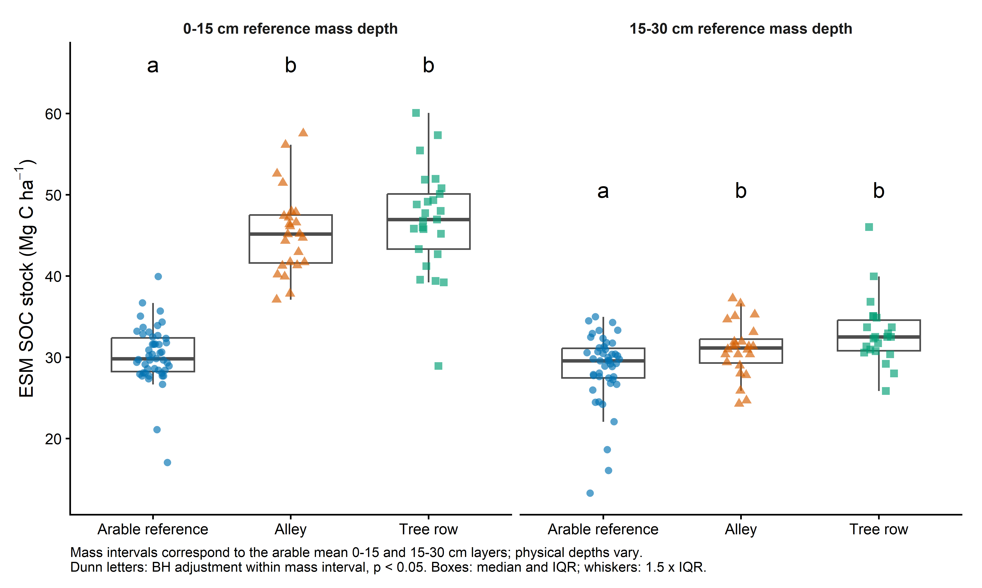
Figure 1 Corrected SOC stocks for 0 to 15 cm and 15 to 30 cm reference mass depths. These labels identify arable reference depths; physical sampling depths differ among profiles. Letters compare locations within each mass interval. Boxes show median and IQR; whiskers use 1.5 times IQR; points are profile estimates.

Supplementary measured soil properties
Land cover | Profiles | BD g/cm3 | SOC content %
Arable reference | 46 | 1.265 (0.129) b | 1.591 (0.151) a
Alley | 24 | 1.251 (0.167) b | 2.111 (0.196) b
Tree row | 22 | 1.108 (0.155) a | 2.241 (0.315) b

Mean (SD) across complete measured 0 to 30 cm profiles. BD uses soil-mass weighting within profiles; SOC content uses an unweighted layer average. Letters compare land covers separately within each property (Dunn, BH-adjusted p < 0.05); shared letters indicate no detected difference. These properties describe measured depth, not ESM reference depth.
The measured fixed-depth figure and tests are retained as soc_stock_by_depth and soc_stock_depth_dunn_BH. The original Word note is preserved in analysis_notes/_history.

Supplementary cumulative coordinate overview
Figure S1 Each facet is one alley or tree-row sampling profile. Black points are the measured cumulative endpoints joined linearly from the origin. Purple dashed segments extend the final measured layer slope. Vertical dotted lines show the two arable reference masses; blue triangles and orange squares identify ESM-corrected 0 to 15 cm and 0 to 30 cm SOC stocks. Asterisks mark shallow-bedrock profiles with upper-reference estimates only.
The standalone vector PDF provides a larger overview of all 49 profiles. Shared axes allow comparisons of sampled mass, SOC and extension length. Tree-row profiles 12, 19 and 24 have shallow bedrock and retain only their 0 to 15 cm reference-mass estimates; no lower increment or total is calculated. Arable profiles define the reference and are retained in the tabular coordinate and extrapolation audits.

Reproducible outputs
Run analysis/04_soc_stocks.R, which sources analysis/04b_soc_ESM.R and analysis/04c_soil_property_letters.R. The SOC_ESM tables contain reference masses, measured coordinates, profile estimates, summary statistics, extrapolation audits and location tests. See results/tables/soc_ESM_README.txt for calculation rules. Fixed-depth stock summaries and supplementary BD and SOC-content tables remain separate.

Soil sample provenance and former cropping treatments
Updated 22 October 2026. The missing sample identities can be recovered. The user confirmed on 22 October 2026 that rows run approximately north to south, with row 6 furthest west. Together with the original design and colleague's account, this confirms the western, middle and eastern sampled bands as rows 6, 10 and 14 respectively.

Methods
Match rawdataSofia records to CSV - Samples in AGRICARBON UOL001-A01 Results v3.3 PUBLISH 2024-03-14 CSV.xlsx using fine dry bulk density and SOC percentage, with a tolerance of 0.005001 in each value to allow two-decimal rounding. Sample suffix .1 is aligned with 0-15 cm and .2 with 15-30 cm. Intersect candidate core IDs across both available layers; retain the original sampling-location codes and potential_samplingID. Inspect page 4 of UOL001 Field Plan.pdf and the original experimental-design screenshot supplied with the request. Geographic bands are inferred from coordinates. Treatment row numbers use the colleague's account, the original numbered design and the user's confirmation on 22 October 2026 that row 6 is furthest west and rows run approximately north to south.

Calculated results
All 188 records match both BD and SOC within rounding tolerance. Each of the 96 profile fingerprints resolves to one distinct AgricARBON core. There are 48 cores in agroforestry Field 2: 24 labelled Alley and 24 labelled Tree row. The remaining 48 cores are in reference Field 1: 47 labelled Arable reference and one incorrectly labelled Tree row. This is a provenance finding, not a recalculation of SOC stocks.
Spatial band | Alley workbook IDs | Confirmed row and block | Former treatment
Western | 1-8 | Row 6 / Block 1 | Continuous fallow
Middle | 9-16 | Row 10 / Block 2 | Continuous cropping
Eastern | 17-24 | Row 14 / Block 3 | Alternate cropping
These are potential_samplingID values within 2_alley, not company core numbers. Each group contains eight profiles with both measured layers. Permanent core IDs and coordinates are retained in results/checks/soil_provenance/soil_profile_crosswalk.csv. The row, block and former-treatment columns are confirmed using the supplied site orientation.
Tree row profile 25 (1_tree_25) matches UOL001-A01-001.0-A-016 at latitude 53.873887, longitude -1.333282, in Field 1. Both layers match. The corresponding profile is absent from the 47 profiles labelled Arable reference. A separate case, Tree row profile 12, matches Field 2 core 032 and lies in the middle band; core-number ranges alone must not define sampling location.

Discussion hypotheses
Within this soil subset each former cropping treatment is represented in only one block and one sampled tree-row band. Multiple cores within a band are spatial subsamples, not independent block replication of management. Treatment differences cannot be separated from block and band differences using these data alone. Alternate cropping denotes the historical rotation in which alley positions changed annually; the sampled side cannot establish a permanent Continuous fallow or Continuous cropping history. Exact hybrid segments and the crop status of a side in a particular year remain unassigned.

Open decisions
The user confirms that the reference field was arable and the field plan description as open grassland is an Agricarbon error. Soil sampling took place in 2024; the earlier 2023 statement was mistaken. Use 2024 as the SOC observation year in methods and scenarios. The company Date extracted column records 24-25 January 2024. Rows run approximately north to south, with row 6 furthest west; former-treatment assignments to rows 6, 10 and 14 are confirmed.
Treat the AgricARBON results as the primary measurement and sample-identity source. The scenario workbook is a derived file with potentially unreliable Excel handling. Tree row profile 25 means two workbook records reproduce an arable core under a Tree row label; it does not imply that the field crew sampled an arable location as a tree row. Rebuild analysis inputs from the company results, preserving original workbook labels as audit fields, then rerun fixed-depth stocks, ESM reference masses, summaries and tests. Existing numerical outputs remain unchanged. Remaining scenario inputs include post-trial management history, reference-field comparability, tree-row/alley area fractions and an explicit stock-to-time trajectory. A cross-sectional stock contrast alone does not establish sequestration through time.

