Soil organic carbon stocks and equivalent soil mass correction
  - Analysis notes for paper drafting | Updated 21 October 2026
Linear equivalent soil mass correction uses the arable mean soil masses as common reference coordinates. Corrected mean stocks are higher in alleys and tree rows than in the arable reference. Fixed-depth estimates remain available separately; corrected stocks are labelled by equivalent mass rather than physical depth.

Methods
The source is rawdataSofia in soil_and_legacy_scenarios.xlsx. Arable reference, Alley and Tree row identify sampling locations, not cropping treatments. Coded identifiers remain in exported profile and summary tables. There are 188 depth records, 96 profiles and 92 profiles with both measured layers.
Layer soil mass (Mg soil per hectare) = supplied fine bulk density (g/cm3) times thickness (cm) times 100. Layer SOC stock (Mg C per hectare) = layer soil mass times SOC content (%) divided by 100. No additional organic-matter subtraction or coarse-fragment correction is applied to the supplied fine bulk density.
The reference upper soil mass is 1775.11 Mg soil per hectare, the mean of 47 arable 0 to 15 cm samples. The mean lower-layer mass is 1959.13 Mg soil per hectare from 46 samples. Their sum, 3734.24, defines the total reference mass corresponding to arable 0 to 30 cm. All available arable observations are used within each layer; one arable profile lacks the lower layer.
For each profile, join the origin and measured cumulative mass versus cumulative SOC endpoints with straight segments. Evaluate SOC at the two reference masses using linear interpolation, without splines. Their difference is the lower reference-mass increment. Complete profiles can extend beyond their measured total mass along the final segment, assuming the measured 15 to 30 cm SOC concentration continues below 30 cm. Record the extrapolated mass, carbon and implied physical depth for every complete profile.
Profiles with only the upper layer were limited by shallow bedrock. Retain an ESM-corrected 0 to 15 cm reference-mass stock by evaluating the measured upper-layer slope at the upper arable reference mass. In these four profiles that reference exceeds the measured mass, so this is a linear extension for mass standardisation, not an observation of soil below bedrock. Do not estimate the 15 to 30 cm reference-mass increment or the 0 to 30 cm total for these profiles. Individual arable profiles are evaluated at the same reference masses as alley and tree-row profiles for comparable distributions.
For supplementary measured 0 to 30 cm soil properties, calculate BD within each complete profile as sum(BD squared times thickness) divided by sum(BD times thickness). SOC content is the arithmetic mean of the two measured layer percentages. These are not ESM-transformed properties. Summaries are means and SD across profiles; SE is SD divided by square root of n. Reference-mass uncertainty is not propagated.
Exploratory location comparisons use Kruskal-Wallis and two-sided tie-corrected Dunn tests. Benjamini-Hochberg adjustment covers three location pairs separately within each reference-mass interval. Fixed-depth tests and letters are retained in separate files. Supplementary BD and SOC-content letters use the same Dunn procedure, with BH adjustment over three land-cover pairs separately for each property, on complete-profile measured 0 to 30 cm values. Shared letters indicate no detected difference. Tests assume independent profiles; spatial clustering remains unresolved.

Calculated results
Location | Profiles | Fixed depth | Linear ESM | ESM SD
Arable reference | 46 | 59.39 | 59.17 | 6.10
Alley | 24 | 75.71 | 76.44 | 6.65
Tree row | 22 | 71.42 | 79.30 | 9.25

All stocks are Mg C per hectare. Fixed depth is measured 0 to 30 cm; linear ESM is the arable 0 to 30 cm reference mass, with profile-specific physical depths. These are distinct estimands. SD describes profile variation, not uncertainty based on independent experimental replication.
Location | Extended profiles | Excluded totals | Maximum depth cm
Arable reference | 22 / 46 | 1 | 36.7
Alley | 12 / 24 | 0 | 40.4
Tree row | 16 / 22 | 3 | 45.2

Extended profiles require soil below the measured 30 cm to reach the common mass. Their corrected stocks depend on continuation of the measured lower-layer concentration. Excluded totals are incomplete profiles; their plotted upper-layer segments can extend to the upper reference only.
At the upper reference mass, arable versus alley and arable versus tree row both have BH-adjusted p below 0.001; alley versus tree row p = 0.655. Upper-reference sample sizes are now 47 arable, 24 alley and 25 tree-row profiles; lower-reference comparisons retain 46, 24 and 22. For the lower reference-mass increment, arable versus alley p = 0.0429, arable versus tree row p = 0.000244, and alley versus tree row p = 0.111. Both intervals therefore have letters a, b, b in arable, alley, tree-row order. In contrast, the original fixed-depth 15 to 30 cm comparisons had no adjusted pairwise significance. Equal-mass intervals must not be described as identical fixed-depth layers.

Discussion hypotheses
The location pattern is consistent with spatial differences in organic inputs and soil conditions, but baseline differences and management history remain alternative explanations. Correcting for soil mass changes the deeper comparison, including carbon assigned below the measured depth where extension is required. It does not establish causal cropping-treatment effects or measured sequestration through time.

Open decisions
Linear interpolation, the arable reference and retention of upper-only estimates at shallow-bedrock profiles are now specified. Confirm spatial clustering, reference comparability and the basis of fine bulk density for final inference. Extrapolated profiles remain explicit in the audit. Upscaling needs tree-row and alley area fractions and compatible area and carbon units with aboveground stocks. A stock difference is not an annual sequestration rate without a justified baseline and timescale.

SOC stocks in equivalent soil mass intervals
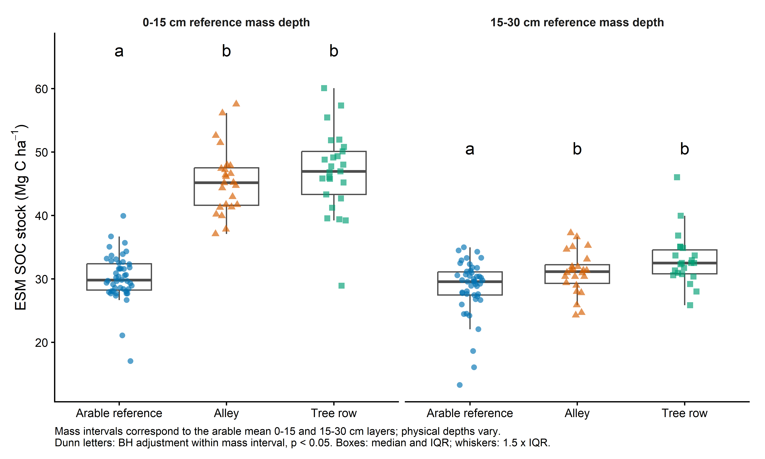
Figure 1 Corrected SOC stocks for 0 to 15 cm and 15 to 30 cm reference mass depths. These labels identify arable reference depths; physical sampling depths differ among profiles. Letters compare locations within each mass interval. Boxes show median and IQR; whiskers use 1.5 times IQR; points are profile estimates.

Supplementary measured soil properties
Land cover | Profiles | BD g/cm3 | SOC content %
Arable reference | 46 | 1.265 (0.129) b | 1.591 (0.151) a
Alley | 24 | 1.251 (0.167) b | 2.111 (0.196) b
Tree row | 22 | 1.108 (0.155) a | 2.241 (0.315) b

Mean (SD) across complete measured 0 to 30 cm profiles. BD uses soil-mass weighting within profiles; SOC content uses an unweighted layer average. Letters compare land covers separately within each property (Dunn, BH-adjusted p < 0.05); shared letters indicate no detected difference. These properties describe measured depth, not ESM reference depth.
The measured fixed-depth figure and tests are retained as soc_stock_by_depth and soc_stock_depth_dunn_BH. The original Word note is preserved in analysis_notes/_history.

Supplementary cumulative coordinate overview
Figure S1 Each facet is one alley or tree-row sampling profile. Black points are the measured cumulative endpoints joined linearly from the origin. Purple dashed segments extend the final measured layer slope. Vertical dotted lines show the two arable reference masses; blue triangles and orange squares identify ESM-corrected 0 to 15 cm and 0 to 30 cm SOC stocks. Asterisks mark shallow-bedrock profiles with upper-reference estimates only.
The standalone vector PDF provides a larger overview of all 49 profiles. Shared axes allow comparisons of sampled mass, SOC and extension length. Tree-row profiles 12, 19 and 24 have shallow bedrock and retain only their 0 to 15 cm reference-mass estimates; no lower increment or total is calculated. Arable profiles define the reference and are retained in the tabular coordinate and extrapolation audits.

Reproducible outputs
Run analysis/04_soc_stocks.R, which sources analysis/04b_soc_ESM.R and analysis/04c_soil_property_letters.R. The SOC_ESM tables contain reference masses, measured coordinates, profile estimates, summary statistics, extrapolation audits and location tests. See results/tables/soc_ESM_README.txt for calculation rules. Fixed-depth stock summaries and supplementary BD and SOC-content tables remain separate.

