SOC sequestration following arable conversion
  - Analysis notes for paper drafting | Updated 22 October 2026
At the arable 0-30 cm equivalent soil mass, annualised SOC excess over the arable reference is 0.408 Mg C per hectare per year for Continuous fallow alleys, 0.866 for Continuous cropping alleys and 0.658 for tree rows. These retrospective contrasts use agreed durations of 32, 19 and 32 years; they are not direct measurements of annual flux or exclusively grassland-induced accumulation.

Methods
The two study fields formed one arable field before silvoarable establishment in 1992. Continuous fallow alleys have remained grassland since 1992. The final crop in Continuous cropping alleys was planted in autumn 2003 and harvested in August 2004; these alleys have remained grassland since cessation. Soil sampling took place in 2024. The adjacent reference remained arable. Durations of 32 years for Continuous fallow, 19 for Continuous cropping and 32 for tree rows were specified by the user; they are fixed analysis conventions, not exact dated exposure estimates.
Input: data/raw/study_site_soil_2024.csv, with full-precision company fine bulk density and SOC, permanent core IDs and corrected location labels. Select 2_alley with former_treatment_code F or C, all 1_tree cores pooled across former treatments, and 3_arable as reference. Exclude Alternate cropping alleys from this calculation. Retain former-treatment identifiers for tree profiles in the profile output. Tree rows are pooled by available complete core, not equally weighted by former treatment.
Layer soil mass = fine BD (g/cm3) times thickness (cm) times 100; layer SOC stock = soil mass times SOC percentage / 100. The reference is the sum of mean arable 0-15 cm mass (1775.327819 Mg/ha, n = 48) and 15-30 cm mass (1957.915887 Mg/ha, n = 47): 3733.243706 Mg soil/ha. All locations, including individual arable profiles, are evaluated at this same mass.
Join the origin and measured cumulative soil-mass/SOC endpoints linearly. Interpolate inside measured mass; if a complete profile falls short of reference mass, extend its final segment using the measured 15-30 cm SOC concentration. No spline, extra coarse-fragment or organic-matter subtraction is applied. Upper-only profiles receive no total-reference estimate. This retains the existing stock-analysis ESM convention; extrapolations are explicit below.

Calculated results
Group | n | ESM stock | Excess | Years | Annualised excess
Arable reference | 47 | 59.14 | 0.00 | - | 0 reference
Alley - Continuous fallow | 8 | 72.20 | 13.06 | 32 | 0.408
Alley - Continuous cropping | 8 | 75.60 | 16.45 | 19 | 0.866
Tree rows | 21 | 80.19 | 21.05 | 32 | 0.658

Stocks and excesses are Mg C per hectare; annualised excesses are Mg C per hectare per year. Arable mean = 59.144888 Mg C/ha. For each selected core: (ESM SOC - arable mean) / agreed years; average the core estimates. The arable zero is defined by the comparison, not an estimate of zero temporal change in the arable field.

Variation and extrapolation audit
Group | Stock SD | Rate SD | Extended / n | Out | Max depth cm
Arable reference | 6.03 | - | 22 / 47 | 1 | 36.7
Alley - Continuous fallow | 4.12 | 0.129 | 3 / 8 | 0 | 40.3
Alley - Continuous cropping | 5.66 | 0.298 | 5 / 8 | 0 | 37.9
Tree rows | 8.30 | 0.259 | 17 / 21 | 3 | 44.9

SD describes variation among complete cores. Rate SD is stock SD divided by duration, holding the shared arable mean fixed; it is not a confidence interval and does not propagate reference-mean, reference-mass, extrapolation or baseline uncertainty. No treatment significance tests are performed. The reference has one excluded upper-only core; tree rows have three. Both alley groups have eight complete cores.
The total reference mass corresponds to arable 0-30 cm; it does not mean each corrected profile represents a physical 0-30 cm depth. Extension uses unmeasured soil below 30 cm at an assumed constant lower-layer SOC concentration. The tree-row result is particularly dependent on extension (17 of 21 complete cores; maximum equivalent depth 44.9 cm). Full profile-specific masses, carbon extensions and equivalent depths are exported.

Discussion hypotheses
The higher annualised value for former Continuous cropping does not establish a faster grassland response. Its denominator is shorter, its sampled block differs, and trees may have affected SOC before the 2004 cessation. The 19-year contrast therefore includes any retained earlier tree effect; without a justified 2004 baseline it cannot isolate post-2004 grassland sequestration. The 32-year tree-row contrast represents pooled soil stock excess associated with this silvoarable history, not tree biomass carbon.
The arable field is a space-for-time counterfactual, not a measured 1992 or 2004 baseline. Shared original field history supports comparability but does not prove identical starting stocks or unchanged reference SOC. Excess may include avoided loss as well as accumulation. Each alley treatment is represented by one block/row band; eight cores are spatial subsamples. Pooled tree rows span three bands and retain their former-management histories. Rates are per hectare of the sampled location, not whole-system area; scenario upscaling requires area fractions.

Open decisions
Assess baseline soil information and arable-management comparability, grassland management and sensitivity to the below-30 cm extension assumption. A no-extrapolation subset can change spatial composition and should not silently replace the main estimate. Historical annualised contrasts do not establish a linear future SOC trajectory. Separate soil from biomass carbon and avoid double counting in scenarios.

Reproduction and validation
Run scripts/calculate_soc_sequestration.py, then analysis/17_soc_sequestration.R using R 4.6.0 with --vanilla. The independent calculation agrees with existing soc_ESM_profile_estimates.csv to 1e-9 Mg C/ha for all 92 complete profiles. Outputs: soc_sequestration_ESM_summary.csv, soc_sequestration_ESM_profiles.csv and soc_sequestration_reference_masses.csv in results/tables. Source measurements and existing stock-analysis outputs are unchanged.

SOC stocks and annualised excess
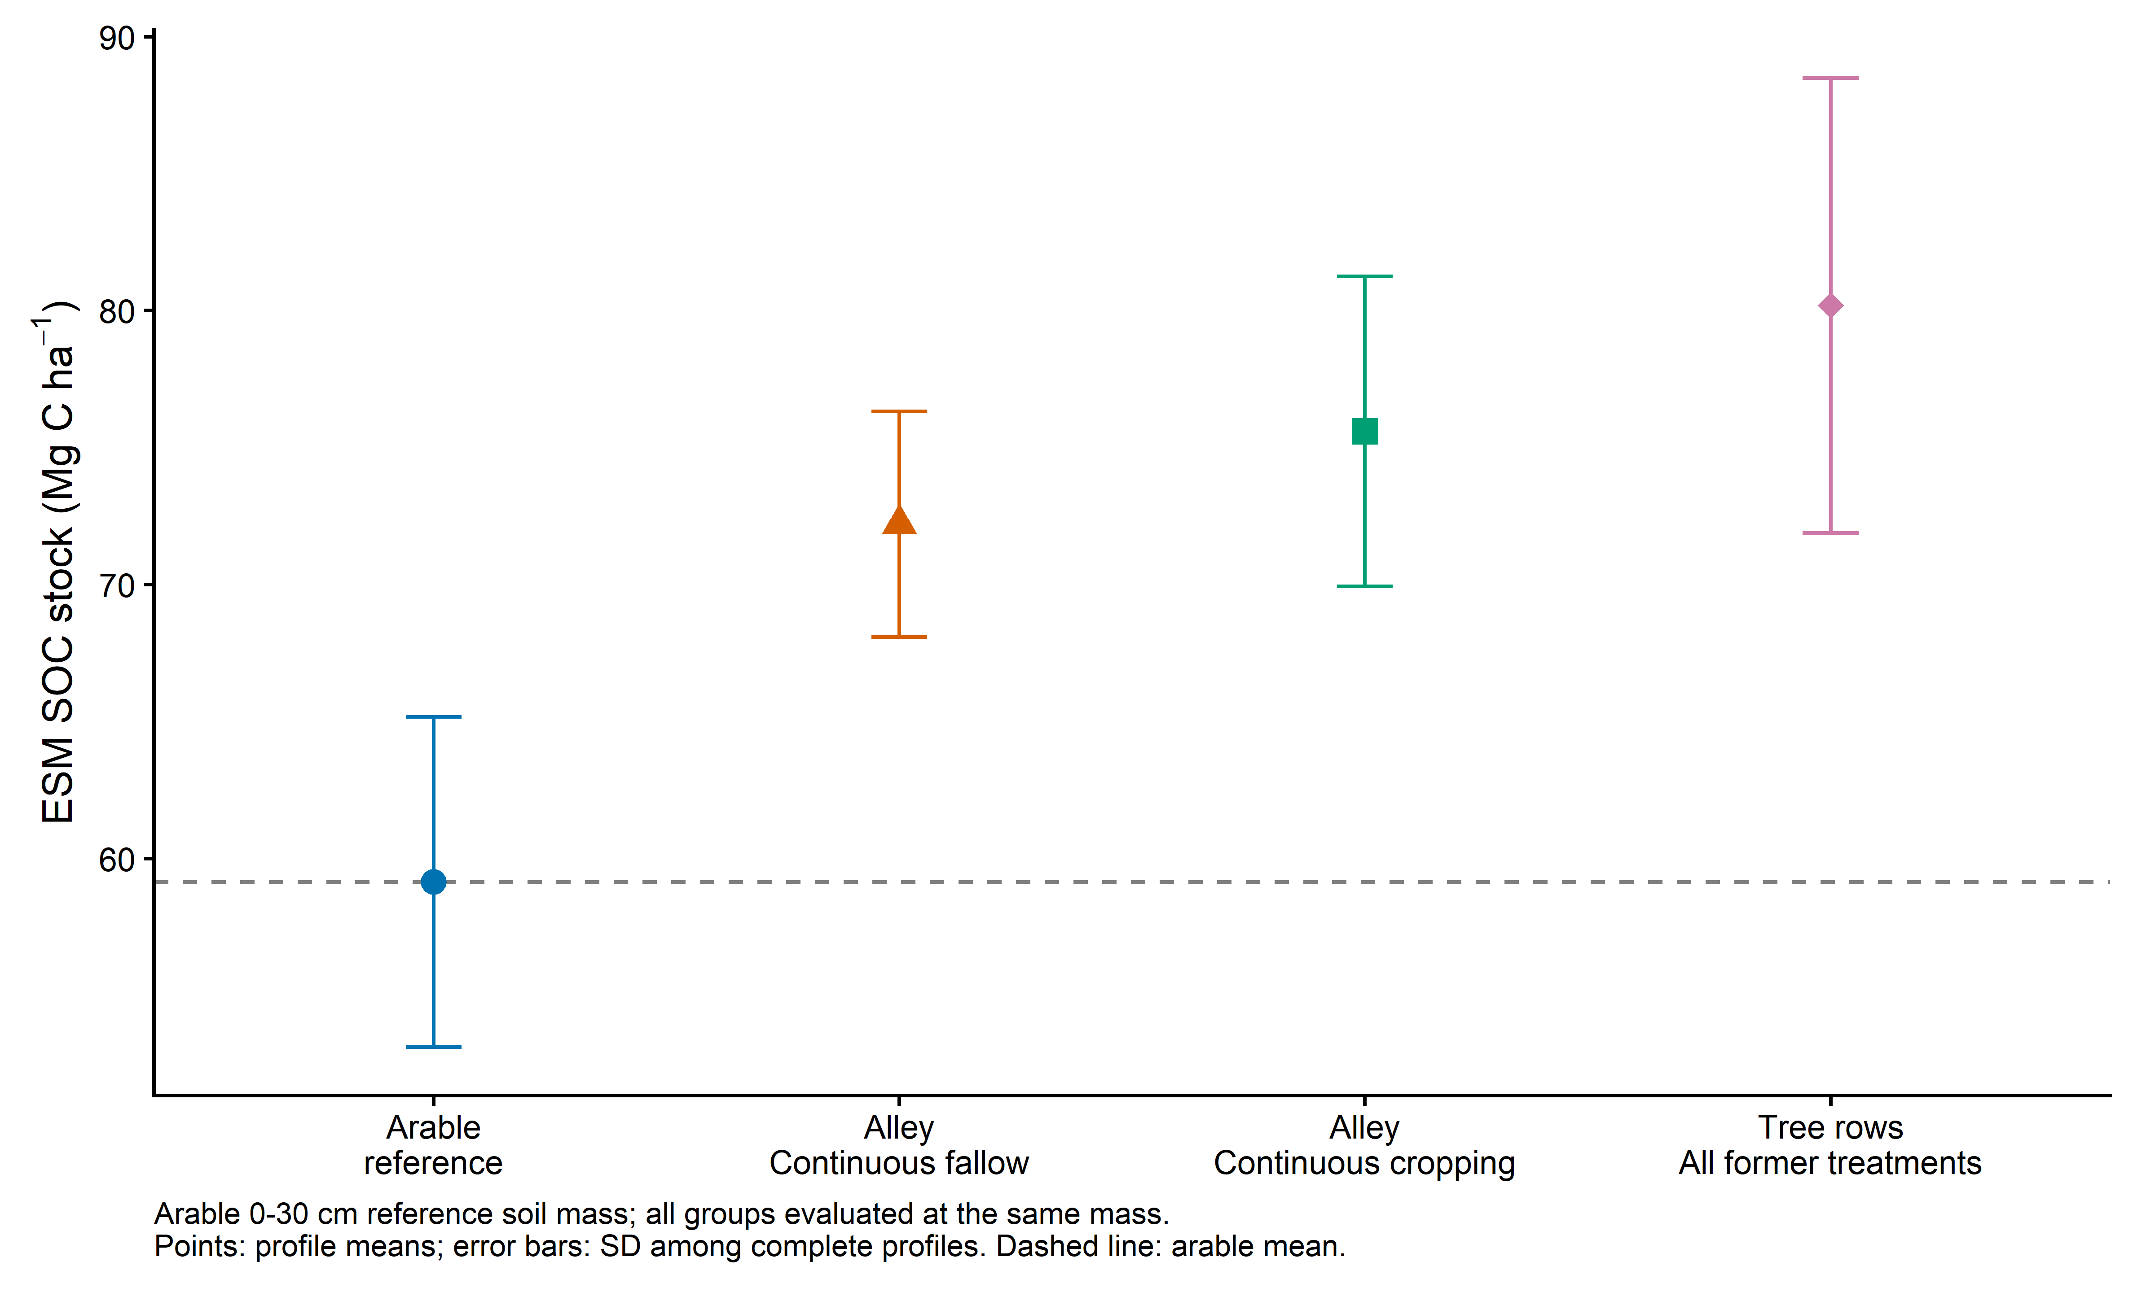
Figure 1 Mean ESM SOC stocks at the arable 0-30 cm reference mass. Error bars show profile SD; dashed line is the arable mean.
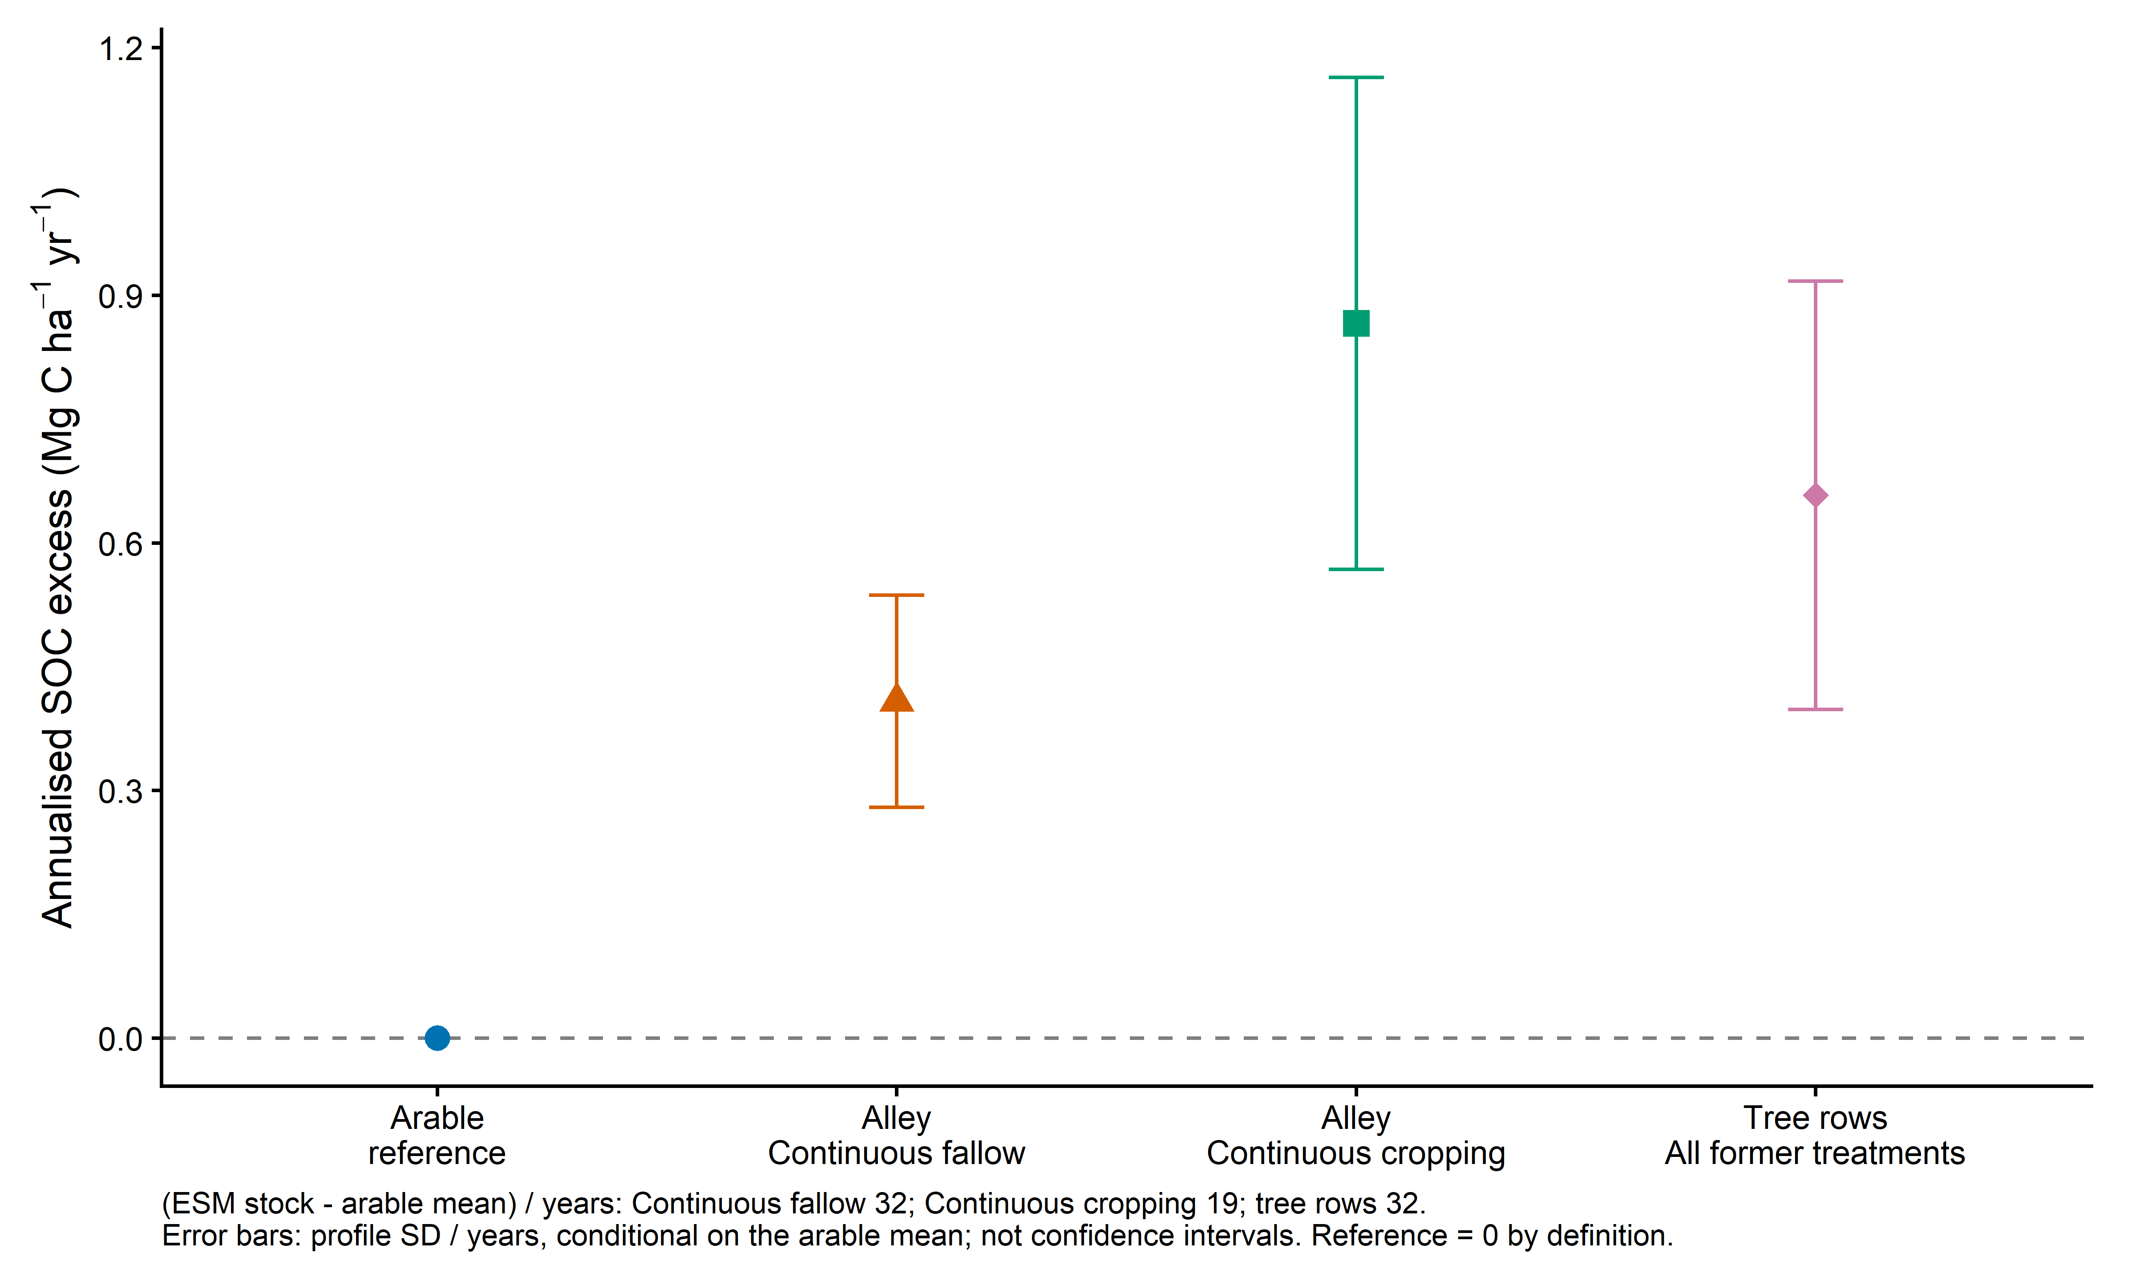
Figure 2 Annualised excess over the arable mean using 32, 19 and 32 years. Error bars show profile SD divided by years, conditional on the arable mean. Arable zero is the defined reference.

