Tree growth and carbon increment analysis
  - Analysis notes for paper drafting | Updated 23 October 2026
This note describes growth and aboveground carbon accumulation through time in the four poplar hybrids. PAIC measures recent growth over an observed interval; MAIC measures average accumulation since planting. The current figures are descriptive, and the measurement gaps require explicit interpretation.

Methods
The trees were planted in 1992. The dataset contains 180 measured trees: Beaupre, Gibecq, Robusta and Trichobel, with 45 trees per hybrid across three experimental blocks. Measurements cover the even-numbered tree rows. The recorded series spans 1993 to 2023; there are no visits in 1999, 2000, 2003 or 2004.
The main preparation retains supplied tree-level carbon stocks, PAIC and MAIC. Separate audit columns reconstruct biomass using the supplied diameter allometry, convert biomass to carbon using a fraction of 0.5, and scale to area using the configured density of 166 trees per hectare. This scaling is an assumption, not a measured whole-system carbon balance.
PAIC is the change in aboveground carbon stock divided by elapsed years between successive visits. MAIC is carbon stock divided by years since planting. Annual plots show hybrid medians and interquartile ranges across trees. These ranges describe variability and are not confidence intervals for independent experimental replicates.
For the final-visit hybrid comparison, tree values were first averaged within each row and hybrid (five trees), then equally across the three treatment rows within each block. Separate additive linear models for PAIC and MAIC included block and hybrid, using 12 block-by-hybrid means (three blocks per hybrid; residual df = 6). All six pairwise hybrid comparisons for each outcome were tested, with Holm correction across the combined family of 12 comparisons. Tests compare means; the table retains medians and quartiles to match the figure. The Gaussian models assume independent blocks and common residual variance; three blocks provide limited scope to assess those assumptions. The additional stock analysis used the same aggregation and stock ~ block + hybrid model, with Holm adjustment across its six pairwise stock comparisons as a separate follow-up family. The one missing Robusta stock value was excluded without imputation; its row mean used four trees, and all row means retained equal weight.

Main results

PAIC varied markedly among visits, whereas MAIC showed smoother changes in accumulation since planting (Figure 1). The highest observed median PAIC was 3.02 for Beaupre and 2.41 for Gibecq, both in 1998; Robusta peaked at 2.43 in 2008 and Trichobel at 3.72 in 2021 (all increments in Mg C ha⁻¹ yr⁻¹). These are maxima among observed visits, not reconstructed annual maxima during measurement gaps.
Median MAIC for Beaupre, Gibecq and Robusta reached its observed maximum in 2009 (1.52, 1.29 and 1.41, respectively), compared with 1.29, 1.09 and 1.23 in 2023. Trichobel reached its highest median MAIC at the final visit, at 2.13. By 2023, Trichobel had the highest median PAIC (2.33), compared with 0.70 for Beaupre, 0.42 for Gibecq and 0.86 for Robusta (Table 1).
Block-adjusted comparisons of 2023 means supported higher PAIC and MAIC in Trichobel than in every other hybrid (all Holm-adjusted p < 0.001). Beaupre also had higher MAIC than Gibecq (adjusted p = 0.042); the remaining pairwise differences were not significant after correction. These tests concern the final visit and do not establish significant differences at every earlier visit. The PAIC comparisons are provisional because residual diagnostics indicate unequal variance among hybrids.
Total aboveground carbon stock also differed among hybrids in 2023 (block-adjusted F₃,₆ = 135.02, p < 0.001). Trichobel had higher stock than all other hybrids (all Holm-adjusted p < 0.001). Beaupre and Robusta both exceeded Gibecq (adjusted p = 0.011 and 0.019, respectively), while Beaupre and Robusta did not differ significantly (p = 0.438). Median stocks were 65.99 for Trichobel, 40.08 for Beaupre, 38.73 for Robusta and 33.77 Mg C ha⁻¹ for Gibecq (Table 1).
Table 1 Aboveground carbon increment and stock at the 2023 visit. Values are tree-level medians [25th–75th percentiles]. PAIC and MAIC are in Mg C ha⁻¹ yr⁻¹; stock is in Mg C ha⁻¹. PAIC covers the 2022–2023 measurement interval and MAIC covers 31 years since planting.
Hybrid | PAIC | MAIC | Carbon stock
Beaupre | 0.70 [0.47–0.94]^{b} | 1.29 [1.15–1.53]^{b} | 40.08 [35.66–47.51]^{b}
Gibecq | 0.42 [0.32–0.77]^{b} | 1.09 [0.99–1.21]^{c} | 33.77 [30.74–37.40]^{c}
Robusta | 0.86 [0.63–1.14]^{b} | 1.23 [1.13–1.35]^{bc} | 38.73 [35.66–41.99]^{b}
Trichobel | 2.33 [1.60–2.78]ª | 2.13 [1.91–2.27]ª | 65.99 [59.26–70.29]ª
n = 45 trees per hybrid for PAIC and MAIC; stock n = 44 for Robusta and 45 for the other hybrids. Letters within each numeric column compare block-adjusted means: hybrids without a shared letter differ at Holm-adjusted p < 0.05. The increment comparisons use a family of 12 tests; the additional stock comparisons use a separate family of six. Shared letters indicate insufficient evidence of a difference. PAIC letters are provisional because of unequal residual spread.

Measurement gaps and interpretation
The 2001 PAIC averages the 1998 to 2001 measurement interval, corresponding to growth years 1998 to 2000 under the adopted convention. Missing visits do not mechanically lower annualised PAIC: dividing by elapsed time already accounts for duration. The gap prevents identification of which individual years contributed to the low average and can smooth annual extremes. The 2005 PAIC similarly covers growth years 2002 to 2004.
Recalculation confirms the dip: mean PAIC across available tree records is approximately 2.65 at the 1998 visit, 0.89 at the 2001 visit and 1.77 at the 2002 visit. The supplied and stock-derived values agree closely at these visits. The cause of the slowdown remains unresolved.
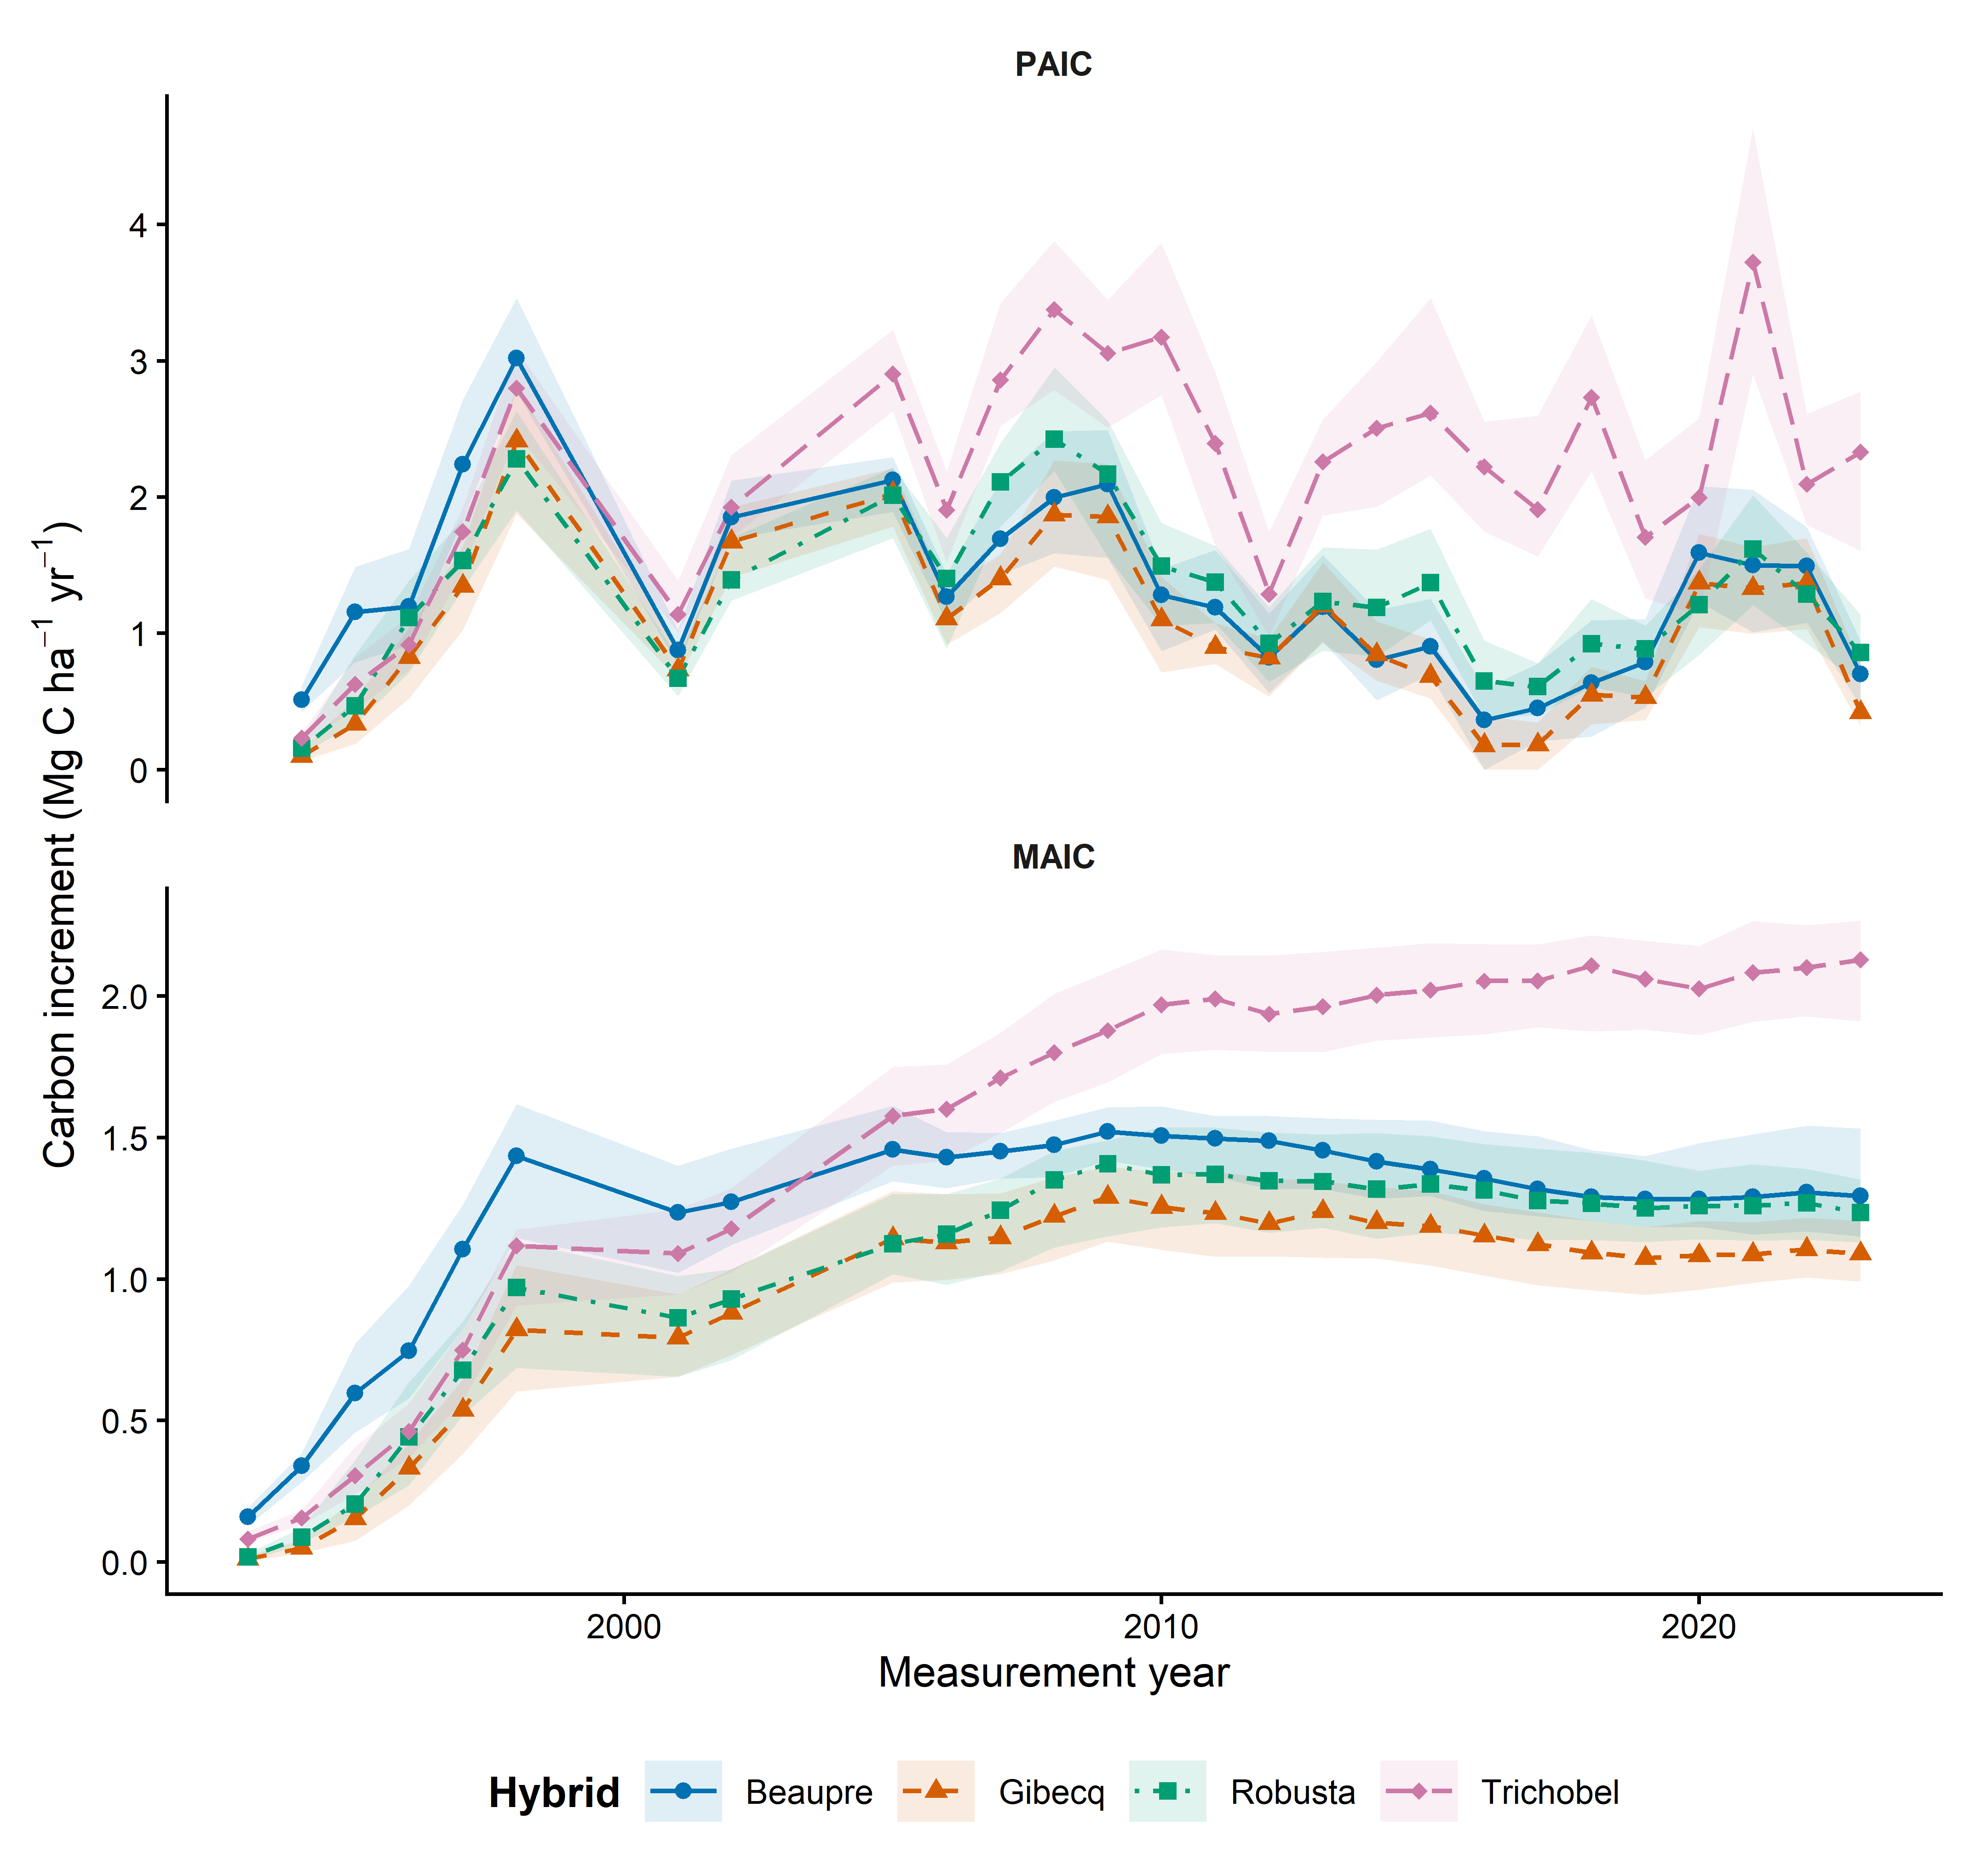
Figure 1 PAIC is periodic annual carbon increment and MAIC is mean annual carbon increment. Symbols and lines identify hybrid medians; shaded ribbons span the 25th to 75th percentiles across trees. The panels use separate vertical scales. PAIC is annualised over the interval between measurements; the 2001 observation therefore averages growth years 1998 to 2000. Lines connect observed visits; missing years are not imputed.

Discussion and decisions still needed
Use PAIC to discuss recent growth and MAIC or stock to discuss accumulated carbon. The 2023 tests use only three block replicates, so smaller hybrid contrasts remain uncertain. A row-level sensitivity analysis also supports all Trichobel contrasts and the Beaupre–Gibecq MAIC contrast, but additionally identifies Robusta–Gibecq differences; those additional comparisons are therefore sensitive to the replication assumption. The tests do not incorporate allometric uncertainty or establish differences across the full time series. The supplied Robusta 2023 MAIC is retained even though one stock value is missing; metric-specific sample sizes are reported. Stock comparisons gave the same significance pattern in the row-level sensitivity analysis. Stock and MAIC represent closely related quantities, so these are not independent lines of evidence; different missingness and multiplicity families can produce different significance patterns. Residual diagnostics for all three outcomes showed no obvious major normality problems. MAIC and stock showed no clear variance concerns, but PAIC residual spread differed among hybrids and its largest Cook distance was 0.699. Its constant-variance assumption is questionable, so PAIC significance results remain provisional pending a sensitivity analysis addressing unequal variance. The row-level sensitivity uses the same variance assumption and does not resolve this concern. With only three blocks, diagnostics cannot establish that assumptions hold.

Files supporting this note
analysis/01_growth_descriptive.R
results/tables/growth_by_year_hybrid.csv
results/checks/tree_response_audit.csv
results/checks/response_comparison.csv
scripts/calc-descriptives.r
results/tables/growth_2023_descriptive.csv
results/tables/growth_2023_hybrid_contrasts.csv
results/tables/growth_2023_row_sensitivity.csv
scripts/test_growth_2023_stock.R
results/tables/growth_2023_stock_contrasts.csv

Descriptions for additional figure exports

paic shared fluctuations
Descriptive comparison of hybrid PAIC on common positive-response measurement years. Panel A shows observed tree-level hybrid medians as thin lines and symbols and separate quadratic trends fitted to log PAIC as thick lines. Panel B shows log-scale residuals divided by the within-hybrid residual standard deviation; zero denotes the fitted trend. Panel C gives Pearson correlations of those standardised departures. Panel D divides Trichobel PAIC by the geometric mean for Beaupre, Gibecq and Robusta; the dashed line at one denotes equal PAIC. No shared year effect is removed. Lines connect observed visits without imputing missing years. Correlations do not establish weather causation; sensitivity analyses use linear detrending and the legacy response series.
Figure file: results/figures/paic_shared_fluctuations.png

trichobel relative paic
Observed tree-level median PAIC for Trichobel divided by the geometric mean of Beaupre, Gibecq and Robusta at each measurement visit. The dashed line at one indicates equal PAIC. Symbols are observed ratios and lines connect visits without imputing missing years. The ratio is descriptive and does not adjust for age or quantify uncertainty.
Figure file: results/figures/trichobel_relative_paic.png

