Weather associations with observed PAIC
  - Current analysis for paper drafting | 23 October 2026
Eight biological hypotheses were compared directly, without excluding weather variables by correlation strength. Summer rainfall and temperature ranked first for all four hybrids, with clearer support in Beaupre and Robusta. The age-only alternative remained more competitive for Gibecq and Trichobel. Summer weather associations remain exploratory and cannot independently explain the causal basis of hybrid performance.

Methods and data alignment
The response is original PAIC, in Mg C ha⁻¹ yr⁻¹: the median of the available tree values within each hybrid and measurement year. Beaupre, Gibecq, Robusta and Trichobel are analysed separately. These summaries pool the sampled cropping treatments; the weather analysis does not estimate treatment effects. PAIC is neither standardised nor detrended before screening or modelling.
The hypothesis comparison uses 24 common complete-weather measurement years from 1994 to 2023 (96 hybrid summaries). Summer associations are then estimated using all 26 years with complete summer weather (104 summaries). Weather in year t − 1 is paired with PAIC measured in year t. Hybrids share weather occasions; four summaries per year do not constitute four independent weather replicates.
PAIC is divided by the years between successive measurements. This accounts for interval duration, but we do not know how growth was distributed among missing years. A multi-year PAIC value is still paired with the final growth year’s weather, following the agreed convention. For example, the 2001 PAIC averages growth years 1998–2000 and is paired with weather in 2000. This limits attribution of individual fluctuations to a particular year’s weather.

Weather variables and biological hypotheses
Candidate group | Variables examined | Biological question
Water supply | Spring and summer rainfall totals (mm) | Does water availability coincide with greater growth?
Warmth | Spring and summer mean air temperature (°C) | Does seasonal warmth coincide with greater growth?
Light | Spring and summer sunshine totals (hours) | Does light availability coincide with greater growth?
Dry conditions | Longest April–September dry spell (days) | Does sustained low rainfall coincide with reduced growth?
Frost | Spring air and ground frost days | Does frost coincide with reduced growth?

Spring means March–May and summer means June–August. A dry day has rainfall <1 mm; the dry spell is the longest consecutive run. Air and ground frost are days with minimum air and grass temperature below 0 °C, respectively. A candidate seasonal value is used only when all expected daily observations for that variable are available. No further daily weather imputation is introduced in these analyses; completeness is assessed on the prepared series.

Timing of PAIC and weather windows
The year labels identify measurements, while the weather must describe the growth that those measurements capture. Let t be the recorded measurement year and s the previous observed measurement year. Under the adopted dormant-season measurement convention, the most recent completed growth year is g = t − 1. This is an alignment of growth and weather, not evidence of a delayed one-year physiological response to weather.
PAIC recorded at t represents the annualised carbon-stock increment over the interval from s to t: PAICₜ = (Cₜ − Cₛ)/(t − s). For consecutive annual visits, s = t − 1. After a measurement gap, s is the last year actually observed. The weather models use supplied annualised tree-level PAIC values, summarised by hybrid medians; separately recalculated stock differences are preparation audits rather than replacements of the supplied response.
The original online discussion used a March 2002 visit as the example: the increment since the preceding annual visit mainly represents the 2001 growing season. Relevant summer weather is therefore June–August 2001. The winter preceding that growing season is December 2000–February 2001. December 2001–February 2002 is the winter after that growth season, immediately before the March 2002 visit; it is not the “previous winter” window defined in these scripts.
Weather window | Dates relative to measurement year t | Example for t = 2002
Spring | 1 March–31 May of t − 1 | 1 March–31 May 2001
Summer | 1 June–31 August of t − 1 | 1 June–31 August 2001
Autumn | 1 September–30 November of t − 1 | 1 September–30 November 2001
Previous winter | 1 December of t − 2 to the last day of February of t − 1 | 1 December 2000–28 February 2001
Winter half-year | 1 October of t − 2 to 31 March of t − 1 | 1 October 2000–31 March 2001
Summer half-year and dry-spell window | 1 April–30 September of t − 1 | 1 April–30 September 2001
All boundaries are inclusive. Winter length follows the actual calendar, including 29 February in leap growth years. A calendar-year winter made from January, February and December of the same year would mix winters on either side of the growth season; the code instead constructs continuous date ranges from daily records.
The current eight hypotheses use spring rainfall, temperature, sunshine and frost; summer rainfall, temperature and sunshine; and the April–September dry spell. Autumn, previous winter and winter-half-year variables are prepared for context but are not tested in the current eight-model comparison. April–September defines the dry-spell search interval; it does not replace June–August as the summer window. A combined previous-winter-plus-summer model and a calendar-year annual model are not part of the present analysis.

Daily aggregation and Methods wording
Rainfall (mm) and sunshine (hours) are daily sums within each window. Temperature is the mean of daily mean-air-temperature values, not an unweighted average of monthly means; summer has 92 days. Spring frost counts use daily minimum air or grass temperature below 0 °C. The dry spell is the longest run of days with rainfall <1 mm within April–September.
Every expected date and required daily value must be available. Completeness is checked on the prepared daily series; these analyses introduce no further gap-filling. The eight hypotheses use 24 identical complete-weather years. The reporting summer model uses all 26 years with complete June–August rainfall and temperature.
Measurement gaps do not change the offset. PAIC measured in 2001 averages the stock change since 1998 over three years, representing growth years 1998–2000. Weather still describes 2000, including June–August 2000 for summer; it is not averaged across the three growth years. Annualisation cannot recover growth within missing years. The final 2023 observation similarly uses summer 2022, not summer 2023.

Suggested Methods paragraph
Periodic annual carbon increment (PAIC) was assigned to the year of the later DBH measurement and annualised over the number of years since the preceding available measurement. Weather predictors were aligned with the preceding growth year (g = t − 1, where t denotes measurement year), consistent with dormant-season measurements recording growth completed in the preceding growing season. Spring predictors were summarised from 1 March to 31 May and summer predictors from 1 June to 31 August of g. Seasonal rainfall and sunshine were summed from daily records, and air temperature was averaged over daily mean values. Spring frost counts used daily minimum air or grass temperature below 0 °C; longest dry spell was calculated over 1 April–30 September of g using a daily rainfall threshold of <1 mm. Only complete daily windows were used. For multi-year measurement intervals, PAIC remained annualised over the full interval but was paired with weather from the final growth year, because the timing of growth within unmeasured years was unknown.

Timing qualification and source trail
The earlier co-author comment identifies March measurements and assumes earlier observers followed that practice; the thesis describes November–March. The tree table contains year labels, not individual visit dates. The code applies t − 1 consistently rather than correcting individual November or March visits. Describe this adopted convention without claiming that every historical visit date was individually verified.
Verified sources: scripts/config.R; scripts/prep/01_tree_growth.R and 02_weather.R; analysis/10_weather_departure_screen.R, 14_raw_paic_weather_final.R and 17_weather_hypothesis_models.R. The 2002 windows and daily summer aggregation were checked directly; dates are recorded in results/checks/weather_timing_methods_audit.csv. The earlier discussion and co-author example are in “Jyoti Code Walkthrough Thesis Analysis” (https://chatgpt.com/c/6a1ebf0c-89a8-8391-abab-ad1e97d666a1).

Comparing the weather hypotheses
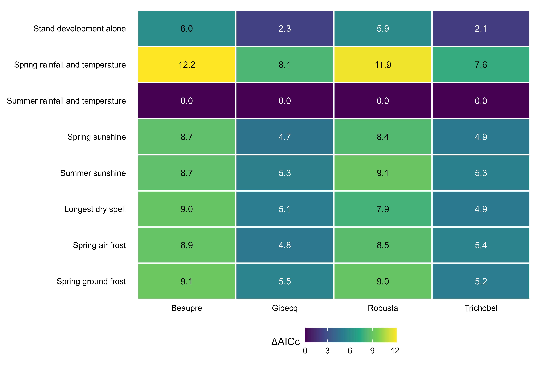
Figure 1. Eight hypothesis models fitted on the same 24 years for each hybrid, with a Gamma log link and linear and squared age. Weather terms are named in the rows. Values are AICc minus the lowest AICc within each hybrid: zero marks the top candidate; lower values indicate more support after penalising complexity. Rankings are exploratory under remaining temporal dependence and prior examination of these data.
We compared the same eight models separately for each hybrid, as defined by the rows in Figure 1. Spring and summer conditions combine rainfall and temperature; other weather models add one sunshine, dry-spell or frost predictor. Every model retains quadratic age. All nine weather candidates enter this comparison; correlations do not filter their inclusion.
Summer conditions ranked first for every hybrid. Age alone ranked second, with AICc differences of 5.98 for Beaupre, 2.30 for Gibecq, 5.85 for Robusta and 2.13 for Trichobel. Support is clearer for Beaupre and Robusta. The other weather hypotheses have differences of at least 4.67; this does not exclude environmental influences absent from the candidate set.

How the hypotheses were compared
AICc balances likelihood against the number of parameters, including Gamma dispersion. Every model uses identical responses and years. Measurement years 2001 and 2019 are excluded because of incomplete spring temperature or ground-frost records. The selected summer model then uses all 26 eligible summer years for the association plot; Figure 1 always compares 24 years.
We also omitted each of the 24 years in turn and refitted all candidates. Summer remained first in 24/24 fits for Beaupre and Robusta, 23/24 for Gibecq and 22/24 for Trichobel. These are influence checks, not independent validation. Earlier data exploration informed the hypotheses; association intervals remain conditional on the selected summer model.

Statistical approach

Allowing for stand development over time
Original positive hybrid medians are fitted with a Gamma generalised linear model and a log link. This allows variability to increase with the fitted mean and keeps fitted PAIC positive. PAIC is not transformed, standardised or detrended before fitting. Each hybrid has its own intercept, weather slopes, age trajectory and dispersion estimate.
For hybrid h and measurement year t, the combined-weather model is:
PAICₕₜ ~ Gamma with mean μₕₜ
log(μₕₜ) = αₕ + βT,ₕ Tₜ + βR,ₕ Rₜ + γ₁,ₕ Aₜ + γ₂,ₕ Aₜ²
T = summer mean temperature − 16 °C; R = (summer rainfall − 200 mm)/100; A = (age in years − 15)/10. Centring improves numerical stability. Both age and age squared are retained together; the squared term allows a curved trajectory on the log-mean scale, including a possible growth peak and subsequent decline.
The age terms allow for PAIC changes associated with stand development over time, which can coincide with changing weather. This reduces the risk that the weather terms absorb the entire long-term growth pattern. All trees were planted together, but hybrids may have different growth trajectories. Age is a proxy for these temporal processes: it does not independently identify ageing or fully remove confounding by calendar year, management or stand conditions.
The same quadratic age specification is used in all eight hypothesis models (32 fits on the common 24 years). The combined summer-weather model ranks first in each hybrid and supplies the final associations. Reporting uses all 26 complete-summer years. Its inputs and estimates were verified against the earlier fit. Model SEs and coefficient tests describe this selected model; they do not include model-selection uncertainty.

Absolute weather contrasts
Temperature is contrasted from 15.31 to 16.31 °C, holding rainfall at 172.44 mm. Rainfall is contrasted from 122.44 to 222.44 mm, holding temperature at 15.81 °C. These contrasts are centred on observed means. Predictions are averaged equally over the same 26 observed ages. Each effect is the higher-weather prediction minus the lower-weather prediction, in Mg C ha⁻¹ yr⁻¹. It describes an absolute association at comparable modelled ages, not the change from the first to the final study year.

Model standard errors
Estimates are presented with ±1 model-based standard error (SE). For the absolute PAIC differences, SEs are calculated by the delta method using the full coefficient covariance matrix. This carries uncertainty from the fitted model onto the carbon-increment scale. The whiskers show ±1 SE, not 95% confidence intervals, and should not be read as a 5% significance test.
Suggested Methods wording: “Hybrid-specific Gamma models with a log link included summer rainfall, summer temperature, age and age squared. Absolute mean PAIC contrasts were averaged over the observed ages and reported with model-based standard errors calculated by the delta method. Coefficient tests used the conventional model t tests. Standard errors and tests assume independent observations and are conditional on the selected model.”

Calculated weather associations by hybrid
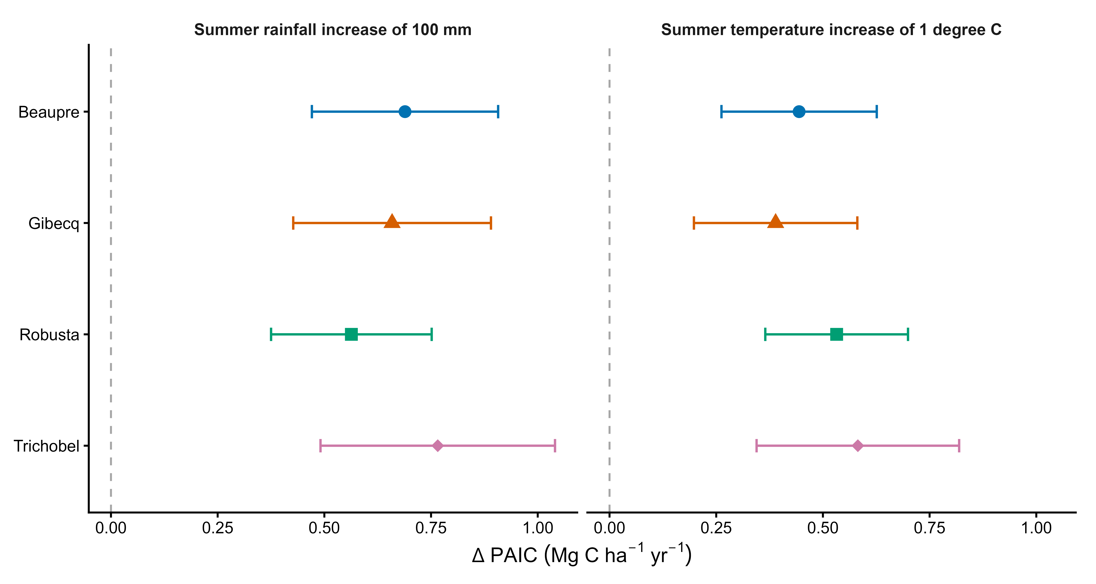
Figure 2. Separate Gamma log-link models include linear and squared age, June–August rainfall and mean temperature for each hybrid, using 26 measurement years. Rainfall is contrasted from 122.44 to 222.44 mm at 15.81 °C; temperature is contrasted from 15.31 to 16.31 °C at 172.44 mm rainfall. Differences are averaged equally over the 26 observed ages and expressed in Mg C ha⁻¹ yr⁻¹. Points show absolute mean PAIC differences; whiskers show ±1 model-based SE calculated by the delta method, not 95% confidence intervals. The dashed line marks zero. Weather describes the preceding growth year, including annualised multi-year intervals.
Hybrid | 100 mm more rainfall | 1 °C higher temperature
Beaupre | 0.69 ± 0.22 | 0.44 ± 0.18
Gibecq | 0.66 ± 0.23 | 0.39 ± 0.19
Robusta | 0.56 ± 0.19 | 0.53 ± 0.17
Trichobel | 0.77 ± 0.27 | 0.58 ± 0.24

Table 1. Absolute mean PAIC differences ±1 model-based SE (Mg C ha⁻¹ yr⁻¹). Contrasts are centred on study-average weather and averaged over the same observed ages. SEs are calculated from the full model coefficient covariance by the delta method.
Rainfall estimates are positive in all hybrids. Trichobel has the largest absolute estimate, 0.77 ± 0.27 Mg C ha⁻¹ yr⁻¹ per 100 mm, followed by Beaupre (0.69 ± 0.22), Gibecq (0.66 ± 0.23) and Robusta (0.56 ± 0.19). Conventional rainfall-coefficient p-values are 0.0020, 0.0046, 0.0052 and 0.0107 for Beaupre, Gibecq, Robusta and Trichobel, respectively.
Temperature estimates are also positive: Beaupre 0.44 ± 0.18, Gibecq 0.39 ± 0.19, Robusta 0.53 ± 0.17 and Trichobel 0.58 ± 0.24 Mg C ha⁻¹ yr⁻¹ per 1 °C. Conventional temperature-coefficient p-values are 0.0152, 0.0396, 0.0026 and 0.0222, respectively. Both weather coefficients have p < 0.05 in each hybrid under these tests. Separate within-hybrid tests do not test whether the hybrid responses differ.

Discussion and limits of interpretation

Possible biological explanation
The hypothesis comparison supports summer conditions over the other weather hypotheses considered. Support relative to age alone is clearer for Beaupre and Robusta. The reporting models associate wetter summers with greater PAIC, compatible with a role for water availability. The grouped summer-model ranking does not establish that both weather variables are individually necessary in every hybrid.
Trichobel has the largest estimated absolute association with both rainfall and temperature. This is a descriptive ranking of point estimates; the separate model tests assess each hybrid’s association with weather, not differences between hybrids. Appropriate wording is: “Trichobel showed the largest estimated absolute PAIC association with summer rainfall and temperature.” The whiskers describe uncertainty in mean associations, not variation in physiological sensitivity between years.
A larger absolute effect can partly reflect Trichobel’s higher baseline PAIC: with a log link, the same proportional association produces more additional carbon at a higher baseline. Absolute differences answer how much carbon increment differs; they do not establish greater physiological sensitivity or climate resistance. The proposed resilience mechanism remains a discussion hypothesis supported by biological expertise, not demonstrated by these models.
A positive weather association can coexist with declining PAIC through time. Observed growth reflects the actual combination of weather, age, stand development and management. Quadratic age allows a curved background trajectory, but age and calendar year advance together in this single cohort. The age terms may absorb weather-related trends as well as unrelated development, so they do not fully separate those processes.

Uncertainty and diagnostic caveats
Weather refers to the growth year preceding measurement; annualisation cannot identify growth timing in missing years. AICc comparison uses 24 shared weather occasions, while final summer estimation uses 26. Reusing observations for selection and estimation makes the results exploratory rather than independent confirmation.
In the 26-year reporting summer models, consecutive-calendar-year residual correlations are approximately 0.35, 0.56, 0.29 and 0.00 for Beaupre, Gibecq, Robusta and Trichobel. The models assume independent observations; remaining temporal dependence may make conventional SEs and p-values optimistic. Results are therefore presented as exploratory associations.
Residual, Gamma quantile, variance-pattern and influence plots were inspected. There is some residual temporal structure, variation in residual spread and influential observations; year-omission checks are retained. Diagnostic plots and summaries are saved with the analysis. These checks do not establish that all model assumptions hold.

Presentation in the paper
Use Figure 1 to show the hypothesis comparison and Figure 2 for the conditional summer-weather associations. Explain that comparison uses 24 common years and the reporting summer models use all 26 eligible summer years. Figure S1 explains the fitted background age patterns at fixed weather; it is optional supporting material rather than a required main-paper result. Retain the age–time confounding, model-selection and temporal-dependence caveats.

Supplementary age trajectories and model fit
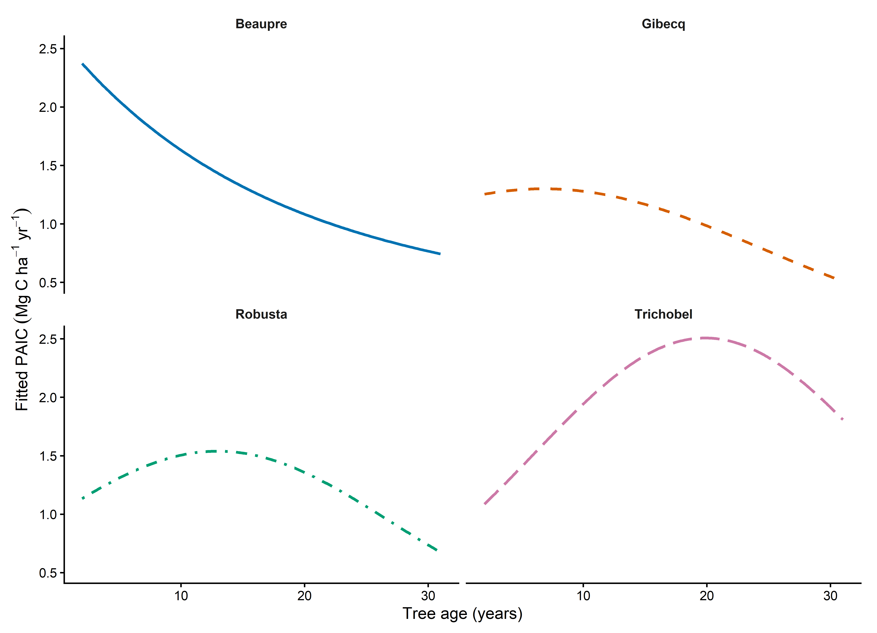
Figure S1. The curves are Gamma log-link fitted means with hybrid-specific linear and squared age terms, holding June to August mean temperature at 15.81 degrees C and rainfall at 172.44 mm. Only the observed age range is shown. Uncertainty bands are omitted. These curves describe conditional fitted shapes, not observed trajectories or independently identified causal effects of age.
The curves show the smooth background PAIC pattern after accounting for summer weather. They are drawn by varying age across its observed range while holding rainfall and temperature at their averages, so individual wet, dry, warm or cool years do not make the curves fluctuate.
Beaupre shows a gradual decline. Gibecq is fairly flat initially, then declines. Robusta rises to a broad peak before declining. Trichobel rises more strongly to a later peak, then declines. These are fitted background patterns during this study.
PAIC is annual carbon addition: declining PAIC means less carbon added each year, not necessarily carbon loss. Age also tracks calendar time, competition and management; the curves do not isolate biological ageing. This plot is optional working material for interpreting the model.
Hybrid | Combined model  pseudo R² | Weather deviance reduction  against quadratic age alone
Beaupre | 0.500 | 41.9%
Gibecq | 0.386 | 32.1%
Robusta | 0.526 | 41.6%
Trichobel | 0.595 | 32.3%

Table S1. These summaries describe the 26-year reporting summer models. Pseudo-R² = 1 − combined-model deviance / intercept-only deviance describes age and weather together. The last column compares that model with quadratic age alone; it is not a causal share of raw PAIC variance explained. The eight-hypothesis AICc comparison is calculated separately on 24 identical years, as shown in Figure 1.

