Weather associations with observed PAIC
  - Current analysis for paper drafting | 23 October 2026
Eight biological hypotheses were compared directly, without excluding weather variables by correlation strength. Summer rainfall and temperature ranked first for all four hybrids, with clearer support in Beaupre and Robusta. The age-only alternative remained more competitive for Gibecq and Trichobel. Summer weather associations remain exploratory and cannot independently explain the causal basis of hybrid performance.

Methods and data alignment
The response is original PAIC, in Mg C ha⁻¹ yr⁻¹: the median of the available tree values within each hybrid and measurement year. Beaupre, Gibecq, Robusta and Trichobel are analysed separately. These summaries pool the sampled cropping treatments; the weather analysis does not estimate treatment effects. PAIC is neither standardised nor detrended before screening or modelling.
The hypothesis comparison uses 24 common complete-weather measurement years from 1994 to 2023 (96 hybrid summaries). Summer associations are then estimated using all 26 years with complete summer weather (104 summaries). Weather in year t − 1 is paired with PAIC measured in year t. Hybrids share weather occasions; four summaries per year do not constitute four independent weather replicates.
PAIC is divided by the years between successive measurements. This accounts for interval duration, but we do not know how growth was distributed among missing years. A multi-year PAIC value is still paired with the final growth year’s weather, following the agreed convention. For example, the 2001 PAIC averages growth years 1998–2000 and is paired with weather in 2000. This limits attribution of individual fluctuations to a particular year’s weather.

Weather variables and biological hypotheses
Candidate group | Variables examined | Biological question
Water supply | Spring and summer rainfall totals (mm) | Does water availability coincide with greater growth?
Warmth | Spring and summer mean air temperature (°C) | Does seasonal warmth coincide with greater growth?
Light | Spring and summer sunshine totals (hours) | Does light availability coincide with greater growth?
Dry conditions | Longest April–September dry spell (days) | Does sustained low rainfall coincide with reduced growth?
Frost | Spring air and ground frost days | Does frost coincide with reduced growth?

Spring means March–May and summer means June–August. A dry day has rainfall <1 mm; the dry spell is the longest consecutive run. Air and ground frost are days with minimum air and grass temperature below 0 °C, respectively. A candidate seasonal value is used only when all expected daily observations for that variable are available. No missing daily weather is imputed.

Comparing the weather hypotheses
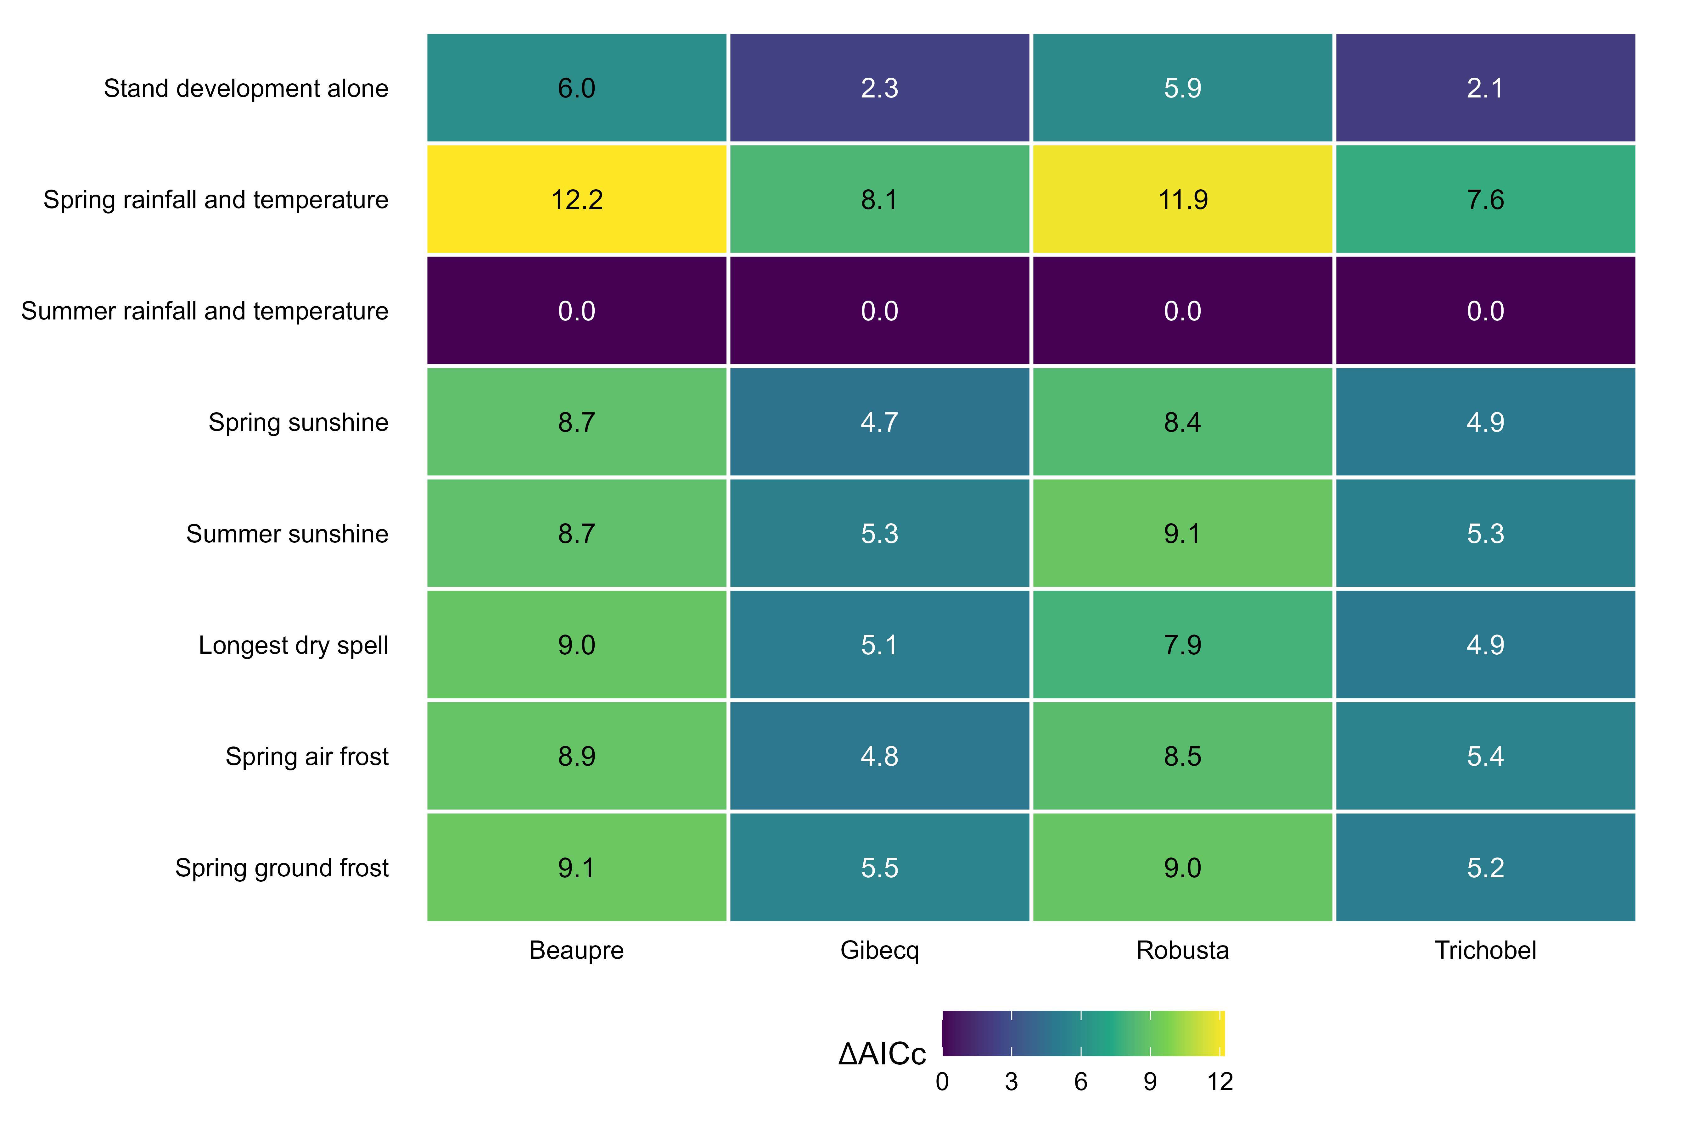
Figure 1. Comparison of eight hypothesis models on the same 24 measurement years for each hybrid. All models use a Gamma log link and include linear and squared age; weather terms are specified by the row labels. Values are AICc minus the lowest AICc within each hybrid, so zero marks the top candidate and lower values indicate more support after penalising complexity. The dark summer-conditions row ranks first in all four hybrids. Rankings are exploratory because temporal dependence remains and hypotheses were informed by earlier examination of the data.
We compared the same eight models separately for each hybrid: quadratic age alone; spring rainfall and temperature; summer rainfall and temperature; spring sunshine; summer sunshine; longest April–September dry spell; spring air frost; and spring ground frost. Every weather model retains quadratic age. Correlations are descriptive background, not a filter determining which hypotheses enter this comparison.
Summer conditions ranked first for every hybrid. The second-ranked candidate was age alone, with AICc differences of 5.98 for Beaupre, 2.30 for Gibecq, 5.85 for Robusta and 2.13 for Trichobel. Support is therefore clearer for Beaupre and Robusta. The other weather hypotheses have AICc differences of at least 4.67. This compares the stated candidate set; it does not demonstrate the absence of other environmental influences.

How the hypotheses were compared
AICc balances fitted likelihood against the number of estimated parameters, including Gamma dispersion. All models use identical responses and years. Measurement years 2001 and 2019 are excluded from this comparison because of incomplete spring temperature or ground-frost records. This avoids giving different hypotheses different weather-year samples. The summer model is subsequently fitted on all 26 eligible summer years for the association plot; comparisons in Figure 1 always use 24 years.
We also omitted each of the 24 years in turn, refitted all candidates and checked the ranking. Summer conditions remained first in 24/24 fits for Beaupre and Robusta, 23/24 for Gibecq and 22/24 for Trichobel. These are influence checks, not independent validation. Hypotheses were informed by earlier exploration of this dataset, so the analysis remains exploratory and the association intervals are conditional on the selected summer model.

Statistical approach

Allowing for stand development over time
Original positive hybrid medians are fitted with a Gamma generalised linear model and a log link. This allows variability to increase with the fitted mean and keeps fitted PAIC positive. PAIC is not transformed, standardised or detrended before fitting. Each hybrid has its own intercept, weather slopes, age trajectory and dispersion estimate.
For hybrid h and measurement year t, the combined-weather model is:
PAICₕₜ ~ Gamma with mean μₕₜ
log(μₕₜ) = αₕ + βT,ₕ Tₜ + βR,ₕ Rₜ + γ₁,ₕ Aₜ + γ₂,ₕ Aₜ²
T = summer mean temperature − 16 °C; R = (summer rainfall − 200 mm)/100; A = (age in years − 15)/10. Centring improves numerical stability. Both age and age squared are retained together; the squared term allows a curved trajectory on the log-mean scale, including a possible growth peak and subsequent decline.
The age terms allow for PAIC changes associated with stand development over time, which can coincide with changing weather. This reduces the risk that the weather terms absorb the entire long-term growth pattern. All trees were planted together, but hybrids may have different growth trajectories. Age is a proxy for these temporal processes: it does not independently identify ageing or fully remove confounding by calendar year, management or stand conditions.
The same quadratic age specification is used in all eight hypothesis models (32 fits on the common 24 years). The combined summer-weather model ranks first in each hybrid and supplies the final associations. Its existing 26-year fit is retained after verifying that its PAIC and common-year summer weather inputs match the current data. The 26-year coefficient intervals describe that fitted model and do not include model-selection uncertainty; they are not model-averaged estimates.

Absolute weather contrasts
Temperature is contrasted from 15.31 to 16.31 °C, holding rainfall at 172.44 mm. Rainfall is contrasted from 122.44 to 222.44 mm, holding temperature at 15.81 °C. These contrasts are centred on observed means. Predictions are averaged equally over the same 26 observed ages. Each effect is the higher-weather prediction minus the lower-weather prediction, in Mg C ha⁻¹ yr⁻¹. It describes an absolute association at comparable modelled ages, not the change from the first to the final study year.

What the dots and whiskers mean
Dots are estimated mean PAIC differences for the stated weather contrasts. Whiskers show uncertainty in those estimates. We generated 1,000 alternative datasets by resampling blocks of three successive observed visits. All four hybrids and their weather move together. We refit the four hybrid models and recalculate the contrasts for each resample. The middle 95% of these values gives a pointwise percentile interval.
Hybrid differences are calculated directly within each resample, preserving their pairing. A wider whisker means the mean association is less precisely estimated; it does not measure year-to-year variability in physiological sensitivity. The models do not estimate separate weather slopes for individual years. Blocks wrap across the record ends and cover three visits, not necessarily three calendar years. Intervals are exploratory, not simultaneous, and omit variable-selection, allometric and weather measurement uncertainty.

Calculated weather associations by hybrid
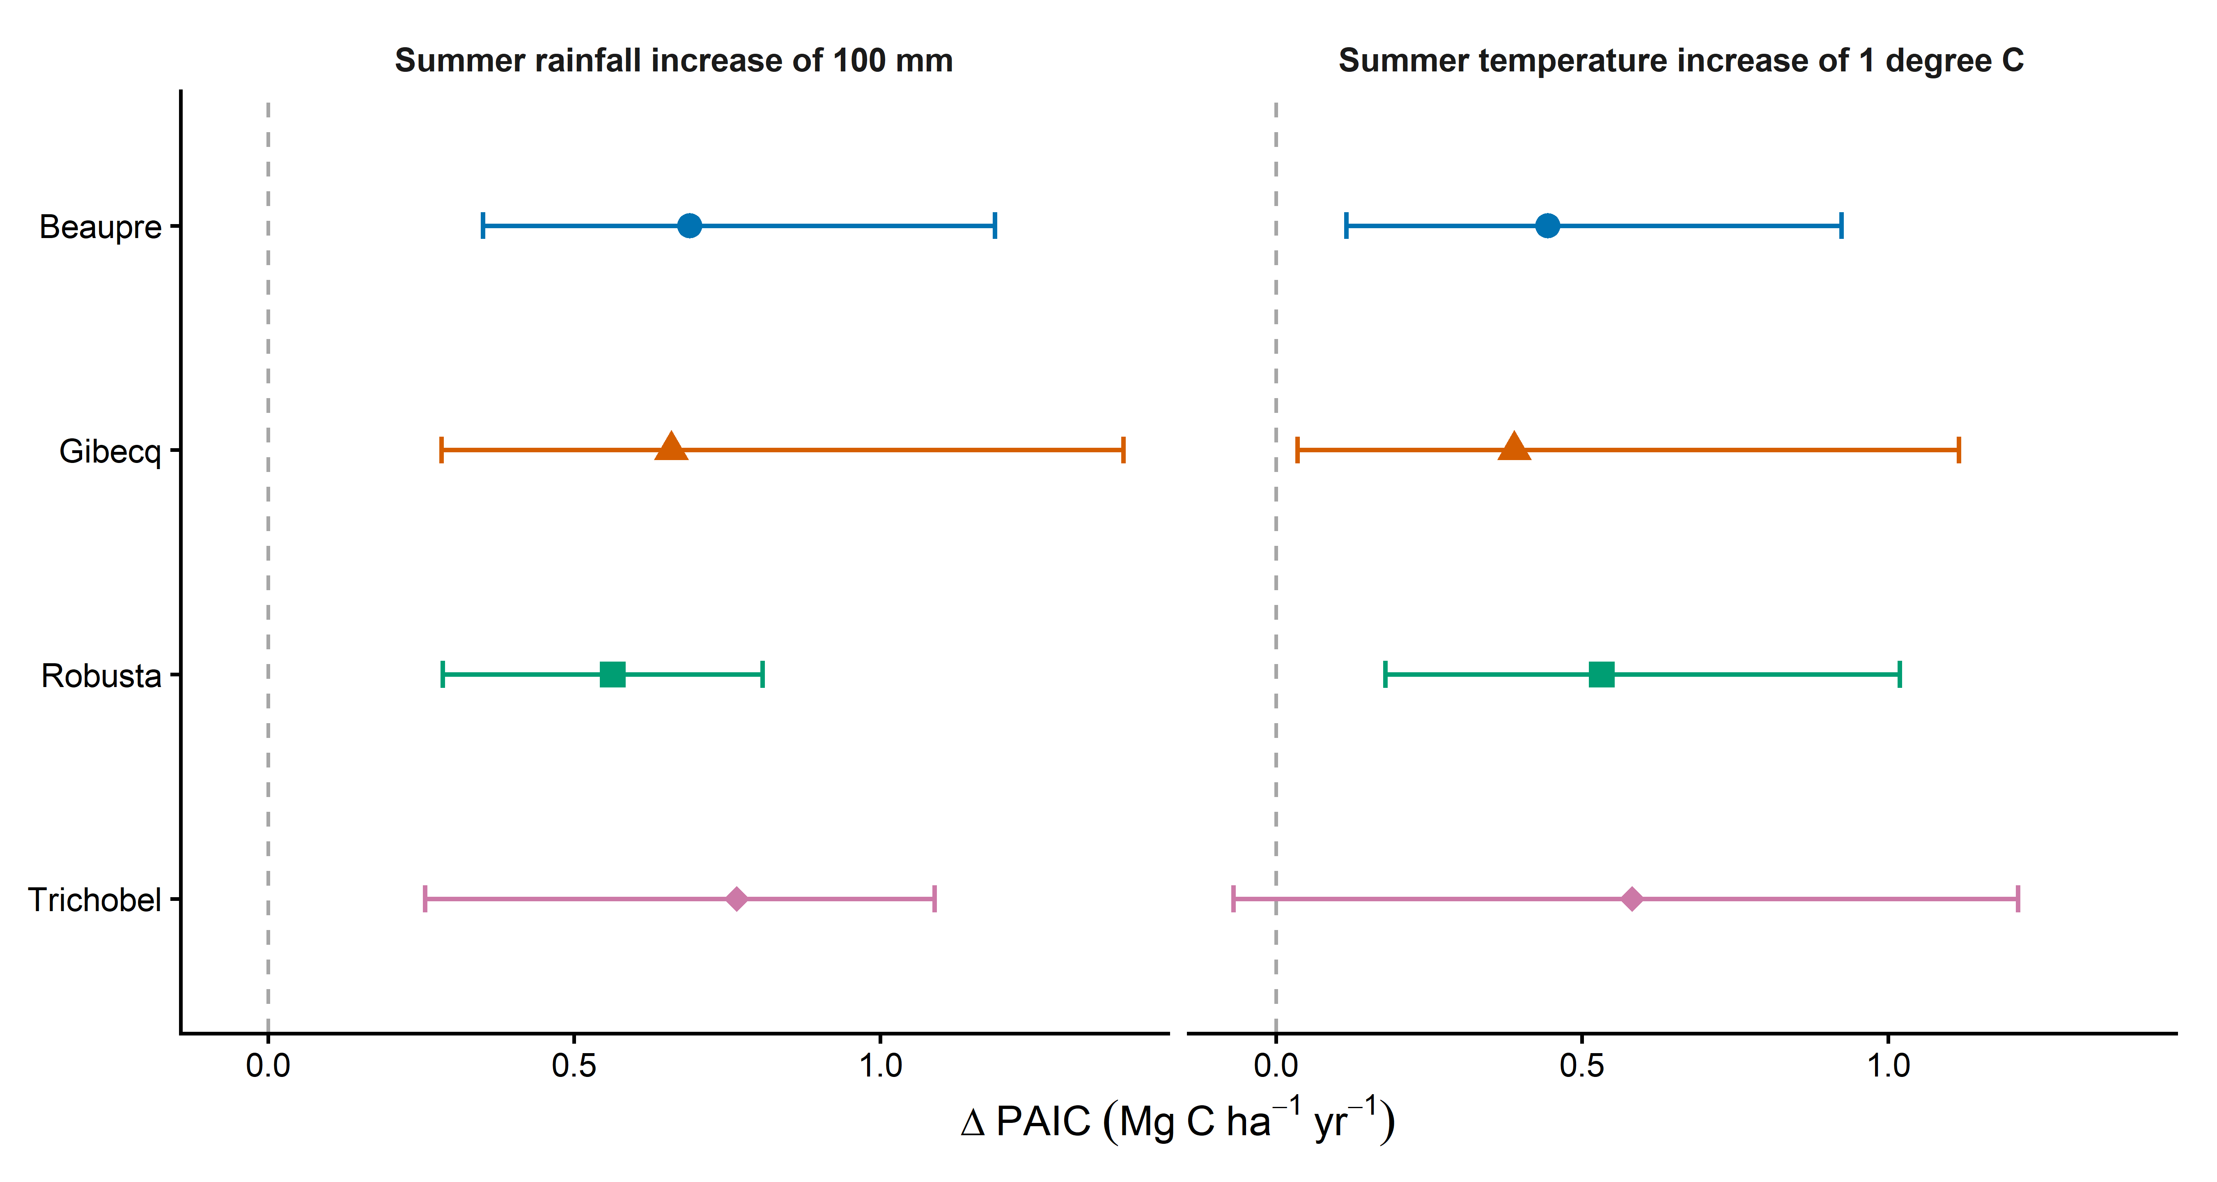
Figure 2. Separate Gamma models with a log link include linear and squared age, June to August rainfall and June to August mean temperature for each hybrid, using 26 measurement years. Rainfall is contrasted from 122.44 to 222.44 mm while temperature is held at 15.81 degrees C; temperature is contrasted from 15.31 to 16.31 degrees C while rainfall is held at 172.44 mm. Differences are averaged equally over the same 26 observed ages and expressed in Mg C per hectare per year. Whiskers are pointwise 95% intervals from 1,000 paired circular three-visit block-bootstrap resamples; they describe uncertainty in mean associations, not annual variability. The dashed vertical line marks zero association. Weather is aligned to the preceding growth year, including annualised multi-year growth intervals.
Hybrid | 100 mm more rainfall | 1 °C higher temperature
Beaupre | 0.69 (0.35, 1.19) | 0.44 (0.11, 0.92)
Gibecq | 0.66 (0.28, 1.40) | 0.39 (0.03, 1.12)
Robusta | 0.56 (0.29, 0.81) | 0.53 (0.18, 1.02)
Trichobel | 0.77 (0.26, 1.09) | 0.58 (-0.07, 1.21)

Table 1. Absolute mean PAIC differences (Mg C ha⁻¹ yr⁻¹) and pointwise 95% intervals from the combined-weather models. Contrasts are centred on mean weather and averaged over common observed ages. An interval extending below zero allows a negative association; fitted PAIC itself remains positive.
Rainfall estimates are positive in all hybrids, and their intervals are above zero. Trichobel has the largest point estimate, 0.77 Mg C ha⁻¹ yr⁻¹ per 100 mm, followed by Beaupre (0.69), Gibecq (0.66) and Robusta (0.56). Direct paired comparisons do not clearly distinguish the hybrid effects: all their pointwise 95% intervals include zero.
Temperature estimates are also positive. Trichobel has the largest point estimate, 0.58 Mg C ha⁻¹ yr⁻¹ per 1 °C, but its interval is broad and includes zero (−0.07 to 1.21). The other estimates are 0.44 for Beaupre, 0.39 for Gibecq and 0.53 for Robusta. None of the paired temperature differences between hybrids has an interval wholly above or below zero. The results therefore do not establish that Trichobel is either more or less temperature-sensitive than the others.

Discussion and limits of interpretation

Possible biological explanation
The hypothesis comparison supports summer conditions over the alternative weather hypotheses considered here. Support relative to age alone is clearer for Beaupre and Robusta; Gibecq and Trichobel have more model uncertainty. In the reporting summer models, wetter summers are associated with greater PAIC in all hybrids, compatible with a role for summer water availability. The combined model ranking does not establish that each of rainfall and temperature is individually necessary in every hybrid.
Trichobel has the largest estimated absolute association with both rainfall and temperature. However, its temperature association is less precisely estimated, and direct comparisons do not establish that its weather responses differ from those of the other hybrids. Appropriate wording is: “Trichobel showed the largest estimated absolute PAIC response to increased summer rainfall, although differences between hybrids were uncertain.” Avoid describing the whiskers as evidence that its response varied more between years.
A larger absolute effect can partly reflect Trichobel’s higher baseline PAIC: with a log link, the same proportional association produces more additional carbon at a higher baseline. Absolute differences answer how much carbon increment differs; they do not establish greater physiological sensitivity or climate resistance. The proposed resilience mechanism remains a discussion hypothesis supported by biological expertise, not demonstrated by these models.
A positive weather association can coexist with declining PAIC through time. Observed growth reflects the actual combination of weather, age, stand development and management. Quadratic age allows a curved background trajectory, but age and calendar year advance together in this single cohort. The age terms may absorb weather-related trends as well as unrelated development, so they do not fully separate those processes.

Uncertainty and diagnostic caveats
Weather refers to the growth year preceding measurement; annualisation cannot identify growth timing in missing years. The hypothesis comparison has 24 shared weather occasions, while the final summer fit has 26. These samples are distinct: AICc is compared only within the common 24-year set. Reusing these observations for selection and estimation makes the results exploratory rather than an independent confirmation.
In the 24-year summer models, correlations of deviance residuals between consecutive calendar years are approximately 0.50, 0.63, 0.38 and 0.02 for Beaupre, Gibecq, Robusta and Trichobel. Temporal dependence is therefore not resolved by the selected mean model. AICc assumes independent errors and its rankings should be treated as approximate; an independent-error AICc win is not a complete model validation. The three-visit bootstrap accommodates some dependence but its block length is not established as sufficient.
All 4,000 bootstrap model fits converged. Nevertheless, some resamples produced very large absolute effects when evaluated across the full reference age range. For affected hybrid–predictor combinations, 1–8 of 1,000 resamples exceeded an absolute difference of 10 Mg C ha⁻¹ yr⁻¹. These values were retained. The central percentile intervals are finite, but the tails indicate unstable extrapolation in some resamples and reinforce the exploratory interpretation. Individual-year omission results and tail checks are saved.

Presentation in the paper
Use Figure 1 to show the hypothesis comparison and Figure 2 for the conditional summer-weather associations. Explain that comparison uses 24 common years and the reporting summer models use all 26 eligible summer years. Figure S1 shows the fitted quadratic age shapes at fixed weather. Retain the age–time confounding, model-selection and temporal-dependence caveats.

Supplementary age trajectories and model fit
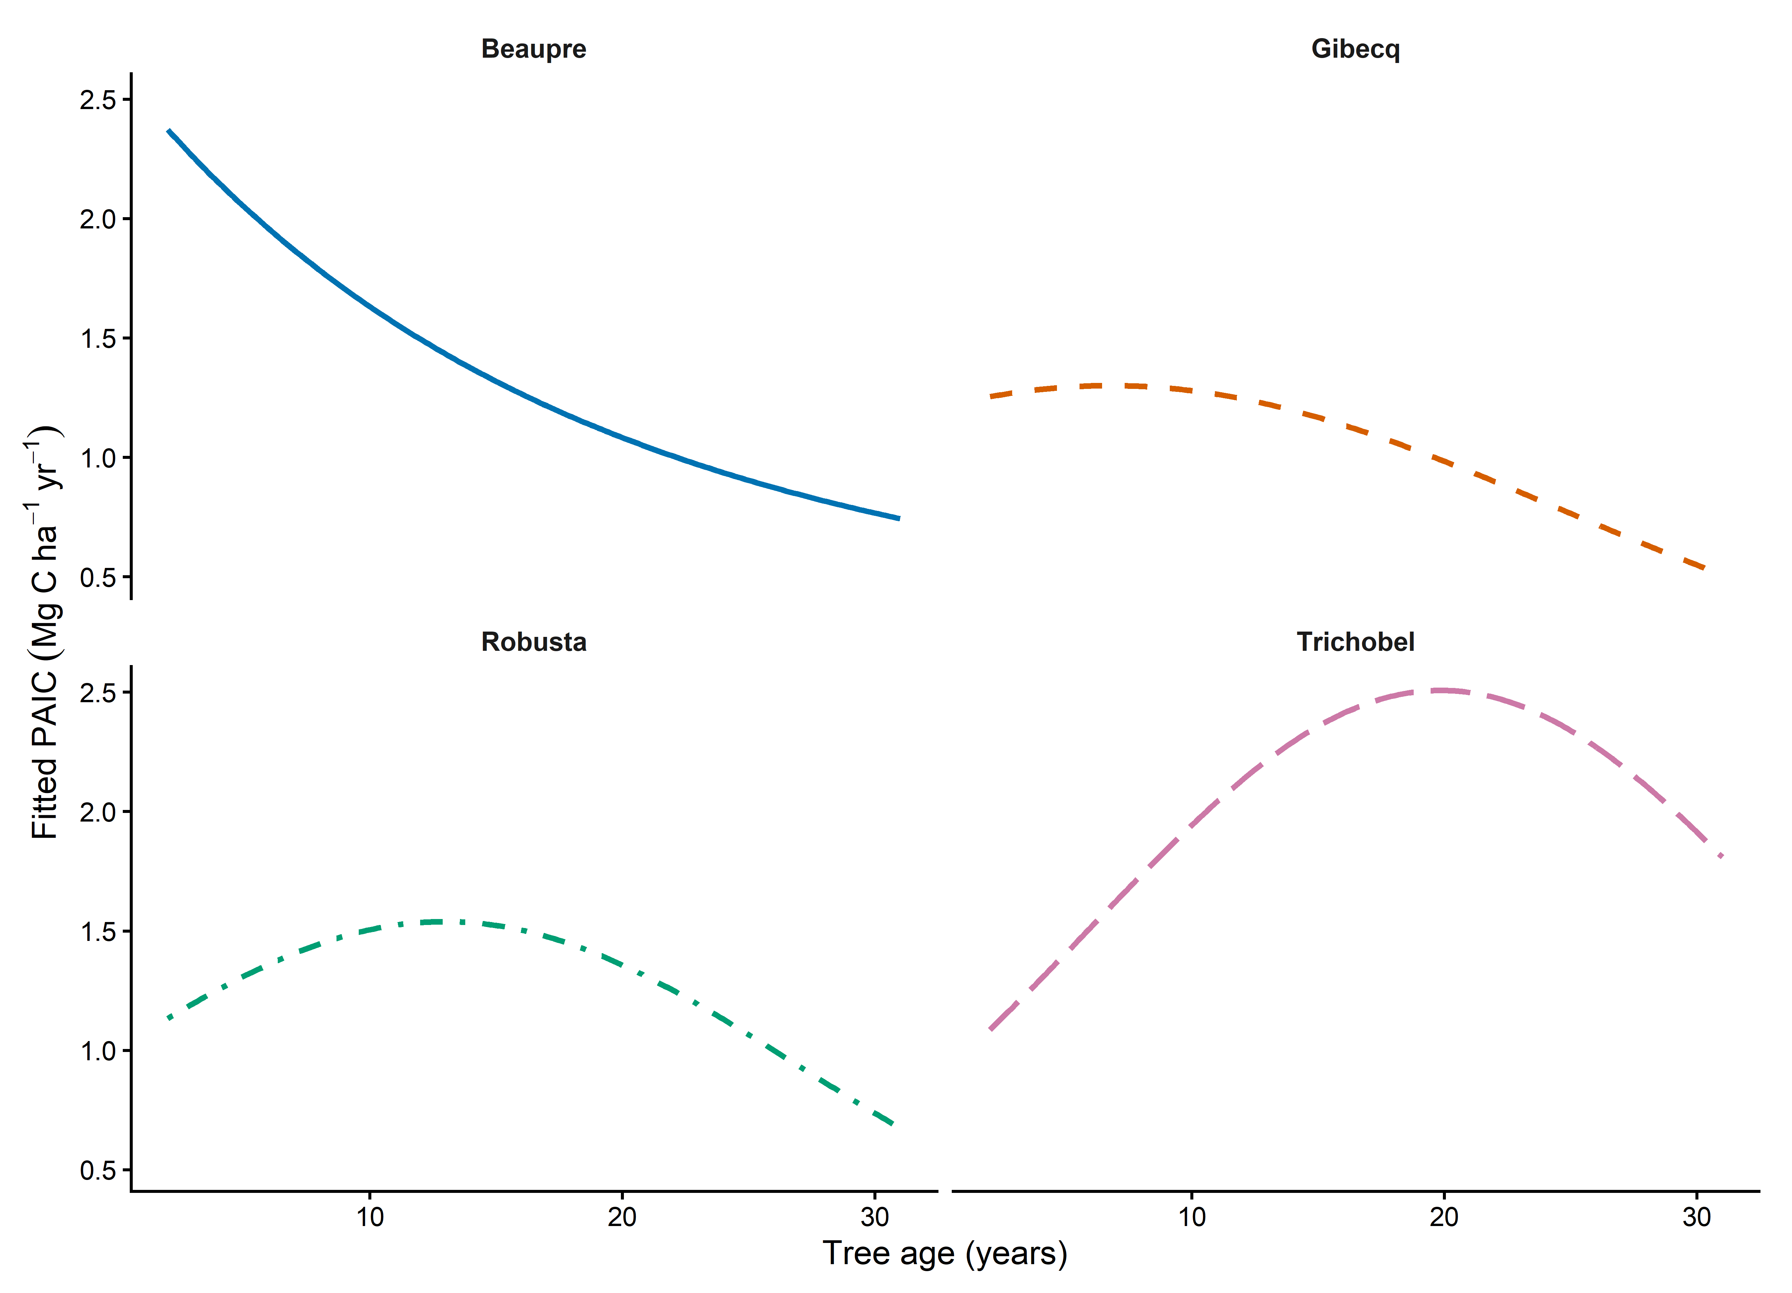
Figure S1. The curves are Gamma log-link fitted means with hybrid-specific linear and squared age terms, holding June to August mean temperature at 15.81 degrees C and rainfall at 172.44 mm. Only the observed age range is shown. Uncertainty bands are omitted. These curves describe conditional fitted shapes, not observed trajectories or independently identified causal effects of age.
The fitted age trajectory declines in Beaupre, bends modestly in Gibecq, and allows a growth peak followed by decline in Robusta and Trichobel. These are conditional descriptions of this cohort at fixed weather, not evidence that hybrids would follow the same trajectory under other management or stand conditions.
Hybrid | Combined model  pseudo R² | Weather deviance reduction  against quadratic age alone
Beaupre | 0.500 | 41.9%
Gibecq | 0.386 | 32.1%
Robusta | 0.526 | 41.6%
Trichobel | 0.595 | 32.3%

Table S1. These summaries describe the 26-year reporting summer models. Pseudo-R² = 1 − combined-model deviance / intercept-only deviance describes age and weather together. The last column compares that model with quadratic age alone; it is not a causal share of raw PAIC variance explained. The eight-hypothesis AICc comparison is calculated separately on 24 identical years, as shown in Figure 1.
Reproducibility: analysis/17_weather_hypothesis_models.R and weather_hypothesis_ tables/model RDS document the 24-year selection comparison and year-omission checks. Analysis 14 and final_weather_ outputs supply the verified 26-year reporting summer associations and age curves. Correlation tables remain descriptive background. Figures use plot_style.R with 600 dpi PNG and vector PDF exports; earlier Word versions and the retired correlation figure are archived.

