Cropping treatment effects and growth legacy
  - Analysis notes for paper drafting | Updated 22 October 2026
This note records the PAIC comparison among continuously cropped, alternately cropped and continuously fallow alleys, during cultivation and after cessation. Continuous cropping reduced PAIC during active cultivation. After cessation, a temporary growth advantage over former continuous fallow is suggestive of release from crop competition, with the strongest interval-specific evidence in growth years 2008 and 2009.

Experimental design and response
Within each of three blocks, six alleys were allocated in adjacent pairs to the three cropping treatments. A measurement row lay between each paired set of alleys. Continuous fallow had both alleys fallow; continuous cropping had both cropped; alternate cropping had one cropped and one fallow, reversed each year. Alternate cropping is not a second wholly fallow treatment.
All available measured trees are retained. There are nine treatment measurement rows with five trees of each of four hybrids per row, giving 180 tree IDs. The design describes guard trees at row ends. Each row by hybrid by interval mean is equally weighted in the model; the five neighbouring trees are subsamples, not independent treatment replicates.

Growth intervals and cessation
The final crop was sown in autumn 2003 and harvested in August 2004, confirmed by the user after consulting a colleague. Cropping then ceased. The primary active model includes intervals through the 2002 visit. The primary post-cropping model starts with the 2005-2006 interval, representing growth year 2005. The 2002-2005 boundary interval covers growth years 2002-2004 under the adopted convention; it is excluded from both primary fits and included with active cropping only in sensitivity analysis. The confirmed harvest date supports these assignments; no model refit is required.
The initial visit has no preceding increment and is excluded. The low PAIC at the 2001 visit is a three-year average across growth years 1998 to 2000. Missing visits limit temporal resolution; they do not themselves cause low annualised growth.

Statistical model
Separate Gaussian mixed models include fixed block and the full treatment by hybrid by interval interaction. Random intercepts represent treatment row, row by hybrid and row by interval. Block remains a design adjustment irrespective of significance. Treatment comparisons average equally across hybrids and observed intervals; this differs from duration-weighting the intervals.
Interval is a categorical factor identifying the period between consecutive visits, not a numerical measure of its length. For example, 1997-1998 represents one year, whereas 1998-2001 represents the three-year measurement gap. PAIC already divides stock change by elapsed years, so annualisation and the interval factor serve different purposes.
The fixed interval effect accounts for shared changes through time, including weather and stand development, without separating their causes. Treatment by interval allows treatment differences to vary between periods. The row by interval random intercept additionally represents fluctuations shared by hybrids within the same treatment row during a particular period.
Overall treatment contrasts use Bonferroni adjustment for three pairs. Interval-specific inference uses Holm adjustment across all three pairs and all intervals within each phase: 21 active, 54 post-cropping and 24 boundary-sensitivity tests. Confidence intervals in the marked figures are pointwise; markers use the phase-wide Holm tests. The three fits are not pooled into a single multiplicity family because the primary phases address separate questions and the third fit is a sensitivity analysis.

Model specification in pseudo R
Fit the same model separately to the active, post-cropping and active-with-boundary datasets. The response is the mean PAIC of available trees in each block by treatment row by hybrid by observed interval. Block, treatment, hybrid and interval are categorical factors. Missing PAIC records are excluded before aggregation.
# One record per treatment row, hybrid and growth interval
dat <- row_hybrid_interval_means_for_selected_phase
dat$row_id <- interaction(dat$block, dat$tree_row)
dat$row_hybrid <- interaction(dat$row_id, dat$hybrid_code)
dat$row_interval <- interaction(dat$row_id, dat$interval)
fit <- lmerTest::lmer(
PAIC ~ block + treatment_code * hybrid_code * interval +
(1 | row_id) + (1 | row_hybrid) + (1 | row_interval),
data = dat, REML = TRUE,
contrasts = sum_to_zero_contrasts_for_fixed_factors
)
anova(fit, type = 3, ddf = "Satterthwaite")
The asterisk expands to all main effects and two-way and three-way interactions among treatment, hybrid and interval. The block term is additive. The random intercepts account for persistent differences among treatment rows, persistent local hybrid differences within rows, and fluctuations shared by hybrids in the same row and interval. There is no separate tree random intercept because trees have already been averaged within each row and hybrid.
Treatment contrasts are obtained from estimated marginal means, averaging equally over hybrids. Overall contrasts additionally average equally over observed intervals. The model is unchanged by displaying treatments without separate hybrid panels.

Block tests and why block is retained
The fixed block term was nonsignificant in both primary models: active cropping F(2, approximately 4) = 0.798, p = 0.511; post cropping F(2, approximately 4) = 0.481, p = 0.650. These are Type III tests with Satterthwaite denominator degrees of freedom. They indicate insufficient evidence of an overall block difference after adjustment for the other model terms; with only three blocks, they do not establish that block effects are zero.
We retain block because treatments were allocated within blocks. It adjusts for baseline spatial differences among those blocks and respects the design when comparing treatments. Its inclusion is specified by the experiment, rather than selected by a preliminary significance test. Removing it solely because p exceeds 0.05 would make the analysis depend on a low-power screening test. The three blocks still provide treatment replication, while neighbouring trees remain subsamples; a nonsignificant block term does not make all trees independent replicates.
Block test sources: results/tables/treatment_PAIC_active_tests.csv and results/tables/treatment_PAIC_post_tests.csv.

Growth during active cropping
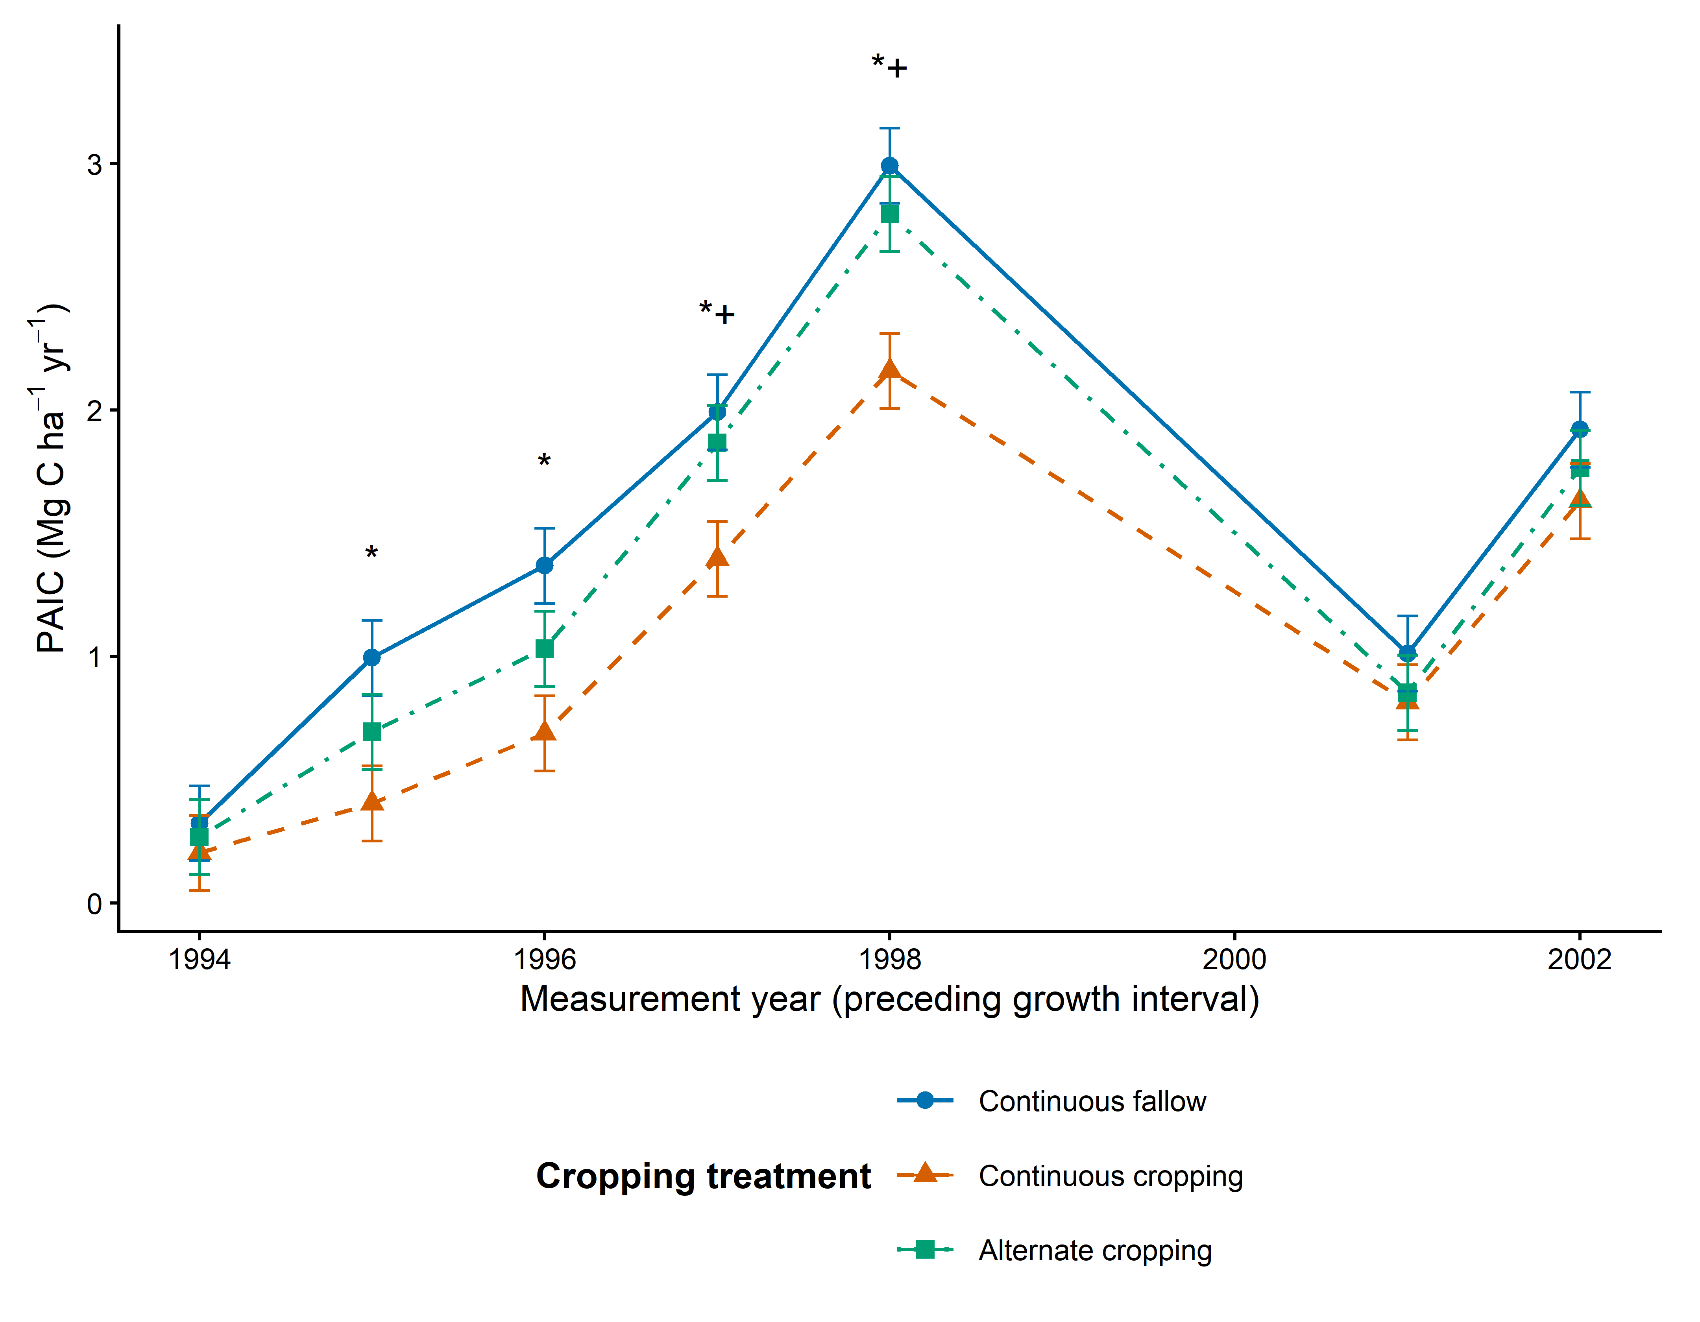
Figure 1 Model-adjusted PAIC during active cropping, averaged equally across hybrids. An asterisk marks continuous cropping versus continuous fallow; a plus marks continuous cropping versus alternate cropping. Markers use Holm adjustment across all 21 treatment-pair by interval tests in this phase. Error bars are pointwise 95 percent confidence intervals. Active cropping Model-adjusted means across hybrids; pointwise 95% CIs. Continuous cropping differs from: * continuous fallow; + alternate cropping (Holm p < 0.05 across all 21 pair-by-interval tests in this phase).
Continuous cropping has lower estimated PAIC than continuous fallow throughout the observed active phase. After phase-wide adjustment, this comparison is significant at the 1995 to 1998 visits; continuous cropping also differs from alternate cropping at the 1997 and 1998 visits. Absence of a marker at other visits does not establish equal growth.
The low point at the 2001 visit is an annualised mean over growth years 1998 to 2000. The missing field visits limit annual resolution but do not themselves explain the low PAIC. Treatment differences narrow in this interval; the possible weather explanation remains untested with interval-aligned predictors.
Figure source: results/figures/treatment_PAIC_active_means.png. Interval inference: results/tables/treatment_PAIC_active_interval_inference.csv.

Main results
Phase | Treatment difference | PAIC difference | Adjusted p
Active | Continuous cropping - Continuous fallow | -0.473 | 0.0068
Active | Alternate cropping - Continuous fallow | -0.190 | 0.1475
Active | Continuous cropping - Alternate cropping | -0.283 | 0.0428
Post | Continuous cropping - Continuous fallow | 0.310 | 0.1026
Post | Alternate cropping - Continuous fallow | 0.127 | 0.7920
Post | Continuous cropping - Alternate cropping | 0.183 | 0.4084

PAIC differences are Mg C per hectare per year. The active treatment omnibus p-value is 0.0057. The post-cropping treatment omnibus p-value is 0.0806; the average post-cropping pairwise contrasts are uncertain and do not exclude shorter-lived differences.
Including the boundary interval gives continuous cropping minus continuous fallow of -0.445, adjusted p = 0.0075. The corresponding continuous cropping minus alternate cropping contrast is -0.260, adjusted p = 0.0506. The continuous-cropping versus continuous-fallow conclusion is consistent; the other active average contrast is sensitive near the conventional threshold.

Differences among hybrids
Hybrid main effects are significant in both primary models, with p below 0.001. Treatment by hybrid interactions are nonsignificant: active p = 0.613 and post p = 0.570. The three-way interactions with interval are also nonsignificant. We therefore display treatment comparisons averaged across hybrids, without claiming that hybrids have equal PAIC or identical treatment responses.

Post cropping intervals surviving adjustment
Growth year | Comparison | Difference | Holm p
2008 | Continuous cropping - Continuous fallow | 0.809 | 0.0024
2009 | Continuous cropping - Continuous fallow | 0.642 | 0.0380

These correspond to the 2009 and 2010 visits. The broader positive pattern over growth years 2007 to 2010 is descriptive, not significant in every year after phase-wide correction. The growth-year-2013 difference does not survive correction; no interval has been removed as a presumed fluke.

Files supporting this note
analysis/03_treatment_active.R
scripts/treatment_presentation.R
analysis/03b_refresh_treatment_figures.R
results/tables/treatment_PAIC_*_overall_contrasts.csv
results/tables/treatment_PAIC_*_interval_inference.csv

Discussion of the post cropping legacy
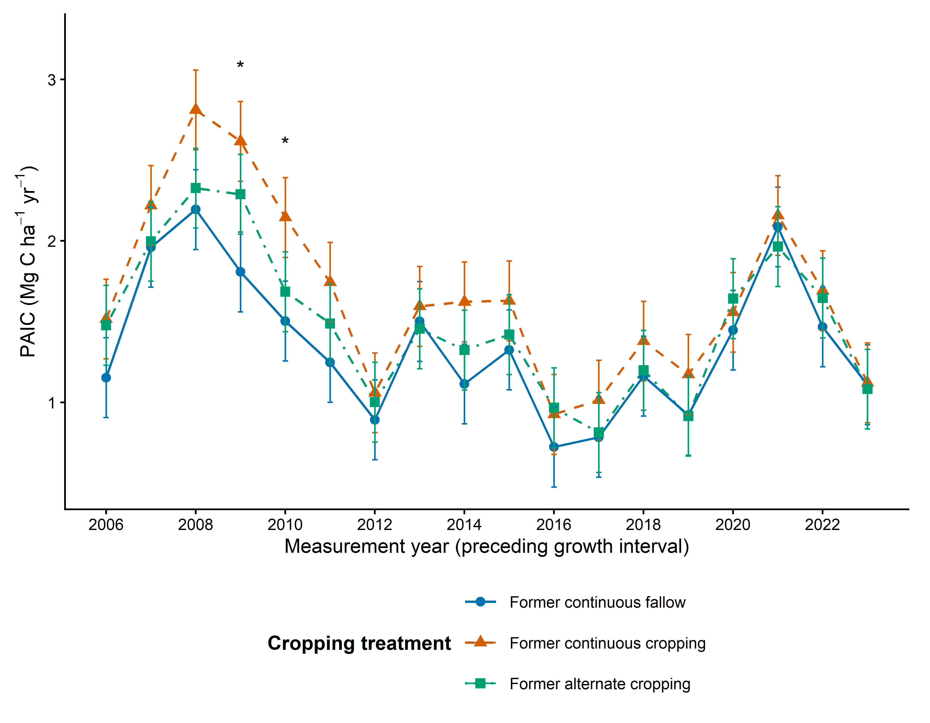
Figure 2 Model-adjusted PAIC averaged across hybrids after cessation. Asterisks mark continuous cropping versus continuous fallow differences after phase-wide Holm correction. Error bars are pointwise 95 percent confidence intervals. After cropping ceased Model-adjusted means across hybrids; pointwise 95% CIs. Continuous cropping differs from: * continuous fallow; + alternate cropping (Holm p < 0.05 across all 54 pair-by-interval tests in this phase).
Suggested drafting language: Following cessation of cropping, trees formerly under continuous cropping showed a temporary PAIC advantage over trees formerly under continuous fallow, with the strongest statistical evidence in growth years 2008 and 2009. This pattern is consistent with release from crop competition, but does not establish that mechanism.
Post-cropping contrasts include consequences of earlier differences in size and condition. Weather, stand development and other temporal influences may contribute to the trajectories. A nonsignificant contrast does not date disappearance of a legacy or demonstrate equivalence between treatments.

Active cropping convergence and remaining decisions
During the 1998 to 2001 interval, PAIC fell in all treatments and the treatment differences narrowed. Continuous fallow minus continuous cropping declined from about 0.83 at the 1998 visit to 0.20 at the 2001 visit, then rose to 0.29 at the 2002 visit. The weather explanation remains untested with interval-aligned predictors.
All current fits converged without singularity. Residual plots show some unequal spread and tail departures; variance assumptions and remaining serial dependence require review before final inferential wording. Three blocks limit independent treatment replication. A biological equivalence threshold would be needed to estimate when a legacy becomes negligible.

Descriptions for additional figure exports

treatment PAIC active contrasts
Active cropping Equal hybrid weights; pointwise 95% CIs. * Holm-adjusted p < 0.05 across all 21 pair-by-interval tests in this phase. A CI excluding zero alone does not establish significance after adjustment.
Figure file: results/figures/treatment_PAIC_active_contrasts.png

treatment PAIC post contrasts
After cropping ceased Equal hybrid weights; pointwise 95% CIs. * Holm-adjusted p < 0.05 across all 54 pair-by-interval tests in this phase. A CI excluding zero alone does not establish significance after adjustment.
Figure file: results/figures/treatment_PAIC_post_contrasts.png

treatment PAIC active with boundary means
Active cropping including boundary interval Model-adjusted means across hybrids; pointwise 95% CIs. Continuous cropping differs from: * continuous fallow; + alternate cropping (Holm p < 0.05 across all 24 pair-by-interval tests in this phase).
Figure file: results/figures/treatment_PAIC_active_with_boundary_means.png

treatment PAIC active with boundary contrasts
Active cropping including boundary interval Equal hybrid weights; pointwise 95% CIs. * Holm-adjusted p < 0.05 across all 24 pair-by-interval tests in this phase. A CI excluding zero alone does not establish significance after adjustment.
Figure file: results/figures/treatment_PAIC_active_with_boundary_contrasts.png

