SOC sequestration following arable conversion
  - Analysis notes for paper drafting | Updated 22 October 2026
At the arable 0-30 cm equivalent soil mass, SOC_ESM sequestration rates are 0.866 Mg C per hectare per year for alley fallow of 19 years, 0.408 for alley fallow of 32 years and 0.658 for tree rows of 32 years. Methods define these rates as retrospective annualised stock differences relative to the arable reference.

Methods
The two study fields formed one arable field before silvoarable establishment in 1992. Continuous fallow alleys have remained grassland since 1992. The final crop in Continuous cropping alleys was planted in autumn 2003 and harvested in August 2004; these alleys have remained grassland since cessation. Soil sampling took place in 2024. The adjacent reference remained arable. Durations of 32 years for Continuous fallow, 19 for Continuous cropping and 32 for tree rows were specified by the user; they are fixed analysis conventions, not exact dated exposure estimates.
Input: data/raw/study_site_soil_2024.csv, with full-precision company fine bulk density and SOC, permanent core IDs and corrected location labels. Select 2_alley with former_treatment_code F or C, all 1_tree cores pooled across former treatments, and 3_arable as reference. Exclude Alternate cropping alleys from this calculation. Retain former-treatment identifiers for tree profiles in the profile output. Tree rows are pooled by available complete core, not equally weighted by former treatment.
Layer soil mass = fine BD (g/cm3) times thickness (cm) times 100; layer SOC stock = soil mass times SOC percentage / 100. The reference is the sum of mean arable 0-15 cm mass (1775.327819 Mg/ha, n = 48) and 15-30 cm mass (1957.915887 Mg/ha, n = 47): 3733.243706 Mg soil/ha. All locations, including individual arable profiles, are evaluated at this same mass.
Join the origin and measured cumulative soil-mass/SOC endpoints linearly. Interpolate inside measured mass; if a complete profile falls short of reference mass, extend its final segment using the measured 15-30 cm SOC concentration. No spline, extra coarse-fragment or organic-matter subtraction is applied. Upper-only profiles receive no total-reference estimate. This retains the existing stock-analysis ESM convention; extrapolations are explicit below.

Calculated results
Group | n | ESM stock | Excess | Years | Sequestration rate
Arable reference | 47 | 59.14 | 0.00 | - | 0 reference
Alley fallow, 19 years | 8 | 75.60 | 16.45 | 19 | 0.866
Alley fallow, 32 years | 8 | 72.20 | 13.06 | 32 | 0.408
Tree rows, 32 years | 21 | 80.19 | 21.05 | 32 | 0.658

Stocks and excesses are Mg C per hectare; SOC_ESM sequestration rates are Mg C per hectare per year. SOC_ESM sequestration rate is defined here as the annualised ESM-adjusted stock excess relative to the adjacent arable reference. Arable mean = 59.144888 Mg C/ha. For each selected core: (ESM SOC - arable mean) / agreed years; average the core estimates. The arable zero is defined by the comparison, not an estimate of zero temporal change in the arable field.

Variation and extrapolation audit
Group | Stock SD | Rate SD | Extended / n | Out | Max depth cm
Arable reference | 6.03 | - | 22 / 47 | 1 | 36.7
Alley fallow, 19 years | 5.66 | 0.298 | 5 / 8 | 0 | 37.9
Alley fallow, 32 years | 4.12 | 0.129 | 3 / 8 | 0 | 40.3
Tree rows, 32 years | 8.30 | 0.259 | 17 / 21 | 3 | 44.9

SD describes variation among complete cores. Rate SD is stock SD divided by duration, holding the shared arable mean fixed; it is not a confidence interval and does not propagate reference-mean, reference-mass, extrapolation or baseline uncertainty. No treatment significance tests are performed. The reference has one excluded upper-only core; tree rows have three. Both alley groups have eight complete cores.
The total reference mass corresponds to arable 0-30 cm; it does not mean each corrected profile represents a physical 0-30 cm depth. Extension uses unmeasured soil below 30 cm at an assumed constant lower-layer SOC concentration. The tree-row result is particularly dependent on extension (17 of 21 complete cores; maximum equivalent depth 44.9 cm). Full profile-specific masses, carbon extensions and equivalent depths are exported.

Discussion hypotheses
The higher sequestration-rate estimate for alley fallow of 19 years (former Continuous cropping) does not establish a faster grassland response. Its denominator is shorter, its sampled block differs, and trees may have affected SOC before the 2004 cessation. The 19-year contrast therefore includes any retained earlier tree effect; without a justified 2004 baseline it cannot isolate post-2004 grassland sequestration. The 32-year tree-row contrast represents pooled soil stock excess associated with this silvoarable history, not tree biomass carbon.
The arable field is a space-for-time counterfactual, not a measured 1992 or 2004 baseline. Shared original field history supports comparability but does not prove identical starting stocks or unchanged reference SOC. Excess may include avoided loss as well as accumulation. Each alley treatment is represented by one block/row band; eight cores are spatial subsamples. Pooled tree rows span three bands and retain their former-management histories. Rates are per hectare of the sampled location, not whole-system area; scenario upscaling requires area fractions.

Open decisions
Assess baseline soil information and arable-management comparability, grassland management and sensitivity to the below-30 cm extension assumption. A no-extrapolation subset can change spatial composition and should not silently replace the main estimate. Historical annualised contrasts do not establish a linear future SOC trajectory. Separate soil from biomass carbon and avoid double counting in scenarios.

Reproduction and validation
Run scripts/calculate_soc_sequestration.py, then analysis/17_soc_sequestration.R using R 4.6.0 with --vanilla. The independent calculation agrees with existing soc_ESM_profile_estimates.csv to 1e-9 Mg C/ha for all 92 complete profiles. Outputs: soc_sequestration_ESM_summary.csv, soc_sequestration_ESM_profiles.csv and soc_sequestration_reference_masses.csv in results/tables. Source measurements and existing stock-analysis outputs are unchanged.

SOC stocks and sequestration rates
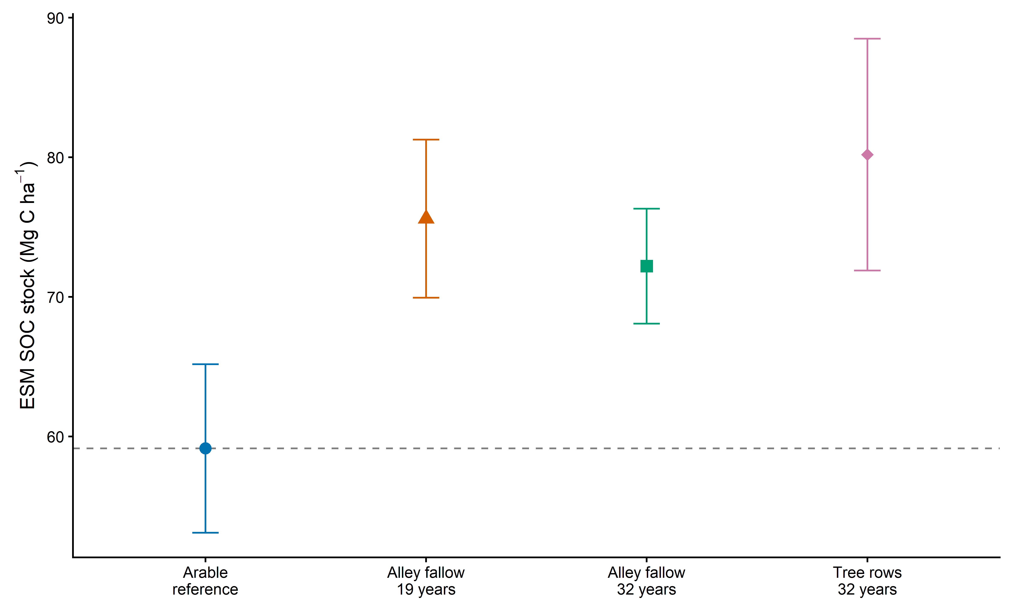
Figure 1 Mean ESM SOC stocks at the arable 0-30 cm reference mass. Error bars show profile SD; dashed line is the arable mean.
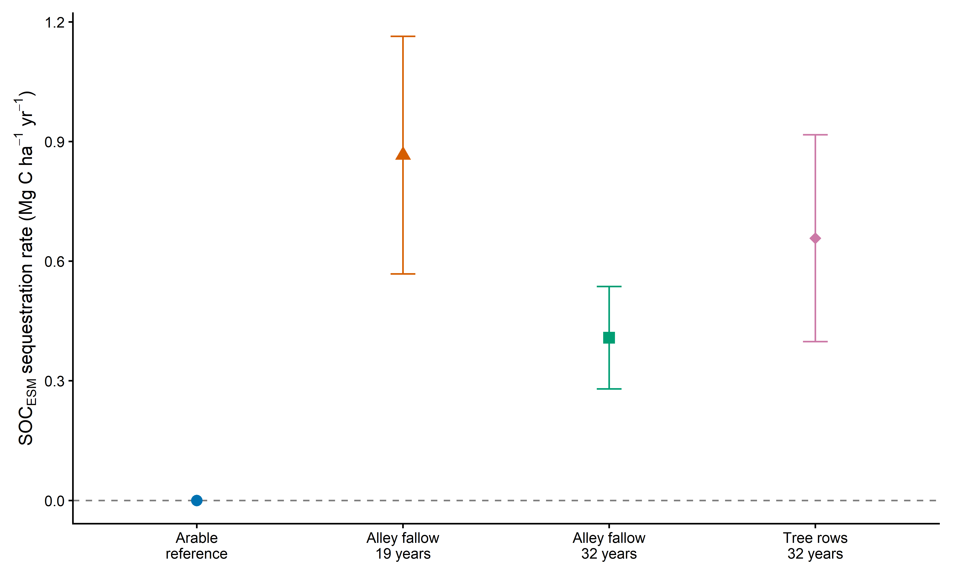
Figure 2 SOC_ESM sequestration rates for alley fallow of 19 years, alley fallow of 32 years and tree rows of 32 years. Error bars show profile SD divided by years, conditional on the arable mean. Arable zero is the defined reference. SOC is soil organic carbon and ESM is equivalent soil mass. Each rate is (mean ESM-adjusted SOC stock minus the adjacent arable mean) divided by the agreed elapsed duration: 19 years for former continuously cropped alleys, 32 years for former continuously fallow alleys and 32 years for tree rows. Points show retrospective annualised stock differences in Mg C per hectare per year. Error bars are profile SD divided by duration, conditional on the arable mean; they are not confidence intervals and do not propagate uncertainty in the reference mean or soil mass. Arable is zero by definition. These stock contrasts do not directly measure annual flux or isolate accumulation caused by grassland.

