Tree growth and carbon increment analysis
  - Analysis notes for paper drafting | Updated 20 October 2026
This note describes growth and aboveground carbon accumulation through time in the four poplar hybrids. PAIC measures recent growth over an observed interval; MAIC measures average accumulation since planting. The current figures are descriptive, and the measurement gaps require explicit interpretation.

Methods
The trees were planted in 1992. The dataset contains 180 measured trees: Beaupre, Gibecq, Robusta and Trichobel, with 45 trees per hybrid across three experimental blocks. Measurements cover the even-numbered tree rows. The recorded series spans 1993 to 2023; there are no visits in 1999, 2000, 2003 or 2004.
The main preparation retains supplied tree-level carbon stocks, PAIC and MAIC. Separate audit columns reconstruct biomass using the supplied diameter allometry, convert biomass to carbon using a fraction of 0.5, and scale to area using the configured density of 166 trees per hectare. This scaling is an assumption, not a measured whole-system carbon balance.
PAIC is the change in aboveground carbon stock divided by elapsed years between successive visits. MAIC is carbon stock divided by years since planting. Annual plots show hybrid medians and interquartile ranges across trees. These ranges describe variability and are not confidence intervals for independent experimental replicates.

Main results
Hybrid | PAIC | MAIC | Carbon stock
Beaupre | 0.70 | 1.29 | 40.08
Gibecq | 0.42 | 1.09 | 33.77
Robusta | 0.86 | 1.23 | 38.73
Trichobel | 2.33 | 2.13 | 65.99

The table gives 2023 medians. PAIC and MAIC are in Mg C per hectare per year; stock is in Mg C per hectare. Trichobel has the highest median values at the final visit. This descriptive ranking does not substitute for a longitudinal statistical comparison.

Measurement gaps and interpretation
The 2001 PAIC averages the 1998 to 2001 measurement interval, corresponding to growth years 1998 to 2000 under the adopted convention. Missing visits do not mechanically lower annualised PAIC: dividing by elapsed time already accounts for duration. The gap prevents identification of which individual years contributed to the low average and can smooth annual extremes. The 2005 PAIC similarly covers growth years 2002 to 2004.
Recalculation confirms the dip: mean PAIC across available tree records is approximately 2.65 at the 1998 visit, 0.89 at the 2001 visit and 1.77 at the 2002 visit. The supplied and stock-derived values agree closely at these visits. The cause of the slowdown remains unresolved.
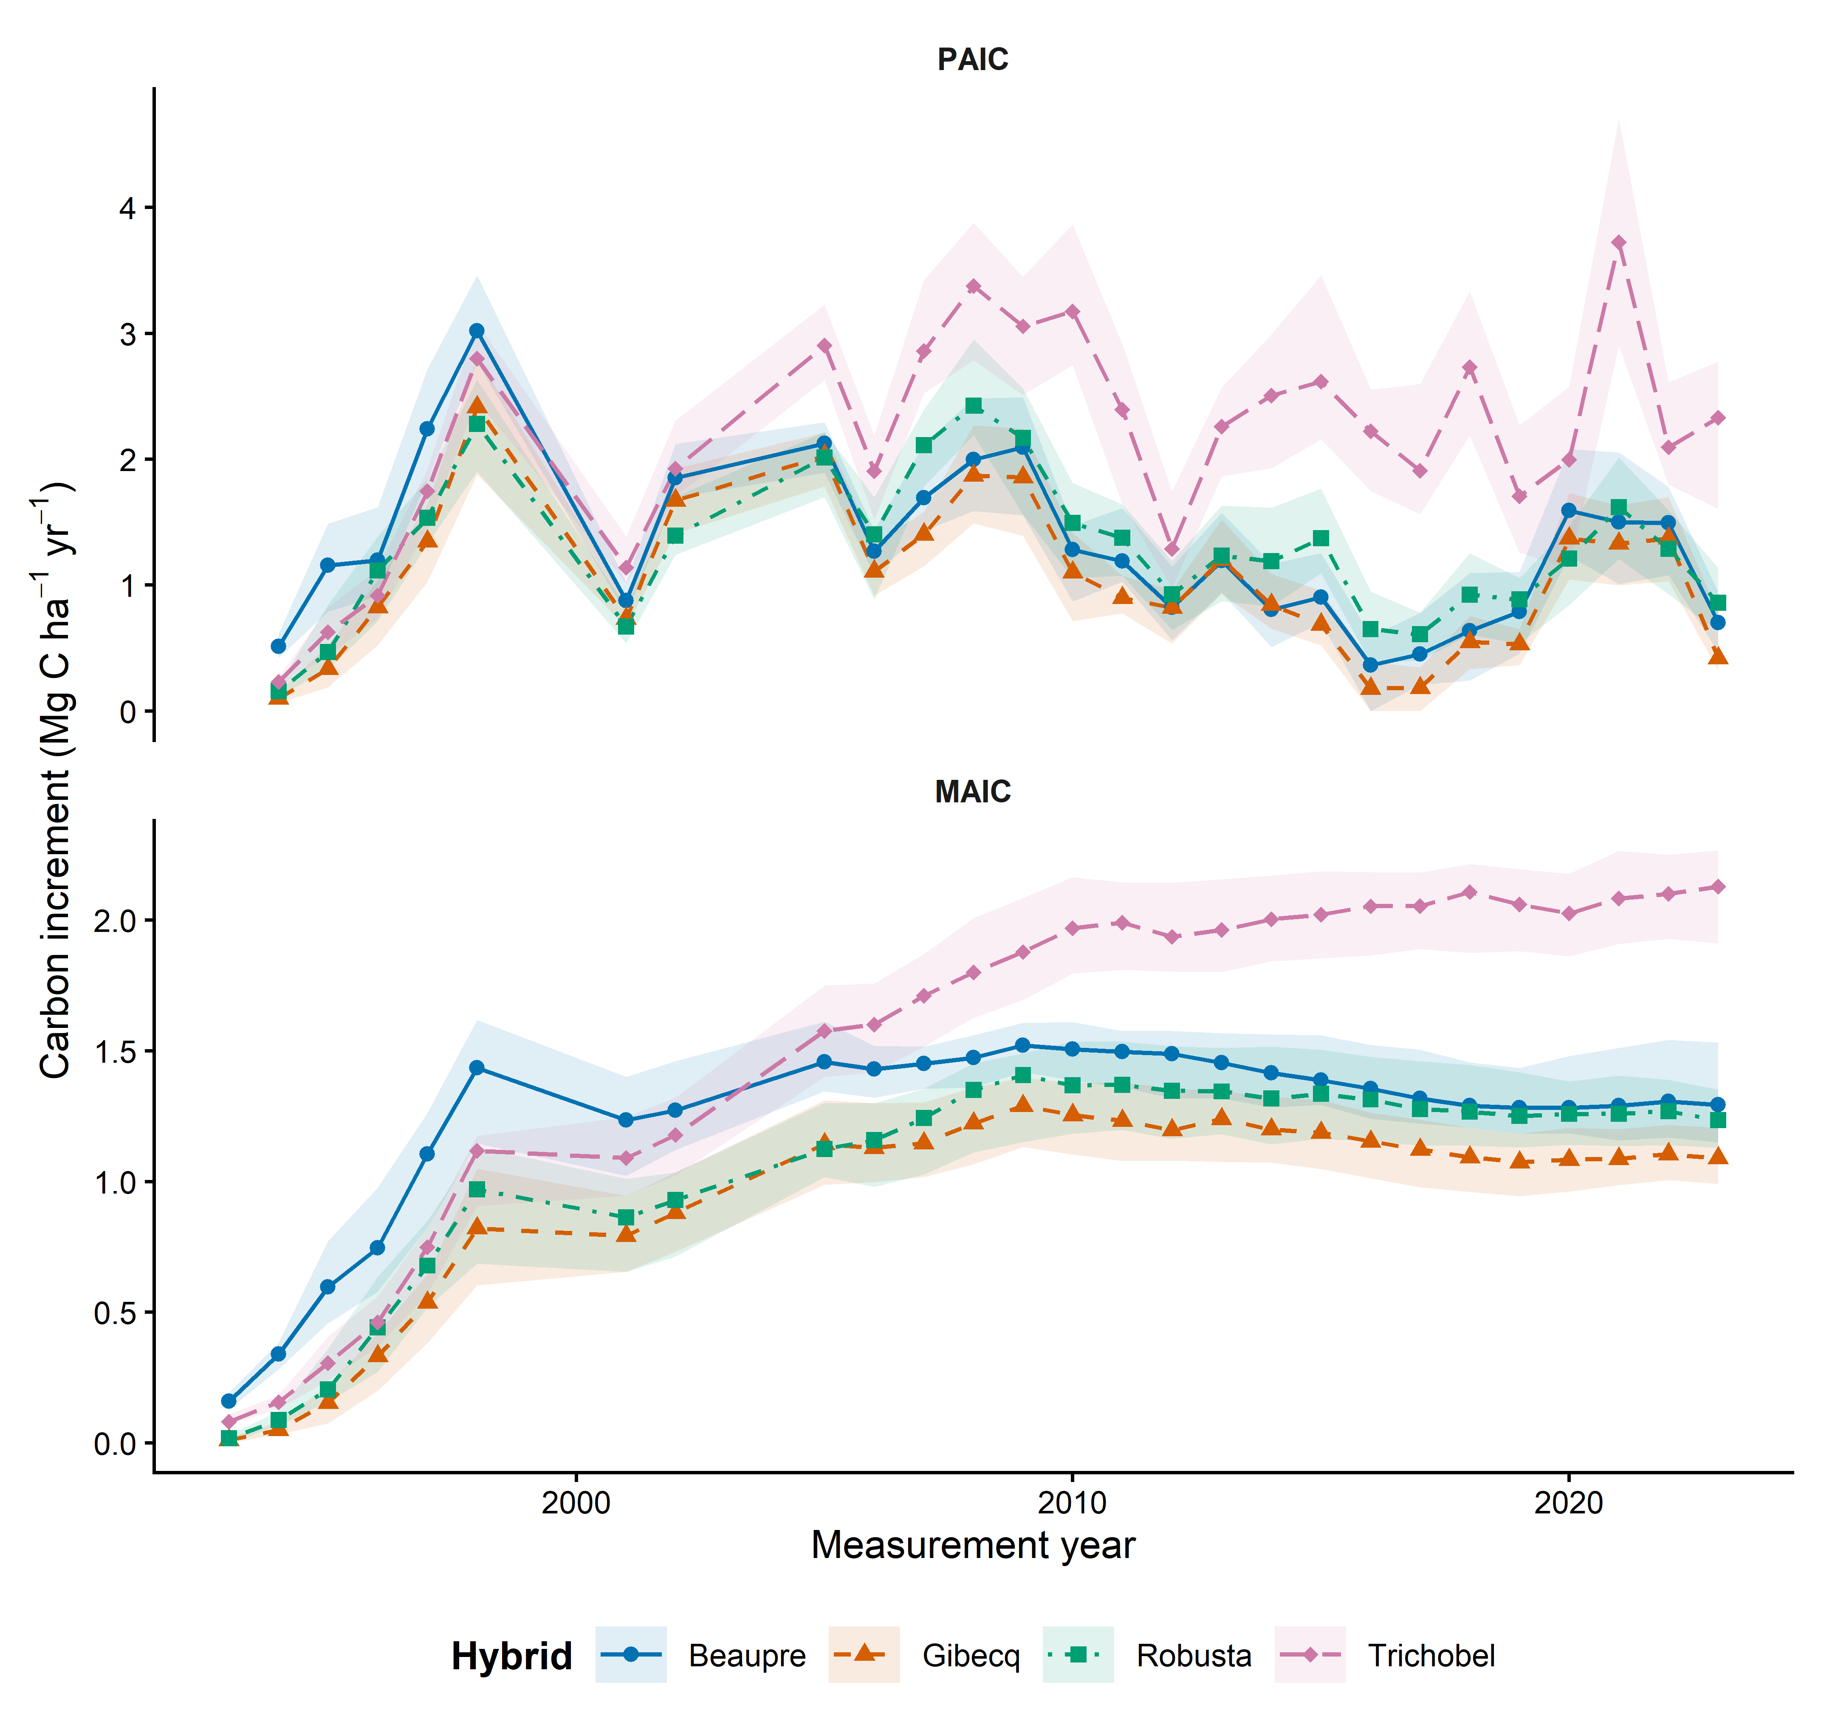
Figure 1 PAIC is periodic annual carbon increment and MAIC is mean annual carbon increment. Symbols and lines identify hybrid medians; shaded ribbons span the 25th to 75th percentiles across trees. The panels use separate vertical scales. PAIC is annualised over the interval between measurements; the 2001 observation therefore averages growth years 1998 to 2000. Lines connect observed visits; missing years are not imputed.

Discussion and decisions still needed
Use PAIC to discuss changes in growth rate, and MAIC or stocks to discuss accumulated carbon. Resolve the remaining Robusta response-summary discrepancy, the treatment of missing or nonpositive observations, and allometric uncertainty before final inference. Do not interpret continued stock differences as evidence that current growth rates remain different.

Files supporting this note
analysis/01_growth_descriptive.R
results/tables/growth_by_year_hybrid.csv
results/checks/tree_response_audit.csv
results/checks/response_comparison.csv

Descriptions for additional figure exports

paic shared fluctuations
Descriptive comparison of hybrid PAIC on common positive-response measurement years. Panel A shows observed tree-level hybrid medians as thin lines and symbols and separate quadratic trends fitted to log PAIC as thick lines. Panel B shows log-scale residuals divided by the within-hybrid residual standard deviation; zero denotes the fitted trend. Panel C gives Pearson correlations of those standardised departures. Panel D divides Trichobel PAIC by the geometric mean for Beaupre, Gibecq and Robusta; the dashed line at one denotes equal PAIC. No shared year effect is removed. Lines connect observed visits without imputing missing years. Correlations do not establish weather causation; sensitivity analyses use linear detrending and the legacy response series.
Figure file: results/figures/paic_shared_fluctuations.png

trichobel relative paic
Observed tree-level median PAIC for Trichobel divided by the geometric mean of Beaupre, Gibecq and Robusta at each measurement visit. The dashed line at one indicates equal PAIC. Symbols are observed ratios and lines connect visits without imputing missing years. The ratio is descriptive and does not adjust for age or quantify uncertainty.
Figure file: results/figures/trichobel_relative_paic.png

