Soil organic carbon stocks and equivalent soil mass correction
  - Analysis notes for paper drafting | Updated 22 October 2026
This analysis quantifies soil organic carbon stocks, bulk density and SOC content in 2024 for the arable reference, alleys and tree rows. Linear equivalent soil mass correction compares stocks at the arable mean soil masses. Tabular total stocks support subsequent area scaling; reference-mass intervals support depth-related interpretation.

Methods
The measurement input is data/raw/study_site_soil_2024.csv, containing 188 layers from 96 permanent company core IDs and 92 complete two-layer profiles. Source values retain full precision. Arable reference, Alley and Tree row identify land cover; former cropping treatments are separate metadata. All profiles were sampled in 2024. Company sample IDs identify layers; core IDs identify profiles. The provenance section below retains the sample-origin record.
Layer soil mass (Mg soil per hectare) equals fine dry bulk density (g/cm3) times layer thickness (cm) times 100. Layer SOC stock (Mg C per hectare) equals soil mass times SOC content (%) divided by 100. Fine BD and SOC content are used directly; no additional organic-matter subtraction or coarse-fragment adjustment is applied. Fixed-depth 0 to 30 cm stocks sum both observed layers and exclude incomplete profiles. Company-supplied stock values are retained as source fields rather than substituted for these calculations.
The upper reference mass is 1775.33 Mg soil per hectare, the mean mass of 48 arable 0 to 15 cm samples. The mean lower-layer mass is 1957.92 from 47 samples. Their sum, 3733.24, is the arable 0 to 30 cm reference mass. Layer means use all available arable observations.
For each core, join the origin and measured cumulative soil-mass and SOC-stock endpoints with straight segments, without splines. Evaluate stocks at the two reference masses using the segment bracketing each target. Where the upper reference exceeds the measured upper-layer mass in a complete profile, the extra mass takes the measured lower-layer SOC concentration. Complete profiles can extend beyond their measured total mass using the final layer slope. The lower reference-mass stock is total minus upper stock. Individual arable profiles are standardised to the same masses as alley and tree-row profiles.
The 4 upper-only profiles are attributed to shallow bedrock. Retain an upper-reference estimate by evaluating their upper-layer slope, extending to the upper reference if necessary. This is a mass-standardisation assumption rather than an observation below bedrock. Do not calculate their lower-reference increment or total stock. Reference mass depth labels denote the arable 0 to 15 and 15 to 30 cm intervals, not equal physical depths in every core.
Supplementary properties use complete measured 0 to 30 cm profiles. Within each core, BD is soil-mass weighted: sum(BD squared times thickness) divided by sum(BD times thickness). SOC content is the simple arithmetic mean of the two layer percentages. These measured-depth properties are not ESM transformed. Location summaries report mean, SD, SE, median and quartiles; SE is SD divided by square root of n. Reference-mass uncertainty is not propagated.
Location tests are Kruskal-Wallis followed by two-sided tie-corrected Dunn comparisons. Benjamini-Hochberg adjustment covers three pairs separately for each reference-mass interval, each fixed-depth interval and each supplementary property. Letters use adjusted p < 0.05; shared letters indicate no detected difference. These tests describe sampled-core contrasts and assume core independence. They do not resolve spatial clustering or identify replicated land-use effects.

Calculated results
Land cover | Profiles | Fixed depth | Linear ESM | ESM SD
Arable reference | 47 | 59.36 | 59.14 | 6.03
Alley | 24 | 75.71 | 76.42 | 6.66
Tree row | 21 | 72.00 | 80.19 | 8.30

Stocks are Mg C per hectare. Fixed depth is measured 0 to 30 cm; ESM is the arable 0 to 30 cm reference mass. Complete-profile counts apply to both totals. SD describes variation across cores, not uncertainty from independent experimental land-use replication.
Land cover | Extended totals | Excluded totals | Maximum depth cm
Arable reference | 22 / 47 | 1 | 36.7
Alley | 12 / 24 | 0 | 40.3
Tree row | 17 / 21 | 3 | 44.9

Extended total stocks assume that the measured lower-layer SOC concentration continues below 30 cm. Upper-only bedrock profiles retain no total. Upper-reference counts are Arable reference 48, Alley 24, Tree row 24.
Reference depth cm | Land-cover comparison | BH adjusted p
0-15 | Arable reference versus Alley | 2.05e-10
0-15 | Arable reference versus Tree row | 9.08e-13
0-15 | Alley versus Tree row | 0.449
15-30 | Arable reference versus Alley | 0.0451
15-30 | Arable reference versus Tree row | 0.000231
15-30 | Alley versus Tree row | 0.0986

ESM letters at 0-15 cm reference mass depth: a, b, b in arable, alley and tree-row order.
ESM letters at 15-30 cm reference mass depth: a, b, b in arable, alley and tree-row order.

SOC stocks in equivalent soil mass intervals
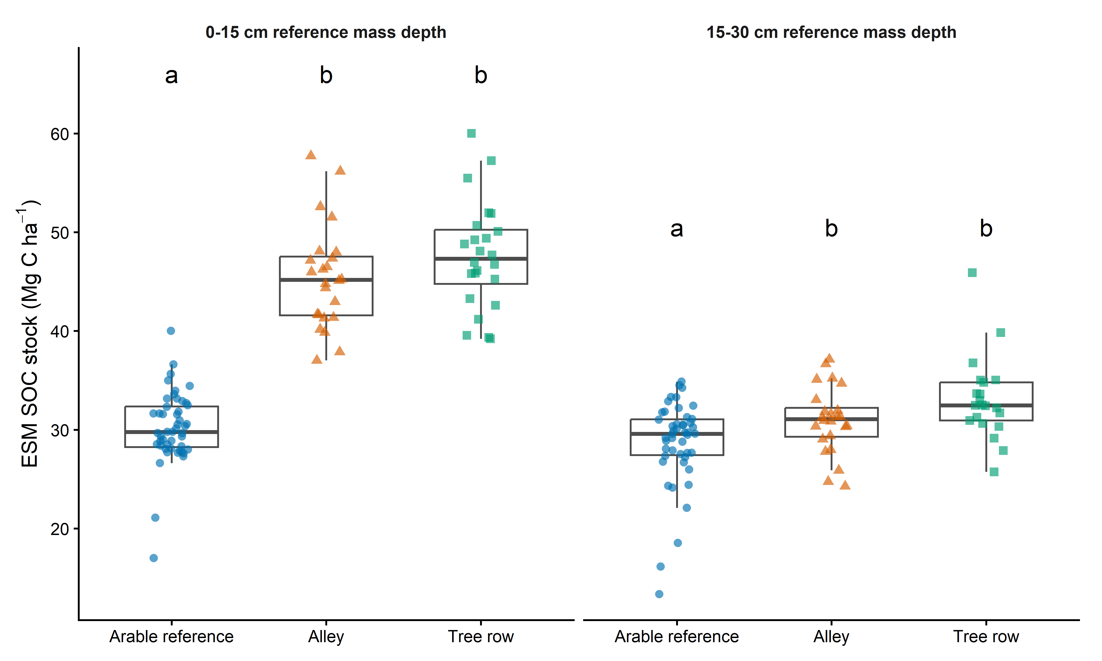
Figure 1 ESM-corrected SOC stocks for the 0 to 15 cm and 15 to 30 cm reference mass depths. Labels denote arable reference depths. Letters compare land covers within each mass interval. Boxes show median and IQR; whiskers use 1.5 times IQR; points are core estimates. Mass intervals correspond to the arable mean 0-15 and 15-30 cm layers; physical depths vary. Dunn letters: BH adjustment within mass interval, p < 0.05. Boxes: median and IQR; whiskers: 1.5 x IQR.

Supplementary bulk density and SOC content
Land cover | Profiles | BD g/cm3 | SOC content %
Arable reference | 47 | 1.265 (0.128) b | 1.590 (0.150) a
Alley | 24 | 1.251 (0.168) b | 2.110 (0.196) b
Tree row | 21 | 1.102 (0.155) a | 2.271 (0.287) b

Mean (SD) across complete measured 0 to 30 cm cores. BD is mass weighted within core; SOC content is an unweighted layer average. Letters compare land covers separately within each property using Dunn tests with BH adjustment, p < 0.05. Shared letters indicate no detected difference. Properties describe measured depth, not the variable physical depth reaching the ESM reference.
Fixed-depth stocks, depth comparisons and the measured 0 to 30 cm figure are available separately as soc_profile_summary, soc_stock_depth_dunn_BH, soc_stock_by_depth and soc_stock_0_30. The primary total ESM table is soc_ESM_total_summary.

Supplementary cumulative coordinate overview
Figure S1 Each facet is an alley or tree-row core. Black points are measured cumulative endpoints joined linearly from the origin. Purple dashed segments extend the final measured slope. Dotted vertical lines show arable reference masses. Blue triangles and orange squares represent ESM-corrected 0 to 15 cm and 0 to 30 cm SOC stocks. Asterisks mark upper-only shallow-bedrock cores. Black: measured cumulative coordinates joined linearly from the origin. Purple dashed: extension using the final measured layer SOC content. Grey dotted lines: arable mean cumulative reference masses (1775 and 3733 Mg soil/ha). Coloured symbols: evaluated stocks. * Shallow bedrock: upper-reference estimate only; no lower interval or full-profile estimate. Shared axes; labels show land cover and company core number (Field 2).
The standalone vector PDF shows all 48 alley and tree-row cores. Facet numbers are company core numbers in agroforestry Field 2, not legacy workbook IDs. The figure-profile key links facet labels to permanent core IDs, coordinates and former-treatment metadata.

Discussion hypotheses
Spatial differences in organic inputs and soil conditions could contribute to land-cover contrasts. Baseline differences, field history and spatial clustering remain alternative explanations. ESM intervals can include soil below 30 cm where extrapolation is required. These cross-sectional contrasts do not establish causal former-treatment effects or measured carbon accumulation through time.

Open decisions
Former cropping treatment is confounded with block and sampled row band in this soil subset, as documented in the provenance record. Cores are spatial subsamples. Upscaling requires tree-row and alley area fractions, a comparable arable baseline and compatible area and carbon units with aboveground stocks. A stock contrast requires an explicit baseline and timescale before interpretation as a sequestration rate.

Soil sample provenance and former cropping treatments
Updated 22 October 2026. The missing sample identities can be recovered. The user confirmed on 22 October 2026 that rows run approximately north to south, with row 6 furthest west. Together with the original design and colleague's account, this confirms the western, middle and eastern sampled bands as rows 6, 10 and 14 respectively.

Methods
Match rawdataSofia records to CSV - Samples in AGRICARBON UOL001-A01 Results v3.3 PUBLISH 2024-03-14 CSV.xlsx using fine dry bulk density and SOC percentage, with a tolerance of 0.005001 in each value to allow two-decimal rounding. Sample suffix .1 is aligned with 0-15 cm and .2 with 15-30 cm. Intersect candidate core IDs across both available layers; retain the original sampling-location codes and potential_samplingID. Inspect page 4 of UOL001 Field Plan.pdf and the original experimental-design screenshot supplied with the request. Geographic bands are inferred from coordinates. Treatment row numbers use the colleague's account, the original numbered design and the user's confirmation on 22 October 2026 that row 6 is furthest west and rows run approximately north to south.

Calculated results
All 188 records match both BD and SOC within rounding tolerance. Each of the 96 profile fingerprints resolves to one distinct AgricARBON core. There are 48 cores in agroforestry Field 2: 24 labelled Alley and 24 labelled Tree row. The remaining 48 cores are in reference Field 1: 47 labelled Arable reference and one incorrectly labelled Tree row. This is a provenance finding, not a recalculation of SOC stocks.
Spatial band | Alley workbook IDs | Confirmed row and block | Former treatment
Western | 1-8 | Row 6 / Block 1 | Continuous fallow
Middle | 9-16 | Row 10 / Block 2 | Continuous cropping
Eastern | 17-24 | Row 14 / Block 3 | Alternate cropping
These are potential_samplingID values within 2_alley, not company core numbers. Each group contains eight profiles with both measured layers. Permanent core IDs and coordinates are retained in results/checks/soil_provenance/soil_profile_crosswalk.csv. The row, block and former-treatment columns are confirmed using the supplied site orientation.
Tree row profile 25 (1_tree_25) matches UOL001-A01-001.0-A-016 at latitude 53.873887, longitude -1.333282, in Field 1. Both layers match. The corresponding profile is absent from the 47 profiles labelled Arable reference. A separate case, Tree row profile 12, matches Field 2 core 032 and lies in the middle band; core-number ranges alone must not define sampling location.

Discussion hypotheses
Within this soil subset each former cropping treatment is represented in only one block and one sampled tree-row band. Multiple cores within a band are spatial subsamples, not independent block replication of management. Treatment differences cannot be separated from block and band differences using these data alone. Alternate cropping denotes the historical rotation in which alley positions changed annually; the sampled side cannot establish a permanent Continuous fallow or Continuous cropping history. Exact hybrid segments and the crop status of a side in a particular year remain unassigned.

Open decisions
The user confirms that the reference field was arable and the field plan description as open grassland is an Agricarbon error. Soil sampling took place in 2024; the earlier 2023 statement was mistaken. Use 2024 as the SOC observation year in methods and scenarios. The company Date extracted column records 24-25 January 2024. Rows run approximately north to south, with row 6 furthest west; former-treatment assignments to rows 6, 10 and 14 are confirmed.
Treat the AgricARBON results as the primary measurement and sample-identity source. The scenario workbook is a derived file with potentially unreliable Excel handling. Tree row profile 25 means two workbook records reproduce an arable core under a Tree row label; it does not imply that the field crew sampled an arable location as a tree row. Rebuild analysis inputs from the company results, preserving original workbook labels as audit fields, then rerun fixed-depth stocks, ESM reference masses, summaries and tests. Existing numerical outputs remain unchanged. Remaining scenario inputs include post-trial management history, reference-field comparability, tree-row/alley area fractions and an explicit stock-to-time trajectory. A cross-sectional stock contrast alone does not establish sequestration through time.

Replacement study site dataset
The new workbook outputs/soil_provenance_20261022/study_site_soil_2024.xlsx and matching data/processed/study_site_soil_2024.csv provide the replacement analysis input. The soil_0_30 sheet contains 188 measured layers from 96 cores, using full-precision company fine BD and SOC values. Corrected membership is 48 Arable reference cores (95 layers), 24 Alley cores (48 layers) and 24 Tree row cores (45 layers). Four cores lack the lower retained layer; no missing layers are imputed.
Sampling locations retain location_code values 1_tree, 2_alley and 3_arable with readable labels. Separate former_treatment_code values F, C and A identify Continuous fallow, Continuous cropping and Alternate cropping for both tree-row and alley cores. Block and original tree-row numbers are included. Former treatment is not a statement of management in 2024. Arable reference has no experimental cropping treatment, block or tree-row assignment. Permanent company core and sample IDs are the new join keys; original workbook IDs and labels remain in legacy audit columns. The company_site_results sheet preserves all 265 source records for the two study fields, including deeper samples, and Guide documents definitions, source provenance and limitations.
The dataset corrects legacy 1_tree_25 to Arable reference and preserves source precision. Existing SOC analysis scripts and numerical outputs have not yet been switched or rerun. Subsequent recalculation must use the new input and stable company IDs. Build with scripts/build_site_soil_data.py followed by scripts/build_site_soil_workbook.mjs; the original company results and scenario workbook remain unchanged.

Descriptions for additional figure exports

soc stock by depth
Letters compare locations within each depth (Dunn, BH-adjusted p < 0.05). Shared letters indicate no detected difference. Boxes: median and IQR; whiskers: 1.5 x IQR; points: samples.
Figure file: results/figures/soc_stock_by_depth.png

soc stock 0 30
2024 complete measured profiles (n = 92). Boxes: median and IQR; whiskers: 1.5 x IQR.
Figure file: results/figures/soc_stock_0_30.png

