Міністерство освіти і науки України

Національний університет „Львівська політехніка”

Кафедра ЕОМ



**Звіт**

З лабораторної роботи № 3

З дисципліни “Моделювання комп’ютерних систем”

На тему: “Поведінковий опис цифрового автомата. Перевірка роботи автомата за допомогою стенда”

**Варіант – 8**

Виконав: ст.гр. КІ-201

Домашовець С. І. Перевірив:

асистент

Козак Н.Б.

Львів 2023

**Мета роботи :** На базі стенда Elbert V2 – Spartan 3A FPGA, реалізувати цифровий автомат для обчислення значення виразу дотримуючись наступних вимог:

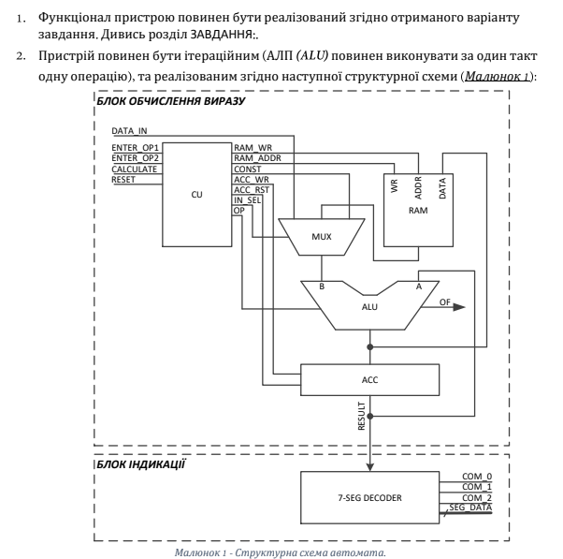

**Завдання**



**Виконання роботи:**

**Файл CU.vhd:**

----------------------------------------------------------------------------------

-- Company:

-- Engineer:

--

-- Create Date: 16:27:31 04/27/2023

-- Design Name:

-- Module Name: CU - Behavioral

-- Project Name:

-- Target Devices:

-- Tool versions:

-- Description:

--

-- Dependencies:

--

-- Revision:

-- Revision 0.01 - File Created

-- Additional Comments:

--

----------------------------------------------------------------------------------

library IEEE;

use IEEE.STD_LOGIC_1164.ALL;

-- Uncomment the following library declaration if using

-- arithmetic functions with Signed or Unsigned values

use IEEE.NUMERIC_STD.ALL;

use IEEE.STD_LOGIC_UNSIGNED.ALL;

-- Uncomment the following library declaration if instantiating

-- any Xilinx primitives in this code.

--library UNISIM;

--use UNISIM.VComponents.all;

entity CU_intf is

port(CLOCK : IN STD_LOGIC;

RESET : IN STD_LOGIC;

ENTER_OP1 : IN STD_LOGIC;

ENTER_OP2 : IN STD_LOGIC;

CALCULATE : IN STD_LOGIC;

RAM_WR : OUT STD_LOGIC;

RAM_ADDR_BUS : OUT STD_LOGIC_VECTOR(1 downto 0);

CONSTANT_BUS : OUT STD_LOGIC_VECTOR(7 downto 0):= "00000010";

ACC_WR : OUT STD_LOGIC;

ACC_RST : OUT STD_LOGIC;

IN_SEL : OUT STD_LOGIC_VECTOR(1 downto 0);

OP_CODE_BUS : OUT STD_LOGIC_VECTOR(1 downto 0)

);

end CU_intf;

architecture CU_arch of CU_intf is

type cu_state_type is (cu_rst, cu_idle, cu_load_op1, cu_load_op2, cu_run_calc0, cu_run_calc1, cu_run_calc2, cu_run_calc3, cu_finish);

signal cu_cur_state : cu_state_type;

signal cu_next_state : cu_state_type;

begin

CONSTANT_BUS <= "00000010";

CU_SYNC_PROC: process (CLOCK)

begin

if (rising_edge(CLOCK)) then

if (RESET = '1') then

cu_cur_state <= cu_rst;

else

cu_cur_state <= cu_next_state;

end if;

end if;

end process;

CUNEXT_STATE_DECODE: process (cu_cur_state, ENTER_OP1, ENTER_OP2, CALCULATE)

begin

--declare default state for next_state to avoid latches

cu_next_state <= cu_cur_state; --default is to stay in current state

--insert statements to decode next_state

--below is a simple example

case(cu_cur_state) is

when cu_rst =>

cu_next_state <= cu_idle;

when cu_idle =>

if (ENTER_OP1 = '1') then

cu_next_state <= cu_load_op1;

elsif (ENTER_OP2 = '1') then

cu_next_state <= cu_load_op2;

elsif (CALCULATE = '1') then

cu_next_state <= cu_run_calc0;

else

cu_next_state <= cu_idle;

end if;

when cu_load_op1 =>

cu_next_state <= cu_idle;

when cu_load_op2 =>

cu_next_state <= cu_idle;

when cu_run_calc0 =>

cu_next_state <= cu_run_calc1;

when cu_run_calc1 =>

cu_next_state <= cu_run_calc2;

when cu_run_calc2 =>

cu_next_state <= cu_run_calc3;

when cu_run_calc3 =>

cu_next_state <= cu_finish;

when cu_finish =>

cu_next_state <= cu_finish;

when others =>

cu_next_state <= cu_idle;

end case;

end process;

CU_OUTPUT_DECODE: process (cu_cur_state)

begin

case(cu_cur_state) is

when cu_rst =>

IN_SEL <= "00";

OP_CODE_BUS <= "00";

RAM_ADDR_BUS <= "00";

RAM_WR <= '0';

ACC_RST <= '1';

ACC_WR <= '0';

when cu_idle =>

IN_SEL <= "00";

OP_CODE_BUS <= "00";

RAM_ADDR_BUS <= "00";

RAM_WR <= '0';

ACC_RST <= '0';

ACC_WR <= '0';

when cu_load_op1 =>

IN_SEL <= "00";

OP_CODE_BUS <= "00";

RAM_ADDR_BUS <= "00";

RAM_WR <= '1';

ACC_RST <= '0';

ACC_WR <= '1';

when cu_load_op2 =>

IN_SEL <= "00";

OP_CODE_BUS <= "00";

RAM_ADDR_BUS <= "01";

RAM_WR <= '1';

ACC_RST <= '0';

ACC_WR <= '1';

when cu_run_calc0 =>

IN_SEL <= "01";

OP_CODE_BUS <= "00";

RAM_ADDR_BUS <= "00";

RAM_WR <= '0';

ACC_RST <= '0';

ACC_WR <= '1';

when cu_run_calc1 =>

IN_SEL <= "10";

OP_CODE_BUS <= "11";

RAM_ADDR_BUS <= "01";

RAM_WR <= '0';

ACC_RST <= '0';

ACC_WR <= '1';

when cu_run_calc2 =>

IN_SEL <= "01";

OP_CODE_BUS <= "10";

RAM_ADDR_BUS <= "01";

RAM_WR <= '0';

ACC_RST <= '0';

ACC_WR <= '1';

when cu_run_calc3 =>

IN_SEL <= "11";

OP_CODE_BUS <= "01";

RAM_ADDR_BUS <= "01";

RAM_WR <= '0';

ACC_RST <= '0';

ACC_WR <= '1';

when cu_finish =>

IN_SEL <= "00";

OP_CODE_BUS <= "00";

RAM_ADDR_BUS <= "00";

RAM_WR <= '0';

ACC_RST <= '0';

ACC_WR <= '0';

when others =>

IN_SEL <= "00";

OP_CODE_BUS <= "00";

RAM_ADDR_BUS <= "00";

RAM_WR <= '0';

ACC_RST <= '0';

ACC_WR <= '0';

end case;

end process;

end CU_arch;

**Елемент CU:**

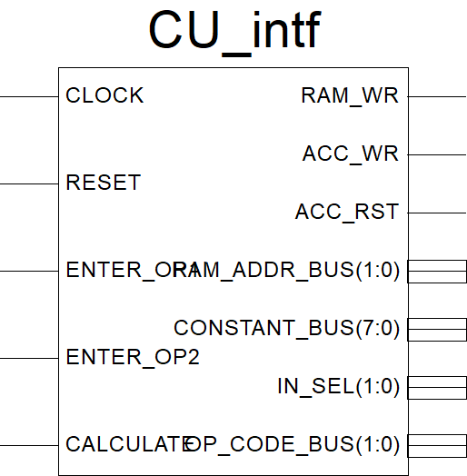

**Файл MUX.vhd:**

----------------------------------------------------------------------------------

-- Company:

-- Engineer:

--

-- Create Date: 15:06:55 04/27/2023

-- Design Name:

-- Module Name: MUX - Behavioral

-- Project Name:

-- Target Devices:

-- Tool versions:

-- Description:

--

-- Dependencies:

--

-- Revision:

-- Revision 0.01 - File Created

-- Additional Comments:

--

----------------------------------------------------------------------------------

library IEEE;

use IEEE.STD_LOGIC_1164.ALL;

-- Uncomment the following library declaration if using

-- arithmetic functions with Signed or Unsigned values

use IEEE.NUMERIC_STD.ALL;

use IEEE.STD_LOGIC_UNSIGNED.ALL;

-- Uncomment the following library declaration if instantiating

-- any Xilinx primitives in this code.

--library UNISIM;

--use UNISIM.VComponents.all;

entity MUX_intf is

port(

DATA_IN : IN STD_LOGIC_VECTOR(7 downto 0);

CONSTANT_BUS : IN STD_LOGIC_VECTOR(7 downto 0);

RAM_DATA_OUT_BUS: IN STD_LOGIC_VECTOR(7 downto 0);

IN_SEL : IN STD_LOGIC_VECTOR(1 downto 0);

IN_SEL_OUT_BUS : OUT std_logic_vector(7 downto 0)

);

end MUX_intf;

architecture MUX_arch of MUX_intf is

begin

INSEL_A_MUX : process(DATA_IN, CONSTANT_BUS, RAM_DATA_OUT_BUS, IN_SEL)

begin

if(IN_SEL = "00") then

IN_SEL_OUT_BUS <= DATA_IN;

elsif(IN_SEL = "01") then

IN_SEL_OUT_BUS <= RAM_DATA_OUT_BUS;

elsif(IN_SEL = "10") then

IN_SEL_OUT_BUS <= CONSTANT_BUS;

else

IN_SEL_OUT_BUS <= STD_LOGIC_VECTOR(CONSTANT_BUS + CONSTANT_BUS);

end if;

end process INSEL_A_MUX;

end MUX_arch;

**Елемент MUX:**

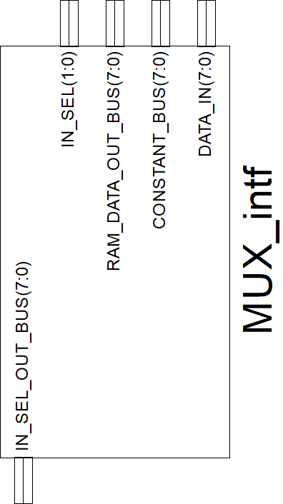

**Файл RAM.vhd:**

----------------------------------------------------------------------------------

-- Company:

-- Engineer:

--

-- Create Date: 16:49:14 04/27/2023

-- Design Name:

-- Module Name: RAM - Behavioral

-- Project Name:

-- Target Devices:

-- Tool versions:

-- Description:

--

-- Dependencies:

--

-- Revision:

-- Revision 0.01 - File Created

-- Additional Comments:

--

----------------------------------------------------------------------------------

library IEEE;

use IEEE.STD_LOGIC_1164.ALL;

-- Uncomment the following library declaration if using

-- arithmetic functions with Signed or Unsigned values

use IEEE.NUMERIC_STD.ALL;

use IEEE.STD_LOGIC_UNSIGNED.ALL;

-- Uncomment the following library declaration if instantiating

-- any Xilinx primitives in this code.

--library UNISIM;

--use UNISIM.VComponents.all;

entity RAM_intf is

port(

RAM_WR : IN STD_LOGIC;

RAM_ADDR_BUS : IN STD_LOGIC_VECTOR(1 downto 0);

ACC_DATA_IN_BUS : IN STD_LOGIC_VECTOR(7 downto 0);

RAM_DATA_OUT_BUS: OUT STD_LOGIC_VECTOR(7 downto 0);

CLOCK : IN STD_LOGIC

);

end RAM_intf;

architecture RAM_arch of RAM_intf is

type ram_type is array (3 downto 0) of STD_LOGIC_VECTOR(7 downto 0);

signal RAM_UNIT : ram_type;

signal RAM_DATA_IN_BUS : STD_LOGIC_VECTOR(7 downto 0);

begin

RAM_DATA_IN_BUS <= ACC_DATA_IN_BUS;

RAM : process(CLOCK, RAM_ADDR_BUS, RAM_UNIT)

begin

if (rising_edge(CLOCK)) then

if (RAM_WR = '1') then

RAM_UNIT(conv_integer(RAM_ADDR_BUS)) <= RAM_DATA_IN_BUS;

end if;

end if;

RAM_DATA_OUT_BUS <= RAM_UNIT(conv_integer(RAM_ADDR_BUS));

end process RAM;

end RAM_arch;

**Елемент RAM:**

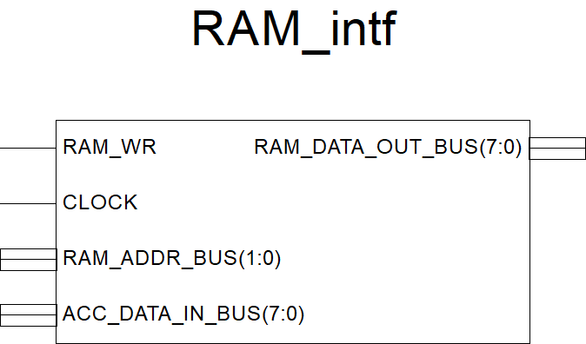

**Файл ALU.vhd:**

----------------------------------------------------------------------------------

-- Company:

-- Engineer:

--

-- Create Date: 16:13:46 04/27/2023

-- Design Name:

-- Module Name: ALU - Behavioral

-- Project Name:

-- Target Devices:

-- Tool versions:

-- Description:

--

-- Dependencies:

--

-- Revision:

-- Revision 0.01 - File Created

-- Additional Comments:

--

----------------------------------------------------------------------------------

library IEEE;

use IEEE.STD_LOGIC_1164.ALL;

-- Uncomment the following library declaration if using

-- arithmetic functions with Signed or Unsigned values

use IEEE.NUMERIC_STD.ALL;

use IEEE.STD_LOGIC_UNSIGNED.ALL;

-- Uncomment the following library declaration if instantiating

-- any Xilinx primitives in this code.

--library UNISIM;

--use UNISIM.VComponents.all;

entity ALU_intf is

port(

IN_SEL_OUT_BUS : IN STD_LOGIC_VECTOR(7 downto 0);

ACC_DATA_OUT_BUS : IN STD_LOGIC_VECTOR(7 downto 0);

OP_CODE_BUS : IN STD_LOGIC_VECTOR(1 downto 0);

ACC_DATA_IN_BUS : OUT STD_LOGIC_VECTOR(7 downto 0);

OVER_FLOW : OUT STD_LOGIC

--OF - overflow

);

end ALU_intf;

architecture ALU_arch of ALU_intf is

begin

ALU : process(OP_CODE_BUS, IN_SEL_OUT_BUS, ACC_DATA_OUT_BUS)

variable A : unsigned(7 downto 0);

variable B : unsigned(7 downto 0);

variable temp : std_logic_vector(8 downto 0);

begin

A := unsigned(ACC_DATA_OUT_BUS);

B := unsigned(IN_SEL_OUT_BUS);

if OP_CODE_BUS = "00" then

ACC_DATA_IN_BUS <= STD_LOGIC_VECTOR(B);

elsif OP_CODE_BUS = "01" then

temp := STD_LOGIC_VECTOR('0' & A) + STD_LOGIC_VECTOR('0' & B);

if (temp(8) = '1') then

OVER_FLOW <= '1';

else

OVER_FLOW <= '0';

end if;

ACC_DATA_IN_BUS <= temp(7 downto 0);

elsif OP_CODE_BUS = "01" then

temp := STD_LOGIC_VECTOR('0' & A) - STD_LOGIC_VECTOR('0' & B);

if (temp(8) = '1') then

OVER_FLOW <= '1';

else

OVER_FLOW <= '0';

end if;

ACC_DATA_IN_BUS <= temp(7 downto 0);

elsif OP_CODE_BUS = "11" then

case(B) is --case(B) is

when x"00" => ACC_DATA_IN_BUS <= STD_LOGIC_VECTOR(A sll 0);

when x"01" => ACC_DATA_IN_BUS <= STD_LOGIC_VECTOR(A sll 1);

when x"02" => ACC_DATA_IN_BUS <= STD_LOGIC_VECTOR(A sll 2);

when x"03" => ACC_DATA_IN_BUS <= STD_LOGIC_VECTOR(A sll 3);

when x"04" => ACC_DATA_IN_BUS <= STD_LOGIC_VECTOR(A sll 4);

when x"05" => ACC_DATA_IN_BUS <= STD_LOGIC_VECTOR(A sll 5);

when x"06" => ACC_DATA_IN_BUS <= STD_LOGIC_VECTOR(A sll 6);

when x"07" => ACC_DATA_IN_BUS <= STD_LOGIC_VECTOR(A sll 7);

when others => ACC_DATA_IN_BUS <= STD_LOGIC_VECTOR(A sll 0);

end case;

else

ACC_DATA_IN_BUS <= "00000000";

end if;

end process ALU;

end ALU_arch;

**Елемент ALU:**

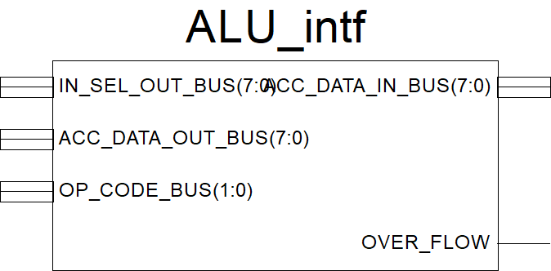

**Файл ACC.vhd:**

----------------------------------------------------------------------------------

-- Company:

-- Engineer:

--

-- Create Date: 15:27:57 04/27/2023

-- Design Name:

-- Module Name: ACC - Behavioral

-- Project Name:

-- Target Devices:

-- Tool versions:

-- Description:

--

-- Dependencies:

--

-- Revision:

-- Revision 0.01 - File Created

-- Additional Comments:

--

----------------------------------------------------------------------------------

library IEEE;

use IEEE.STD_LOGIC_1164.ALL;

-- Uncomment the following library declaration if using

-- arithmetic functions with Signed or Unsigned values

use IEEE.NUMERIC_STD.ALL;

use IEEE.STD_LOGIC_UNSIGNED.ALL;

-- Uncomment the following library declaration if instantiating

-- any Xilinx primitives in this code.

--library UNISIM;

--use UNISIM.VComponents.all;

entity ACC_intf is

port(

CLOCK : IN STD_LOGIC;

ACC_RST : IN STD_LOGIC;

ACC_WR : IN STD_LOGIC;

ACC_DATA_IN_BUS : IN STD_LOGIC_VECTOR(7 downto 0);

ACC_DATA_OUT_BUS : OUT STD_LOGIC_VECTOR(7 downto 0)

);

end ACC_intf;

architecture ACC_arch of ACC_intf is

signal ACC_DATA : STD_LOGIC_VECTOR(7 downto 0);

begin

ACC : process(CLOCK, ACC_DATA)

begin

if (rising_edge(CLOCK)) then

if(ACC_RST = '1') then

ACC_DATA <= "00000000";

elsif (ACC_WR = '1') then

ACC_DATA <= ACC_DATA_IN_BUS;

end if;

end if;

ACC_DATA_OUT_BUS <= ACC_DATA;

end process ACC;

end ACC_arch;

**Елемент ACC:**

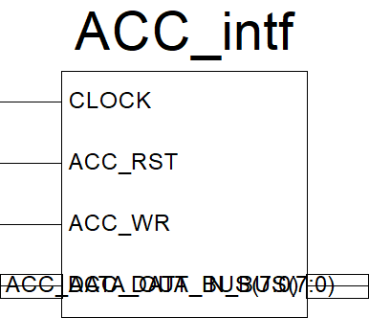

**Файл SEGDEC.vhd:**

----------------------------------------------------------------------------------

----------------------------------------------------------------------------------

library IEEE;

use IEEE.STD_LOGIC_1164.ALL;

-- Uncomment the following library declaration if using

-- arithmetic functions with Signed or Unsigned values

use IEEE.NUMERIC_STD.ALL;

use IEEE.STD_LOGIC_UNSIGNED.ALL;

-- Uncomment the following library declaration if instantiating

-- any Xilinx primitives in this code.

--library UNISIM;

--use UNISIM.VComponents.all;

entity SEGDEC_intf is

port(

CLOCK : IN STD_LOGIC;

ACC_DATA_OUT_BUS : IN STD_LOGIC_VECTOR(7 downto 0);

RESET : IN STD_LOGIC;

OverFlow_IN : IN STD_LOGIC;

COMM_ONES : OUT STD_LOGIC;

COMM_DECS : OUT STD_LOGIC;

COMM_HUNDREDS : OUT STD_LOGIC;

SEG_A : OUT STD_LOGIC;

SEG_B : OUT STD_LOGIC;

SEG_C : OUT STD_LOGIC;

SEG_D : OUT STD_LOGIC;

SEG_E : OUT STD_LOGIC;

SEG_F : OUT STD_LOGIC;

SEG_G : OUT STD_LOGIC;

DP : OUT STD_LOGIC;

OverFlow_OUT : OUT STD_LOGIC := '0'

);

end SEGDEC_intf;

architecture SEGDEC_arch of SEGDEC_intf is

signal ONES_BUS : STD_LOGIC_VECTOR(3 downto 0) := "0000";

signal DECS_BUS : STD_LOGIC_VECTOR(3 downto 0) := "0000";

signal HONDREDS_BUS : STD_LOGIC_VECTOR(3 downto 0) := "0000";

begin

OVERFLOW_INDICATE : process(OverFlow_IN, RESET)

begin

--if rising_edge(CLOCK) then

if (RESET = '1') then

OverFlow_OUT <= '0';

elsif (RESET = '0' and OverFlow_IN = '1') then

OverFlow_OUT <= '1';

end if;

--end if;

end process OVERFLOW_INDICATE;

BIN_TO_BCD : process (ACC_DATA_OUT_BUS)

variable hex_src : STD_LOGIC_VECTOR(7 downto 0) ;

variable bcd : STD_LOGIC_VECTOR(11 downto 0) ;

begin

bcd := (others => '0') ;

hex_src := ACC_DATA_OUT_BUS;

for i in hex_src'range loop

if bcd(3 downto 0) > "0100" then

bcd(3 downto 0) := bcd(3 downto 0) + "0011" ;

end if ;

if bcd(7 downto 4) > "0100" then

bcd(7 downto 4) := bcd(7 downto 4) + "0011" ;

end if ;

if bcd(11 downto 8) > "0100" then

bcd(11 downto 8) := bcd(11 downto 8) + "0011" ;

end if ;

bcd := bcd(10 downto 0) & hex_src(hex_src'left) ; -- shift bcd + 1 new entry

hex_src := hex_src(hex_src'left - 1 downto hex_src'right) & '0' ; -- shift src + pad with 0

end loop ;

HONDREDS_BUS <= bcd (11 downto 8);

DECS_BUS <= bcd (7 downto 4);

ONES_BUS <= bcd (3 downto 0);

end process BIN_TO_BCD;

INDICATE : process(CLOCK)

type DIGIT_TYPE is (ONES, DECS, HUNDREDS);

variable CUR_DIGIT : DIGIT_TYPE := ONES;

variable DIGIT_VAL : STD_LOGIC_VECTOR(3 downto 0) := "0000";

variable DIGIT_CTRL : STD_LOGIC_VECTOR(6 downto 0) := "0000000";

variable COMMONS_CTRL : STD_LOGIC_VECTOR(2 downto 0) := "000";

begin

if (rising_edge(CLOCK)) then

if(RESET = '0') then

case CUR_DIGIT is

when ONES =>

DIGIT_VAL := ONES_BUS;

CUR_DIGIT := DECS;

COMMONS_CTRL := "001";

when DECS =>

DIGIT_VAL := DECS_BUS;

CUR_DIGIT := HUNDREDS;

COMMONS_CTRL := "010";

when HUNDREDS =>

DIGIT_VAL := HONDREDS_BUS;

CUR_DIGIT := ONES;

COMMONS_CTRL := "100";

when others =>

DIGIT_VAL := ONES_BUS;

CUR_DIGIT := ONES;

COMMONS_CTRL := "000";

end case;

case DIGIT_VAL is --abcdefg

when "0000" => DIGIT_CTRL := "1111110";

when "0001" => DIGIT_CTRL := "0110000";

when "0010" => DIGIT_CTRL := "1101101";

when "0011" => DIGIT_CTRL := "1111001";

when "0100" => DIGIT_CTRL := "0110011";

when "0101" => DIGIT_CTRL := "1011011";

when "0110" => DIGIT_CTRL := "1011111";

when "0111" => DIGIT_CTRL := "1110000";

when "1000" => DIGIT_CTRL := "1111111";

when "1001" => DIGIT_CTRL := "1111011";

when others => DIGIT_CTRL := "0000000";

end case;

else

DIGIT_VAL := ONES_BUS;

CUR_DIGIT := ONES;

COMMONS_CTRL := "000";

end if;

COMM_ONES <= COMMONS_CTRL(0);

COMM_DECS <= COMMONS_CTRL(1);

COMM_HUNDREDS <= COMMONS_CTRL(2);

SEG_A <= DIGIT_CTRL(6);

SEG_B <= DIGIT_CTRL(5);

SEG_C <= DIGIT_CTRL(4);

SEG_D <= DIGIT_CTRL(3);

SEG_E <= DIGIT_CTRL(2);

SEG_F <= DIGIT_CTRL(1);

SEG_G <= DIGIT_CTRL(0);

DP <= '0';

end if;

end process INDICATE;

end SEGDEC_arch;

**Елемент SEGDEC:**

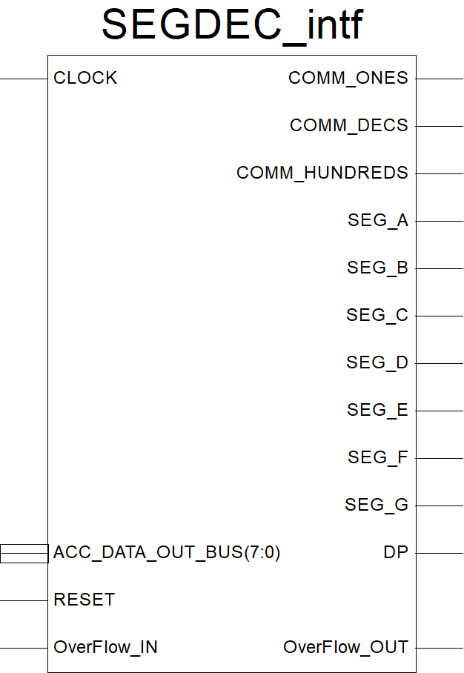

**Схема для Top Level:**

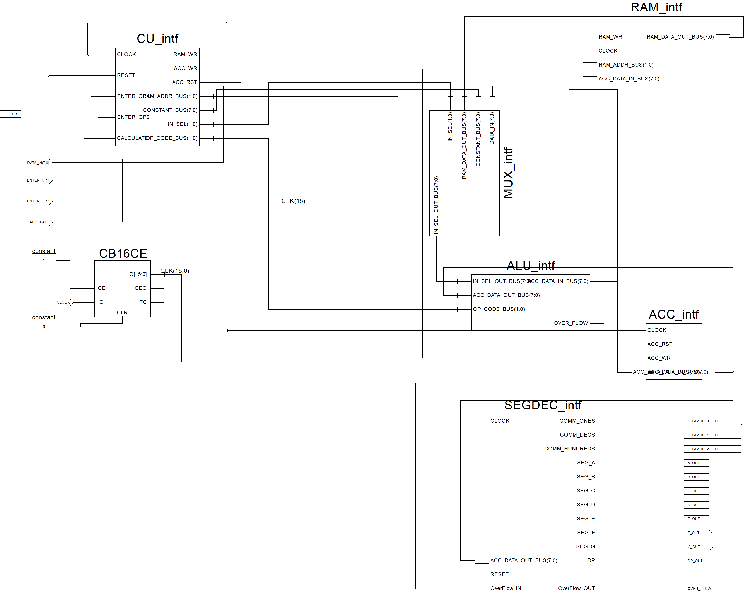

**Файл Constraints.ucf:**

#**************************************************************************************************************************************************#

# UCF for ElbertV2 Development Board #

#**************************************************************************************************************************************************#

CONFIG VCCAUX = "3.3" ;

# Clock 12 MHz

NET "CLOCK" LOC = P129 | IOSTANDARD = LVCMOS33 | PERIOD = 12MHz;

####################################################################################################

# LED

####################################################################################################

NET "OVERFLOW" LOC = P46 | IOSTANDARD = LVCMOS33 | SLEW = SLOW | DRIVE = 12;

####################################################################################################

# Seven Segment Display

####################################################################################################

NET "A_OUT" LOC = P117 | IOSTANDARD = LVCMOS33 | SLEW = SLOW | DRIVE = 12;

NET "B_OUT" LOC = P116 | IOSTANDARD = LVCMOS33 | SLEW = SLOW | DRIVE = 12;

NET "C_OUT" LOC = P115 | IOSTANDARD = LVCMOS33 | SLEW = SLOW | DRIVE = 12;

NET "D_OUT" LOC = P113 | IOSTANDARD = LVCMOS33 | SLEW = SLOW | DRIVE = 12;

NET "E_OUT" LOC = P112 | IOSTANDARD = LVCMOS33 | SLEW = SLOW | DRIVE = 12;

NET "F_OUT" LOC = P111 | IOSTANDARD = LVCMOS33 | SLEW = SLOW | DRIVE = 12;

NET "G_OUT" LOC = P110 | IOSTANDARD = LVCMOS33 | SLEW = SLOW | DRIVE = 12;

NET "DP_OUT" LOC = P114 | IOSTANDARD = LVCMOS33 | SLEW = SLOW | DRIVE = 12;

NET "COMMON_2_OUT" LOC = P124 | IOSTANDARD = LVCMOS33 | SLEW = SLOW | DRIVE = 12;

NET "COMMON_1_OUT" LOC = P121 | IOSTANDARD = LVCMOS33 | SLEW = SLOW | DRIVE = 12;

NET "COMMON_0_OUT" LOC = P120 | IOSTANDARD = LVCMOS33 | SLEW = SLOW | DRIVE = 12;

####################################################################################################

# DP Switches

####################################################################################################

NET "DATA_IN(0)" LOC = P70 | PULLUP | IOSTANDARD = LVCMOS33 | SLEW = SLOW | DRIVE = 12;

NET "DATA_IN(1)" LOC = P69 | PULLUP | IOSTANDARD = LVCMOS33 | SLEW = SLOW | DRIVE = 12;

NET "DATA_IN(2)" LOC = P68 | PULLUP | IOSTANDARD = LVCMOS33 | SLEW = SLOW | DRIVE = 12;

NET "DATA_IN(3)" LOC = P64 | PULLUP | IOSTANDARD = LVCMOS33 | SLEW = SLOW | DRIVE = 12;

NET "DATA_IN(4)" LOC = P63 | PULLUP | IOSTANDARD = LVCMOS33 | SLEW = SLOW | DRIVE = 12;

NET "DATA_IN(5)" LOC = P60 | PULLUP | IOSTANDARD = LVCMOS33 | SLEW = SLOW | DRIVE = 12;

NET "DATA_IN(6)" LOC = P59 | PULLUP | IOSTANDARD = LVCMOS33 | SLEW = SLOW | DRIVE = 12;

NET "DATA_IN(7)" LOC = P58 | PULLUP | IOSTANDARD = LVCMOS33 | SLEW = SLOW | DRIVE = 12;

####################################################################################################

# Switches

####################################################################################################

NET "ENTER_OP1" LOC = P80 | PULLUP | IOSTANDARD = LVCMOS33 | SLEW = SLOW | DRIVE = 12;

NET "ENTER_OP2" LOC = P79 | PULLUP | IOSTANDARD = LVCMOS33 | SLEW = SLOW | DRIVE = 12;

NET "CALCULATE" LOC = P78 | PULLUP | IOSTANDARD = LVCMOS33 | SLEW = SLOW | DRIVE = 12;

NET "RESET" LOC = P75 | PULLUP | IOSTANDARD = LVCMOS33 | SLEW = SLOW | DRIVE = 12;

####################################################################################################

**Файл TestTopLevel.vhd:**

-- Vhdl test bench created from schematic D:\Lab_3_Example\TopLevel.sch - Mon May 01 21:40:52 2023

--

-- Notes:

-- 1) This testbench template has been automatically generated using types

-- std_logic and std_logic_vector for the ports of the unit under test.

-- Xilinx recommends that these types always be used for the top-level

-- I/O of a design in order to guarantee that the testbench will bind

-- correctly to the timing (post-route) simulation model.

-- 2) To use this template as your testbench, change the filename to any

-- name of your choice with the extension .vhd, and use the "Source->Add"

-- menu in Project Navigator to import the testbench. Then

-- edit the user defined section below, adding code to generate the

-- stimulus for your design.

--

LIBRARY ieee;

USE ieee.std_logic_1164.ALL;

USE ieee.numeric_std.ALL;

LIBRARY UNISIM;

USE UNISIM.Vcomponents.ALL;

ENTITY TopLevel_TopLevel_sch_tb IS

END TopLevel_TopLevel_sch_tb;

ARCHITECTURE behavioral OF TopLevel_TopLevel_sch_tb IS

COMPONENT TopLevel

PORT( RESE : IN STD_LOGIC;

ENTER_OP1 : IN STD_LOGIC;

ENTER_OP2 : IN STD_LOGIC;

CALCULATE : IN STD_LOGIC;

COMMON_0_OUT : OUT STD_LOGIC;

COMMON_1_OUT : OUT STD_LOGIC;

COMMON_2_OUT : OUT STD_LOGIC;

A_OUT : OUT STD_LOGIC;

B_OUT : OUT STD_LOGIC;

C_OUT : OUT STD_LOGIC;

D_OUT : OUT STD_LOGIC;

E_OUT : OUT STD_LOGIC;

F_OUT : OUT STD_LOGIC;

G_OUT : OUT STD_LOGIC;

DP_OUT : OUT STD_LOGIC;

CLOCK : IN STD_LOGIC;

DATA_IN : IN STD_LOGIC_VECTOR (7 DOWNTO 0);

OVER_FLOW : OUT STD_LOGIC);

END COMPONENT;

signal op1 : STD_LOGIC_VECTOR(7 DOWNTO 0);

signal op2 : STD_LOGIC_VECTOR(7 DOWNTO 0);

SIGNAL RESE : STD_LOGIC;

SIGNAL ENTER_OP1 : STD_LOGIC;

SIGNAL ENTER_OP2 : STD_LOGIC;

SIGNAL CALCULATE : STD_LOGIC;

SIGNAL COMMON_0_OUT : STD_LOGIC;

SIGNAL COMMON_1_OUT : STD_LOGIC;

SIGNAL COMMON_2_OUT : STD_LOGIC;

SIGNAL A_OUT : STD_LOGIC;

SIGNAL B_OUT : STD_LOGIC;

SIGNAL C_OUT : STD_LOGIC;

SIGNAL D_OUT : STD_LOGIC;

SIGNAL E_OUT : STD_LOGIC;

SIGNAL F_OUT : STD_LOGIC;

SIGNAL G_OUT : STD_LOGIC;

SIGNAL DP_OUT : STD_LOGIC;

SIGNAL CLOCK : STD_LOGIC;

SIGNAL DATA_IN : STD_LOGIC_VECTOR (7 DOWNTO 0);

SIGNAL OVER_FLOW : STD_LOGIC;

constant CLK_period: time := 1 us;

constant TC_period: time := 65536 us;

BEGIN

UUT: TopLevel PORT MAP(

RESE => RESE,

ENTER_OP1 => ENTER_OP1,

ENTER_OP2 => ENTER_OP2,

CALCULATE => CALCULATE,

COMMON_0_OUT => COMMON_0_OUT,

COMMON_1_OUT => COMMON_1_OUT,

COMMON_2_OUT => COMMON_2_OUT,

A_OUT => A_OUT,

B_OUT => B_OUT,

C_OUT => C_OUT,

D_OUT => D_OUT,

E_OUT => E_OUT,

F_OUT => F_OUT,

G_OUT => G_OUT,

DP_OUT => DP_OUT,

CLOCK => CLOCK,

DATA_IN => DATA_IN,

OVER_FLOW => OVER_FLOW

);

CLK_process : process

begin

CLOCK <= '1';

wait for CLK_period/2;

CLOCK <= '0';

wait for CLK_period/2;

end process CLK_process;

stim_proc: process

begin

RESE <= '1';

ENTER_OP1 <= '0';

ENTER_OP2 <= '0';

CALCULATE <= '0';

DATA_IN <=(others => '0');

wait for 2*CLK_period;

RESE <='0';

wait for 4*TC_period;

ENTER_OP1 <='1';

DATA_IN <= op1;

wait for 2*TC_period;

ENTER_OP1 <='0';

wait for 4*TC_period;

ENTER_OP2 <='1';

DATA_IN <= op2;

wait for 2*TC_period;

ENTER_OP2 <='0';

wait for 4*TC_period;

CALCULATE <= '1';

wait for 8*TC_period;

wait;

end process stim_proc; --1.835 s

END;

Перевірка результату

OP1=00001000;

OP2=00000101;

((OP1 << 2) – OP2) + 4 = 00011111;

1) OP1 << 2= 00001000 + 00000010 = 00100000;

2) (OP1 << 2) – OP2 = 00100000 - 00000101 = 00011011;

3) ((OP1 << 2) – OP2) + 4 = 00011011 + 00000100 = 00011111;

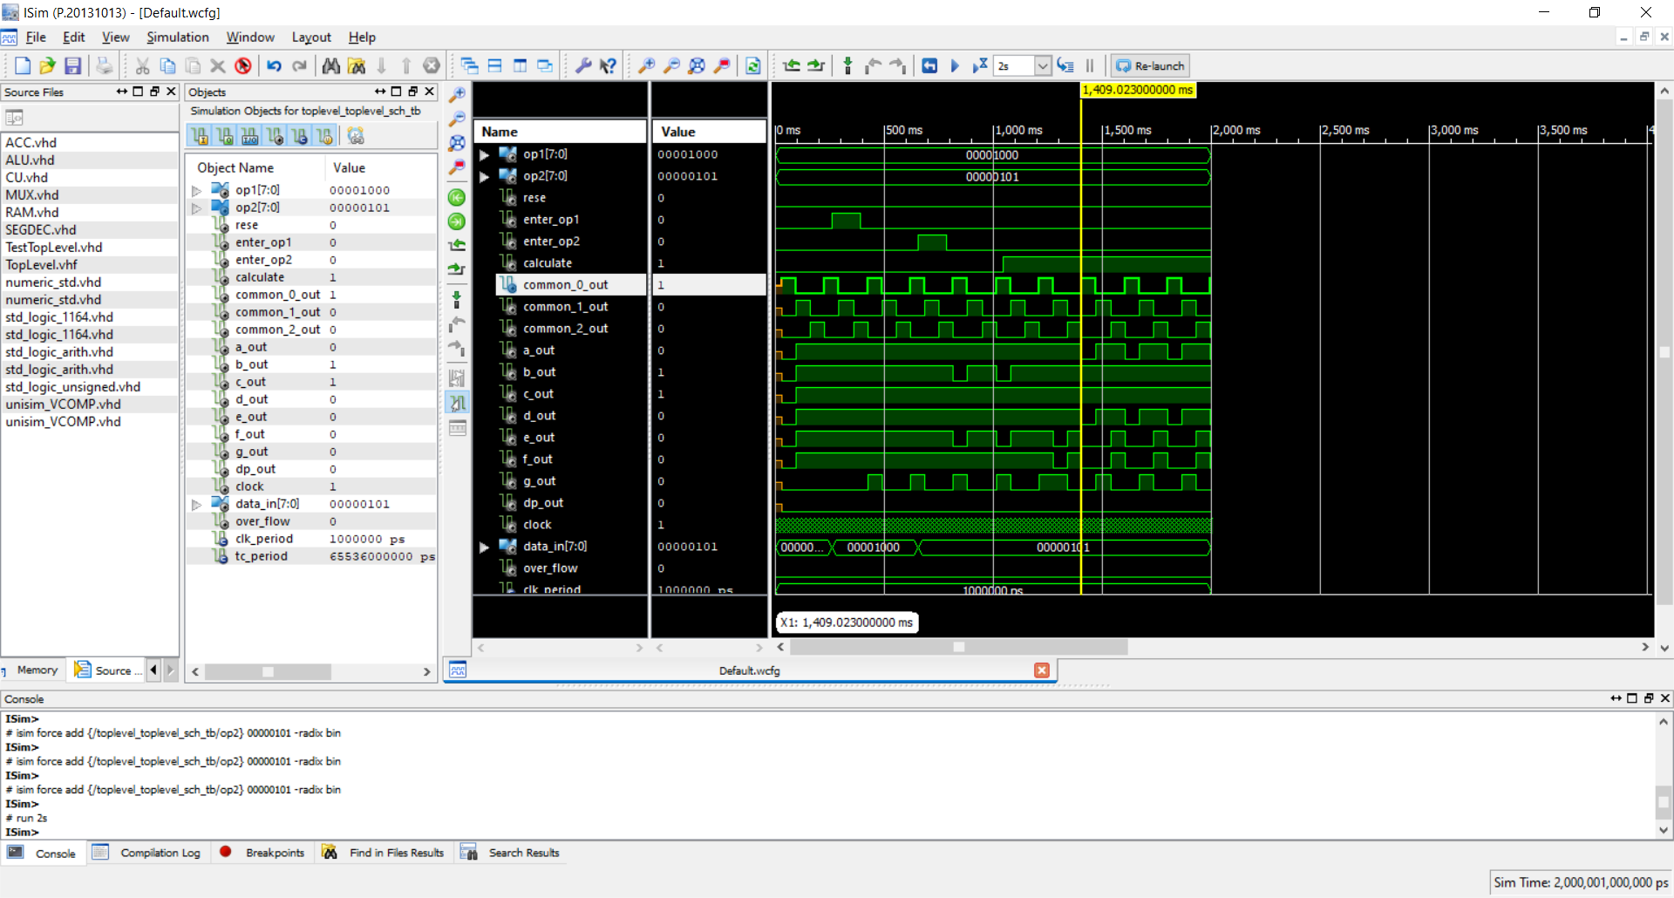

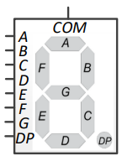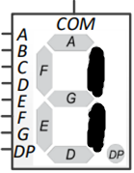

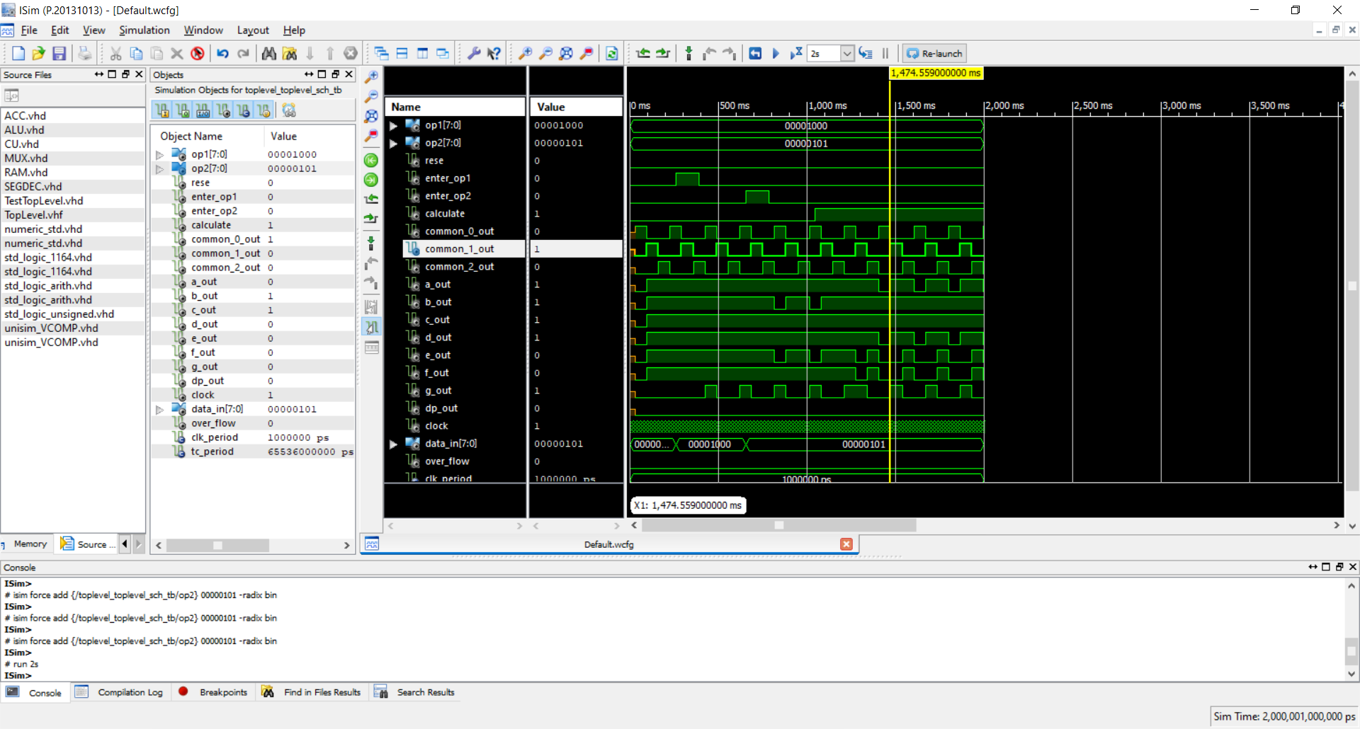

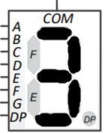

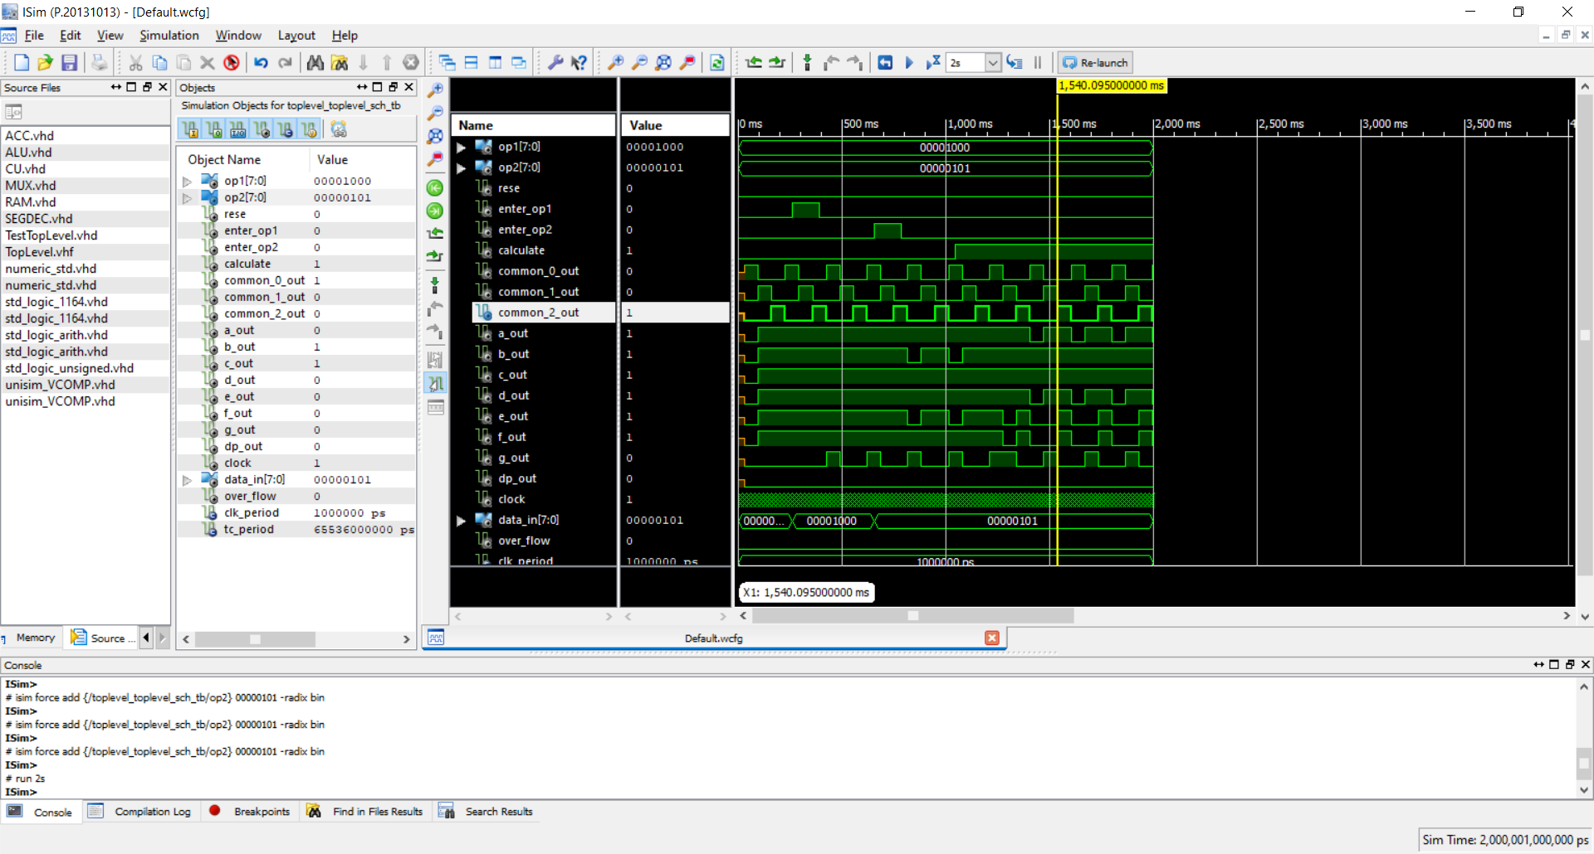

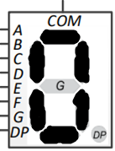

**Висновок:** Під час даної лабораторної роботи, я на базі стенда Elbert V2 – Spartan 3A FPGA, реалізувала цифровий автомат для обчислення значення заданого виразу.