**METABOLIC CHARACTERIZATION OF NEUROGENETIC DISORDERS INVOLVING GLUTAMATERGIC NEUROTRANSMISSION**

Sofía Illescas, Yaiza Diaz-Osorio, Anna Serradell, Lucía Toro, Natalia Juliá-Palacios, Juliana Ribeiro-Constante, Xavier Altafaj, Mireia Olivella, Mar O’Callaghan, Alejandra Darling, Judith Armstrong, Rafael Artuch, Àngels García-Cazorla (*), Alfonso Oyarzábal (*)

FILIACIONES

(*) co-corresponding

Word count (excluding bibliography): 4411 words.

Number of figures and tables: 5 figures + 1 table

Supplementary figures and tables: 1 supp figure + 1 supp table

# ABSTRACT

The study of inborn errors of neurotransmission has been mostly focused on monoamine disorders, GABAergic and glycinergic defects. The study of the glutamatergic synapse using the same approach than classic neurotransmitter disorders is challenging due to the lack of biomarkers in the CSF. However, a metabolomic approach can provide both insight into their molecular basis and outline novel therapeutic alternatives.

We have performed a semi-targeted metabolomic analysis on CSF samples from 25 patients with neurogenetic disorders with an important expression in the glutamatergic synapse and 5 controls. Samples from patients diagnosed with MECP2, CDKL5, GRINpathies and STXBP1 related encephalopathies were included. We have performed univariate (UVA) and multivariate statistical analysis (MVA), using Wilcoxon rank-sum test, principal component analysis (PCA), and oPLS-DA. By using the results of both analyses, we have identified the metabolites that were significantly altered and that were important in the separation of the respective groups. On these, we performed pathway- and network-based analyses to define which metabolic pathways were possibly altered in each pathology.

We have observed alterations in the tryptophan, phenylalanine and branched-chain amino acid metabolism pathways, which interestingly depend on the same transporter to cross the blood-brain barrier (BBB). Analysis of the expression of LAT1 transporter in brain samples from a mouse model of Rett syndrome (MECP2) revealed a decrease in the transporter expression, that was already noticeable at pre-symptomatic stages.

The study of the glutamatergic synapse from this perspective advances the understanding of their pathophysiology, shining light on an under-studied feature as is their metabolic component.

# SYNOPSIS

Metabolic characterization of glutamatergic synapse disorders reveals alterations in tryptophan metabolism, which study can unveil new therapeutic targets.

# GENERAL CONSIDERATIONS

**CONTRIBUTIONS OF INDIVIDUAL AUTHORS:**

Sofía Illescas (SI): Performed the data analysis and interpretation. Manuscript drafting.

Yaiza Diaz-Osorio (YDO): Data analysis. Samples preparation and interpretation. Manuscript drafting.

Anna Serradell (AS): Western Blot experiments. Manuscript drafting.

Lucía Toro (LT): Western Blot experiments. Manuscript drafting.

Natalia Julià-Palacios (NJP): Clinical care and assessment of the patients. Manuscript drafting.

Juliana Ribeiro-Constante (JRC): Clinical care and assessment of the patients. Manuscript drafting.

Xavier Altafaj (XA): Evaluation of the impact of GRIN mutations. Manuscript drafting.

Mireia Olivella (MO): Evaluation of the impact of GRIN mutations. Manuscript drafting.

Mar O’Callaghan (MO’C): Clinical care and assessment of the patients. Manuscript drafting.

Alejandra Darling (AD): Clinical care and assessment of the patients. Manuscript drafting.

Judith Armstrong (JA): Genetic diagnosis of the patients. Manuscript drafting.

Rafael Artuch (RA): Biochemical analysis in CSF. Manuscript drafting.

Àngels García-Cazorla (AGC): Study conceptualization, clinical care and assessment of the patients and funding acquisition. Manuscript writing

Alfonso Oyarzábal (AO): Study conceptualization, data interpretation, manuscript writing.

**AUTHORS WHO SERVES AS GUARANTOR FOR THE ARTICLE**: Alfonso Oyarzabal and Àngels García-Cazorla

**COMPETING INTEREST STATEMENT**:

All the authors confirm absence of any competing interest and independence from the sponsors. The content of the article has not been influenced by the sponsors.

**FUNDING INFORMATION**:

This work has been funded with a FI21/0073 and “Instituto de Salud Carlos III (ISCIII)” and “Fondo Europeo de desarrollo regional (FEDER)” grant.

**ETHICS APPROVAL**:

All parents or legal representatives of the patients gave written informed consent. This study was approved by the local institutional ethics committee (Sant Juan de Déu Hospital ID number: PIC-131-18). All research work has been carried away following the principles under the Helsinki declaration.

No vertebrate animals have been sacrificed ad hoc for this study. However, mouse brain protein samples, surpluses from other projects, have been used. Such extraction was made under approval from Committee for Animal Experimentation of Universitat de Barcelona.

**KEY WORDS:**

Neurodevelopmental diseases, metabolomics, tryptophan, Rett syndrome, SLC7A5.

**DATA AVAILABILITY:**

Metabolomic raw data will be shared after publication upon request

# INTRODUCTION

Biochemical pathways of neurotransmission and their related diseases have been well-described during the last couple of decades. This group of disorders constitute what the scientific community considers as inborn errors of neurotransmission and mainly involve disorders of monoaminergic, GABAergic and glycinergic neurotransmission. These diseases are characterized by the detection of abnormal concentration of metabolites that belong to these pathways. Glutamatergic neurotransmission has been poorly considered in this category of disorders probably because no validated markers have been described so far as possible biochemical signatures. However, glutamatergic signaling is the most abundant form of synaptic communication leading to the development of crucial functions in the brain such as excitability and neuronal plasticity. Therefore, it is not surprising that glutamatergic neurotransmission has been described to be impaired in a plethora of diseases with different clinical presentations, ranging from attention deficit, intellectual disability or autism spectrum disorders (ASDs) to other monogenic diseases as Rett or Fragile X syndromes 1–6. For example, several studies have found the excitatory neurotransmitter glutamate to be increased in the blood and brain tissue of ASD patients, leading to the hypothesis that some types of ASD is caused by an increase in the excitation/inhibition (E/I) ratio due to either a lack of GABA-ergic neurons or a deficiency in their activity 6–9. Similarly, Rett syndrome (RTT) patients and animal models have shown higher levels of glutamate and a reduced expression of metabotropic glutamate receptors 5 and 7 (mGlu5, mGlu7) 10,11, together with a clear involvement of the GABAergic system12.

A systematic review of disorders of the glutamatergic synapse has found around 80 different genetic disorders that are localized in the glutamatergic synapse (i.e: receptors, pre-synaptic and post-synaptic pathways) leading to impaired glutamatergic transmission (Ribeiro-Constante et al, in preparation). Neurophysiological studies in cellular and animal models have been the bases so far to determine how glutamatergic transmission is disturbed in these neuro genetic conditions.

Omic technologies are emerging as useful approaches to complex diseases, advancing in their description and identification of biomarkers 13–17. Metabolomics is a relatively new area of research that can capture patient-specific variation such as response to treatment, exposure to environmental conditions, or disease progression, which makes it a promising avenue for personalized medicine 18,19. One of the main advantages of metabolomics is that it offers a more accurate picture of the phenotype. It allows researchers to study not only the information encoded in the genome of a patient, but also the effect that genomic, proteomic regulation have on its expression.

In this work we have studied the metabolic profile of patients affected with different genetic neurodevelopmental disorders (NDDs) in which glutamatergic neurotransmission has been proposed as a major event in the disease progression, comparing patients CSF samples with healthy controls. The joint study of different pathologies that display common molecular features has helped on the identification of shared pathophysiological mechanisms, common to neurodevelopmental diseases.

# MATERIALS AND METHODS

**PATIENTS AND SAMPLES**

Cerebrospinal fluid (CSF) was collected from a total of 25 patients and 5 healthy controls as previously reported20–22. The metabolomic study was done on the last fraction collected (being the others used for biochemistry studies, neurotransmitters detection, pterins and amino acids). Patients presented mutations in genes that have been widely reported to involve glutamatergic transmission: *CDKL5* (n=2), *GRIN* (n=7), *MECP2* (n=12), and *STXBP1* (n=4). The median age at the time of collection was 6 years, ranging from 1 to 18 years old, as seen in Table 1. The majority of patients were female (n=19) due to the large proportion of Rett syndrome patients that were included in this study.

All samples were obtained under the ethical approval of the Ethics Committee of Hospital Sant Joan de Déu.

**METABOLOMICS ANALYSIS:**

Samples were sent to the Centre for Omic Sciences (COS) Joint Unit of the Universitat Rovira i Virgili-Eurecat, where a targeted metabolomics analysis was conducted by liquid chromatography with tandem mass spectrometry (LC-MS-MS) for tryptophan related metabolites and acylcarnitines. Gas chromatography–mass spectrometry (GC-MS) was performed for organic acids and sugar metabolites related to energy metabolism and the TCA cycle. A total of 82 metabolites were detected, and the results were presented as micromolar (μM) concentrations.

**LC-MS/MS:** CSF (50 μL) samples were diluted in methanol (200 μL, 100%) and the set of labelled internal standards (DL-Kynurenine, DL-Tryptophan, 5-Hydroxyindole-3-acetic acid, L-Citrulline, 2-Picolinic acid, Nicotinic acid, Kynurenic acid, Indole-3-acetic acid (Sigma Aldrich); Serotonin hydrochloride, rac Kynurenine-d4 Trifluoroacetic Acid Salt, D-Tryptophan-d5, 5-Hydroxyindole-3-Acetic Acid-d2 (5-HIAA-d2), Serotonin-d4 Hydrochloride, 2-Picolinic-d4 Acid, Nicotinic acid-d4, 3-Hydroxyanthranilic acid, 3-Hydroxyanthranilic acid-d3, Kynurenic acid-d5, Indole-2,4,5,6,7-d5-3-acetic-α,α-d2 Acid, 3-Indolepropionic-d2 Acid, N-Acetyl-5-hydroxytryptamine (Toronto Research Chemicals); Trigonelline Hydrochloride (TCI); Anthranilic acid (Glentham life sciences); Hydrocortisone, Androstenedione, Testosterone, Progesterone (Sigma Aldrich and Toronto Research Chemicals). Following centrifugation (10 min, 15000 rpm, 4ºC), the supernatant was dried in a SpeedVac concentrator and reconstituted in methanol (50 μL, 100%).

The equipment consisted on an UHPLC 1290 Infinity II Series coupled to a QqQ/MS 6490 Series (Agilent Technologies) and a Kinetex 2.6 μm Polar C18, 100 Å, 150 x 2.1 mm (Phenomenex) analytical column. Chromatographic separation was performed in mode negative electrospray ionization (ESI) at 20ºC with an injection volume of 1 μL. Mobile phase A was formic acid (0.1%) and mobile phase B was methanol:formic acid (10:1, v/v).

**GC-MS:** CSF (50 μL) samples were diluted in water:methanol (200 μL, 8:2, v/v) and the set of labelled internal standards (Succinic-d4 acid, myristic-d27 acid, d-glucose 13C6 and L-Methionine-(carboxy-13C,methyl-d3) (Sigma Aldrich)). Following centrifugation (5 min, 15000 rpm, 4ºC), the supernatants were dried in a SpeedVac concentrator at 45ºC and reconstituted in methoxyamine (30 μL, 100%). Samples were incubated at 37ºC for 90 min. and then silylated with 45 μL of MSTFA + 1 % at room temperature for 60 min.

The separation was performed on a GC-QTOF 7200 and a HP5-MS UI capillary column (30 m x 250 μm I.D., 0.25 μm film thickness), both from Agilent Technologies. Helium (>99.999%) was used as the carrier gas with a constant flow 1.1 mL/min. Initial oven temperature was set at 60ºC, then increased by 10ºC/min. to 320ºC and held constant for 10 min. Samples were injected in split mode 1:20 at injection temperature 250ºC. Compounds were detected through MS in electron ionization (70 eV) and full-scan monitoring mode (m/z 50–600) mode with an acquisition rate of 5 spectra/s. Ion source temperature was 250ºC and quadrupole temperature was 200ºC.

Organic acids were identified and semi-quantified using the spectra library Fiehn-pct-2013 and their pure analytical standards (Pyruvic acid, lactic acid, glycolic acid, 3-hydroxybutyric acid, glycerol, succinic acid, glyceric acid, fumaric acid, malic acid, d-threitol, threonic acid, α-ketoglutaric acid, arabitol, glycerol-1-phosphate, 3-phosphoglyceric acid, citric acid, d-mannitol, myo-inositol, glucose-6-phosphate, d-sucrose and α-tocopherol (Sigma Aldrich)).

**STATISTICAL ANALYSIS**

The goal of the analysis was to compare the metabolic profiles of patients to those of healthy controls. All statistical tests were conducted in R version 4.3.0. Metabolic profiles of patients were compared to those of health controls, either all together or categorized on the glutamatergic behavior of the disease (hypo-glutamatergic diseases vs hyper-glutamatergic + GABAergic).

The metabolite concentrations were log2-transformed in order to account for the expected high variability and noise found in metabolomics data. Multivariate statistical methods were applied on the transformed data in order to account for the small sample size and the inherent multicollinearity of the data. Unsupervised principal component analysis (PCA) was performed in order to obtain an overall view of the variation between samples and their separation into clusters. Ward hierarchical clustering with Euclidian distance combined with a heatmap (pheatmap version 1.0.12) was used to compare the log-transformed concentrations of all the analyzed metabolites in patients and controls. Orthogonal partial least-squares discriminant analysis (OPLS-DA) from the ropls package (version 1.32.0) was used as a supervised model to identify metabolites responsible for group separation. Models were evaluated by goodness of fit (R2Y), goodness of prediction (Q2Y), and the root mean square error of estimation (RMSEE). 7-fold cross-validation was performed to mitigate the risk of overfitting caused by the high dimensionality of the data. Metabolites were selected based on their variable importance in projection (VIP) scores (VIP > 1). Permutation testing (n=1000) was used to determine the statistical significance of the results (p<0.05).

The results of the classification models were corroborated by performing Wilcoxon Mann–Whitney tests comparing each metabolite concentration in patients and in controls. The non-parametric test was chosen due to the small number of samples. Correction for the false discovery rate (FDR) was applied in order to account for the issue of multiple testing (p<0.05).

Pathway analysis was performed for metabolites with p<0.05 or VIP score > 1 using the Kyoto Encyclopedia of Genes and Genomes (KEGG) database and the KEGGREST package (version 1.40.0). Pathways were identified as important when two or more of their metabolite components were found to be altered between the disease groups and the healthy controls. The results were plotted after excluding pathways that are ubiquitous or unrelated to synaptic metabolism. Special attention was given to the tryptophan metabolism pathway, as well as to the amino acid substrates of Large Neutral Amino Acid Transporter (LAT1).

**WESTERN BLOT**

Proteins were extracted from brain isolates through a 30’ cold incubation with RIPA and protease inhibitors. Following extraction, proteins were quantified by Bradford method and prepared at a homogenous concentration in Laemmli Buffer in reductive denaturing conditions and subjected to SDS-PAGE and transferred to a nitrocellulose membrane. Membranes were blocked with TBS-Tween (0.05%): milk 5% for 1h at room temperature. Primary antibodies were incubated O/N at 4ºC in blocking buffer, at the following concentrations: SLC7A5 (1:2000, 28670, Proteintech). Tubulin (1:50,000, ab7291, Abcam) was used as a loading control. The secondary antibodies used were HRP-conjugated goat anti-Rabbit and goat anti-Mouse IgG antibodies (Thermo Fisher) and were detected using the PierceTM ECL Western Blotting substrate (Thermo Fisher). Quantification of protein expression was performed using Fiji software.

Both B6.129P2(C)-*Mecp2tm1.1Bird*/J and control littermates mice were used. To increase the translational value of the work, only female mice have been used, as they have been reported to better recapitulate the disease phenotype. Mice were housed in standard cages with ad libitum access to food and water and in controlled environmental conditions of light (12 h dark/light cycle starting at 7:30 am), temperature (22°C) and humidity (60%). Mice were genotyped following the provider recommendations.

# RESULTS

Cerebrospinal fluid (CSF) samples were collected from 29 individuals with four different disease related to glutamatergic neurotransmission (Figure 1A):

- Mutations in genes affecting glutamate/GABAergic balance: 12 patients with Rett syndrome (bearing mutations in MECP2) and 2 with CDKL5 deficiency.

- Mutations in genes leading to hypoglutamatergic function: A total of 10 patients, 6 GRIN patients with mutations functionally annotated as loss-of-function and 4 STXP1 patients. GRIN patients bore mutations in either *GRIN1* or *GRIN2B*, that encode GluN1 and GluN2B subunit of NMDA receptors respectively, and LoF mutations in result in reduced transmission in response to glutamate activation23, leading to a neurodevelopmental disorder characterized by developmental delay, intellectual disability and epilepsy24,25. On the other hand, STXBP1 participates in the regulation of synaptic vesicle docking and fusion in the presynaptic terminal, and mutations affecting their expression have been associated with a globally reduced glutamatergic neurotransmission26,27.

- We have included 5 controls obtained from children who were visited in the emergency department of our hospital and underwent a lumbar puncture for a clinical suspicion of meningitis/encephalitis being finally this hypothesis not confirmed due to a CSF study negative for microbiology tests and with a normal cytology and biochemistry.

All patients and controls were within pediatric age, ranging from 2 to 15 years old. Patients and controls from both genders were included, though the majority were female because of the higher prevalence of RTT on girls. Summary of mutations and clinical characteristics has been summarized in Table 1.

All CSF samples were subjected to a semi-targeted metabolomic analysis, through which we measured the concentrations of metabolites related with energy and amino acids metabolism, with a special coverage of tryptophan and tyrosine metabolism. DOUBT- The total concentration of metabolites detected was similar among all samples, giving confidence in the results and in the differences observed in each population. The analysis identified a total of 68 metabolites (Supplementary Table 1). Dimensionality reduction through Principal Component Analysis (PCA) revealed that, despite some crossovers, patients from both groups were more similar to each other than to the controls, as they assembled in two different clusters (Figure 1B). This profile was maintained after separating RTT and hypo-glutamatergic patients (Figure 1C,D), where again, both CDKL5 and MeCP2 patients, as well as STXBP1 and GRIN2B patients were more similar to each other than to controls. Hierarchical clustering with Ward’s method criterion, a clustering algorithm that finds groups with the least internal variance, was performed using all the analyzed metabolites. This revealed that both groups had a similar underlying structure, with two main clusters containing metabolic alterations, that are consistent across these different pathologies.

In order to overcome the overlapping of controls and patients and to prioritize clinically relevant metabolic differences we performed feature selection through the supervised method Orthogonal Partial Least Squares Discriminant Analysis (OPLS-DA). This technique efficiently differentiated patients from controls in both scenarios (RTT and hypo-glutamatergic samples) (Figure 2A, B). The models showed a strong ability to discriminate between classes (R2Y=0.939and 0.960 for RTT and hypo-glutamatergic respectively), and a prediction accuracy ≥ 0.8 (Q2Y= 0.816 and 0.866) after permutation (n=1000).

The models identified possible shared metabolic pathways that contribute to their pathophysiology. Multivariate feature selection identified 18 influential metabolites for RTT patients and 17 for hypo-glutamatergic disorders (Figure 2C,D). Univariate hypothesis testing found 17 significantly altered metabolites in RTT and 7 in hypo-glutamatergic disorders. There were 10 metabolites in RTT and 7 in hypo-glutamatergic disorders that were selected by both methods (Figure 2E, F). Integrating the results of multivariate and univariate analysis, and performing hierarchical clustering including metabolites that had a *p* < 0.5 level or VIP score >1 resulted in perfect separation of patients and controls (Figure 2G-H).

To determine which pathways were most impacted by the alterations in metabolite concentrations, we assessed KEGG pathway over-representation for metabolites that had a *p* < 0.5 level or VIP score >1. The most affected pathways were related to amino acid metabolism and transport, including tryptophan and its metabolites. (Figure 3A).

In humans, tryptophan (Trp) metabolism can occur through two different pathways: the kynurenine pathway, through which Trp is degraded into kynurenic acid and 2-picolinic acid, and the serotonin pathway, converting Trp into 5-HT for final production of serotonin, metabolized into 5-hydroxyindoleacetic acid (5-HIAA) (Figure 4A). Several of these metabolites were found to be decreased in patients, although tryptophan itself was not. As shown in Figure 4B, even though there were no statistically significant differences in the concentration of tryptophan, we detected a tendency to decrease in the concentration of metabolites of both pathways. Samples from both groups showed a decrease in both kynurenine (RTT: 0.009 uM, hypo-glutamatergic: 0.008 uM, controls: 0.079 uM; median values) and kynurenic acid (RTT: 0.0004 uM, hypo-glutamatergic: 0.0002 uM, controls: 0.004 uM; median values), though only the RTT decrease in kynurenine was statistically significant. Moreover, both groups had significantly decreased concentrations of 5-hydroxy-3-indoleacetic acid (RTT: 0.109 uM, hypo-glutamatergic: 0.077 uM, controls: 0.436 uM; median values). 15 out of the 24 patients (62.5%) had reduced concentration of 5-HIAA in CSF (Table 1), measured by high-performance liquid chromatography with electrochemical detection and compared with age-matched reference values established by our laboratory (342 samples collected over the past 15 years). There was no correlation between the decrease in CSF [5-HIAA] and any drugs the patients were taking at the moment.

Interestingly, tryptophan and its metabolic derivatives were not the only ones with reduced concentrations in patients (Figure 4C). Both groups showed decreased concentrations of two of the three branched-chain amino acids (BCAAs) (Val: RTT: 51.154 uM, hypo-glutamatergic: 60.427 uM, controls: 65.424 uM; Leu: RTT: 28.775 uM, hypo-glutamatergic: 34.484 uM, controls: 45.910 uM; Ile: RTT: 8.409 uM, hypo-glutamatergic: 8.582 uM, controls: 9.461 uM; median values) . Similarly, phenylalanine was found to be significantly decreased in both groups (RTT: 23.920 uM, hypo-glutamatergic: 27.016 uM, controls: 89.806 uM; median values), while 4-hydroxyphenyllactic acid was only reduced in RTT patients (RTT: 1.453 uM, hypo-glutamatergic: 2.811 uM, controls: 2.470 uM; median values) In contrast, all patients showed threonine concentration values within a control-range (RTT: 114.431 uM, hypo-glutamatergic: 148.299 uM, controls: 137.977 uM; median values).

Valine, leucine, isoleucine, threonine, tryptophan, tyrosine, and phenylalanine, along with other large neutral amino acids, are preferentially transported across the blood-brain barrier through a facilitative Na+-independent transporter named LAT1 (system L Amino Acid transporter), coded by the *SLC7A5* gene. We investigated its expression in a model of RTT, the B6.129P2(C)-*Mecp2tm1.1Bird*/J female mice. Remarkably, brain samples from RTT female mice showed a significant decrease in the expression of LAT1, compared to littermate controls (Figure 5A,B). This was observed at two different neurodevelopmental stages, 3 and 7 months old mice, pointing towards a potential involvement of amino acid brain transport and metabolism in the pathophysiology of several neurodevelopmental diseases.

Although not profoundly studied in this paper, other metabolic routes appeared to be involved in the diseases’ pathophysiology. Besides amino acids metabolism, aminoacyl tRNA biosynthesis metabolism appeared over-represented. Other non- amino acids-related pathways included pentose phosphate pathway and TCA cycle, exemplifying the importance of energy and oxidative stress metabolism transversal to different neurodevelopmental diseases. Finally, metabolites such as indole-3-acetic and indole-3-propionic acids pointed towards a possible involvement of the gut microbiome and the gut-brain axis in neurodevelopmental disorders.

¿Hay alguna relación entre estos metabolitos y la edad, síntomas, gravedad, de los pacientes? ¿Se ha mirado?

# DISCUSSION

Defective glutamatergic neurotransmission is one of the main features outstanding in the pathophysiology of many genetic neurodevelopmental diseases, from loss-of-function mutations in *GRIN2B* that result in the inability of NMDA receptors to respond to glutamate neurotransmission25 to the unbalance between GABA and glutamate neurotransmission, characteristic in Rett syndrome12. Yet, other elements contribute to the landscape of neurodevelopmental diseases, such as inflammation 28–31, neuronal32,33and glia34 maturation or metabolism35 and neuroinmunometabolism36,37. Specifically, metabolic alterations are known to play key roles in the pathophysiology of neurodevelopmental diseases, and they have been explored in several non-metabolic diseases, such as Rett syndrome35,38, autism spectrum and psychiatric disorders or epileptic encephalopathies35. The study of metabolism in neurodevelopmental pathologies will favor not only the advance in the knowledge of these diseases, but also the identification of biomarkers and new therapeutic targets.

In our work we have studied the neurometabolic component of four neurodevelopmental diseases in which the main element of their pathophysiology is an altered glutamatergic neurotransmission. For that, we have analyzed cerebrospinal fluid 29 samples from patients and controls distributed in three different groups: a) patients with conditions associated to increased glutamatergic activity and unbalanced glutamate/GABAergic activity (mutations in *MECP2* and *CDKL5*), b) patients with encephalopathies associated to hypo-glutamatergic activity (with mutations in *STXBP1* and *GRIN1* and *GRIN2B* genes) and c) controls. One of the main objectives of this work is to understand whether the metabolic alterations associated with defects in glutamatergic neurotransmission may be common to several pathologies, or different for each clinical entity. As we are analyzing the metabolic profile of non-primary metabolic diseases, differences between patients and controls are expected to be subtle. Our study found that despite some overlapping between patients and controls when all metabolites were taken into account, patients clustered together regardless of mutation, pointing towards shared metabolic alterations underlying in their pathophysiology.

While studying these alterations in CSF can suppose a limitation to the study, especially due to the difficulty of obtaining samples from controls, it allows us to understand more accurately what is occurring in the brains of patients during the course of the disease15,17,39.Analysis of metabolic variations in patients and controls CSF has revealed common alterations that are shaping the pathophysiology of neurodevelopmental diseases. Integrating multivariate and univariate analysis identified 25 metabolites in Rett + CDKL5 and 17 in hypo-glutamatergic disorders that were contributing to their pathophysiology. Pathway analysis of our data showed that the metabolic routes differing between patients and controls were mostly involved in amino acid and energy metabolism, especially in tryptophan metabolism. The two groups of patients showed highly similar metabolic profiles, though several metabolites were identified as significant altered on Rett and CDKL5 but not on hypo-glutamatergic disorders. This could be explained due to the smaller number of hypo-glutamatergic patients that were available for the study. Further studies including larger cohort of these specific disorders will confirm and extend these results.

Previous work on the study of metabolic alterations in neurodevelopmental diseases has focused on pathways as energy metabolism, redox homeostasis or lipid metabolism, yet the role of amino acids metabolism in non-metabolic diseases has been understudied. Amino acids are essential players in brain function and development: besides protein synthesis, they act as neuromodulators and are the biosynthetic precursors of various neurotransmitters. Primary dysregulation of amino acids metabolism result in neurodevelopmental pathologies that exemplify their importance in the function of the developing brain. Such is the case of as Aromatic L-amino Acid Decarboxylase (AADC) deficiency, in which both tyrosine and tryptophan metabolism is impaired40,41, or BCAAs metabolism that can lead to Maple Syrup Urine Disease (MSUD)42 or to a treatable form of autism43. Given the importance of amino acids in the regulation of development and neurotransmission it is of great interest to study these pathways in pathologies whose main pathophysiological elements are not amino acid metabolism itself.

One of the metabolic routes in which we have found alterations common to all diseases studied is tryptophan metabolism. Tryptophan is an essential amino acid that is the precursor of several neuroactive compounds. The majority of tryptophan is catabolized through the kynurenine pathway, and on a lower rate, through the serotonin pathway, by which the neurotransmitter serotonin is synthesized 44. We have found a decrease in the concentration of different metabolites in both metabolic branches, as samples from all disease groups showed a reduction in both kynurenine and kynurenic acid concentrations, together with lowered concentrations of 5-hydroxy-3-indoleacetic acid. The decrease in 5-HIAA was confirmed by HPLC in 62.5% of the samples. Alterations in the kynurenine pathway have been previously reported in developmental and epileptic encephalopathy patients, in which abnormal concentration of neurotransmitter was identified in 33% of the samples, being 5-HIAA deficit was the most prevalent alteration (91%) 45. It has also being studied in other diseases with unclear genetic etiology as diverse as migraine, schizophrenia, suicidality or autism spectrum disorders 46–49.

Kynurenine pathway plays essential roles in cell function: it has a key function in energy metabolism by regulation of the coenzyme nicotinamide adenine dinucleotide (NAD+)50 and has been implicated in the process of inflammation 51,52, along with the neuroprotective role of kynurenic acid, an intermediate metabolite of the kynurenine pathway that acts as an antagonist to the N-methyl-D-aspartate receptors (NMDARs). Further studies in patients and animal models shall expand the knowledge of this downregulation and its direct relationship with glutamatergic neurotransmission, elucidating whether it is a cause of consequence of the pathology53. Aligned with that, it shall be explored whether the generalized tryptophan metabolism reduction is related with a reduced tryptophan brain availability due to increased peripheral kynurenine metabolism, associated with pro-inflammatory conditions54.

Alterations in tryptophan metabolism are often associated with alterations in other amino acids38. Specific analysis of the concentration of large neutral amino acids in our samples has revealed a generalized decrease in both disease groups. These are transported into the brain through the Large Neutral Amino Acids Transporter (LAT1, coded by the *SLC7A5* gene), responsible for the transport tryptophan and other amino acids such as BCAAs, threonine or phenylalanine. Besides amino acids transport, LAT1 has been reported to regulate Kv1.2 potassium channels55, modifying the functional outcomes of epilepsy-linked channelopathies56. On top of that, mutations *SLC7A5* (together with other variants in genes encoding for Large Amino Acid Transporters) increase the risk of Autism Spectrum Disorder57,58 and is essential for perinatal neuronal excitability59 and survival and granule cell development through mTOR regulation60. We have analyzed the transporter expression in brain tissue from a mouse model of Rett syndrome, noticing a decrease that was already detectable at pre-symptomatic stages. This is the first report to our knowledge of a reduced expression of this transporter in Rett syndrome. Further studies shall investigate the relationship between this and the decreased expression of other transporters and the blood-brain barrier integrity61, with the potential implications in brain metabolism.

Studying neurodevelopmental and neurotransmitter-related diseases under the metabolic prism advances on their knowledge from a transversal view, favoring the identification of biomarkers and shared pathophysiological features that can be addressed as new therapeutic targets. Our work highlights the importance of metabolism in the pathophysiology of diseases related to glutamatergic neurotransmission, focusing on tryptophan metabolism. The study in CSF allows us to understand more faithfully the metabolism of the developing brain, and will benefit from future work in extended series of patients. These results propose new questions that will mark future lines of work, such as their implication in other neurodevelopmental pathologies and the study of how these alterations can be used for therapeutic purposes.

Las enfermedades hipoglutamatérgicas conllevan una menor expresión del transportador de glucosa cerebral, ¿puede esto contribuir a unas alteraciones algo diferenciales en estas enfermedades?

Tal vez sería interesante en discutir lo que se ha hallado (si es que hay algo descrito) en las enfermedades que hemos estudiado: MECP2, CDKL5, GRIN….en modelos animales en cuanto a barrera hematoencefálica (por los transportadores), metab energético,etc…seguro no hay nada excepto en Rett y en hipofunción glutamatérgica también…

# BIBLIOGRAPHY

1. Thapar A, Cooper M, Rutter M. Neurodevelopmental disorders. *The lancet Psychiatry*. 2017;4(4):339-346. doi:10.1016/S2215-0366(16)30376-5

2. Parenti I, Rabaneda LG, Schoen H, Novarino G. Neurodevelopmental Disorders: From Genetics to Functional Pathways. *Trends Neurosci*. 2020;43(8):608-621. doi:10.1016/j.tins.2020.05.004

3. Wang H-T, Zhu Z-A, Li Y-Y, et al. CDKL5 deficiency in forebrain glutamatergic neurons results in recurrent spontaneous seizures. *Epilepsia*. 2021;62(2):517-528. doi:10.1111/epi.16805

4. Tang X, Jaenisch R, Sur M. The role of GABAergic signalling in neurodevelopmental disorders. *Nat Rev Neurosci*. 2021;22(5):290-307. doi:10.1038/s41583-021-00443-x

5. Chen GT, Geschwind DH. Challenges and opportunities for precision medicine in neurodevelopmental disorders. *Adv Drug Deliv Rev*. 2022;191:114564. doi:10.1016/j.addr.2022.114564

6. Lopatina OL, Malinovskaya NA, Komleva YK, et al. Excitation/inhibition imbalance and impaired neurogenesis in neurodevelopmental and neurodegenerative disorders. *Rev Neurosci*. 2019;30(8):807-820. doi:10.1515/revneuro-2019-0014

7. Rubenstein JLR, Merzenich MM. Model of autism: increased ratio of excitation/inhibition in key neural systems. *Genes Brain Behav*. 2003;2(5):255-267. doi:10.1034/j.1601-183x.2003.00037.x

8. Nelson SB, Valakh V. Excitatory/Inhibitory Balance and Circuit Homeostasis in Autism Spectrum Disorders. *Neuron*. 2015;87(4):684-698. doi:10.1016/j.neuron.2015.07.033

9. Uzunova G, Pallanti S, Hollander E. Excitatory/inhibitory imbalance in autism spectrum disorders: Implications for interventions and therapeutics. *world J Biol psychiatry Off J World Fed Soc Biol Psychiatry*. 2016;17(3):174-186. doi:10.3109/15622975.2015.1085597

10. Gogliotti RG, Senter RK, Rook JM, et al. mGlu5 positive allosteric modulation normalizes synaptic plasticity defects and motor phenotypes in a mouse model of Rett syndrome. *Hum Mol Genet*. 2016;25(10):1990-2004. doi:10.1093/hmg/ddw074

11. Gogliotti RG, Senter RK, Fisher NM, et al. mGlu(7) potentiation rescues cognitive, social, and respiratory phenotypes in a mouse model of Rett syndrome. *Sci Transl Med*. 2017;9(403). doi:10.1126/scitranslmed.aai7459

12. Ure K, Lu H, Wang W, et al. Restoration of Mecp2 expression in GABAergic neurons is sufficient to rescue multiple disease features in a mouse model of Rett syndrome. *Elife*. 2016;5:e14198. doi:10.7554/elife.14198

13. Tebani A, Afonso C, Marret S, Bekri S. Omics-Based Strategies in Precision Medicine: Toward a Paradigm Shift in Inborn Errors of Metabolism Investigations. *Int J Mol Sci*. 2016;17(9). doi:10.3390/ijms17091555

14. Heywood WE, Galimberti D, Bliss E, et al. Identification of novel CSF biomarkers for neurodegeneration and their validation by a high-throughput multiplexed targeted proteomic assay. *Mol Neurodegener*. 2015;10:64. doi:10.1186/s13024-015-0059-y

15. Wang T, Li C, Ma Y, et al. Metabolomics of cerebrospinal fluid reveals prognostic biomarkers in pediatric status epilepticus. *CNS Neurosci Ther*. Published online June 2023. doi:10.1111/cns.14312

16. Peters TMA, Merx J, Kooijman PC, et al. Novel cerebrospinal fluid biomarkers of glucose transporter type 1 deficiency syndrome: Implications beyond the brain’s energy deficit. *J Inherit Metab Dis*. 2023;46(1):66-75. doi:10.1002/jimd.12554

17. Peters TMA, Engelke UFH, de Boer S, et al. Confirmation of neurometabolic diagnoses using age-dependent cerebrospinal fluid metabolomic profiles. *J Inherit Metab Dis*. 2020;43(5):1112-1120. doi:10.1002/jimd.12253

18. Jacob M, Lopata AL, Dasouki M, Abdel Rahman AM. Metabolomics toward personalized medicine. *Mass Spectrom Rev*. 2019;38(3):221-238. doi:10.1002/mas.21548

19. Karczewski KJ, Snyder MP. Integrative omics for health and disease. *Nat Rev Genet*. 2018;19(5):299-310. doi:10.1038/nrg.2018.4

20. Batllori M, Molero-Luis M, Ormazabal A, et al. Cerebrospinal fluid monoamines, pterins, and folate in patients with mitochondrial diseases: systematic review and hospital experience. *J Inherit Metab Dis*. 2018;41(6):1147-1158. doi:10.1007/s10545-018-0224-x

21. Cortès-Saladelafont E, Molero-Luis M, Cuadras D, et al. Gamma-aminobutyric acid levels in cerebrospinal fluid in neuropaediatric disorders. *Dev Med Child Neurol*. 2018;60(8):780-792. doi:10.1111/dmcn.13746

22. Ormazabal A, García-Cazorla A, Fernández Y, Fernández-Alvarez E, Campistol J, Artuch R. HPLC with electrochemical and fluorescence detection procedures for the diagnosis of inborn errors of biogenic amines and pterins. *J Neurosci Methods*. 2005;142(1):153-158. doi:10.1016/j.jneumeth.2004.08.007

23. Sabo SL, Lahr JM, Offer M, Weekes ALA, Sceniak MP. GRIN2B-related neurodevelopmental disorder: current understanding of pathophysiological mechanisms. *Front Synaptic Neurosci*. 2022;14:1090865. doi:10.3389/fnsyn.2022.1090865

24. Platzer K, Lemke JR. GRIN2B-Related Neurodevelopmental Disorder. In: Adam MP, Mirzaa GM, Pagon RA, et al., eds. ; 1993.

25. García-Recio A, Santos-Gómez A, Soto D, et al. GRIN database: A unified and manually curated repertoire of GRIN variants. *Hum Mutat*. 2021;42(1):8-18. doi:10.1002/humu.24141

26. Miyamoto H, Tatsukawa T, Shimohata A, et al. Impaired cortico-striatal excitatory transmission triggers epilepsy. *Nat Commun*. 2019;10(1):1917. doi:10.1038/s41467-019-09954-9

27. Miyamoto H, Shimohata A, Abe M, et al. Potentiation of excitatory synaptic transmission ameliorates aggression in mice with Stxbp1 haploinsufficiency. *Hum Mol Genet*. 2017;26(24):4961-4974. doi:10.1093/hmg/ddx379

28. Pecorelli A, Cervellati C, Cordone V, Hayek J, Valacchi G. Compromised immune/inflammatory responses in Rett syndrome. *Free Radic Biol Med*. 2020;152:100-106. doi:10.1016/j.freeradbiomed.2020.02.023

29. Freitas BC, Beltrão-Braga PCB, Marchetto MC. Modeling Inflammation on Neurodevelopmental Disorders Using Pluripotent Stem Cells. *Adv Neurobiol*. 2020;25:207-218. doi:10.1007/978-3-030-45493-7_7

30. Wang L, Wang B, Wu C, Wang J, Sun M. Autism Spectrum Disorder: Neurodevelopmental Risk Factors, Biological Mechanism, and Precision Therapy. *Int J Mol Sci*. 2023;24(3). doi:10.3390/ijms24031819

31. Matta SM, Hill-Yardin EL, Crack PJ. The influence of neuroinflammation in Autism Spectrum Disorder. *Brain Behav Immun*. 2019;79:75-90. doi:10.1016/j.bbi.2019.04.037

32. Batool S, Raza H, Zaidi J, Riaz S, Hasan S, Syed NI. Synapse formation: from cellular and molecular mechanisms to neurodevelopmental and neurodegenerative disorders. *J Neurophysiol*. 2019;121(4):1381-1397. doi:10.1152/jn.00833.2018

33. Lim L, Mi D, Llorca A, Marín O. Development and Functional Diversification of Cortical Interneurons. *Neuron*. 2018;100(2):294-313. doi:10.1016/j.neuron.2018.10.009

34. Kim YS, Choi J, Yoon B-E. Neuron-Glia Interactions in Neurodevelopmental Disorders. *Cells*. 2020;9(10). doi:10.3390/cells9102176

35. A O, U M, Lf B, A G-C. Energy metabolism in childhood neurodevelopmental disorders. *EBioMedicine*. 2021;69:103474. doi:10.1016/j.ebiom.2021.103474

36. Mitra S, Banik A, Saurabh S, Maulik M, Khatri SN. Neuroimmunometabolism: A New Pathological Nexus Underlying Neurodegenerative Disorders. *J Neurosci Off J Soc Neurosci*. 2022;42(10):1888-1907. doi:10.1523/JNEUROSCI.0998-21.2022

37. Douglas A, Stevens B, Lynch L. Interleukin-17 as a key player in neuroimmunometabolism. *Nat Metab*. 2023;5(7):1088-1100. doi:10.1038/s42255-023-00846-3

38. Neul JL, Skinner SA, Annese F, et al. Metabolic Signatures Differentiate Rett Syndrome From Unaffected Siblings. *Front Integr Neurosci*. 2020;14:7. doi:10.3389/fnint.2020.00007

39. Mussap M, Antonucci R, Noto A, Fanos V. The role of metabolomics in neonatal and pediatric laboratory medicine. *Clin Chim Acta*. 2013;426:127-138. doi:10.1016/j.cca.2013.08.020

40. Wassenberg T, Molero-Luis M, Jeltsch K, et al. Consensus guideline for the diagnosis and treatment of aromatic l-amino acid decarboxylase (AADC) deficiency. *Orphanet J Rare Dis*. 2017;12(1):12. doi:10.1186/s13023-016-0522-z

41. Rizzi S, Spagnoli C, Frattini D, Pisani F, Fusco C. Clinical Features in Aromatic L-Amino Acid Decarboxylase (AADC) Deficiency: A Systematic Review. *Behav Neurol*. 2022;2022:2210555. doi:10.1155/2022/2210555

42. Strauss KA, Carson VJ, Soltys K, et al. Branched-chain α-ketoacid dehydrogenase deficiency (maple syrup urine disease): Treatment, biomarkers, and outcomes. *Mol Genet Metab*. 2020;129(3):193-206. doi:10.1016/j.ymgme.2020.01.006

43. Tangeraas T, Constante JR, Backe PH, et al. BCKDK deficiency: a treatable neurodevelopmental disease amenable to newborn screening. *Brain A J Neurol*. 2023;146(7):3003-3013. doi:10.1093/brain/awad010

44. Ruddick JP, Evans AK, Nutt DJ, Lightman SL, Rook GAW, Lowry CA. Tryptophan metabolism in the central nervous system: medical implications. *Expert Rev Mol Med*. 2006;8(20):1-27. doi:10.1017/S1462399406000068

45. Juliá-Palacios N, Molina-Anguita C, Sigatulina Bondarenko M, et al. Monoamine neurotransmitters in early epileptic encephalopathies: New insights into pathophysiology and therapy. *Dev Med Child Neurol*. 2022;64(7):915-923. doi:10.1111/dmcn.15140

46. Strasser B, Becker K, Fuchs D, Gostner JM. Kynurenine pathway metabolism and immune activation: Peripheral measurements in psychiatric and co-morbid conditions. *Neuropharmacology*. 2017;112(Pt B):286-296. doi:10.1016/j.neuropharm.2016.02.030

47. Bryleva EY, Brundin L. Suicidality and Activation of the Kynurenine Pathway of Tryptophan Metabolism. *Curr Top Behav Neurosci*. 2017;31:269-284. doi:10.1007/7854_2016_5

48. Lovelace MD, Varney B, Sundaram G, et al. Recent evidence for an expanded role of the kynurenine pathway of tryptophan metabolism in neurological diseases. *Neuropharmacology*. 2017;112(Pt B):373-388. doi:10.1016/j.neuropharm.2016.03.024

49. Fujigaki H, Yamamoto Y, Saito K. L-Tryptophan-kynurenine pathway enzymes are therapeutic target for neuropsychiatric diseases: Focus on cell type differences. *Neuropharmacology*. 2017;112(Pt B):264-274. doi:10.1016/j.neuropharm.2016.01.011

50. Castro-Portuguez R, Sutphin GL. Kynurenine pathway, NAD(+) synthesis, and mitochondrial function: Targeting tryptophan metabolism to promote longevity and healthspan. *Exp Gerontol*. 2020;132:110841. doi:10.1016/j.exger.2020.110841

51. Savitz J. The Kynurenine Pathway: A Finger in Every Pie. *Mol Psychiatry*. 2020;25(1):131-147. doi:10.1038/s41380-019-0414-4

52. Cervenka I, Agudelo LZ, Ruas JL. Kynurenines: Tryptophan’s metabolites in exercise, inflammation, and mental health. *Science*. 2017;357(6349). doi:10.1126/science.aaf9794

53. Joisten N, Ruas JL, Braidy N, Guillemin GJ, Zimmer P. The kynurenine pathway in chronic diseases: a compensatory mechanism or a driving force? *Trends Mol Med*. 2021;27(10):946-954. doi:10.1016/j.molmed.2021.07.006

54. Wang Q, Liu D, Song P, Zou M-H. Tryptophan-kynurenine pathway is dysregulated in inflammation, and immune activation. *Front Biosci (Landmark Ed*. 2015;20(7):1116-1143. doi:10.2741/4363

55. Lamothe SM, Sharmin N, Silver G, et al. Control of Slc7a5 sensitivity by the voltage-sensing domain of Kv1 channels. *Elife*. 2020;9. doi:10.7554/eLife.54916

56. Baronas VA, Yang RY, Morales LC, Sipione S, Kurata HT. Slc7a5 regulates Kv1.2 channels and modifies functional outcomes of epilepsy-linked channel mutations. *Nat Commun*. 2018;9(1):4417. doi:10.1038/s41467-018-06859-x

57. Tărlungeanu DC, Deliu E, Dotter CP, et al. Impaired Amino Acid Transport at the Blood Brain Barrier Is a Cause of Autism Spectrum Disorder. *Cell*. 2016;167(6):1481-1494.e18. doi:10.1016/j.cell.2016.11.013

58. Cascio L, Chen C-F, Pauly R, et al. Abnormalities in the genes that encode Large Amino Acid Transporters increase the risk of Autism Spectrum Disorder. *Mol Genet genomic Med*. 2020;8(1):e1036. doi:10.1002/mgg3.1036

59. Knaus LS, Basilico B, Malzl D, et al. Large neutral amino acid levels tune perinatal neuronal excitability and survival. *Cell*. 2023;186(9):1950-1967.e25. doi:10.1016/j.cell.2023.02.037

60. Sokolov AM, Holmberg JC, Feliciano DM. The amino acid transporter Slc7a5 regulates the mTOR pathway and is required for granule cell development. *Hum Mol Genet*. 2020;29(18):3003-3013. doi:10.1093/hmg/ddaa186

61. Pepe G, Fioriniello S, Marracino F, et al. Blood-Brain Barrier Integrity Is Perturbed in a Mecp2-Null Mouse Model of Rett Syndrome. *Biomolecules*. 2023;13(4). doi:10.3390/biom13040606

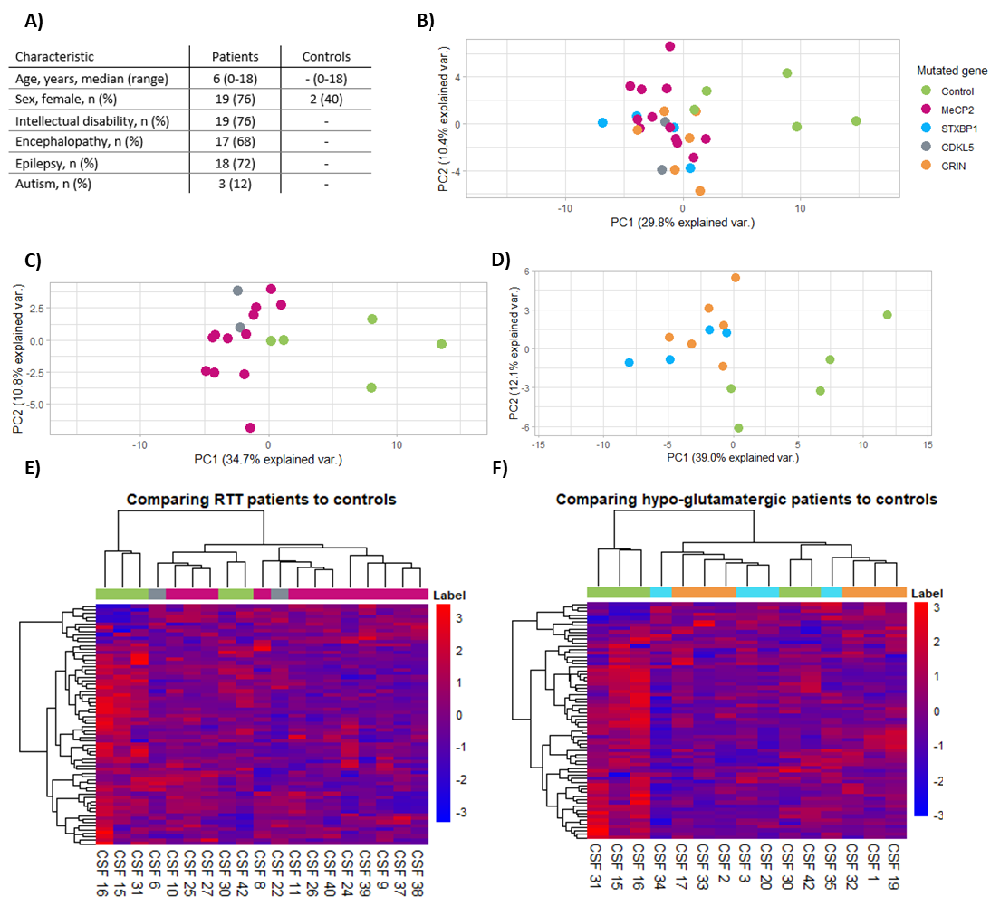FIGURES and FIGURE LEGENDS

**Figure 1. Unsupervised multivariate analysis of patient and control CSF metabolite concentrations. A- C. PCA score plots showing the separation of patients from controls on the first two principal components.** A) All samplesB) MeCP2 and CDKL5. C) hypo-glutamatergic. **D and E. Ward hierarchical clustering showing log-transformed metabolite concentrations.** Both MeCp2 /CDKL5 (C) and hypo-glutamatergic (D) patients form homogeneous groups regardless of genotype. There is some overlap with controls, but mostly patients cluster together and have a markedly decreased expression of most metabolites

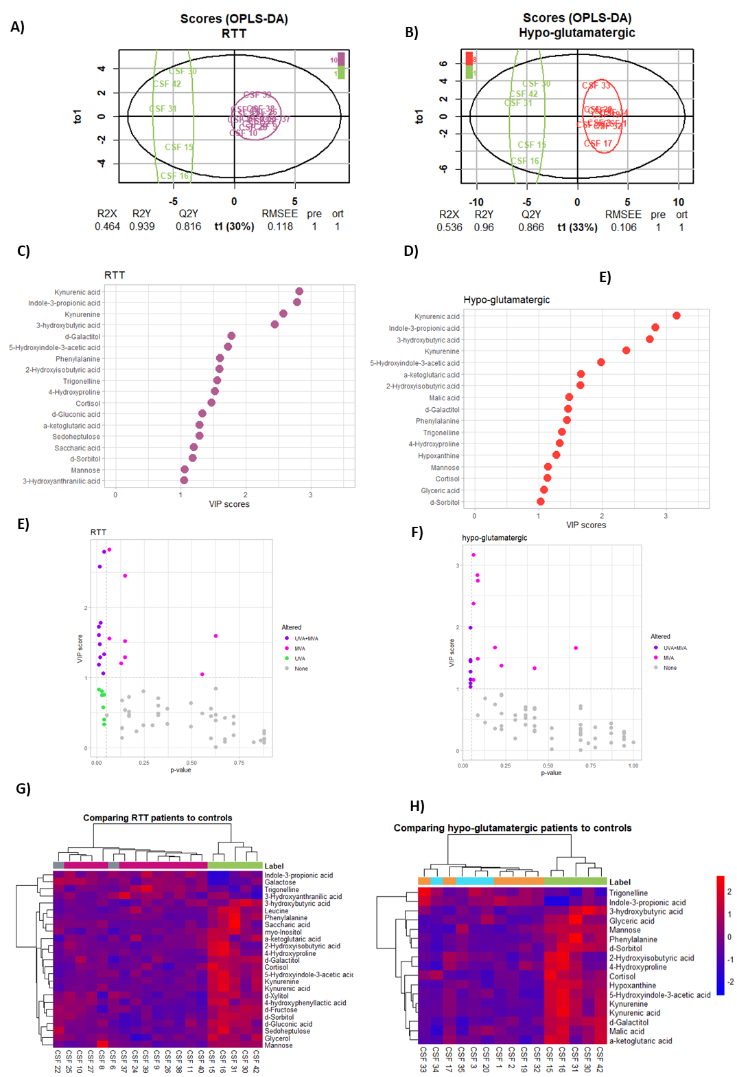

**Figure 2. Identification of significantly altered metabolites and their impact on group classification A-B)** OPLS-DA score plots showing separations of controls compared to **A)** **RTT** and **B)** **hypo-glutamatergic patients.** Although control samples showed high intergroup variability, both OPLS-DA models showed good separation between the groups (R2Y(cum) > 0.9 ,Q2Y(cum) > 0.8, RMSEE < 0.2). **C-D) VIP scores.** Both diseases show similar metabolic alterations. **C) RTT** had 18 metabolites with VIP score > 1 **D)** **hypo-glutamatergic** patients ha 17. The highest VIP scores in both cases belonged to tryptophan metabolites. **E-F) Integrated results of UVA and MVA analysis. E) RTT** had a subset of metabolites that were only identified by UVA **F) hypo-glutamatergic patients.** For both groups there was a small number of metabolites identified as altered by both univariate and multivariate analyses. Both diseases showed similar metabolic alterations, though RTT (**C**) had a higher number of significantly altered metabolites. Interestingly, RTT patients showed some metabolites that were significantly altered but did not contribute to the classification of the OPLS-DA model. **G-H)** **Hierarchical clustering using only the selected metabolites** showed perfect separation between patients and controls for both groups. **G) RTT patients** showed a few more metabolites that had increased concentrations when compared to controls than did **H) hypo-glutamatergic patients**, but overall the altered metabolites were decreased in both groups of patients.

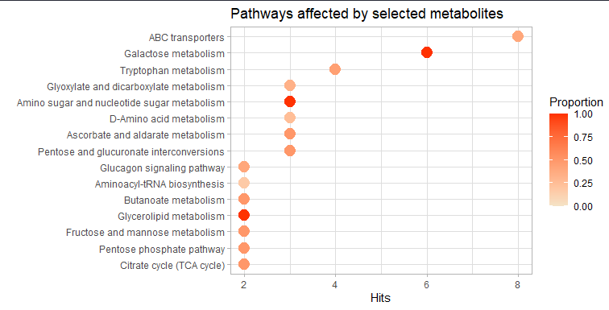**Figure 3. Pathways affected by selected metabolites.** Altered metabolites for both RTT and hypo-glutamatergic patients had the highest impact in galactose metabolism, amino sugar and nucleotide sugar metabolism, and glycerolipid metabolism. The pathways that were most altered were ABC transporters, galactose metabolism, and tryptophan metabolism.

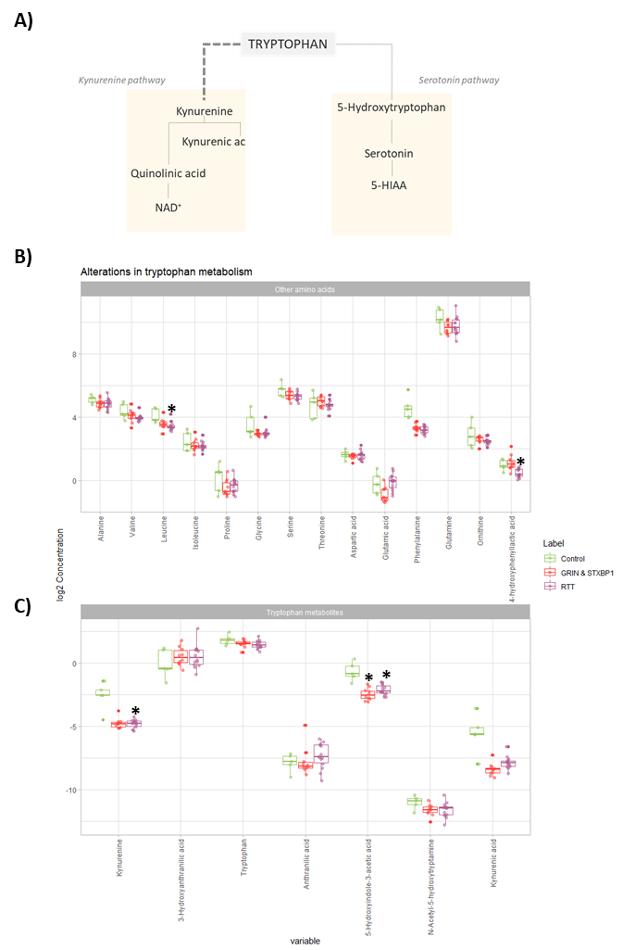**Figure 4.** **Alterations in amino acid metabolism. A)** All patients showed decreased levels of amino acids transported by LAT1. Leucine, phenylalanine, and the tyrosine metabolite 4-hydroxyphenyllactic acid were significantly decreased in RTT patients, while hypo-glutamatergic patients showed a similar tendency but were only significantly altered in phenylalanine and had slightly increased 4-hydroxyphenyllactic acid. Both groups had non-significantly decreased levels of valine. **B)** **Alterations in tryptophan metabolism.** Of the metabolites involved in tryptophan metabolism that were analyzed, only 5-Hydroxyindole-3-acetic acid was significantly decreased in both disease groups, while kynurenine was significantly decreased in RTT patients and non-significantly decreased in hypo-glutamatergic patients. Tryptophan, N-Acetyl-5-hydroxytryptamine, anthranilic acid, and kynurenic acid showed a slight decrease that was not statistically significant in both RTT and hypo-glutamatergic patients. 3-Hydroxyanthranilic acid did not vary between either group and the controls.