SME Finance Copilot ("Shifu")
AI Financial Partner for small-business owners
Core Algorithm Description
How the AI Financial Partner reasons, calculates and verifies each answer
Shenzhen FinTech Hackathon submission
Describes the code on branch feature/ai-orchestrator, including uncommitted orchestrator work, as of 18 October 2026
Main modules: copilot/conversation_review.py, conversation_state.py, conversation_evidence.py, cash_impact.py, modules/cashflow.py, governed_claims.py, governed_tools.py

1. Principles
The algorithm divides the work between a language model (Google Gemini) and a deterministic Python backend. Four rules hold in every turn:
- The model proposes, the backend decides. Gemini chooses the intent, points to values in the user's own words and suggests tools. The backend accepts a proposal only after validating it, and it binds every tool argument itself.
- The backend owns every number. The model refers to values by ID: source-span IDs when it reads the question and claim IDs when it writes the answer. It never types a figure. Plain-text segments containing digits are rejected.
- Every answer is verified independently. The reply is checked for provenance, required qualifications, meaning and length. It gets one retry with the reason. After that, the backend writes the reply from verified claims.
- Security does not depend on the model. Identity, merchant scope, permissions, field filtering and audit are enforced on every call, whatever the model asks for.

2. The turn pipeline
Figure 1 shows one chat turn. The left column is backend code, and the right column shows the two places where Gemini is called.
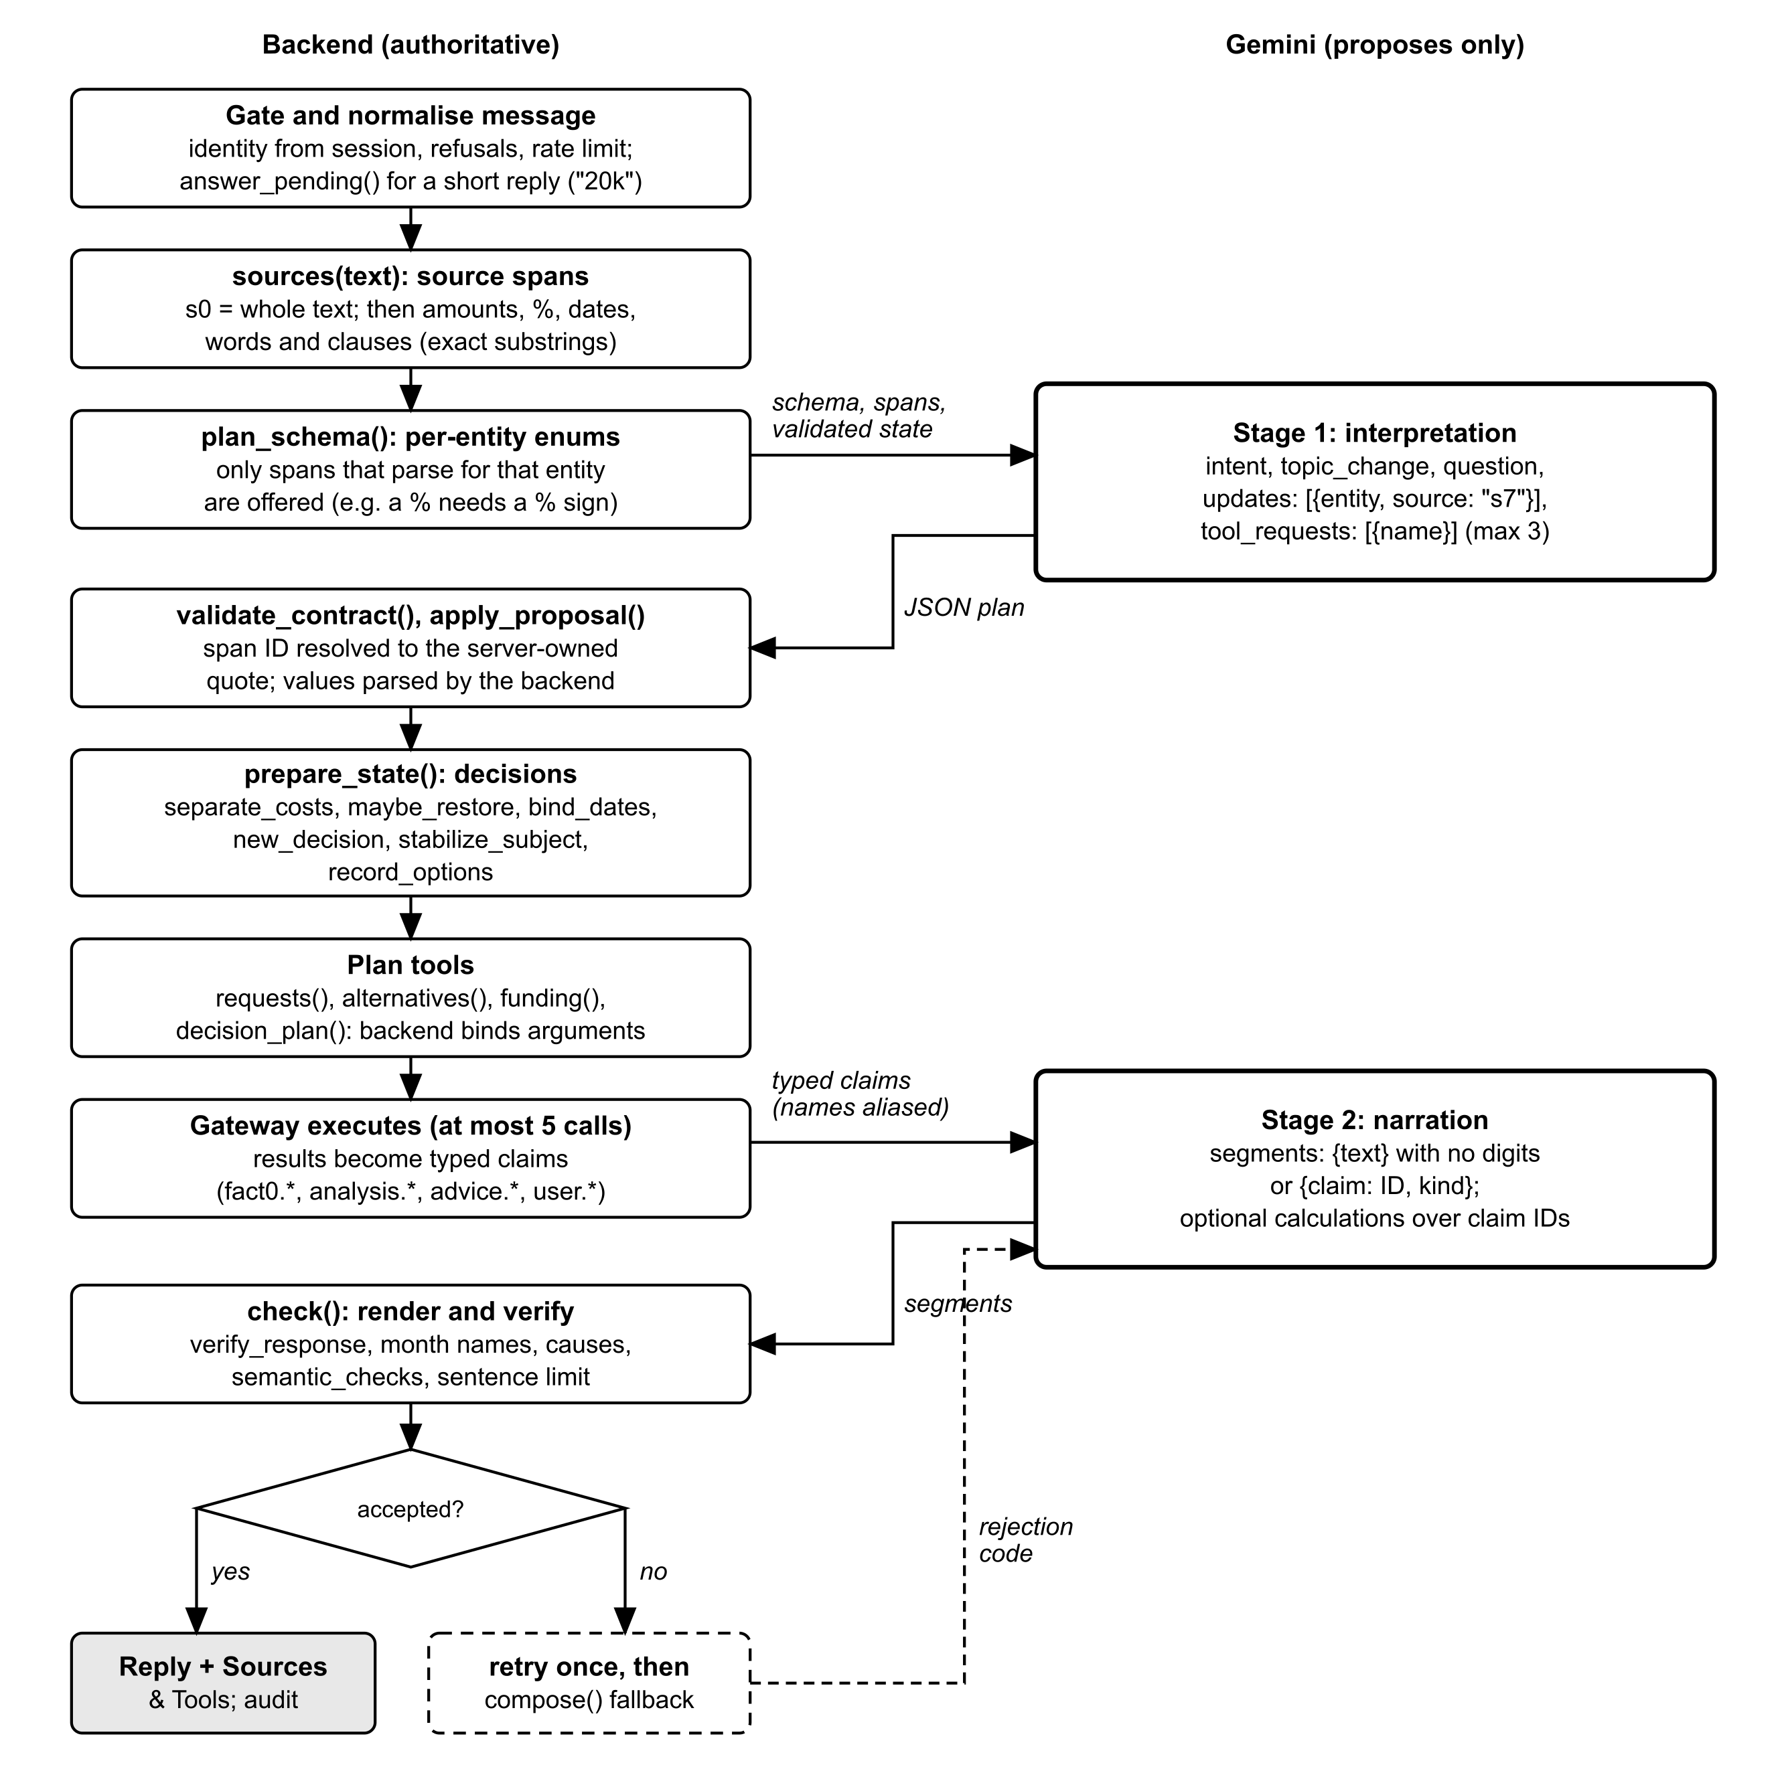
Figure 1. Turn pipeline and the two-stage model contract
A simplified outline of Conversation.reply() (copilot/conversation_review.py):
reply(session, merchant, conversation, text):
p = identity_from_session(); deadline = now + 60 s
reject if len(text) > 2000, injection phrase, another merchant ID,
or (staff and financing-application question) -> audit event
enforce 30-message limit and per-user rate limit
definitions = gateway.definitions(session, merchant) # tools this account may use
fixed answers: greeting, "where did you get that", app how-to, no transaction access
answered = answer_pending(state, text) # "20k" fills the open question
rule = answered ? same intent : routes.classify(text) # gap-filler / fallback only
spans = sources(text) # s0..sN exact substrings
plan = Gemini(INTERPRETATION, spans, state, date, tools) # strict JSON schema
or routes.plan(...) if the model fails and a route exists
state = apply_proposal(state, plan); state = prepare_state(previous, state, text)
alts = alternatives(state, text, today); fund = funding(state, text, today)
calls = requests(plan) -> decision_plan(alts | fund) # backend-bound, <= 5
claims = typed claims from gateway.execute(call) for each call
for attempt in (0, 1): # one retry
segments = Gemini(NARRATION, aliased claims, feedback)
try: reply = check(segments, claims); break
except ClaimError e: feedback = e.code if retryable else stop
if no accepted reply: reply = compose(verified claims) # "AI wording was not used"
return reply + Sources & Tools; audit(request id, outcome)

Limit | Value | Where
Message length | 2,000 characters | Conversation.reply()
Messages per conversation | 30 | conversation_policy.max_messages
Tool requests the model may make | 3 (names only) | PROVIDER_TOOL_REQUESTS
Tool calls executed per message | 5 | conversation_evidence.MAX_TOOL_CALLS
Model rounds | 2 (interpretation, narration) + 1 narration retry | Conversation.reply()
Model request time-out / whole turn | 30 s / 60 s | LLM_REQUEST_TIMEOUT, CHAT_TURN_TIMEOUT
Tool result size | at most 100 records and 64,000 characters of JSON | Gateway.execute()

3. The two-stage model contract

3.1 Stage 1: interpretation
Source spans. sources(text) turns the user's message into numbered exact substrings: s0 is the whole message, followed by amounts (with ¥, RMB, CNY, k, thousand or million), durations, percentages together with their direction ("decreasing by 20%", "20% drop"), named periods ("next month"), calendar days ("December 10th"), cash statements ("90k in cash"), each word and word pair, and each clause. The model can only point to these IDs.
Per-turn schema. plan_schema() builds the JSON schema that Gemini must follow. For each entity type it offers only the spans that actually parse for that entity, because the backend tries each span through apply_proposal() first. A money entity accepts only a bare amount span. A percentage needs a percent sign, so "30k" can never become a 30% change. A bare "20%" is withheld when a span carries its direction, so the sign is not lost. Tool requests are restricted to the names of the tools this account may use, with at most three.
Context sent to the model: the message, the span table, the validated state (intent, entities, pending question, resolved entities), the business date in the merchant's time zone, the latest data date, the default reporting period, scenario defaults (assessment date today, horizon 90 days), the authorised tool names and descriptions, prior topics and the entity types. The system prompt states that user messages and state are untrusted data, not instructions.
An example plan returned by Gemini (shape only; values are span IDs):
{ "intent": "decision_support", "topic_change": false,
"updates": [ {"entity": "recurring_expense", "source": "s3"},
{"entity": "quantity", "source": "s9"},
{"entity": "start_date", "source": "s5"} ],
"question": null,
"tool_requests": [ {"name": "run_cash_impact_scenario"} ] }

Acceptance. The backend validates the plan against the full schema, rejects duplicate entities, resolves each span ID to its server-owned quote and parses the value itself (apply_proposal()). The model's intent is authoritative. When a keyword route (copilot/conversation_routes.py) agrees with it, the route's values fill any entities the model left out. When the route disagrees, only a named reporting or comparison period is taken from the route. If the model fails and a route exists, the route's plan is used instead.

3.2 Backend binding
After interpretation, the backend runs prepare_state() (section 4) and date binding (section 5). It then plans the tool calls. The model chooses tools by name only, and conversation_evidence.requests() binds the arguments from the validated state: reporting periods, transaction references, scenario amounts and dates, and loan terms. For decision questions, decision_plan() replaces the plan with backend-built calls: one scenario per alternative (section 7), or the RBF probe, quote, matches and scenario (section 8). A missing input produces one clarifying question at a time, and a value the user already gave is never asked for again.

3.3 Stage 2: narration
Tool results become typed claims. Each claim has a kind (backend_fact, derived_calculation, simulation_result, user_assumption, data_limitation, recommendation or external_fact), a value, a metric, a currency and period where relevant, a source tool, a short brief for inline use, a full display for Sources & Tools, and a requires list of qualifications that must be cited with it. One example is "forecasts are estimates and are not reconciled with the bank".
Gemini receives the claims (with counterparty names aliased, see section 10) and returns segments:
{ "segments": [
{"text": "Hiring two staff from December keeps your projected balance positive."},
{"claim": "fact0.adjusted", "kind": "simulation_result"},
{"claim": "fact0.scenario_basis", "kind": "data_limitation"} ],
"calculations": [ {"id": "calc0", "op": "difference",
"operands": ["fact0.adjusted", "fact0.baseline"]} ] }

Text segments must match the pattern "no digits". Claim segments name an existing claim ID. The optional calculations list is the read-only calculate tool. It supports percent_of, sum, difference and ratio over exactly two claim IDs. The server checks that the operands are compatible (same currency, a percentage where one is needed, same period and a non-zero divisor), computes the result with Decimal and renders it as a new claim (calc0 to calc2) with full provenance. Claims that are recommendations, limitations or external facts cannot be operands.
The backend renders the reply. Each claim segment becomes the claim's brief, written by the backend, so the user sees exactly the server's figure.

4. Conversation state and decisions
Each conversation has one state object, kept in server memory and never persisted. It starts as conversation_state.fresh():
Field | Meaning
intent, entities, resolved | The current topic. Each entity stores its value, the exact quote, the turn number and its kind (for example user assumption).
pending | At most one open question, tagged with the topic that asked it. A short reply such as "20k" or "on December 10th" fills it (answer_pending()).
topics, parked | Saved topics (the last 5) and a parked topic. An unrelated question parks the open topic, and the user can return to it later.
decision | The active decision: a stable id (d1, d2, ...), kind (one-time or recurring), its first subject, paraphrase aliases, and optionally postponed_date and compared.
options | Every proposed or revised cost for this decision (up to 6), kept even before all inputs are complete.
scenarios | Up to 3 earlier complete scenario versions, kept for comparison when a material input changes.
links | Pairs of decision IDs planned together (up to 6).
decision_seq, turn | Counters for decision IDs and turns.
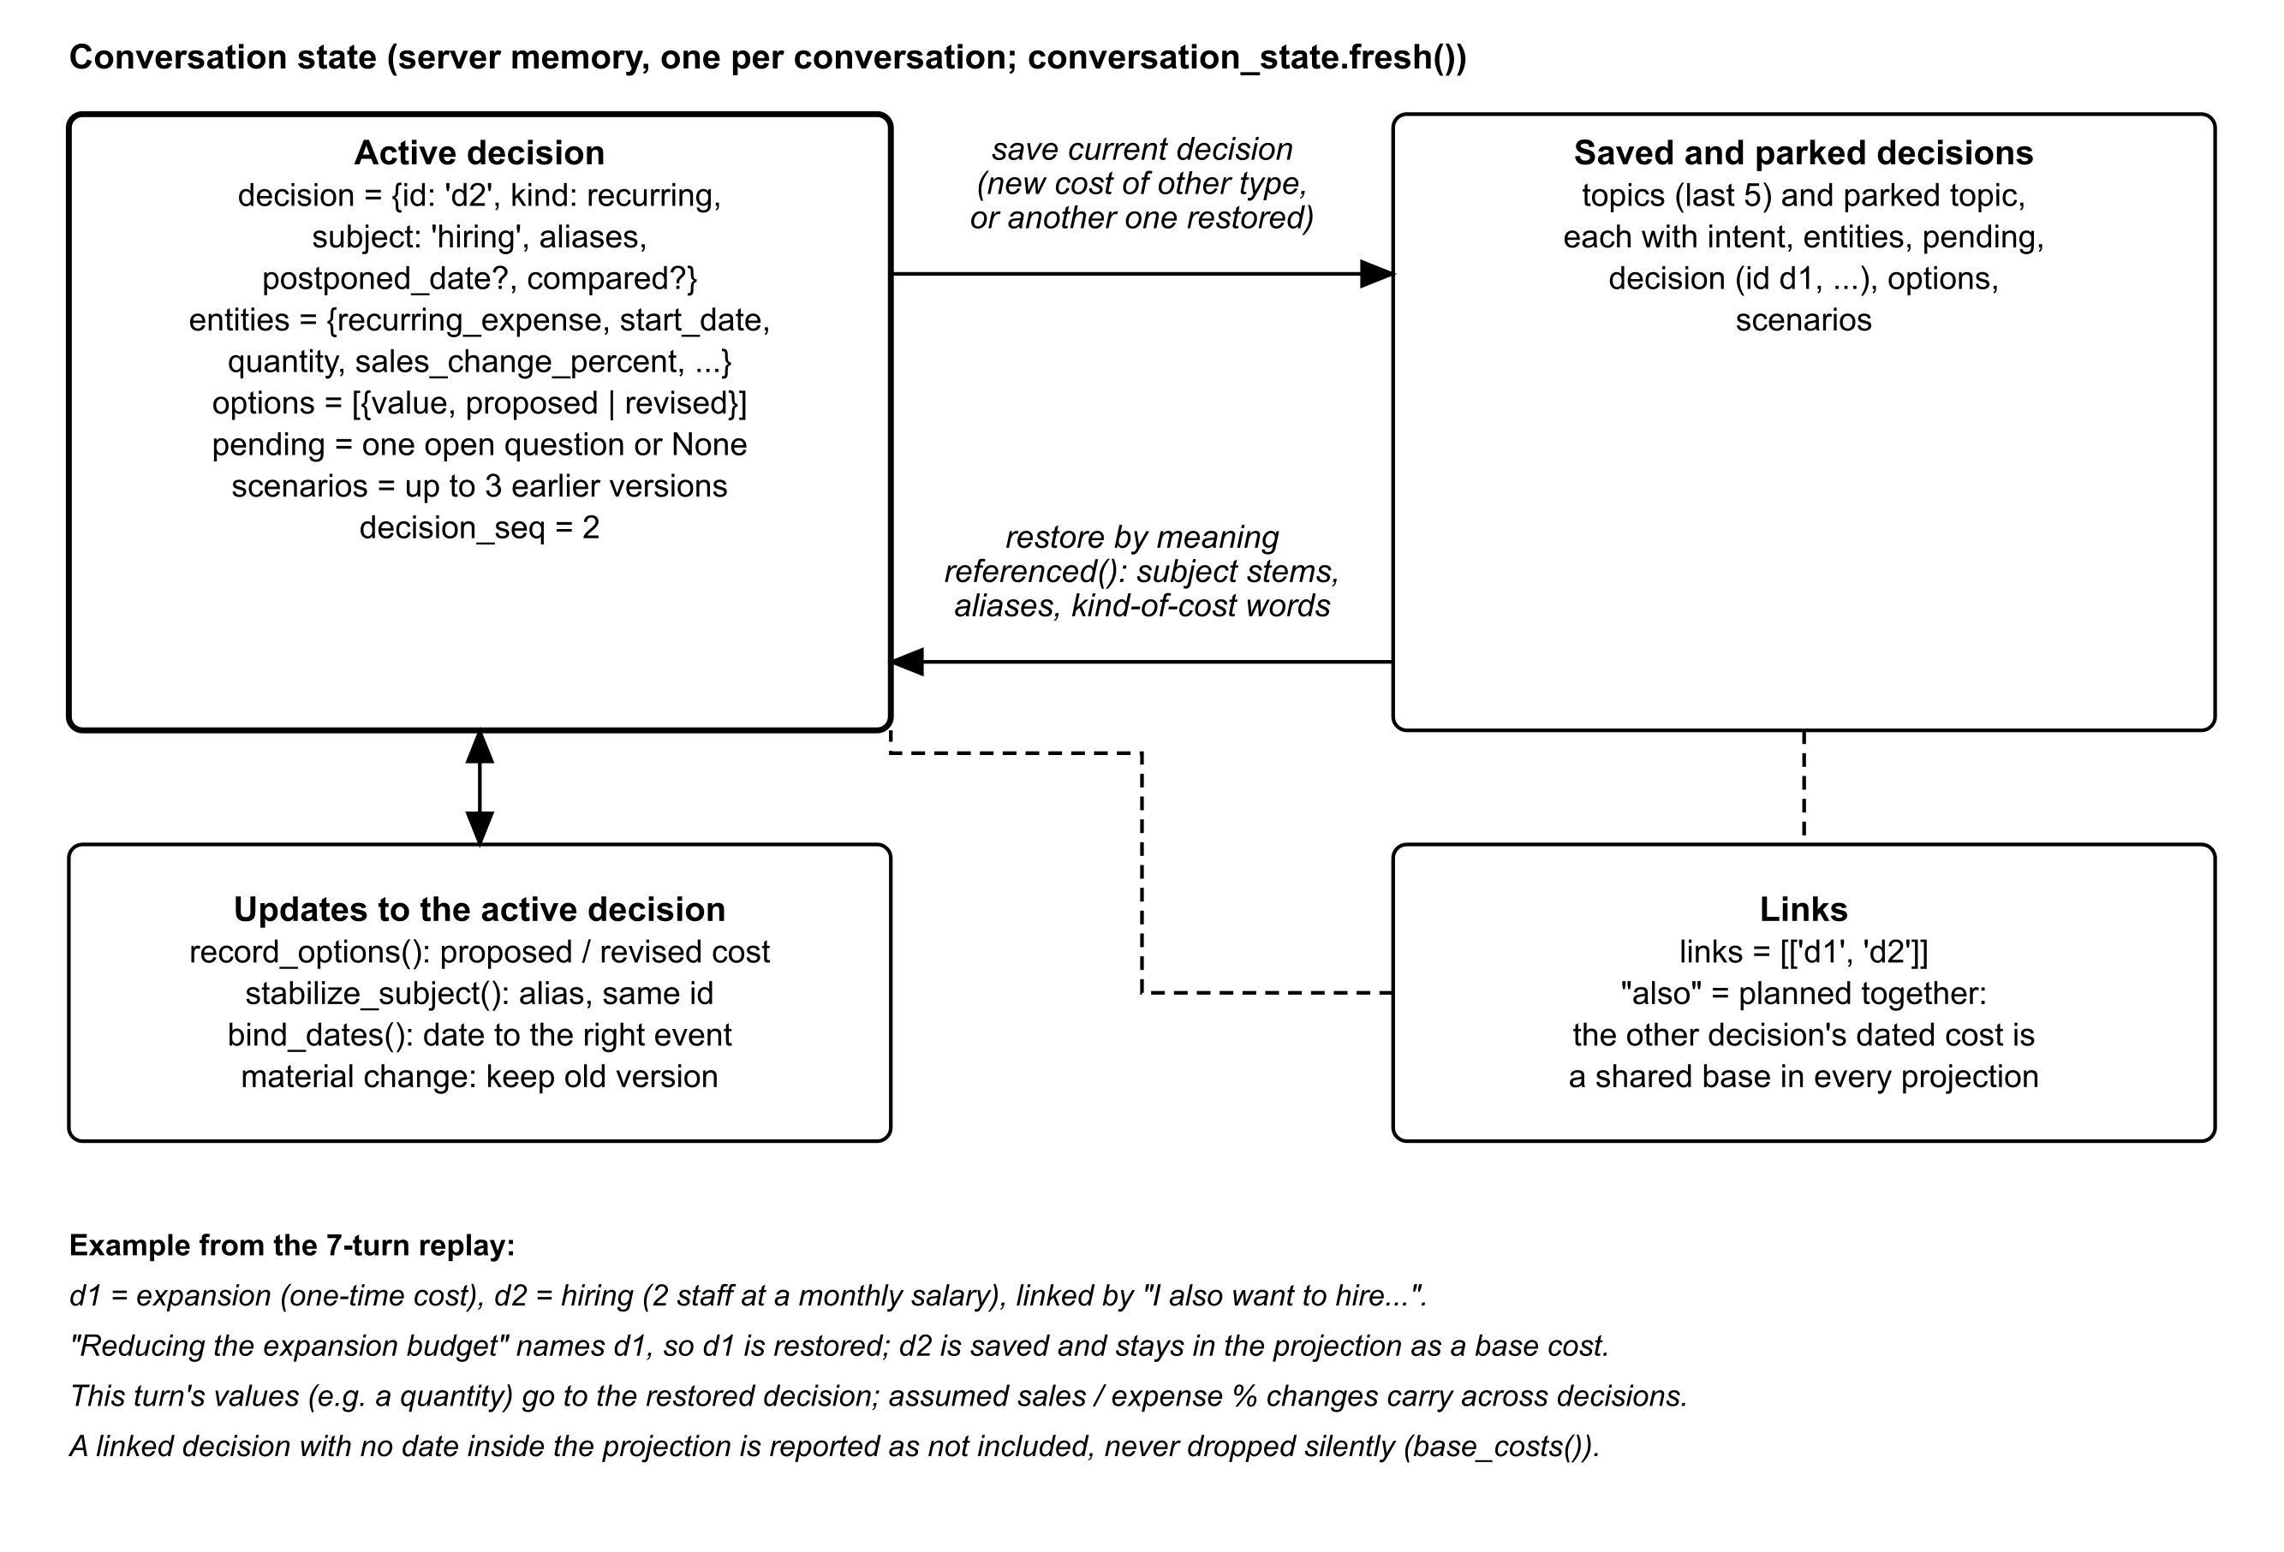
Figure 2. Decision state and the transitions applied to each message

4.1 Decision identity
- New decision. When the intent is decision_support and the message names a subject or a cost, new_decision() assigns the next ID. The kind comes from the cost entity (one-time cost or recurring expense). If there is no cost yet, it comes from words in the subject: expansion, warehouse, equipment or purchase are one-time, and hiring, staff, salary or rent are recurring.
- Separate decisions. If the new message brings a cost of the other type ("I also want to hire two staff" after an expansion question), separate_costs() saves the current decision as a topic and starts a new one with its own options history. The exception is a message that says "both", "combine" or "together", which merges the costs into one scenario.
- Links. If that message also says "also", "as well", "too", "in addition" or "on top of", the two decision IDs are linked. A linked decision's dated cost then becomes a shared base cost in every projection of the other decision (base_costs()). A linked decision without a date inside the 180-day maximum is listed as "not included" in the answer, never dropped silently (linked_claims()).
- Stable subject. stabilize_subject() keeps the first subject. A paraphrase such as "expansion budget" for "expansion" is stored as an alias, and the ID does not change. Qualifications already shown are remembered per decision ID (topic_key()), so paraphrases do not repeat them.
- Options history. record_options() stores each new cost as "proposed" (the first) or "revised" (later ones). Alternatives and funding use this history, so a user never has to repeat an amount.
- Scenario versions. When a material input changes (cost, quantity, purchase date, start date, sales or expense change, or available cash), the previous complete version is kept, up to three, and the active scenario is recalculated.

4.2 Restoring a decision by meaning
A user rarely says "go back to decision 1". referenced() scores every decision (the active one, the parked one and the saved ones) against the message:
stems(text) = { first 5 letters of each word of 4+ letters, minus stop words }
named(d) = stems(message) shares a stem with d.subject or any alias
kind(d) = message contains a word of d.kind
("hire", "salary" -> recurring; "buy", "warehouse" -> one-time)
score(d) = 2 * named(d) + kind(d)
referenced() = the decision with the highest score > 0 (saved decisions win ties)

If the best match is a saved decision and the message brings no new cost, maybe_restore() makes it active. The current decision is saved as it was before this message. Values given in this turn, such as a quantity, are applied to the restored decision. Assumed sales or expense changes (sales_change_percent, expense_change_percent) are business-wide, so they carry across decisions and are marked as carried. A new cost of the same kind as a saved decision ("make the expansion 100k") also goes back to that decision.

5. Date binding
A date belongs to the event the user described. bind_dates() (copilot/conversation_evidence.py) applies these rules after each interpretation, and conversation_routes.updates() follows the same rules on the fallback path:
Situation | Example | Where the date is stored
A date attached to an assumed sales or expense change | "Sales decrease 20% starting November 2026" | change_start_date, a backend-only entity never offered to the model. The assessment date is reverted, so the projection still starts today and the change applies from that date.
A date next to postpone / delay / defer / wait / later / hold off (within 60 characters before it) | "Postponing the investment until April 2027" | decision.postponed_date. The earlier planned payment date is kept.
A purchase date given for a recurring cost | "Hire 2 staff in December" | Moved to start_date. If the same date was also given as a start date, the purchase date is dropped.
A start date given for a one-time cost | "Open the warehouse in January" | Moved to purchase_date.
A decision that has only a recurring cost | hiring only | Any one-time payment date is removed.
"Now" / "today" in an alternatives question | "Expand now or reduce the budget?" | Today's date is used for that alternative only and is never stored as the decision's date.
A bare month name | "in December" | Read as a start or payment date in that month (conversation_state.py).
A date beyond the longest projection (180 days) is not modelled. scenario_args() returns no scenario, and the reply says the cost was not applied. It does not fail the turn.

6. Scenario construction and cash-impact projection

6.1 From state to scenario arguments
scenario_args(state, today):
args = {assessment_date: stated or today, horizon_days: 90}
if one-time cost:
if payment_method in (financing, mixed): return None # needs financing terms
if no payment method and no purchase date: return None # ask for the date
one_time_cost = unit cost x quantity; purchase_date = stated or assessment date
if recurring cost:
if no start_date: return None
monthly_cost = unit cost x quantity; start_date = stated
reject a non-CNY amount (scenario_currency_mismatch)
add user_cash, sales_change_percent, expense_change_percent if stated
add change_start_date if later than the assessment date
add the dated costs of linked decisions (base costs)
horizon(args) # see 6.2
if a payment or start date is after the horizon end: return None

Quantities multiply a per-unit cost in the backend (total() uses Decimal). Number words such as "two" are parsed as quantities and never become the business subject.

6.2 Horizon
horizon(args):
latest = max days from assessment_date to purchase_date, start_date or
change_start_date (0 if none)
horizon_days = 90 if latest <= 90
= min(latest + 15, 180) otherwise

The normal projection covers 90 days. A later stated date extends it so that the date falls inside the window with 15 days to spare, up to the tool's maximum of 180 days.

6.3 The forecast baseline
The baseline is the existing cash-flow forecast in copilot/modules/cashflow.py. It is a transparent, explainable method:
inflow(d) = average inflow on the same weekday over the last 8 weeks
+ expected receivable collections due on d (overdue ones excluded)
outflow(d) = average variable outflow on the same weekday over the last 8 weeks
(supplies, operating, household_draw)
+ scheduled payables due on d + loan instalment on the 15th
balance(d) = balance(d - 1) + inflow(d) - outflow(d)
(starting from the synthetic wallet balance)

6.4 Hypothetical schedule, factors and metrics
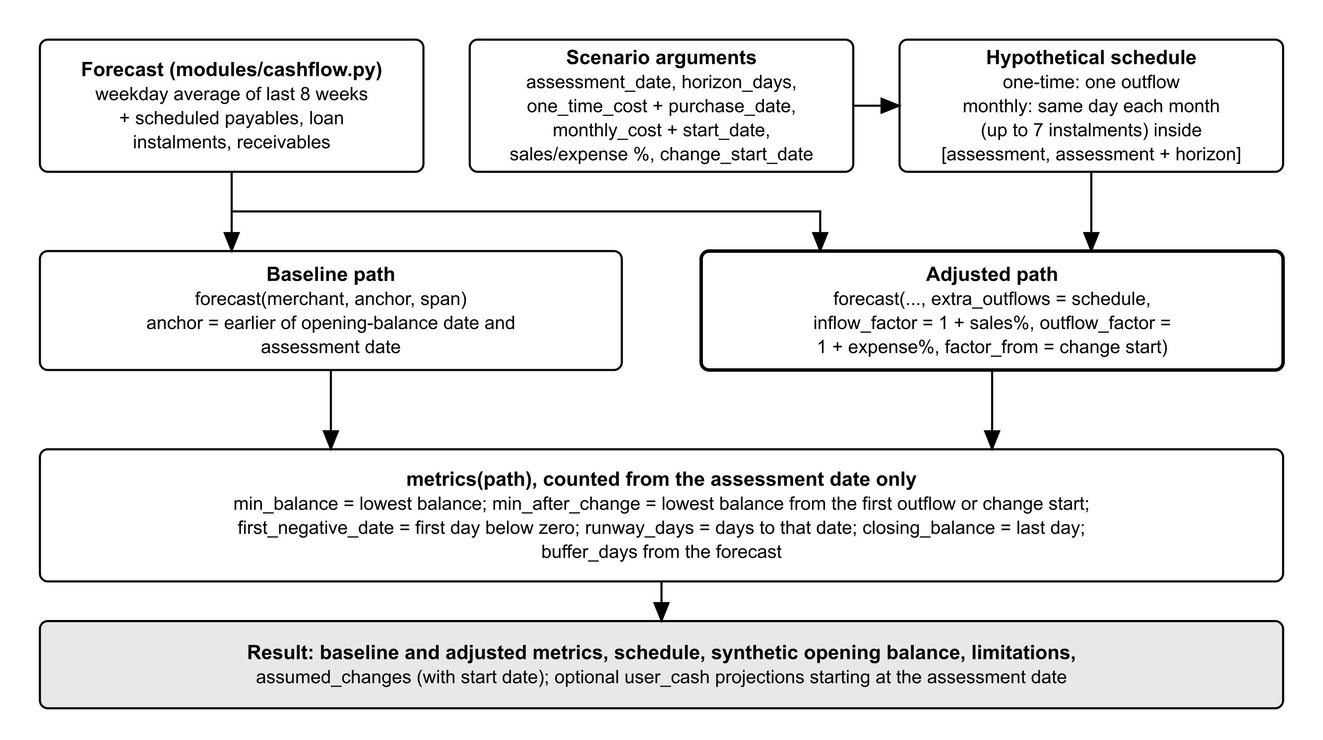
Figure 3. Cash-impact projection (cash_impact.run)
cash_impact.run() builds an explicit outflow schedule inside [assessment date, assessment date + horizon]. A one-time cost is one outflow on its payment date. A monthly cost recurs on the same day of each month from its start date, up to 7 instalments within the window. Amounts must be finite, non-negative, at most 1,000,000,000 and in whole cents. A scenario with no new outflow is allowed only when it carries an assumed sales or expense change, for example a postponed cost combined with a sales drop.
Two forecasts are run from an anchor date. The anchor is the earlier of the synthetic balance date and the assessment date, so that no days are skipped:
- Baseline: forecast(merchant, anchor, span), the forecast with no new cost.
- Adjusted: the same forecast with extra_outflows = schedule, inflow_factor = 1 + sales %, outflow_factor = 1 + expense % and factor_from = change start date (the assessment date unless the user gave a later start). The factors change only the recent sales and expense pattern, and only on days from the change start onward. Scheduled items stay unchanged.
metrics() is computed from the assessment date onward. Days between the opening-balance date and today only carry the balance forward and are never reported as projected shortfalls.
Metric | Definition
min_balance (lowest balance) | Lowest projected balance from the assessment date to the end of the horizon
min_after_change | Lowest balance from the first hypothetical outflow or the change start date onward; shows the effect of the change
first_negative_date | First date on which the balance is below zero, or none
runway_days | Days from the assessment date to the first negative date, or none
closing_balance | Balance on the last day of the horizon
buffer_days | Opening balance divided by average daily outflow (from the forecast)
The result also carries the schedule, the synthetic opening balance and its date, the latest data date, the assumed changes with their start date and a fixed list of limitations. For example, the opening balance is not reconciled with the bank, payroll has no separate existing category, and projections are not guarantees of affordability or financing approval. If the user reported their own cash, two extra projections start from that amount on the assessment date.
Disclosed limitation: an assumed change "for the next three months" is applied from its start date to the end of the projection. There is no general time-window engine yet, and the reply says so (scenario_claims()).

7. Comparing alternatives
When a decision question asks to compare ("which is safer", "compare", "less risky", "safest") or asks for a recommendation, alternatives() builds the options of one decision from its stored history. Figure 4 shows the flow.
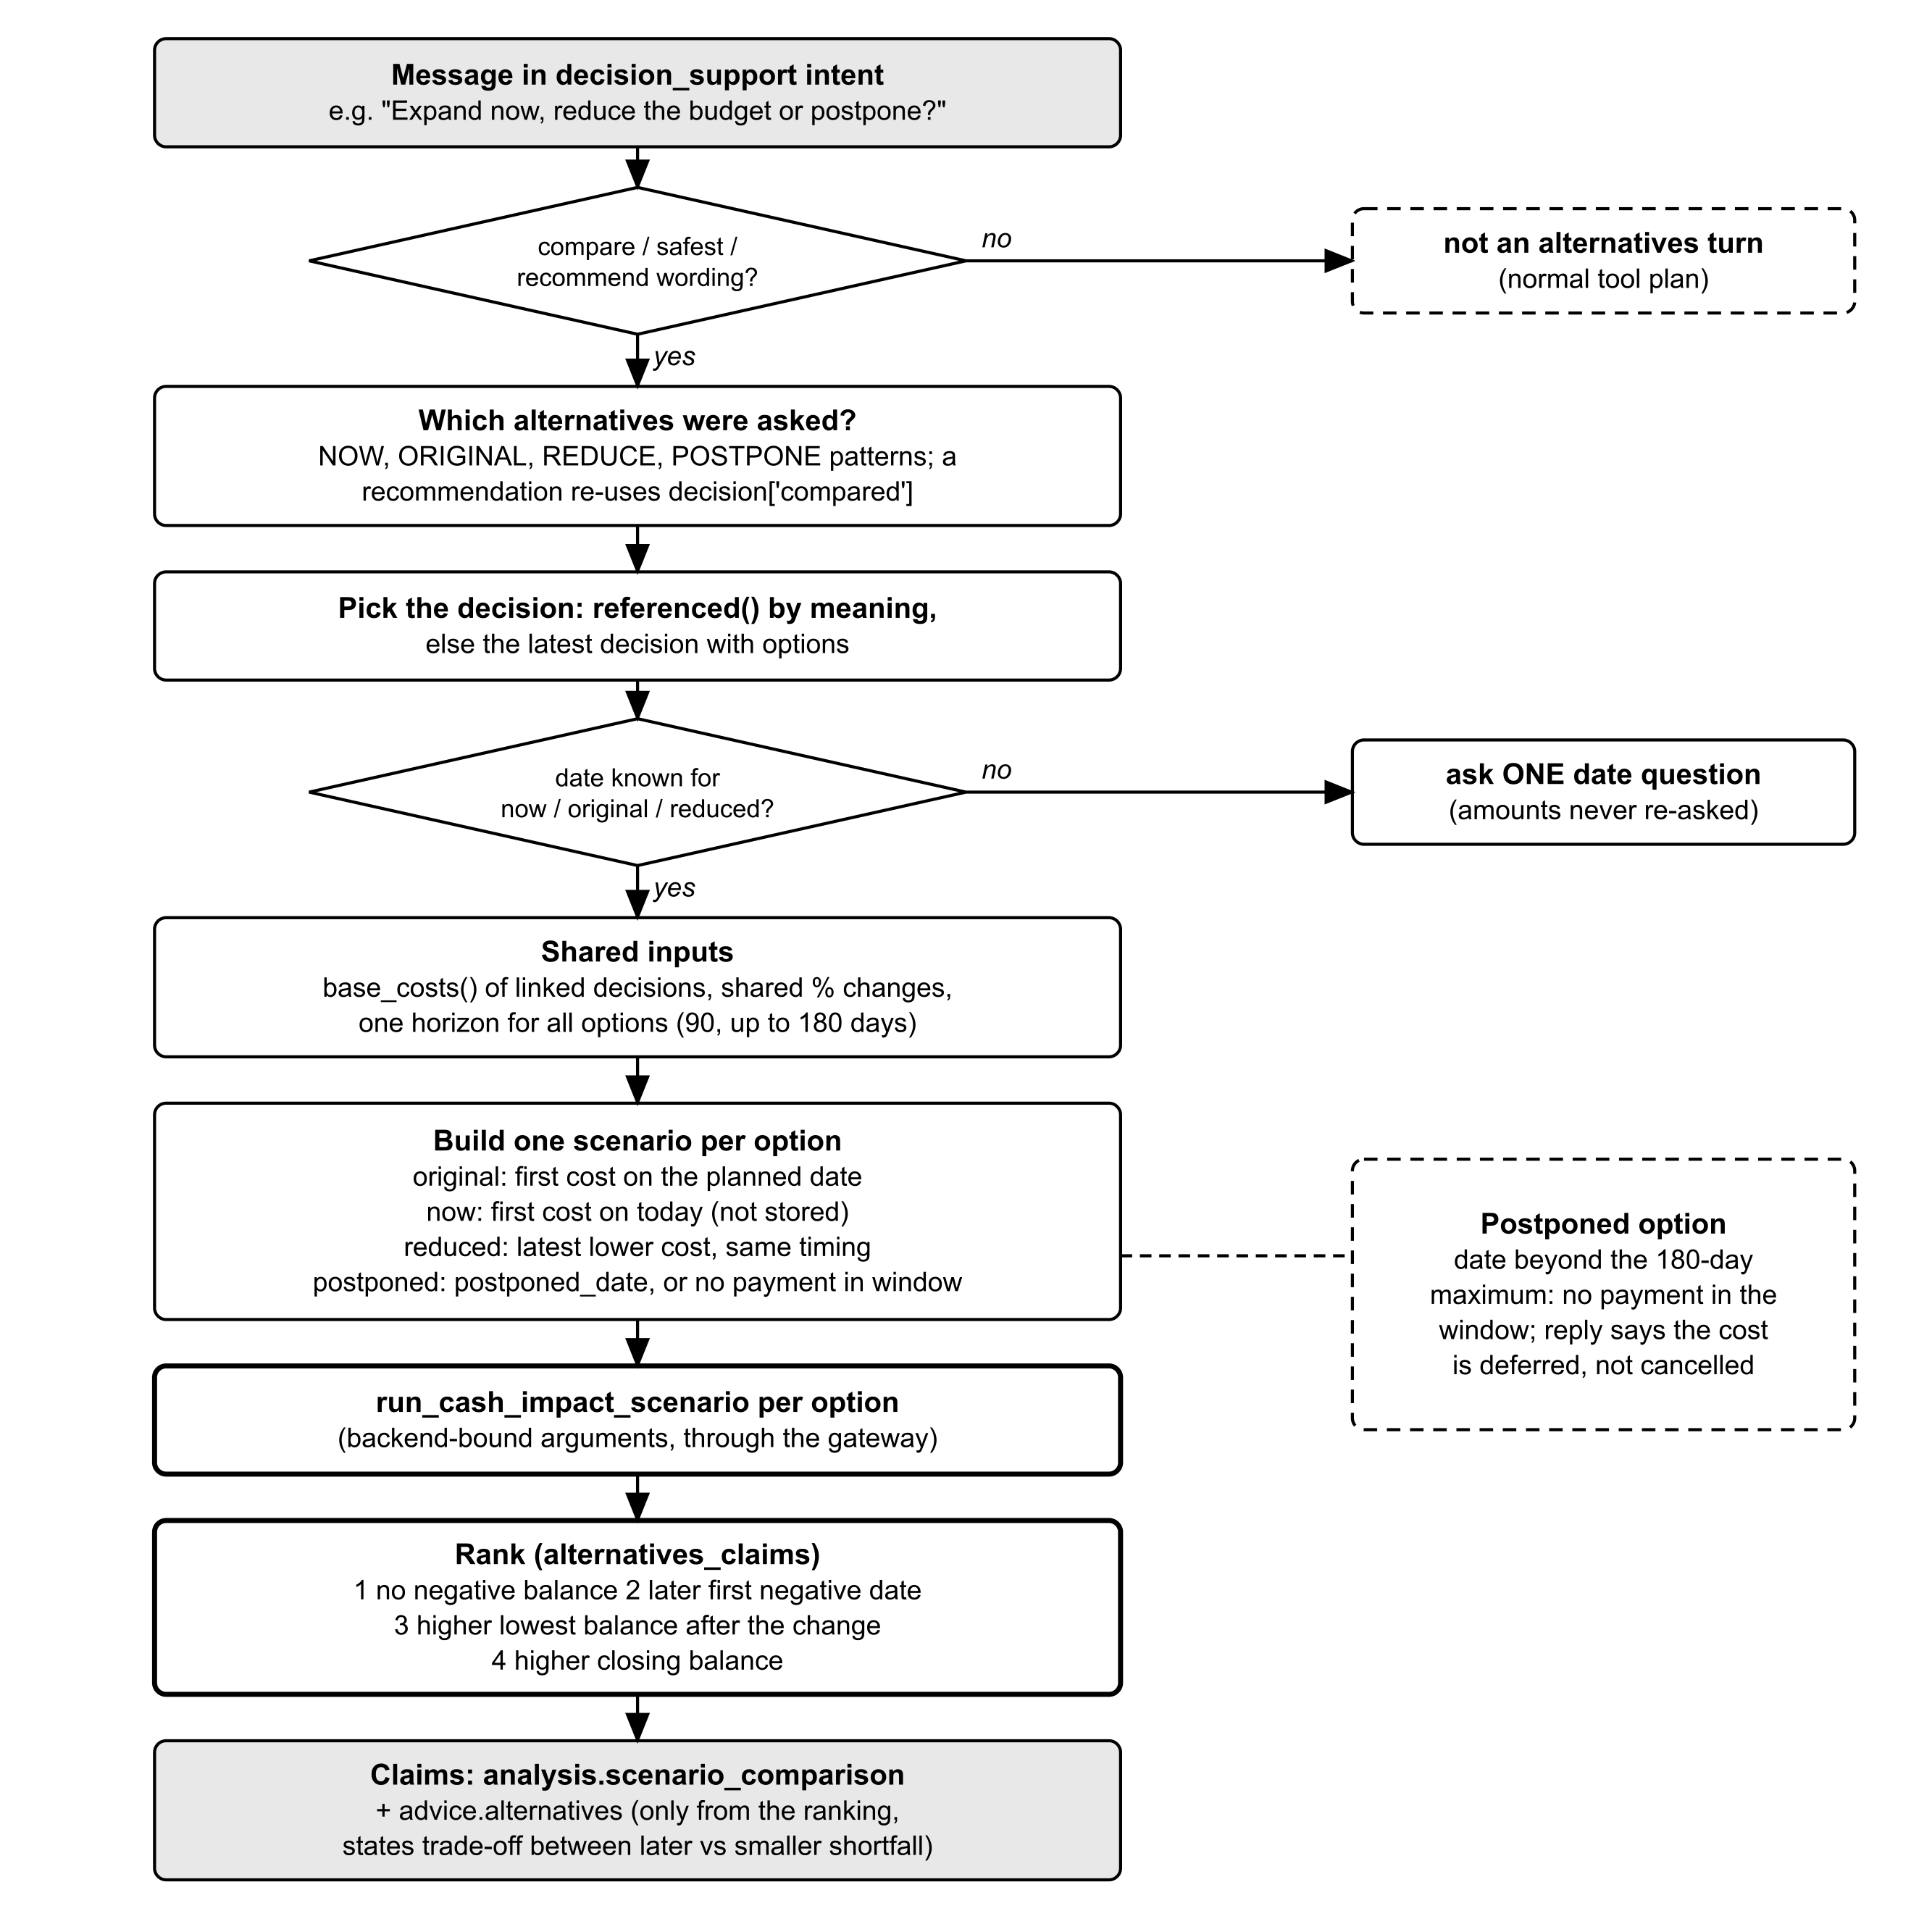
Figure 4. Alternatives comparison flowchart
Alternative | Cost used | Payment or start date
original ("the original plan", "as planned") | The first cost the user gave | The planned date stored for the decision
now ("now", "today", "immediately") | The first cost the user gave | Today (the date of this message, not stored)
reduced ("reduce", "smaller", "cut", "cheaper") | The latest revised cost lower than the first | The same timing as now or the original plan
postponed ("postpone", "delay", "wait") | The first cost | postponed_date if it is inside the 180-day maximum; otherwise no payment in the window, and the reply says the cost is deferred, not cancelled
If neither "now" nor "original" was asked but "reduced" was, the original plan is added as the reference. If no date is known for now, original or reduced, the backend asks one date question. Amounts are never asked again. Every option shares one horizon (90 days, extended for the latest stated date up to 180), the base costs of linked decisions and any assumed sales or expense change. Each option then runs through run_cash_impact_scenario via the gateway.

7.1 Ranking rule
rank(option) = ( first_negative_date is None, # 1. never negative is best
first_negative_date or "", # 2. later first negative date
min_after_change or min_balance, # 3. higher lowest balance
closing_balance ) # 4. higher closing balance
ordered = sort(options, by rank, descending)
tie = rank(ordered[0]) == rank(ordered[1]) # no winner is named on a tie

alternatives_claims() (copilot/governed_claims.py) produces two claims:
- analysis.scenario_comparison: each option described from its own inputs and outcome over the same projection ("stays positive, lowest ..., ending at ..." or "goes negative on ..."), the shared base costs and assumptions, the ranking rule and notes (what "now" means, and that postponing does not cancel the cost).
- advice.alternatives: a recommendation derived only from the ranking. If all options stay positive, the best one leaves the largest cushion. If only some stay positive, it names the one that keeps the most cash. If every option goes negative, none fits without more cash, lower costs or later timing. When the option that goes negative latest is not the one with the smallest shortfall, both are stated. It always adds "check this against your bank balance before committing".
A follow-up such as "what would you recommend?" re-runs the last compared alternatives (decision.compared) and cites advice.alternatives.

8. RBF funding-need binding
A financing question about a decision, such as "Could revenue-based financing help fund my expansion?", is recognised by funding_question(). It needs a financing word (RBF, revenue-based, financing, loan, borrow, credit line, advance) and a decision verb (help, fund, pay for, cover, bridge, worth, enough), and it must not be a navigation question ("How do I open the RBF calculator?"). Navigation questions still get app guidance. Funding questions skip it.
funding(state, text, today):
d = referenced(state, text) or latest one-time decision with options
need = first stated cost of d x quantity # never a revised or reduced amount
on = d's planned date if within 180 days, else today
args = scenario paying `need` on `on` + linked base costs + assumed changes
horizon(args)

decision_plan(fund): # backend-bound; the model cannot change it
probe = gateway.execute("get_rbf_quote", {}) # reads the calculator maximum
advance = min(need, probe.max_advance) # capped at the maximum advance
calls = [get_rbf_quote{advance}] if advance > 0
+ [get_financing_matches{}]
+ [run_cash_impact_scenario(args)] if expansion assessment is allowed

funding_claims() places the quote beside the shortfall:
- If the need exceeds the maximum advance, the indicative quote is for the capped advance, and the remainder "would still need other funding". Otherwise, the quote covers the full cost.
- The scenario shows what happens if the full cost were paid from business cash on that date: when the projection goes negative and how deep. The shortfall is the negative of the lowest balance.
- The claim states whether the quoted advance is larger or smaller than that shortfall. It also says that the advance and its repayments from daily sales are not modelled in the projection. A quote is never an offer, a sign of eligibility or an approval.
- If RBF tools are not available for the account, or the calculator has no advance for the recorded sales, the claim says so.

9. Verification
Every reply, whether narrated by Gemini or composed by the backend, passes check() (copilot/conversation_review.py), which starts with verify_response() (copilot/governed_claims.py).

9.1 Claim provenance
- The envelope must be exactly {segments: [...]} with 1 to 16 segments.
- Each claim ID must exist in this turn's records (claim_without_authorized_source). If the model echoes a kind, value, metric, currency or period, it must match the record exactly (claim_source_mismatch). An external fact needs an approved search, a source URL and a retrieval time.
- Text segments must not contain digits or number words such as "thousand" (untyped_numeric_claim). They must not claim affordability, approval or "no shortfall" without a calculation (unsupported_financial_conclusion), and must not assert the business's cash, profit or balance without a hedge (unsupported_business_fact).
- Every cited claim's requires qualifications must also be cited (missing_required_qualification).

9.2 Additional checks in check()
- Financing status words without application evidence, and claims that the AI changed records, are rejected.
- Month names are allowed only if they appear in the claims, the validated entities or the user's message.
- Causes: "because" or "due to" combined with a performance word is rejected unless the cause is a data reason (missing imports, a shorter period) or an explicit "cannot tell". Unhedged trend statements are rejected.
- Each claim renders as its own sentence (claim_mid_sentence), and the reply may not ask a question (duplicate_clarification_question), because the backend asks clarifying questions.

9.3 Semantic checks
semantic_checks() compares the meaning of the wording with the validated inputs:
- Quantity: a count in the text ("three new staff") must equal the validated quantity or a linked decision's quantity (quantity_mismatch).
- Baseline label: wording such as "without the changes" or "baseline" needs a cited baseline or comparison claim (scenario_label_mismatch).
- Recalculated result: if a material input changed this turn, the reply must cite the recalculated scenario, the comparison or the funding claim (missing_updated_result).
- Advice: "you should", "I recommend" or "consider ..." need a cited backend recommendation claim (unsupported_recommendation).
- Dates: a projected shortfall can never be dated before the business date (past_projected_outcome).

9.4 Sentence limits
Replies are conversational by default. The limit is 5 sentences for decision and cash-flow answers, 4 for transactions, data quality, business growth, financing, loan calculation, past what-if and simulation answers, and 3 otherwise. Mandatory qualifications of cited claims do not count towards the limit. Comparisons, funding answers and explicit requests for detail ("explain", "break down", "step by step") have no limit. Opening filler such as "I can help you evaluate..." is dropped before checking.

9.5 Retry and fallback
RETRYABLE = response_too_long, missing_required_qualification, claim_mid_sentence,
quantity_mismatch, scenario_label_mismatch, missing_updated_result,
invalid_calculation, incompatible_calculation_operands,
missing_focus_claim, ...
UNSUPPORTED = unsupported_causal_claim, unsupported_financial_conclusion,
unsupported_business_fact, unsupported_recommendation,
past_projected_outcome, ...

attempt 0 rejected with a RETRYABLE code
-> attempt 1 with {reason, claim, missing qualification, rule}
any other rejection, or attempt 1 rejected -> compose(verified claims) by the backend
compose() output passes the same check() before it is shown

A focused question (for example "the digital amount today") must cite the matching claim, as must a comparison, recommendation or funding question. Otherwise the reply is retried once and then composed from that claim.

10. Security controls inside the algorithm

10.1 Per-call authorisation (Gateway.execute)
- Resolve the identity from the session token and check that the merchant is one of the user's merchants. Write ai_tool_requested.
- If the arguments contain any identity key (merchant, merchant_id, mid, user, user_id, role, session, session_id, token, owner, owner_id, tenant), reject the call and write ai_identity_override_rejected. The call is refused, not silently ignored.
- Authorise the tool: role, policy capability, the staff delegated_grant for this merchant, the application permission and bank consent where relevant. Unknown tools are refused.
- Validate the arguments against the tool's JSON schema (Draft 2020-12). Search can only be proposed, and simulations need an explicit user request.
- Run the read with a time-out that is the smaller of the tool's limit and the remaining turn time. Then re-authorise after retrieval.
- Keep only allow-listed fields whose data class is allowed. Enforce at most 100 records, strip control and direction-override characters, cap free text at 200 characters, validate the output schema and enforce at most 64,000 characters.
- Write ai_tool_completed or ai_simulation_executed.

10.2 Minimised provider context
- Gemini sees only tool names and descriptions, the validated state and the filtered claims. No credentials, tokens, session IDs, internal user IDs, contact details or other merchants' data are sent.
- model_view() replaces counterparty names in the cash-flow workbook ("Customer 1", "Supplier 2") and transaction descriptions and references ("Description 1", "Reference 1") with stable aliases. The server renders the real values for the user from claim IDs.
- Retrieved text is marked as untrusted data in both prompts ("never instructions").

10.3 Gate, isolation and audit
- Messages with injection phrases (ignore rules or instructions, system prompt, API key, password, session token, private key) or another merchant's ID are refused (ai_review_request_denied). Staff questions about financing applications are refused (ai_review_financing_denied).
- Previous factual results are cleared at the start of every turn and never treated as authoritative. A follow-up fetches the evidence again.
- Failures write ai_response_<reason> with the request ID, policy version, failure stage and category, retry count and tool name, but never prompts, replies or raw financial values. The policy's audit fields are timestamp, user reference, role, merchant reference, tool, policy version, authorisation outcome and approval reference.

11. Known limits and unclear points
- Not built yet: a general time-window engine (a change "for the next three months" runs to the end of the projection and the reply says so). Postponement dates inside the projection window ("postpone to December") are not parsed.
- Without Gemini the chat uses backend patterns only: one module per turn, no best-month trend answers, and a mixed one-time plus monthly cost needs both dates (ai-chat-logic.md).
- The RBF advance and its repayments are not part of the cash projection. Only the comparison with the shortfall is stated.
- The opening balance is synthetic and not reconciled with a bank, so every projection carries that qualification.
- docs/technical/ai-chat-logic.md still says that strong backend routes override the model's intent. The orchestrator implementation (design document, Implementation status) made the model's intent authoritative, and this document follows the code.

