SME Finance Copilot ("Shifu")
AI Financial Partner for small-business owners
System Architecture
What the application is built with and how a request flows through it
Shenzhen FinTech Hackathon submission
Describes the code on branch feature/ai-orchestrator, including uncommitted orchestrator work, as of 18 October 2026
Source of truth: the repository code and docs/technical/ai-orchestrator-design.md (Implementation status)

1. Summary
SME Finance Copilot ("Shifu") is a web application for small-business owners. Its central feature, the AI Financial Partner, is a chat assistant that answers questions about the business using only authorised, read-only business data. Examples are sales for a period, cash-flow forecasts, "can I afford to hire?" decisions and revenue-based financing (RBF) quotes. The demo runs on a synthetic dataset in Chinese yuan (CNY).
The architecture follows one rule: the AI model orchestrates, and the backend stays the authority. Google Gemini interprets the question, chooses which tools to use and writes the connecting words of the reply. The Python backend owns identity, merchant access, every financial figure, every calculation and the final verification of the answer. The model never types a financial number. Every figure in a reply is rendered by the backend from a server-owned "claim".
The rest of this document describes the software stack (section 2), the components (section 3), the request flow (section 4), the AI provider configuration (section 5), the server and deployment (section 6), the data, roles, policy and tools (section 7), testing (section 8) and the security architecture (section 9).

2. Software stack
The backend is plain Python with very few third-party libraries. There is no web framework: the HTTP server comes from the Python standard library.
Layer | Technology | Where in the repository
Language and runtime | Python 3.12 (the Docker base image is python:3.12-slim) | Dockerfile
HTTP server | Standard library http.server.ThreadingHTTPServer with a custom request handler; JSON APIs and static assets | copilot/server.py
Third-party Python libraries | Babel (CLDR currency metadata), tzdata (IANA time zones, used with zoneinfo), jsonschema (policy and tool input/output validation); pytest is optional for running tests | requirements.txt
Other standard library modules | sqlite3 (identity database), hashlib.scrypt (password hashing), urllib (HTTPS calls to the AI provider), decimal (money arithmetic), zoneinfo, threading | copilot/auth.py, governed_partner.py, cash_impact.py
Front end | Static HTML pages, CSS and vanilla JavaScript (no front-end framework); Lucide icon sprite | web/ (index.html, login.html, bank.html, financial-partner.js, ...)
Storage | SQLite database for identity, roles, sessions, merchants, financing and settings (SQL migrations 001 to 012); JSON Lines files for the transaction ledger and the audit and execution logs | copilot/auth.py, copilot/migrations/, copilot/demo_environment.py
Validation | JSON Schema (Draft 2020-12) for the governance policy, every tool's input and output, and the model's structured replies | config/ai_governance_policy.schema.json, copilot/governed_tools.py, copilot/conversation_review.py
AI provider | Google Gemini, called through its OpenAI-compatible /chat/completions endpoint over HTTPS | copilot/governed_partner.py, copilot/llm_config.py
Agent interface | Model Context Protocol (MCP) server, JSON-RPC over stdio or HTTP | copilot/mcp_server.py
Containers and hosting | Docker image; Railway configuration | Dockerfile, railway.toml, copilot/deployment.py
Testing | Python unittest (pytest-compatible); Node.js Playwright scripts that drive Microsoft Edge for browser checks and replays | tests/, scripts/verify_*.cjs

3. Components
Figure 1 shows the main components. Everything on the server runs in one Python process. The only external service on the chat path is the Gemini endpoint. Public web research (Tavily) is optional and switched off by default.
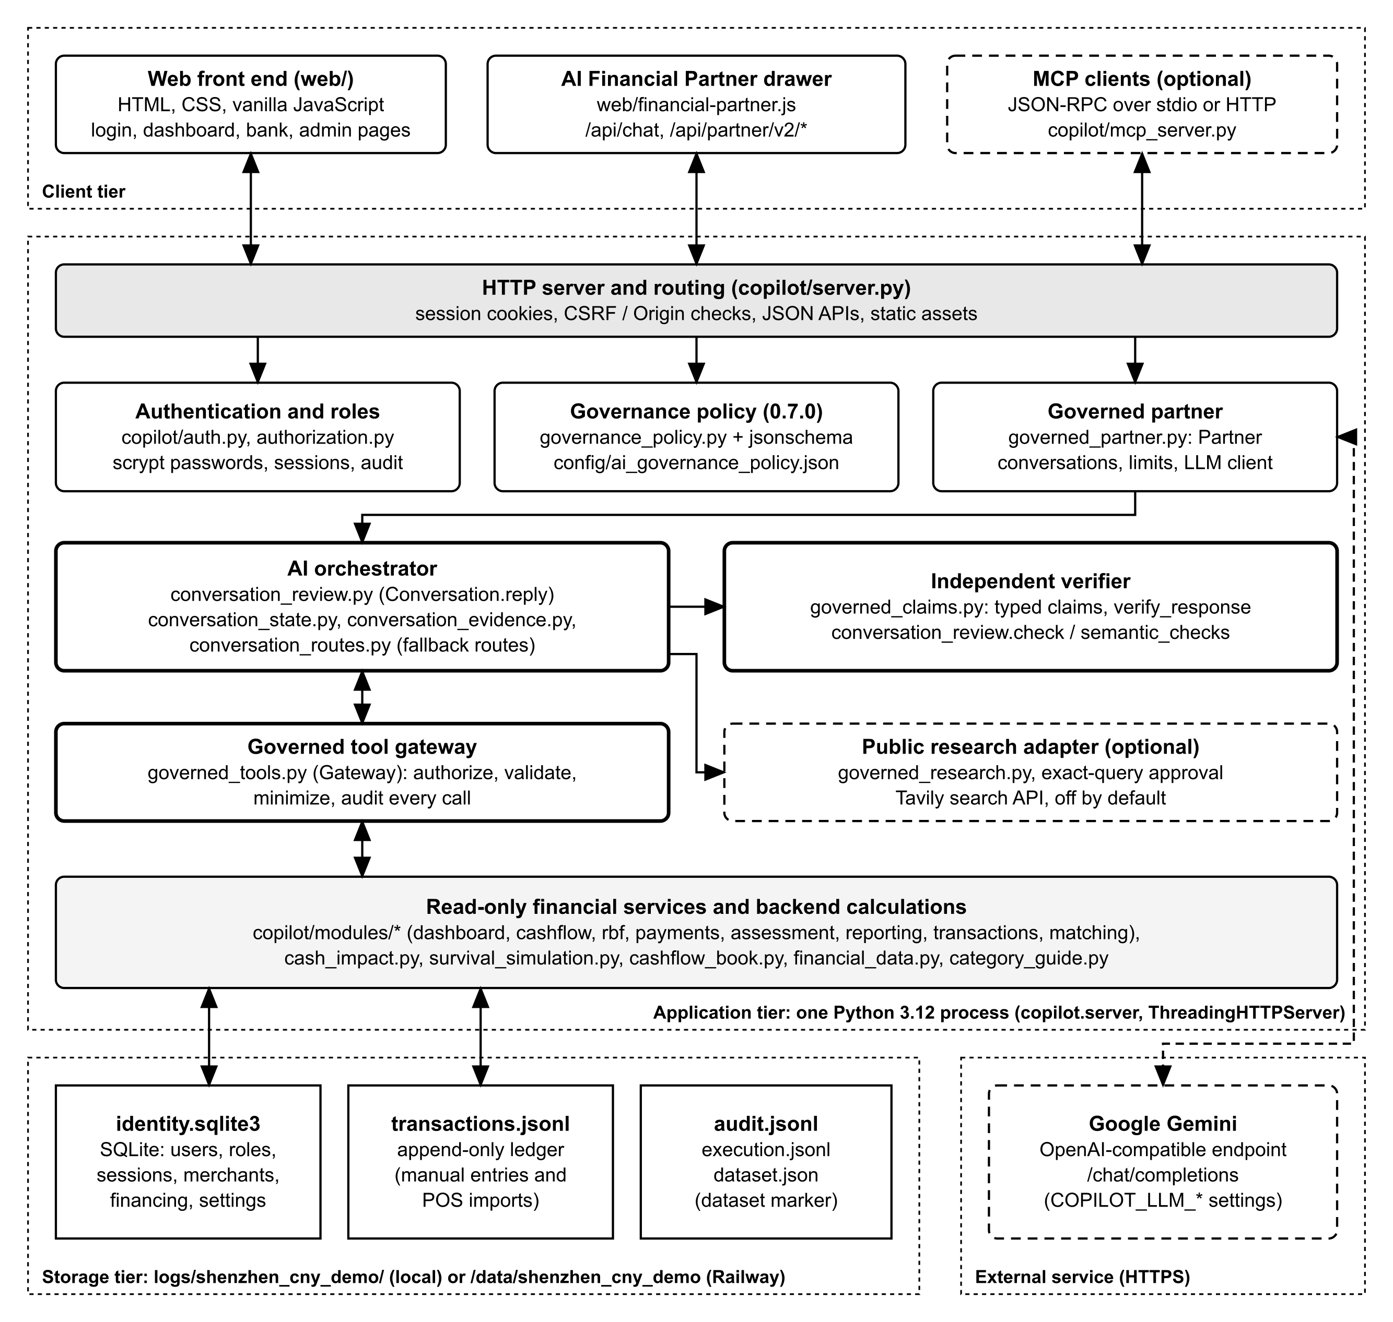
Figure 1. Overall architecture (dashed boxes are optional or external)
Component | Module(s) | Responsibility
HTTP server and routing | copilot/server.py | Serves the web pages and JSON APIs, checks session cookies, CSRF tokens and Origin, and passes chat requests to the governed partner.
Authentication and roles | copilot/auth.py, authorization.py, security.py | Users, sessions and passwords (scrypt), the four roles, delegated staff grants, bank consent, the rate limiter and audit records.
Governance policy | copilot/governance_policy.py, config/ai_governance_policy.json | Loads and validates the AI policy (version 0.7.0, default effect deny). An invalid or missing policy switches governed AI off.
Governed partner | copilot/governed_partner.py | Conversation lifecycle (one active conversation per login session, 30 messages, 30-minute idle time-out), the turn deadline and the HTTPS client for the model.
AI orchestrator | copilot/conversation_review.py, conversation_state.py, conversation_evidence.py, conversation_routes.py | Runs each chat turn: interpretation with Gemini, conversation state and decisions, tool planning, narration with Gemini, and the fallbacks. Keyword routes are only a gap-filler and fallback.
Governed tool gateway | copilot/governed_tools.py | The only way the AI reaches data. It authorises every call, rejects identity arguments, validates arguments and results, filters fields and writes audit events.
Financial services | copilot/modules/* (dashboard, cashflow, rbf, payments, assessment, reporting, transactions, matching), cash_impact.py, survival_simulation.py, cashflow_book.py, financial_data.py | Deterministic, read-only calculations used by both the screens and the chat: sales summaries, channel mix, cash-flow forecast, cash-impact scenarios, RBF quotes, loan repayment and maturity assessment.
Independent verifier | copilot/governed_claims.py, conversation_review.check() | Turns tool results into typed claims, renders every figure and rejects replies that break the rules (see section 4).
Public research (optional) | copilot/governed_research.py | A fixed-topic public search that needs a separate, single-use human approval for each query. It is not configured by default.
MCP server | copilot/mcp_server.py | Exposes the same governed tool registry to authenticated MCP clients.

4. Request flow
Figure 2 follows a single chat message from the browser to the reply. The numbered stages match the target flow in the orchestrator design document.
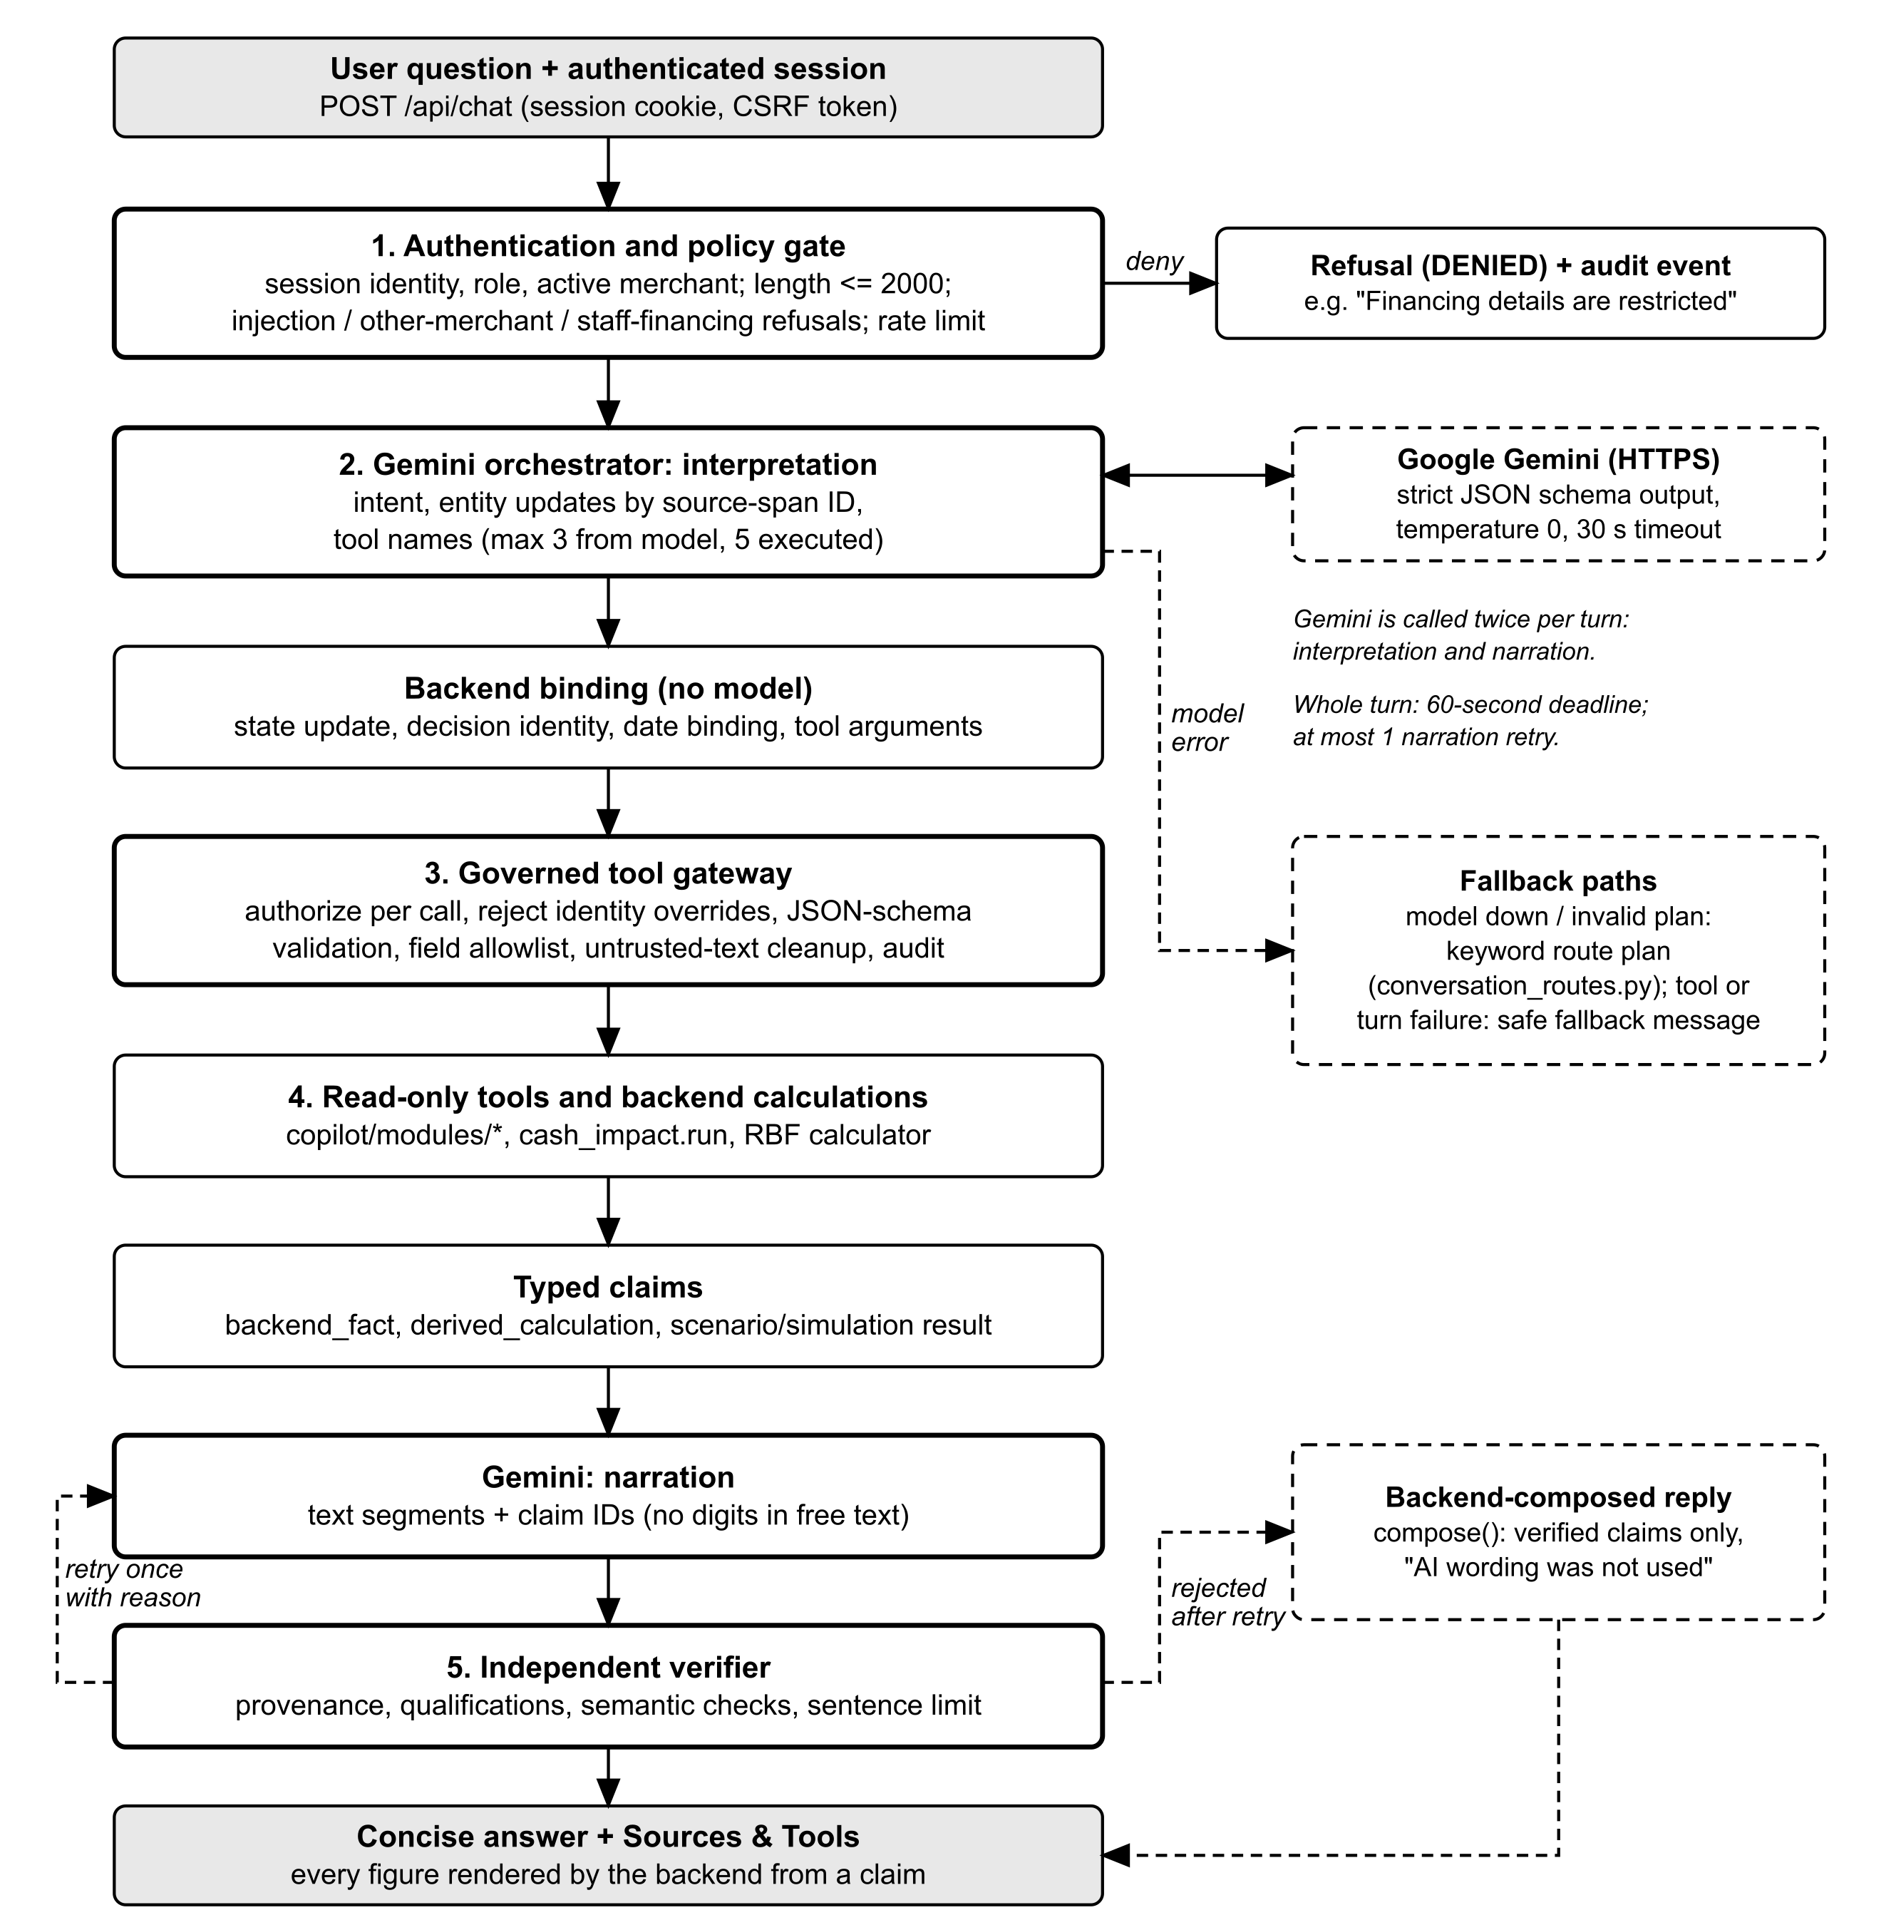
Figure 2. Request flow for one chat turn
- Authentication and policy gate. The browser posts the question to /api/chat with its session cookie and CSRF token. The server resolves the user, role and active merchant from the session, never from the message. It rejects messages longer than 2,000 characters. It refuses prompt-injection phrases, references to another merchant ID and, for staff, financing-application records. It also applies the 30-message conversation limit and a per-user rate limit. Each refusal writes an audit event. Greetings, "where did you get that?" and app how-to questions get a fixed backend answer.
- Gemini orchestrator: interpretation. The backend splits the message into exact text spans and sends Gemini the spans, the validated conversation state, the business date and the names of the tools this account may use. Gemini returns a strict JSON plan: an intent, the entity values it found (by span ID, never retyped) and up to three tool names. The model's intent is authoritative, and keyword routes only fill gaps.
- Backend binding. The backend updates the conversation state, decision identities and dates, and sets every tool argument itself: periods, amounts, dates and the RBF advance.
- Governed tool gateway. At most five tool calls run per message. For each one the gateway re-authorises the user for that tool and merchant, validates the arguments and the result against JSON schemas, keeps only allow-listed fields and cleans free text.
- Read-only tools and backend calculations. The financial modules compute the results. These become typed claims: backend facts, derived calculations, scenario or simulation results and user assumptions.
- Gemini: narration. Gemini writes the reply as a list of segments. Each segment is either plain text containing no digits or a reference to a claim ID. It may also ask for a calculation (percent of, sum, difference or ratio) over claim IDs, which the server computes.
- Independent verifier. The backend renders every claim and checks provenance, required qualifications, meaning and length. A rejected reply is retried once with the reason. If the retry is also rejected, the backend writes the reply from verified claims, and the user interface labels it "AI wording was not used".
- Reply. The browser shows a short answer plus a "Sources & Tools" section with the full evidence and its qualifications. An audit event records the request ID and outcome, but not the prompt or the reply.
Limits per message: 5 executed tool calls, 3 tool requests from the model, 2 model rounds (interpretation and narration), 1 narration retry, a 30-second time-out per model request and a 60-second deadline for the whole turn.

4.1 Failure handling
- If the model is unavailable, times out or returns an invalid plan, questions that a backend route recognises are answered from backend tools and verified claims. Other questions get a safe fallback message.
- If narration fails or is rejected twice, the backend composes the reply from the verified claims of the current turn.
- Provider failure, time-out, permission denial, tool failure and verification failure have separate user-facing labels. They are also counted (counts only) in Partner.fallbacks.
- Earlier results are never reused as the answer to a new question: the evidence is fetched again.

5. AI provider: Google Gemini
The governed chat calls Gemini through Google's OpenAI-compatible API. model_request() in copilot/governed_partner.py builds a standard /chat/completions request and posts it with urllib. No vendor SDK is used.
Setting | Purpose | Value or rule
COPILOT_LLM_BASE_URL | Provider endpoint | Must be HTTPS with no embedded credentials. .env.example names the Gemini OpenAI-compatible base URL as the verified alternative.
COPILOT_LLM_MODEL | Model name | .env.example recommends gemini-3.5-flash. Its comment notes that 2.5-flash is retired and that 3.5-flash-lite produced garbled narration in a live replay.
COPILOT_LLM_API_KEY | Provider credential | A secret, kept only in the local .env file or the hosting secret store and never committed. It is sent only as a Bearer header.
COPILOT_GOVERNED_LIVE | Opt-in for live AI | Defaults to no. Without it the chat runs in deterministic mode (backend routes only, labelled as not live AI).
COPILOT_LLM_MAX_TOKENS, COPILOT_LLM_REASONING_EFFORT | Output budget | Defaults are 4,096 tokens and low reasoning effort, so that a thinking model does not truncate the JSON.
Each request uses temperature: 0 and a strict json_schema response format. The interpretation schema and the narration schema are both generated per turn by the backend. Two details exist because Gemini rejects larger schemas with HTTP 400. First, tool requests are names only, and the backend binds the arguments. Second, claim IDs are sent as plain strings and validated by the backend afterwards.
copilot/llm_config.py loads only an allowlist of LLM-related keys from the local .env file. It does no variable interpolation and runs no shell commands. Values already set in the process environment win. Other storage settings are never read from .env.
Data sent to Gemini: only the question, its text spans, the validated conversation state, tool names and descriptions, and field-filtered claims. Counterparty names, transaction descriptions and references are replaced by aliases such as "Customer 1". Credentials, tokens, session IDs, internal user IDs, contact details and other merchants' records are never sent. Provider data-retention terms still need review before any real customer data is processed (provider_retention_requires_review in the policy).

6. Server and deployment

6.1 Local demo
python -m pip install -r requirements.txt
python -m copilot.server --host 127.0.0.1 --port 8000
# then open http://127.0.0.1:8000/login

By default the server uses the synthetic dataset shenzhen_cny_demo, stored under logs/shenzhen_cny_demo/. configure_storage() in copilot/demo_environment.py points the identity database, transaction ledger, audit log and execution log at that folder, and it fails closed rather than recreating older storage. The authentication mode defaults to authenticated.
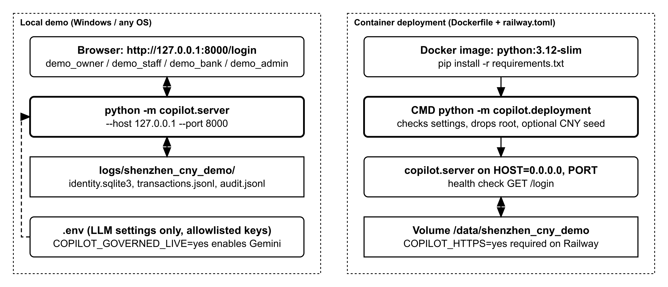
Figure 3. Local and container deployment

6.2 Container and Railway
- Dockerfile: python:3.12-slim, installs requirements.txt, exposes port 8000, has a health check on /login and runs python -m copilot.deployment.
- copilot/deployment.py: container start-up only. It requires a private COPILOT_APPROVAL_SECRET of at least 32 characters and refuses symbolic links, hard links or special files in the data directory. It then prepares the mounted directory and drops root privileges before starting the server. The CNY dataset is seeded only when COPILOT_INITIALIZE_CNY=yes is set on an empty volume. On Railway it also requires COPILOT_DATA_DIR=/data/shenzhen_cny_demo, COPILOT_HTTPS=yes (secure cookies) and HOST=0.0.0.0.
- railway.toml: builds from the Dockerfile, uses the Docker CMD, checks health at /login and restarts on failure (up to 3 retries).
This document does not claim that a production deployment has been carried out. The governance document states that a production deployment was not run.

7. Data, roles, policy and tools

7.1 Demo dataset
The dataset shenzhen_cny_demo contains six synthetic merchants, M001 to M006 (copilot/deployment.py, copilot/data/shenzhen_reference.json), in CNY. Most replays in the design documents use merchant M002. The data is synthetic, and a "Digital Payments Simulator" provides sandbox payment activity that is excluded from all financial figures. The opening cash balance used by the forecast is a synthetic wallet balance that is not reconciled with a bank. Every scenario result says so.

7.2 Demo roles
Demo account | Canonical role | What the AI Financial Partner may do
demo_owner | SME_OWNER | All read-only tools for the owner's own merchants, including scenarios, financing matches and RBF quotes.
demo_staff | SME_STAFF | A tool is available only when the staff member holds the matching existing delegated grant for the active merchant (for example view_dashboard for sales and channel mix, view_forecasts for cash flow and scenarios, view_financing for matches and RBF). Financing application status and details are always denied.
demo_bank | BANK | No merchant summaries or cash flow through the chat. Financing tools stay denied even with consent, because the granular permissions are absent.
demo_admin | SYSTEM_ADMIN | Uses the administration portal. The backend grants no merchant assistant context to this role.
Passwords for the demo accounts are supplied privately, and none is embedded in the repository.

7.3 Governance policy
config/ai_governance_policy.json (policy sme-finance-ai-governance, version 0.7.0, status "proposed", schema 1.0.0, default effect deny) is the single source of truth for what the AI may do. It is validated at start-up against its JSON schema and by semantic checks. Its sections are roles, data classifications (D0 to D4), capabilities, tools, authorization_policy, conversation_policy, web_research_policy, simulation_policy, financial_response_policy, execution_policy and security_controls. The policy can only restrict access and never grants a permission that the application itself does not grant. Version 0.7.0 adds a delegated_grant for each staff-conditional capability.

7.4 Read-only tools registered for the AI
Tool | What it reads or computes
get_financial_summary, get_transaction_trends, get_payment_channel_mix, get_income_summary, get_business_highlights | Dashboard figures: sales, counts, digital capture, channel mix, averages and expense split, receivables
get_cash_flow, get_cash_flow_alerts, get_cashflow_book | Cash-flow forecast, rule-based alerts and the uploaded receivables/payables workbook
run_cash_impact_scenario, run_survival_simulation | Hypothetical one-time or monthly costs and sales/expense % changes against the forecast; only when the user asked for a simulation
get_transaction_details, get_recent_transactions, get_data_quality | Transaction History records and import data quality
get_financing_matches, get_rbf_quote, calculate_loan_repayment, get_business_maturity | Indicative financing matches, RBF calculator, loan repayment estimate and maturity assessment
get_financing_status, get_financing_details | One financing application by APP- reference (never for staff)
search_public_financial_information | Only proposes a public search, which a human approves separately
No tool can pay, submit, approve, edit, delete or export anything. The policy's execution section records that no financial write tools are registered.

7.5 MCP server
copilot/mcp_server.py exposes the same governed registry over JSON-RPC, by stdio (python -m copilot.mcp_server) or HTTP. An authenticated client first calls conversation/start with a merchant. It then passes the returned conversation reference in params._meta.conversation to tools/list and tools/call. Tool arguments cannot select a merchant, and the older broad tools (including payment and action tools) are no longer available to authenticated MCP clients.

8. Testing and tooling
- Unit and integration tests: 40 files in tests/, written with Python unittest and runnable with pytest. The tests most relevant to the AI are test_ai_orchestrator.py (46 test functions, covering the orchestrator, decisions, date binding, alternatives and RBF binding), test_ai_governance.py, test_affordability_claims.py, test_conversation_state.py, test_conversation_integration.py, test_live_claim_contract.py and test_ai_reasoning_regression.py. Live-provider tests (test_ai_live_gemini.py, test_provider_connectivity.py) need a configured key.
- Offline runs: set COPILOT_LOAD_LLM_ENV=no so the tests never read the local .env file. The tests use disposable identities, ledgers and provider doubles.
- Browser checks and replays: Node.js scripts in scripts/ (for example verify_partner_ui.cjs and verify_owner_partner.cjs; 22 of them use Playwright) start a test server and drive headless Microsoft Edge through login, chat, navigation and role checks. scripts/assess_gemini.py and verify_owner_partner_gemini.py replay conversations against live Gemini.
Test results are not reported in this document. The suite was not re-run while it was written, and other work on the branch is in progress. The design document records that the live replay of its test plan passed on 17 October 2026.

9. Security architecture
The controls below are implemented in the gate, the gateway and the verifier. The Core Algorithm Description describes them in more detail.
Control | How it is enforced
Server-side identity and merchant scope | User, role and merchant come from the session. Tool arguments such as merchant_id, user_id, role or token are rejected and audited (ai_identity_override_rejected).
Per-call authorisation | Every tool call is authorised against the role, the policy capability, the delegated grant and the merchant, and checked again after the data is retrieved.
Default deny and strict schemas | Unknown tools, roles or arguments are refused. Tool inputs and outputs are validated with JSON Schema (additional properties not allowed).
Data minimisation | Per-tool field allow-lists and data classes, at most 100 records and 64 KB per result, control and direction-override characters stripped, free text capped at 200 characters, names aliased before reaching Gemini.
Read-only | No write or action tools are registered. A request to submit, approve, pay, edit, delete or export is answered by a backend route (conversation_routes.py) with a refusal and guidance to the right screen.
Backend-owned numbers | The model can only cite claim IDs. Free text containing digits is rejected by the schema.
Conversation isolation | Conversations live in server memory per user, session and merchant. They are cleared on merchant switch, logout, expiry or a permission change, and never persisted.
Audit | Events record user reference, role, merchant reference, tool, policy version and outcome, but no prompts, replies, keys or raw financial values.
Fail-safe | Per-user rate limit, turn deadline and model time-outs. A provider outage never produces an invented answer.

10. Open points
- The governance policy is marked "proposed", and the governance document makes no claim of production readiness.
- A live request to the public research provider (Tavily) has not been verified.
- Not yet built (design document): a general time-window engine, so a change "for the next three months" still runs across the whole projection and the reply says so. Postponement dates inside the projection window are not parsed.
- docs/technical/ai-chat-logic.md still says that "strong backend routes override" the model's intent. The orchestrator implementation removed this ("strong rules win" removed; the model's intent is authoritative). This document follows the implementation.
- The design document targets a per-user rate limit of about 20 requests per minute. The chat uses the shared RateLimiter (copilot/security.py), which is created without an explicit limit and so uses rate_limit_per_minute = 60 from copilot/config.py.

