SME Finance Copilot System Guide
  - User operation business logic and technical architecture
Version 1.0 | Generated 14 October 2026 | 2026 Shenzhen International FinTechathon
Implementation baseline 679d55f7057e8611690501d828338ba3dbd7ecd1
Repository sofiamallari/SMEFinance
Documentation branch feature/task04-documentation
SME Finance Copilot helps small-business users review recorded financial activity, explore indicative financing and prepare confirmed sandbox actions. This guide explains the implemented application so teammates can operate it, verify its assumptions and discuss business specifications before formal QA.
Task 03 was accepted through merged PR3 on main. The stored Task03 report describes its earlier uncommitted execution checkpoint; this document’s revision above is the merged baseline. Task04 changes documents only. No real payment, bank settlement, lender approval, production deployment, Task03.1 or Task05 implementation is claimed.

How to read this guide
1 Access navigation and terminology
2 Feature operating and logic reference F01 to F16
3 Financial formulas and worked examples M01 to M15
4 End to end user journeys
5 Architecture and processing diagrams
6 API persistence and security reference
7 Business assumptions and unresolved specifications
8 Team checkout deployment and test instructions
9 Verified evidence and feature traceability

Access navigation and terminology
Role | Business access | Administration or restrictions
Business Owner / owner | Assigned Dashboard, transactions, payments, forecasts, financing and partner as enabled | Own consent and confirmed sandbox applications; cannot approve actual credit
Staff / staff | Assigned operational modules and partner, subject to explicit grants | Encoding needs merchant grant; upload needs optional permission AND merchant grant; no financing
Financing Agent / lender_analyst | Assigned consent-authorized financing/forecasts/application information | No transaction changes/payment simulation; application review only for assigned packet
User Administrator / user_admin | No inherited financial access | Manage authorized business accounts and memberships; not privileged administrator roles
Security Administrator / security_admin | No inherited financial access | Security policy and broader account administration with reauthentication
Legacy Coach / coach | Consent-authorized advisory capabilities | Compatible read/advice workflow; new assignments disabled unless configured
demo_guest | Only explicit local demo mode | Not a normal authenticated unrestricted role

This is the implemented boundary, not a formally approved final institutional policy. Role permissions and AI ceilings may be reduced by local Security Controls. Everyone needs current merchant membership; Agent/coach category consent and application assignment are additional requirements.
Module | Current route or subviews
Dashboard | /dashboard
Merchant Transactions | Single /merchant-transactions/single; Bulk /merchant-transactions/import; History /merchant-transactions/history; Quality /merchant-transactions/data-quality
Digital Payments | /payment-sandbox (legacy route name retained)
Cash Flow | /cash-flow
Financing | Overview /financing; RBF /financing/rbf; Applications /financing/applications
AI Financial Partner | Persistent right panel; legacy /copilot compatible route
Administration | /admin/users; /admin/security; Owner /consents

Canonical means a normalized committed ledger record. Sandbox means no real money moves. VERIFIED means the backend checked an answer against authorized records; it does not certify a bank fact. ESTIMATED identifies projections/forecasts. Provisional means implemented but still requiring business approval. Synthetic seed is fictional historical activity and business attributes included in the demonstration.

Feature operating and logic reference

F01 Sign in and merchant access
Purpose Establish the authenticated user and the business they are allowed to operate.
Starting page /login
Prerequisites Sign in with the feature’s permitted role, select an assigned merchant, and use demonstration data. Apply any explicit grants, category consent or confirmation described below.
1. Open /login and enter your assigned username and password. Do not share credentials.
2. If asked, replace the administrator-issued temporary password and sign in again.
3. Select an assigned merchant. The business menu reflects effective permissions; the role selector is not an authenticated role switch.
4. Use Sign out when finished. To test a different role, sign out and use that role’s separate account.
Business logic Passwords use salted scrypt. Sessions have idle and absolute expiry; suspension, password changes, role edits and revocation invalidate access. Failed authentication can temporarily lock accounts. Merchant membership is necessary but not sufficient: every action also needs its role permission, optional Staff grant and applicable consent.
Technical logic web/login.html calls authentication endpoints. AuthStore creates a random session and stores its SHA-256 token digest in SQLite. Principal is server-derived and has a live authorization resolver. Authenticated entry points ignore client-controlled demo identity headers. Cookie writes require CSRF; MCP bearer sessions use the same authorization.
Security All roles sign in separately. Administrators have account/security authority, not financial authority. Financing Agent access requires membership, consent category and an assigned application. Legacy coach is compatible but new assignment is disabled by default.
Expected outcomes and limits Successful sign-in routes business users to their first authorized view, normally Dashboard. Administrator accounts land on administrative pages. Missing credentials give 401; unauthorized actions give 403; some unknown/unassigned merchant requests give 404 to avoid revealing existence.
API POST /api/auth/login; GET /api/auth/me; POST /api/auth/logout; POST /api/auth/change-password
Source copilot/auth.py : login (line 200); copilot/auth.py : _authorize (line 261); copilot/server.py : Handler (line 107)

F02 Dashboard and recorded financial insights
Purpose Review recorded sales, expenses, net income, transaction activity and payment-channel behavior.
Starting page /dashboard
Prerequisites Sign in with the feature’s permitted role, select an assigned merchant, and use demonstration data. Apply any explicit grants, category consent or confirmation described below.
1. Select Dashboard and confirm the merchant and currency.
2. Choose From and Through dates and daily, weekly, monthly, quarterly or yearly granularity; click Apply.
3. Read Expenses, Net income, Recorded net sales, Digital capture and Incentive milestone. Review sales/refund volume, revenue and trend charts.
4. Check the source and reporting-period banner before comparing an AI answer. Ask for the same explicit date range.
Business logic Default dates span 90 days ending at the available business-data date. The shared projection includes completed canonical records and synthetic seed history. Expenses subtract from income, not from recorded sales. Refunds and reversals subtract from sales. Dashboard sales/refund volume differs from the AI completed count, which also includes expenses. Incentives use calendar windows and the underlying data date, independently of dashboard display dates.
Technical logic web/index.html loadDashboard consumes FinancialData.dashboard. Existing dashboard functions build mix, capture, trends, incentives and receivables; canonical Decimal totals override headline revenue, expense and income values. The legacy API key mix.gross_revenue represents recorded net sales, despite its name.
Security Owner and permitted Staff/coach need view_dashboard for the selected merchant. Administrator roles have no automatic access; Financing Agents do not receive dashboard/raw transaction access by default.
Expected outcomes and limits Figures refresh after imports/payments. An empty period has zero recorded totals; actual business revenue remains unknown. Zero/negative channel totals cannot be represented as a normal pie; a note replaces the pie. Negative-refund channel ratios need business review before financing.
API GET /api/dashboard; GET /api/financial-metrics
Source copilot/financial_data.py : dashboard (line 88); copilot/modules/dashboard.py : build_dashboard (line 159); copilot/modules/dashboard.py : incentive_status (line 91)
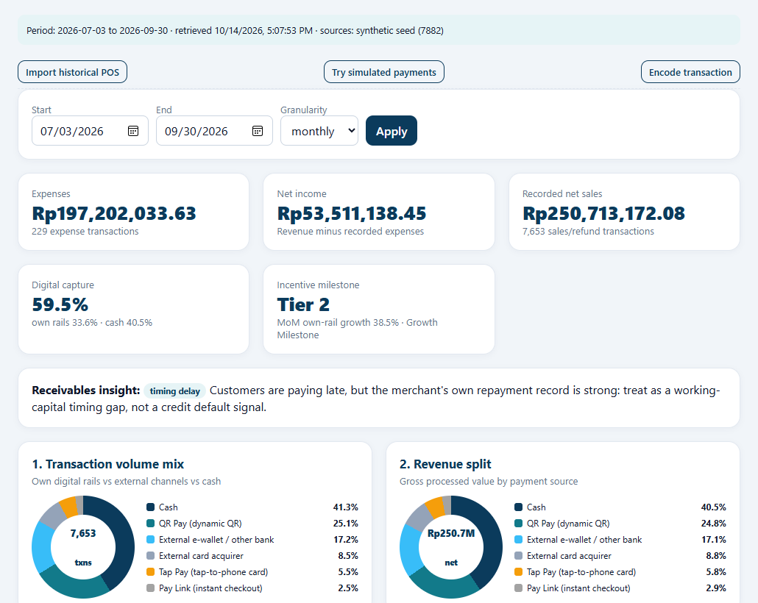
Actual current UI detail captured 14 October 2026 from disposable synthetic data. Cropped for readability.

F03 Single transaction entry
Purpose Save one sale, expense, refund or reversal with explicit status and payment method.
Starting page /merchant-transactions/single
Prerequisites Sign in with the feature’s permitted role, select an assigned merchant, and use demonstration data. Apply any explicit grants, category consent or confirmation described below.
1. Expand Merchant Transactions and select Single Transaction.
2. Enter transaction date/time, a positive absolute net amount, type, channel, status, external reference, category and optional description. Currency is fixed by the merchant.
3. Use completed only for completed activity; use pending, failed or voided where appropriate.
4. Click Save transaction once and inspect the confirmed transaction ID. Open Transaction History and Dashboard to verify the effect.
Business logic The canonical normalizer signs sale positive and expense/refund/reversal negative. Financial effect is zero unless completed. Required fields, allowed enum values, exact cents, merchant currency and dates are validated. Completed zero values are rejected; amounts are finite and capped at one trillion. Manual reference is required by the UI; protected scope/provenance fields cannot be client supplied.
Technical logic The current form calls POSImportService.single, normalizes the record, checks duplicates and appends an idempotent batch to TransactionJournal. SQLite records the run and confirmed result. Legacy entry APIs are retained separately for compatibility, not the current form’s primary path.
Security Owner needs create_transactions. Staff also needs an explicit merchant-level create_transactions grant. Financing Agent and administrator roles cannot encode transactions. The saved actor is authenticated and audit events are generated.
Expected outcomes and limits A confirmed journal record appears in history; completed activity reaches financial projection. Invalid/future dates, wrong currency, formula-like text, sensitive card/credential patterns and duplicate conflicts reject saving. Repeating the same accepted manual idempotency key returns its outcome; different content must not be substituted.
API POST /api/merchant-transactions/entry
Source copilot/pos_import.py : single (line 359); copilot/canonical_transactions.py : normalize (line 86); copilot/transaction_journal.py : append_batch (line 107)
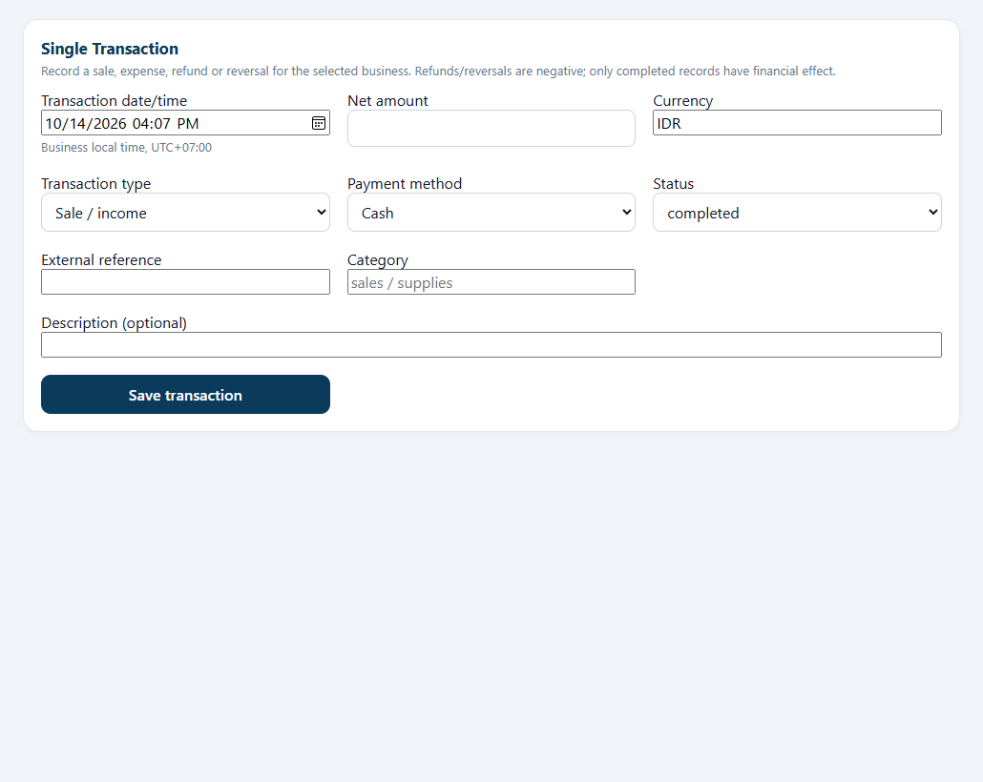
Actual current UI detail captured 14 October 2026 from disposable synthetic data. Cropped for readability.

F04 Bulk POS acquisition and field mapping
Purpose Import transaction-level CSV or XLSX reports with explicit monetary meaning.
Starting page /merchant-transactions/import
Prerequisites Sign in with the feature’s permitted role, select an assigned merchant, and use demonstration data. Apply any explicit grants, category consent or confirmation described below.
1. Select Bulk POS Import, then Upload Files or Select Folder. Folder selection sends selected browser files, not access to the computer’s directories.
2. Click Continue to Map Columns. Review each file separately.
3. Map date/time, net or gross amount, currency, type, status and payment method. Set only explicit supported defaults. Choose date format and timezone.
4. Check discount, tax and refund components when using gross. Keep settlement separate. Reuse mapping only for matching schemas. Click Run validation.
Business logic Acquisition accepts up to 10 files, 3,000,000 bytes each, 10,000,000 total, 5,000 rows and 30 columns. XLSX expanded content is capped at 20,000,000 bytes. Sensitive headers, unsafe paths, workbook formula cells and aggregate summary layouts are blocked. Each row must represent one transaction. Generic Amount is not automatically treated as net; settlement columns cannot be mapped as sales.
Technical logic merchant-transactions.js sends base64 file content to POSImportService.stage. pos_extract parses bounded CSV/OOXML and detects schema/summary issues. Source signatures bind staged material to merchant, actor and authenticated session. Mappings, dataset signatures and version are stored in SQLite; staged runs expire after 1,800 seconds.
Security Owner needs bulk_import. Staff needs membership, enabled role action, individual optional bulk_import permission AND merchant bulk_import grant. Staging is private to its actor/session. Administrator authority does not bypass these checks.
Expected outcomes and limits Valid files produce a mapping view before any financial save. Unsupported format, oversized/unsafe content, sensitive columns or ambiguous monetary mapping stop processing. Back navigation preserves mapping; cancellation does not save transactions.
API POST /api/pos-import/stage; GET /api/pos-import/{batch_id}
Source copilot/pos_extract.py : extract_files (line 122); copilot/pos_import.py : stage (line 91); copilot/pos_import.py : _mapping (line 137)
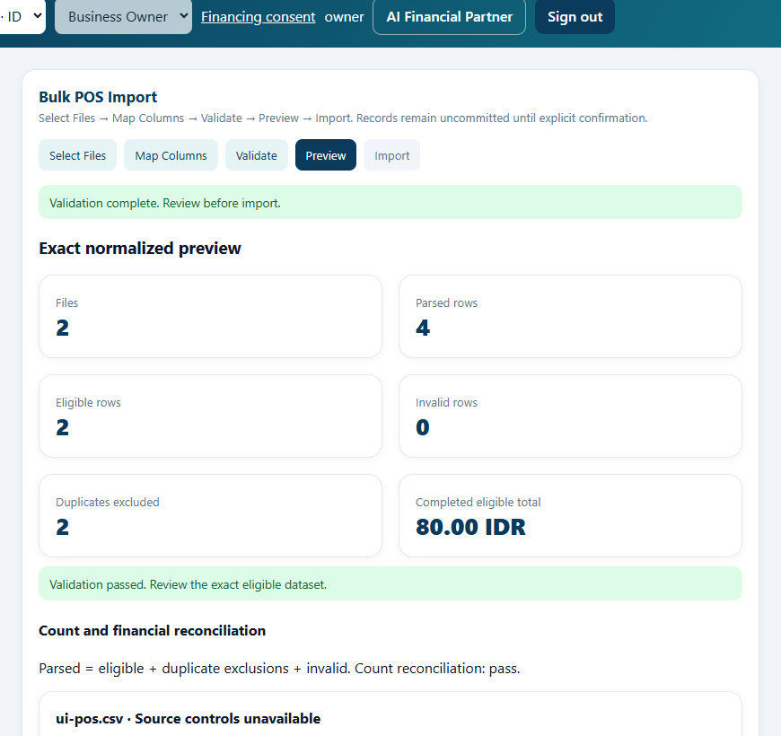
Actual synthetic application screenshot retained from verified Task 03 browser evidence; not a new Task 04 acceptance result.

F05 Duplicate reconciliation preview and commit
Purpose Make the exact normalized import reviewable before committing financial records.
Starting page /merchant-transactions/import
Prerequisites Sign in with the feature’s permitted role, select an assigned merchant, and use demonstration data. Apply any explicit grants, category consent or confirmation described below.
1. On validation, inspect errors, duplicate exclusions, count reconciliation and any reported controls.
2. Fix invalid rows or mappings and validate again. A warning with unavailable controls is not proof of financial reconciliation.
3. Continue to Preview and inspect the normalized rows, sources, signed amounts and excluded duplicates.
4. Click Confirm Import and accept the explicit confirmation only if correct. Review the backend-confirmed result and history.
Business logic Duplicate candidates use merchant-scoped reference or row fingerprint. Exact duplicates with reference or same file/row identity are excluded; conflicting references or ambiguous reference-less matches block commit. Count identity is parsed = eligible + duplicates + invalid. Reported control amounts compare completed-net or nominal-net basis as chosen; absent controls are marked not_available. Invalid, ambiguous or mismatched controls make validation_failed.
Technical logic POSImportService.validate computes signatures and preview token. commit verifies session, signature, current validation version, token and confirmed=true, and rechecks ledger duplicates. A committing run appends one checksummed journal batch and is finalized in SQLite. Recovery distinguishes a saved batch from an absent/inconsistent append.
Security Authorization is repeated for stage, validate, preview and commit. A successful batch commit replay is denied with 409; fetch its outcome instead. The preview binds exact data and actor/session; alert acknowledgement cannot authorize a bad import.
Expected outcomes and limits Only validated, confirmed rows are added. A concurrent duplicate invalidates preview and requires revalidation. Expired/cancelled/integrity-failed sessions cannot commit. Partial uncertainty raises an alert and requires verified recovery, not blind retries.
API POST /api/pos-import/{batch_id}/validate; GET /api/pos-import/{batch_id}/preview; POST /api/pos-import/{batch_id}/commit; POST /api/pos-import/{batch_id}/cancel
Source copilot/pos_import.py : _duplicates (line 154); copilot/pos_import.py : validate (line 168); copilot/pos_import.py : commit (line 284); copilot/pos_import.py : recover (line 333)

F06 Transaction history and data quality monitoring
Purpose Inspect committed records and follow validation/import quality findings.
Starting page /merchant-transactions/history and /merchant-transactions/data-quality
Prerequisites Sign in with the feature’s permitted role, select an assigned merchant, and use demonstration data. Apply any explicit grants, category consent or confirmation described below.
1. Open Transaction History and filter dates, status, source and channel. Use page controls for more rows.
2. Open Data Quality & Monitoring and click Refresh / Recheck. Inspect import counts, failure/duplicate rates and unresolved alerts.
3. Open a run to inspect mapping, reconciliation and findings.
4. If authorized, acknowledge an open alert with a meaningful reason; resolve only after acknowledgement and recorded evidence.
Business logic History contains committed canonical journal records, not all synthetic seed activity shown by finance modules. Monitoring runs during foreground validation, commit, recovery and expiry checks, not a continuous scheduler. Alert lifecycle is open → acknowledged → resolved; reasons require 8–500 characters. Status changes do not modify transactions or override validation. History page limits are 1–100 with nonnegative offset.
Technical logic POSImportService.history and monitoring query journal and SQLite run/alert/event data. The left menu badge uses the backend count of unresolved alerts for the selected authorized merchant. Duplicate rate is excluded duplicate rows / parsed rows, not duplicate batches.
Security History needs view_transactions; monitoring needs view_quality_monitoring. Staff alert changes require matching explicit acknowledge/resolve grants. Run details and alerts remain merchant scoped. Suspended or unassigned users lose access even if a tab remains open.
Expected outcomes and limits Filters do not change financial records. An empty history does not imply an empty synthetic dashboard. Current UI includes obsolete text saying Task 03 integration is deferred; integration is implemented. The Source selector lacks a simulated_payment option, so use All to see simulation records.
API GET /api/merchant-transactions/history; GET /api/data-quality; GET /api/data-quality/runs/{id}; POST /api/data-quality/alerts/{id}
Source copilot/pos_import.py : history (line 389); copilot/pos_import.py : monitoring (line 411); copilot/pos_import.py : alert_action (line 451)
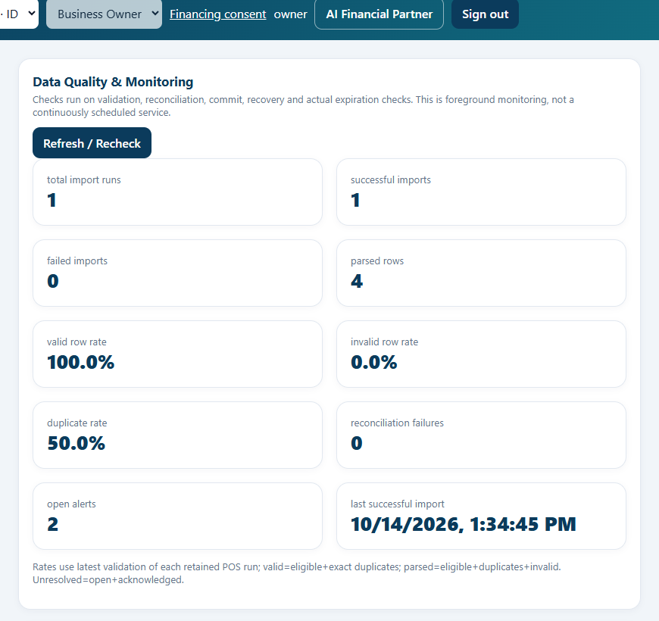
Actual synthetic application screenshot retained from verified Task 03 browser evidence; not a new Task 04 acceptance result.

F07 QR Tap and Pay Link simulations
Purpose Demonstrate payment collection and its recorded financial effect without real money.
Starting page /payment-sandbox
Prerequisites Sign in with the feature’s permitted role, select an assigned merchant, and use demonstration data. Apply any explicit grants, category consent or confirmation described below.
1. Select Digital Payments. Enter a standalone amount or select POS products and quantities.
2. Choose QR Pay, Tap Pay or Pay Link. Review amount, method and currency in the proposed action.
3. Confirm the proposal. No payment exists before confirmation.
4. Use the displayed customer simulation control. For Pay Link, select an offered digital payment channel. Inspect PAID, merchant fee and sandbox settlement.
Business logic Standalone amounts must be positive finite exact cents and at most one trillion. Cart price/quantity validations apply; configured demonstration tax is included. QR expires after 300 seconds, Tap after 120 seconds and Pay Link after 72 hours. Only pending requests may pay; QR/Tap channel must match method. A review flag blocks payment; velocity/repeated-amount flags do not by themselves imply a credit decision.
Technical logic web/index.html requests PartnerState proposals and confirmations, then uses payment pay/status endpoints. PaymentSimulator manages PENDING → PAID/EXPIRED/CANCELLED/FAILED. Ecosystem payments calculate stage-based MDR and increment the sandbox wallet; external channels record sales but have no internal wallet settlement. Paid events append canonical PAY-reference markers and persist payment state.
Security Owner or permitted Staff needs simulate_payments and T2. Read-only coach/Financing Agent and administrators cannot pay. No card-number input is supported. The QR is a deterministic visual placeholder; the sandbox.pay.local link is not a live payment processor.
Expected outcomes and limits PAID becomes one canonical sale and updates financial reports. Pending/failed/expired/cancelled requests do not create sales. A duplicate payment attempt after PAID is rejected. A proposal expires in five minutes even if the resulting Pay Link can remain pending longer.
API GET /api/pos/catalog; POST /api/partner/actions; POST /api/partner/actions/confirm; POST /api/payments/pay; GET /api/payments/status
Source copilot/modules/payments.py : create (line 121); copilot/modules/payments.py : simulate_customer_payment (line 178); copilot/financial_data.py : record_payment (line 97); copilot/partner_state.py : confirm (line 62)
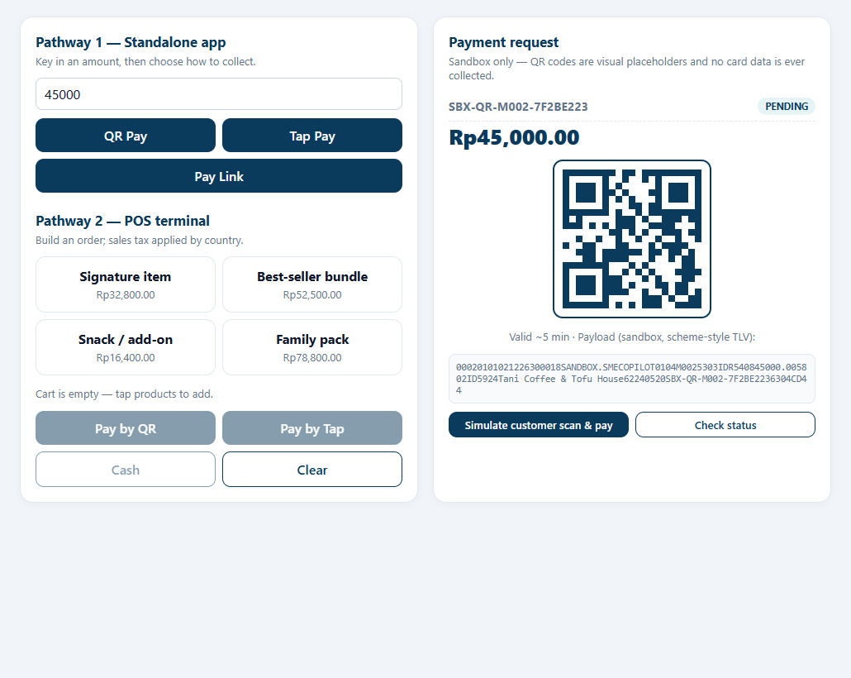
Actual current UI detail captured 14 October 2026 from disposable synthetic data. Cropped for readability.

F08 Refund accounting and payment recovery
Purpose Represent refunds as reductions to sales and prevent duplicate sandbox effects after restart.
Starting page Single Transaction / Bulk POS Import; linked simulator refund is backend only
Prerequisites Sign in with the feature’s permitted role, select an assigned merchant, and use demonstration data. Apply any explicit grants, category consent or confirmation described below.
1. For an accounting refund, open Single Transaction and choose Refund, or import a transaction-level refund row.
2. Enter the positive absolute refunded amount, correct original channel, distinct reference and completed status; save or confirm import.
3. Compare the same reporting period: sales less refunds gives net sales.
4. A linked simulator refund has no current UI button or HTTP endpoint. Ask a developer to demonstrate the existing backend refund method with disposable data; do not invent a browser route.
Business logic Manual/POS refunds are signed negative but are not automatically linked or capped to an original payment and do not undo wallet settlement. The backend PaymentSimulator.refund instead requires a PAID payment, exact positive amount, idempotency key and amount ≤ remaining unrefunded payment. Reusing a key with changed reference/amount is rejected. Paid status remains PAID internally; status analysis labels full/partial refunds separately.
Technical logic record_refund appends a deterministic REF marker related to payment reference and exact wallet delta. SQLite retains payment/refund/wallet state. Startup reconciliation repairs tested journal-to-SQLite interruption gaps and fails closed on inconsistent refund totals. This is not a cross-store distributed atomic transaction.
Security Browser accounting refunds require create_transactions/bulk_import grants and merchant isolation. Backend linked refund is not exposed as an authorized HTTP/MCP write tool; a production refund workflow and its final permission model require specification.
Expected outcomes and limits A 100 sale plus a 25 accounting refund has net sales 75. Linked refund additionally changes the sandbox wallet by its implemented net fee-adjusted amount. Manual accounting refunds alone do not move funds. Restart/idempotency tests passed in Task 03; no end-user linked-refund UI is claimed.
API No linked simulator refund HTTP endpoint; accounting refund uses transaction entry/import
Source copilot/modules/payments.py : refund (line 200); copilot/financial_data.py : record_refund (line 111); copilot/financial_data.py : reconcile_payment_state (line 162)

F09 Cash flow forecast and risk alerts
Purpose Review estimated balance paths and rule-based financial warning indicators.
Starting page /cash-flow
Prerequisites Sign in with the feature’s permitted role, select an assigned merchant, and use demonstration data. Apply any explicit grants, category consent or confirmation described below.
1. Open Cash Flow for the selected merchant.
2. Read Balance today, Lowest projected (30d), Cash buffer and the balance forecast chart.
3. Read alerts and recommended actions, then verify that their source assumptions apply to this business.
4. Ask “Show my cash flow forecast” or “Show my financial report” in the partner and inspect estimated labels and evidence.
Business logic A 56-day weekday profile includes zero-activity dates. Future inflow is weekday-average sales plus expected receivables; outflow is weekday-average supplies/operating/household draws plus due payables and monthly debt service on day 15. Overdue receivables are excluded by default. Balance starts from synthetic merchant wallet plus simulated settled wallet, not imported sales. First negative projected day determines runway.
Technical logic cashflow.forecast uses projected merchant rows, obligations and model configuration; /api/cashflow returns forecast and alert list. AI evidence includes balances, buffer and validated severity counts. Financial report projection repeats last 30-day net sales and is a different calculation from cash balance forecast.
Security view_forecasts and T0 are required. Financing Agents need assigned scope and current forecasts consent. Financial reports additionally require view_reports; Staff does not automatically receive that permission.
Expected outcomes and limits Forecasts are estimates, not guaranteed collections or real bank balances. Missing obligations, synthetic balances and unchanged assumptions can materially change interpretation. No variable outflow yields an unavailable buffer, not infinite certainty. Task 03.1 scenario/survival simulation is deferred.
API GET /api/cashflow; POST /api/chat
Source copilot/modules/cashflow.py : forecast (line 38); copilot/modules/cashflow.py : alerts (line 79); copilot/modules/reporting.py : report (line 5)
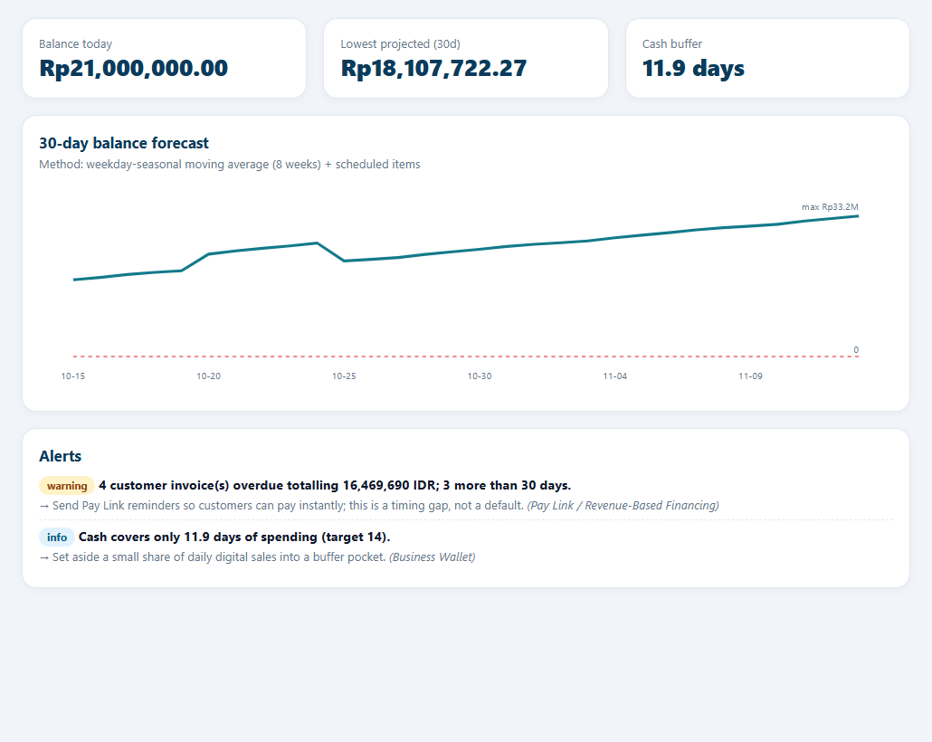
Actual current UI detail captured 14 October 2026 from disposable synthetic data. Cropped for readability.

F10 Business assessment and financing overview
Purpose Compare indicative financing and noncredit support options with stage and readiness signals.
Starting page /financing
Prerequisites Sign in with the feature’s permitted role, select an assigned merchant, and use demonstration data. Apply any explicit grants, category consent or confirmation described below.
1. Expand Financing and select Overview.
2. Review the ranked catalog options and their fit/rationale.
3. Inspect Not yet eligible explanations to understand missing stage/readiness/evidence conditions.
4. Ask “What financing fits my business?” or “How is my business doing?” and treat results as indicative sandbox analysis.
Business logic Seven dimension scores form a weighted composite and gated stage. Stage/readiness filters exclude products before scoring; RBF also needs RBF eligibility, purchase-order financing needs orders, and invoice financing needs open invoices. Matching combines constraint fit, stage fit, readiness and affordability. Catalog parameters and merchant attributes are provisional/demo inputs, not lender offers.
Technical logic assessment.py produces signals, scores, stage and constraints; matching.py uses provider-neutral CATALOG and returns top five recommendations plus exclusions. Existing /api/cycle provides progression details for compatible legacy workflows. Gemini match labels are resolved from actual catalog IDs, never arbitrary model names.
Security Owner, consent-authorized Financing Agent and compatible coach need view_financing and T1. Staff finance menus/tools are hidden and rejected by backend. Administrative permissions confer no finance access.
Expected outcomes and limits A recommendation does not approve an application or promise a limit. Empty/invalid financial inputs can cause safe insufficient-evidence behavior. Some base readiness/operational inputs are synthetic and not editable in the current merchant UI.
API GET /api/match; GET /api/cycle
Source copilot/modules/assessment.py : assess (line 203); copilot/modules/assessment.py : place_stage (line 110); copilot/modules/matching.py : match (line 70)
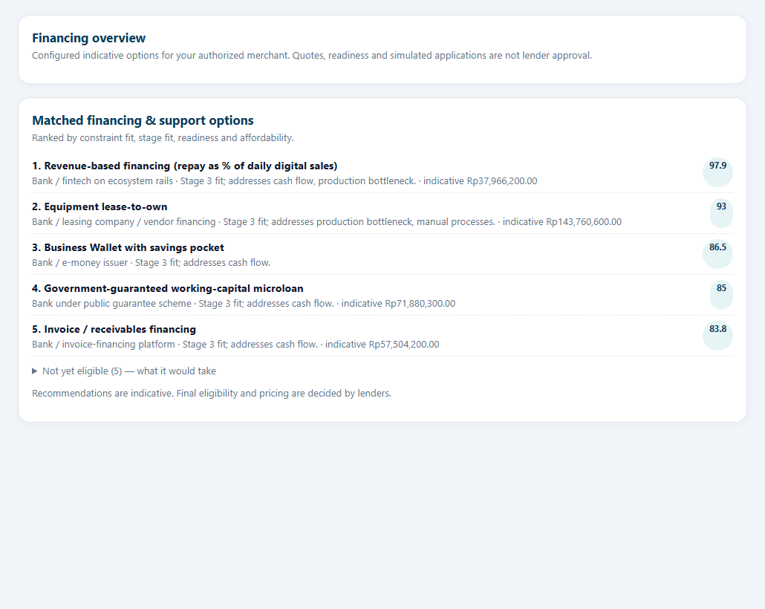
Actual current UI detail captured 14 October 2026 from disposable synthetic data. Cropped for readability.

F11 RBF calculator and repayment simulation
Purpose Explore an indicative advance, fee, sales-linked remittance and estimated payoff.
Starting page /financing/rbf
Prerequisites Sign in with the feature’s permitted role, select an assigned merchant, and use demonstration data. Apply any explicit grants, category consent or confirmation described below.
1. Expand Financing and select RBF Calculator. Check eligibility and basis monthly ecosystem sales.
2. Move the advance slider within displayed bounds.
3. Review fee, total repayable, remittance rate, estimated payoff and strong/typical/slow/no-sales examples.
4. Compare fixed daily installments with gross profit; read warnings. Ask “Quote RBF advance 10000000” only where available limits permit it.
Business logic Ecosystem sales over 90 days size limits; all digital sales determine verified-share eligibility. Fees depend on advance/monthly ecosystem basis; milestone discounts reduce flat fee rate. Remittance grows with advance/max limit, capped at 18%. Last 90 days of ecosystem sales are cycled to estimate payoff; negative sales cannot generate negative repayment. Eligibility and quote functions are separate: a calculated quote is not approval.
Technical logic rbf.limits, eligibility, quote and recommend_advance feed dedicated UI. POST quote uses deterministic backend calculation; binary search recommends an advance meeting target payoff where possible. Payoff loops at most 1,080 simulated days; schedule returns first 14 days. Quotes and calculations do not save an application.
Security view_financing and T1 required, plus Agent/coach consent. Application preparation requires separate T3/submit authority and explicit confirmation. A quote cannot elevate the user’s permissions.
Expected outcomes and limits Invalid/nonpositive or over-limit advance fails; no sales produces zero repayment and can yield unavailable payoff. Final lender terms are unavailable. Python rounding and 100-unit limit rounding are current demonstration conventions, including currencies that normally use different minor units.
API GET /api/rbf/limits; POST /api/rbf/quote
Source copilot/modules/rbf.py : limits (line 51); copilot/modules/rbf.py : eligibility (line 60); copilot/modules/rbf.py : quote (line 79); copilot/modules/rbf.py : recommend_advance (line 145)
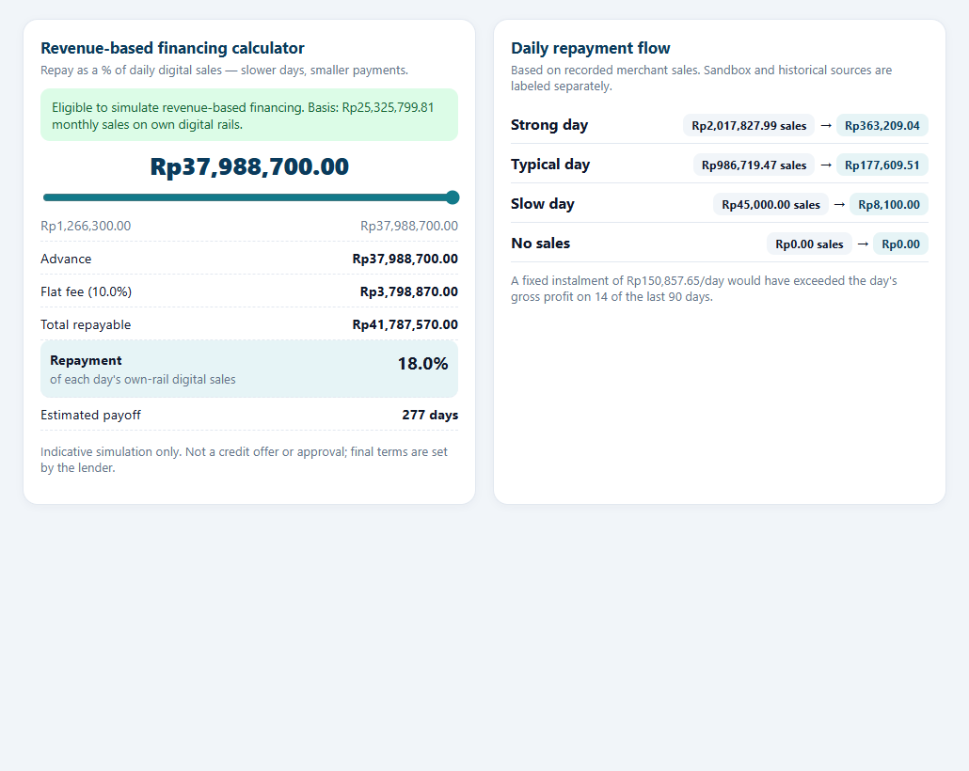
Actual synthetic application screenshot retained from verified Task 03 browser evidence; not a new Task 04 acceptance result.

F12 Consent and confirmed financing application
Purpose Share selected financial categories and prepare an explicitly approved sandbox application.
Starting page /consents and /financing/applications
Prerequisites Sign in with the feature’s permitted role, select an assigned merchant, and use demonstration data. Apply any explicit grants, category consent or confirmation described below.
1. As Owner, click Financing consent. Select an active assigned Agent, categories, purpose and future expiry; grant consent.
2. Open the partner and request “Submit my financing application for 10000000” using an amount within limits.
3. Review the exact RBF proposal, amount, selected merchant and expiry. Confirm exact simulated action.
4. Open Financing → Applications to inspect the saved reference. Revoke consent from the consent page when sharing should stop.
Business logic Consent categories are reports, assessment, forecasts, financing and applications; expiry is within 366 days. Submission requires active owner consent to an assigned recipient. Only the configured RBF product is supported by the new confirmed action. Proposal is not submission. Confirmation binds user/session/merchant/data version, expires after 300 seconds and reauthorizes. T4 remains prohibited.
Technical logic AuthStore stores consents; PartnerState stores proposed/executing/executed/review_required action data. Existing PolicyGuard issues a fresh T3 approval token at confirmation. prepare_financing_application packages verified sandbox data; submit_packet persists applications and assigned recipient. A repeated confirmed executed action returns its result, not a second packet.
Security Owner needs manage_consents, prepare_application, submit_application and T3. Staff, Agent and administrators cannot submit Owner applications. Changes in merchant data require a new proposal. Consent revocation immediately stops future consent-authorized access; previously displayed/exported knowledge cannot be recalled.
Expected outcomes and limits SUBMITTED_FOR_LENDER_REVIEW means simulated submission only. Unknown recipient, missing categories, expired/revoked consent, stale proposal and changed identity reject access. An uncertain execution enters review_required, with no automatic retry.
API GET/POST /api/consents; POST /api/consents/{id}/revoke; GET /api/applications; POST /api/partner/actions/confirm
Source copilot/auth.py : grant_consent (line 492); copilot/auth.py : submit_packet (line 525); copilot/partner_state.py : propose (line 33); copilot/partner_state.py : confirm (line 62)
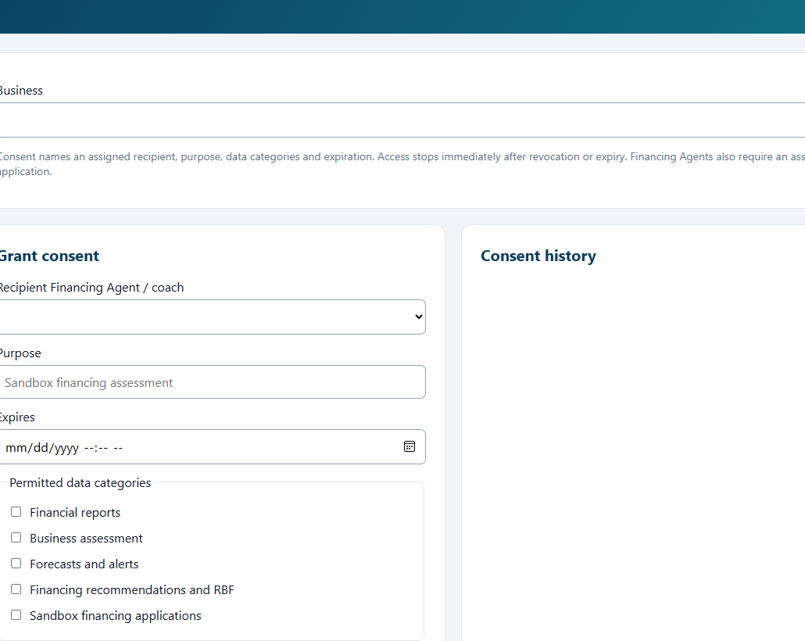
Actual current UI detail captured 14 October 2026 from disposable synthetic data. Cropped for readability.

F13 Financing Agent application review
Purpose Let an assigned consent-authorized Agent record a sandbox review outcome.
Starting page /financing/applications
Prerequisites Sign in with the feature’s permitted role, select an assigned merchant, and use demonstration data. Apply any explicit grants, category consent or confirmation described below.
1. Sign out of the Owner account and sign in with a separate Financing Agent account.
2. Select the assigned merchant and open Financing → Applications.
3. Review the visible application and select its review control.
4. Enter request_information, sandbox_recommended or sandbox_declined and a meaningful note. Confirm and inspect the review record.
Business logic Only the packet’s assigned recipient can record a review. Outcome is restricted to three simulated values; note length is 1–1,000 characters. Reviews append to a separate table. They do not change the packet’s submitted status into a real approval or disburse money.
Technical logic application_list filters rows to Owner or assigned recipient. review_application stores outcome/note/time and audit event in SQLite; the UI presents reviews with the application. Chat application-status evidence only reports the existing submitted packet status, not a model-invented review decision.
Security Agent needs view_applications and review_application, category consent and assigned application, as well as membership. Another Agent or any administrative account cannot infer or modify a packet simply by knowing its ID.
Expected outcomes and limits A saved review remains explicitly simulated. Revoking consent denies new financing requests and review actions. Missing assignment, invalid outcome or empty note fails. There is no real underwriting approval state.
API GET /api/applications; POST /api/applications/{id}/review
Source copilot/auth.py : application_list (line 537); copilot/auth.py : review_application (line 544); copilot/agent.py : financial_result (line 77)
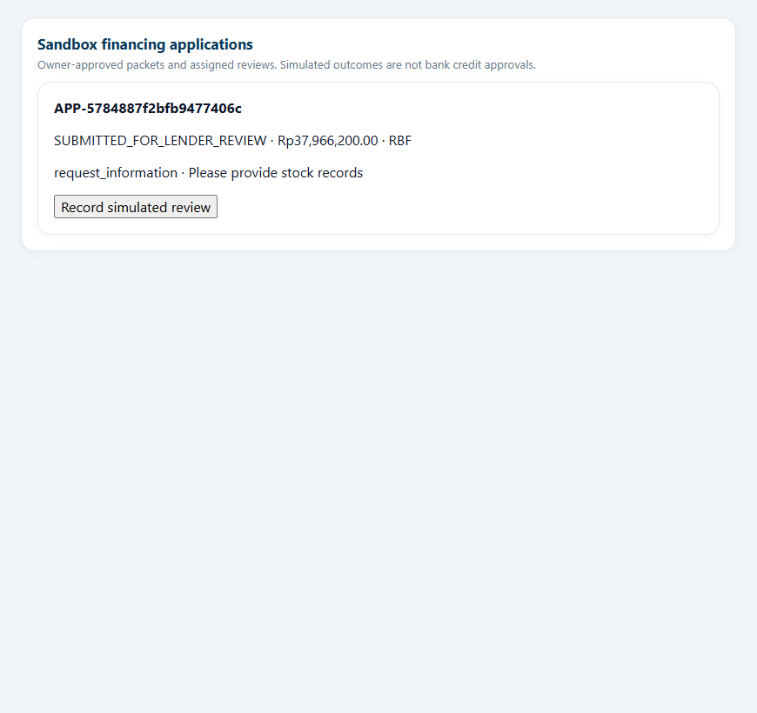
Actual synthetic application screenshot retained from verified Task 03 browser evidence; not a new Task 04 acceptance result.

F14 AI Financial Partner questions and follow ups
Purpose Answer SME finance questions from authorized backend evidence while rejecting unsupported claims.
Starting page Persistent right panel in business workspace
Prerequisites Sign in with the feature’s permitted role, select an assigned merchant, and use demonstration data. Apply any explicit grants, category consent or confirmation described below.
1. Open AI Financial Partner if collapsed. Choose a module suggestion or type a finance question.
2. Ask “Show recorded sales 2026-10-01 to 2026-10-14” and inspect Evidence, period and limitations.
3. Ask “Show my financial report” for totals, projection and rule-alert counts.
4. For RBF, ask an explicit quote then “What about that fee?” Switch modules to verify conversation display persists; switch merchant and ask afresh.
Business logic Finance-only routing is conservative English pattern matching. Unrelated requests are redirected; unsupported approval/FX/bank/credit metrics are withheld. Server chooses one requested read capability and fixes scope/dates/amount from parser/context. Gemini proposes that tool and copies exact allowed claims. Claim values, currency, period, merchant, source, IDs, provenance and status must all match; extra prose/fabricated claims reject the model result.
Technical logic agent.handle delegates safe reads to verified_agent.execute. reliability.Fact/validate_claims enforce typed evidence; backend render constructs final prose. ai_agent._post uses stdlib HTTP with 15-second read-plan/explanation timeouts. partner_context stores preferences and evidence IDs by user/session, with merchant/role/data-version checks; browser threads are separate per merchant.
Security use_copilot plus each financial tool permission is mandatory. Tool exposure excludes writes and intersects live role/tier/consent. Imported descriptions and tool prose do not become instructions. Final backend authorization repeats before publishing. Admin accounts have no financial chatbot authority.
Expected outcomes and limits VERIFIED means checked against sandbox records; ESTIMATED means forecast, not guarantee. HYPOTHESIS exists in schema but unrestricted causal hypotheses are not generated. Errors/invalid JSON/429/model failure cause deterministic fallback with safe metadata, not automatic permission relaxation. Full browser transcript does not persist after reload/logout; finite testing is not universal attack-proof certification.
API POST /api/chat
Source copilot/verified_agent.py : execute (line 55); copilot/reliability.py : validate_claims (line 70); copilot/reliability.py : domain (line 90); copilot/partner_state.py : context (line 11)
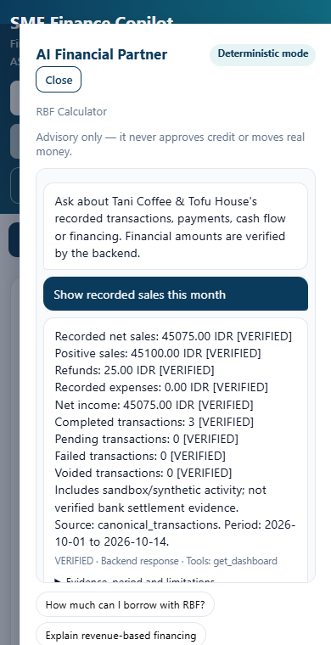
Actual synthetic application screenshot retained from verified Task 03 browser evidence; not a new Task 04 acceptance result.

F15 User Administration and Staff access requests
Purpose Manage accounts, merchant memberships, account status and explicit Staff grants.
Starting page /admin/users
Prerequisites Sign in with the feature’s permitted role, select an assigned merchant, and use demonstration data. Apply any explicit grants, category consent or confirmation described below.
1. Sign in as User Administrator or Security Administrator and open User Administration.
2. Search/filter accounts. Create an Owner, Staff or Financing Agent with the correct role, memberships and required Agent organization.
3. Assign Staff transaction grants per merchant and the optional upload permission where needed.
4. Re-enter your administrator password when required. Give the temporary password privately; the new user must change it. Use account actions to suspend/unlock/reset/revoke sessions as authorized.
Business logic Roles cannot exceed fixed server boundaries. User Administrators cannot create or manage privileged administrator roles; Security Administrators have broader account administration. Membership does not automatically grant Staff encoding/upload actions. Sensitive edits invalidate sessions. An Owner can submit a staff-access request for administrators, but the request itself does not grant permissions.
Technical logic web/users.html and admin.js call AuthStore create/update/account_action APIs. SQLite holds users, memberships, optional_permissions, merchant_transaction_grants and requests. Audit history accompanies account changes; last-active administrator protections prevent unsafe removal.
Security manage_users/manage_staff_accounts are administrative permissions independent of finance. Sensitive operations require recent reauthentication. New coach assignments require explicit local configuration; demo_guest is not an authenticated unrestricted account path.
Expected outcomes and limits Valid account changes persist and require fresh sessions. Duplicate usernames/emails, unsafe roles, invalid memberships, missing Staff grants or stale reauthentication fail. No self-service merchant creation exists; the application provides preconfigured synthetic merchants.
API GET/POST /api/admin/users; PATCH /api/admin/users/{id}; POST /api/admin/users/{id}/{action}; POST /api/staff-access-requests
Source copilot/auth.py : create_user (line 359); copilot/auth.py : update_user (line 365); copilot/auth.py : account_action (line 414); copilot/auth.py : staff_request (line 558)
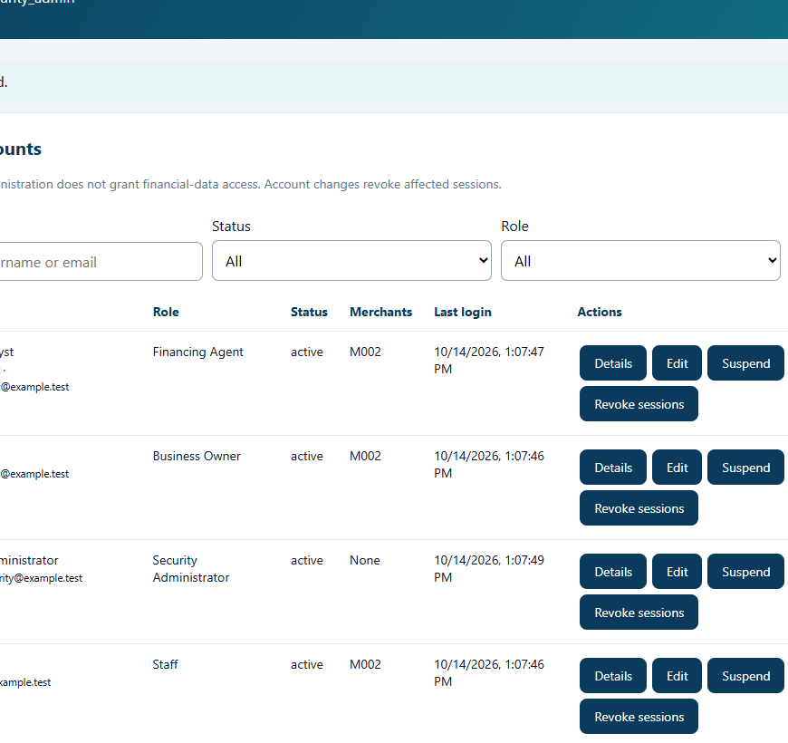
Actual synthetic application screenshot retained from verified Task 03 browser evidence; not a new Task 04 acceptance result.

F16 Security Controls and configuration portability
Purpose Review and constrain authentication, permissions, AI tiers, consent/audit controls and portable policy.
Starting page /admin/security
Prerequisites Sign in with the feature’s permitted role, select an assigned merchant, and use demonstration data. Apply any explicit grants, category consent or confirmation described below.
1. Sign in as Security Administrator and open Security Controls.
2. Navigate Overview, Authentication, Roles & Permissions, AI & MCP Controls, Consent Policies, Audit & Monitoring, and Configuration.
3. Change only authorized supported settings; inspect bounds and reauthenticate before saving.
4. Export policy JSON. To import, select a supported file, validate and review differences, cancel or explicitly apply, then reauthenticate. Filter audit events and review alerts afterward.
Business logic Policy permissions stay within immutable role boundaries; tier ceilings can only remain at/below fixed role maxima. T4 cannot be enabled. Schema-version-1 JSON contains supported authentication settings, permissions and tiers, not accounts/credentials/sessions/financial data. Preview is revision-bound and expires; importing an old preview after policy changes is blocked.
Technical logic security.html/security-admin.js consume AuthStore policy and SecurityConfiguration services. JSON parser rejects duplicate keys, nonfinite values, unsupported fields and files over 64 KiB. Canonical policy digest/revision and current state protect confirm. SQLite audit logs and bounded monitoring expose operational events; no external centralized control plane is introduced.
Security manage_security and Security Administrator identity are required. Recent password reauthentication protects changes. Administrative settings cannot confer merchant data or elevate AI authority beyond fixed boundaries. Configuration exports must still be treated as internal policy material.
Expected outcomes and limits Validated confirmed changes apply locally. Cancellation preserves policy. Invalid JSON, widened role permissions, T4 tiers or stale previews fail. Consent Policies mostly explains enforced behavior; it is not an arbitrary consent-engine editor. Monitoring is bounded/foreground, not a background SOC.
API GET/PATCH /api/security/policies; GET /api/security/audit; GET /api/security/events; GET /api/security/config/export; POST /api/security/config/validate; POST /api/security/config/import
Source copilot/auth.py : update_policies (line 458); copilot/security_configuration.py : normalize (line 42); copilot/security_configuration.py : parse_file (line 62)
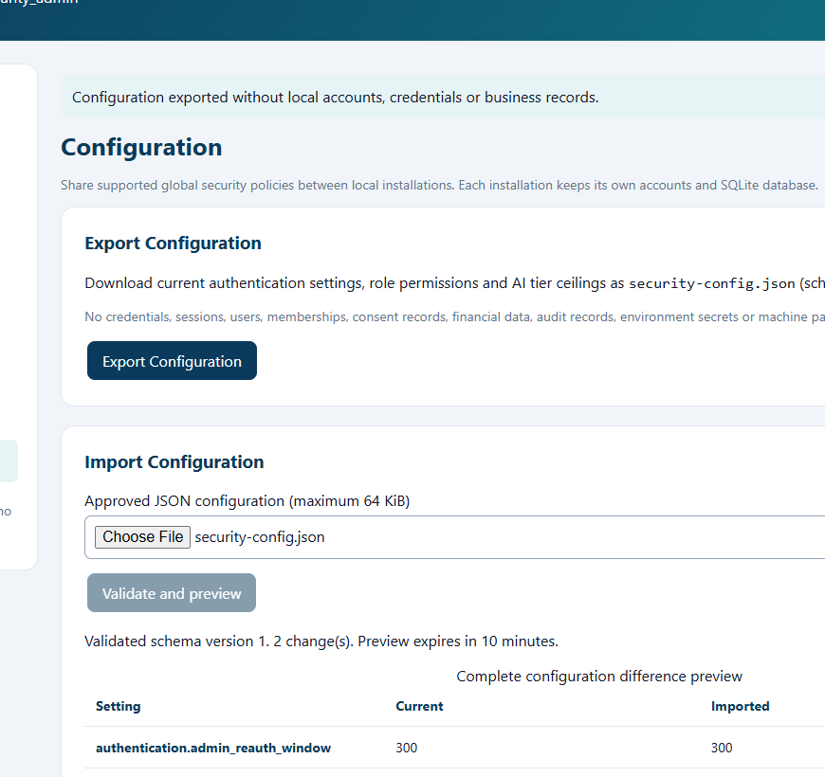
Actual synthetic application screenshot retained from verified Task 03 browser evidence; not a new Task 04 acceptance result.

Financial formulas and worked examples
All examples use synthetic amounts in one merchant currency unless a currency is explicitly named. They illustrate implemented arithmetic, not financial advice. Input provenance, period and units must remain attached to the result. Source references below point to inspected functions at the baseline revision.

M01 Gross and normalized net
Implemented expression N = G - D + T - R; signed amount = +abs(N) for sale, -abs(N) for expense/refund/reversal.
Variables units and inputs G is mapped gross; D discount, T tax and R refund component, all in the merchant currency. Inputs come from one transaction row.
Worked example G=1,000; D=50; T=100; R=0 gives N=1,050. A separate refund of 25 is signed -25.
Boundary conditions If both net and gross exist, abs(mapped net) must equal calculated N. Negative adjustments, negative gross/calculated net, completed zero and mixed currencies reject the row. Missing gross with monetary adjustments rejects it. Settlement is not revenue.
Source copilot/canonical_transactions.py : normalize (line 86)

M02 Sales expenses refunds and income
Implemented expression Net sales = sum(completed sales) - sum(abs(completed refunds and reversals)); expenses = sum(abs(completed expenses)); net income = net sales - expenses.
Variables units and inputs Inclusive reporting dates, one merchant/currency, completed canonical records plus synthetic base activity. Gross sales sum source gross only where all represented sales have it.
Worked example Sale 100; refund 25; expense 20 gives recorded net sales 75, expenses 20 and net income 55. Pending sale 80 contributes zero.
Boundary conditions Gross is unavailable rather than inferred where any sales source provides only net. A refund component already included in a source net and a separate refund row can double-reduce revenue if a user imports both representations; reconcile source meaning.
Source copilot/financial_data.py : aggregate (line 45)

M03 Counts shares and trends
Implemented expression Volume share(channel) = channel transaction count / total count; revenue share(channel) = channel signed sales / signed sales total; period trend = sums grouped by chosen date bucket.
Variables units and inputs Channel count uses legacy count weights; canonical appended records have count=1. AI completed count includes expenses, while dashboard sales volume excludes expense rows.
Worked example Two cash sales and one card sale have cash volume 2/3. Cash revenue 75 and card revenue 25 gives cash revenue share 75%.
Boundary conditions Zero denominator uses legacy fallback 1. Net negative/mixed-channel refunds can produce nonstandard shares; negative pie displays are suppressed and financing ratios may reject analysis. Provenance record_count counts represented rows, not weighted ticket count.
Source copilot/modules/dashboard.py : channel_mix (line 43)

M04 Digital capture
Implemented expression Digital share = digital net sales / all net sales; ecosystem share = QR/Tap/Pay Link net sales / all net sales; cash share = 1 - digital share.
Variables units and inputs Source channel flags are in config.CHANNELS; external card/wallet are digital but not ecosystem.
Worked example Cash 40, external card 20 and QR 40 gives digital share 60%, ecosystem share 40%, cash share 40%.
Boundary conditions Self-recorded digital POS rows are demonstration evidence, not verified bank settlements. Refunds and zero totals require interpretation; ratios are not guaranteed to describe gross turnover.
Source copilot/modules/dashboard.py : capture_metrics (line 71)

M05 Incentive calendar run rate
Implemented expression Current run rate = current ecosystem sales / elapsed days × days in month; growth = (run rate - previous ecosystem sales) / previous ecosystem sales.
Variables units and inputs Current partial calendar month uses the business-data date. Previous ecosystem share must be at least 10% of previous total.
Worked example Current month 15 of 30 days has 650; run rate=1,300. Previous ecosystem sales=1,000 gives growth 30% and Tier 2.
Boundary conditions Tier 1/2/3 thresholds are 15%/30%/50%; largest achieved tier is selected. Low/zero prior ecosystem base gives no inferred growth. Rewards are illustrative, not actual cash payouts.
Source copilot/modules/dashboard.py : incentive_status (line 91)

M06 Cash forecast
Implemented expression Balance(d) = Balance(d-1) + weekday average sales(d) + scheduled receivables(d) - weekday average eligible expenses(d) - scheduled payables(d) - debt service(d).
Variables units and inputs Weekday averages cover 56 calendar days including zeros. Expenses include supplies, operating and household_draw. Debt service is scheduled on the 15th.
Worked example Opening 1,000; average inflow 200; variable outflow 120; bill 100; receivable 50; debt 0 gives next balance 1,030.
Boundary conditions Receivables already paid are omitted; overdue excluded unless explicitly requested internally. Opening wallet is base sandbox wallet plus simulated settlement, not imported revenue. No independent balance reconciliation or real bank connector.
Source copilot/modules/cashflow.py : forecast (line 38)

M07 Cash buffer and runway
Implemented expression Average daily outflow = sum(seven weekday expense averages)/7 + monthly debt service/30; buffer days = opening wallet / average daily outflow; runway = first future day with balance < 0.
Variables units and inputs Currency cancels in buffer ratio; results are days. Forecast horizon defaults to 30.
Worked example Wallet 1,000 and average variable outflow 100 plus monthly debt 300 gives average 110/day and buffer 9.1 days.
Boundary conditions Zero average outflow gives unavailable buffer. Runway None means no negative day within the finite horizon, not permanent solvency. Negative starting wallets may produce negative buffer.
Source copilot/modules/cashflow.py : forecast (line 38)

M08 Repeat sales projection
Implemented expression Projected next 30-day recorded sales = sum(recorded net sales in the preceding 30 days).
Variables units and inputs Input is projected merchant transaction history; result is merchant currency and ESTIMATED.
Worked example Recent 30-day net sales 12,000 gives projected next 30-day sales 12,000.
Boundary conditions This repeats sales, not profit or available cash. No seasonality adjustment in this projection; weekday seasonality belongs to the distinct cash forecast. Missing or synthetic inputs limit confidence.
Source copilot/modules/reporting.py : report (line 5)

M09 RBF sales basis limits and eligibility
Implemented expression Monthly ecosystem basis B = sum(last 90 days ecosystem sales)/90 × 30; min = round(max(0,B)×0.05,-2); max = round(max(0,B)×1.5,-2).
Variables units and inputs B and limits use merchant currency; eligibility also considers digital sales/total, elapsed history and repayment ratio.
Worked example Ecosystem sales 18,000,000 over 90 days gives B=6,000,000; minimum=300,000; maximum=9,000,000.
Boundary conditions Eligibility requires at least 60 elapsed days, digital share ≥30%, on-time ratio ≥85%, positive total net sales. Digital share uses all digital channels; repayment basis only ecosystem. Elapsed history is not 60 actual daily observations. Quote checks positivity/max separately and does not itself enforce minimum/eligibility.
Source copilot/modules/rbf.py : limits (line 51)

M10 RBF fee and repayment total
Implemented expression Fee rate = tier(advance/B) - milestone discount, floored at zero; fee = round(advance×fee rate,2); total = round(advance+fee,2).
Variables units and inputs Tiers: ratio ≤0.5 →14%; ≤1 →12%; above1 →10%. Incentive Tier 1/2/3 discount 0/1/2 percentage points.
Worked example B=6,000,000 and advance=3,000,000 with incentive Tier2 gives fee rate13%, fee390,000 and total3,390,000.
Boundary conditions Tier thresholds use inclusive upper bounds. These are flat fees, not interest amortization; annualized cost is simple fee rate divided by payoff years, not an APR disclosure. Unapproved demonstration lending terms.
Source copilot/modules/rbf.py : quote (line 79)

M11 RBF remittance and daily replay
Implemented expression Rate = min(0.06 + advance/max_advance ×0.12, 0.18); payment(d) = min(max(0,round(ecosystem_sales(d)×rate,2)), remaining debt).
Variables units and inputs Replay cycles the last 90 days. Payments and debt are in the same merchant currency.
Worked example Advance3,000,000/max9,000,000 gives rate10%. Daily ecosystem sales200,000 pays20,000. Total3,390,000 pays in170 days, with final payment10,000; zero sales pays0.
Boundary conditions Stop when remaining≤0.005 or after1,080 days. Payoff may be unavailable; warning beyond540 days, target365 days. Rate returned rounded4 decimals; replay uses calculated unrounded rate. Amounts use Python round, not a separately approved currency rounding policy.
Source copilot/modules/rbf.py : quote (line 79)

M12 Recommended advance and comparison
Implemented expression Thirty binary-search iterations seek the largest advance with estimated payoff≤365 days between configured minimum and maximum; fixed daily comparison = total debt / estimated payoff days.
Variables units and inputs Quote replay is deterministic and size is rounded to nearest100. Stress count counts the last90 days with sales×gross_margin < fixed daily comparison.
Worked example Total3,390,000/170 gives equivalent fixed daily19,941.18. A 20,000 sales day at40% gross margin has gross profit8,000 and is a stress day.
Boundary conditions The search assumes payoff behavior suitable for bisection; best starts at lower bound even if no candidate meets target. No guaranteed optimum or real underwriting. Zero/unavailable payoff gives unavailable fixed comparison.
Source copilot/modules/rbf.py : recommend_advance (line 145)

M13 Financing matching
Implemented expression Score = round(0.45×constraint fit + 0.25×stage fit + 0.15×readiness + 0.15×affordability,1).
Variables units and inputs Components are score points. Eligible products have stage fit100; priority1/2/3 constraint hits contribute100/70/40, capped100, or10 with none. Readiness=min(100,60+credit_score-min_score).
Worked example Constraint100, stage100, readiness80, affordability60 gives score91.0.
Boundary conditions Hard filters apply before scoring. Affordability for credit is max(0,100-(monthly_cost/monthly_sales×100)×20); monthly_cost=size×indicative annual cost/12. Catalog cost assumptions are not lender pricing. Ties preserve configured product order.
Source copilot/modules/matching.py : match (line 70)

M14 Assessment composite and gates
Implemented expression Composite = round(sum(dimension_score × configured weight),1); each dimension is clipped to0..100.
Variables units and inputs Weights: financial .18, formalization .12, digital .15, market .13, operational .14, credit .18, sustainability .10. Source factors combine transaction signals and synthetic merchant fields.
Worked example All seven dimensions60 gives composite60 and provisional Stage3 if financial≥45 and credit≥40. Credit35 instead caps it toStage2.
Boundary conditions Thresholds0/35/50/65/78 select stages1–5. Stage4 gates financial60, credit55, operations50; Stage5 gates financial70, credit65, market60, operations65. Owner transition flag promotes stage≥4 toStage6 in actual code, despite stricter config comment. Needs business clarification.
Source copilot/modules/assessment.py : place_stage (line 110)

M15 POS cart MDR settlement and refunds
Implemented expression Subtotal=sum(price×quantity); tax=round(subtotal×configured tax rate,2); total=round(subtotal+tax,2); MDR=round(amount×stage_rate,2); ecosystem settlement=round(amount-MDR,2).
Variables units and inputs Demo tax rates IDR11%, PHP12%, MYR6%, THB7%, VND10%, SGD9%; stage MDR1..6:0%,0.3%,0.6%,0.8%,1%,1%. External payments have internal settlement0.
Worked example PHP cart100 tax12 gives total112. A1,000 ecosystem payment at0.6% has fee6 and settlement994. Linked refund250 reduces wallet by248.50 under the implemented retained-fee proportional rule.
Boundary conditions No legal tax guidance: rates are demo assumptions. Refund wallet effect is amount×(1-MDR rate), rounded after subtraction; original net_settled field remains original. Negative/overprecision/nonfinite prices/amounts fail. Gross cart tax inclusion is not automatically exposed as canonical gross components.
Source copilot/modules/payments.py : simulate_customer_payment (line 178)

Actual rule alert thresholds
Condition | Alert behavior
First negative day≤7 | RUNWAY_CRITICAL
First negative day≤14 and not critical | RUNWAY_LOW
Later negative day within30 | RUNWAY_WATCH
Buffer<14 and no negative projected day | BUFFER_THIN
7-day sales drop≥20% with nonzero prior7 days | SALES_DROP
Unpaid invoice due before data date | RECEIVABLES_OVERDUE; warning if any aged>30 days, otherwise info
Supplier bills next7 days>50% wallet, nonzero due | OBLIGATIONS_DUE
Household draws / inflows>25%, with nonzero inflows | FUNDS_MIXING
Cash revenue share>60% | CASH_DEPENDENCE

Source copilot/modules/cashflow.py : alerts (line 79)
AI reports expose severity counts derived from these rules. Cash Flow UI retains individual messages/actions. For example, wallet1,000 and upcoming bills600 triggers the due-obligations warning because600>500. These are provisional risk indicators, not default or underwriting determinations.

Assessment factor implementation
The following factor expressions are extracted from the actual source rather than invented here. Variables m and s mean the projected merchant and assessment.signals result. _clip bounds0..100. Scores sum factors, clip and round to one decimal; the composite/gates are described in M14. Attributes such as gross margin, repayment record, units, bookkeeping, capacity and transition flag are synthetic base inputs without a general profile-editing UI.

financial health
gross_margin: min(m.gross_margin / 0.45, 1) * 25
sales_stability: _clip(100 - s['sales_cv'] * 150) * 0.25
cash_buffer: min(s['buffer_days'] / 30, 1) * 20
fund_separation: max(0, 1 - s['household_draw_ratio'] / 0.3) * 15
debt_load: max(0, 1 - s['debt_service_ratio'] / 0.4) * 15

formalization
business_registered: 35 if m.business_registered else 0
tax_registered: 25 if m.tax_registered else 0
bookkeeping: {'none': 0, 'manual': 15, 'digital': 30}[m.bookkeeping]
separate_account: 10 if m.separate_business_account else 0

digital maturity
digital_share: s['digital_share'] * 50
ecosystem_share: s['ecosystem_share'] * 25
pos_adopted: 15 if m.pos_adopted else 0
device_access: 10 if m.has_smartphone else 0

market access
online_marketplaces: min(m.online_marketplaces, 3) * 12
payment_channels: min(s['channels_used'], 6) / 6 * 20
locations: min(m.units, 4) / 4 * 15
b2b_customers: 10 if m.receivables else 0
growth: _clip(50 + s['sales_growth_90d'] * 250) * 0.19

operational capacity
team_size: min(math.log1p(m.employees) / math.log1p(30), 1) * 30
systems: (15 if m.pos_adopted else 0) + (15 if m.bookkeeping == 'digital' else 0)
multi_unit: min(m.units - 1, 3) / 3 * 20
capacity_headroom: max(0, 1 - max(m.capacity_utilization - 0.6, 0) / 0.4) * 20

credit readiness
on_time_repayment: _clip((m.repayment_on_time_ratio - 0.6) / 0.4 * 100) * 0.35
lateness: max(0, 1 - m.max_days_late / 30) * 15
credit_history: min(m.prior_loans, 4) / 4 * 15
verified_data: min(s['digital_share'] / 0.6, 1) * 20
debt_capacity: max(0, 1 - s['debt_service_ratio'] / 0.4) * 15

sustainability
years_operating: min(m.years_operating / 10, 1) * 35
trajectory: _clip(50 + s['sales_growth_90d'] * 250) * 0.25
continuity: 20 if m.succession_planned else 0 if m.owner_transition_expected else 15
consistency: max(0, 1 - s['zero_sales_days'] / 20) * 20
Source copilot/modules/assessment.py : signals (line 36); copilot/modules/assessment.py : score_dimensions (line 65); copilot/modules/assessment.py : identify_constraints (line 142)

End to end user journeys

J01 Merchant onboarding and access
Administrator creates a business account with an existing merchant membership → privately supplies temporary password → user changes password → signs in again → selects merchant. This is account onboarding; no UI creates new merchants or edits synthetic merchant profiles.

J02 Transaction to financial insights
Owner or explicitly authorized Staff saves one transaction, or validates/previews/confirms POS import → committed history shows records → Dashboard is refreshed with the same dates → AI recorded totals agree. Pending/failed rows remain financially ineffective.

J03 Payment to financial reporting
Owner/Staff creates an exact proposal → confirms → receives pending QR/Tap/Link → simulates payment → PAID produces one canonical sale → reports show simulated_payment provenance. External Link channels record sales without an internal-wallet credit.

J04 Refund to recalculated totals
For browser accounting: choose completed Refund in Single Transaction or import a refund row → save/confirm → same-date sales decrease. This does not update payment-service refunded status or wallet. For linked simulator refund: developer invokes backend method on disposable data → linked marker, capped amount and wallet delta update; no end-user endpoint exists.

J05 Forecast review
Open Cash Flow → compare opening balance and forecast → inspect alerts and source assumptions → ask cash buffer/forecast question → inspect ESTIMATED evidence. Verify bills/receivables are demonstration inputs before interpreting risk.

J06 RBF quote and application
Owner checks Overview and Calculator → compares indicative size/fee/rate/payoff → grants category consent to an assigned Agent → requests an explicit RBF application → reviews and confirms the five-minute proposal → sees saved sandbox packet.

J07 AI analysis and follow up
Ask explicit sales/date question → inspect sources and period → request RBF quote → ask fee follow-up → change business module and retain conversation display → change merchant and request fresh analysis. Old action buttons require a fresh proposal; no full transcript survival across reload/logout is promised.

J08 Administrator permissions
Security Administrator reviews role boundaries/tier limits → makes bounded change after reauthentication → User Administrator changes Staff account/merchant grants → affected user signs in again → navigation reflects grants and backend denies prohibited actions. Approval of a business policy is separate from applying technical configuration.

J09 Staff restrictions
Staff with encoding grant saves a sale → cannot open Financing → asking for an RBF quote is denied before provider planning → optional upload alone without merchant bulk grant is insufficient. Ask administrator to review permissions; do not switch the role dropdown to bypass identity.

J10 Agent review and revocation
Assigned Agent signs in with current category consent → sees assigned application → appends permitted simulated review → Owner revokes consent → new finance access/review is denied. Submitted packet and historical review remain audit records, not a real approval.

Architecture and processing diagrams
Each diagram is a compact implementation path. Shaded rounded nodes mark decisions, with labelled success and failure branches. The feature entries provide full criteria and data fields. Sources and matching PNGs are retained in docs/task04/diagrams; diagrams are not screenshots and do not claim a new acceptance test.

Application architecture
Browser requests enter the existing HTTP server. It authenticates before calling services. Journal and SQLite remain separate stores; Gemini receives authorized, constrained material only. Failure returns controlled HTTP errors or verified fallback.
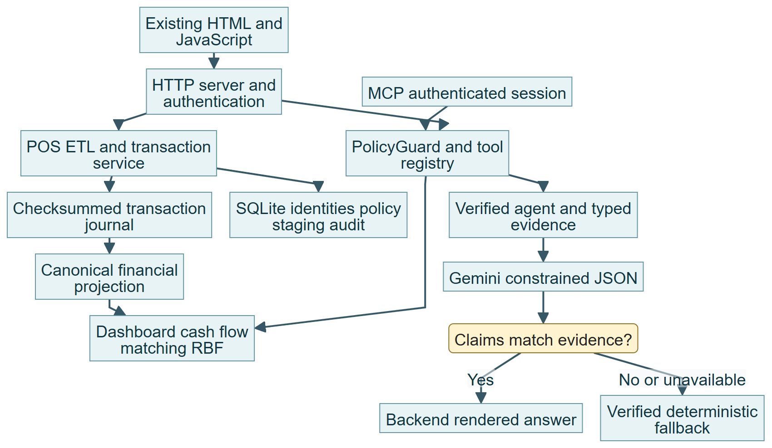
Diagram 01 | Mermaid source 01_architecture.mmd

Role navigation and authorization
Sign-in yields a server-derived Principal. Every route/API and tool requires current membership and action permission; Agent access adds assignment/category consent. Navigation hiding improves usability but is not the security boundary.
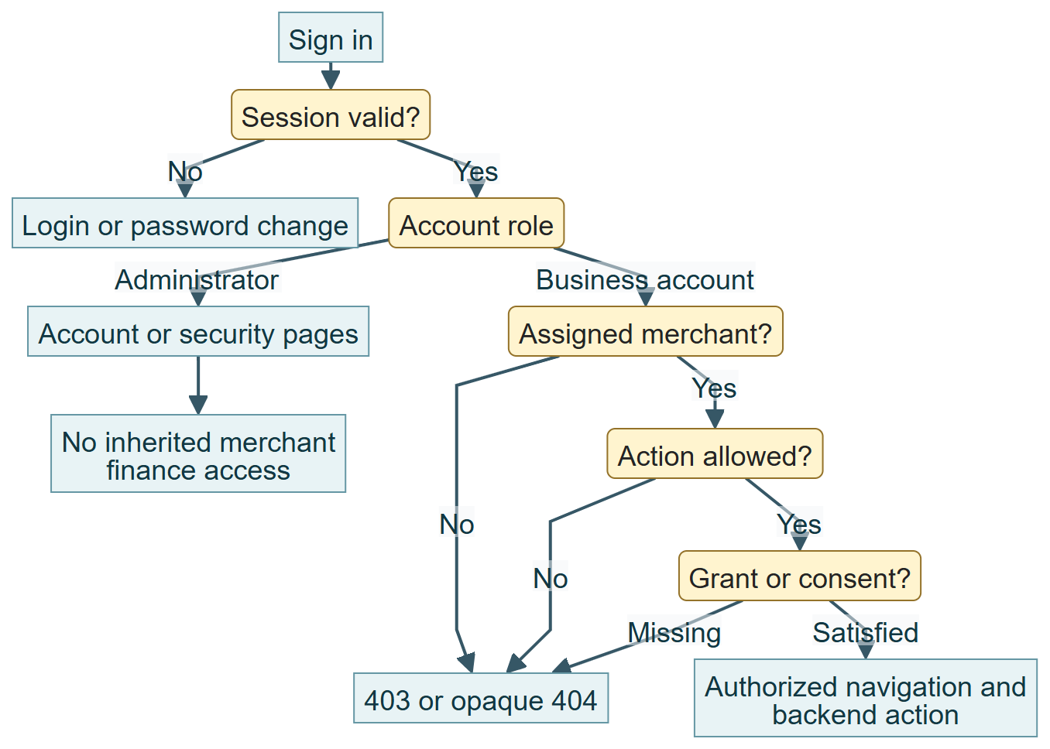
Diagram 02 | Mermaid source 02_access.mmd

Merchant transaction lifecycle
Manual entry normalizes one record and obtains a scoped idempotency result. Only completed signed rows affect projected finance. Canonical records are append-only; failed input does not silently save.
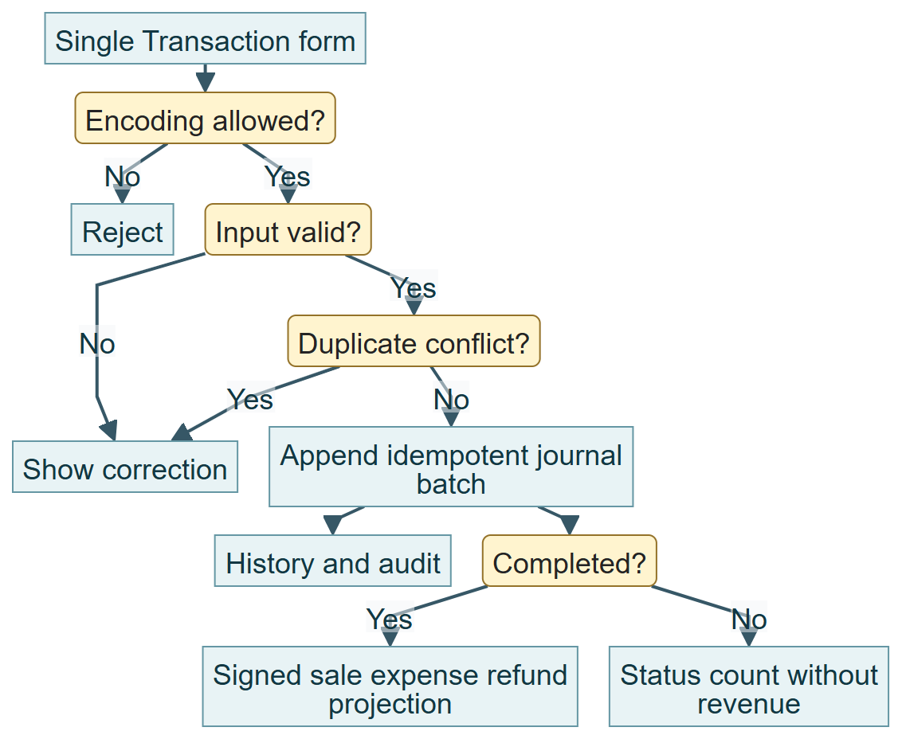
Diagram 03 | Mermaid source 03_transaction.mmd

POS import and reconciliation
Selected files are bounded and private. Mapping establishes net/gross meaning. Invalid/ambiguous/control mismatches block import; a signed preview and explicit confirmation precede journal append. Concurrent duplicate changes require revalidation.
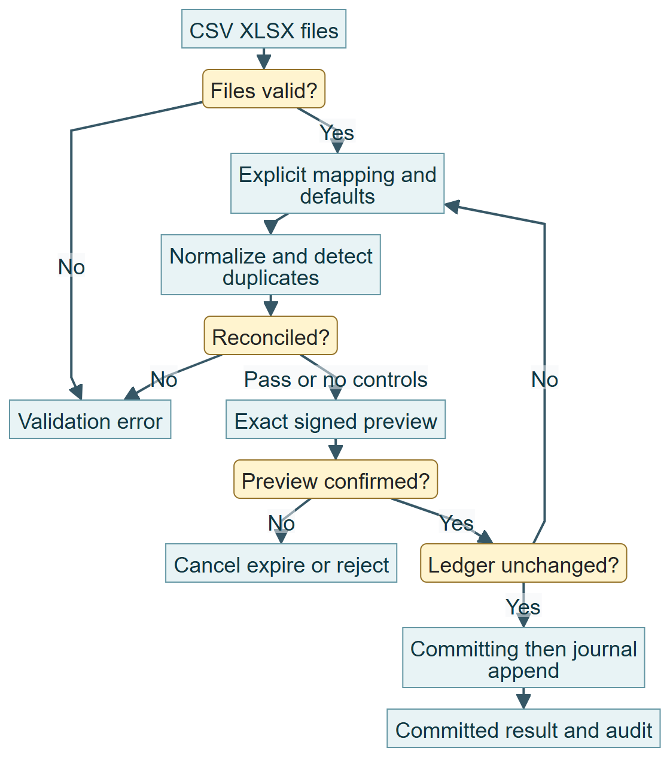
Diagram 04 | Mermaid source 04_pos.mmd

Digital payment and refund lifecycle
An approved sandbox proposal creates PENDING. Payment status/expiry is authoritative. Paid events create one canonical sale; backend-only linked refunds create negative records and adjust wallet. Manual refunds only adjust accounting.
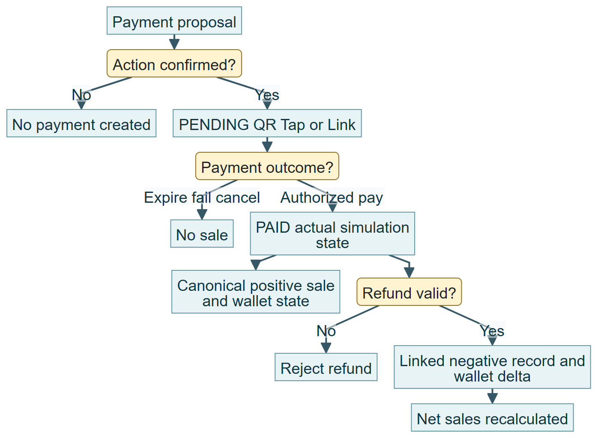
Diagram 05 | Mermaid source 05_payment.mmd

Dashboard aggregation
Requested dates select completed projected data. Decimal totals are shared with AI; channel/trend modules retain compatible fields. Synthetic seed volume is not the same as canonical journal row count.
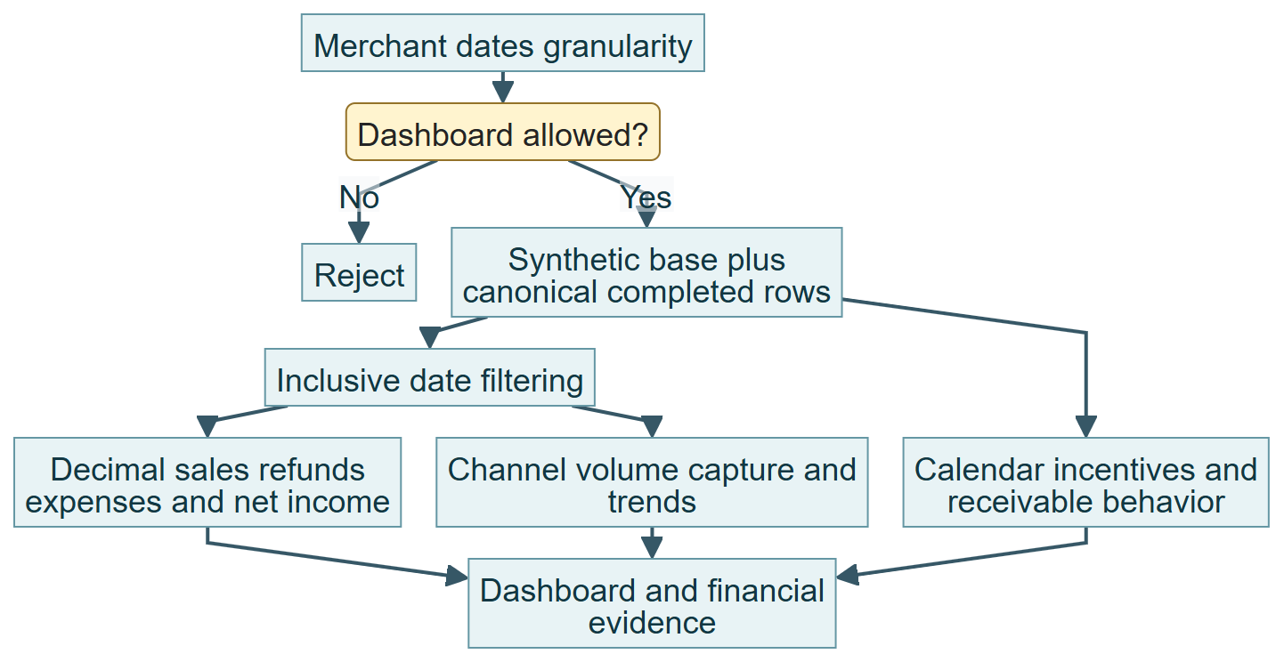
Diagram 06 | Mermaid source 06_dashboard.mmd

Cash flow forecast generation
The existing 56-day weekday profile and scheduled items project cash balances for 30 days. Imported sales are forecast inputs, not proof of wallet settlement. Negative projected balance triggers runway rules.
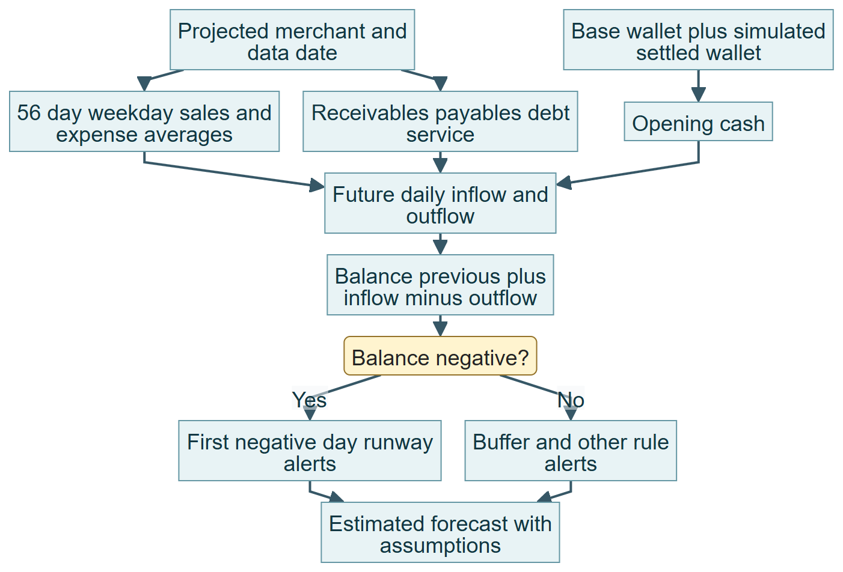
Diagram 07 | Mermaid source 07_cashflow.mmd

RBF quote and repayment
Sales-derived sizing, separate eligibility checks, fee tiers and daily ecosystem remittance calculate an indicative quote. Replayed history stops at payoff or the 1,080-day loop ceiling; no lender approval occurs.
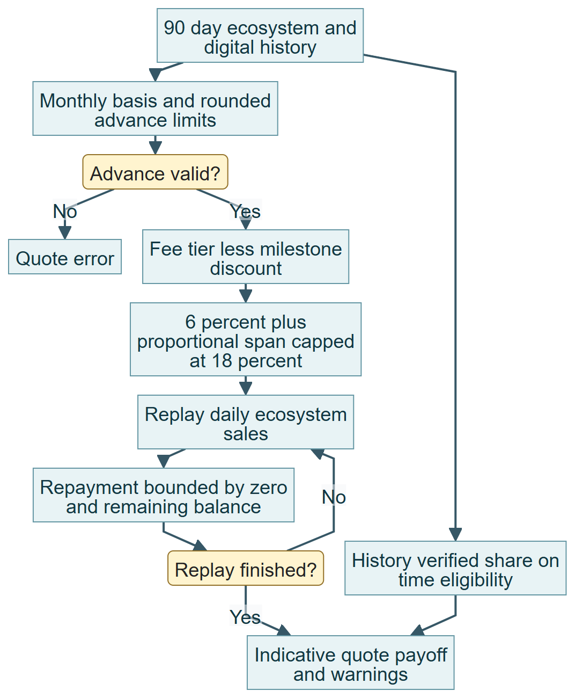
Diagram 08 | Mermaid source 08_rbf.mmd

Financing application and review
Current consent and exact confirmation permit a sandbox packet. Only its assigned Agent can append a simulated review. Neither submission nor review is a credit approval.
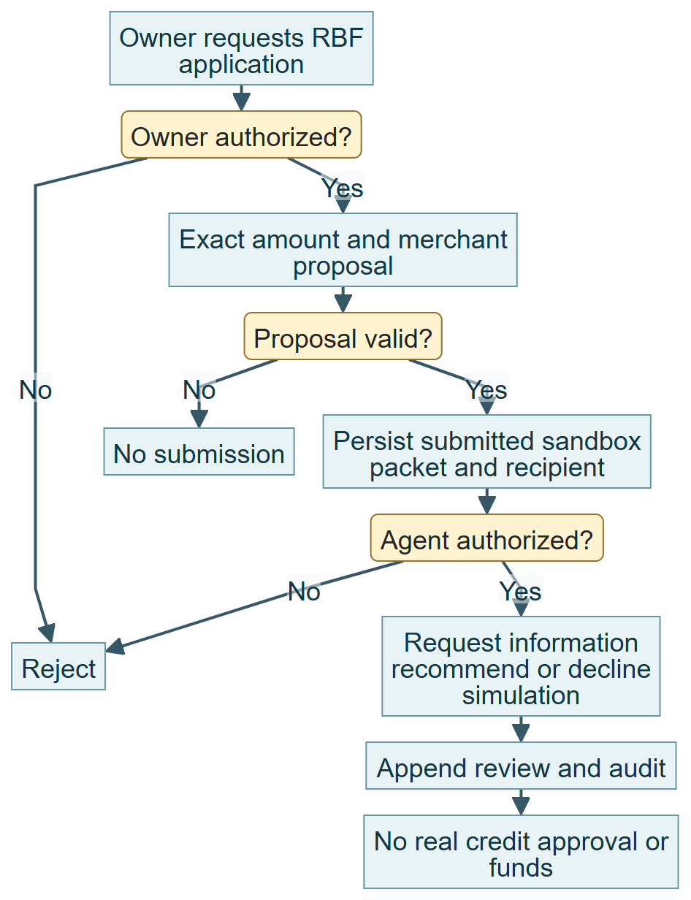
Diagram 09 | Mermaid source 09_application.mmd

AI classification and routing
Finance routing occurs before model planning. Invalid scope and unavailable metrics never establish facts. The requested authorized capability is selected deterministically; Gemini cannot change merchant context.
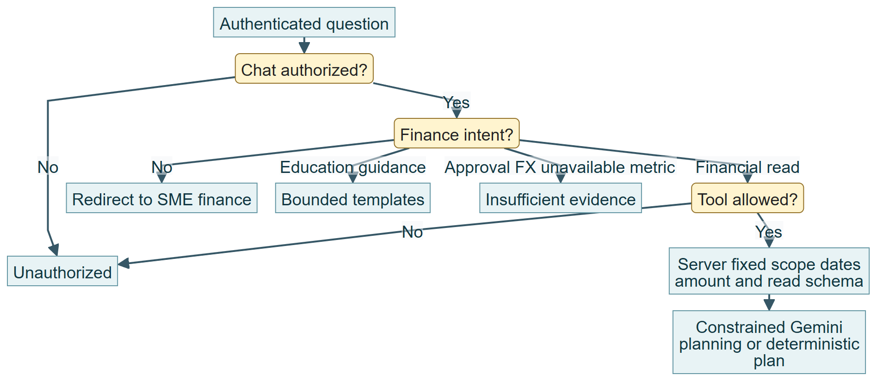
Diagram 10 | Mermaid source 10_ai_route.mmd

Evidence verification and answer generation
Facts carry exact values, dates, currency, status and provenance. Models must return all permitted claims with no extra prose. Backend equality/freshness/authorization decides the final response.
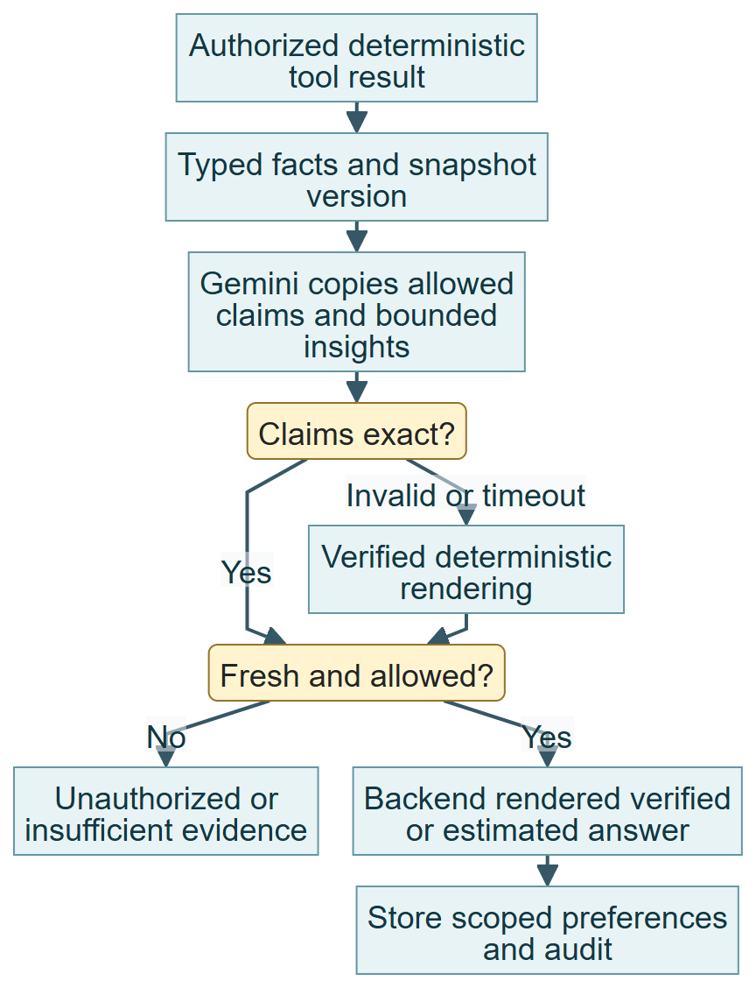
Diagram 11 | Mermaid source 11_ai_verify.mmd

Consent and financial action confirmation
Owner consent is independent from action confirmation. SQLite compare-and-set claims execution; expiry, session binding and reauthorization prevent stale or foreign actions. Ambiguous failures require review.
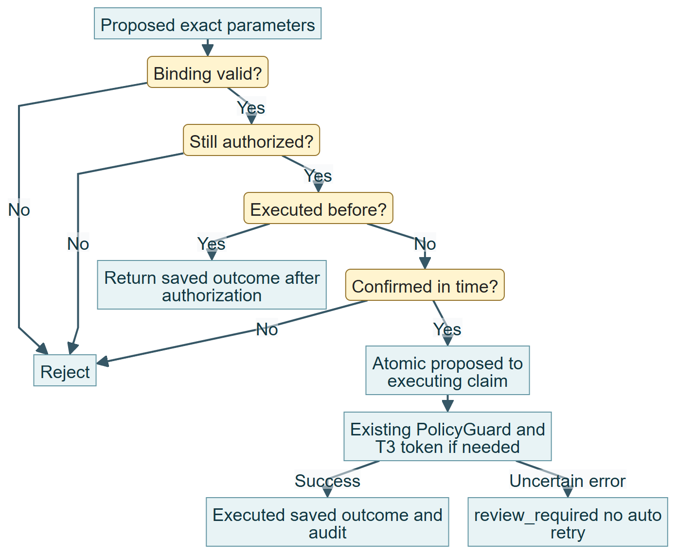
Diagram 12 | Mermaid source 12_confirmation.mmd

Cross merchant denial
Supplying another merchant in a chat prompt does not change server scope. Membership, action permission, consent and assignment are checked independently of visual menu state.
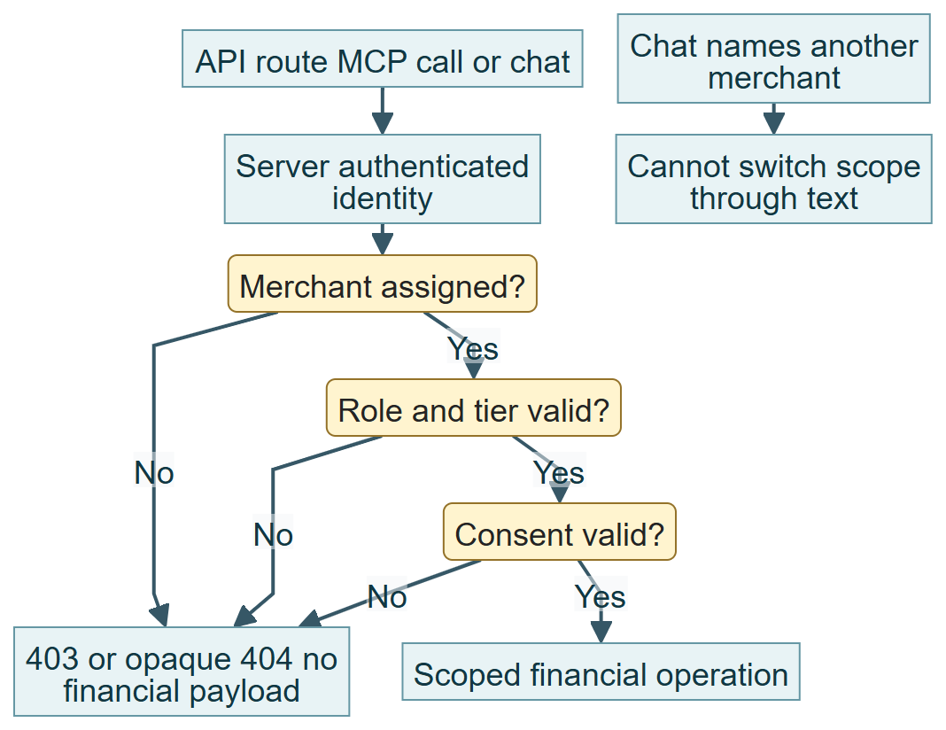
Diagram 13 | Mermaid source 13_cross_scope.mmd

Payment recovery and idempotency
The canonical marker and SQLite state reconcile at startup. A paid/refund marker repairs the tested persistence gap; mismatched scope or refund totals require review. This does not claim distributed exactly-once semantics.
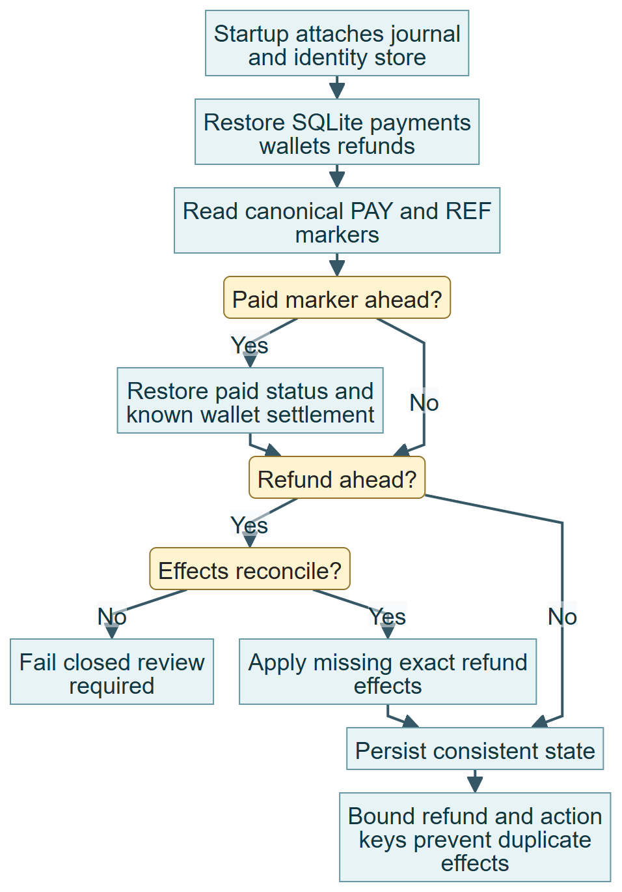
Diagram 14 | Mermaid source 14_recovery.mmd

API persistence and security reference
The source of truth is copilot/server.py:Handler with existing services below. Financial requests specify the selected merchant; the server derives identity and does not trust client actor/role metadata. Ordinary validation fails400; identity fails401; authorization fails403; unknown or concealed resources may give404; stale/replay/conflicting state gives409. 202 represents an approval requirement, not credit approval.
Feature and API family | Authoritative processing
F01 POST /api/auth/login; GET /api/auth/me; POST /api/auth/logout; POST /api/auth/change-password | web/login.html calls authentication endpoints.
F02 GET /api/dashboard; GET /api/financial-metrics | web/index.html loadDashboard consumes FinancialData.dashboard.
F03 POST /api/merchant-transactions/entry | The current form calls POSImportService.single, normalizes the record, checks duplicates and appends an idempotent batch to TransactionJournal.
F04 POST /api/pos-import/stage; GET /api/pos-import/{batch_id} | merchant-transactions.js sends base64 file content to POSImportService.stage.
F05 POST /api/pos-import/{batch_id}/validate; GET /api/pos-import/{batch_id}/preview; POST /api/pos-import/{batch_id}/commit; POST /api/pos-import/{batch_id}/cancel | POSImportService.validate computes signatures and preview token.
F06 GET /api/merchant-transactions/history; GET /api/data-quality; GET /api/data-quality/runs/{id}; POST /api/data-quality/alerts/{id} | POSImportService.history and monitoring query journal and SQLite run/alert/event data.
F07 GET /api/pos/catalog; POST /api/partner/actions; POST /api/partner/actions/confirm; POST /api/payments/pay; GET /api/payments/status | web/index.html requests PartnerState proposals and confirmations, then uses payment pay/status endpoints.
F08 No linked simulator refund HTTP endpoint; accounting refund uses transaction entry/import | record_refund appends a deterministic REF marker related to payment reference and exact wallet delta.
F09 GET /api/cashflow; POST /api/chat | cashflow.forecast uses projected merchant rows, obligations and model configuration; /api/cashflow returns forecast and alert list.
F10 GET /api/match; GET /api/cycle | assessment.py produces signals, scores, stage and constraints; matching.py uses provider-neutral CATALOG and returns top five recommendations plus exclusions.
F11 GET /api/rbf/limits; POST /api/rbf/quote | rbf.limits, eligibility, quote and recommend_advance feed dedicated UI.
F12 GET/POST /api/consents; POST /api/consents/{id}/revoke; GET /api/applications; POST /api/partner/actions/confirm | AuthStore stores consents; PartnerState stores proposed/executing/executed/review_required action data.
F13 GET /api/applications; POST /api/applications/{id}/review | application_list filters rows to Owner or assigned recipient.
F14 POST /api/chat | agent.handle delegates safe reads to verified_agent.execute.
F15 GET/POST /api/admin/users; PATCH /api/admin/users/{id}; POST /api/admin/users/{id}/{action}; POST /api/staff-access-requests | web/users.html and admin.js call AuthStore create/update/account_action APIs.
F16 GET/PATCH /api/security/policies; GET /api/security/audit; GET /api/security/events; GET /api/security/config/export; POST /api/security/config/validate; POST /api/security/config/import | security.html/security-admin.js consume AuthStore policy and SecurityConfiguration services.

Legacy transaction routes /api/transactions, /api/transactions/preview, /api/transactions/import, /api/transactions/entry and /api/transactions/manage remain implemented for compatibility. They have a different legacy income/expense schema and demo-date validation; they are not interchangeable with the current canonical POS schema. Do not use legacy manage as an assumed canonical-row editing UI.
POST /mcp provides the existing authenticated MCP interface; stdio requires a server-authenticated session token supplied privately through COPILOT_MCP_SESSION_TOKEN. Shared tool schemas live in tools_spec.py; MCP API keys or environment demo identities do not establish authenticated merchant authorization. ask_copilot and financial tools re-use existing guards. Never distribute bearer/session tokens in docs or scripts.
Store | Main data and integrity
SQLite migrations001 | users memberships optional_permissions sessions reset_tokens security_policies role_permissions consents audit_events
Migration002 | applications application_reviews staff_access_requests
Migration003 | Security configuration revision tracking
Migration004 | POS runs mapping/staging/signatures quality rules alerts/events merchant_transaction_grants
Migration005 | partner_context preferences and partner_actions bound execution state
Migration006 | simulated_payment_state simulated_wallet_state simulated_refund_state
Transaction journal | Canonical rows and batch markers with checksums, thread/interprocess writer locking; SQLite and journal are separate stores

Audit events bind actor, scope and outcomes; configured logs use hash chains/PII masking. A hash chain detects edits to included records but is not an independent immutable external archive. The current server uses a local standard-library ThreadingHTTPServer; no production multi-node topology or distributed database is implied.
Tier | Implemented authority
T0 | Authorized read-only analytics/evidence
T1 | Advice, matching and deterministic quotes
T2 | Permitted sandbox payment writes
T3 | Owner-confirmed application with consent and existing approval token
T4 | Permanently prohibited real credit approval, disbursement and limit changes

Authentication defaults and permitted ranges
These are source defaults, not a claim about the owner installation’s currently saved policy. Security Controls can change settings only within the implemented bounds. Passwords additionally require mixed character categories when enabled; credential values are never included in this guide.
Setting | Default | Permitted range or rule
Idle session timeout | 1,800 seconds | 300–3,600
Absolute session lifetime | 28,800 seconds | 900–86,400
Failed attempt threshold | 5 | 3–10
Lockout duration | 900 seconds | 60–3,600
Password minimum | 12 characters | 12–128
Mixed password requirement | Enabled | Boolean; policy validation applies
Reset expiration | 1,800 seconds | 300–3,600
Administrator reauthentication window | 300 seconds | 60–600

Source copilot/auth.py : check_password (line 129); copilot/auth.py : _session (line 234); copilot/auth.py : login (line 200)
Authority = fixed role boundary intersect enabled policy, live membership, explicit grants/consent and tier ceiling. PolicyGuard is used at execution, not just navigation. T3 HMAC tokens are user/action/merchant scoped, time-limited and single-use. The durable action record additionally binds exact parameters and session, and uses SQLite compare-and-set. An already-executed action returns its saved outcome after reauthorization; an uncertain outcome needs manual review.
Evidence is merchant/currency/period scoped with metric, exact value, evidence ID, source, as_of, quality, method version, record count, assumptions, limitations and status. Validation requires complete exact typed equality and no free prose. Context freshness is five minutes; version includes canonical rows, payments, wallet, currency and configured RBF/cashflow formulas. Every answer re-retrieves data. This is not a global atomic snapshot of every administrative/quality store.

Business rules requiring team decisions
Rule | Implemented behavior and classification | Decision or impact
BR01 | Confirmed requirement: T4 never approves real credit, disburses money or changes limits | Retain permanently; lender decisions remain external
BR02 | Provisional security matrix: role/action boundaries and adjustable ceilings | Business/security owners must approve final operational access; hiding menus is insufficient
BR03 | Provisional RBF limits, fee tiers, remittance, eligibility, payoff and incentive discounts | Financing owner TBD; changes affect quotes, matching and affordability
BR04 | Demo tax and MDR values, synthetic balances/obligations and channel labels | Tax/payment/business owners TBD; not legal tax or real settlement rules
BR05 | Provisional cents and nearest-100 rounding in every currency | Finance owner TBD; define approved currency-specific rounding before live use
BR06 | Confirmed requirement: saved authorized evidence controls AI financial claims | Retain typed equality and deterministic calculations; language coverage remains provisional
BR07 | Unresolved: paid/refund backend exists without linked-refund UI/API | Specify authorized workflow, original payment linkage, fee treatment and audit before implementing
BR08 | Unresolved: canonical accounting refunds are not capped/linked to original sale | Review overrefund prevention and avoid duplicated refund components/rows
BR09 | Demo assumption: imported digital channel indicates captured evidence | Not a bank-verification claim; confirm external settlement connector requirements
BR10 | Unresolved: extraction advertises 10 MB batch while HTTP MAX_BODY is 4,100,000 bytes | Base64 JSON may reject a batch below UI limit; smaller combined uploads currently required
BR11 | Unresolved: Stage6 config comment and actual stage>=4 transition branch differ | Assessment owner TBD; guide follows actual implementation rather than the comment
BR12 | Incomplete: full transcript reload persistence, FX, bank balances, real lender approval, merchant self-service onboarding | No implied implementation; agree scope separately
BR13 | Provisional: five-minute facts/actions, 30-minute POS staging, ten-minute security preview | Security/product owners TBD; changes affect freshness and usability
BR14 | Incomplete: continuous DQ monitoring, distributed atomic snapshot and uncertain-action auto recovery | Foreground monitoring and fail-closed/manual-review are current behavior; no distributed exactly-once claim
BR15 | Deferred: Task03.1 survival/scenario innovation and Task05 QA reporting framework | Not implemented or introduced by this documentation task

Approval status: merged Task 03 establishes the accepted code baseline; no evidence establishes formal business approval for provisional parameter values. Responsible business owners are unassigned unless your team names them. Record approval and specification changes before production implementation.
Source copilot/modules/assessment.py : place_stage (line 110); copilot/modules/payments.py : refund (line 200); copilot/pos_extract.py : extract_files (line 122); copilot/server.py : Handler (line 107)

Team checkout and local deployment
The following commands are instructions for teammates, not deployment actions executed during Task 04. Documentation is still local until the owner approves a commit and publication. Pull the approved release branch when these documents are published. Never delete existing local work to follow these instructions.

First clone on Windows PowerShell
cd "C:\Users\User\source\repos"
git clone https://github.com/sofiamallari/SMEFinance.git
cd SMEFinance
git status --short
git branch --show-current
cd sme-finance-copilot
python --version
Use your own repository location; C:\Users\User is the owner’s laptop path, not a required path for every teammate. If Python is unavailable on Windows, try py; on macOS use python3 and a path such as ~/source/SMEFinance/sme-finance-copilot. Python 3.10 or newer is required by the code; tests were verified with the bundled Python runtime.

Update an existing clean checkout
cd "C:\Users\User\source\repos\SMEFinance"
git status --short
git branch --show-current
git pull --ff-only
cd sme-finance-copilot
Run pull on the branch your team has approved. If status shows changes, preserve them and ask the maintainer how to integrate the update. Do not reset, clean, force pull or switch over unrelated work. A failed fast-forward needs review, not a forced reset.

Initialize and start a fresh installation
python -m copilot.auth migrate
python -m copilot.auth bootstrap --username admin --email admin@example.test
python -m copilot.server --host 127.0.0.1 --port 8000
Bootstrap only before any user exists. Type and confirm a private administrator password at the terminal prompt; nothing is embedded in these guides. Existing installations keep their accounts and must not bootstrap again. Open http://127.0.0.1:8000/login. Keep the server terminal open; Ctrl+C stops it. Create separate business accounts through User Administration.

Gemini configuration without sharing secrets
Create local sme-finance-copilot/.env and keep it ignored. Set the endpoint to https://generativelanguage.googleapis.com/v1beta/openai/, model to gemini-3.1-flash-lite, and API key locally. The key is never supplied in chat or committed. Only four LLM keys auto-load; identity/security settings use process environment variables. Local keys are not available after a teammate pulls Git.
# Nonsecret model override if local .env still names an older model
$env:COPILOT_LLM_MODEL = "gemini-3.1-flash-lite"
python -m copilot.server --host 127.0.0.1 --port 8000
The app also works with verified deterministic answers when no provider is configured or Gemini fails. “Configured” is not “connected”; a successful verified answer or opt-in assessment establishes connection. Failure/429 uses fallback; no quota dashboard or automatic rate-limit retry loop is implemented.

Persist and protect installation data
Path relative to application | Purpose
logs/identity.sqlite3 | Users sessions consents security policies applications staging audit and durable simulation state
logs/manual_transactions.jsonl | Canonical transaction journal and append-only batch markers
logs/audit.jsonl and logs/execution.jsonl | Configured security/tool operation evidence
.env | Private local LLM configuration; ignored, not distributed
web/ and copilot/ | Frontend and authoritative backend code
docs/task04/ | System guide, shorter team guide and supporting diagram sources/images

These are defaults, overridden by COPILOT_IDENTITY_DB, COPILOT_TRANSACTION_FILE, COPILOT_AUDIT_LOG and COPILOT_EXEC_LOG. The working directory affects relative paths: always start from the application folder. Back up the database and journal together during a controlled server stop, including configured paths; do not delete them to solve a login problem. Fresh clones do not carry another teammate’s local database or passwords.

Optional Docker local demonstration
Existing Dockerfile uses Python 3.12, a nonroot app user and /app/logs. This guide has not built or verified a container during Task 04. The Dockerfile COPY . . and missing .dockerignore can embed local secrets/databases: build only from a clean tracked-code export, never the configured owner checkout.
# From repository root export tracked approved source to a separate directory
git archive --format=zip --output=..\SMEFinance-clean.zip HEAD sme-finance-copilot
Expand-Archive ..\SMEFinance-clean.zip ..\SMEFinance-clean
cd ..\SMEFinance-clean\sme-finance-copilot
docker build -t sme-finance-copilot .
docker volume create sme-finance-data
docker run -d --name sme-finance-local -p 127.0.0.1:8000:8000 -v sme-finance-data:/app/logs sme-finance-copilot
# Fresh container only: initialize and privately bootstrap its own database
docker exec -it sme-finance-local python -m copilot.auth migrate
docker exec -it sme-finance-local python -m copilot.auth bootstrap --username admin --email admin@example.test
Choose unused export/container names instead of overwriting existing ones. Supply any provider secrets separately as runtime configuration from an approved secret mechanism. The named volume preserves local container data; Python/host and Docker installs have independent databases unless explicitly configured. Internet production hosting is not provided: TLS reverse proxy, secure cookies (COPILOT_HTTPS=yes behind HTTPS), access controls, backups and deployment review remain required. Do not bind insecure demo mode publicly.

Existing test and verification commands
python -m unittest discover -s tests -q
python -m unittest tests.test_reliability tests.test_financial_partner tests.test_partner_integration -q
# Optional real Gemini assessment; synthetic/disposable scope
python scripts/assess_partner.py
Normal tests disable real provider keys and isolate identity/journal data. Expect an OK summary; exact count/time depends on the checked-out revision. At Task 03 baseline all261 methods passed; do not expect the older reference guide’s71 tests or a guaranteed30-second runtime. Optional existing Playwright scripts require Node/Playwright and Microsoft Edge; run browser scripts serially because they share fixture port8124. No new Task05 runner is introduced.
node scripts/verify_partner_ui.cjs
node scripts/verify_auth_ui.cjs
node scripts/verify_pos_ui.cjs
node scripts/verify_security_ui.cjs

Troubleshooting and shared team workflow
Problem | Action
No module named copilot | Confirm terminal is in SMEFinance/sme-finance-copilot and contains README.md, copilot and web
Bootstrap only before first user exists | Use the existing administrator; use authorized password reset, not database deletion
Staff upload denied | Verify optional bulk_import AND merchant-level bulk_import grant, membership and enabled role action
Agent financing denied | Verify assignment/application, current category consent, membership and role/tier policy
Server unreachable or port busy | Keep terminal running; use --port8001 and matching browser URL if8000 is occupied
Gemini fallback | Check local endpoint/model/key privately; use assessed model; inspect safe fallback reason, never paste secret/header
Unexpected totals | Match merchant/currency/date window and completed status; distinguish seed history, accounting refund and simulation settlement
Tests fail | Record test ID/revision/safe error; investigate without overwriting local work or weakening tests

Team practice: name an owner for business rules; report issue with merchant/date range, role, feature ID, expected versus actual behavior and sanitized evidence. Discuss provisional rules before changing code. Use a review branch and request approval for commit/push/merge. The owner’s API key, passwords, sessions, local logs and databases are not team-sharing artifacts.

Verified evidence and feature traceability
Existing Task03 evidence | Recorded result
Backend regression | 261 tests; failures0; errors0; skipped0
Syntax and critical reliability | 54 Python files; 8 critical verifier methods
Acceptance and integration | 42 acceptance methods and 16 integration methods
Gemini assessed model | gemini-3.1-flash-lite
Live returned claims | 46 validated; 0 unsupported observed
Numeric comparisons | 3/3
Workspace browser | 7 journeys; 0 JavaScript errors

These are existing Task03 results reviewed for this guide, not a newly executed Task04 full regression. Screenshots come from disposable fixture captures and retained synthetic Task03 evidence. Finite scenarios do not prove universal hallucination/injection resistance. Docker, real settlement, real underwriting and production hosting were not verified. Task04 validates documentation, references, diagram rendering and Word readability without creating a QA framework.
Feature | Related existing tests
F01 Sign in and merchant access | tests/test_authentication.py
F02 Dashboard and recorded financial insights | tests/test_financial_partner.py; tests/test_pos_import.py
F03 Single transaction entry | tests/test_pos_import.py
F04 Bulk POS acquisition and field mapping | tests/test_pos_import.py
F05 Duplicate reconciliation preview and commit | tests/test_pos_import.py
F06 Transaction history and data quality monitoring | tests/test_pos_import.py
F07 QR Tap and Pay Link simulations | tests/test_modules.py; tests/test_partner_integration.py
F08 Refund accounting and payment recovery | tests/test_partner_integration.py; tests/test_financial_partner.py
F09 Cash flow forecast and risk alerts | tests/test_modules.py; tests/test_financial_partner.py
F10 Business assessment and financing overview | tests/test_modules.py
F11 RBF calculator and repayment simulation | tests/test_modules.py; tests/test_financial_partner.py
F12 Consent and confirmed financing application | tests/test_authentication.py; tests/test_security_agent.py
F13 Financing Agent application review | tests/test_authentication.py
F14 AI Financial Partner questions and follow ups | tests/test_reliability.py; tests/test_financial_partner.py
F15 User Administration and Staff access requests | tests/test_authentication.py
F16 Security Controls and configuration portability | tests/test_security_configuration.py

Source references use repo-relative paths and function/line locators at the revision shown on the cover. Application root is sme-finance-copilot. If code changes, review related formulas, screenshots, APIs, permissions and diagrams together. The shorter SME_Finance_Copilot_Team_Run_Guide.docx is an intentional operational companion, not a duplicate architecture package. The older downloaded run/test guide is retained unchanged as a reference; its role switching, persistence notes,71-test count and old navigation no longer describe authenticated Task03.

