3) How many females and how many male passengers travelled for a minimum distance of 600 KM s?



4) Find the minimum ticket price for Sleeper Bus.



5) Select passenger names whose names start with character 'S'



6) Calculate price charged for each passenger displaying Passenger name, Boarding City, Destination City, Bus_Type, Price in the output

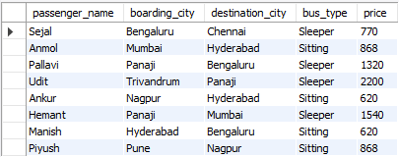

7) What is the passenger name and his/her ticket price who travelled in Sitting bus for a distance of 1000 KM s

No one has travelled for 1000 KM in sitting bus.

8) What will be the Sitting and Sleeper bus charge for Pallavi to travel from Bangalore to Panaji?

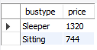

9) List the distances from the "Passenger" table which are unique (non-repeated distances) in descending order.

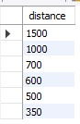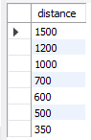

10) Display the passenger name and percentage of distance travelled by that passenger

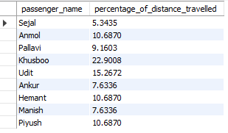

11) Display the distance, price in three categories in table Price a) Expensive if the cost is more than 1000 b) Average Cost if the cost is less than 1000 and greater than 500 c) Cheap otherwise

