http://localhost:8080/EmployeeManagement/login

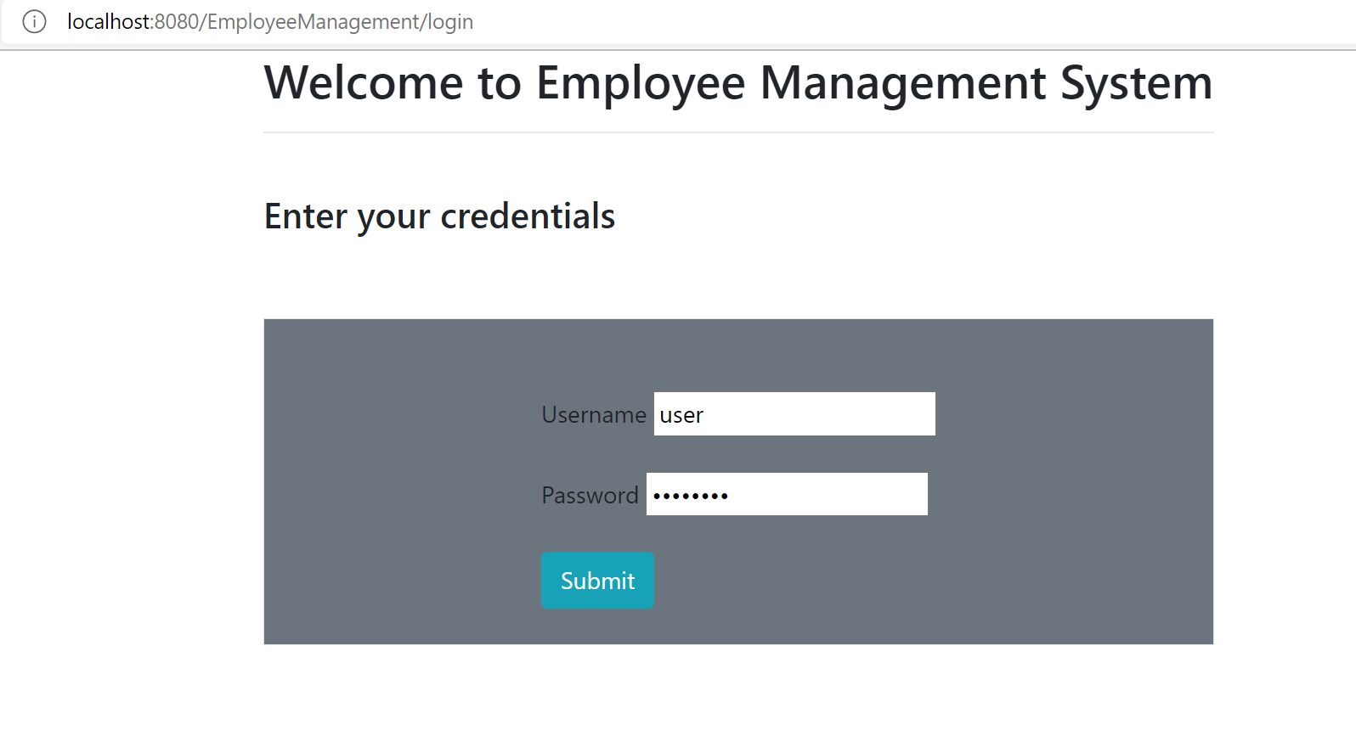

ADMIN SCREENS

<http://localhost:8080/EmployeeManagement/employee/admin/>

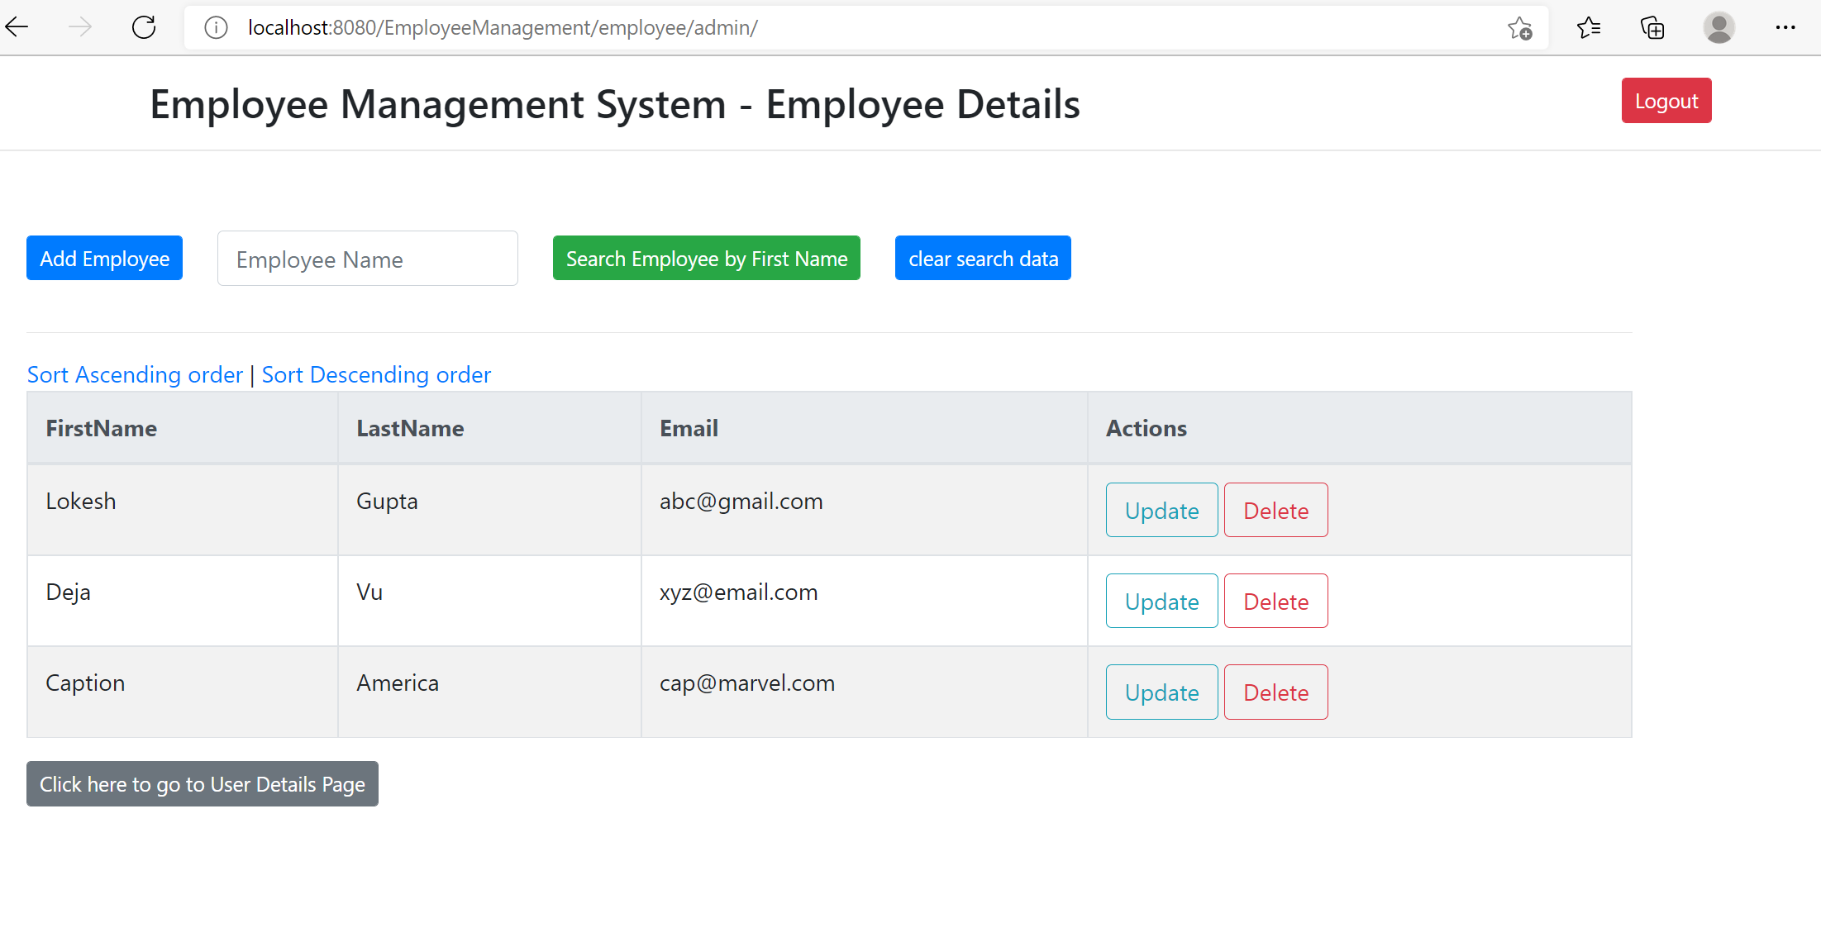

Add Employee -> http://localhost:8080/EmployeeManagement/employee/showFormForAdd

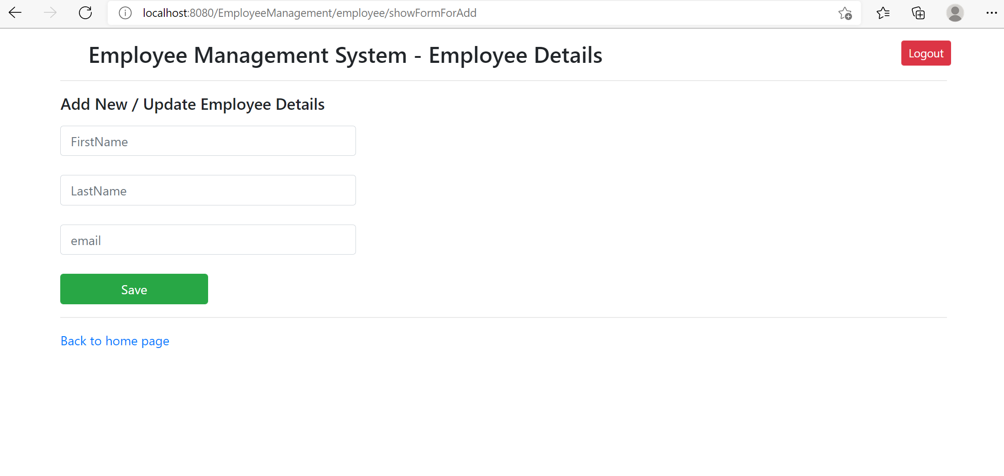

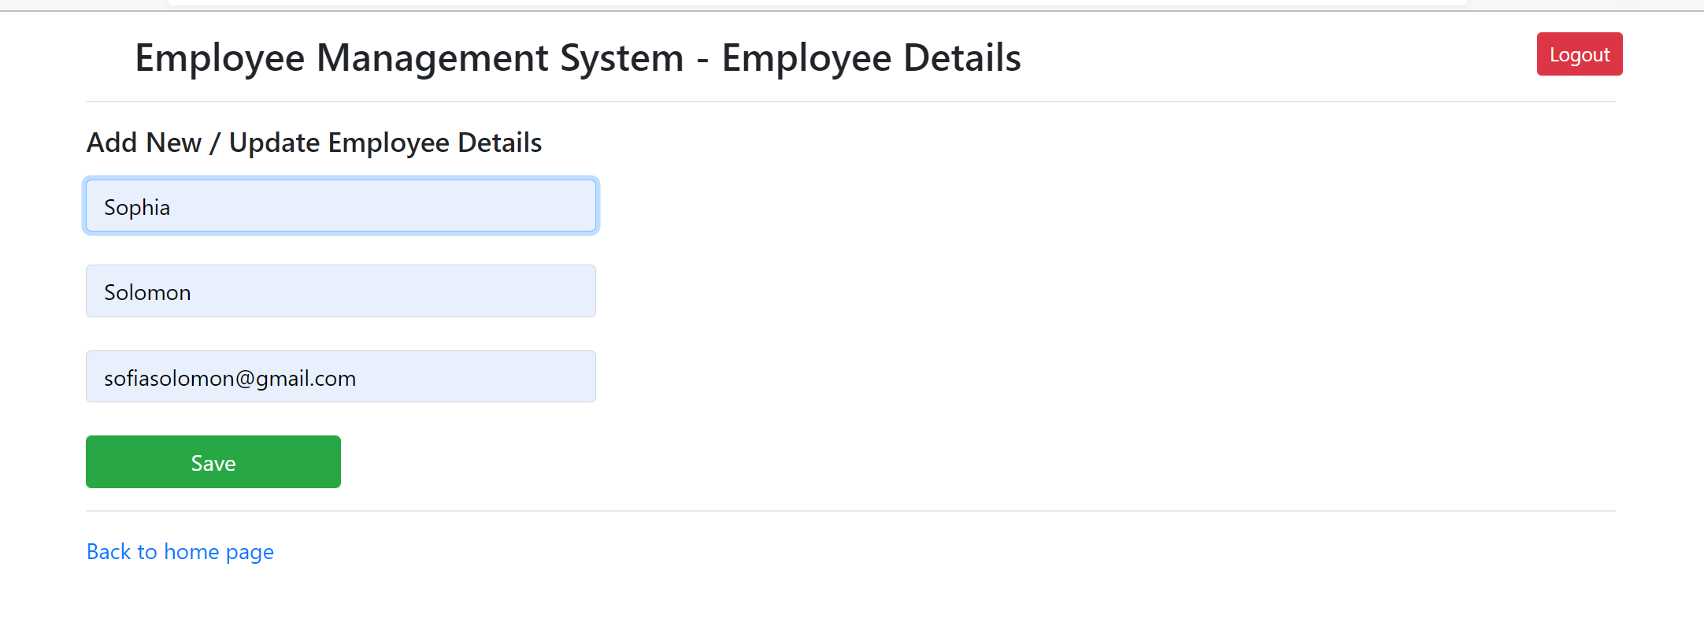

Search Employee

<http://localhost:8080/EmployeeManagement/employee/search?firstName=Sophia>

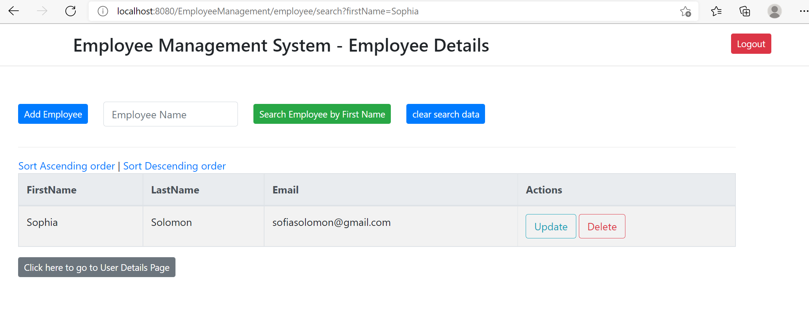

Update Employee

<http://localhost:8080/EmployeeManagement/employee/showFormForUpdate?empId=1>

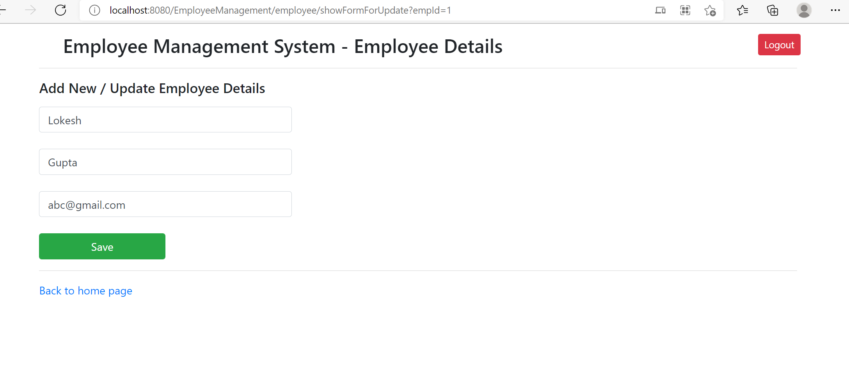

Delete Employee

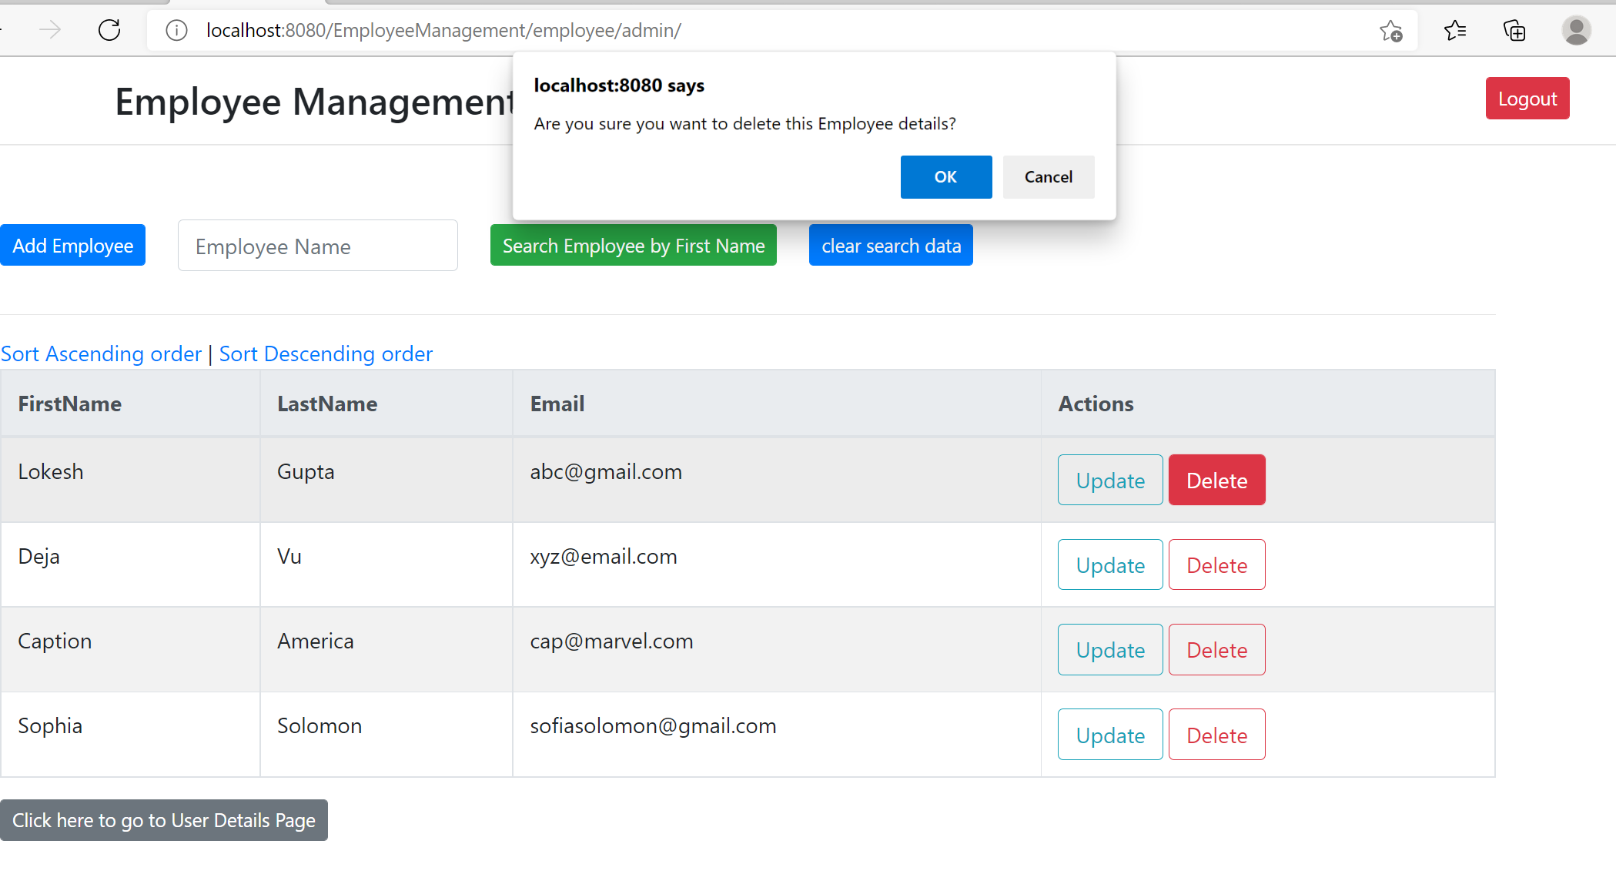

Sort Ascending order

<http://localhost:8080/EmployeeManagement/employee/adminsort?order=1>

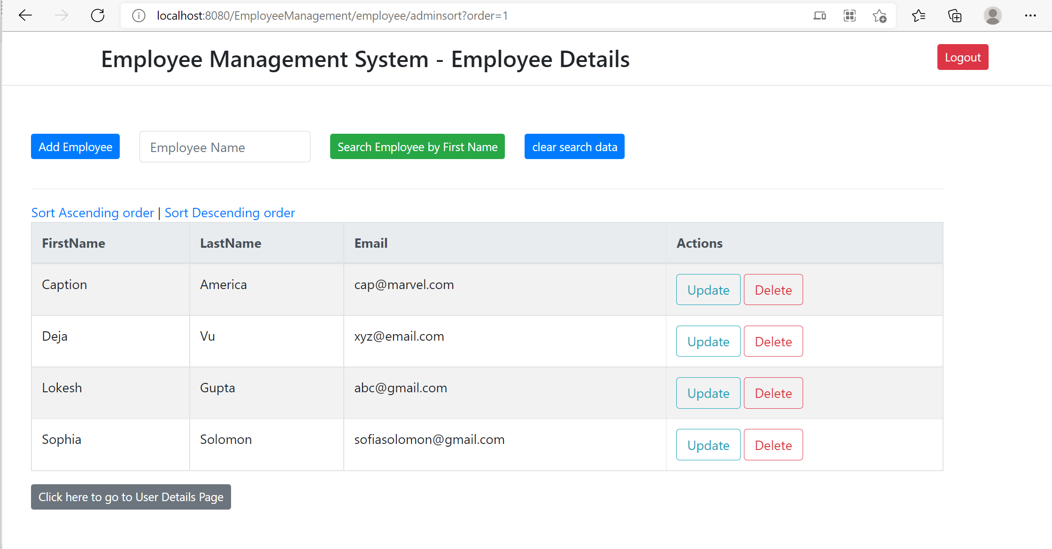

Sort Descending order -> http://localhost:8080/EmployeeManagement/employee/adminsort?order=2

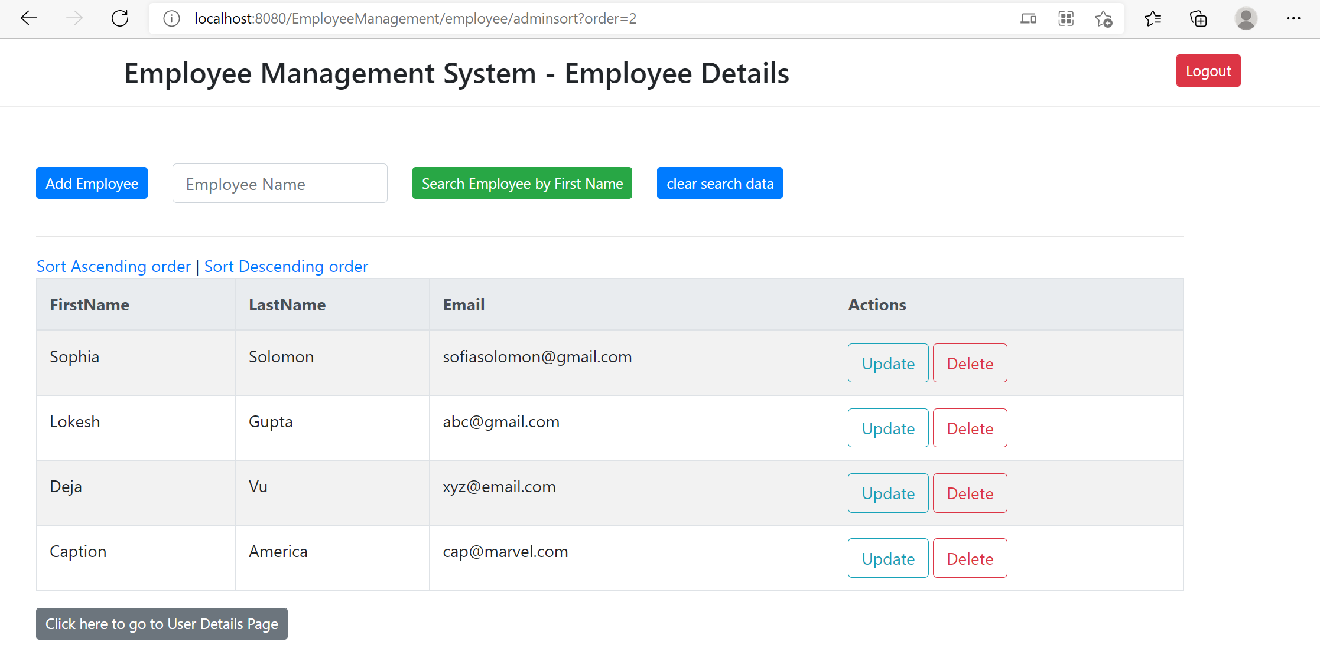

Goto User Details Page

<http://localhost:8080/EmployeeManagement/user/list>

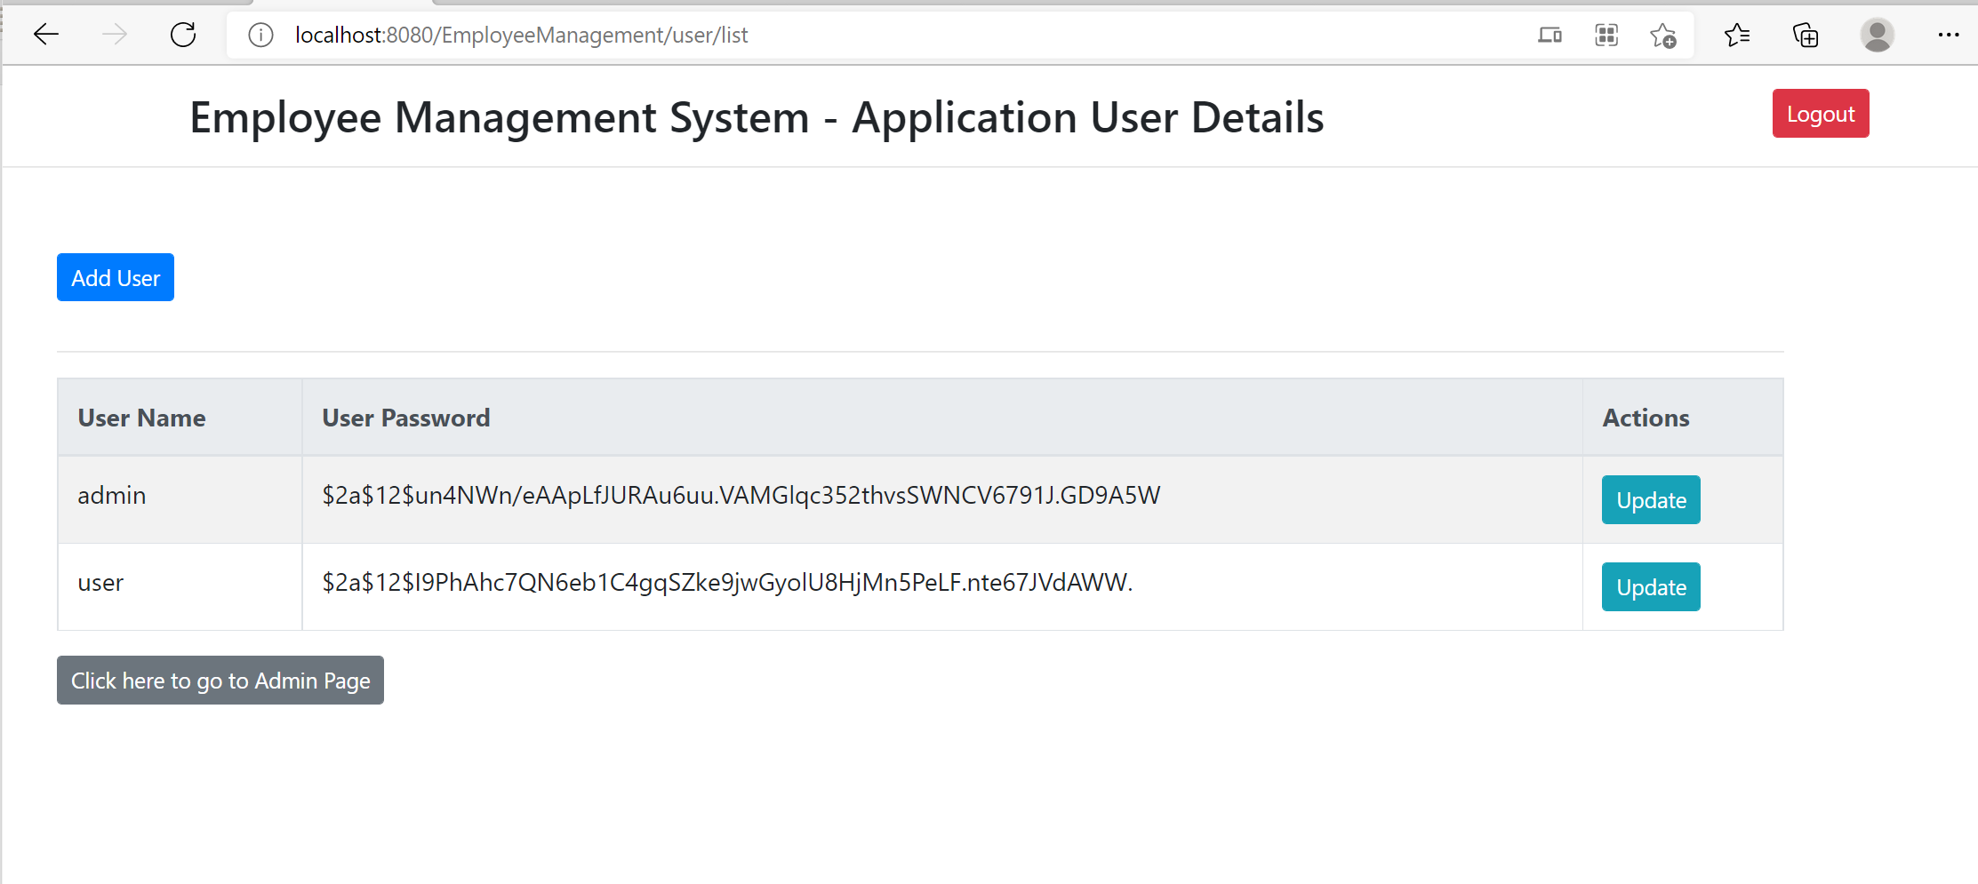

Add new User

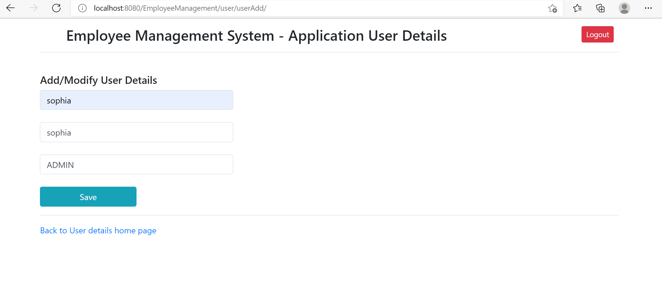

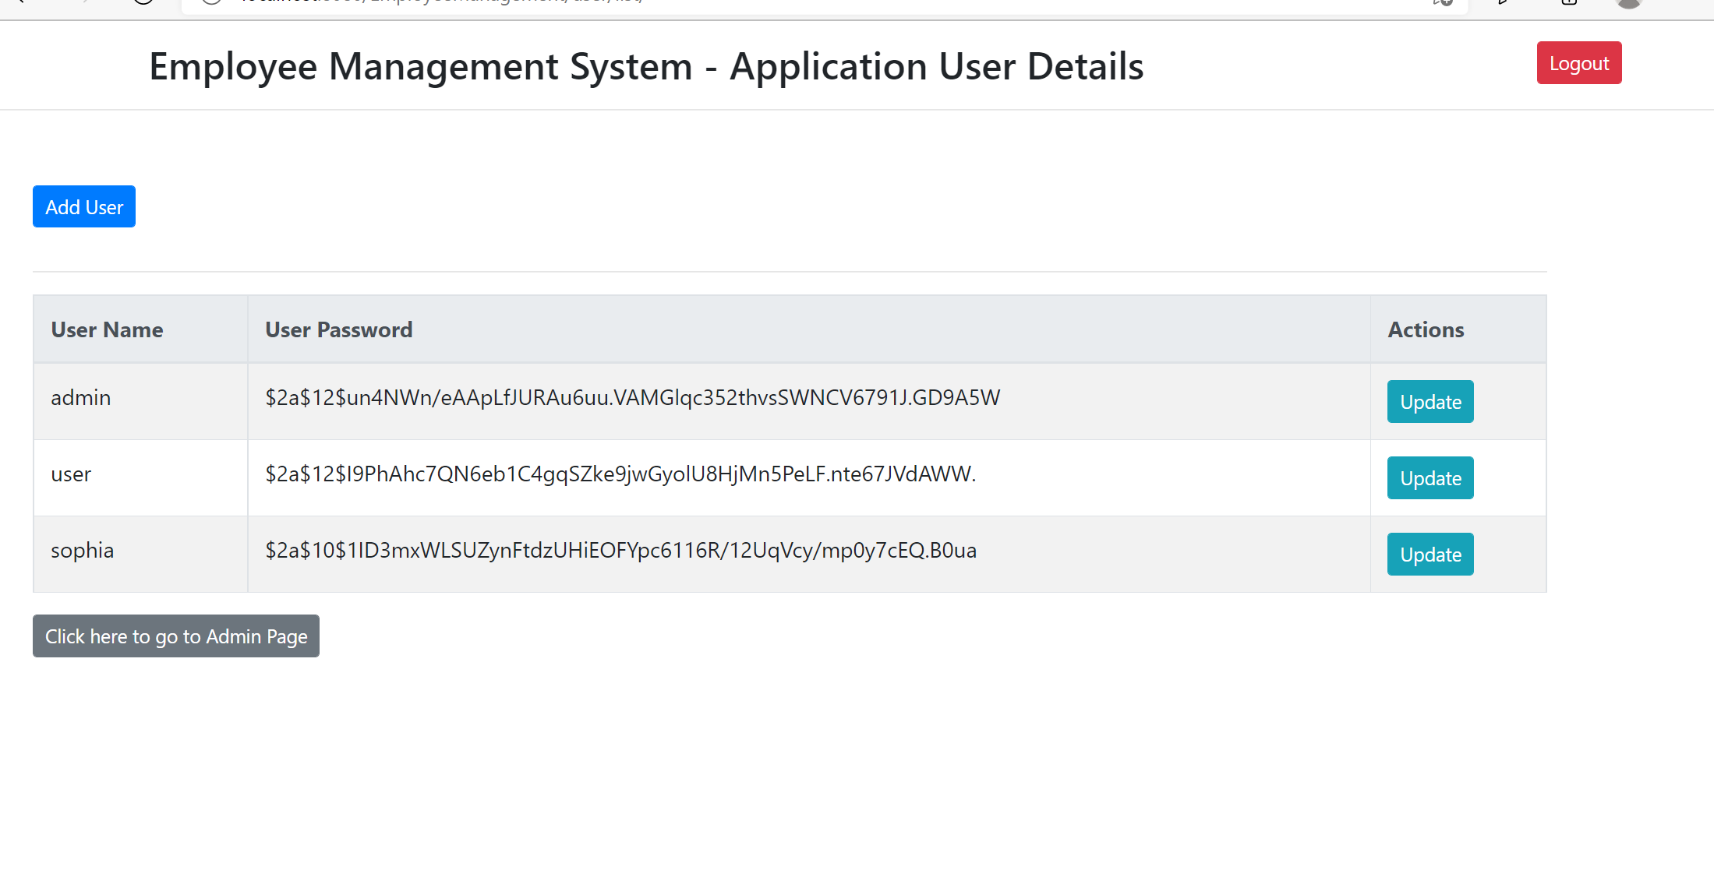

Update user Role / Password

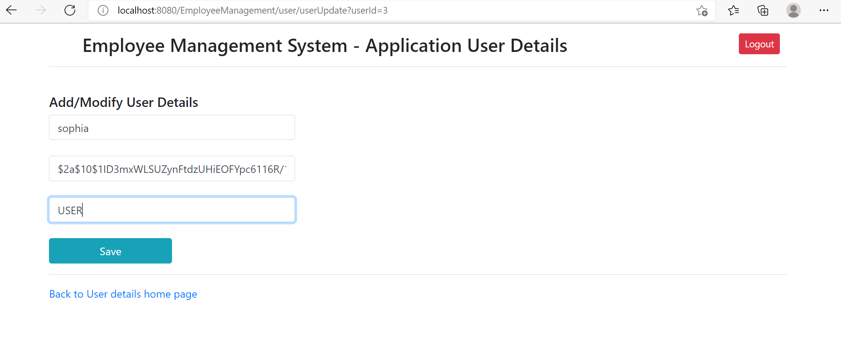

Login page for ordinary User

<http://localhost:8080/EmployeeManagement/employee/user/>

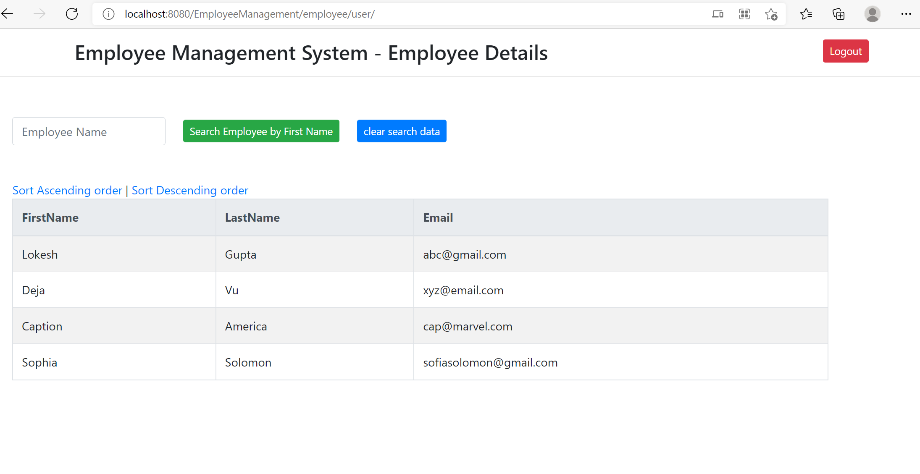

Search User –

<http://localhost:8080/EmployeeManagement/employee/searchasuser?firstName=Sophia>

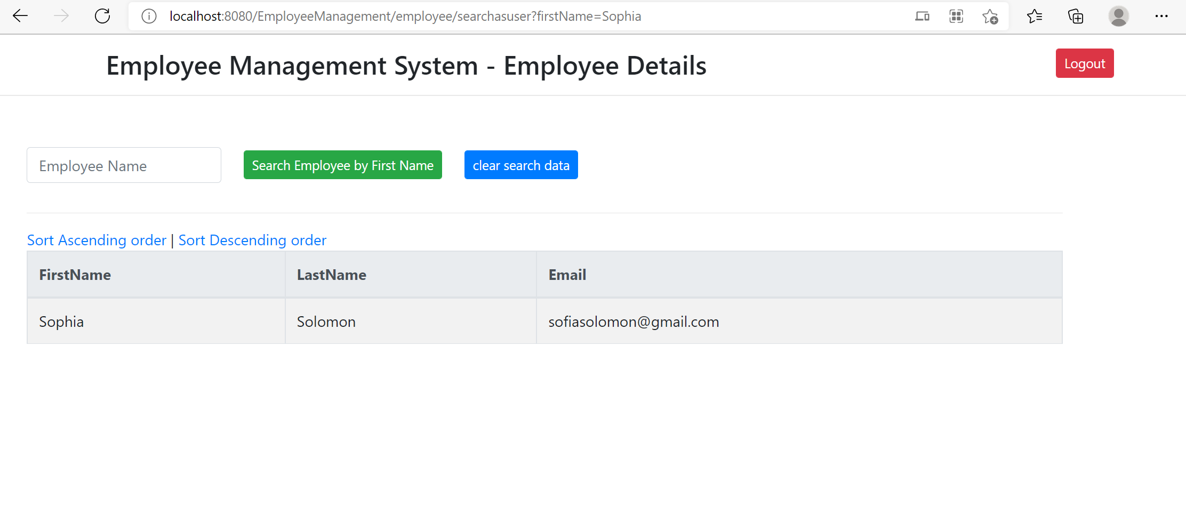

Sort Ascending Order

<http://localhost:8080/EmployeeManagement/employee/usersort?order=1>

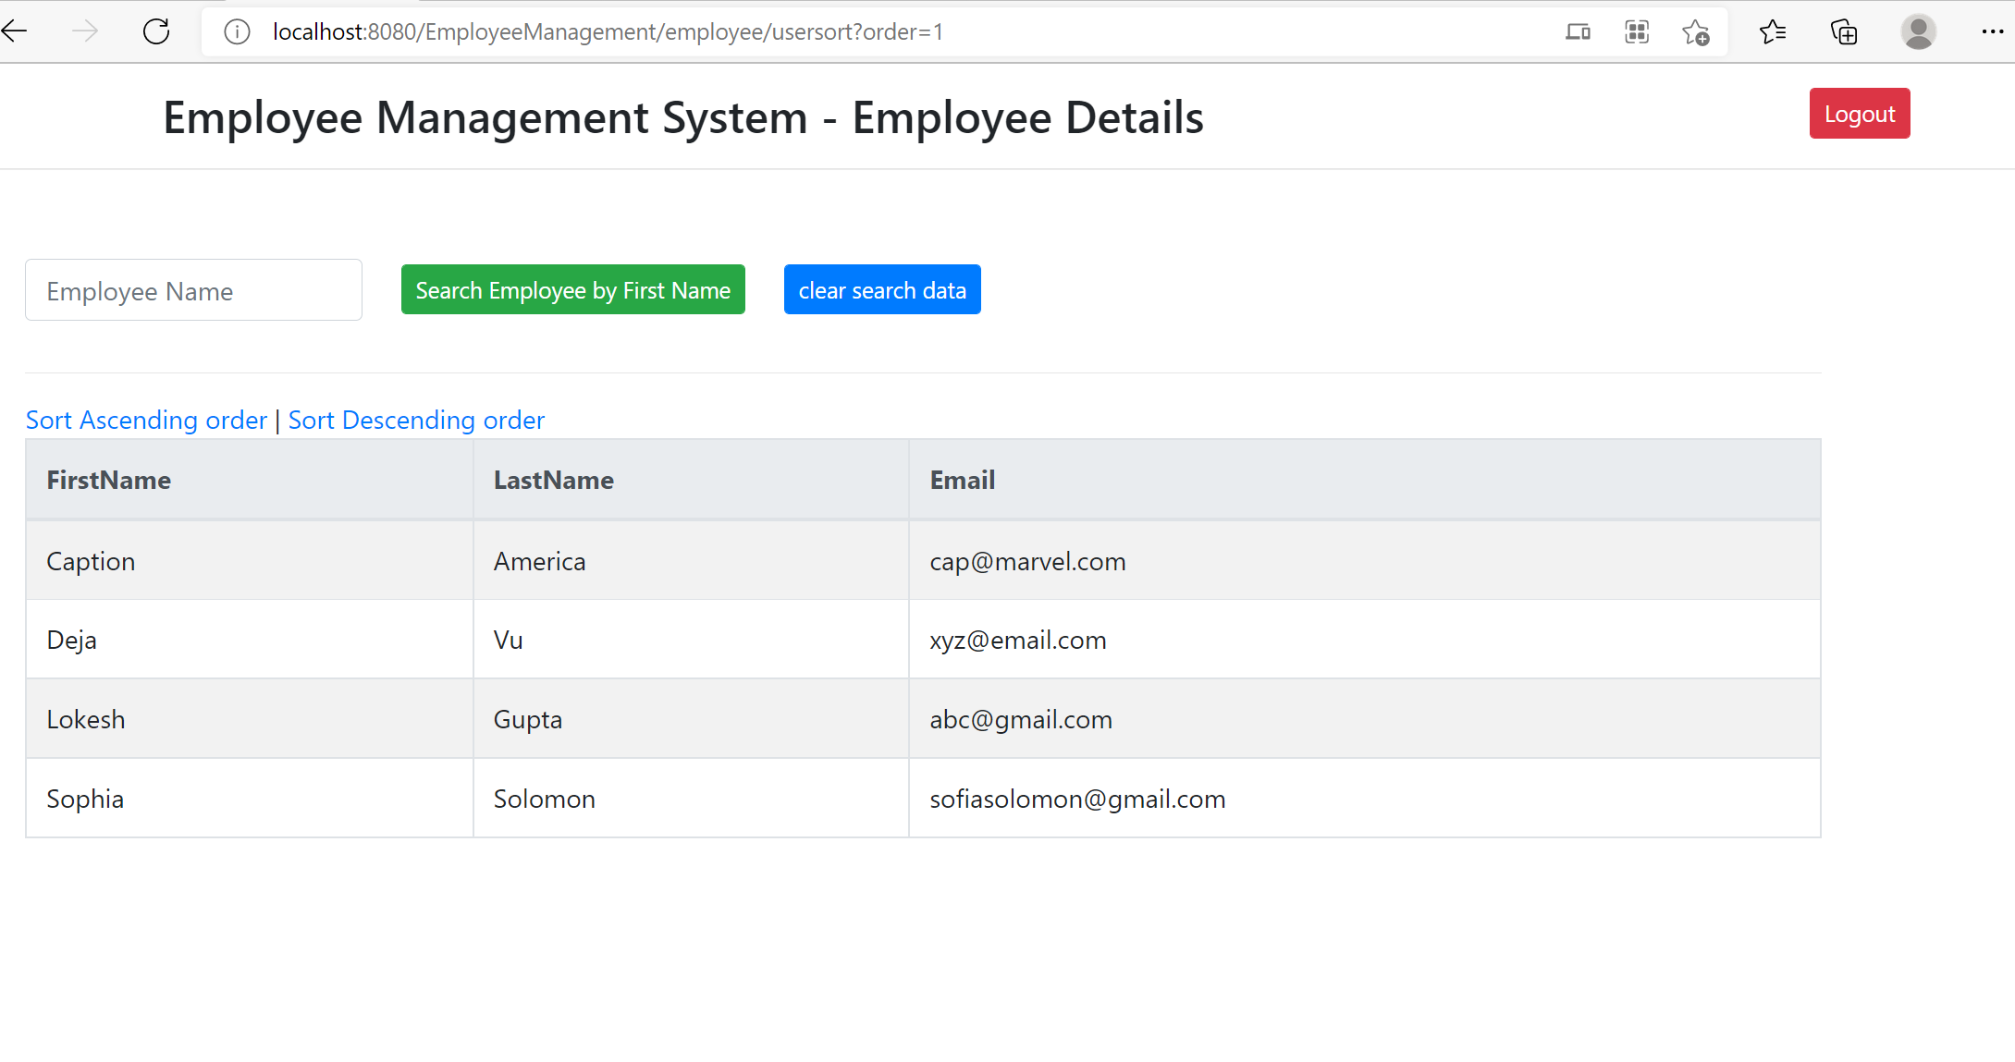

Sort Descending order

<http://localhost:8080/EmployeeManagement/employee/usersort?order=2>

