**ADMIN ROLE OPERATIONS**

* Update Student Information

<http://localhost:8080/StudentManagement/student/showFormForUpdate?studentId=1>

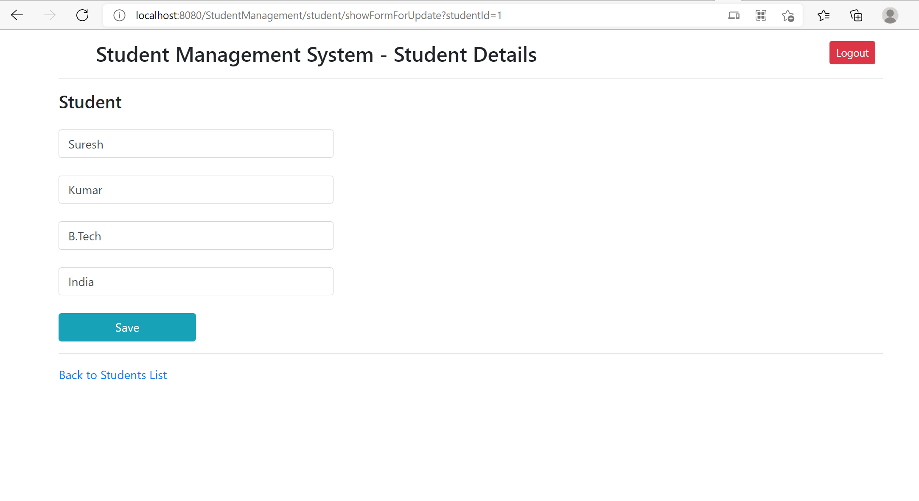

* Add Student

<http://localhost:8080/StudentManagement/student/showFormForAdd>

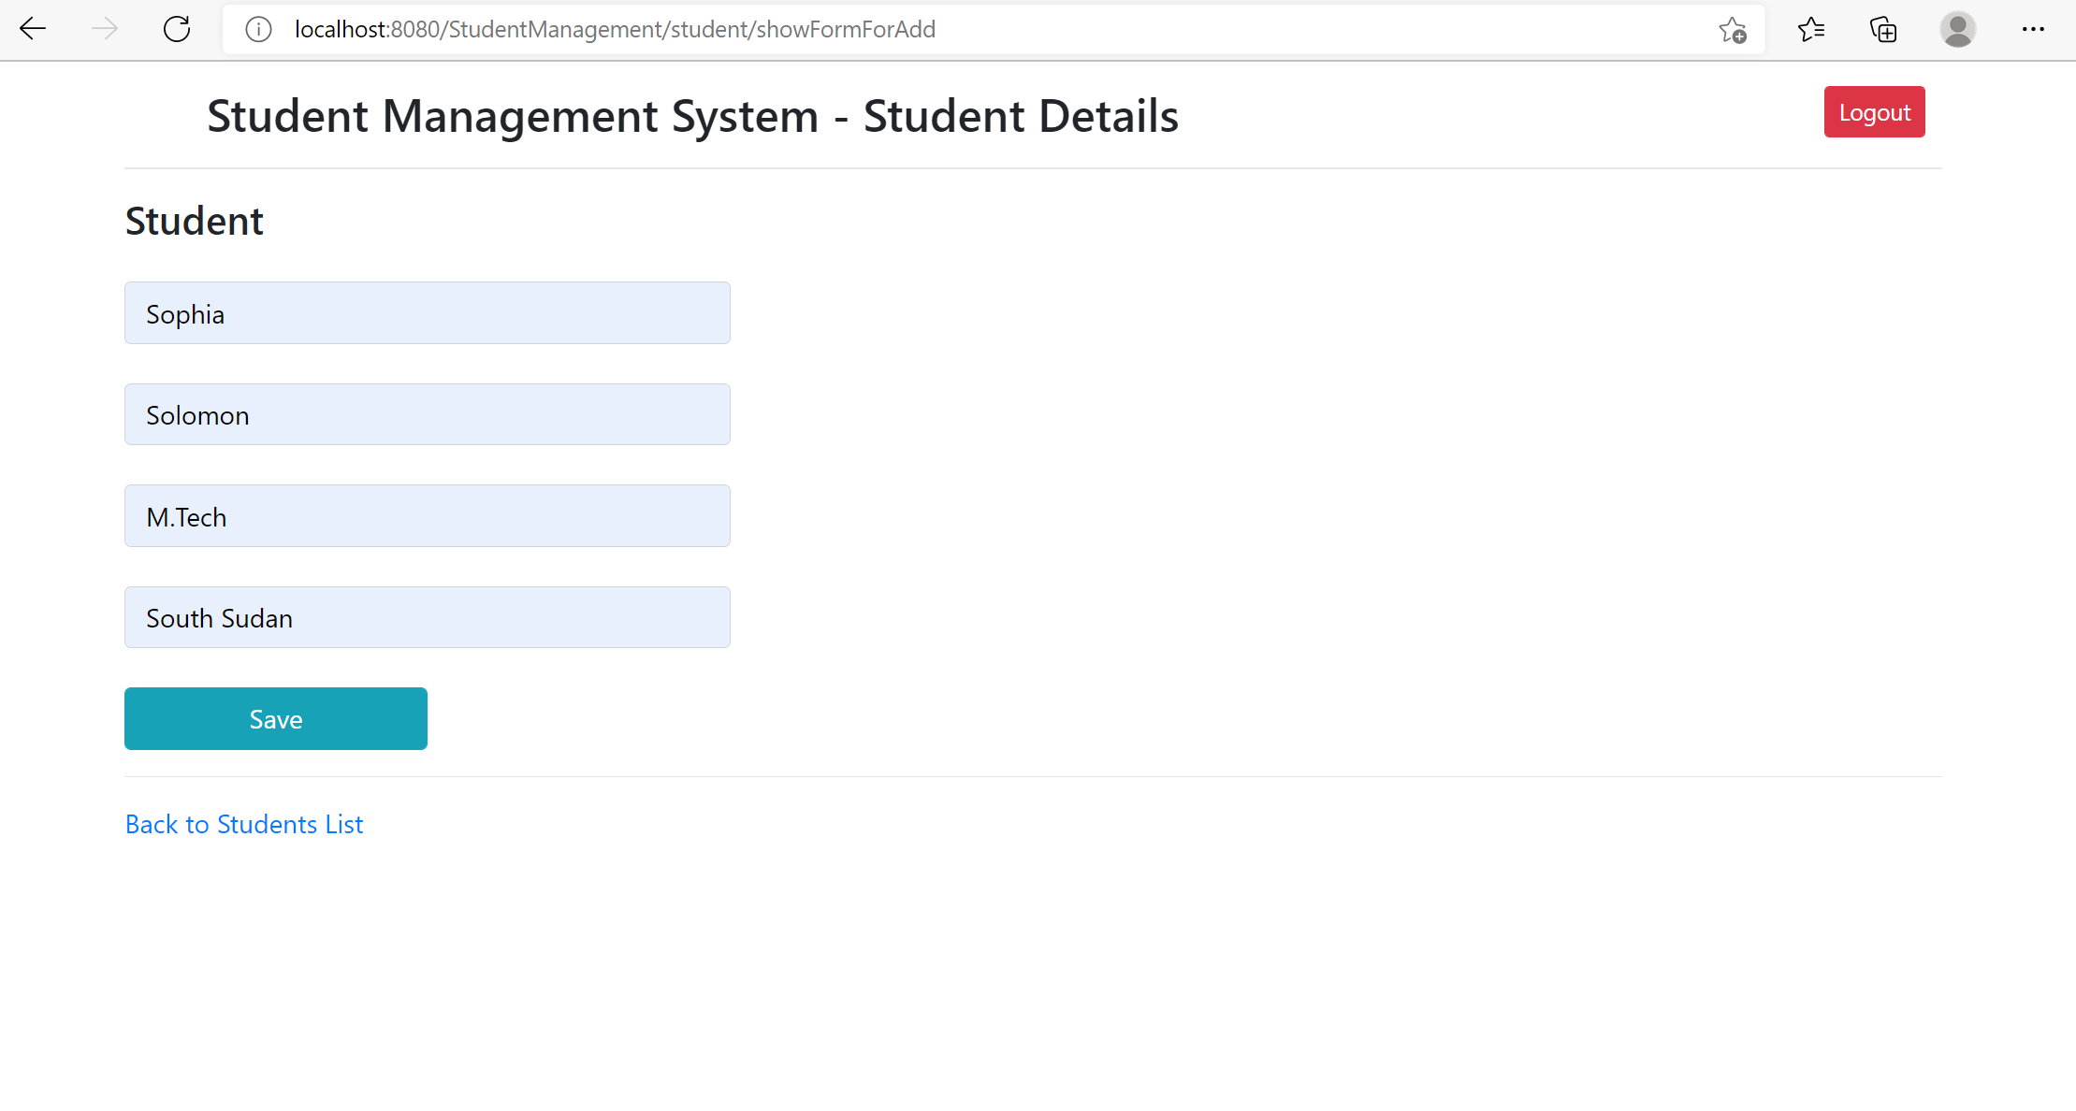

* List Student

<http://localhost:8080/StudentManagement/student/list>

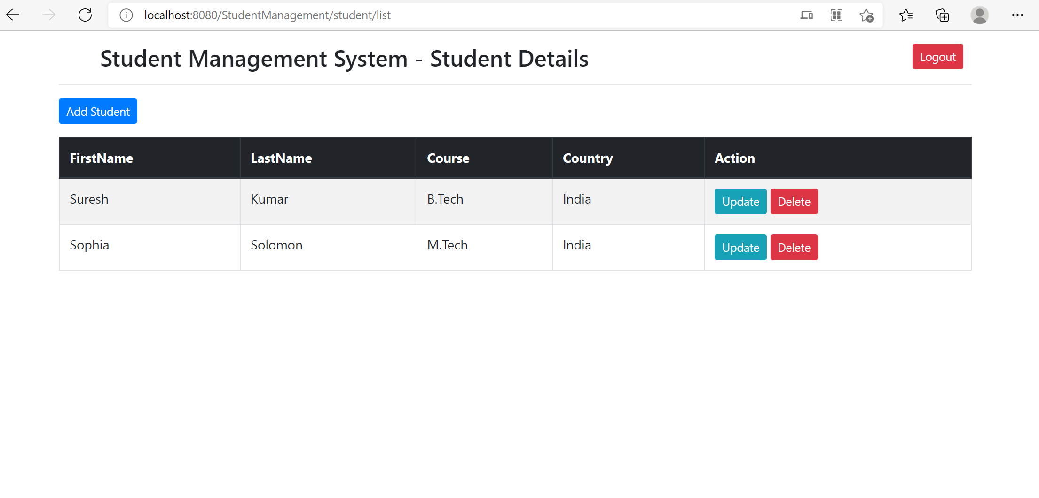

* Delete Student - 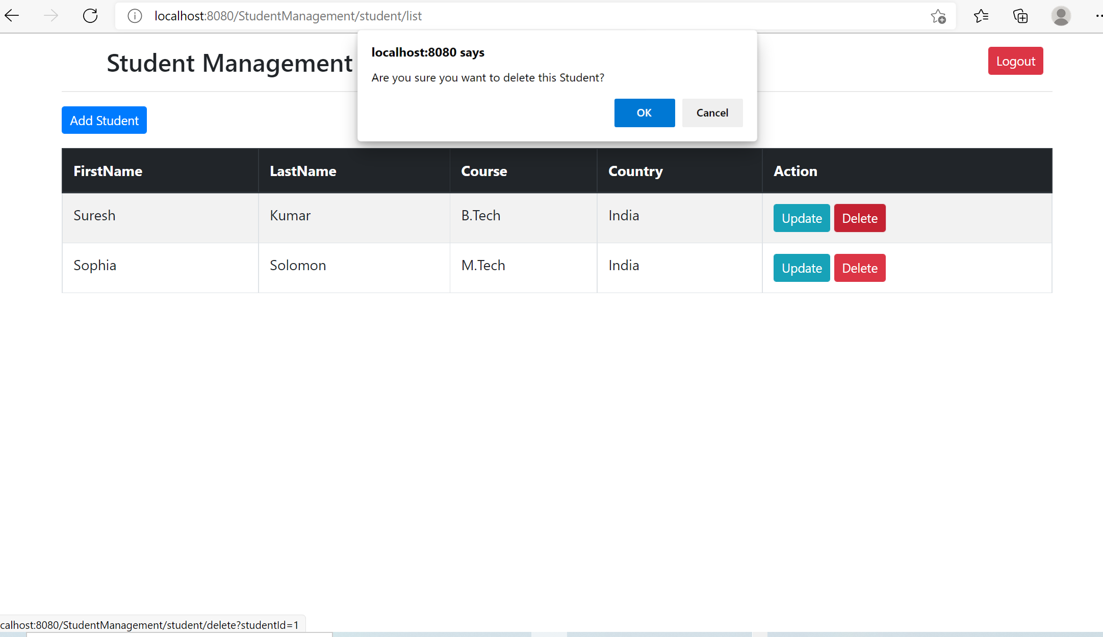

**User Role operations**

* List Student Details

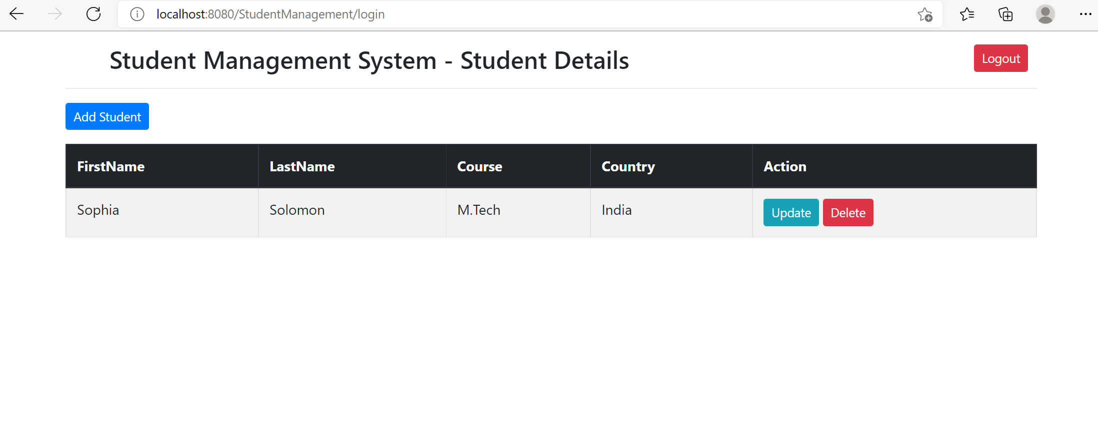

* Add student details

http://localhost:8080/StudentManagement/student/showFormForAdd

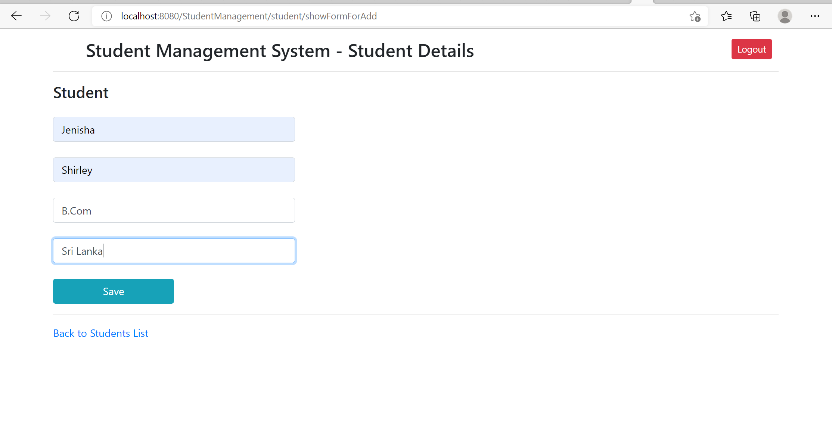

* Update Student Details

<http://localhost:8080/StudentManagement/student/showFormForUpdate?studentId=2>

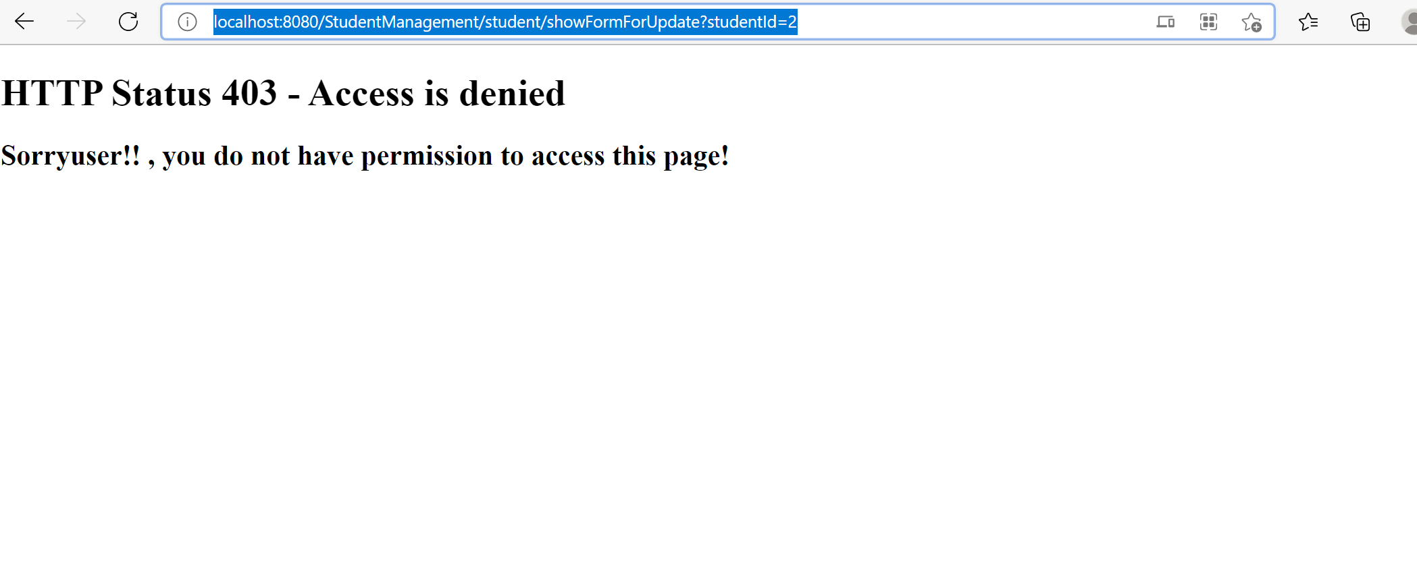

* Delete Student details

<http://localhost:8080/StudentManagement/student/delete?studentId=2>

