Post with 100

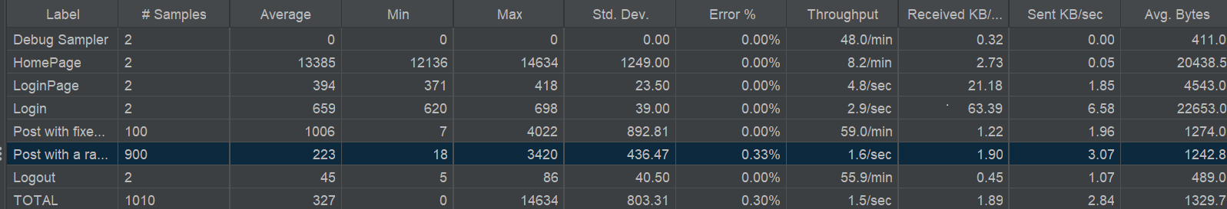

Post with 1000

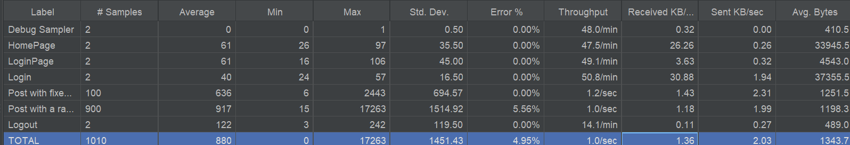

Post with 2000

