**Capacity Test Report**

The object of testing is a blog that is based on technology BlogEngine.NET.

Goal: Get results of Capacity testing for Blog

**Terms in report**

Capacity- how many users your application can handle before either performance or stability becomes unacceptable.

Throughput - indicates the number of transactions per time (seconds, minutes, hours) an application can handle.

Response time - is the amount of time from the moment that a user sends a request until the time that the application indicates that the request has completed.

**Test Description**

Capacity test of Blog - BlogEngine.NET 3.2 performed for …. on Blog until test end, with next users action flow:

…..

For testing capacity all actions after first visiting Home Page will continue 50 times for each user.

(test data is in addition and test environment).

**Conclusion**

1. Maximum recommended number is 48.5
2. The most common error is happened when open random page

**Graphical results of capacity testing**

**Metricts**

Ramp-up is the amount of time it will take to add all test users (threads) to test execution.

Duration is time how long it will execute test.

Median: It is the time in the middle of a set of samples result. It indicates that 50% of the samples took no more than this time

95% Line: 95% of the samples took no more than this time.

99% Line: 99% of the samples took no more than this time.

Min: The shortest time taken by a sample for specific label.

Max**:** The longest time taken by a sample for specific label.

Throughput: Throughput is the number of requests that are processed per time unit (seconds, minutes, hours) by the server. This time is calculated from the start of first sample to the end of the last sample. Larger throughput is better.

**VM Virtual Box**

**Users: _150__  
Ramp-up: __300_  
Duration: ___**

1. **Capacity: _50__users**

|  |  |  |  |  |  |  |  |  |  |  |
| --- | --- | --- | --- | --- | --- | --- | --- | --- | --- | --- |
| **Label** | **# Samples** | **Average** | **Median** | **90% Line** | **95% Line** | **99% Line** | **Min** | **Max** | **Error %** | **Throughput** |
| Main Page | 133 | 180 | 136 | 404 | 434 | 500 | 11 | 519 | 0.00% | 0.50283 |
| Open predefined date | 70 | 190 | 177 | 416 | 449 | 497 | 9 | 524 | 0.00% | 0.2656 |
| Open Large Calendar | 132 | 198 | 172 | 411 | 490 | 592 | 19 | 599 | 0.00% | 0.50126 |
| Open a random date | 1165 | 180 | 141 | 410 | 451 | 519 | 8 | 613 | 0.00% | 4.40737 |
| Open random page | 1198 | 172 | 139 | 387 | 445 | 530 | 0 | 609 | 1.25% | 4.54087 |
| Open Contacts | 131 | 179 | 141 | 383 | 462 | 494 | 8 | 496 | 0.00% | 0.50145 |
| Open a post | 1691 | 189 | 156 | 412 | 458 | 527 | 10 | 610 | 0.00% | 6.40196 |
| Add Comment | 35523 | 203 | 186 | 419 | 469 | 526 | 3 | 673 | 0.00% | 134.34919 |
| Search by name | 255 | 189 | 153 | 419 | 478 | 508 | 12 | 604 | 0.00% | 0.96459 |
| TOTAL | 40298 | 200 | 182 | 418 | 468 | 526 | 0 | 673 | 0.04% | 151.74897 |

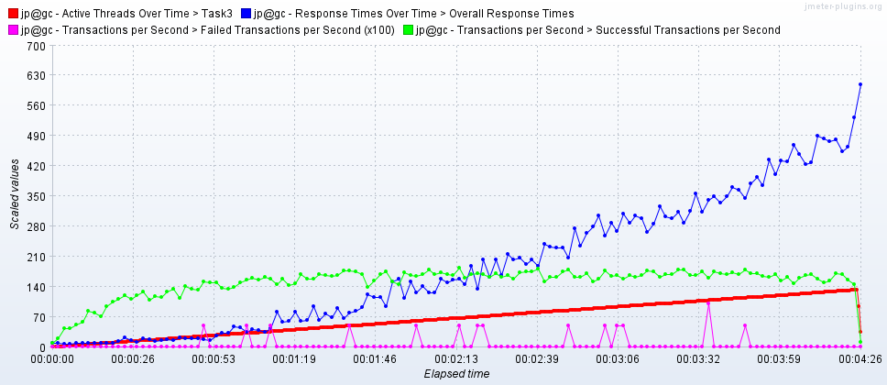

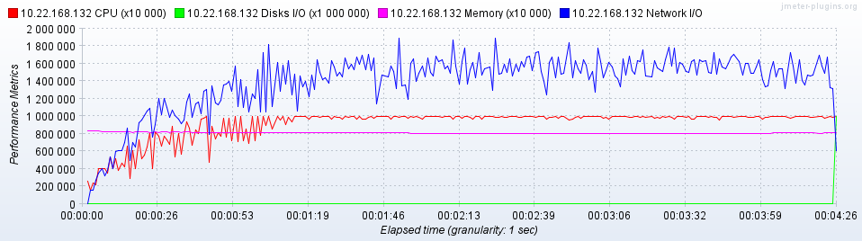

**2. Capacity:   
………**

**Test Load Report Additional**

[**Test Environment & Tools**](https://www.softwaretestinghelp.com/test-bed-test-environment-management-best-practices/)

VM:

Workstation: Oracle VM Virtual Box 5.2

Base memory: 2048 MB

Processor(s):1

OS: Windows Server 2016 (64-bit)

Host:

Workstation: Vbox

Installed memory: 2 Gb

Processor: Intel(R) Core(TM) i7-7700 CPU 3.60Hz

OS: Windows 10 (64-bit)

Test tool: Apache JMeter 5.

**Test data**

**Date for Open Random Date** randomized in format yyyy/mm/dd

**Date for Open Predefined Date from** csv file in format yyyy/mm/dd

**Name for Search by Name** is Lorem154538686

**Data for POST Request Add Comment** takes from GET Request of Post Page, Author-Name+RandomNumber, E-mail – Mail+ RandomNumber @mail, Text of comment - Hello its my comment+ RandomNumber

**Scenario:**

