**Load Test Report**

The object of testing is a blog that is based on technology BlogEngine.NET.

Goal: Get results of load testing for Blog under a specific scenario

**Terms in report**

Load testing - checks the System Under Test against its performance requirements or objectives, specifically those regarding response time, throughput, and resources utilization under a given (usually, but not necessarily, average or normal) load.

Throughput - indicates the number of transactions per time (seconds, minutes, hours) an application can handle.

Response time - is the amount of time from the moment that a user sends a request until the time that the application indicates that the request has completed.

**Test Description**

Load test of Blog - BlogEngine.NET 3.2 performed for 2 users perform edit script on Blog for 1 and half hour

**Conclusion**

1. The TPS and response time is stable during 1 and half hour testing, there’s some peak in the CPU usage
2. The most common error: Got 500 when Update Post , error rate is 0.06%

**Graphical results of load testing**

**Metricts**

Ramp-up is the amount of time it will take to add all test users (threads) to test execution.

Duration is time how long it will execute test.

Median: It is the time in the middle of a set of samples result. It indicates that 50% of the samples took no more than this time

95% Line: 95% of the samples took no more than this time.

99% Line: 99% of the samples took no more than this time.

Min: The shortest time taken by a sample for specific label.

Max**:** The longest time taken by a sample for specific label.

Throughput: Throughput is the number of requests that are processed per time unit (seconds, minutes, hours) by the server. This time is calculated from the start of first sample to the end of the last sample. Larger throughput is better.

**VM Virtual Box**

**Users: _2__  
Ramp-up: __4_  
Duration: __1:24:25_**

|  |  |  |  |  |  |  |  |  |  |
| --- | --- | --- | --- | --- | --- | --- | --- | --- | --- |
| **Label** | **# Samples** | **Average** | **Median** | **90% Line** | **95% Line** | **99% Line** | **Min** | **Max** | **Error %** |
| Home Page | 32 | 24 | 16 | 33 | 35 | 161 | 13 | 161 | 0.00% |
| Login Page | 32 | 8 | 4 | 18 | 20 | 31 | 2 | 31 | 0.00% |
| Login | 32 | 31 | 25 | 48 | 60 | 75 | 18 | 75 | 0.00% |
| Open predefined date | 1564 | 72 | 84 | 128 | 163 | 234 | 12 | 1036 | 0.00% |
| Open a random post | 1564 | 33 | 21 | 72 | 81 | 109 | 17 | 990 | 0.00% |
| Click edit link | 1564 | 5 | 3 | 6 | 12 | 36 | 2 | 943 | 0.00% |
| Get post parameters | 1564 | 5 | 4 | 6 | 12 | 32 | 2 | 422 | 0.00% |
| Update Post | 1564 | 47 | 39 | 60 | 72 | 103 | 33 | 1057 | 0.06% |
| Logout | 30 | 122 | 92 | 120 | 131 | 932 | 17 | 932 | 0.00% |
| TOTAL | 7946 | 33 | 20 | 85 | 93 | 170 | 2 | 1057 | 0.01% |

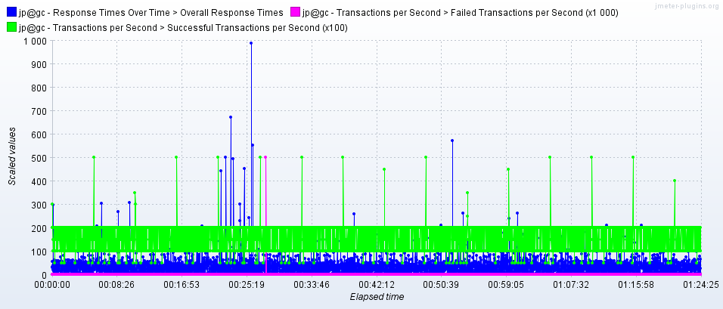

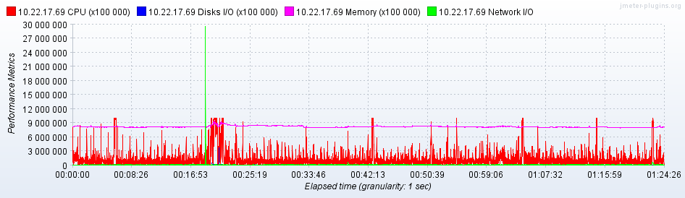

**Test Load Report Additional**

[**Test Environment & Tools**](https://www.softwaretestinghelp.com/test-bed-test-environment-management-best-practices/)

VM:

Workstation: Oracle VM Virtual Box 5.2

Base memory: 2048 MB

Processor(s):

OS: Windows Server 2016 (64-bit)

Host:

Workstation: Vbox

Installed memory: 2 Gb

Processor: Intel(R) Core(TM) i7-7700 CPU 3.60Hz

OS: Windows 10 (64-bit)

Test tool: Apache JMeter 5.

**Test data**

2 Editor: Editor_01, Editor_02

**Edit Script**

