# **Task6 with 100 Posts**

**Capacity – 237.8 users**

|  |  |  |  |  |  |  |  |  |  |
| --- | --- | --- | --- | --- | --- | --- | --- | --- | --- |
| **Label** | **# Samples** | **Average** | **Median** | **90% Line** | **95% Line** | **99% Line** | **Min** | **Max** | **Error %** |
| Main Page | 559 | 93 | 26 | 376 | 440 | 556 | 7 | 665 | 0.00% |
| Open predefined date | 6247 | 101 | 22 | 397 | 475 | 561 | 6 | 736 | 0.00% |
| Search by name | 6238 | 101 | 23 | 396 | 470 | 550 | 7 | 763 | 0.00% |
| Stay at the same page | 4729 | 0 | 0 | 0 | 1 | 1 | 0 | 21 | 0.00% |
| Home Page | 3127 | 103 | 23 | 402 | 470 | 559 | 7 | 776 | 0.00% |
| Open a random post | 4816 | 102 | 23 | 395 | 470 | 564 | 6 | 756 | 0.00% |
| Get random date | 2084 | 0 | 0 | 1 | 1 | 1 | 0 | 15 | 0.00% |
| Open a random date | 2084 | 100 | 18 | 392 | 471 | 562 | 5 | 714 | 0.00% |
| Open Large Calendar | 2081 | 102 | 22 | 400 | 472 | 565 | 9 | 722 | 0.00% |
| Open the first post | 2593 | 103 | 24 | 400 | 474 | 573 | 6 | 716 | 0.00% |
| Open Contacts | 1041 | 103 | 24 | 395 | 474 | 555 | 6 | 742 | 0.00% |
| Add Comment | 1480 | 99 | 21 | 389 | 465 | 551 | 3 | 773 | 0.00% |
| Open Random Page | 4575 | 103 | 24 | 399 | 475 | 558 | 6 | 768 | 0.00% |
| TOTAL | 41654 | 85 | 16 | 371 | 457 | 552 | 0 | 776 | 0.00% |

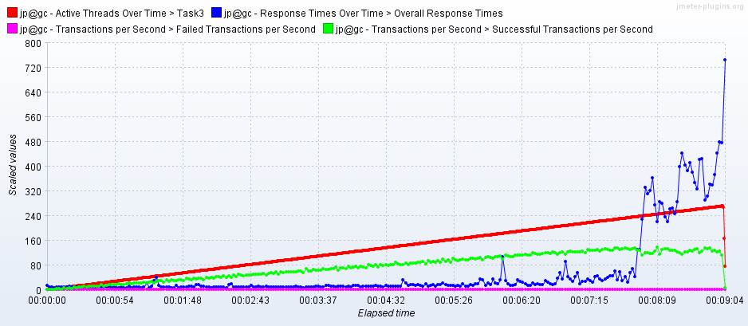

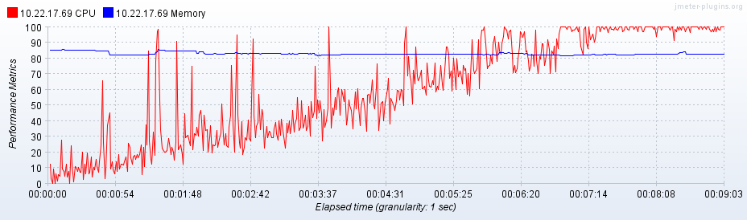

# **Task3 with 100 posts**

**Capacity – 165.6 users**

|  |  |  |  |  |  |  |  |  |  |
| --- | --- | --- | --- | --- | --- | --- | --- | --- | --- |
| **Label** | **# Samples** | **Average** | **Median** | **90% Line** | **95% Line** | **99% Line** | **Min** | **Max** | **Error %** |
| Main Page | 443 | 191 | 54 | 639 | 759 | 1146 | 8 | 1916 | 0.00% |
| Open a random date | 2657 | 219 | 67 | 662 | 766 | 1446 | 5 | 1990 | 0.00% |
| Open Large Calendar | 2585 | 235 | 85 | 674 | 767 | 1341 | 9 | 2034 | 0.00% |
| Open Random Page | 7821 | 216 | 69 | 658 | 750 | 1366 | 6 | 2037 | 0.00% |
| Open predefined date | 2645 | 212 | 65 | 658 | 772 | 1351 | 6 | 2072 | 0.00% |
| Open a random post | 3049 | 216 | 64 | 672 | 766 | 1296 | 6 | 1984 | 0.00% |
| Add Comment | 3037 | 209 | 64 | 656 | 745 | 1264 | 3 | 1979 | 0.00% |
| Home Page | 2560 | 215 | 72 | 656 | 740 | 1288 | 7 | 2044 | 0.00% |
| Open the first post | 3045 | 220 | 74 | 654 | 748 | 1364 | 6 | 2009 | 0.00% |
| Open Contacts | 2663 | 216 | 67 | 665 | 755 | 1456 | 6 | 1993 | 0.00% |
| Search by name | 2625 | 230 | 75 | 673 | 790 | 1370 | 7 | 2013 | 0.00% |
| TOTAL | 33130 | 218 | 69 | 662 | 759 | 1361 | 3 | 2072 | 0.00% |

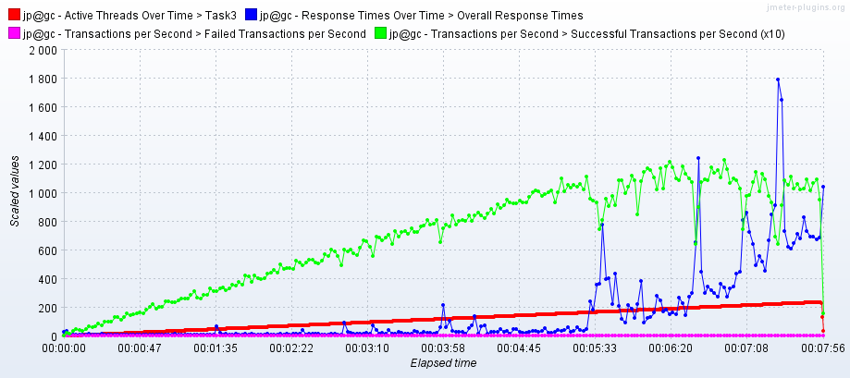

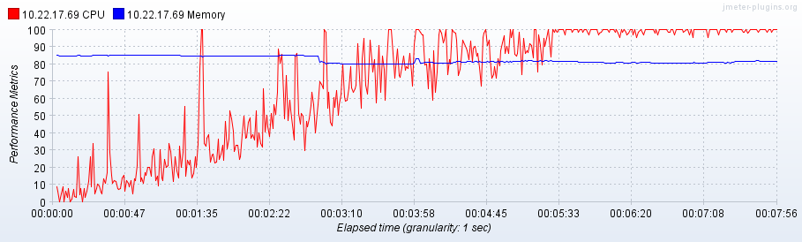

# Task3 with 1000 Posts

**Capacity – 90.3 users**

|  |  |  |  |  |  |  |  |  |  |
| --- | --- | --- | --- | --- | --- | --- | --- | --- | --- |
| **Label** | **# Samples** | **Average** | **Median** | **90% Line** | **95% Line** | **99% Line** | **Min** | **Max** | **Error %** |
| Main Page | 203 | 440 | 226 | 1085 | 1365 | 1653 | 15 | 1747 | 0.00% |
| Open Contacts | 927 | 491 | 344 | 1166 | 1378 | 1663 | 10 | 1826 | 0.00% |
| Open a random date | 926 | 499 | 373 | 1179 | 1442 | 1724 | 11 | 1872 | 0.00% |
| Open Random Page | 2730 | 489 | 342 | 1162 | 1389 | 1686 | 11 | 1899 | 0.00% |
| Open predefined date | 936 | 487 | 350 | 1120 | 1363 | 1737 | 11 | 1832 | 0.00% |
| Search by name | 923 | 506 | 347 | 1214 | 1450 | 1743 | 16 | 1850 | 0.00% |
| Open the first post | 1130 | 520 | 425 | 1195 | 1421 | 1697 | 12 | 1951 | 0.00% |
| Open a random post | 1150 | 494 | 328 | 1168 | 1449 | 1707 | 12 | 1859 | 0.00% |
| Home Page | 900 | 493 | 321 | 1140 | 1438 | 1713 | 13 | 1804 | 0.00% |
| Add Comment | 1133 | 484 | 340 | 1162 | 1361 | 1668 | 4 | 1790 | 0.00% |
| Open Large Calendar | 966 | 527 | 379 | 1192 | 1465 | 1729 | 31 | 1924 | 0.00% |
| TOTAL | 11924 | 497 | 349 | 1168 | 1409 | 1701 | 4 | 1951 | 0.00% |

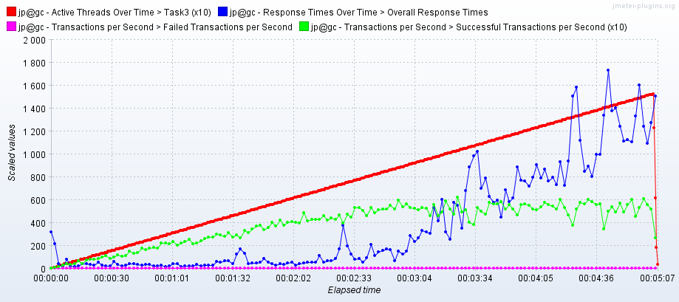

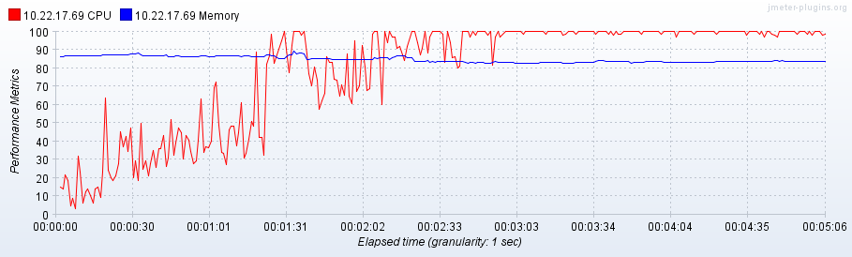

# **Task6 with 1000 Posts**

**Capacity – 111 users**

|  |  |  |  |  |  |  |  |  |  |
| --- | --- | --- | --- | --- | --- | --- | --- | --- | --- |
| **Label** | **# Samples** | **Average** | **Median** | **90% Line** | **95% Line** | **99% Line** | **Min** | **Max** | **Error %** |
| Main Page | 506 | 1495 | 1456 | 3091 | 3487 | 4117 | 14 | 4441 | 0.00% |
| Open predefined date | 4927 | 1587 | 1541 | 3130 | 3695 | 4179 | 11 | 4461 | 0.00% |
| Search by name | 4890 | 1588 | 1541 | 3133 | 3715 | 4183 | 16 | 4550 | 0.00% |
| Open Random Page | 3687 | 1570 | 1527 | 3125 | 3671 | 4179 | 11 | 4441 | 0.00% |
| Home Page | 2476 | 1597 | 1561 | 3131 | 3705 | 4174 | 13 | 4506 | 0.00% |
| Open a random post | 3764 | 1587 | 1544 | 3124 | 3705 | 4165 | 12 | 4453 | 0.00% |
| Get random date | 1650 | 0 | 0 | 1 | 1 | 7 | 0 | 40 | 0.00% |
| Open a random date | 1650 | 1589 | 1546 | 3121 | 3709 | 4164 | 11 | 4484 | 0.00% |
| Open Large Calendar | 1638 | 1607 | 1565 | 3146 | 3726 | 4193 | 31 | 4544 | 0.00% |
| Open the first post | 2024 | 1588 | 1541 | 3131 | 3686 | 4179 | 12 | 4462 | 0.00% |
| Open Contacts | 819 | 1586 | 1533 | 3122 | 3705 | 4161 | 10 | 4434 | 0.00% |
| Stay at the same page | 3595 | 0 | 0 | 1 | 1 | 1 | 0 | 6 | 0.00% |
| Add Comment | 1149 | 1574 | 1533 | 3107 | 3653 | 4180 | 4 | 4449 | 0.00% |
| TOTAL | 32775 | 1331 | 1009 | 3082 | 3477 | 4157 | 0 | 4550 | 0.00% |

