**Capacity Test Report**

The object of testing is a blog that is based on technology BlogEngine.NET.

Goal: Get results of Capacity testing for Blog

**Terms in report**

Capacity- how many users your application can handle before either performance or stability becomes unacceptable.

Throughput - indicates the number of transactions per time (seconds, minutes, hours) an application can handle.

Response time - is the amount of time from the moment that a user sends a request until the time that the application indicates that the request has completed.

**Test Description**

Capacity test of Blog - BlogEngine.NET 3.2 performed for …. on Blog until test end, with next users action flow:

…..

For testing capacity all actions after first visiting Home Page will continue 50 times for each user.

(test data is in addition and test environment).

**Conclusion**

1. Metric for 4 runs

|  |  |  |
| --- | --- | --- |
| **100 Posts** | | |
|  | **Task3** | **Task6** |
| Comfort zone | Max throughput < 98.3 Response time < 50.2 Users < 134.4 | Max throughput < 40.1 Response time <113.7 Users < 64.2 |
| Degradation zone | Max throughput: 98.3 - 127.8 Response time: 50.2 - 351.2 Users: 134.4 - 196.7 | Max throughput: 40.1 - 135.8 Response time: 113.7 - 234.1 Users < 227.8 |
| Frustration zone | Max throughput < 127.8 Response time > 351.2 Users > 196.7 | Max throughput < 135.8 Response time > 234.1 Users > 227.8 |
| Capacity point | 196.7 Users | 227.8 Users |
| **1000 Posts** | | |
|  | **Task3** | **Task6** |
| Comfort zone | Max throughput < 35.6 Response time < 33.4 Users < 48.2 | Max throughput < 66.9 Response time < 60.2 Users < 109 |
| Degradation zone | Max throughput :35.6 - 56.7 Response time: 33.4-367.9 Users: 86 | Max throughput: 66.9 -73.3 Response time: 60.2 - 100.3 Users - 127 |
| Frustration zone | Max throughput < 56.7 Response time > 367.9 Users > 86 | Max throughput < 73 Response time > 100.3 Users > 127 |
| Capacity point | 86 Users | 127 Users |

1. 100 posts vs. 1000 posts

The testing is designed as volume testing, to understand the performance by increase volume of data

The performance results were better small volume of data, in our case, 100 posts

As query in huge volume data increase the load of the system

1. Task3 vs. Task6

The different distribution of the action caused different performance results

As in real life, different user behavior will cause different impact to the testing target

The system performance is more stable in Task6 scenario

**Graphical results of capacity testing**

**Metrics**

Ramp-up is the amount of time it will take to add all test users (threads) to test execution.

Duration is time how long it will execute test.

Median: It is the time in the middle of a set of samples result. It indicates that 50% of the samples took no more than this time

95% Line: 95% of the samples took no more than this time.

99% Line: 99% of the samples took no more than this time.

Min: The shortest time taken by a sample for specific label.

Max**:** The longest time taken by a sample for specific label.

Throughput: Throughput is the number of requests that are processed per time unit (seconds, minutes, hours) by the server. This time is calculated from the start of first sample to the end of the last sample. Larger throughput is better.

**VM Virtual Box**

1. **Capacity testing for Task3, 100 posts**

|  |  |  |  |  |  |  |  |  |  |
| --- | --- | --- | --- | --- | --- | --- | --- | --- | --- |
| **Label** | **# Samples** | **Average** | **Median** | **90% Line** | **95% Line** | **99% Line** | **Min** | **Max** | **Error %** |
| Main Page | 411 | 150 | 48 | 455 | 567 | 875 | 8 | 2411 | 0.00% |
| Open Large Calendar | 2461 | 184 | 68 | 508 | 613 | 1347 | 9 | 2753 | 0.00% |
| Search by name | 2331 | 197 | 69 | 540 | 637 | 2079 | 7 | 2752 | 0.00% |
| Open the first post | 2771 | 184 | 62 | 522 | 618 | 1048 | 7 | 2737 | 0.00% |
| Open predefined date | 2413 | 180 | 64 | 520 | 622 | 1034 | 7 | 2766 | 0.00% |
| Open a random post | 2607 | 177 | 65 | 485 | 609 | 1331 | 7 | 2759 | 0.00% |
| Add Comment | 2682 | 161 | 57 | 478 | 588 | 846 | 3 | 2206 | 0.00% |
| Open Random Page | 7143 | 180 | 67 | 525 | 626 | 1065 | 5 | 2758 | 0.00% |
| Home Page | 2408 | 187 | 66 | 522 | 646 | 1308 | 7 | 2780 | 0.00% |
| Open Contacts | 2378 | 180 | 60 | 518 | 621 | 1301 | 6 | 2759 | 0.00% |
| Open a random date | 2376 | 189 | 67 | 531 | 638 | 1222 | 6 | 2823 | 0.00% |
| TOTAL | 29981 | 181 | 64 | 516 | 623 | 1235 | 3 | 2823 | 0.00% |

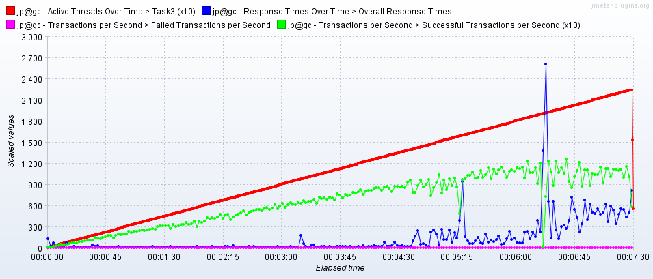

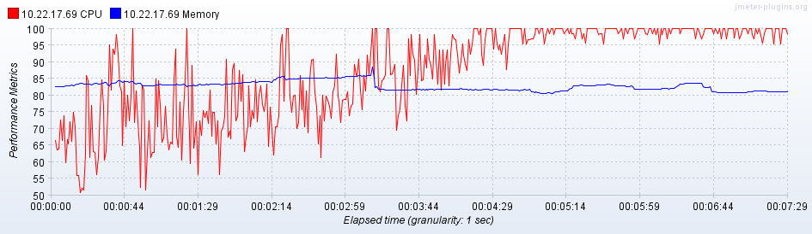

1. **Capacity for Task3, 1000 posts**

|  |  |  |  |  |  |  |  |  |  |
| --- | --- | --- | --- | --- | --- | --- | --- | --- | --- |
| **Label** | **# Samples** | **Average** | **Median** | **90% Line** | **95% Line** | **99% Line** | **Min** | **Max** | **Error %** |
| Main Page | 383 | 1776 | 1702 | 3878 | 4451 | 4910 | 15 | 8053 | 0.00% |
| Search by name | 1874 | 1855 | 1840 | 3722 | 4318 | 4949 | 16 | 5064 | 0.00% |
| Open predefined date | 1872 | 1828 | 1852 | 3667 | 4156 | 4889 | 11 | 5110 | 0.00% |
| Open a random date | 1850 | 1832 | 1852 | 3693 | 4155 | 4701 | 10 | 5120 | 0.00% |
| Open Contacts | 1867 | 1850 | 1845 | 3723 | 4148 | 4728 | 10 | 5084 | 0.00% |
| Open Random Page | 5508 | 1845 | 1853 | 3732 | 4177 | 4880 | 11 | 5161 | 0.00% |
| Home Page | 1840 | 1871 | 1865 | 3757 | 4227 | 4812 | 14 | 5049 | 0.00% |
| Open the first post | 2280 | 1839 | 1848 | 3697 | 4172 | 4773 | 12 | 5073 | 0.00% |
| Open a random post | 2238 | 1881 | 1853 | 3743 | 4256 | 4938 | 12 | 5079 | 0.00% |
| Add Comment | 2240 | 1836 | 1839 | 3714 | 4226 | 4866 | 5 | 5139 | 0.00% |
| Open Large Calendar | 1918 | 1910 | 1881 | 3796 | 4307 | 4943 | 33 | 5157 | 0.00% |
| TOTAL | 23870 | 1852 | 1853 | 3726 | 4207 | 4895 | 5 | 8053 | 0.00% |

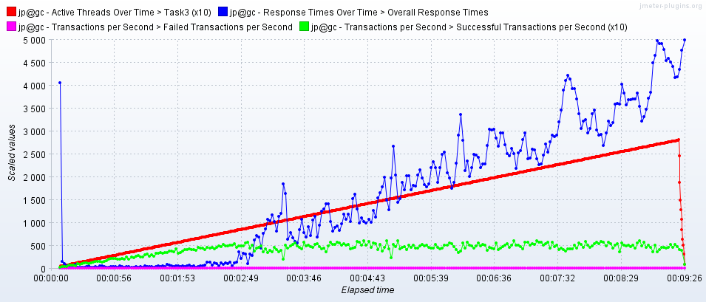

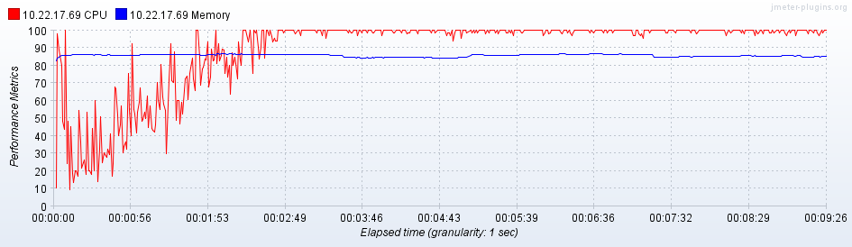

1. **Capacity for Task6, 100 posts**

|  |  |  |  |  |  |  |  |  |  |
| --- | --- | --- | --- | --- | --- | --- | --- | --- | --- |
| **Label** | **# Samples** | **Average** | **Median** | **90% Line** | **95% Line** | **99% Line** | **Min** | **Max** | **Error %** |
| Main Page | 617 | 256 | 85 | 678 | 949 | 1556 | 8 | 3415 | 0.00% |
| Open predefined date | 6826 | 262 | 112 | 681 | 929 | 1496 | 7 | 2153 | 0.00% |
| Search by name | 6805 | 254 | 101 | 670 | 909 | 1451 | 7 | 2015 | 0.00% |
| Open Random Page | 5105 | 264 | 109 | 687 | 940 | 1469 | 7 | 3565 | 0.00% |
| Home Page | 3421 | 270 | 120 | 691 | 952 | 1571 | 7 | 4300 | 0.00% |
| Open a random post | 5268 | 267 | 116 | 697 | 938 | 1477 | 7 | 3394 | 0.00% |
| Stay at the same page | 5064 | 0 | 0 | 0 | 1 | 1 | 0 | 16 | 0.00% |
| Get random date | 2281 | 0 | 0 | 1 | 1 | 1 | 0 | 22 | 0.00% |
| Open a random date | 2281 | 269 | 116 | 696 | 982 | 1602 | 6 | 2161 | 0.00% |
| Open the first post | 2836 | 266 | 121 | 695 | 933 | 1467 | 7 | 2169 | 0.00% |
| Open Large Calendar | 2273 | 259 | 111 | 677 | 915 | 1481 | 9 | 2016 | 0.00% |
| Open Contacts | 1136 | 258 | 106 | 669 | 915 | 1468 | 6 | 1922 | 0.00% |
| Add Comment | 1615 | 253 | 108 | 672 | 891 | 1412 | 3 | 2188 | 0.00% |
| TOTAL | 45528 | 220 | 62 | 646 | 869 | 1443 | 0 | 4300 | 0.00% |

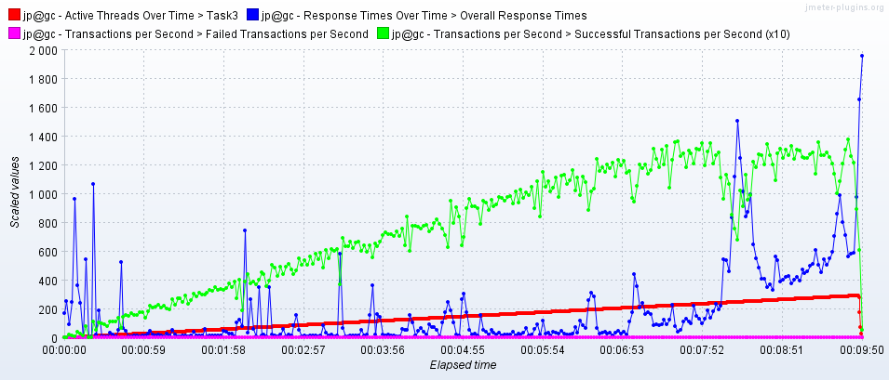

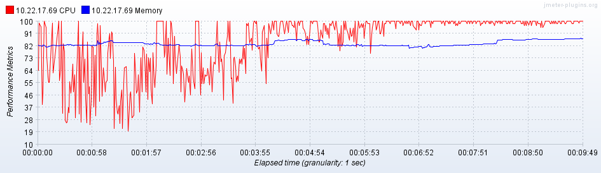

1. **Capacity for Task3, 1000 posts**

|  |  |  |  |  |  |  |  |  |  |
| --- | --- | --- | --- | --- | --- | --- | --- | --- | --- |
| **Label** | **# Samples** | **Average** | **Median** | **90% Line** | **95% Line** | **99% Line** | **Min** | **Max** | **Error %** |
| Main Page | 522 | 1573 | 1565 | 3295 | 4397 | 5271 | 15 | 9483 | 0.00% |
| Open predefined date | 5079 | 1590 | 1609 | 3202 | 3957 | 5250 | 11 | 5822 | 0.00% |
| Home Page | 2551 | 1598 | 1618 | 3212 | 3960 | 5243 | 14 | 5825 | 0.00% |
| Search by name | 5041 | 1586 | 1611 | 3184 | 3904 | 5243 | 16 | 5787 | 0.00% |
| Get random date | 1701 | 0 | 0 | 1 | 1 | 1 | 0 | 52 | 0.00% |
| Open a random date | 1701 | 1591 | 1612 | 3214 | 3958 | 5230 | 9 | 5799 | 0.00% |
| Open Large Calendar | 1688 | 1604 | 1635 | 3197 | 3933 | 5307 | 31 | 5804 | 0.00% |
| Stay at the same page | 3732 | 0 | 0 | 1 | 1 | 1 | 0 | 28 | 0.00% |
| Open the first post | 2088 | 1590 | 1612 | 3186 | 3912 | 5244 | 12 | 5852 | 0.00% |
| Open a random post | 3883 | 1589 | 1608 | 3191 | 3922 | 5236 | 12 | 5980 | 0.00% |
| Open Contacts | 844 | 1583 | 1598 | 3185 | 3880 | 5212 | 10 | 5771 | 0.00% |
| Open Random Page | 3781 | 1605 | 1627 | 3197 | 3920 | 5251 | 11 | 5751 | 0.00% |
| Add Comment | 1185 | 1572 | 1592 | 3143 | 3888 | 5207 | 4 | 5734 | 0.00% |
| TOTAL | 33796 | 1336 | 1216 | 3022 | 3761 | 5223 | 0 | 9483 | 0.00% |

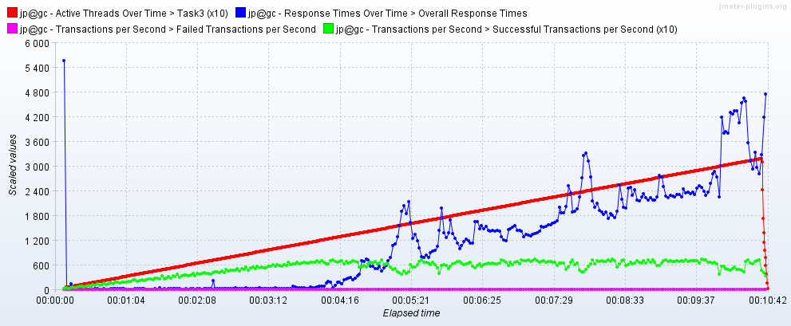

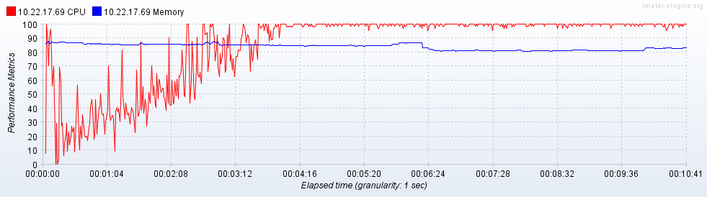

**Test Load Report Additional**

[**Test Environment & Tools**](https://www.softwaretestinghelp.com/test-bed-test-environment-management-best-practices/)

VM:

Workstation: Oracle VM Virtual Box 5.2

Base memory: 2048 MB

Processor(s):

OS: Windows Server 2016 (64-bit)

Host:

Workstation: Vbox

Installed memory: 2 Gb

Processor: Intel(R) Core(TM) i7-7700 CPU 3.60Hz

OS: Windows 10 (64-bit)

Test tool: Apache JMeter 5.

**Test data**

**Date for Open Random Date** randomized in format yyyy/MM/dd

**Date for Open Predefined Date from** csv file in format yyyy/MM/dd

**Name for Search by Name** is Tester or Test01

**Data for POST Request Add Comment**

Author : Sofia_${__Random(1,100)}

Comments: ${__RandomString(10,abcdefghijklmnopqrstuvwxyz,random_string)}

