Business Requirements Document(BRD) Template
Project/Initiative
Month 20YY
Version X.XX

Company Information

Document Revisions
Date | Version Number | Document Changes
05/02/20xx | 0.1 | Initial Draft

Approvals
Role | Name | Title | Signature | Date

Introduction

Project Summary

Objectives
The Wishlist and comparison feature increases hotel booking conversion by allowing users to save hotels to multiple lists, compare them side by side (distance, breakfast, price, highlighting), and receive price drop and low-availability notifications. The feature collects Wishlist data to enable future personalized marketing campaigns, while providing cross-device cloud sync for registered users and temporary cookie-based access for unregistered users.

Background
[Provide a brief history of how the project came to be proposed and initiated, including the business issues/problems identified, and expected benefit of implementing the project/developing the product.]

Business Drivers
[List the business drivers that make development of this product important. These can be financial, operational, market or environmental.]

Project Scope

In Scope Functionality

- Multiple Lists: Users can create multiple separate lists (e.g., "Vacation 2026", "Business Trip", "Weekend in Odesa")
- Temporary Wishlist: Unregistered users can add hotels to a temporary Wishlist stored via browser cookies
- Permanent Wishlist: Registered users can save their Wishlist permanently and access it from any device
- Side-by-Side Table: Users can compare hotels in a side-by-side comparison table
- Comparison Limit: Users can compare up to 3–5 hotels simultaneously
- Comparison Parameters: Hotels are compared by distance to sea/center, breakfast availability, and total price
- Difference Highlighting: The system highlights differences between hotels in the comparison view
- Price Drop Alerts: The system sends notifications when the price of a saved hotel decreases
- Low Availability Alerts: The system sends notifications when the number of available rooms in a saved hotel becomes critically low

Out of Scope Functionality

- Personalized discount notifications based on user's Wishlist data ( "A hotel you saved is now 10% cheaper")
- Comparison by additional parameters (pool, parking, Wi-Fi, rating, etc.)
- Price history graph or price change tracking. The system only sends current price drop notifications based on Wishlist data, without storing or visualizing price history. (e.g., "Price was 100€, now 90€")

System Perspective
[Provide a complete description of the factors that could prevent successful implementation or accelerate the projects, particularly factors related to legal and regulatory compliance, existing technical or operational limitations in the environment, and budget/resource constraints.]

Assumptions

Constraints

Risks

- .

Issues

Business Process Overview
[Describe how the current process(es) work, including the interactions between systems and various business units. Include visual process flow diagrams to further illustrate the processes the new product will replace or enhance.
Use case documentation and accompanying activity or process flow diagrams can be used to create the description(s) of the proposed or “To-Be” processes.]

Current Business Process (As-Is)
At any point during or after deployment of web apps or web sites (internal or external) to support business activities, development/support teams may create and deploy widgets.
- CMS / database administrators for the employee portal use the CMS tool to create widgets. They can test widgets in the designated staging environment, then register them and deploy to production.
- Development teams may deploy widgets to development and testing environments set up for their development projects. They must check widget code into and out of the source code repository according to their projects’ development schedule.
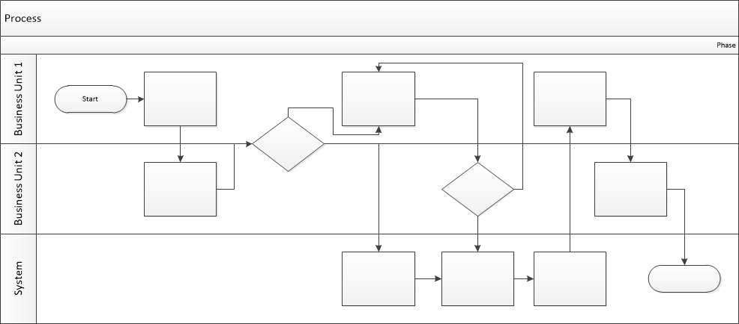

Proposed Business Process (To-Be)
- Technical Lead searches repository
- If widget is not found, user creates a new widget name record.
- WINS validates that all fields have been completed.
- WINS confirms that no similar widgets exist
- User confirms record to be created.

- User searches repository to locate existing widget description.
- WINS displays record
- User selects Edit to open and modify record
- WINS validates all fields completed correctly
- User confirms changes.
- WINS confirms changes and updates Audit table.


Stakeholder Requirements
- SR-001: Users must be able to create multiple separate lists
- SR-002: Users must be able to compare hotels side by side
- SR-003: Users must be able to compare hotels by distance, breakfast, and total price
- SR-004: The system must highlight differences between hotels
- SR-005: Users must receive price drop notifications for hotels
- SR-006: Users must receive low-availability notifications for hotels
- SR-007: Unregistered users must have temporary wishlist (cookies)
- SR-008: Registered users must be able to access their wishlist from any device

The requirements in this document are prioritized as follows:
Value | Rating | Description
1 | Critical | This requirement is critical to the success of the project. The project will not be possible without this requirement.
2 | High | This requirement is high priority, but the project can be implemented at a bare minimum without this requirement.
3 | Medium | This requirement is somewhat important, as it provides some value but the project can proceed without it.
4 | Low | This is a low priority requirement, or a “nice to have” feature, if time and cost allow it.
5 | Future | This requirement is out of scope for this project, and has been included here for a possible future release.

Functional Requirements
Req# | Priority | Description | Rationale | Use Case Reference | Impacted Stakeholders
General / Base Functionality
FR-G-001 | 1 | The system shall allow the user to create multiple lists | Allow users to create different lists | UC-WISHLIST-01 | User
FR-G-002 | 1 | The system shall display a comparison table with hotels shown side by side | Allow users to see all hotels together | UC-COMPARE-01 | User
FR-G-003 | 1 | The system shall display distance to sea/center for each hotel | Enable users to choose hotels based on location convenience | UC-COMPARE-01 | User
FR-G-004 | 2 | The system shall display breakfast availability for each hotel | Allow users to filter hotels by meal inclusion preference | UC-COMPARE-01 | User
FR-G-005 | 2 | The system shall display total price for each hotel | Help users compare final costs | UC-COMPARE-01 | User
FR-G-006 | 1 | The system shall store unregistered users' Wishlist in browser cookies (temporary) | Allow users to try the feature before registration | UC-WISHLIST-02 | User
FR-G-007 | 1 | The system shall store registered users' Wishlist on the server (permanent) | Preserve Wishlist permanently and prevent data loss | UC-WISHLIST-03 | Registered user
FR-G-008 | 1 | The system shall allow users to access their Wishlist from any device | Enable seamless experience across PC, mobile, and tablet | UC-WISHLIST-03 | User
FR-G-009 | 2 | The system shall highlight differences between hotel options | Allow users to spot key differences | UC-COMPARE-01 | User
FR-G-010 | 2 | The system shall notify the user when a hotel price decreases | Encourage users to book when price becomes more attractive | UC-NOTIFY-01 | Registered user
FR-G-011 | 2 | The system shall notify the user when room availability is critically low | Create urgency and reduce missed booking opportunities | UC-NOTIFY-02 | Registered user
Security Requirements
FR-S-001 | 1 | None specified by stakeholders
Reporting Requirements
FR-R-001 | 2 | None specified by stakeholders
Usability Requirements
FR-U-001 | 1 | The system shall limit hotel comparison to a maximum of 5 hotels simultaneously | Prevent interface overload and improve readability | UC-COMPARE-01 | User
Audit Requirements
FR-A-001 | 1 | None specified by stakeholders

Non-Functional Requirements
[Include technical and operational requirements that are not specific to a function. This typically includes requirements such as processing time, concurrent users, availability, etc.]
ID | Requirement
NFR-001 | None specified by stakeholders
NFR-002
NFR-003
NFR-004
NFR-005

Appendices

List of Acronyms
[If needed, create a list of acronyms used throughout the BRD document to aid in comprehension.]

Glossary of Terms
[If needed, identify and define any terms that may be unfamiliar to readers, including terms that are unique to the organization, the technology to be employed, or the standards in use.]

Related Documents
[Provide a list of documents or web pages, including links, which are referenced in the BRD.]

