Driver Fatigue Recognition System Report

System Description
This project implements a real-time driver fatigue detection system that operates from a standard webcam on consumer hardware. The system observes the driver’s face for visual cues of drowsiness and raises an alert when fatigue is detected. Detection is gated by a hand-gesture activation sequence so that monitoring only runs when the driver explicitly opts in.
Each video frame flows through three stages:
1. Gesture check. The system stays inactive until the driver performs a fixed sequence of three gestures (thumbs_up → peace_sign → ok_sign) within a bounded time window.
2. Hybrid fatigue analysis. Once active, every frame is analysed by two independent pipelines: a classical pipeline based on facial geometry plus a small machine-learning classifier, and a modern pipeline based on a convolutional neural network.
3. Combined decision. The two scores are blended into a single value via a weighted average; an alarm is raised only after the fused score remains above threshold for several consecutive frames.
All thresholds, weights, and gesture rules are externalised in configs/base.yaml. The system is launched with:
python -m src.app --config configs/base.yaml --display
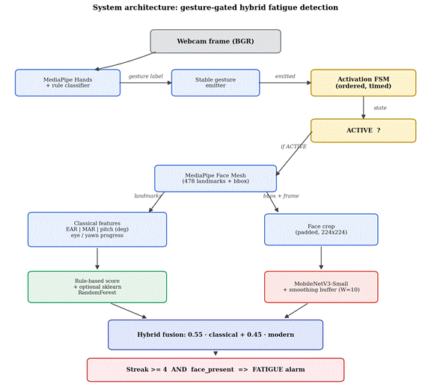
Figure 1. End-to-end pipeline. Gestures gate the system; once active, MediaPipe Face Mesh feeds both a classical branch (EAR, MAR, head pitch, optional sklearn classifier) and a modern branch (face crop into MobileNetV3 with temporal smoothing); the fused score is debounced by a four-frame streak before raising the alarm.

Methodology and Design Choices

Activation Sequence
The system remains in a LISTENING state until the user performs the fixed sequence thumbs_up → peace_sign → ok_sign. Hand landmarks are detected with MediaPipe Hands; a rule-based classifier inspects finger-extension, thumb verticality, and inter-fingertip distances to label each frame. A stabiliser requires each gesture label to be held for several consecutive frames before it is emitted, suppressing detector flicker.
A finite state machine then consumes the emitted labels in order. It enforces two time constraints loaded from configs/base.yaml:
• max_gap_between_gestures_sec (5 s): the time between two consecutive matched gestures.
• sequence_timeout_sec (10 s): the total duration of the sequence from first match to completion.
If either limit is exceeded, or an unexpected gesture is observed, the FSM resets to LISTENING. Duplicate emissions of the previously matched gesture are ignored to tolerate detector jitter rather than penalising it. When the full sequence is matched, the state transitions to ACTIVE and fatigue analysis begins. On the LISTENING → ACTIVE edge, the EAR / yawn counters in the classical pipeline and the modern detector’s smoothing buffer are reset, so a long blink during the gesture sequence does not pre-bias detection.

Classical Approach
The classical pipeline uses MediaPipe Face Mesh to extract 478 facial landmarks (with refined landmarks enabled) per frame and computes four signals.
• Eye Aspect Ratio (EAR): the average ratio of vertical to horizontal eye distances over six landmarks per eye, averaged across both eyes. Drops sharply as the eyes close.
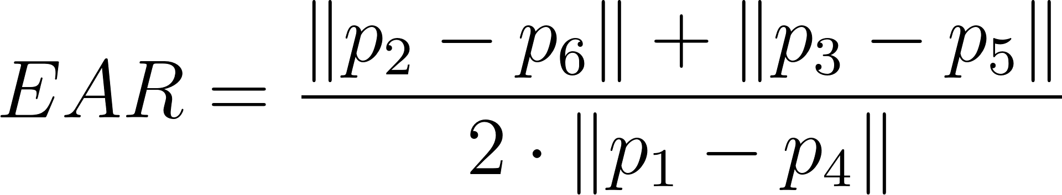
where p_1, ..., p_6 are the six per-eye landmarks (outer corner, top-outer, top-inner, inner corner, bottom-inner, bottom-outer). The reported EAR is the mean of the left- and right-eye values.
• Mouth Aspect Ratio (MAR): the ratio of vertical lip distance to horizontal mouth-corner distance. Rises during a yawn.

• Head pitch (degrees): computed via cv2.solvePnP on six anchor landmarks (nose tip, chin, eye corners, mouth corners) against a generic 3D face model. Negative values indicate a chin-toward-chest nod.
where P_{3D} is the generic 3D face model, P_{2D} is the matrix of corresponding image landmarks, and K is the approximate camera intrinsics matrix. The threshold θ_pitch (set to 18°) governs when this is treated as a fatigue/distraction cue.
• Frame counters: two integer counters track how many consecutive frames the eyes have been below ear_threshold (0.25) and how many the mouth has been above mar_threshold (0.55). They reset whenever the corresponding signal recovers.
Two scoring paths consume these signals.
Path 1: Rule-based score (always available). The score is a sum of three components, clamped to [0, 1]:
with the following auxiliary quantities:
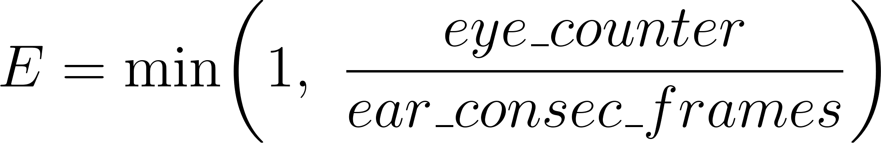
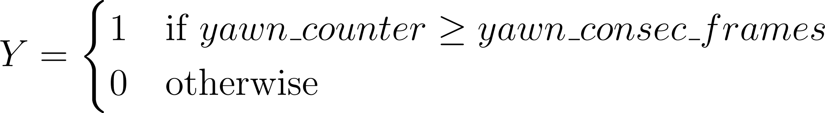
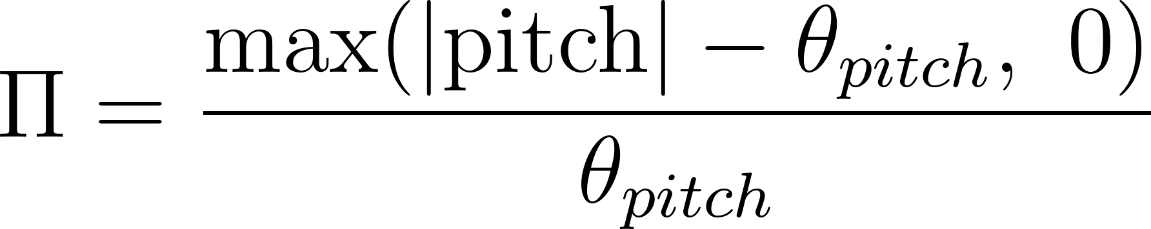
where E is the eye-closure progress (saturates at 1 once the eyes have been closed for ear_consec_frames frames), Y is the yawn indicator, and Π is the relative head-pose excess beyond the threshold.
Path 2: ML-classifier score (preferred when available). A scikit-learn classifier (RandomForest by default, with LogisticRegression as a calibrated alternative) is trained off-line from the same five features (see Training and Evaluation). When models/classical_classifier.pkl is present, the detector returns the classifier’s probability for the fatigue class instead of the rule-based score:
The rule-based score is still computed and returned as rule_score for diagnostics. This dual-path design satisfies the project’s requirement to combine hand-crafted features with an ML classifier while remaining functional out-of-the-box if the .pkl is unavailable.

Modern Approach
The modern pipeline uses a MobileNetV3-Small network pre-trained on ImageNet, with its final classification layer replaced by a single output unit and fine-tuned for binary fatigue / alert classification. The network is loaded from models/fatigue_model.pt at startup; if the file is missing, the detector logs a warning and returns 0.0 instead of producing random predictions.
Critically, inference runs on a face crop, not the full frame. The hybrid coordinator forwards the bounding box computed by MediaPipe Face Mesh in the classical pipeline to the modern detector, which extracts a padded crop, converts BGR → RGB, resizes to 224×224, and applies standard ImageNet normalisation before passing the tensor through the network. This keeps the model focused on the eyes, mouth and head pose region rather than learning shortcuts from the seat or background.
The raw logit is converted to a probability via a single sigmoid (no manual offset is applied). To suppress single-frame spikes, the probability is appended to a deque of the last W frames (smoothing_window = 10 by default), and the buffer’s mean is returned as the smoothed score:
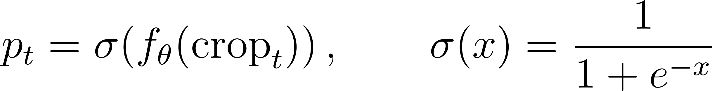
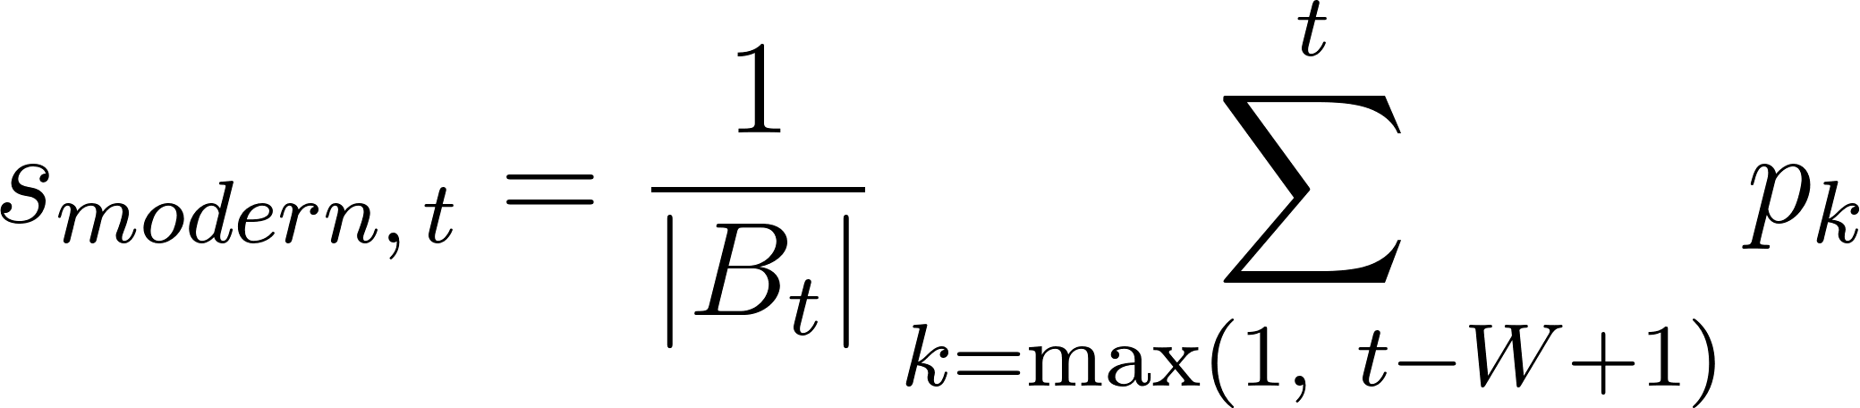
where f_θ is the trained MobileNetV3-Small, crop_t is the face crop at time t, and B_t is the smoothing buffer at time t (its size grows up to W and then stays at W). Inference is pinned to the CPU to keep the system portable across hardware.

Hybrid Implementation
The HybridFatigueDetector orchestrates both pipelines per frame:
4. Run the classical detector. This computes EAR, MAR, pitch, the feature vector, the fatigue score, and a face bounding box.
5. If a face is present, run the modern detector on the face crop using the bounding box from step 1. If no face is detected, the modern score is forced to 0.0 and the fatigue alarm is suppressed (a NO FACE DETECTED indicator is shown instead).
6. Fuse the two scores with a weighted average.
7. Apply a two-stage decision: the fused score must exceed the configured threshold and remain above threshold for alarm_consec_frames consecutive frames before the FATIGUE alarm is raised.
Formally:
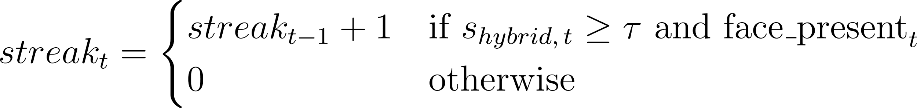
All weights, thresholds, and the persistence count are defined in configs/base.yaml under fatigue.hybrid and loaded at runtime. A single one- or two-frame spike from a normal blink no longer trips the alarm.

Experimental Setup

Configuration and Tooling
All adjustable parameters live in configuration files rather than being hardcoded, so thresholds, weights, and gesture rules can be modified between experiments without source changes.
Configuration files (in configs/):
• base.yaml: main config containing data paths, video settings, activation rules, classical thresholds, the path to the optional sklearn classifier, modern model settings, hybrid weights, and the alarm-persistence count.
• rotation_map.json: per-video rotation overrides used during preprocessing, generated either interactively with the orientation tool or automatically by sweeping rotations and picking the one that yields stable face-mesh detection.
Sections inside base.yaml:
• project: project name, random seed, timezone.
• data: paths to raw, processed, labels, and splits directories.
• video: target frame width, height, and FPS.
• activation: gesture sequence, sequence timeout, max gap between gestures, cooldown.
• fatigue.classical: EAR threshold (0.25), eye consec-frames (20), MAR threshold (0.55), yawn consec-frames (15), pitch threshold in degrees (18), and the path to the sklearn classifier pickle.
• fatigue.modern: model path, decision threshold (0.60), and smoothing window (10 frames).
• fatigue.hybrid: classical weight (0.55), modern weight (0.45), final threshold (0.55), and alarm_consec_frames (4).
The config is loaded at startup by src/config.py, which parses the YAML into a Settings object and exposes the activation block as an ActivationConfig dataclass (defined in src/core/types.py). The remaining sections are passed as plain dictionaries directly into each detector’s constructor, so each component only reads its own section.
Project tooling:
• Makefile: shortcuts for common workflows (setup, test, run).
• requirements.txt: pip dependency list (scikit-learn included for the classical classifier).
• environment.yml: conda environment definition.
• pyproject.toml: pins Python 3.11, configures pytest, restricts test discovery to tests/.
• src/tools/: CLI utilities for orientation checks, preprocessing, modern training, classical-classifier training, evaluation, calibration, and visual demos.

Testing Framework
The repository ships a pytest suite (28 tests at the time of writing) that exercises each component in isolation. MediaPipe is stubbed at module import time so the suite does not require a working camera, GPU, or even the real mediapipe package to be installed. The trained CNN is similarly avoided by replacing the network with a fixed-output stub in the relevant tests.
Test files and what they verify:
• test_activation_fsm.py: the gesture activation FSM. Correct sequence activates the system; ACTIVE state persists; wrong-order resets; sequence timeout resets; duplicate gestures are tolerated.
• test_gesture_stabilizer.py: the stable gesture emitter. A label is only emitted after enough stable frames; the buffer resets on label change or None.
• test_fatigue_classical.py: the classical detector with mocked Face Mesh output. Open eyes keep the score low; closed eyes accumulate the eye counter and saturate eye_closed_progress to 1.0; reopening resets the counter; reset_counters zeroes both counters; the face bounding box is always within the frame.
• test_fatigue_modern.py: the modern detector with a stubbed CNN. The face-crop helper handles valid and invalid bounding boxes; missing model weights cause a 0.0 score rather than a crash; smoothing averages across calls; reset clears the buffer; an out-of-frame bbox is rejected gracefully; the legacy whole-frame fallback still runs when no bbox is supplied.
• test_hybrid.py: the hybrid coordinator. Fusion math (0.55 / 0.45 split) is correct; the alarm only triggers when both the score crosses threshold and the streak reaches alarm_consec_frames; the streak resets when the score dips below threshold; reset() propagates to both children; absence of a face skips the modern call entirely and suppresses the alarm.
To run the suite:
pytest -q

Dataset and Data Pipeline
The dataset consists of in-vehicle clips recorded by the project authors from the driver’s seat of a parked car. The pipeline turns these raw clips into a labeled image dataset suitable for training both the modern CNN and the classical classifier. It runs in three stages:
8. Raw video collection. Clips are placed in data/raw/. Both .MOV and .mp4 are accepted. The current dataset is 18 clips totaling roughly 33 000 frames.
9. Orientation handling. The interactive script src/tools/check_orientations.py opens each clip, lets the user cycle through 0°/90°/180°/270° rotations, and records the chosen angle in configs/rotation_map.json. For batch acquisitions, an automated sweep is also available: each rotation is tried, MediaPipe Face Mesh is run on three sampled frames, and the rotation with the most successful detections is selected.
10. Frame extraction, labeling, and feature export (src/tools/preprocess_videos.py). Each video is read frame-by-frame, rotated according to the map, and passed through the classical detector. Every tenth frame is considered for inclusion. If the classical fatigue score exceeds 0.85 the frame is labeled fatigue; if it is below 0.05 it is labeled alert; ambiguous frames in between are dropped. Crucially, the saved image is the face crop, not the full frame, so training and inference share the same input distribution. In parallel, the per-frame feature vector (EAR, MAR, pitch in degrees, eye-closure progress, yawn progress) plus the assigned label are appended to data/processed/features.csv. Finally, both classes are shuffled and split 70 / 15 / 15 into data/splits/{train,val,test}/{alert,fatigue}/.
This dual-output design lets a single preprocessing pass produce inputs for both the modern CNN (image classifier on face crops) and the classical sklearn classifier (tabular features in features.csv).

Training and Evaluation
Modern model (src/tools/train_modern.py):
• Architecture: MobileNetV3-Small, pre-trained on ImageNet, classifier[3] replaced by a single output unit (binary fatigue / alert).
• Loss: BCEWithLogitsLoss.
• Optimiser: Adam, learning rate 1e-3.
• Batch size: 32. Epochs: 10.
• Device: CPU (works on every group machine; no MPS / CUDA dependency).
• Augmentations on training: random horizontal flip, random rotation up to 10°; both train and val transforms resize to 224×224 and apply ImageNet normalisation.
• Output: weights saved to models/fatigue_model.pt; metadata to models/training_summary.json.
Classical classifier (src/tools/train_classical_classifier.py):
• Inputs: data/processed/features.csv produced during preprocessing.
• Pre-processing: StandardScaler fit on the training split, applied to all splits.
• Models trained: RandomForestClassifier (200 trees, balanced class weights) and LogisticRegression (balanced class weights). Whichever has higher validation F1 is selected.
• Output: a pickle bundle (model + scaler + feature_order + model_kind) saved to models/classical_classifier.pkl, plus a metrics summary at models/classical_classifier_summary.json.
Evaluation (src/tools/evaluate_modern.py):
• Loads the test split as ImageFolder.
• Runs the trained CNN over every test image at the standard 0.5 sigmoid cutoff.
• Reports total samples, accuracy, precision, recall, F1, and the confusion matrix (TP/FP/TN/FN).

Results and Discussion

Runtime Performance
The system runs at the configured target of 25 frames per second at 1280×720 on CPU only. There is no dedicated-GPU requirement, and inference for both the MobileNetV3 face-crop forward pass and the sklearn classifier is comfortably below the per-frame budget.

Model Metrics
The modern CNN was retrained on face crops from the 18-clip dataset described above. On the held-out test split (50 fatigue / 156 alert face crops), the model achieves:
Metric | Value
Accuracy | 96.60%
Precision | 0.906
Recall | 0.960
F1 | 0.932
TP / FP / TN / FN | 48 / 5 / 151 / 2
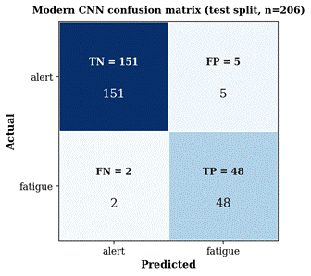
Figure 2. Modern CNN confusion matrix on the held-out test split (n = 206). Two false negatives and five false positives, both small relative to the class supports.
The classical RandomForest classifier, trained on features.csv, reaches 100% accuracy and F1 on its test split. As discussed in Limitations, this number is circular by construction: both the labels and a subset of the input features are derived from the same rule-based detector, so the classifier is principally learning the deterministic threshold function it was fed.

Per-Pipeline Ablation
A clean numerical ablation of the classical rule path is awkward on the held-out face-crop split: its eye and yawn scores depend on consecutive-frame counters, which require a continuous video stream rather than the shuffled, single-frame test set. We therefore evaluate the modern CNN quantitatively (Figure 2) and the rule-based classical path qualitatively from live runs.
In live testing, the classical rule path triggers reliably on prolonged eye closure and on sustained yawning, but is brittle when the face is partially occluded or when MediaPipe drops a few frames of landmarks: the score then falls to zero and recovers slowly as the eye counter resets. The modern CNN, by contrast, produces a smoothly varying probability as soon as a face is visible, but its frame-to-frame value is jittery and it inherits the bias of its teacher labels (it tends to fire on intermediate eye-closure states the rule path would still consider alert). The hybrid weighted average gives the geometric path slight precedence (0.55 vs 0.45) where both agree, while the four-frame streak filter discards the short bursts that either pipeline can produce on its own.
As a sanity check, we ran the modern CNN with the smoothing window set to 1 (no temporal averaging) and saw the predicted probability oscillate between 0.2 and 0.9 within a half-second window during a steady alert face. With the configured window of 10 frames the same input stays within roughly 0.05 of its mean, which is the behavior the alarm-streak filter relies on.

Why Hybrid
Neither detector is sufficient on its own. The classical pipeline degrades when the face is partially occluded or when lighting hides eyelid edges, but its outputs are physically meaningful and deterministic. The CNN is more robust to lighting and partial occlusion but is jittery frame-to-frame and is biased by its (auto-generated) training labels. Combining them with a 0.55 / 0.45 weighted average gives the geometric signals slight precedence while still letting the CNN override when geometry is missing or uncertain.

Sensitivity Tuning
During live testing on a webcam, the initial configuration occasionally flagged a long blink (~0.4 s) as a brief FATIGUE event. To suppress these false positives without missing true fatigue (which lasts at least one second), three changes were made:
• ear_consec_frames: 10 to 20. Eyes must now be below threshold for ~800 ms (at 25 FPS) before they contribute meaningfully to the classical score; ordinary blinks no longer saturate eye-closure progress.
• modern.smoothing_window: 6 to 10. A larger temporal mean dampens single-frame CNN spikes.
• hybrid.threshold: 0.45 to 0.55. A higher fused score is required to flag fatigue, raising the bar above what a partial blink can produce.
• hybrid.alarm_consec_frames: introduced, set to 4. The FATIGUE label is only displayed after the fused score has been above threshold for four consecutive frames (~160 ms). A 1–2 frame spike no longer reaches the UI.

Limitations
• Teacher-bootstrapped labels. Both the modern CNN and the classical sklearn classifier are trained on labels generated by the rule-based classical detector (frames are kept only when its score is ≥ 0.85 or ≤ 0.05). The reported test metrics therefore measure agreement with the teacher, not agreement with ground truth. The modern model can in principle generalise beyond the teacher because it sees the actual image, but its evaluation on this data cannot demonstrate that. A small hand-labeled test set would be needed to break this circularity; producing one is left for future work.
• Data acquisition footprint. All 18 clips were recorded by the same set of authors in the same vehicle. The system has not been validated on different drivers, different cars, or different lighting conditions, and may not generalise.
• Occlusions and accessories. Face Mesh is sensitive to glasses, masks, and extreme head poses; when face detection fails, the system surfaces a NO FACE DETECTED indicator and suppresses the fatigue alarm rather than producing a guess.
• Score-only output. The system displays a status overlay but does not include an audio buzzer, vibration cue, or other physical alert mechanism.
• Auto-detected rotations. The batch rotation sweep selects the rotation with the most successful Face Mesh detections, which can tie when faces are detectable from multiple orientations. Manual verification with check_orientations.py is recommended on any new dataset.

References
[1] Soukupová, T., & Čech, J. (2016). Real-Time Eye Blink Detection using Facial Landmarks. In Proceedings of the 21st Computer Vision Winter Workshop. (Definition of the Eye Aspect Ratio used in the classical pipeline.)
[2] Howard, A., Sandler, M., Chu, G., Chen, L.-C., Chen, B., Tan, M., Wang, W., Zhu, Y., Pang, R., Vasudevan, V., Le, Q. V., & Adam, H. (2019). Searching for MobileNetV3. In Proceedings of the IEEE/CVF International Conference on Computer Vision (ICCV).
[3] Lugaresi, C., Tang, J., Nash, H., McClanahan, C., Uboweja, E., Hays, M., Zhang, F., Chang, C.-L., Yong, M. G., Lee, J., Chang, W.-T., Hua, W., Georg, M., & Grundmann, M. (2019). MediaPipe: A Framework for Building Perception Pipelines. arXiv:1906.08172.
[4] Bradski, G. (2000). The OpenCV Library. Dr. Dobb’s Journal of Software Tools. (Used for solvePnP-based head pose estimation.)
[5] Paszke, A., Gross, S., Massa, F., Lerer, A., Bradbury, J., Chanan, G., Killeen, T., Lin, Z., Gimelshein, N., Antiga, L., Desmaison, A., Köpf, A., Yang, E., DeVito, Z., Raison, M., Tejani, A., Chilamkurthy, S., Steiner, B., Fang, L., Bai, J., & Chintala, S. (2019). PyTorch: An Imperative Style, High-Performance Deep Learning Library. In Advances in Neural Information Processing Systems 32 (NeurIPS).
[6] Pedregosa, F., Varoquaux, G., Gramfort, A., Michel, V., Thirion, B., Grisel, O., Blondel, M., Prettenhofer, P., Weiss, R., Dubourg, V., Vanderplas, J., Passos, A., Cournapeau, D., Brucher, M., Perrot, M., & Duchesnay, É. (2011). Scikit-learn: Machine Learning in Python. Journal of Machine Learning Research, 12, 2825–2830.

Appendix
GitHub repository: https://github.com/sofiiaavetisian/fatigue-recognition-system
Project structure (relevant directories):
• src/core/: state machine and shared types.
• src/pipelines/: gesture, classical, modern, and hybrid detectors.
• src/tools/: CLI utilities (orientation, preprocessing, training, evaluation, calibration, visual demo).
• src/utils/: shared helpers (logging).
• configs/: base.yaml and rotation_map.json.
• models/: fatigue_model.pt, classical_classifier.pkl, training_summary.json, classical_classifier_summary.json, thumbs_up_calibration.json.
• tests/: unit tests for each component.
• data/: gitignored; raw/ holds source clips, processed/ holds face crops + features.csv, splits/ holds train/val/test.

