Introduction to Databases
Assignment 2

Screenshots:

- tested non-optimized query

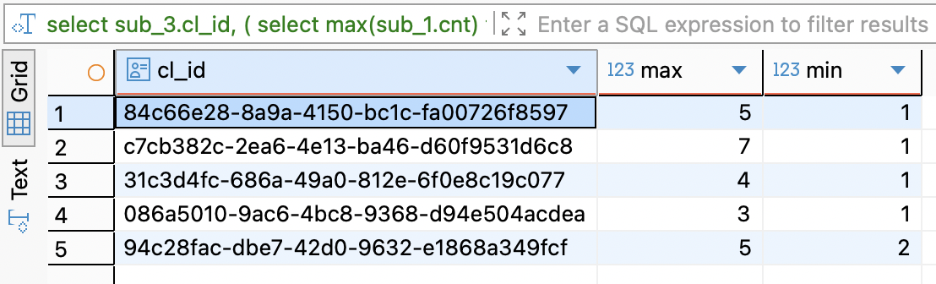

- tested optimized query

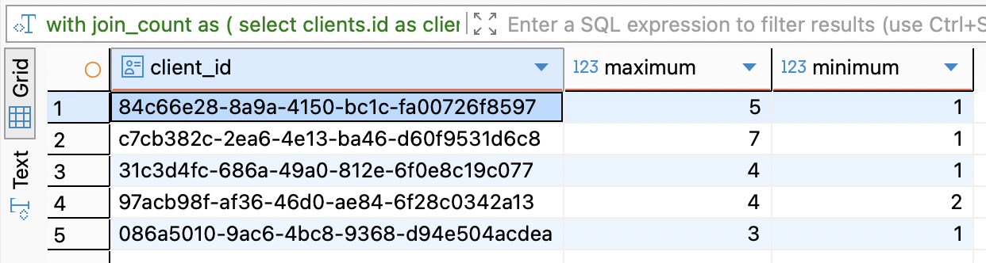

- explain analyze for non-optimized query

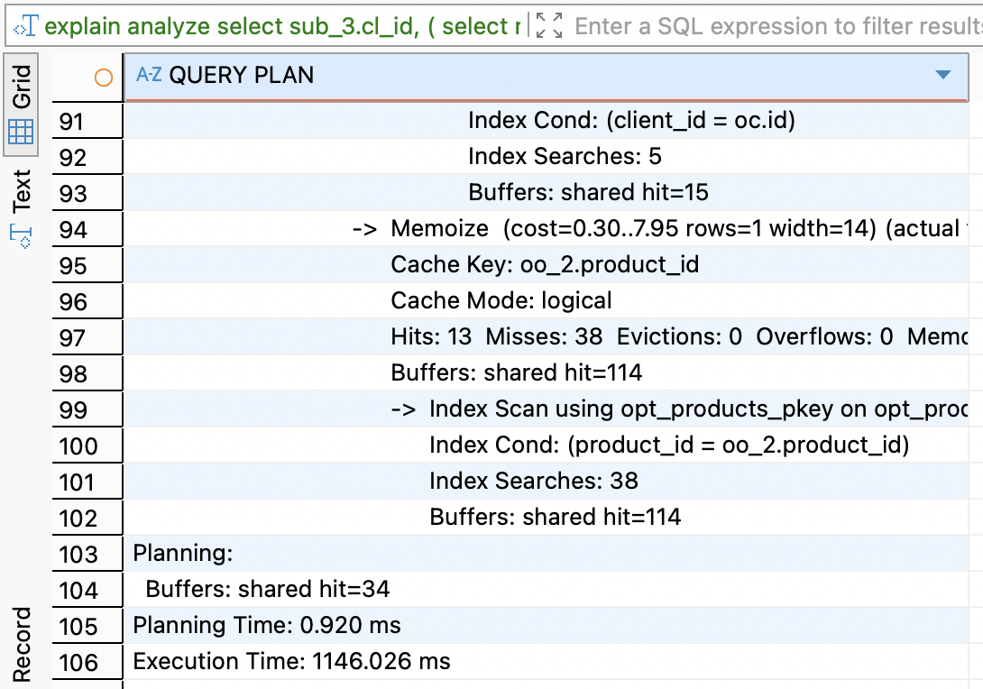

- explain analyze for optimized query

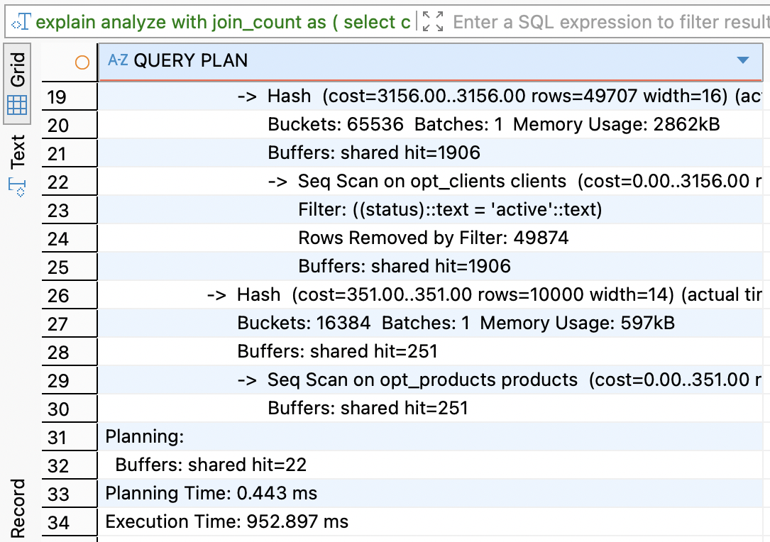

- optimized query with set enable_hashjoin = off

