DOKUMENTACIJA

<https://sofirvovic.github.io/cvperfect/>

Web programiranje 1

Sofija Rvovic 102/21

Smer: Internet tehnologije

Modul: Web Programiranje

Predmet: Web Programiranje 1

Sadržaj:

1.Uvod 1

1.1. Korišćeni alata 1

1.2. Opis funkcionalnosti 1

1.3. Template 1

2.Organizacija 1

2.1. Organizaciona šema 1

2.2. Mapa sajta 2

2.3. Stranice I opis funkcionalnosti 2

3. Kodovi 5

3.1. HTML 5

3.1.1. Index.html 5

3.1.2. author.html 17

3.2. CSS(SCSS) 18

3.3. Javascript 33

# 1.Uvod

## 1.1. Korišćeni alata

Za izradu sajta su korišćeni: HTML, CSS(SCSS), Bootstrap, JavaScript, jQuery, Wow.js, Animate,

Korišteni editor: VS Code

## 1.2. Opis funkcionalnosti

* Plugin za slajder (Bootstrap) koji koristi Jquery
* Animirani sadržaj se aktivira prilikom ulaska u viewport (Wow.js I Animate)
* Otvaranje modala sa formom
* Provera forme I ispisivanje gresaka
* Poruka za uspešno popunjenu formu I njeno gašenje
* Dinamičko ispisivanje instgram feed sekcije
* Pojavljivanje popup-a da se proveri author strana

## 1.3. Template

Za izradu sajta nije korišćen third party template.

# 2.Organizacija

## 2.1. Organizaciona šema

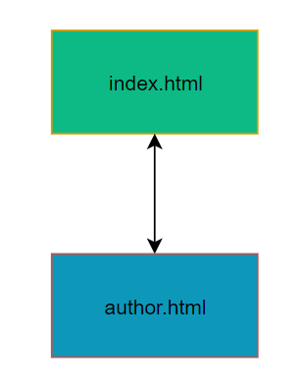

## 

## 2.2. Mapa sajta

<?xml version="1.0" encoding="UTF-8"?>

<urlset

      xmlns="http://www.sitemaps.org/schemas/sitemap/0.9"

      xmlns:xsi="http://www.w3.org/2001/XMLSchema-instance"

      xsi:schemaLocation="http://www.sitemaps.org/schemas/sitemap/0.9

            http://www.sitemaps.org/schemas/sitemap/0.9/sitemap.xsd">

<url>

  <loc>https://sofirvovic.github.io/cvperfect/index.html</loc>

  <lastmod>2022-12-14T13:17:51+00:00</lastmod>

  <priority>1.00</priority>

</url>

<url>

  <loc>https://sofirvovic.github.io/cvperfect/author.html</loc>

  <lastmod>2022-12-14T13:17:51+00:00</lastmod>

  <priority>0.80</priority>

</url>

</urlset>

## 2.3. Stranice I opis funkcionalnosti

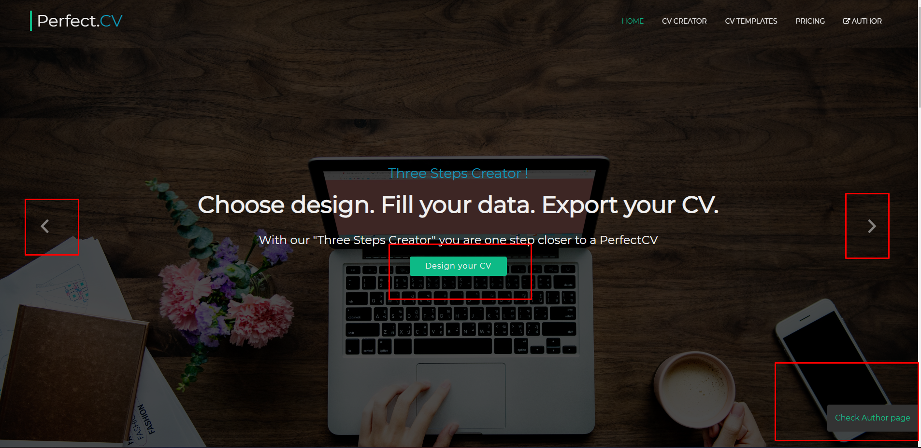

Prva sekcija koja je vidljiva pri ulasku na sajt je hero section koja ima dva slajdera. Navigacija između slajdera se vrši chevron dugmadima označenim na slici. Takođe, slajderi se sami smenjuju nakon 5 sekundi. Nakon 3 sekunde od ulaska na sajt u donjem desnom uglu se pojavljuje popup koji nas, kada ga kliknemo void na author stranu. Nakon 6 sekundi, ako ne kliknemo na popup on nestaje. Oba slajdera imaju dugmad, Design your CV. Klikom na ta dugmad otvara se modal koji sadrži formu za registraciju.

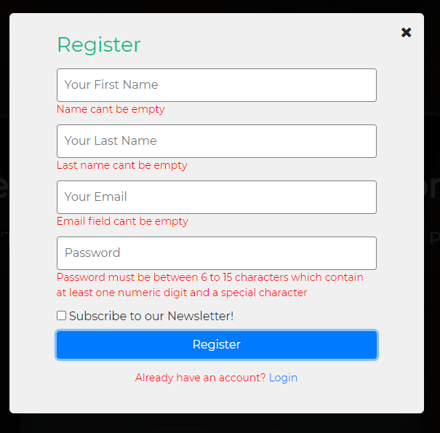

Klikom na close dugme u gornjem desnom uglu forme gasi se forma. Takođe, klikom negde van forme zatvaramo formu. Korišćenjem JS-a vrši se validacija forme. Za Name I Last name proveramo da li su polja prazna. Za Email proverama da li je polje prazno I da li je uneti format validan. Za password proveramo broj I tip karaktera. Uneti string mora biti između 6 I 15 karaktera, ora sadržati jedan broj I jedan specijalni karaktera. Subscribe checkbox nije obavezan. Ukoliko izgasimo formu polja se kliruju. Ako je forma uspešno popunjena pojavljuje se poruka da je registracija uspešna i da proverimo email. 3 sekunde nakon uspešno popunjene forme modal se gasi.





Klikom na Register CV Now otvaramo formu za registraciju.

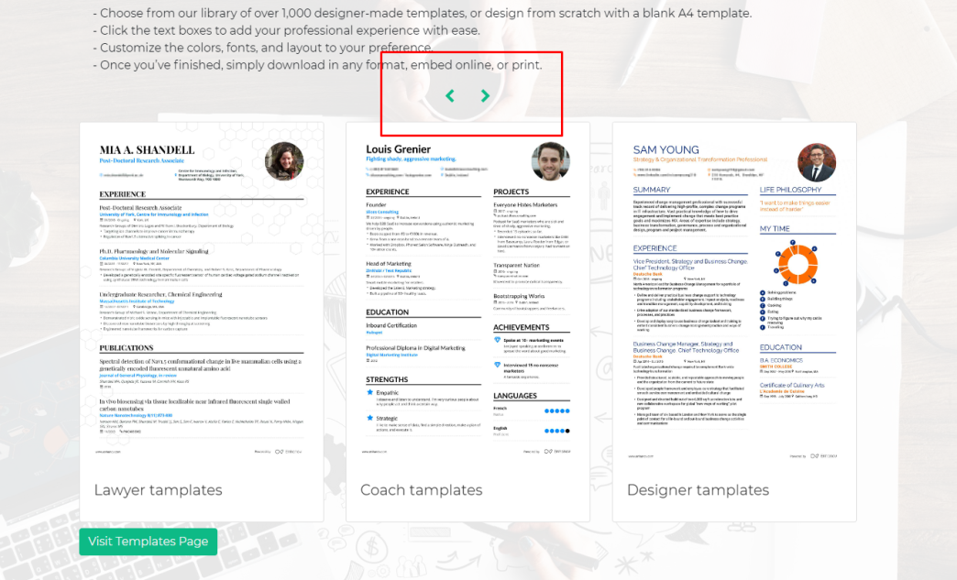

Navigacija izmedju CV templejta. – bootstrap

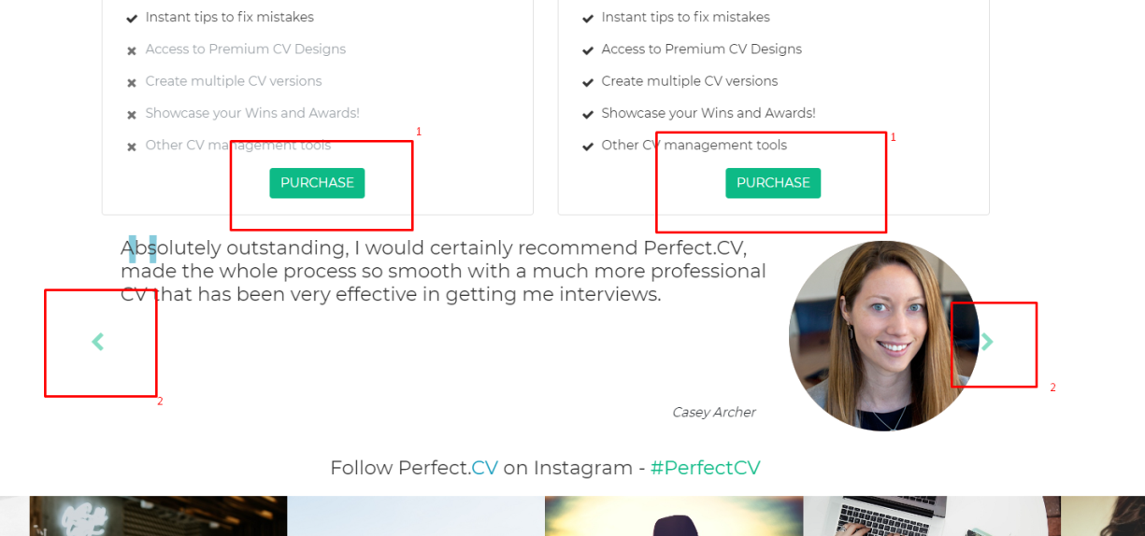

1. Otvaranje forme
2. Navigacije testimonijala – bootstrap

# Kodovi

## HTML

### Index.html

<!DOCTYPE html>

<html lang="en">

<head>

    <meta charset="UTF-8">

    <meta http-equiv="X-UA-Compatible" content="IE=edge">

    <meta name="viewport" content="width=device-width, initial-scale=1.0">

    <meta name="description" content="CV Perfect - Resume creator">

    <meta name="keywords" content="CV, Resume, Create, Job, Search">

    <meta name="author" content="Sofija Rvovic">

    <link href="lib/animate/animate.min.css" rel="stylesheet">

    <link href="lib/font-awesome/css/font-awesome.min.css" rel="stylesheet">

    <link href="lib/ionicons/css/ionicons.min.css" rel="stylesheet">

    <link rel="stylesheet" href="lib/bootstrap/css/bootstrap.min.css">

    <link rel="stylesheet" href="css/main.css">

    <title>PerfectCV</title>

</head>

<body>

*<!-- Header : Start -->*

    <header id="header" class="d-flex">

        <div class="d-flex justify-content-between align-items-center w-100">

            <div class="logo">

                <a href="#">Perfect.<span class="blue-text">CV</span></a>

            </div>

            <nav class="desktop-menu d-none d-lg-flex">

                <a href="#" class="nav-el active">Home</a>

                <a href="#three-steps" class="nav-el">CV Creator</a>

                <a href="#library" class="nav-el">CV Templates</a>

                <a href="#pricing" class="nav-el">Pricing</a>

                <a href="author.html" class="nav-el"><i class="fa fa-external-link" aria-hidden="true"></i>  Author</a>

            </nav>

        </div>

    </header>

*<!-- Header : End -->*

    <button type="button" id="mobile-nav-toggle" class="mobile-menu-act d-block d-lg-none"><i class="fa fa-bars"></i></button>

    <div class="mobile-menu-container">

        <div class="mobile-menu-overlay"></div>

        <nav class="mobile-menu">

            <a href="#" class="mobile-menu-act">Home</a>

            <a href="#three-steps" class="mobile-menu-act">CV Creator</a>

            <a href="#library" class="mobile-menu-act">CV Templates</a>

            <a href="#pricing" class="mobile-menu-act">Pricing</a>

            <a href="author.html" class="nav-el"><i class="fa fa-external-link" aria-hidden="true"></i>  Author</a>

        </nav>

    </div>

*<!-- Main Content : Start -->*

    <main>

        <section id="caru">

            <div class="caru-container">

                <div id="caruCarousel" class="carousel  slide carousel-fade" data-ride="carousel">

                    <div class="carousel-inner" role="listbox">

                        <div class="carousel-item active">

                            <div class="carousel-background"><img src="img/2.jpg" alt="cv perfect hero" ></div>

                            <div class="carousel-container">

                                <div class="carousel-content">

                                    <h3>Three Steps Creator !</h3>

                                    <h1>Choose design. Fill your data. Export your CV.</h1>

                                    <h4>With our "Three Steps Creator" you are one step closer to a PerfectCV</h4>

                                    <a href="#" class="btn-main form-open">Design your CV</a>

                                </div>

                            </div>

                        </div>

                        <div class="carousel-item">

                            <div class="carousel-background"><img src="img/1.jpg" alt="cv perfect hero" ></div>

                            <div class="carousel-container">

                                <div class="carousel-content">

                                    <h3 class="green-text">Three Steps Creator !</h3>

                                    <h1>We take care of the design, you take care of the content.</h1>

                                    <h4>Perfect.<span class="green-text">CV</span> helps you create an outstanding CV in

                                        minutes.</h4>

                                    <a href="#" class="btn-main btn-main-first form-open">Design your CV</a>

                                </div>

                            </div>

                        </div>

                        <a class="carousel-control-prev" href="#caruCarousel" role="button" data-slide="prev">

                            <span class="carousel-control-prev-icon ion-chevron-left" aria-hidden="true"></span>

                            <span class="sr-only">Previous</span>

                        </a>

                        <a class="carousel-control-next" href="#caruCarousel" role="button" data-slide="next">

                            <span class="carousel-control-next-icon ion-chevron-right" aria-hidden="true"></span>

                            <span class="sr-only">Next</span>

                        </a>

                    </div>

                </div>

            </div>

        </section>

        <section id="three-steps">

            <div class="container">

                <h3 class="section-header steps-header">

                    <span class="green-left">Build</span> your job-winning resume in three simple steps

                </h3>

                <div class="row ">

                    <div class="col-md-4 wow fadeInUp">

                        <div class="three-steps-col">

                            <div class="img">

                                <img src="img/fillData.jpg" alt="cv perfect data" class="img-thumbnail">

                                <div class="icon"><i class="fa fa-pencil"></i></div>

                            </div>

                            <h2 class="title"><a href="#">1. Fill Data</a></h2>

                            <p>

                                Just fill our form with your data, atach an image and you are ready to go!

                            </p>

                        </div>

                    </div>

                    <div class="col-md-4 wow fadeInUp" data-wow-delay="0.1s">

                        <div class="three-steps-col">

                            <div class="img">

                                <img src="img/chooseDesign.jpg" alt="cv perfect design" class="img-thumbnail" loading="lazy">

                                <div class="icon"><i class="ion-ios-color-wand"></i></div>

                            </div>

                            <h2 class="title"><a href="#">2. Choose Design</a></h2>

                            <p>

                                You can use our CV creator to create custom CV form or you can choose one of our

                                predisegned templates.

                            </p>

                        </div>

                    </div>

                    <div class="col-md-4 wow fadeInUp" data-wow-delay="0.2s">

                        <div class="three-steps-col">

                            <div class="img">

                                <img src="img/exportCV.jpg" alt="cv perfect export" class="img-thumbnail" loading="lazy">

                                <div class="icon"><i class="fa fa-file"></i></div>

                            </div>

                            <h2 class="title"><a href="#">3. Export Your CV</a></h2>

                            <p>

                                Once you are finished and satisfied with the look of your CV export it to desired

                                format.

                            </p>

                        </div>

                    </div>

                </div>

            </div>

        </section>

        <section id="register-cv">

            <div class="container">

                <div class="row registerCV-cols row justify-content-center align-items-center ">

                    <div class="col-12 col-lg-7 wow fadeInUp col-7 offset-md-1">

                        <h2>Job Search - Register your .<span class="blue-text">CV</span></h2>

                        <p>

                            Upload your CV today to be headhunted by 9,687 companies, and apply to 173,384 jobs with

                            1-click apply.

                        </p>

                    </div>

                    <div class="col-12 col-lg-3 wow fadeInUp col-3 offset-md-1">

                        <button class="btn-main btn form-open">Register CV Now</button>

                    </div>

                </div>

            </div>

        </section>

        <section id="library">

            <div class="container">

                <div class="section-header library-header">

                    <h3 class="text-center"><span class="green-left">Discover</span> our CV templates library. </h3>

                    <p>With PerfectCV builder, applying for your dream job is easy and fast. Choose from hundreds

                        designer-made templates and customize them within a few clicks.</p>

                    <ul class="fa-ul">

                        <li> - Choose from our library of over 1,000 designer-made

                            templates, or design from scratch with a blank A4 template.</li>

                        <li>- Click the text boxes to add your professional experience

                            with ease.</li>

                        <li>- Customize the colors, fonts, and layout to your preference.

                        </li>

                        <li>- Once you’ve finished, simply download in any format, embed

                            online, or print.</li>

                    </ul>

                </div>

                <div id="multi-item-example" class="carousel slide carousel-multi-item wow fadeInUp"

                    data-ride="carousel">

                    <div class="controls-top">

                        <a class="btn-floating" href="#multi-item-example" data-slide="prev"><i

                                class="fa fa-chevron-left"></i></a>

                        <a class="btn-floating" href="#multi-item-example" data-slide="next"><i

                                class="fa fa-chevron-right"></i></a>

                    </div>

                    <div class="carousel-inner" role="listbox">

                        <div class="carousel-item no-background active">

                            <div class="col-md-4">

                                <div class="card mb-2">

                                    <img class="card-img-top" src="img/resLib/resume1.jpg" alt="Card image cap" loading="lazy">

                                    <div class="card-body">

                                        <h5 class="card-title">WebDesigner tamplates</h5>

                                    </div>

                                </div>

                            </div>

                            <div class="col-md-4 clearfix d-none d-md-block">

                                <div class="card mb-2">

                                    <img class="card-img-top" src="img/resLib/resume2.jpg" alt="Card image cap" loading="lazy">

                                    <div class="card-body">

                                        <h5 class="card-title">Doctor tamplates</h5>

                                    </div>

                                </div>

                            </div>

                            <div class="col-md-4 clearfix d-none d-md-block">

                                <div class="card mb-2">

                                    <img class="card-img-top" src="img/resLib/resume3.jpg" alt="Card image cap" loading="lazy">

                                    <div class="card-body">

                                        <h5 class="card-title">Teacher tamplates</h5>

                                    </div>

                                </div>

                            </div>

                        </div>

                        <div class="carousel-item no-background">

                            <div class="col-md-4">

                                <div class="card mb-2">

                                    <img class="card-img-top" src="img/resLib/resume4.jpg" alt="Card image cap" loading="lazy">

                                    <div class="card-body">

                                        <h5 class="card-title">Lawyer tamplates</h5>

                                    </div>

                                </div>

                            </div>

                            <div class="col-md-4 clearfix d-none d-md-block">

                                <div class="card mb-2">

                                    <img class="card-img-top" src="img/resLib/resume1.jpg" alt="Card image cap" loading="lazy">

                                    <div class="card-body">

                                        <h5 class="card-title">Coach tamplates</h5>

                                    </div>

                                </div>

                            </div>

                            <div class="col-md-4 clearfix d-none d-md-block">

                                <div class="card mb-2">

                                    <img class="card-img-top" src="img/resLib/resume2.jpg" alt="Card image cap" loading="lazy">

                                    <div class="card-body">

                                        <h5 class="card-title">Designer tamplates</h5>

                                    </div>

                                </div>

                            </div>

                        </div>

                        <div class="carousel-item no-background">

                            <div class="col-md-4">

                                <div class="card mb-2">

                                    <img class="card-img-top" src="img/resLib/resume3.jpg" alt="Card image cap" loading="lazy">

                                    <div class="card-body">

                                        <h5 class="card-title">Artist tamplates</h5>

                                    </div>

                                </div>

                            </div>

                            <div class="col-md-4 clearfix d-none d-md-block">

                                <div class="card mb-2">

                                    <img class="card-img-top" src="img/resLib/resume4.jpg" alt="Card image cap" loading="lazy">

                                    <div class="card-body">

                                        <h5 class="card-title">Therapist tamplates</h5>

                                    </div>

                                </div>

                            </div>

                            <div class="col-md-4 clearfix d-none d-md-block">

                                <div class="card mb-2">

                                    <img class="card-img-top" src="img/resLib/resume1.jpg" alt="Card image cap" loading="lazy">

                                    <div class="card-body">

                                        <h5 class="card-title">Trainer tamplates</h5>

                                    </div>

                                </div>

                            </div>

                        </div>

                    </div>

                    <div class="col-md-12 justify-content-center align-items-center d-md-block">

                        <button class="btn btn-primary">Visit Templates Page</button>

                    </div>

                </div>

            </div>

        </section>

        <section id="pricing">

            <div class="container  wow fadeInDown">

                <div class="section-header pricing-header">

                    <h3><span class="greenLeft">Pricing</span> Guide</h3>

                    <h4>Perfect.<span class="cv">CV</span> is free to use as long as you want<br> and <span

                            class="mainHover">PRO</span> includes even more possibilities

                    </h4>

                </div>

                <div class="row">

                    <div class="col-lg-6">

                        <div class="card mb-5 mb-lg-0">

                            <div class="card-body">

                                <h5 class="card-title text-muted text-uppercase text-center">Free</h5>

                                <h6 class="card-price text-center">$0<span class="period">/month</span></h6>

                                <hr>

                                <div class="icon"><i class="fa fa-paper-plane"></i></div>

                                <ul class="fa-ul">

                                    <li><span class="fa-li"><i class="fa fa-check"></i></span>Full access to Thre Steps

                                        Creator</li>

                                    <li><span class="fa-li"><i class="fa fa-check"></i></span>Unlimited entries</li>

                                    <li><span class="fa-li"><i class="fa fa-check"></i></span>Pro sections, colors &

                                        backgrounds</li>

                                    <li><span class="fa-li"><i class="fa fa-check"></i></span>Instant tips to fix

                                        mistakes</li>

                                    <li class="text-muted"><span class="fa-li"><i class="fa fa-times"></i></span>Access

                                        to Premium CV Designs</li>

                                    <li class="text-muted"><span class="fa-li"><i class="fa fa-times"></i></span>Create

                                        multiple CV versions</li>

                                    <li class="text-muted"><span class="fa-li"><i

                                                class="fa fa-times"></i></span>Showcase your Wins and Awards!</li>

                                    <li class="text-muted"><span class="fa-li"><i class="fa fa-times"></i></span>Other

                                        CV management tools</li>

                                </ul>

                                <div class="col-lg-12 purchase"><button class="btn btn-primary text-uppercase form-open">PURCHASE</button></div>

                            </div>

                        </div>

                    </div>

                    <div class="col-lg-6">

                        <div class="card mb-5 mb-lg-0">

                            <div class="card-body">

                                <h5 class="card-title text-muted text-uppercase text-center">Pro</h5>

                                <h6 class="card-price text-center">$5<span class="period">/month</span></h6>

                                <hr>

                                <div class="icon"><i class="fa fa-fighter-jet"></i></div>

                                <ul class="fa-ul">

                                    <li><span class="fa-li"><i class="fa fa-check"></i></span>Full access to Thre Steps

                                        Creator</li>

                                    <li><span class="fa-li"><i class="fa fa-check"></i></span>Unlimited entries</li>

                                    <li><span class="fa-li"><i class="fa fa-check"></i></span>Pro sections, colors &

                                        backgrounds</li>

                                    <li><span class="fa-li"><i class="fa fa-check"></i></span>Instant tips to fix

                                        mistakes</li>

                                    <li><span class="fa-li"><i class="fa fa-check"></i></span>Access to Premium CV

                                        Designs</li>

                                    <li><span class="fa-li"><i class="fa fa-check"></i></span>Create multiple CV

                                        versions</li>

                                    <li><span class="fa-li"><i class="fa fa-check"></i></span>Showcase your Wins and

                                        Awards!</li>

                                    <li><span class="fa-li"><i class="fa fa-check"></i></span>Other CV management tools

                                    </li>

                                </ul>

                                <div class="col-lg-12 purchase">

                                    <button class="btn btn-primary text-uppercase form-open">PURCHASE</button>

                                </div>

                            </div>

                        </div>

                    </div>

                </div>

            </div>

        </section>

        <section id="testimonials">

            <div class="container">

                <div class="row">

                    <div id="carouselExampleIndicators"

                        class="carousel slide w-100 justify-content-center align-items-center" data-ride="carousel">

                        <div class="carousel-inner">

                            <div class="carousel-item active">

                                <div class="row justify-content-center align-items-center">

                                    <div class="col-12 col-md-9">

                                        <h4><span class="testim-sign">"</span>Absolutely outstanding, I would certainly

                                            recommend Perfect.CV, made the whole process so smooth with a much more

                                            professional CV that has been very effective in getting me interviews.

                                        </h4>

                                        <p class="font-italic float-right author">Casey Archer</p>

                                    </div>

                                    <div class="col-12 col-md-3 text-center">

                                        <img src="img/testim1.png" alt="cv perfect testimonial" loading="lazy">

                                    </div>

                                </div>

                            </div>

                            <div class="carousel-item ">

                                <div class="row justify-content-center align-items-center">

                                    <div class="col-12 col-md-9">

                                        <h4><span class="testim-sign">"</span>Thank to PerfectCV, I found my dream job. Thank you guys, you rock!

                                            I will reccomend PerfectCV to all my friends.

                                        </h4>

                                        <p class="font-italic float-right author">Andrew Forest</p>

                                    </div>

                                    <div class="col-12 col-md-3 text-center">

                                        <img src="img/testim1.png" alt="cv perfect testimonial" loading="lazy">

                                    </div>

                                </div>

                            </div>

                        </div>

                        <a class="carousel-control-prev" href="#carouselExampleIndicators" role="button"

                            data-slide="prev">

                            <span class="carousel-control-prev-icon " aria-hidden="true"><i

                                    class="fa fa-chevron-left"></i></span>

                            <span class="sr-only">Previous</span>

                        </a>

                        <a class="carousel-control-next" href="#carouselExampleIndicators" role="button"

                            data-slide="next">

                            <span class="carousel-control-next-icon" aria-hidden="true"><i

                                    class="fa fa-chevron-right"></i></span>

                            <span class="sr-only">Next</span>

                        </a>

                    </div>

                </div>

            </div>

        </section>

        <section id="instagram">

            <div class="container-fluid">

                <div class="section-header instagram-header">

                    <h4>Follow Perfect.<span class="blue-text">CV</span> on Instagram - <span

                            class="green-text">#PerfectCV</span></h4>

                </div>

                <div class="row insta-feed"></div>

            </div>

        </section>

    </main>

*<!-- Main Content : End -->*

*<!-- Footer : Start -->*

    <footer class="justify-content-center align-items-center">

        <div class="container text-center text-md-left ">

            <div class="row footer-row">

                <div class="col-md-4 my-auto">

                    <h1><a href="#"><span class="green-left">Perfect.</span><span class="blue-text">CV</span></a></h1>

                </div>

                <div class="col-md-4  my-auto links">

                    <h6 class="text-uppercase font-weight-bold">Useful links</h6>

                    <hr class="teal accent-3 mb-4 mt-0 d-inline-block mx-auto" style="width: 60px;">

                    <p><a href="sitemap.xml">Sitemap</a></p>

                    <p><a href="dokumentacija.pdf" target"_blank"=>Documentation</a></p>

                    <p><a href="#">CV Examples</a></p>

                    <p><a href="#">Help</a></p>

                </div>

                <div class="col-md-4  my-auto">

                    <h6 class="text-uppercase font-weight-bold">Contact</h6>

                    <hr class="teal accent-3 mb-4 mt-0 d-inline-block mx-auto" style="width: 60px;">

                    <p><i class="fa fa-home mr-3"></i> Denmark, Awe1 33412, DE</p>

                    <p><i class="fa fa-envelope mr-3"></i> office@perfectcv.com</p>

                    <p><i class="fa fa-phone mr-3"></i> + 13 64 62 61</p>

                    <p><i class="fa fa-print mr-3"></i> + 13 64 62 61</p>

                </div>

            </div>

        </div>

        <div class="container-fluid footerBottom">

            <div class="footer-copyright text-center text-black-50 py-3">

                <span>© 2022 Copyright: Perfect.CV</span>

            </div>

        </div>

    </footer>

*<!-- Footer : End -->*

*<!-- Modal    -->*

    <div class="login-register">

        <div class="form-overlay form-close"></div>

        <div class="container">

            <div class="row d-flex justify-content-center align-items-center">

                <div class="col-12 col-md-6 d-flex flex-column justify-content-center align-items-center form-container">

                    <div class="register-form w-100">

                        <h3 class="green-text mb-3">Register </h3>

                        <form id="reg-form" action="/" novalidate   >

                            <input id="name" type="text" placeholder="Your First Name">

                            <p class="name-error mt-0 error-text"></p>

                            <input id="last-name" type="text" placeholder="Your Last Name">

                            <p class="lastname-error mt-0 error-text"></p>

                            <input id="email" type="email" placeholder="Your Email">

                            <p class="email-error mt-0 error-text"></p>

                            <input id="password" type="password" placeholder="Password" autocomplete="on">

                            <p class="password-error mt-0 error-text"></p>

                            <div>

                                <input class="w-auto" type="checkbox" id="newsletter" name="newsletter" value="yes">

                                <label for="newsletter"> Subscribe to our Newsletter!</label>

                            </div>

                            <button class="btn btn-primary w-100" type="submit">Register</button>

                        </form>

                        <p class="mt-3 text-center">Already have an account?

                            <a href="#" class="login">Login</a>

                        </p>

                    </div>

                    <div class="success w-100 h-100">

                        <h3 class="green-text mb-3">Congratulations</h3>

                        <h3 class="blue-text mb-3">You registered successfully</h3>

                        <p>Please check your mail to confirm your registration!</p>

                    </div>

                    <i class="fa fa-times form-close"></i>

                </div>

            </div>

        </div>

    </div>

    <div class="author-popup">

        <a href="author.html">Check Author page</a>

    </div>

    <script src="lib/jquery/jquery.min.js"></script>

    <script src="lib/jquery/jquery-migrate.min.js"></script>

    <script src="lib/bootstrap/js/bootstrap.min.js"></script>

    <script src="lib/wow/wow.min.js"></script>

    <script src="js/main.js"></script>

</body>

</html>

### author.html

Napomena: index.html I author.html su isti sem header I main dela.

*<!-- Header : Start -->*

    <header id="header" class="d-flex">

        <div class="d-flex justify-content-between align-items-center w-100">

            <div class="logo">

                <a href="#">Perfect.<span class="blue-text">CV</span></a>

            </div>

            <nav class="desktop-menu">

                <a href="index.html" class="nav-el"><i class="fa fa-hand-o-left  " aria-hidden="true"></i>   Back to Home</a>

            </nav>

        </div>

    </header>

*<!-- Header : End -->*

    <main>

        <section class="author-page d-flex justify-content-center align-items-center">

            <div class="container d-flex justify-content-center align-items-center">

                <div class="row text-center">

                    <div class="col-12 col-md-10 mx-auto">

                        <img src="img/author.png" alt="">

                        <p>

                            Hi, my name is Sofija Rvovic, 21 yeard old student of ICT, Academy of Technical and Art Applied Studies, Belgrade. I was born in Prijepolje,

                            little town located in southwest of Serbia. Beside programing, I like to watch tutorials about web and UI design. Thank you for checking my page.

                        </p>

                    </div>

                </div>

            </div>

        </section>

    </main>

## CSS(SCSS)

$first-color: #333333;

$first-hover-color: #0dba86;

$second-hover-color: #0d98ba;

$white-text: #f0f0f0;

$main-font: "Montserrat", sans-serif;

html {

    scroll-behavior: smooth;

    scroll-padding-top: 4*rem*;

}

body {

    font-family: $main-font;

    margin: 0;

    padding: 0;

    overflow-x: hidden;

    a {

        text-decoration: none;

        &:hover {

            text-decoration: none;

        }

    }

}

h1,

h2,

h3,

h4,

h5,

span {

    color: $first-color;

}

.blue-text {

    color: $second-hover-color;

}

.green-text {

    color: $first-hover-color;

}

.green-left {

    border-left: 3*px* solid $first-hover-color;

    padding-left: 4*px*;

}

header {

    padding: 30*px* 10*px*;

    height: 92*px*;

    position: fixed;

    left: 0;

    top: 0;

    right: 0;

    transition: all 0.5*s*;

    z-index: 997;

    &.header-scrolled {

        background: rgba(51, 51, 51, 0.9);

        padding: 15*px* 15*px*;

        height: 72*px*;

        transition: all 0.5*s*;

    }

    .logo {

        a {

            font-size: 34*px*;

            line-height: 1;

            color: $white-text;

            padding-left: 10*px*;

            border-left: 4*px* solid $first-hover-color;

            transition: 0.2*s* ease;

        }

    }

    nav {

        a {

            font-size: 14*px*;

            margin-left: 18*px*;

            padding: 10*px*;

            text-transform: uppercase;

            color: $white-text;

            &.active {

                color: $first-hover-color;

            }

            &:hover {

                color: $first-hover-color;

            }

        }

    }

*@media* (min-width: 1024*px*) {

        padding: 30*px* 65*px*;

        &.header-scrolled {

            padding: 15*px* 65*px*;

        }

    }

}

#mobile-nav-toggle {

    z-index: 9999;

    position: fixed;

    right: 1.5*rem*;

    top: 1.5*rem*;

    border: 0;

    background: none;

    font-size: 24*px*;

    transition: all 0.4*s*;

    outline: none;

    cursor: pointer;

    i {

        color: $white-text;

    }

}

.mobile-menu-container {

    position: fixed;

    z-index: 999;

    width: 100*%*;

    height: 100*%*;

    visibility: hidden;

    * {

        transition:all 0.5s ease;

    }

    .mobile-menu-overlay {

        position: absolute;

        width: 100*%*;

        height: 100*%*;

        background-color: rgba(0, 0, 0, 0.5);

        opacity: 0;

    }

    .mobile-menu {

        background: #100e0e;

        color: #fff;

        position: absolute;

        width: 50*%*;

        height: 100*%*;

        display: flex;

        flex-direction: column;

        padding: 2*rem*;

        margin-left: -100*%*;

        a {

            color: #fff;

            padding: 0.5*rem*;

            &.author {

                color: $first-hover-color;

            }

        }

    }

    &.active {

        visibility: visible;

        .mobile-menu-overlay  {

            opacity: 1;

        }

        .mobile-menu {

            margin-left: 0;

        }

    }

}

.no-background {

    background-image: none *!important*;

}

#caru {

    display: table;

    width: 100*%*;

    height: 100*vh*;

    background: #000;

    .carousel-item {

        width: 100*%*;

        height: 100*vh*;

        background-size: cover;

        background-position: center;

        background-repeat: no-repeat;

        &::before {

            content: "";

            background-color: rgba(0, 0, 0, 0.7);

            position: absolute;

            height: 100*%*;

            width: 100*%*;

            top: 0;

            right: 0;

            left: 0;

            bottom: 0;

        }

    }

    .carousel-container {

        display: -webkit-box;

        display: -webkit-flex;

        display: -ms-flexbox;

        display: flex;

        -webkit-box-pack: center;

        -webkit-justify-content: center;

        -ms-flex-pack: center;

        justify-content: center;

        -webkit-box-align: center;

        -webkit-align-items: center;

        -ms-flex-align: center;

        align-items: center;

        position: absolute;

        bottom: 0;

        top: 0;

        left: 0;

        right: 0;

    }

    .carousel-background img {

        max-width: 100*%*;

    }

    .carousel-content {

        text-align: center;

    }

    h1 {

        color: $white-text;

        margin: 0 auto;

        font-size: 24*px*;

        font-weight: 700;

        padding: 0 33*px*;

    }

    h4 {

        color: $white-text;

        font-size: 17*px*;

        margin: 0 auto;

        padding: 15*px* 33*px*;

    }

    p {

        width: 80*%*;

        margin: 0 auto 30*px* auto;

        color: $white-text;

    }

    h3 {

        color: $second-hover-color;

        margin-bottom: 20*px*;

    }

    span {

        color: $white-text;

    }

*@media* (min-width: 1024*px*) {

        h1 {

            font-size: 48*px*;

            margin-bottom: 30*px*;

            padding: 0 50*px*;

        }

        h4 {

            font-size: 24*px*;

            padding: 0;

        }

    }

    .carousel-fade {

        overflow: hidden;

        .carousel-inner {

            transition-property: opacity;

            .carousel-item,

            .active.carousel-item-left,

            .active.carousel-item-right {

                opacity: 0;

            }

            .active,

            .carousel-item-next.carousel-item-left,

            .carousel-item-prev.carousel-item-right {

                opacity: 1;

                transition: 0.5*s*;

            }

            .carousel-item-next,

            .carousel-item-prev,

            .active.carousel-item-left,

            .active.carousel-item-right {

                left: 0;

                -webkit-transform: translate3d(0, 0, 0);

                transform: translate3d(0, 0, 0);

            }

        }

    }

    .carousel-control-prev,

    .carousel-control-next {

        width: 10*%*;

    }

    .carousel-control-next-icon,

    .carousel-control-prev-icon {

        background: none;

        font-size: 32*px*;

        line-height: 1;

    }

    .carousel-indicators li {

        cursor: pointer;

        width: 20*px*;

        background-color: $white-text;

    }

}

*/* 3 Steps --*/*

#three-steps {

    background: url("../img/aboutBg.jpg") center top no-repeat fixed;

    background-size: cover;

    padding: 60*px* 0 40*px* 0;

    position: relative;

    &::before {

        content: "";

        position: absolute;

        left: 0;

        right: 0;

        top: 0;

        bottom: 0;

        background: rgba(255, 255, 255, 0.8);

        z-index: 9;

    }

    .steps-header {

        text-align: center;

        padding-bottom: 25*px*;

    }

    .container {

        position: relative;

        z-index: 10;

    }

    .three-steps-col {

        background: #fff;

        border-radius: 0 0 4*px* 4*px*;

        box-shadow: 0*px* 2*px* 12*px* rgba(0, 0, 0, 0.08);

        margin-bottom: 20*px*;

        .img {

            position: relative;

            img {

                border-radius: 4*px* 4*px* 0 0;

            }

        }

        .icon {

            width: 64*px*;

            height: 64*px*;

            padding-top: 8*px*;

            text-align: center;

            position: absolute;

            background-color: $first-hover-color;

            border-radius: 50*%*;

            text-align: center;

            border: 4*px* solid #fff;

            left: calc(50*%* - 32*px*);

            bottom: -30*px*;

            transition: 0.3*s*;

            &:hover {

                background-color: $second-hover-color;

            }

        }

        i {

            font-size: 36*px*;

            line-height: 1;

            color: #fff;

            transition: 0.3*s*;

        }

        &:hover i {

            color: $white-text;

        }

        h2 {

            color: $first-color;

            text-align: center;

            font-weight: 700;

            font-size: 20*px*;

            padding: 0;

            margin: 40*px* 0 12*px* 0;

            a {

                color: $first-color;

            }

        }

        p {

            font-size: 15*px*;

            line-height: 24*px*;

            color: $first-color;

            margin-bottom: 0;

            padding: 0 20*px* 20*px* 20*px*;

            min-height: 92*px*;

        }

    }

}

*/* Register CV - start --*/*

#register-cv {

    padding: 25*px*;

    background: rgba(51, 51, 51, 0.9);

    a.btn-main.btn {

        color: $white-text;

        background: $first-hover-color;

        &:hover {

            background: $second-hover-color;

        }

    }

    h2,

    p {

        color: $white-text;

    }

}

*/* Register CV - end --*/*

#library {

    background: url("../img/libraryBg.jpg") center top no-repeat fixed;

    background-size: cover;

    padding: 60*px* 0 40*px* 0;

    position: relative;

    &::before {

        content: "";

        position: absolute;

        left: 0;

        right: 0;

        top: 0;

        bottom: 0;

        background: rgba(255, 255, 255, 0.9);

        z-index: 0;

    }

    .col-md-4 {

        float: left;

    }

    .library-header h3,

    p {

        position: relative;

    }

    .btn-primary {

        background-color: $first-hover-color;

        border: 1*px* solid $first-hover-color;

        color: $white-text;

        &:hover {

            background-color: $second-hover-color;

            border: 1*px* solid $second-hover-color;

            color: $white-text;

        }

    }

    .controls-top {

        margin-bottom: 20*px*;

        text-align: center;

        a.btn-floating {

            color: $first-hover-color;

            font-size: 20*px*;

            padding: 16*px*;

        }

    }

}

section#pricing {

    padding: 25*px*;

    .pricing-header {

        text-align: center;

    }

    hr {

        margin: 10*px* 0;

    }

    .card-title {

        margin: 0.5*rem* 0;

        font-size: 0.9*rem*;

        letter-spacing: 0.1*rem*;

        font-weight: bold;

    }

    .card-price {

        font-size: 19*px*;

        margin: 0;

        margin-bottom: 33*px*;

        .period {

            font-size: 15*px*;

        }

    }

    ul {

        padding-top: 33*px*;

        color: #333333;

        li {

            margin-bottom: 1*rem*;

        }

    }

    .text-muted {

        opacity: 0.7;

    }

    btn {

        font-size: 80*%*;

        border-radius: 5*rem*;

        letter-spacing: 2*px*;

        font-weight: bold;

        padding: 15*px*;

        opacity: 0.7;

        transition: all 0.2*s*;

    }

    .purchase {

        text-align: center;

    }

    .btn-primary {

        background-color: $first-hover-color;

        border: 1*px* solid $first-hover-color;

        &:hover {

            background-color: $second-hover-color;

            border: 1*px* solid $second-hover-color;

        }

    }

    .icon {

        top: 77*px*;

        width: 64*px*;

        height: 64*px*;

        padding-top: 15*px*;

        text-align: center;

        position: absolute;

        background-color: $first-hover-color;

        border-radius: 50*%*;

        text-align: center;

        border: 4*px* solid #fff;

        left: calc(50*%* - 32*px*);

        transition: 0.3*s*;

        color: $white-text;

        font-size: 35*px*;

        &:hover {

            background-color: $second-hover-color;

        }

        i {

            position: relative;

            bottom: 16*px*;

        }

    }

}

#testimonials {

    padding: 70*px* 0;

    padding: 0 16*px*;

    .col-md-9 {

        padding-left: 39*px*;

    }

    .col-md-3 {

        margin-left: -30*px*;

    }

    span.carousel-control-prev-icon,

    span.carousel-control-next-icon {

        color: $first-hover-color;

        font-size: 25*px*;

        background-image: none;

    }

    .carousel-control-prev {

        justify-content: initial;

    }

    .testim-sign {

        color: rgba(13, 152, 186, 0.5);

        font-size: 150*px*;

        position: absolute;

        top: -44*px*;

        z-index: -99;

    }

    a.carousel-control-prev {

        width: 3*%*;

    }

    a.carousel-control-next {

        width: 3*%*;

    }

    .author {

        padding-right: 30*px*;

    }

    img {

        width: 150*px*;

    }

    h4 {

        min-height: 200*px*

    };

*@media* (min-width: 1024*px*) {

        padding: 0;

        img {

            width: auto;

        }

    }

}

#instagram {

    padding: 25*px* 0 0 0;

    overflow: hidden;

    .container-fluid {

        padding-left: 0;

        padding-right: 0;

    }

    .img-thumbnail {

        padding: 0;

        background-color: #333;

        border: none;

        border-radius: 0;

        max-width: 100*%*;

        height: auto;

    }

    .col-md-2 {

        padding: 0;

    }

    .section-header.instagram-header {

        text-align: center;

        margin-bottom: 20*px*;

    }

}

footer {

    color: $white-text;

    background-color: $first-color;

    a {

        color: $white-text;

        &:hover {

            text-decoration: none;

            color: $white-text;

        }

        span {

            color: $white-text;

        }

    }

    .links  {

        a:hover {

            color: $first-hover-color;

        }

        margin: 20*px* 0 *!important*;

    }

*@media* (min-width: 768*px*) {

        .links  {

            margin:0 *!important*;

        }

    }

    .footer-row {

        padding: 35*px* 0 25*px*;

    }

    h6 {

        color: $white-text;

    }

    .footer-copyright span {

        color: $white-text;

    }

    hr {

        border-top: 2*px* solid $first-hover-color;

    }

    .footerBottom {

        padding: 0;

        background: #444444;

    }

}

.btn-main {

    font-family: $main-font;

    font-weight: 500;

    font-size: 16*px*;

    letter-spacing: 1*px*;

    display: inline-block;

    padding: 8*px* 32*px*;

    border-radius: 4*px*;

    transition: 0.5*s*;

    margin: 20*px* 10*px* 10*px* 10*px*;

    color: $white-text;

    background: $first-hover-color;

    &:hover {

        background: $second-hover-color;

        color: $white-text;

        text-decoration: none;

    }

}

.btn-main-first {

    background: $second-hover-color;

    &:hover {

        background: $first-hover-color;

    }

}

.login-register {

    position: fixed;

    width: 100*%*;

    height: 100*%*;

    top: 0;

    left: 0;

    z-index: 99;

    display: flex;

    justify-content: center;

    align-items: center;

    padding: 0 16*px*;

    display: none;

    .form-overlay {

        position: absolute;

        width: 100*%*;

        height: 100*%*;

        background-color: rgba(0, 0, 0, 0.9);

    }

    .form-container {

        padding: 10*px*;

        background-color: $white-text;

        border-radius: 6*px*;

        height: 550*px*;

        input {

            width: 100*%*;

            padding: 10*px*;

            border: 1*px* solid rgba(0, 0, 0, 0.5);

            border-radius: 4*px*;

        }

        p {

            margin-bottom: 10*px*;

            font-size: 14*px*;

            color: red;

        }

        .form-close {

            font-size: 20*px*;

            position: absolute;

            top: 1*rem*;

            right: 1*rem*;

            cursor: pointer;

        }

    }

    .success {

        display: none;

        flex-direction: column;

        justify-content: center;

        align-items: center;

    }

*@media* (min-width: 1024*px*) {

        .form-container {

            padding: 65*px*;

        }

    }

}

.author-popup {

    background-color: #333333;

    position: fixed;

    bottom: 32*px*;

    right: -100*%*;

    z-index: 9999;

    padding: 16*px*;

    border-radius: 4*px* 0 0 4*px*;

    transition: 1*s* ease;

    a {

        color: $first-hover-color;

    }

}

.author-page {

    min-height: 100*vh*;

    background-image: url("../img/aboutBg.jpg");

    color: $white-text;

    padding: 100*px* 2*px*;

    p {

        font-size: 22*px*;

    }

    img {

        height: 370*px*;

        margin-bottom: 20*px*;

    }

}

## Javascript

(function ( $ ) {

    "use strict";

*// Initiate the wowjs animation library*

*new* WOW().init();

$(window).scroll(function() {

*if* ($(*this*).scrollTop() *>* 100) {

      $('#header').addClass('header-scrolled');

      $('#mobile-nav-toggle').css('top', '1rem');

    } *else* {

      $('#header').removeClass('header-scrolled');

      $('#mobile-nav-toggle').css('top', '1.5rem');

    }

  });

*//carousel*

*var* caruCarousel *=* $(".carousel");

*var* caruCarouselIndicators *=* $(".carousel-indicators");

caruCarousel.find(".carousel-inner").children(".carousel-item").each(function(index) {

    (index *===* 0) *?*

    caruCarouselIndicators.append("<li data-target='#caruCarousel' data-slide-to='" *+* index *+* "' class='active'></li>") *:*

    caruCarouselIndicators.append("<li data-target='#caruCarousel' data-slide-to='" *+* index *+* "'></li>");

    $(*this*).css("background-image", "url('" *+* $(*this*).children('.carousel-background').children('img').attr('src') *+*"')");

    $(*this*).children('.carousel-background').remove();

});

}( jQuery ));

*// Active menu element*

*let* menuElements *=* document.querySelectorAll(".nav-el");

menuElements.forEach(menuEl => {

    menuEl.addEventListener("click", ()=> {

*let* activeMenuEl *=* document.querySelector(".active");

      activeMenuEl.classList.remove("active");

      menuEl.classList.add("active");

    })

});

*// Mobile menu*

*let* mobileBtn *=* document.querySelector("#mobile-nav-toggle"),

    mobileBtnIcon *=* document.querySelector("#mobile-nav-toggle i"),

    mobileMenu *=* document.querySelector(".mobile-menu-container"),

    flag *=* false,

    mobileMenuActivator *=* document.querySelectorAll(".mobile-menu-act");

mobileMenuActivator.forEach(el =>{

  el.addEventListener("click", ()=> {

    flag *=* *!*flag;

*if*(flag){

      mobileMenu.classList.add("active");

      mobileBtnIcon.classList.remove("fa-bars");

      mobileBtnIcon.classList.add("fa-times");

      document.body.style.overflowY *=* "hidden";

    } *else* {

      mobileMenu.classList.remove("active");

      mobileBtnIcon.classList.remove("fa-times");

      mobileBtnIcon.classList.add("fa-bars");

      document.body.style.overflowY *=* "scroll";

    }

  })

})

*//Form open/close logic*

*let* formOpen *=* document.querySelectorAll(".form-open"),

    formClose *=* document.querySelectorAll(".form-close"),

    form *=* document.querySelector(".login-register"),

    registerForm *=* document.querySelector(".register-form"),

    formSuccess *=* document.querySelector(".success");

formOpen.forEach(fs => {

  fs.addEventListener("click", ()=> {

    form.style.display *=* "flex";

    formSuccess.style.display *=* "none";

    clearForm()

  })

})

formClose.forEach(fc => {

  fc.addEventListener("click", ()=> {

    form.style.display *=* "none";

    registerForm.style.display *=* "block";

  })

})

*//Author popup show*

*let* authorPopup *=* document.querySelector(".author-popup");

setTimeout(()=>{

  authorPopup.style.right *=* "0";

},3000)

setTimeout(()=>{

  authorPopup.style.right *=* "-100%";

},6000)

*// Dynamic content - instagram feed*

*let* instaImgs *=* [

  "img/insta/1.jpg",

  "img/insta/2.jpg",

  "img/insta/3.jpg",

  "img/insta/4.jpg",

  "img/insta/5.jpg",

  "img/insta/6.jpg",

];

*let* instaFeed *=* document.querySelector(".insta-feed");

*for* (*let* i *=* 0; i *<*instaImgs.length; i*++*) {

  instaFeed.insertAdjacentHTML("afterbegin" , `<div class="col-md-2"><img src=${instaImgs[i]} alt="cv perfect insta" class="img-thumbnail w-100" loading="lazy"></div>`);

}

*// Form validation*

*let* regForm *=* document.querySelector("#reg-form");

*let* regFormName *=* document.querySelector("#name");

*let* regFormLast *=* document.querySelector("#last-name");

*let* regFormEmail *=* document.querySelector("#email");

*let* regFormPass *=* document.querySelector("#password");

*let* validRegex *=* /*^*[a-zA-Z0-9.!#$%&'*+/=?^_`{|}~-]*+*@[a-zA-Z0-9-]*+*(?:\.[a-zA-Z0-9-]*+*)*\*$*/;

*let* passRegex *=* /*^*(?=.*\**[0-9])(?=.*\**[!@#$%^&*])[a-zA-Z0-9!@#$%^&*]*{7,15}$*/;

function clearForm(){

  regFormName.value *=* "";

  regFormLast.value *=* "";

  regFormEmail.value *=* "";

  regFormPass.value *=* "";

}

regForm.addEventListener("submit", (e)=> {

*let* errors *=* 0;

*let* errorMsgs *=* document.querySelectorAll(".error-text");

  errorMsgs.forEach(errMsg => {

    errMsg.innerHTML *=* " ";

  })

*if*(regFormName.value *==* '' *||* regFormName.value *==* null) {

    document.querySelector(".name-error").innerHTML *=* "Name cant be empty";

    errors*++*;

  }

*if*(regFormLast.value *==* '' *||* regFormName.value *==* null) {

    document.querySelector(".lastname-error").innerHTML *=* "Last name cant be empty";

    errors*++*;

  }

*if*(regFormEmail.value *==* '' *||* regFormEmail.value *==* null) {

    document.querySelector(".email-error").innerHTML *=* "Email field cant be empty";

    errors*++*;

    } *else* *if*(*!*regFormEmail.value.match(validRegex)) {

    document.querySelector(".email-error").innerHTML *=* "Email is not valid!";

    errors*++*;

  }

*if*(*!*regFormPass.value.match(passRegex)) {

    document.querySelector(".password-error").innerHTML *=* "Password must be between 6 to 15 characters which contain at least one numeric digit and a special character";

    errors*++*;

  }

*if*(errors *==* 0) {

    registerForm.style.display *=* "none";

    formSuccess.style.display *=* "flex";

    clearForm();

    setTimeout(()=>{

      form.style.display *=* "none";

    },3000)

  }

  e.preventDefault();

});