
Database system
Written by Sofia Daniela Fernandez La Rosa


Wells international college

Name of Student | Sofia Daniela Fernandez La Rosa | ID | 19079

Assessment 1 – Project and Research

Instructions:
This is an individual assessment.
In this assessment (project) you will need to perform two tasks.
Task 1- you will analyse an ERD to answer some questions
Task 2- you will be working through a number of tasks to develop a database based on a given scenario
You need to use MS Access to develop the database but you may use any software package of your choice to draw the ERD for the project.
Duration:
Trainer will set the duration of the assessment.
Online Diagram: http://demo2026.somee.com/Databasesystem

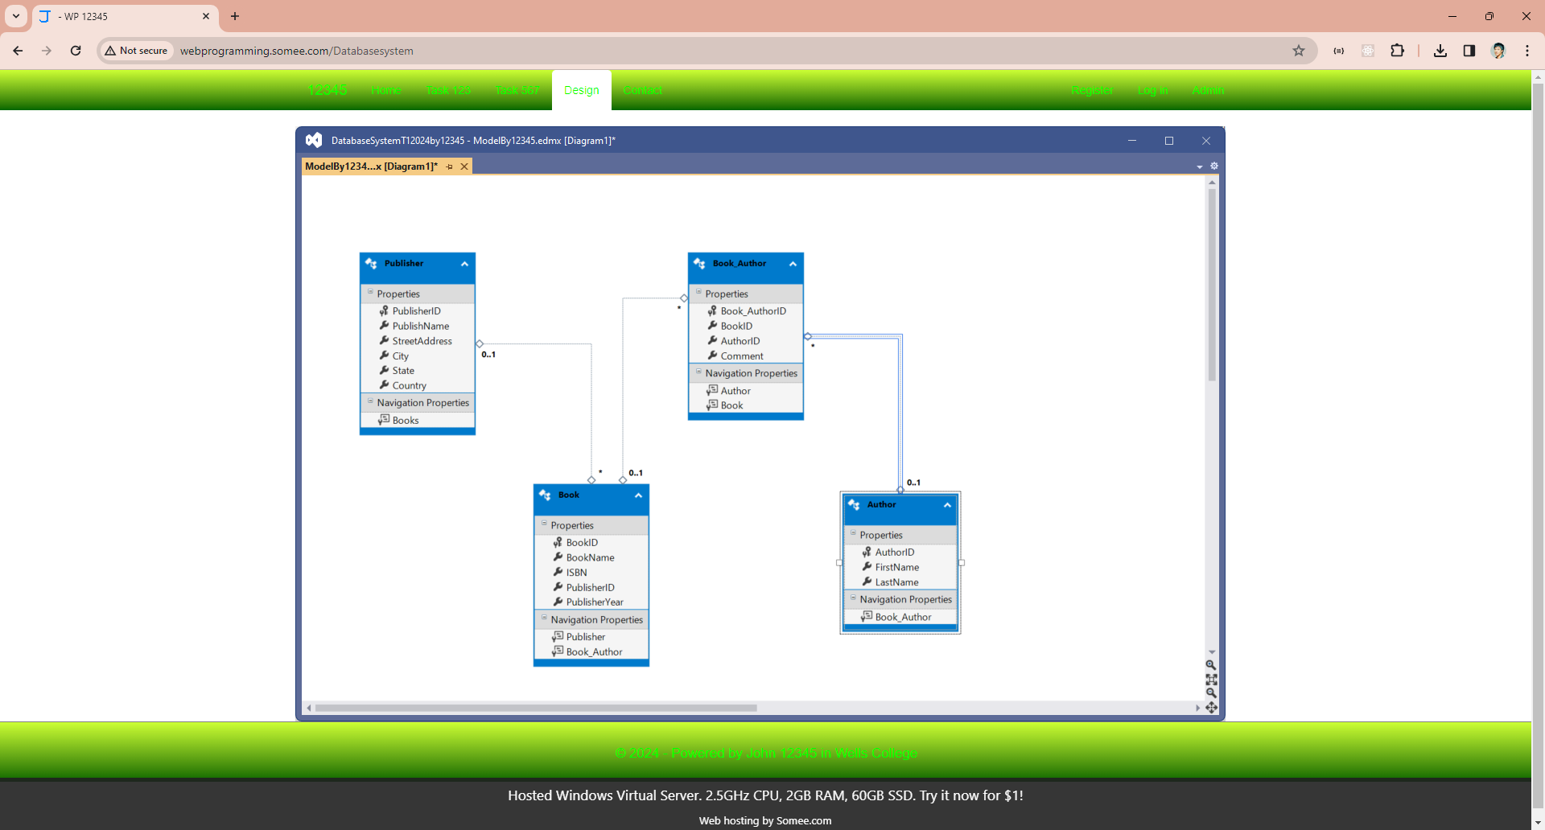

You could check or edit admin user: http://demo2026.somee.com/About
Need admin login: user name: wells || pw: 123456
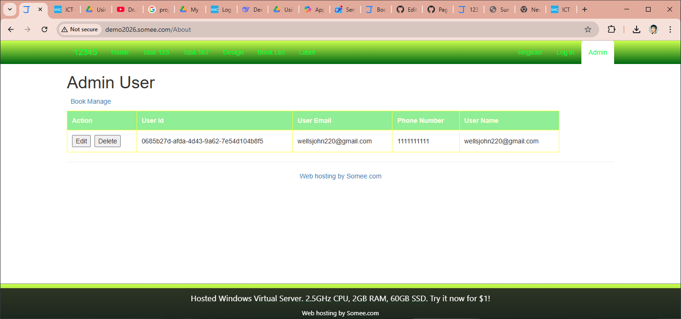

Your tasks:
Task 1-Review an ERD and answer questions
An ERD developed for the Basic Library System is shown in the Figure below.
Basic Library System
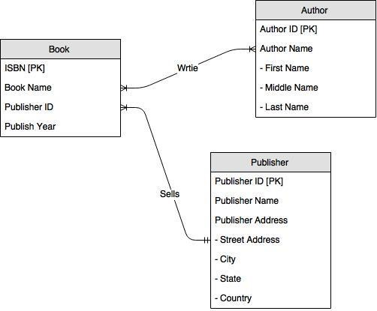

Above diagram is not good for database design. Because Book and Author are many to many relationships. It means one book could be written by one or many authors. And one author could write one or many books. So, I design using visual studio 2022 to make diagram:

In a relational SQL database, the three tables book, publisher, and author are designed to organise and manage information about books and the people or organisations connected to them. Each table represents a separate entity, and together they demonstrate important relational database concepts such as primary keys, foreign keys, and relationships between tables.
The book table contains information about individual books. It includes Book_ID, which serves as the primary key and uniquely identifies each book record. It also includes Book_Name, which stores the title of the book, and Publisher_ID, which acts as a foreign key. The Publisher_ID connects each book to a specific publisher in the publisher table. This table is central to the database because it links books to their publishers.
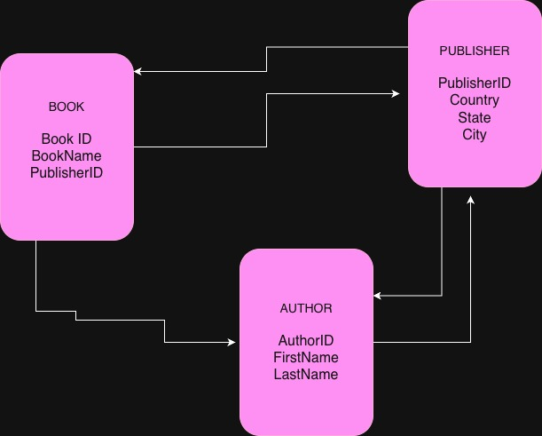
The publisher table stores information about publishing companies. It includes Publisher_ID as the primary key to uniquely identify each publisher. Additional attributes such as Country, State, and City describe the publisher’s location. The relationship between publisher and book is one-to-many, meaning one publisher can publish many books, but each book is associated with only one publisher. This relationship is maintained through the foreign key in the book table.
The author table contains details about authors. It includes Author_ID as the primary key, along with First_Name and Last_Name to store the author’s name. In the current structure, the author table is separate and not directly linked to the book table. However, in a complete database design, there is usually a many-to-many relationship between books and authors, since one author can write multiple books and one book can have multiple authors. This would normally require an additional junction table to connect books and authors.
Overall, these three tables demonstrate fundamental principles of relational database design. Each table focuses on a specific entity, primary keys ensure unique identification of records, and foreign keys establish relationships between tables. This structure helps maintain data integrity, reduce redundancy, and support efficient SQL queries.

Now, answer the following questions:
- Name the entities in the ERD for the Basic Library System.
Book
Author
Publisher

- Name the attributes in the ERD for the Basic Library System
Book {BookID ISBN, Book Name, Publisher ID, Publish Year}
Book_ID is the primary key that uniquely identifies each book.
Book_Name stores the title of the book.
Publisher_ID is a foreign key that links the Book entity to the Publisher entity.

- List the primary keys for each entity in the ERD for the Basic Library System
See above highlight with yellow colour
Book => BookID
Book: Book_ID
Publisher: Publisher_ID
Author: Author_ID
Each primary key uniquely identifies a record within its respective table and ensures entity integrity in the database.

- List the composite attributes identified or foreign key in the ERD for the Basic Library System.
Book {BookID, Book Name, Publisher ID, Publish Year} Publish Id is foreign key
Book_Author {Book_AuthorID, BookID, AuthorID, Comment} high light key is composite attributes identified. Here, if do not use Book_AuthorID for primary key, you need set index key for BookID and AuthorID. It means BookID or AuthorID could duplicate but could not same time duplicate!

If you need view author full name, or view publish address, how to write your code?
I created view Publish Address using this code:
CREATE VIEW [ViewPublish] AS
SELECT PublisherID AS [Publish ID], PublishName AS [Publish Name], StreetAddress + ' ' + City + ' ' + State + ' ' + Country AS [Publish Address]
FROM Publisher

SELECT * FROM ViewPublish

Output:
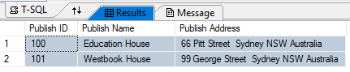
Author Name View?
…
Here is a sample:
CREATE VIEW [ViewAuthor] AS
SELECT AuthorID AS [Author ID], Author.FirstName + ' ' + Author.LastName AS [Author Full Name]
FROM Author
SELECT * FROM ViewAuthor
Output:
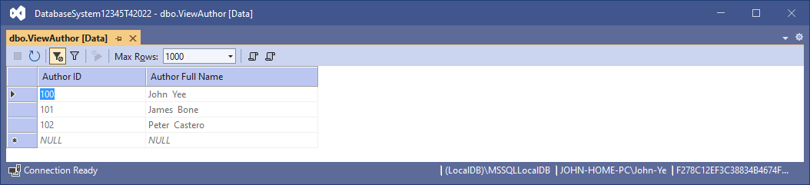
- List the relationships in the ERD for the Basic Library System.
see my diagram above

- Write Enterprise Rules that describe the degree and membership for each relationship in the ERD for the Basic Library System.
- An AUTHOR writes one or many BOOKs
- A BOOK is written by one or many AUTHORS
- A PUBLISHER sells one or more BOOKs
- A BOOK is sold by one and only one PUBLISHER
- Book_Author ???

Here is my First diagram about library System: One Publisher could publish zero or one or many books.

Or one book must be published by one Publisher.

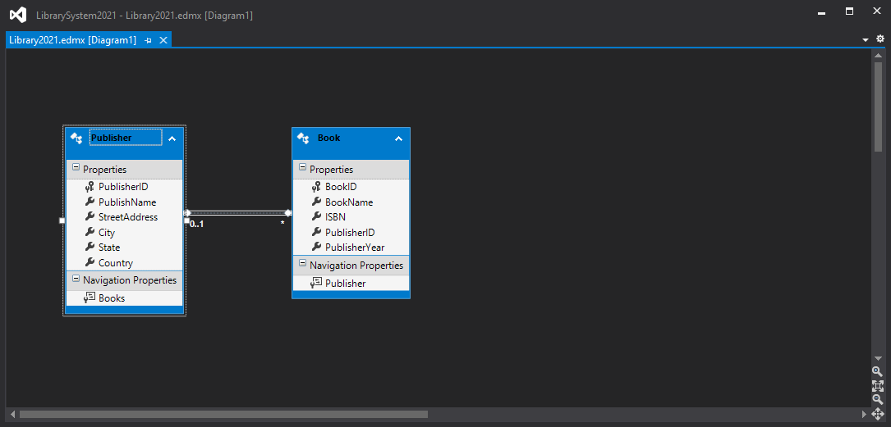

Task 2-Develop a Database for a Library Information System
Consider the following description for a Library Information System:
A library needs to keep records of current loans of copies of books to borrowers and reservations for book titles. Each borrower is identified by a BORROWER# and each copy of a book title in the library is identified by an ACCESS# as the library may have more than one copy of a given book title. The NAME and ADDRESS of each borrower is held so that communications such as overdue loan reminders can be sent when necessary. The information required about book titles is TITLE, AUTHORS, PUBLISHERS, PUBLICATION DATE, and ISBN. For individual copies of a book title the PURCHASE PRICE and CURRENT PRICE are required, where purchase price is the price the library paid at the time of purchase and current price is the current listed price charged to borrowers who lose books. ISBN is an internationally used identifier for a book title. A borrower may have any number of books out on loan at any one time, but a book may be borrowed by only one borrower at a time. The DUE DATE for each loan is recorded so that overdue notices can be sent out. Book titles out on loan may be reserved by other borrowers pending their return. Borrowers may make a reservation for only one book title at a time. Reservations for a book title are processed in order of the date the reservation was made as copies are returned.

In order to simplify the design, I just used four entities to do below the tasks:
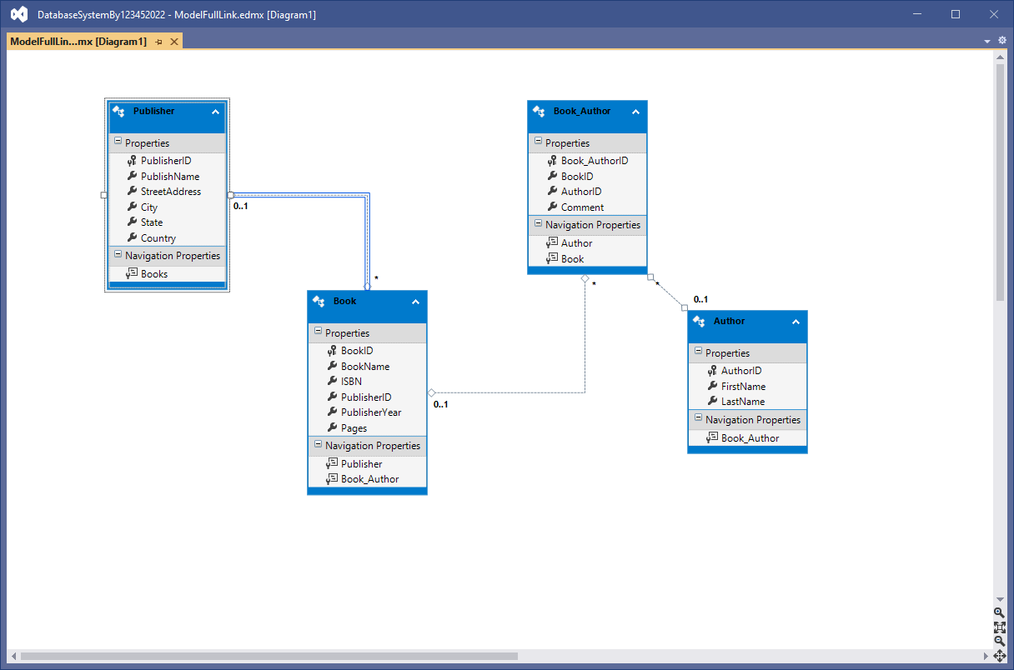

- List Enterprise Rules and any assumptions that are required to complete an ERD.
Publisher sell or publish no, or one or many Books
Any book must be published by one publisher.

Please write the other relationships
…

- Develop an ERD for the Library Information System and confirm with your Trainer before proceeding to the next task. To do that you must consider followings:
  - Characteristics of entities
  - Characteristics of relationships
  - One to one
  - One to Many
  - Many to many
(In above diagram, must break one to many relationships using another combination foreign keys table, here I use Book_Author)
  - Characteristics of attributes
- Types of attributes
…
- Primary Key attributes
…
- Attribute domain
Group of entities named domain, for example dbo.
  - Extended characteristics of relationships (here I did not develop membership entity)
o Degree of relationship
Entity-Relationship occurrence diagrams and degree of relationship
o Membership constraints
Membership constraints combined with degree of relationships
  - Enterprise rules (see above)
  - Normalising the data model
  - Occurrence of attributes
  - Multi-valued attributes
  - Many: many relationships
  - Guidelines for drawing an extended and detailed Entity-Relationship Diagram
- Create a sample Data Dictionary for the ERD (for one entity only) which must contain-
  - The entity descriptions (one entity only)
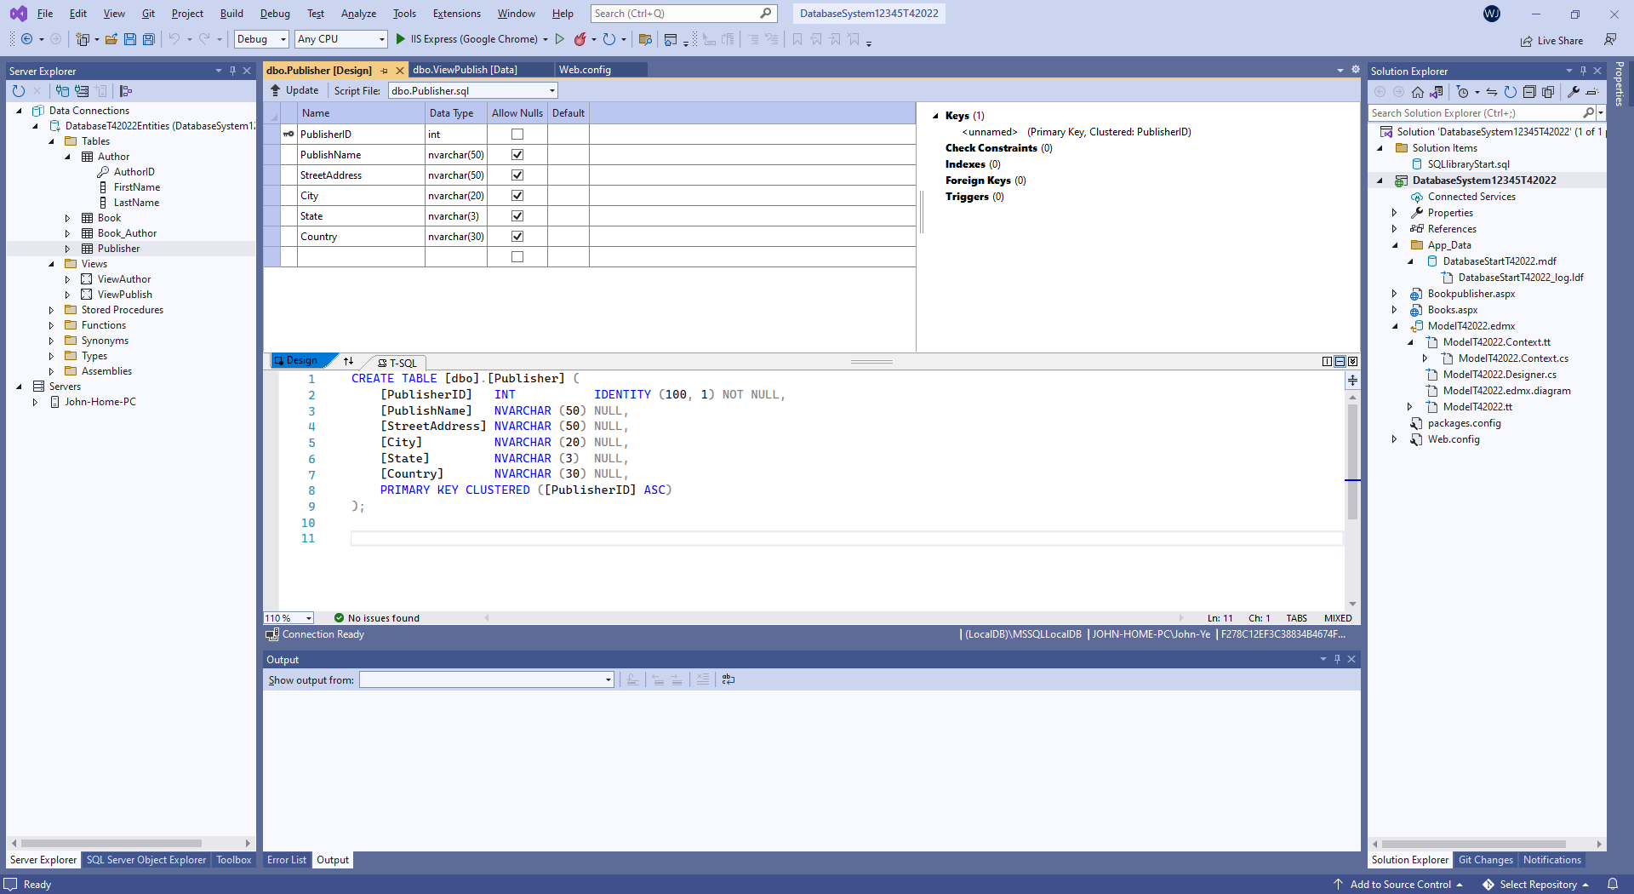
…

  - A list of attributes to be included in the data dictionary from the documentation of the entity (the one you have chosen to describe)
See above screen shot for each entity.
  - o Attribute name (User name)
  - o Alias (Synonym)
  - o Data Source
    - Data Structure
    - Type
    - Length and format
    - Characteristics
    - Range of values and meanings of values
    - Description
  - The attribute descriptions
    - A list of attributes
    - The primary key
    - Description of the entity
    - Business rules affecting the entity
Or you can simply use the forms in Appendix A for the task.
Author table see above.
Book: ???

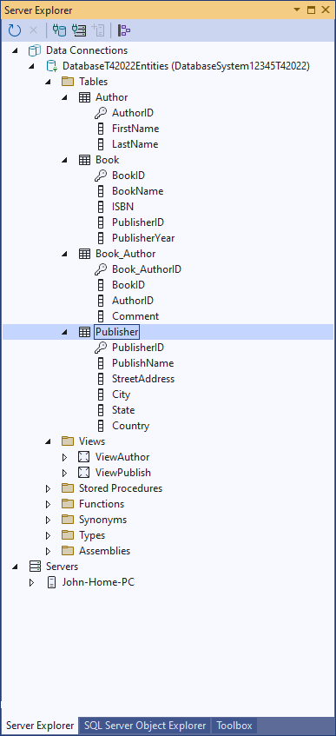
- Use MS Access and Create a Blank Access database and name it as DB_LIS(or LibrarySystem2022).
I created database using Server named:
DatabasSystem12345T42022

- Create all the tables required (refer to your ERD entities) in DB_LIS.

Here show four tables:
Author
Book
Book_Author
Publisher

- Name the tables as Tb_Borrower, Tb_BooksTitle, etc.
N/A

SELECT * FROM INFORMATION_SCHEMA.TABLES WHERE TABLE_TYPE='BASE TABLE'

Or
SELECT * FROM INFORMATION_SCHEMA.TABLES

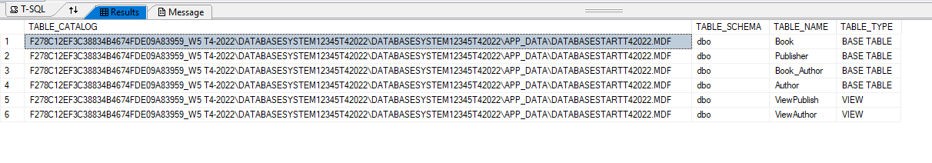

Or another way:

CREATE VIEW [Tb_Borrower] AS
SELECT * FROM INFORMATION_SCHEMA.TABLES WHERE TABLE_TYPE='BASE TABLE';

SELECT * FROM Tb_Borrower

If you need modify your SQL, change CREATE to ALTER
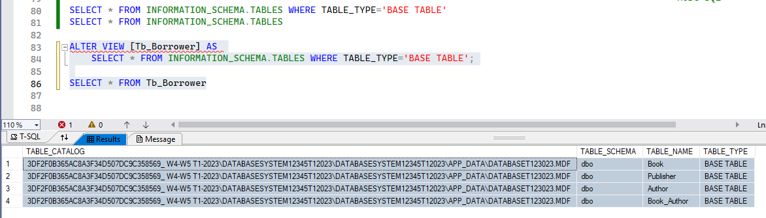

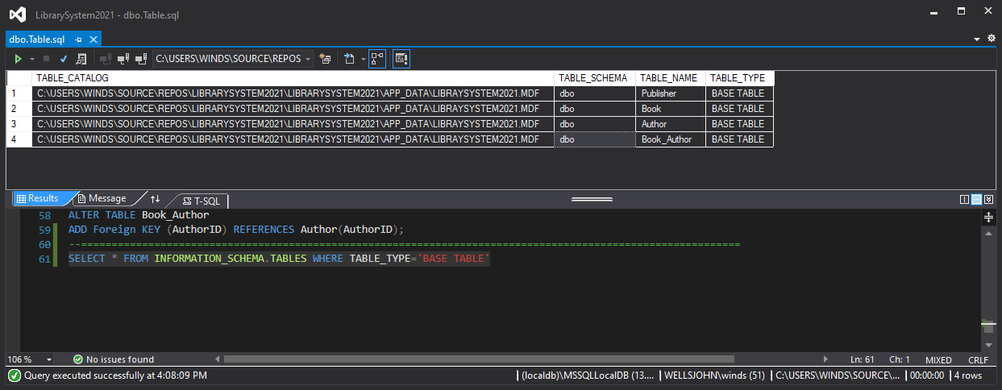

Or:
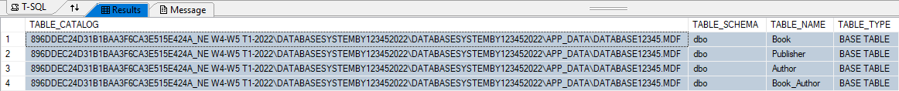

How to create view TB_BooksTitle?
…?

- Choose appropriate Fields (refer to you ERD; attributes of the entities) and Data types in properties of the tables
See above my sample

- Fill at least 3 records in each table
Book Table:
10000 | Learn Java Program | 101 | 2020 | NULL
10001 | Learn C# Program | 101 | 2020 | NULL
10002 | Learn PHP Program | 100 | 2020 | NULL
10003 | Learn HTML Program | 100 | 2021 | NULL
10004 | Database Design Introduction | 100 | 2019 | NULL

Author Table:
100 | Wells College | 101 Sussesx Street | Sydney | NSW | Australia
101 | James Bone | 007 Sydney Street | Woologoon | NSW | Australia

Publisher Table:
…

- Create a relationship between the tables, and make a query to get records for the books’ Borrower’s name, Book Title, Author, and the Due Date which are from same publisher.
Create view: One publisher with its books, author name, and publisher details etc.

CREATE VIEW [ViewOnePublish] AS
SELECT Publisher.PublisherID, Publisher.PublishName,
Publisher.StreetAddress, Publisher.City, Publisher.State, Publisher.Country,
Book.BookName,
Author.FirstName, Author.LastName
FROM Author INNER JOIN Book_Author ON Author.AuthorID = Book_Author.AuthorID
INNER JOIN Book ON Book_Author.BookID = Book.BookID
INNER JOIN Publisher ON Book.PublisherID = Publisher.PublisherID
WHERE (Publisher.PublisherID = 100)

SELECT * From ViewOnePublish

- Make a report of output of question 9.
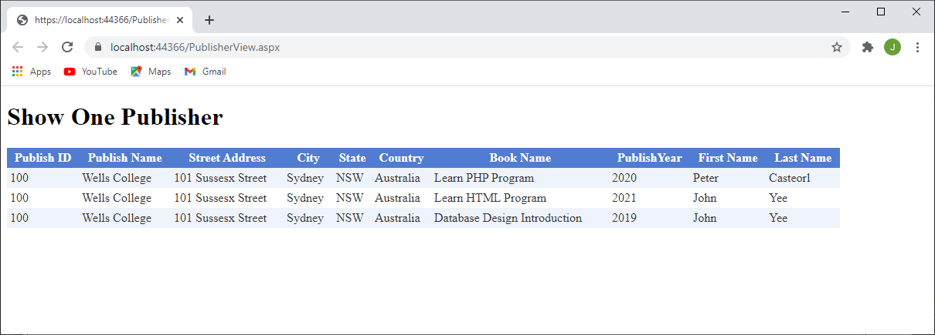
Or
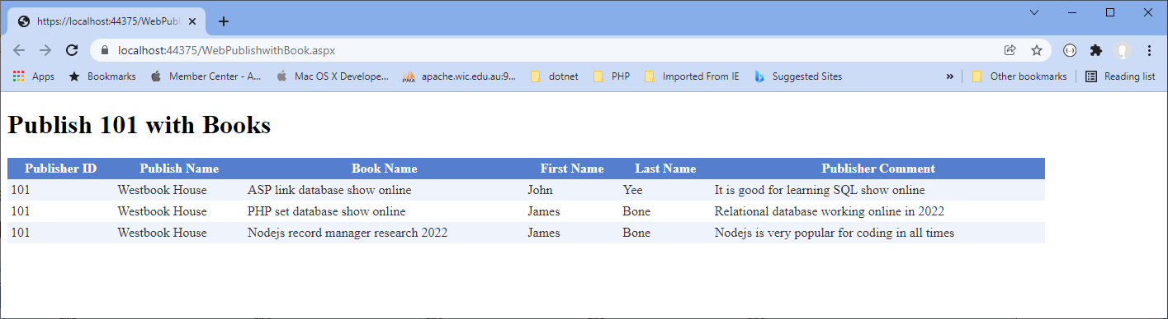

I could use view, so the code will be much easier:
ConnectionString="<%$ ConnectionStrings:ConnectionString %>" SelectCommand="SELECT * From ViewOnePublish">

- Make forms for all the tables
I will design table using C# and ASP late.

- Select Author make a form of this output
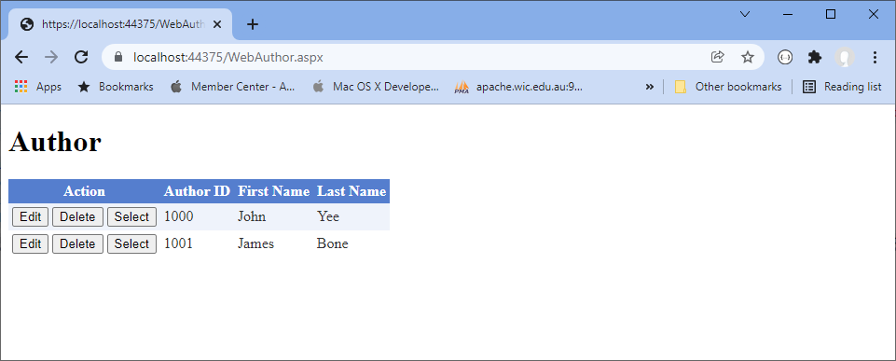

And published to http://webprogramming.somee.com/Booklist
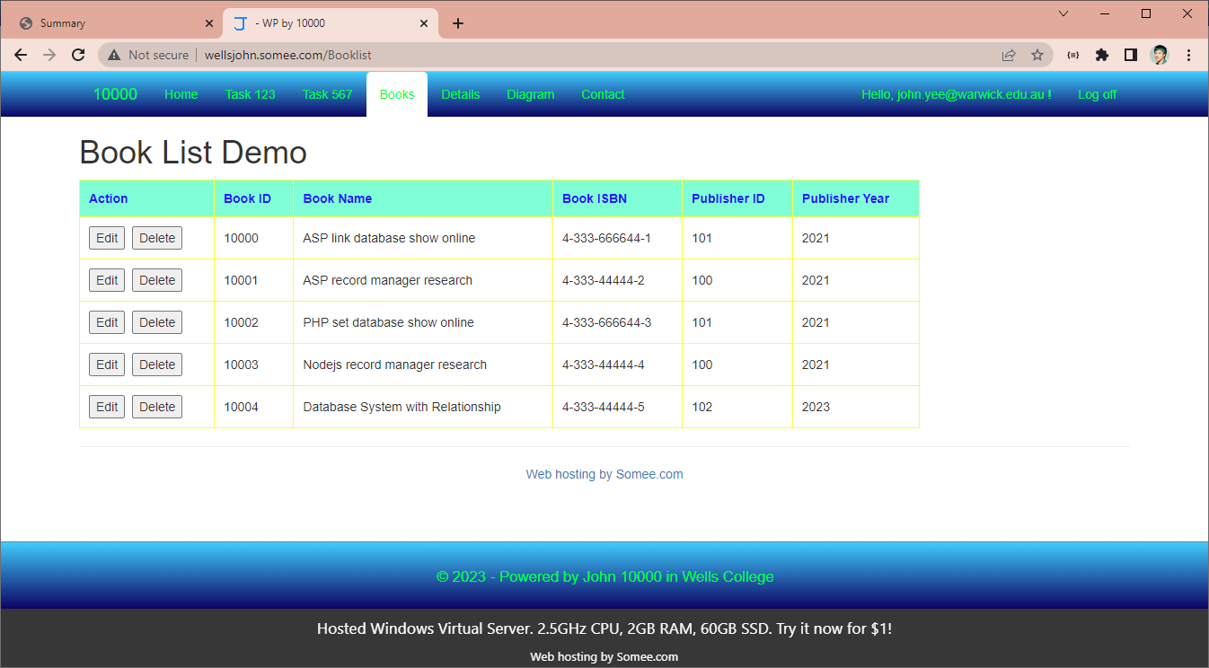

In order to get your database online, you need run SQL on the server:
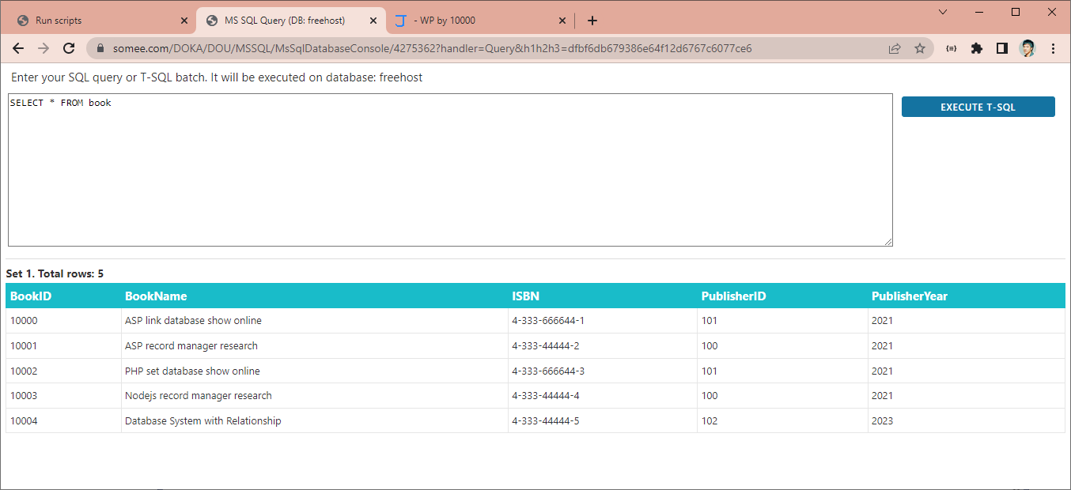
Or on the local:
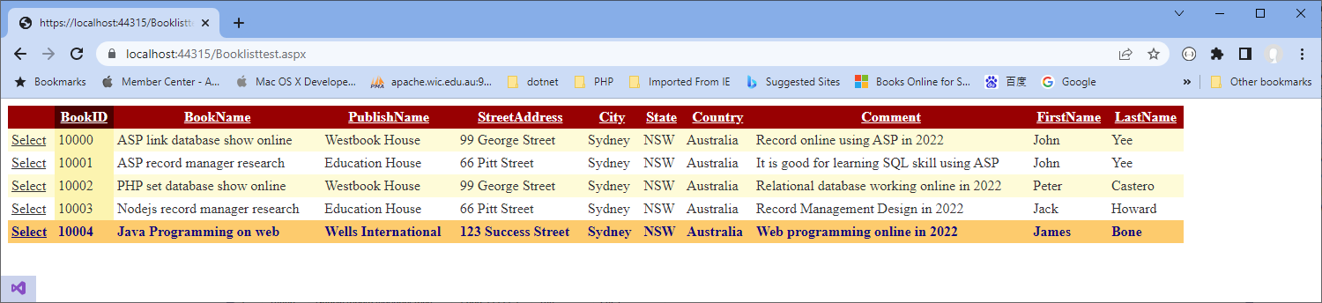

- Deploy a password for the database
N/A
We did subject “Web Programming”

All above screen shot, need show your id and demo it is your works!
Below the answers are example. We only have two weeks, so below the tasks are optional.
- Assume members, authors, receptionist and the network administrators are going to access the database. Specify each of their access requirements in terms of CRUD access and type of lock (exclusive or shared) can be applied to the database.

R=Read; A=Add; E=Edit; D=Delete

 | Author | Book | Author_Book | Publish | Comment
Authors | RAE | RE | RE | R | Part
Receptionist | RAE | READ | READ | R | Part
Admin | RAED | RAED | RAED | RAED | Full
Users | R | R | R | R | limited

Current project, I use the build in database, so when I check the permission: use
- Exec sp_table_privileges @table_name = 'Author'
- Exec sp_table_privileges @table_name = 'Book'

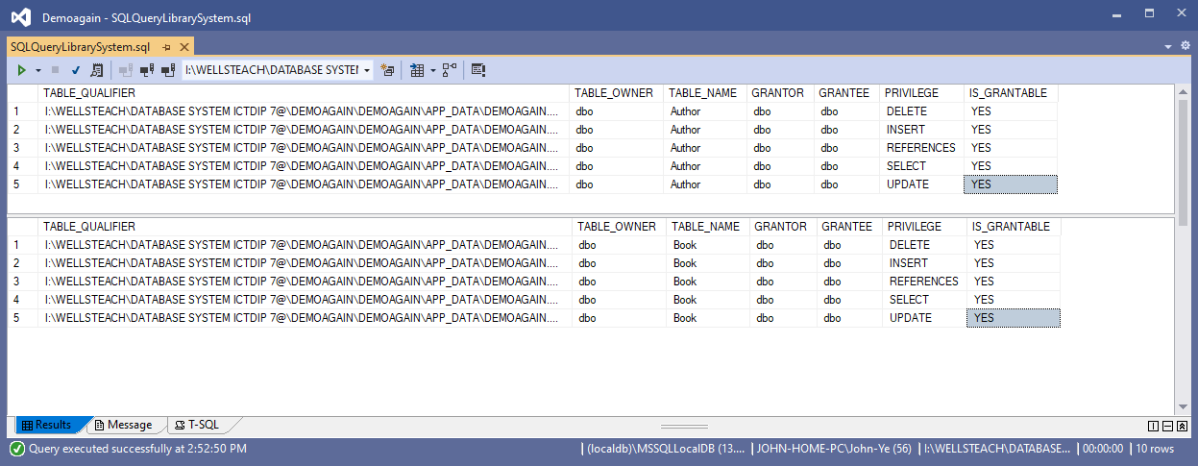
- Write down the database backup and recovery procedures. You should clarify-
Backup schedule
  - Type of backup (full back up or incremental backup)
  - Method will be used for restoring the database to an accurate position

BACKUP DATABASE [L:\DATABASE SYSTEM 2021\BASICLIBRARYSYSTEM\BASICLIBRARYSYSTEM\APP_DATA\LIBRARYSYSTEM.MDF]
TO DISK = N'D:\dbbackup\LIBRARYSYSTEM.MDF.bak'
WITH NOFORMAT, NOINIT, NAME = N'L:\DATABASE SYSTEM 2021\BASICLIBRARYSYSTEM\BASICLIBRARYSYSTEM\APP_DATA\LIBRARYSYSTEM.MDF-Full Database Backup',
SKIP, NOREWIND, NOUNLOAD, STATS = 10
GO
--==============================================================================
RESTORE DATABASE [L:\DATABASE SYSTEM 2021\BASICLIBRARYSYSTEM\BASICLIBRARYSYSTEM\APP_DATA\LIBRARYSYSTEM.MDF]
FILE = N'LibrarySystem' FROM DISK = N'D:\dbbackup\LIBRARYSYSTEM.MDF.bak' WITH FILE = 1, MOVE N'LibrarySystem_log'
TO N'L:\DATABASE SYSTEM 2021\BASICLIBRARYSYSTEM\BASICLIBRARYSYSTEM\APP_DATA\LIBRARYSYSTEM.ldf', NOUNLOAD, STATS = 10
GO

Below the code to test on my computer:

BACKUP DATABASE [C:\Users\John-Ye\Source\Repos\WebSQLinjection\WebSQLinjection\App_Data\DatabaseTestinjection.MDF]
TO DISK = N'D:\dbbackup\DatabaseTestinjection.MDF.bak'
WITH NOFORMAT, NOINIT, NAME = N'C:\Users\John-Ye\Source\Repos\WebSQLinjection\WebSQLinjection\APP_DATA\DatabaseTestinjection.MDF-Full Database Backup',
SKIP, NOREWIND, NOUNLOAD, STATS = 10
GO

RESTORE DATABASE [C:\Users\John-Ye\Source\Repos\WebSQLinjection\WebSQLinjection\App_Data\DatabaseTestinjection.MDF]
FILE = N'DatabaseTestinjection' FROM DISK = N'D:\dbbackup\DatabaseTestinjection.MDF.bak' WITH FILE = 1, MOVE N'DatabaseTestinjection_log'
TO N'C:\Users\John-Ye\Source\Repos\WebSQLinjection\WebSQLinjection\App_Data\DatabaseTestinjection.ldf', NOUNLOAD, STATS = 10
Go

- Submit your database file (DB_LIS.mdb) along with other documents to your Trainer and demonstrate various functionalities as per the Trainer.

Or
Show your working on your web project, which we created last subject web programming.

