**Introduction**

This document outlines the initial development of a chatbot using IBM Cloud Watson Assistant. The purpose is to define the chatbot persona, design the conversation flow, and configure key components.

**Setting Up Watson Assistant**

Begin by creating a Watson Assistant instance within IBM Cloud. Access the Watson Assistant dashboard, where we will configure the chatbot's behavior and responses.

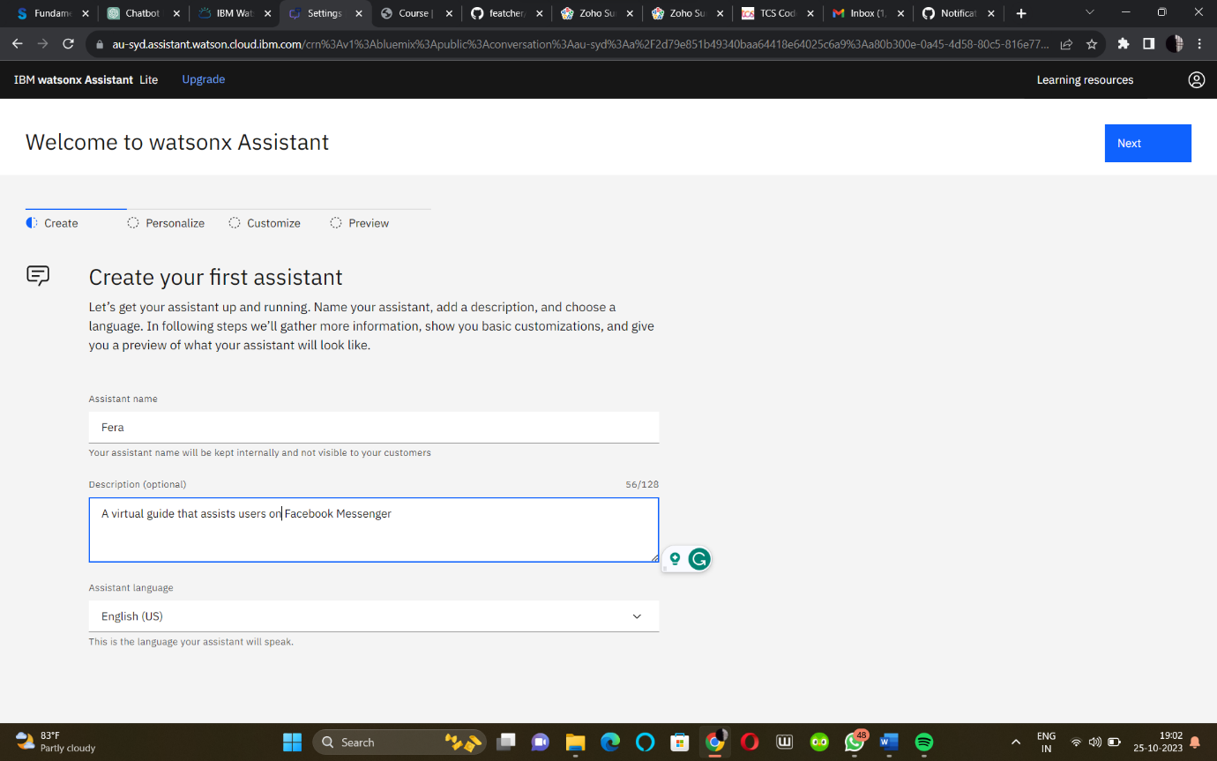

**Defining the Chatbot Persona**

We'll name the chatbot and decide on its character and tone. This step establishes the personality that the chatbot will convey during interactions with users.

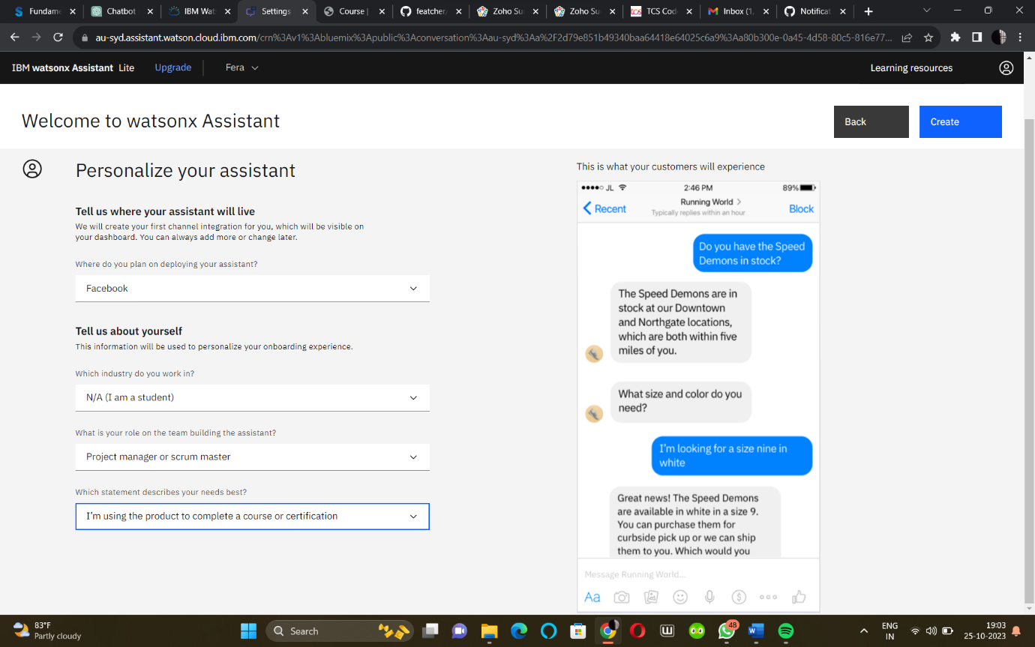

**Designing the Conversation Flow**

Outline the chatbot's conversation structure, including greetings, closing phrases, and user guidance. This creates a coherent and user-friendly experience.

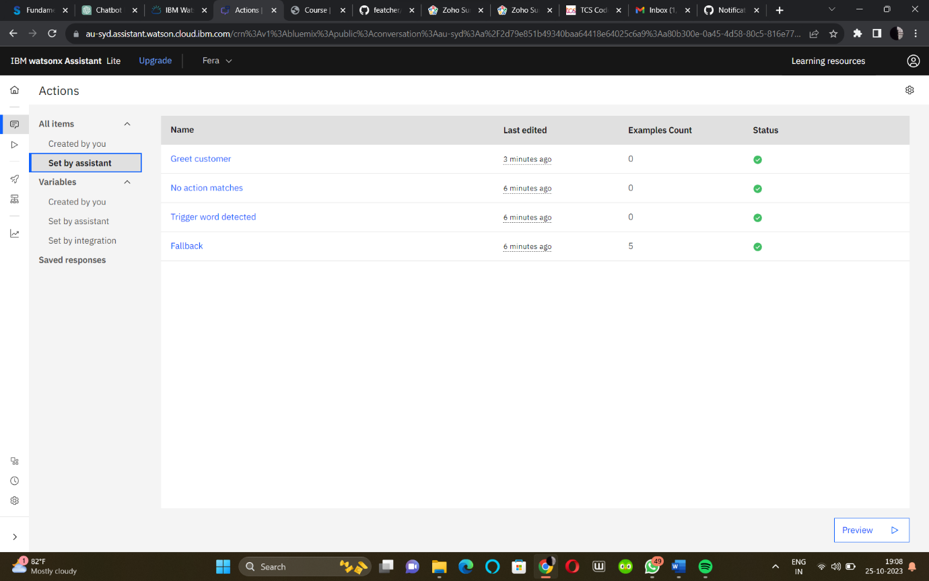

**Creating Intents**

Identify user intents, the core concepts the chatbot should understand. Add examples for each intent, enhancing the chatbot's ability to recognize user queries.

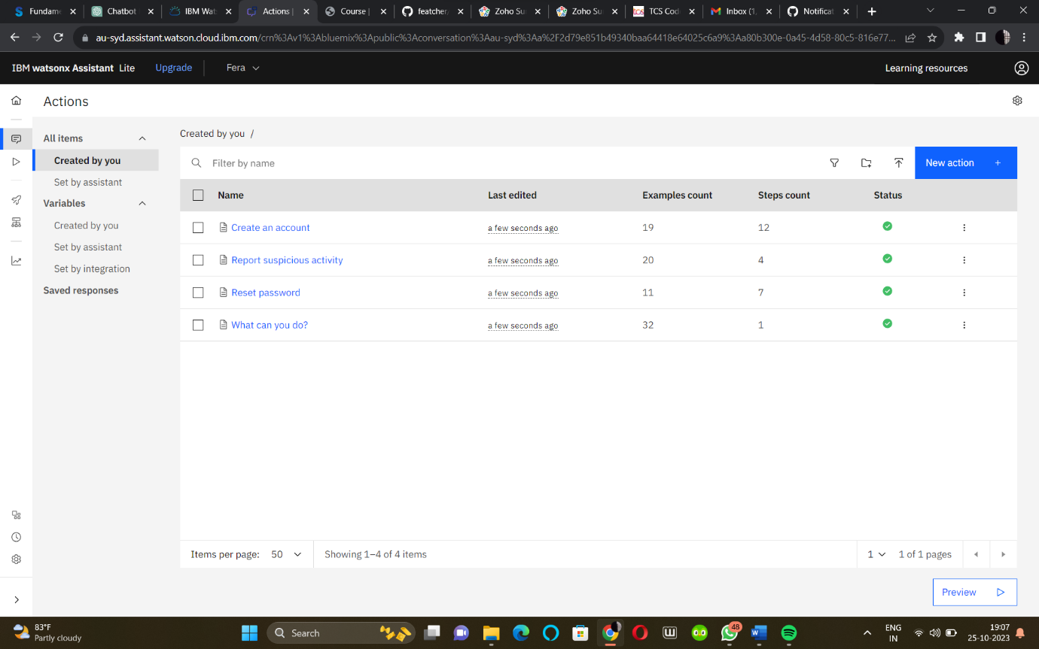

**Configuring Entities**

Define entities, specific pieces of information to extract from user input. Establish entity values and synonyms to improve recognition accuracy.

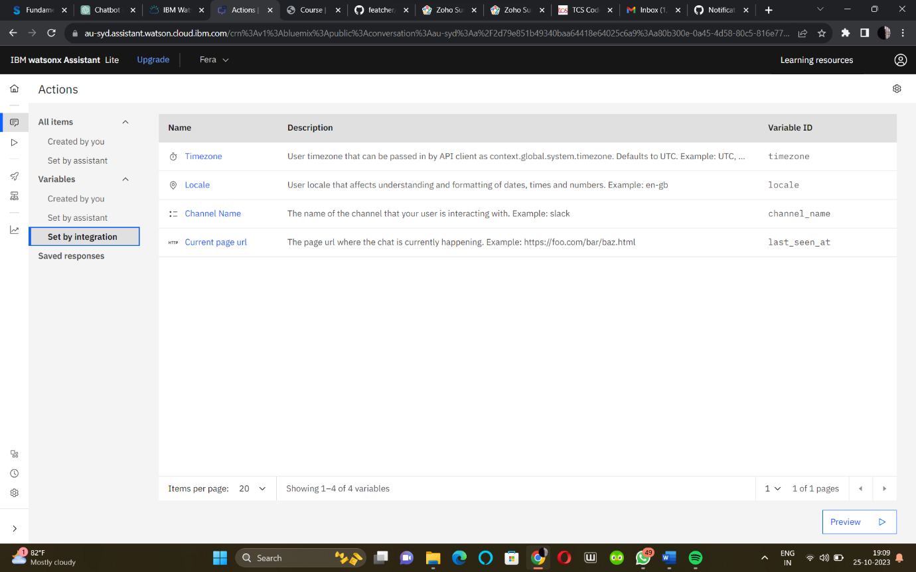

**Building Dialog Nodes**

Create dialog nodes to structure the conversation. Assign responses and establish conditional branching to guide interactions effectively.

**Training and Testing**

Train the chatbot using the provided training data and test it within the Watson Assistant interface to ensure it responds correctly to user queries.

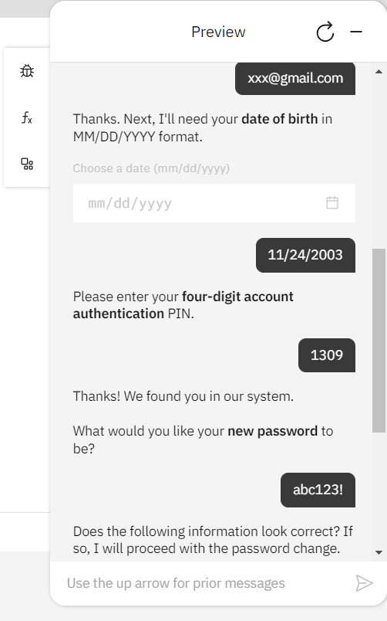

**Conclusion**

This marks the completion of the initial development phase. The chatbot's persona is defined, and the conversation flow is designed. Further testing and refinement will follow.

In the next phases, we will continue building and enhancing our chatbot to create a more effective and engaging user experience.

Chatbot URL:

https://au-syd.assistant.watson.cloud.ibm.com/crn%3Av1%3Abluemix%3Apublic%3Aconversation%3Aau-syd%3Aa%2F2d79e851b49340baa64418e64025c6a9%3Aa80b300e-0a45-4d58-80c5-816e77b0f8ef%3A%3A/assistants/2554de8e-4867-4364-a685-e07e393b5e9b/actions/variables/integration