This phase marks a pivotal step in our project as we proceed to integrate our chatbot with popular messaging platforms, specifically Facebook Messenger and Slack, via their respective APIs.

**Integration with Messaging Platforms**

We'll leverage the APIs provided by Facebook Messenger and Slack to seamlessly connect our chatbot with these widely used communication channels. This integration extends our chatbot's reach, making it accessible to a broader audience.

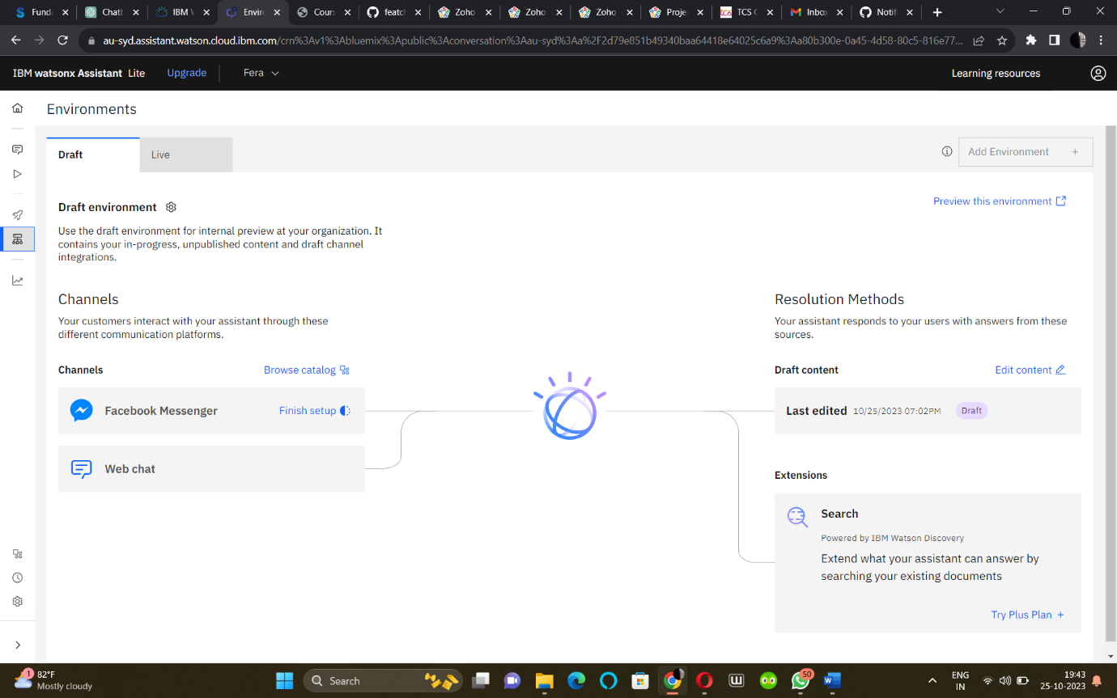

**Natural Conversation Flow**

Ensuring a natural conversation flow is paramount. We'll refine the dialogue design to create an engaging and intuitive experience for users. The chatbot will greet users, respond to queries, and handle common scenarios, keeping the conversation flowing smoothly.

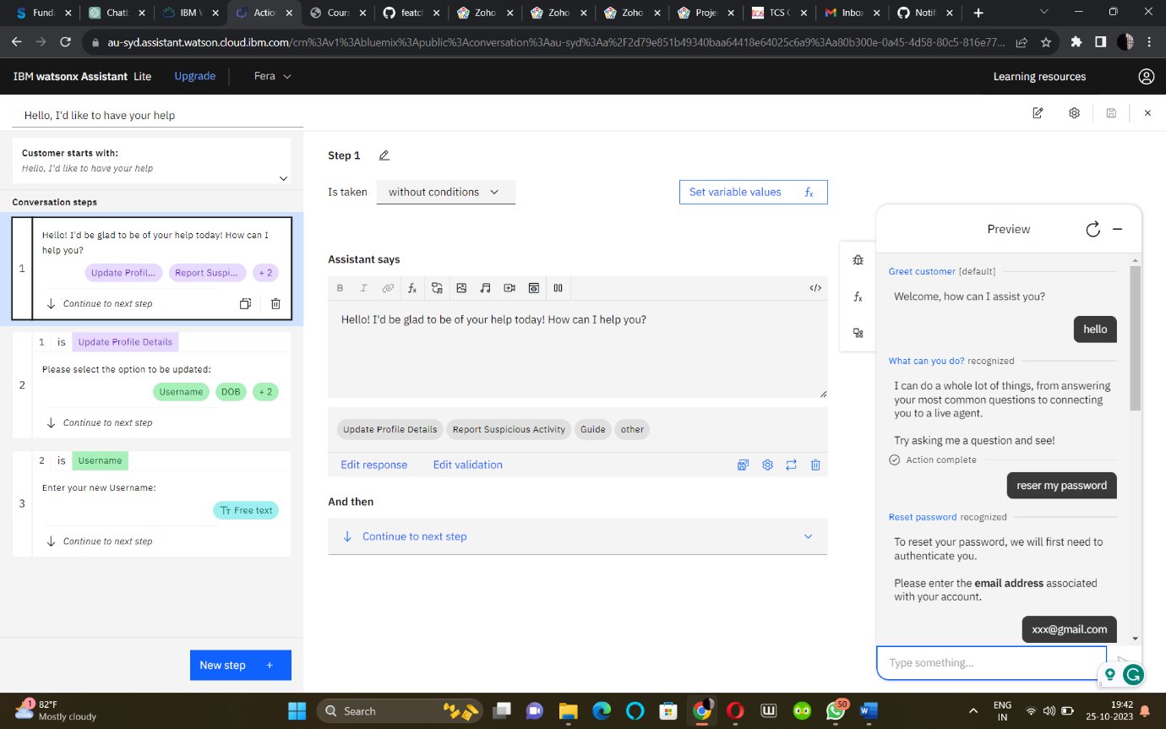

**Informative and Accurate Responses**

Our focus remains on providing accurate and informative responses. We'll fine-tune the chatbot's knowledge base, improve entity recognition, and enhance the accuracy of intent matching to address user queries effectively.

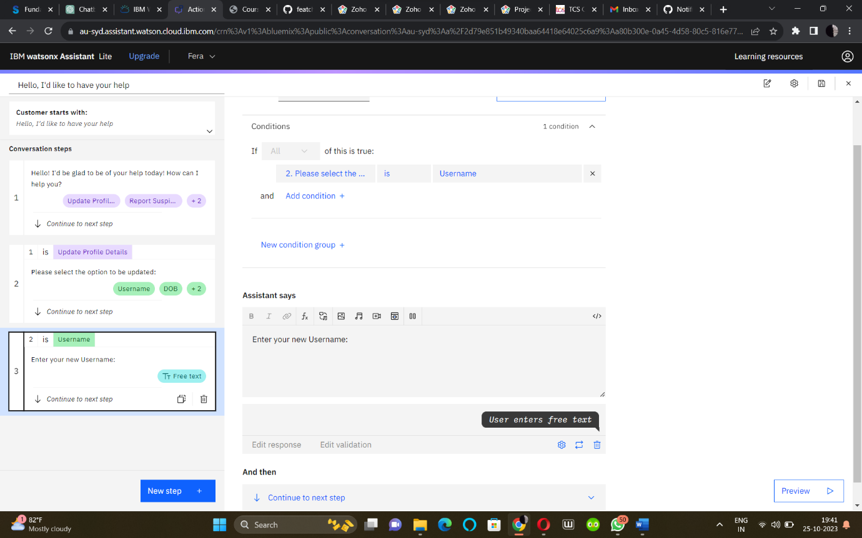

**Conclusion and Next Steps**

In this phase, our chatbot takes a significant leap by becoming accessible on Facebook Messenger and Slack. The improvements in conversation flow and response accuracy contribute to a more satisfying user experience. Moving forward, we will continue to refine and expand the chatbot's capabilities, making it a valuable virtual guide for our users.

As we progress, we remain dedicated to delivering a robust and user-friendly chatbot that serves our project's goals effectively.

Chatbot URL:

https://au-syd.assistant.watson.cloud.ibm.com/crn%3Av1%3Abluemix%3Apublic%3Aconversation%3Aau-syd%3Aa%2F2d79e851b49340baa64418e64025c6a9%3Aa80b300e-0a45-4d58-80c5-816e77b0f8ef%3A%3A/assistants/2554de8e-4867-4364-a685-e07e393b5e9b/actions/actions/custom