**Project Objective**

The objective of this project is to create a virtual guide that can help users navigate social platforms like Stack and Facebook Messenger. The chatbot will be able to answer questions about how to use these platforms, as well as provide tips and tricks for getting the most out of them.

**Design Thinking Process**

The design thinking process was used to develop the chatbot. This process involves five steps: empathize, define, ideate, prototype, and test.

1. Empathize: The first step was to empathize with the users of social platforms. This was done by conducting interviews and surveys to understand their needs and pain points.
2. Define: After empathizing with the users, the next step was to define the problem that the chatbot would solve. The problem that was defined was that users of social platforms often have difficulty finding the information they need.
3. Ideate: The next step was to ideate on solutions to the problem. This was done by brainstorming a list of possible features and functionality for the chatbot.
4. Prototype: After ideating on solutions, the next step was to prototype the chatbot. This was done by creating a low-fidelity prototype to test the feasibility of the idea.
5. Test: The final step was to test the prototype. This was done by conducting user tests to get feedback on the chatbot's design and functionality.

**Development Phases**

The chatbot was developed in three phases: planning, development, and testing.

1. Planning: The planning phase involved creating a project plan and timeline. This also involved identifying the resources that would be needed to develop the chatbot.
2. Development: The development phase involved coding the chatbot and integrating it with Watson Assistant. This also involved testing the chatbot to ensure that it was working as expected.
3. Testing: The testing phase involved conducting user tests to get feedback on the chatbot's design and functionality. This also involved fixing any bugs that were found during the testing process.

**Chatbot Persona**

The chatbot's persona is that of a friendly and helpful assistant. The chatbot is always willing to help users find the information they need.

**Conversation Flow**

The chatbot's conversation flow is designed to be as natural as possible. The chatbot will ask users questions to understand what they are looking for, and then provide them with the information they need.

**Technical Implementation**

The chatbot is implemented using Watson Assistant. Watson Assistant is a cloud-based platform that allows developers to create chatbots that can understand natural language and respond to questions in a conversational way.

**Examples of User Queries and Chatbot Responses**

User: "I want to update my profile with my new name."

Bot: "Sure, I can help with that. Please provide your new name."

User: "My username needs to be changed."

Bot: "No problem, what would you like your new username to be?"

User: "I need to update my date of birth."

Bot: "Great! Please enter your new date of birth."

User: "How can I change my other personal details?"

Bot: "To update other personal details, please specify which information you'd like to change."

**Snapshots of Final Steps and Publishing Fera:**

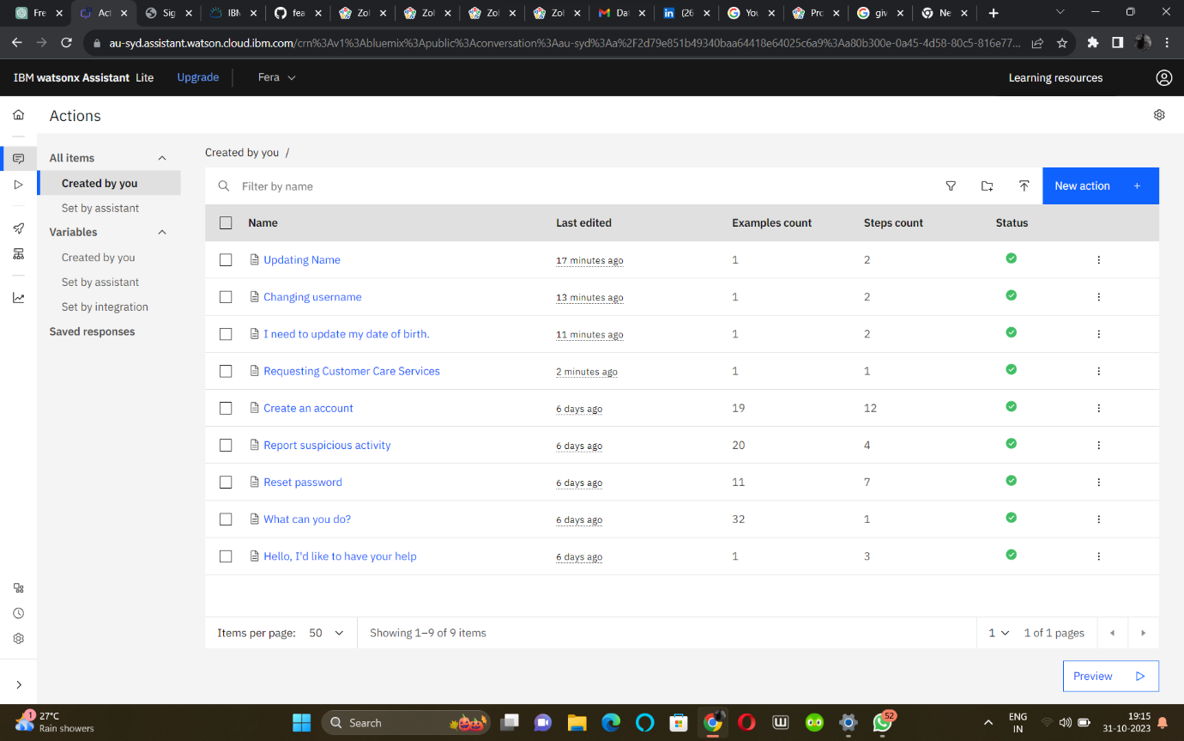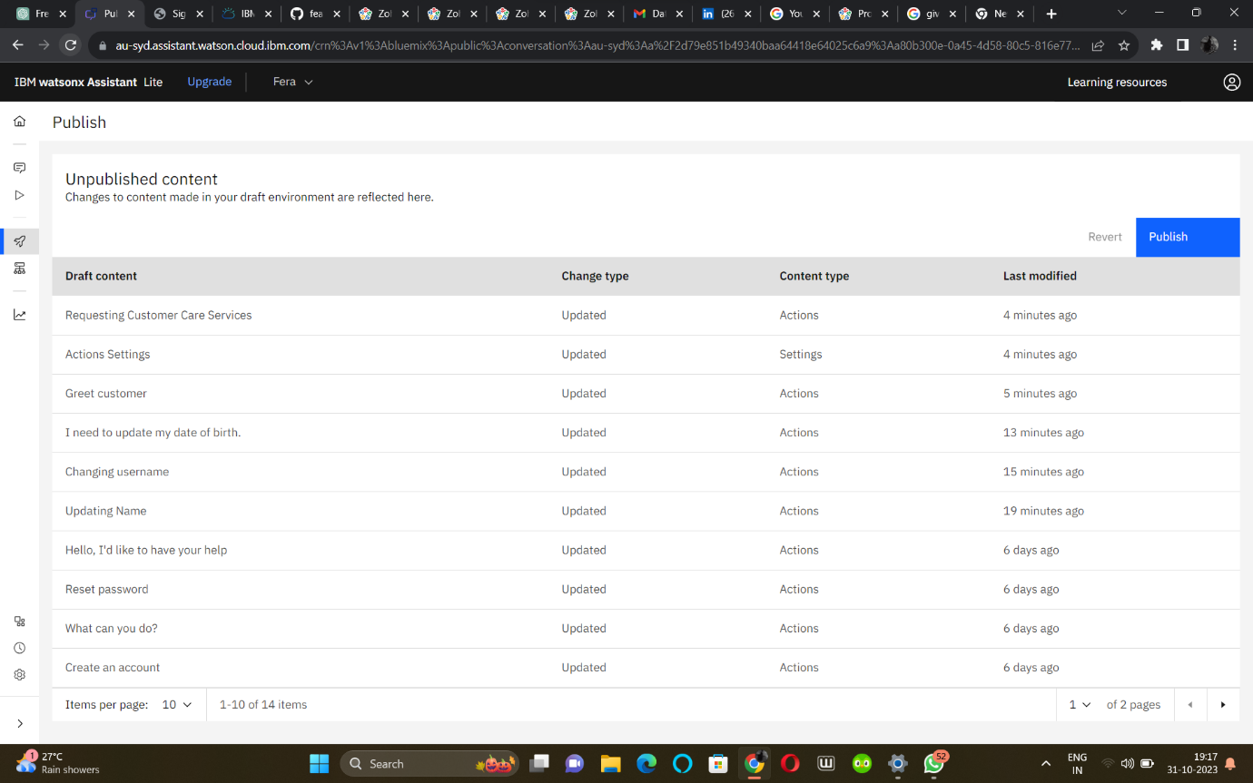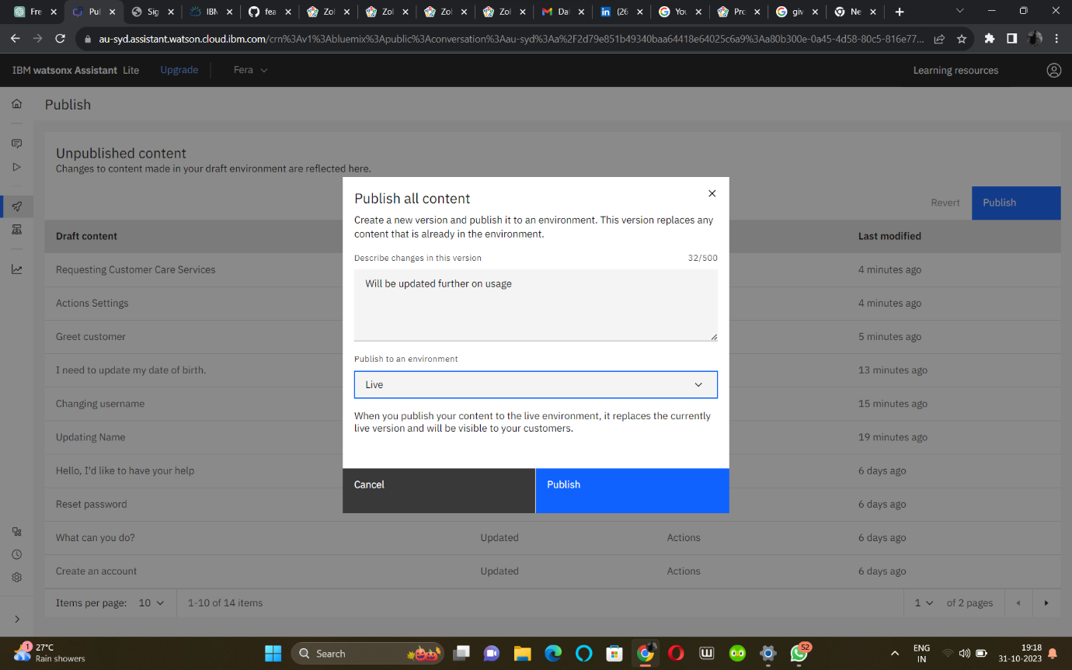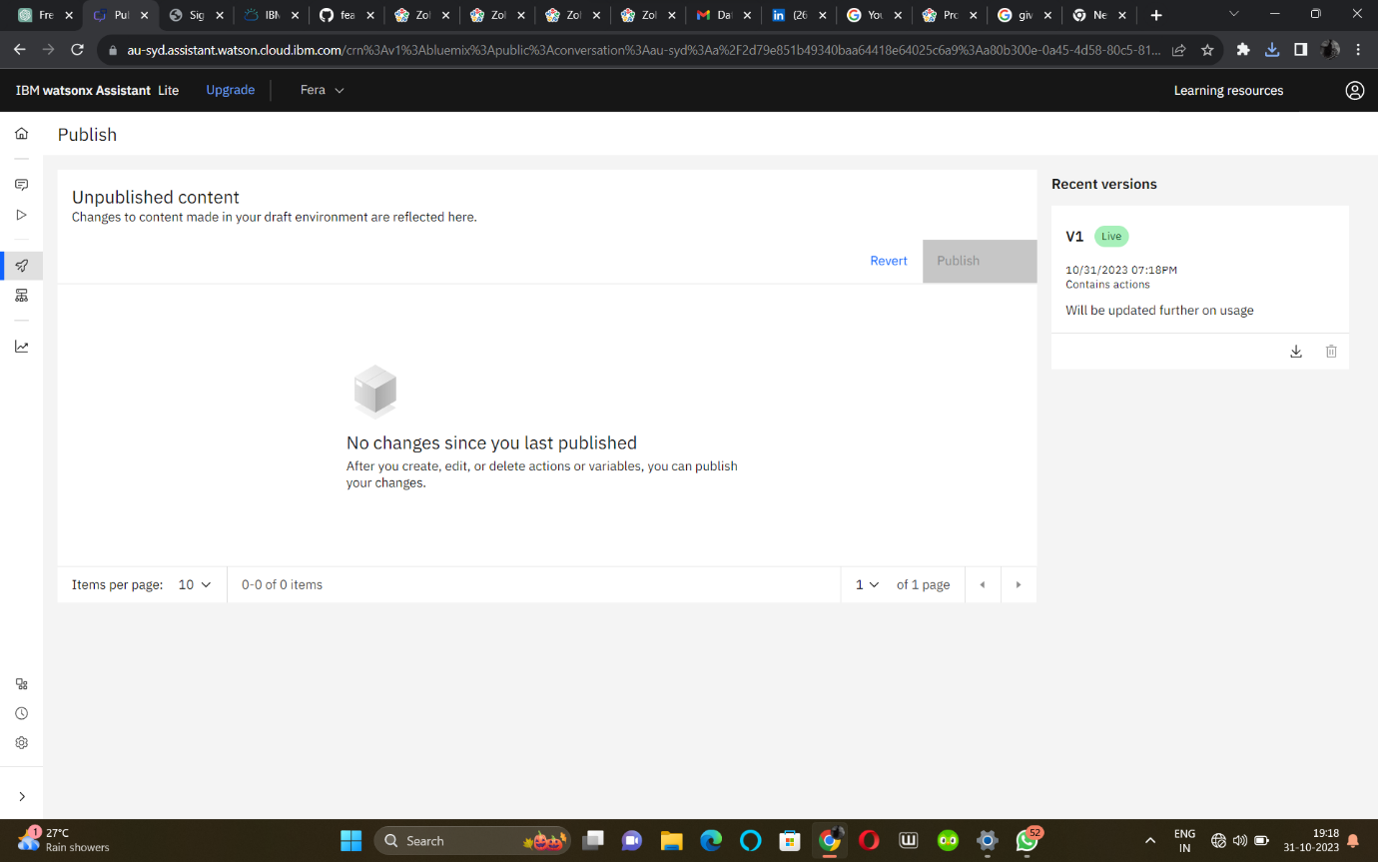

**Conclusion**

In this project, we have developed a versatile chatbot designed for deployment on social platforms like Facebook Messenger. This chatbot has been equipped to handle a wide range of user interactions, including updating user profiles, reporting suspicious activity, providing jokes for entertainment, facilitating customer care services, and addressing common queries. With the ability to engage users effectively and provide relevant responses, this chatbot aims to enhance user experiences, offer assistance, and promote engagement. As technology continues to evolve, this chatbot serves as an example of how AI-powered conversational agents can be deployed to meet user needs and deliver valuable services across various communication channels.