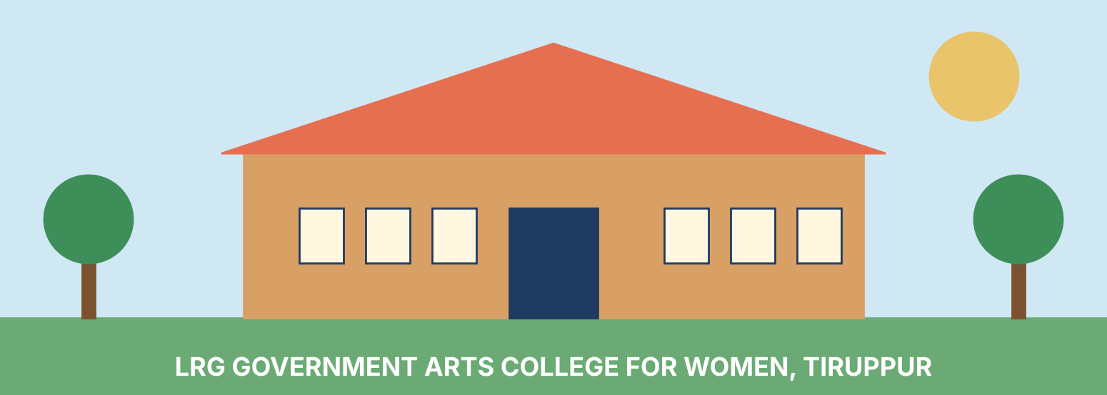
LRG Government Arts College for Women
Tirupur, Tamil Nadu
A Complete College Profile
History | Courses | Fees | Admission | Facilities | Student Life

1. Introduction
LRG Government Arts College for Women is a government institution in Tirupur, Tamil Nadu, dedicated exclusively to the higher education of women. The college began its journey on 15 July 1971 and has since grown from a handful of departments into a multi-disciplinary college offering undergraduate, postgraduate and research programmes in arts, science and commerce.
The college is affiliated to Bharathiar University and is approved by the Government of Tamil Nadu. It is described as the one and only government women's college serving three major districts of the state: Coimbatore, Tirupur and Erode. For thousands of young women from families of every background, it has been the most accessible doorway to a degree.
This document gives a complete overview of the college: how it began, how its departments grew, what courses it offers, what they cost, how admission works, what facilities are available and why the college matters to its region.

1.1 College at a Glance
Item | Details
Name | LRG Government Arts College for Women
Type | Government (women only)
Established | 15 July 1971
Location | Palladam Main Road, Tirupur - 641604, Tamil Nadu
Affiliation | Bharathiar University, Coimbatore
Approval | Government of Tamil Nadu
Medium of instruction | English and Tamil
Mode of study | Full time
Admission basis | Merit-based
Programmes | UG, PG, M.Phil. and Ph.D.

1.2 Why This College Matters
Higher education for women in semi-urban and rural Tamil Nadu has historically been limited by distance, cost and social expectations. A government women's college addresses all three. Fees are kept low, the campus is a safe and women-only environment, and instruction is available in Tamil as well as English, so that students from Tamil-medium schools can continue their studies without losing confidence.

2. History and Growth
The college was founded on 15 July 1971. Its inception and growth are regarded as a milestone in the history of higher education in the region, because until then women in these districts had no government college of their own. The college often describes itself as a great banyan tree that gives shelter to students from every stratum of society.

2.1 Early Years: Arts First
The first undergraduate departments were in the arts stream. The Department of Tamil began in 1972 and the Department of History followed in 1974. The Department of Zoology was the first in the science category. In 1977 two more undergraduate courses, English and Mathematics, were added to the existing list.

2.2 Expansion into Science
As demand for science courses grew, the Department of Chemistry was started in 1980 and the Department of Physics in 1985. These additions turned the college into a balanced arts and science institution.
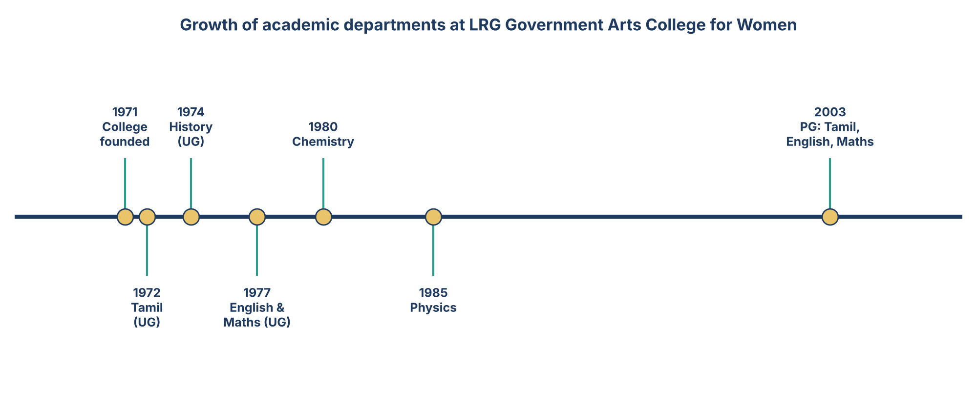
Figure 1: Key milestones in the growth of departments (years as recorded in the college profile).

2.3 Postgraduate Programmes and Career-Oriented Courses
The year 2003 was a landmark. Postgraduate programmes in Tamil, English and Mathematics were established, allowing students to continue to a master's degree on the same campus. At the undergraduate level the college also introduced need-based and career-oriented courses such as Physics with Computer Applications and B.Com., with the aim of improving the employability of women students.

2.4 Growth in Numbers of Programmes
Over five decades the college has moved from two arts departments to a wide range of streams across B.A., B.Sc. and B.Com., with postgraduate courses (M.A., M.Sc., M.Com.), M.Phil. and Ph.D. programmes on top. The sections that follow describe this academic structure in detail.

3. Mission and Social Role
The college works for the upliftment of women in society. Its approach is to give women access to quality higher education at a very low cost, to encourage them to become independent and to plant the seed of confidence and well-being in their minds.

3.1 Guiding Aims
- Provide affordable, merit-based higher education to women from all sections of society.
- Offer instruction in both Tamil and English so that language is never a barrier.
- Strengthen employability through career-oriented and application-based courses.
- Prepare students for higher studies, research and competitive examinations.
- Build character, leadership and social responsibility through co-curricular activity.

3.2 Serving Three Districts
Because it is the only government women's college for Coimbatore, Tirupur and Erode districts, the college draws students from a very wide catchment area. Many of them are first-generation graduates in their families. For such students, a government college with low fees is often the only realistic route to a degree.

3.3 Impact on Students and Families
A degree changes the options available to a young woman: she can take up a job, prepare for government examinations, move on to a master's programme or start her own enterprise. Tirupur is well known as a major hub of the knitwear and garment industry, so graduates in commerce, computer applications and science also have local industry around them to look to for employment and internships.

4. Academic Programmes
The college offers a comprehensive range of programmes at the undergraduate, postgraduate and doctoral levels. Study is full time, and all courses are affiliated to Bharathiar University.

4.1 Programmes by Level
Level | Degrees | Notes
Undergraduate | B.A., B.Sc., B.Com., BBA | Core of the college; most students join here
Postgraduate | M.A., M.Sc., M.Com. | PG started in 2003 with Tamil, English and Maths
Research | M.Phil., Ph.D. | For students aiming at teaching and research
Other | Physical education programmes | Listed in college directories

4.2 Undergraduate Courses Offered
Directory listings show a total of fifteen full-time undergraduate courses across three degrees: nine B.Sc. courses, four B.A. courses and two B.Com. courses.
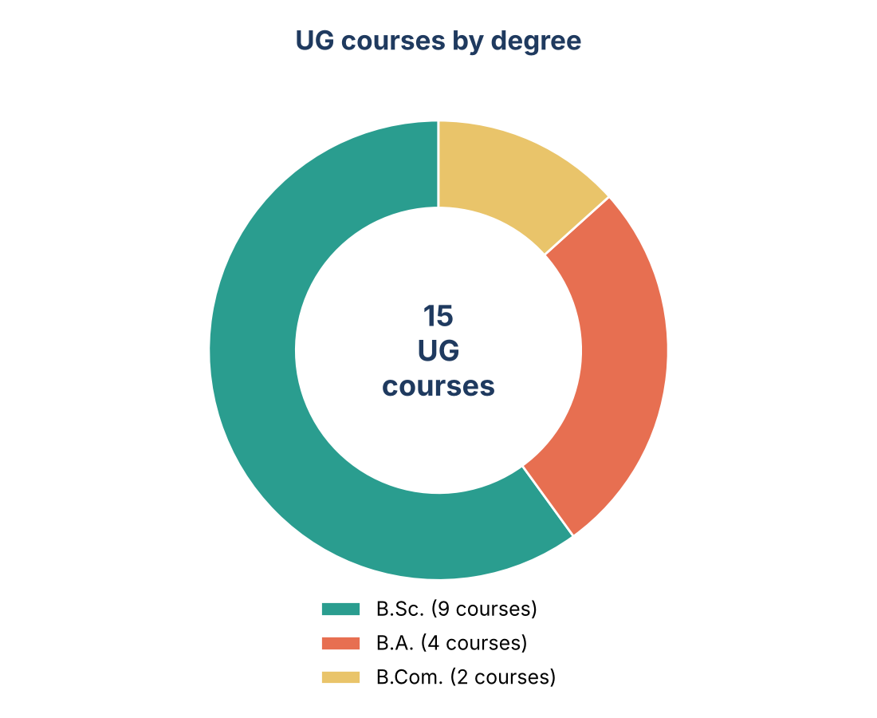
Figure 2: Number of UG courses by degree, based on public college-directory data.

4.3 Streams Available
Arts and languages: Tamil, English, History and Economics.
Science: Physics, Chemistry, Mathematics, Zoology, Microbiology, Food Science, Electronics and Computer Science / Computer Applications.
Commerce: B.Com. (General) and B.Com. with Computer Applications.
Note: the exact set of courses and the number of seats can change from year to year, so applicants should confirm the current list from the college prospectus or the official admission notification.

5. Fees and Admission

5.1 Fee Structure
One of the biggest strengths of a government college is its low fee. The first-year fees reported for the undergraduate degrees are shown below.
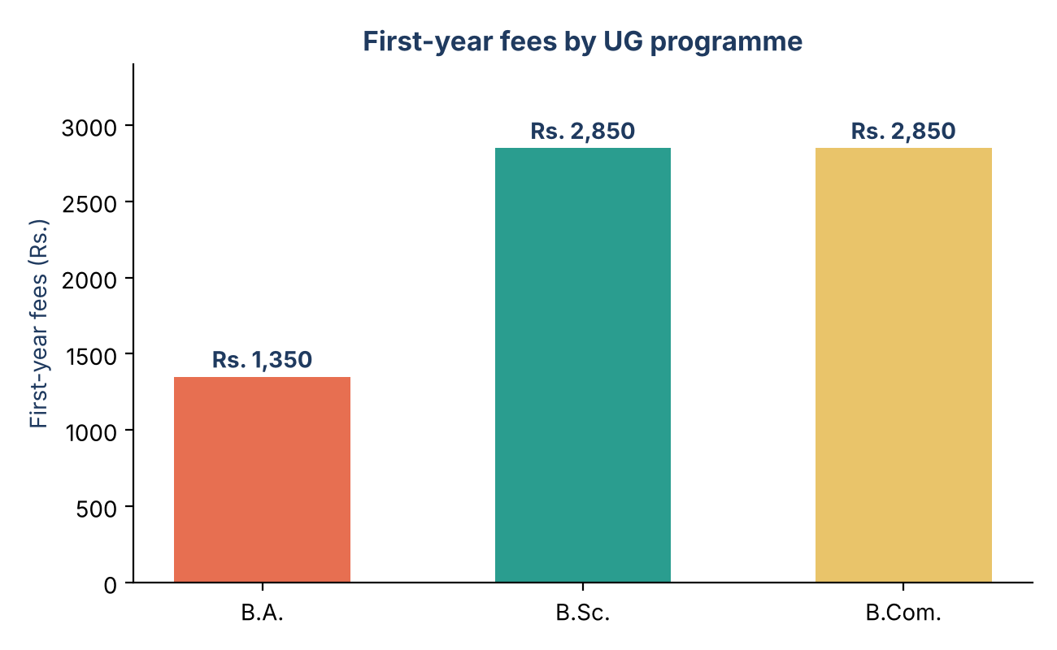
Figure 3: First-year fees for undergraduate degrees, as listed in public directories.
Degree | First-year fees (Rs.) | Eligibility
B.A. | 1,350 | 10+2 pass
B.Sc. | 2,850 | 10+2 pass
B.Com. | 2,850 | 10+2 pass

These figures are taken from third-party directories and should be treated as indicative. Actual fees may include additional charges set by the government or university, and may change every year.

5.2 Admission Process
Admission to all programmes is merit-based. For undergraduate courses, eligibility is a pass in 10+2 (higher secondary), and seats are allotted according to marks and the government's reservation rules. Applications for the last published cycle were invited in May, so students should watch for notifications at the same time every year.

5.3 Step-by-Step for Applicants
- Watch for the official admission notification in May after the higher secondary results.
- Fill in the online application and choose your preferred courses in order of priority.
- Keep scanned copies of marksheets, transfer certificate, community certificate and photographs ready.
- Attend counselling or certificate verification on the date announced.
- Pay the fees and complete admission formalities within the given time.

6. Facilities and Campus Life
The college is located on Palladam Main Road in Tirupur. Public directories list a range of student facilities for the college, and a college visit is the best way to see exactly what is available at present.

6.1 Facilities Listed
Facility | What it offers students
Library | Books, reference material and reading space for coursework and exam preparation
Laboratories | Practical work for the science and computer departments
Hostel | Accommodation for students who come from distant places
Sports | Grounds and equipment for games and physical education
Transport | Access by road along Palladam Main Road
Cafeteria | Food and refreshments on campus
Medical support | Basic health support for students
Wi-Fi | Internet access for learning

6.2 Learning Environment
Smaller classes in a women-only setting make it easier for many students to take part in discussion, ask questions and lead activities. Departments typically organise seminars, guest lectures, department associations and student clubs, which help students develop communication and leadership skills alongside their degree.

6.3 Co-curricular Activities
Women's colleges in Tamil Nadu commonly run National Service Scheme units, youth red cross, sports teams, cultural programmes and literary competitions. Students are encouraged to take part, since certificates and experience from these activities add value to a graduate's profile.

7. Student Outcomes

7.1 Higher Education
A steady number of graduates continue to higher studies. Public data for recent years records 456 undergraduate students opting for higher education. The presence of M.A., M.Sc., M.Com., M.Phil. and Ph.D. programmes on the same campus makes it easy for students to continue without moving elsewhere.

7.2 Employment Paths
Placement information published for the college is limited, and no verified salary or recruiter data is available. Graduates generally follow these paths:
- Teaching, after B.Ed. or higher degrees and eligibility tests.
- Government jobs through TNPSC, banking, railway and other competitive examinations.
- Private sector roles in accounting, IT support, laboratories and the garment and textile industry around Tirupur.
- Self-employment and small business, supported by skills in commerce and computer applications.

7.3 Improving Employability
Students can improve their prospects by taking add-on certificate courses, learning spoken English and computer skills, completing internships with local industry and starting competitive-exam preparation from the second year of their degree.

8. Why Choose This College
- Government institution with very low fees compared with private colleges.
- Only government women's college for Coimbatore, Tirupur and Erode districts.
- More than fifty years of experience since 1971.
- Courses in arts, science and commerce, plus PG, M.Phil. and Ph.D.
- Tamil and English medium of instruction.
- Affiliated to Bharathiar University, so degrees are widely recognised.

8.1 Points to Consider
Seats are limited and admission depends on marks, so apply to more than one course and check the latest cut-off before deciding.

8.2 Tips for Students
- Choose a course based on interest and career goals, not only on marks.
- Attend classes regularly and use the library well.
- Take part in at least one club or activity each year.
- Build English and computer skills from the first semester.

9. Contact Details
Item | Details
Address | LRG Government Arts College for Women, Palladam Main Road, Tirupur - 641604, Tamil Nadu, India
Affiliated university | Bharathiar University, Coimbatore
Best way to confirm details | Visit the college office or the Bharathiar University / Tamil Nadu higher education admission websites

10. Conclusion
LRG Government Arts College for Women, Tirupur has spent more than five decades widening access to higher education for women in the Coimbatore, Tirupur and Erode region. From two arts departments in the early 1970s it has grown into a college offering many streams in arts, science and commerce, with postgraduate and research options as well. Its low fees, merit-based admission, bilingual instruction and women-only environment make it an important institution for first-generation learners and for families who want a safe and affordable college.
For anyone considering joining, the best next step is to check the latest admission notification, compare the courses that match your interests and visit the campus.

Sources and Notes
Information in this document is compiled from public college directories and the college's own profile (Careers360, Collegedunia, Admistay and Scholar9 listings). Fee figures, course counts and facility lists come from these third-party pages and may be outdated. Sections on student activities, employment paths and tips are general guidance and not official statements by the college. Please verify all details with the college before making decisions.

