**-- Create database**

CREATE DATABASE IF NOT EXISTS walmartSales;

USE walmartSales;

**-- Create table**

CREATE TABLE IF NOT EXISTS sales(

invoice_id VARCHAR(30) NOT NULL PRIMARY KEY,

branch VARCHAR(5) NOT NULL,

city VARCHAR(30) NOT NULL,

customer_type VARCHAR(30) NOT NULL,

gender VARCHAR(30) NOT NULL,

product_line VARCHAR(100) NOT NULL,

unit_price DECIMAL(10,2) NOT NULL,

quantity INT NOT NULL,

tax_pct FLOAT(6,4) NOT NULL,

total DECIMAL(12, 4) NOT NULL,

date DATETIME NOT NULL,

time TIME NOT NULL,

payment VARCHAR(15) NOT NULL,

cogs DECIMAL(10,2) NOT NULL,

gross_margin_pct FLOAT(11,9),

gross_income DECIMAL(12, 4),

rating FLOAT(2, 1)

);

**-- Data cleaning**

SELECT * FROM sales;

**-- Add the time_of_day column**

SELECT

time,

(CASE

WHEN `time` BETWEEN "00:00:00" AND "12:00:00" THEN "Morning"

WHEN `time` BETWEEN "12:01:00" AND "16:00:00" THEN "Afternoon"

ELSE "Evening"

END) AS time_of_day

FROM sales;

ALTER TABLE sales ADD COLUMN time_of_day VARCHAR(20);

UPDATE sales

SET time_of_day = (

CASE

WHEN `time` BETWEEN "00:00:00" AND "12:00:00" THEN "Morning"

WHEN `time` BETWEEN "12:01:00" AND "16:00:00" THEN "Afternoon"

ELSE "Evening"

END

);

**-- Add day_name column**

SELECT

date, DAYNAME(date)

FROM sales;

ALTER TABLE sales ADD COLUMN day_name VARCHAR(10);

UPDATE sales

SET day_name = DAYNAME(date);

**-- Add month_name column**

SELECT

date,

MONTHNAME(date)

FROM sales;

ALTER TABLE sales ADD COLUMN month_name VARCHAR(10);

UPDATE sales

SET month_name = MONTHNAME(date);

**-- GENERIC QUESTIONS**

-- 1 How many unique cities does the data have?

SELECT

DISTINCT city

FROM sales;

RESULT:

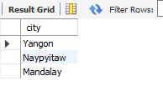

-- 2 In which city is each branch?

SELECT

DISTINCT city,

branch

FROM sales;

RESULT:

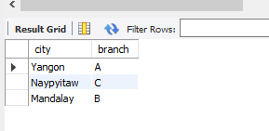

**-- PRODUCT QUESTIONS**

-- 1 How many unique product lines does the data have?

SELECT

DISTINCT product_line

FROM sales;

RESULT:

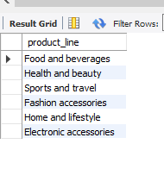

-- 2 What is the most selling product line

SELECT

SUM(quantity) as qty,

product_line

FROM sales

GROUP BY product_line

ORDER BY qty DESC;

RESULT:

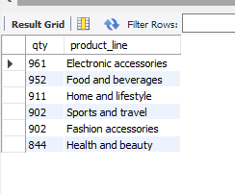

-- 3 What is the total revenue by month

SELECT

month_name AS month,

SUM(total) AS total_revenue

FROM sales

GROUP BY month_name

ORDER BY total_revenue;

RESULT:

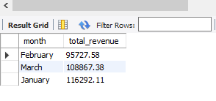

-- 4 What month had the largest COGS?

SELECT

month_name AS month,

SUM(cogs) AS cogs

FROM sales

GROUP BY month_name

ORDER BY cogs;

RESULT:

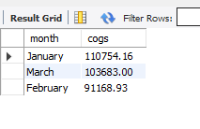

-- 5 What product line had the largest revenue?

SELECT

product_line,

SUM(total) as total_revenue

FROM sales

GROUP BY product_line

ORDER BY total_revenue DESC;

RESULT:

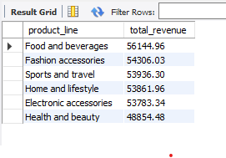

-- 6 What is the city with the largest revenue?

SELECT

branch,

city,

SUM(total) AS total_revenue

FROM sales

GROUP BY city, branch

ORDER BY total_revenue;

RESULT:

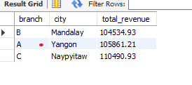

-- 7 What product line had the largest VAT?

SELECT

product_line,

AVG(tax_pct) as avg_tax

FROM sales

GROUP BY product_line

ORDER BY avg_tax DESC;

RESULT:

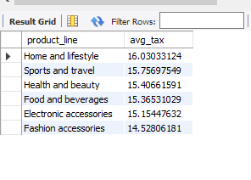

-- 8 Fetch each product line and add a column to those product

-- line showing "Good", "Bad". Good if its greater than average sales

SELECT

AVG(quantity) AS avg_qnty

FROM sales;

SELECT

product_line,

CASE

WHEN AVG(quantity) > 6 THEN "Good"

ELSE "Bad"

END AS remark

FROM sales

GROUP BY product_line;

RESULT:

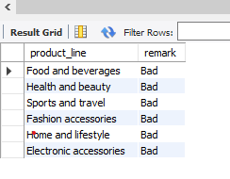

-- 9 Which branch sold more products than average product sold?

SELECT

branch,

SUM(quantity) AS qnty

FROM sales

GROUP BY branch

HAVING SUM(quantity) > (SELECT AVG(quantity) FROM sales);

RESULT:

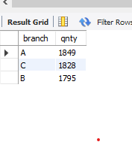

-- 10 What is the most common product line by gender

SELECT

gender,

product_line,

COUNT(gender) AS total_cnt

FROM sales

GROUP BY gender, product_line

ORDER BY total_cnt DESC;

RESULT:

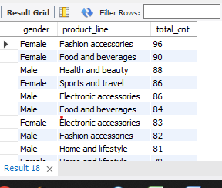

-- 11 What is the average rating of each product line

SELECT

ROUND(AVG(rating), 2) as avg_rating,

product_line

FROM sales

GROUP BY product_line

ORDER BY avg_rating DESC;

RESULT:

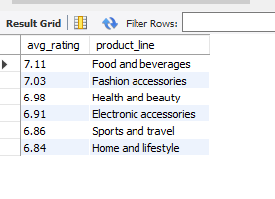

-------------------------------------------------------------------------------------------------------------------

--CUSTOMER QUESTIONS

-- 1 How many unique customer types does the data have?

SELECT

DISTINCT customer_type

FROM sales;

RESULT:

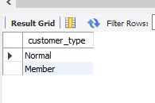

-- 2 How many unique payment methods does the data have?

SELECT

DISTINCT payment

FROM sales;

RESULT:

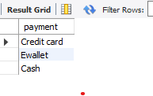

-- 3 What is the most common customer type?

SELECT

customer_type,

count(*) as count

FROM sales

GROUP BY customer_type

ORDER BY count DESC;

RESULT:

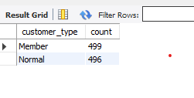

-- 5 Which customer type buys the most?

SELECT

customer_type,

COUNT(*)

FROM sales

GROUP BY customer_type;

RESULT:

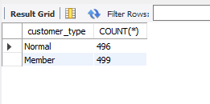

-- 6 What is the gender of most of the customers?

SELECT

gender,

COUNT(*) as gender_cnt

FROM sales

GROUP BY gender

ORDER BY gender_cnt DESC;

RESULT:

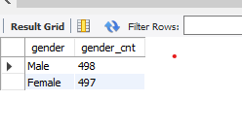

-- 7 What is the gender distribution per branch?

SELECT

branch,gender,

COUNT(*) as gender_cnt

FROM sales

GROUP BY branch,gender

ORDER BY branch,gender_cnt DESC;

RESULT:

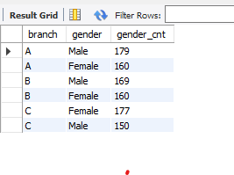

Gender per branch is more or less the same hence, I don't think has an effect of the sales per branch and other factors

-- 8 Which time of the day do customers give most ratings?

SELECT

time_of_day,

AVG(rating) AS avg_rating

FROM sales

GROUP BY time_of_day

ORDER BY avg_rating DESC;

RESULT:

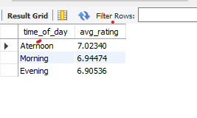

-- Looks like time of the day does not really affect the rating, its

-- more or less the same rating each time of the day.

-- 9 Which time of the day do customers give most ratings per branch?

SELECT branch,

time_of_day,

AVG(rating) AS avg_rating

FROM sales

GROUP BY branch,time_of_day

ORDER BY avg_rating DESC;

RESULT:

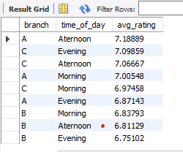

-- Branch A and C are doing well in ratings, branch B needs to do a

-- little more to get better ratings.

-- 10 Which day fo the week has the best avg ratings?how many sales are made on these days?

SELECT

day_name,

AVG(rating) AS avg_rating,

SUM(total) as total_sales

FROM sales

GROUP BY day_name

ORDER BY avg_rating DESC;

RESULT:

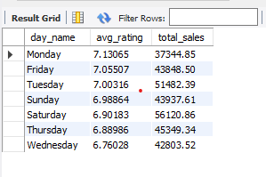

-- Mon, Tue and Friday are the top best days for good ratings

-- 11 Which day of the week has the best average ratings to branch C?

SELECT

day_name,

COUNT(day_name) total_sales

FROM sales

WHERE branch = "C"

GROUP BY day_name

ORDER BY total_sales DESC;

RESULT:

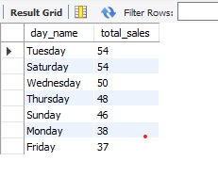

**-- SALES QUESTION**

-- 1 Number of sales made in each time of the day per weekday.

SELECT

day_name as week_day,time_of_day,

COUNT(*) AS total_sales

FROM sales

WHERE day_name = "Sunday"

GROUP BY time_of_day

ORDER BY total_sales DESC;

RESULT:

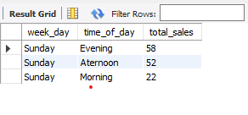

-- Evenings experience most sales, the stores are

-- filled during the evening hours

-- 2 Which of the customer types brings the most revenue?

SELECT

customer_type,

SUM(total) AS total_revenue

FROM sales

GROUP BY customer_type

ORDER BY total_revenue DESC;

RESULT:

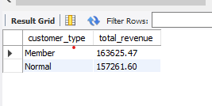

-- 3 Which city has the largest tax/VAT percent?

SELECT

city,

ROUND(AVG(tax_pct), 2) AS avg_tax_pct

FROM sales

GROUP BY city

ORDER BY avg_tax_pct DESC;

RESULT:

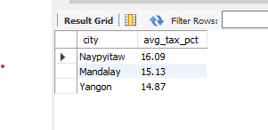

-- 4 Which customer type pays the most in VAT?

SELECT

customer_type,

AVG(tax_pct) AS total_tax

FROM sales

GROUP BY customer_type

ORDER BY total_tax;

RESULT:

