**USE pizzahut;**

**-- Basic:**

-- 1.Retrieve the total number of orders placed.

SELECT

COUNT(*) AS total_no_orders

FROM

orders;

**RESULT:**

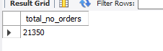

-- 2.Calculate the total revenue generated from pizza sales.

SELECT

ROUND(SUM(od.quantity*p.price),2) AS total_revenue

FROM order_details od JOIN pizzas p

ON p.pizza_id=od.pizza_id;

**RESULT:**

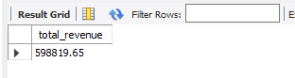

**-- 3.Identify the highest-priced pizza.**

SELECT

pt.name, p.price

FROM

pizza_types pt

JOIN

pizzas p ON pt.pizza_type_id = p.pizza_type_id

ORDER BY p.price DESC

LIMIT 1;

**RESULT:**



**-- 4.Identify the most common pizza size ordered.**

SELECT

p.size, COUNT(od.order_details_id) order_count

FROM

pizzas p

JOIN

order_details od ON p.pizza_id = od.pizza_id

GROUP BY p.size

ORDER BY order_count DESC;

**RESULT:**

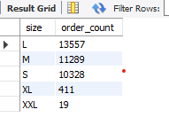

**-- 5.List the top 5 most ordered pizza types along with their quantities.**

SELECT

pt.name, SUM(od.quantity) Quantity

FROM

pizza_types pt

JOIN

pizzas p ON pt.pizza_type_id = p.pizza_type_id

JOIN

order_details od ON od.pizza_id = p.pizza_id

GROUP BY pt.name

ORDER BY Quantity DESC

LIMIT 5;

**RESULT:**

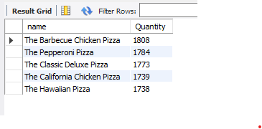

**-- Intermediate:**

**-- 6.Join the necessary tables to find the total quantity of each pizza category ordered.**

SELECT

pt.category, SUM(od.quantity) AS Quantity

FROM

pizza_types pt

JOIN

pizzas p ON pt.pizza_type_id = p.pizza_type_id

JOIN

order_details od ON od.pizza_id = p.pizza_id

GROUP BY pt.category

ORDER BY Quantity DESC;

**RESULT:**

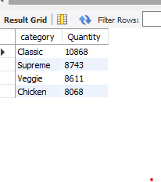

**-- 7.Determine the distribution of MAX 10 orders by hour of the day.**

SELECT

HOUR(order_time) , COUNT(order_id)

FROM

orders

GROUP BY HOUR(order_time)

ORDER BY COUNT(order_id) DESC

LIMIT 10 ;

**RESULT:**

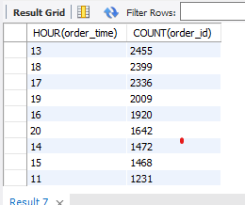

**-- 8.Join relevant tables to find the category-wise distribution of pizzas.**

SELECT

category, COUNT(name)

FROM

pizza_types

GROUP BY category;

**RESULT:**

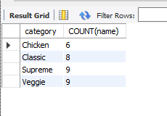

-- 9.Group the orders by date and calculate the average number of pizzas ordered per day.

SELECT

ROUND(AVG(quantity), 0) avg_pizza_ordered_per_day

FROM

(SELECT

o.order_date, SUM(od.quantity) AS quantity

FROM

orders o

JOIN order_details od ON o.order_id = od.order_id

GROUP BY o.order_date) AS Order_quantity;\

**RESULT:**



**-- 10.Determine the top 3 most ordered pizza types based on revenue.**

SELECT

pt.name, SUM(od.quantity * p.price) AS revenue

FROM

pizza_types pt

JOIN

pizzas p ON pt.pizza_type_id = p.pizza_type_id

JOIN

order_details od ON od.pizza_id = p.pizza_id

GROUP BY pt.name

ORDER BY revenue DESC

LIMIT 3;

**RESULT:**

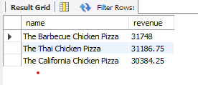

**-- Advanced:**

**-- 11.Calculate the percentage contribution of each pizza type to total revenue.**

SELECT

pt.category,

CONCAT( ROUND(SUM(od.quantity * p.price) / (SELECT

ROUND(SUM(od.quantity * p.price), 2) AS total_sales

FROM

order_details od

JOIN

pizzas p ON p.pizza_id = od.pizza_id) * 100, 2),"%") AS revenue

FROM

pizza_types pt

JOIN

pizzas p ON pt.pizza_type_id = p.pizza_type_id

JOIN order_details od ON od.pizza_id=p.pizza_id

GROUP BY pt.category

ORDER BY revenue DESC;

**RESULT:**

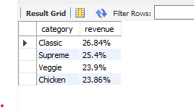

**-- 12.Analyze the cumulative revenue generated over time.**

WITH salesCTE AS

(

SELECT o.order_date AS order_date,

SUM(od.quantity * p.price) AS revenue

FROM order_details od JOIN pizzas p

ON od.pizza_id=p.pizza_id

JOIN orders o

on o.order_id=od.order_id

GROUP BY o.order_date

)

SELECT order_date,

ROUND(SUM(revenue)over(ORDER BY order_date) ,2)AS cum_revenue

FROM salesCTE;

**RESULT:**

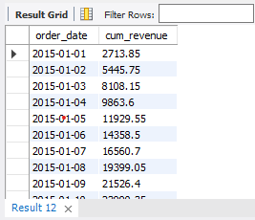

**-- 13.Determine the top 3 most ordered pizza types based on revenue for each pizza category.**

WITH CTE AS

(

SELECT

pt.category,pt.name,

ROUND(SUM((od.quantity*p.price)),2)AS revenue

FROM pizza_types pt JOIN pizzas p

ON pt.pizza_type_id=p.pizza_type_id

JOIN

order_details od

ON od.pizza_id=p.pizza_id

GROUP BY pt.category,pt.name

)

SELECT category,name,revenue

FROM

(

SELECT category,name,revenue,

RANK() OVER (PARTITION BY category ORDER BY revenue DESC) AS rn

FROM CTE) AS a

WHERE rn <3

order by category;

**RESULT:**

