DSCD611: PROGRAMMING FOR DATA SCIENTISTS
TERM PAPER

Physicochemical Predictors of White Wine Quality: Evidence from Statistical and Machine Learning Models

GROUP: B13
Desmond Lemuel Torsi………………………………22424834
Eugene Boye Afari ………………………………………………22424749
Emmanuel Asante Opoku…………………22426020 (Head)
Samuel Ofori……………………………….22424281
Henry Asiedu Adade……………………….22428542

Abstract
This study examines how physicochemical properties influence white wine quality using statistical and machine learning methods. The results show that alcohol is the strongest positive determinant of quality, while volatile acidity is the most influential negative factor, with free sulfur dioxide and chlorides playing secondary roles. Ensemble machine learning models, particularly Random Forest, outperform linear approaches but explain only about one-third of quality variation. SHAP-based interpretability confirms both the importance and direction of feature effects, highlighting that while key chemical attributes matter, wine quality is also shaped by unobserved sensory and winemaking factors.

INTRODUCTION
- Background
Wine quality assessment is inherently complex, combining chemical composition with sensory perception. While expert tasters ultimately evaluate quality, physicochemical properties provide objective, measurable indicators that strongly influence aroma, flavor, mouthfeel, and overall acceptability. Advances in statistical modeling and machine learning have enabled more systematic analysis of how these physicochemical attributes relate to perceived wine quality.
Although several studies have examined wine chemistry (Cortez et al., 2009; Ofoedu et al., 2022; Sui et a., 2024) there is still limited consensus on which physicochemical properties are the most critical determinants of white wine. This gap in empirical understanding hinders winemakers’ ability to optimize production processes and improve product consistency using objective, data-driven criteria. Therefore, a systematic analysis of the relationships between physicochemical properties and white wine quality is needed to provide clear, evidence-based insights into the key predictors of quality.

This study investigates the relationship between key physicochemical properties and white wine quality using data from the UCI Machine Learning Repository. By integrating correlation analysis, classical regression techniques, regularized models, robust regression and machine learning approaches, the study aims to identify the most influential determinants of quality and evaluate the predictive capacity of physicochemical variables.
  - Objectives
- To investigate if wine ingredients are highly correlated
- To examine the relationship between key physicochemical properties and wine quality
- To identify the most significant physicochemical determinants that impact wine quality.
- To develop and evaluate predictive models that use physicochemical attributes to classify or predict white wine quality.
- To analyze the extent to which individual features contribute to variations in quality scores.
- To investigate the direction and variability of wine features, in the chosen model.

Methodology
2.1 Research design
A quantitative, observational study using secondary data on physicochemical measurements and sensory quality scores, from UCI Machine Learning repository. The design combines descriptive statistics, inferential analysis and predictive modelling (regression and classification.
2.2 Data preprocessing
The data consisted of 4, 898 entries, on 12 variables, without missing values. The target variable is wine quality. The explanatory variables are fixed acidity, volatile acidity, citric acid, residual sugar, free sulfur dioxide, total sulfur dioxide, density, pH, sulphates and alcohol. All variables are numeric. As large as about 937 entries were duplicated but were dropped. There were issues of outliers with some features but were corrected by winsorization. The data was split into train, validation and testing. The first split was 80% (training and validation) and 20% test. The second split was 80% train and 20% validation (of the initial 80%). In all, the data was split into 64% training, 16% validation and 20% testing. Because the features were measured on different scales, standardization became imperative. Without scaling, variables like total sulfur dioxide or residual sugar will dominate distance-based or gradient-based algorithms simply because they have larger numeric ranges, but not because they are more important. We therefore normalized the data using z-score normalization.

2.3 Modelling and Evaluation
Objective 1 was to verify if wine chemistry variables are highly correlated. This was achieved by both the Pearson pairwise correlation matrix and multicollinearity test using variance inflation factor. A heatmap was done to give a good pictorial view of the pairwise correlation matrix. The second objective was to examine the relationship between key physicochemical properties and wine quality, without essentially making a causality claim. This objective was achieved with the Pearson correlation and a heatmap. Objective 3 is to identify the most significant physicochemical determinants that influence wine quality. This was carried out using Ordinary Least Squares (OLS) as the baseline model, in a linear regression analysis. Ridge, LASSO, ElasticNet and Huber regression were estimated for side-by-side coefficient comparisons. The fourth objective is to develop and evaluate predictive models that use physicochemical attributes to predict wine quality. This objective employed the building and comparison of statistical and machine learning techniques. The statistical models are OLS, Ridge, LASSO, ElasticNet and Huber. The machine learning algorithms are Random Forest, Support Vector Machines, Decision Trees, Gradient Boosting Machines and Artificial Neural Networks. The evaluation metrics considered are R-squared, root mean squared error (RMSE), mean absolute error (MAE), maximum error and mean absolute percentage error (MAPE). The fifth objective is to analyze the extent to which each feature contributes to the variations in wine quality. This feature importance selection was done using the SHapley Additive exPlanations (SHAP) model. The last objective was to verify the direction and variability of the feature importance for the selected model. This was done with the SHAP Beeswarm plot.

Analyses and Discussion of Results

  - Introduction
This chapter presents the analyses and discussion of results arising from the empirical investigation of the relationship between physicochemical properties and white wine quality. The chapter is structured around the study’s stated objectives and integrates exploratory, statistical and machine learning analyses to provide a comprehensive understanding of both the determinants and predictability of wine quality. The chapter begins with exploratory data analysis (EDA), including descriptive statistics, visualizations and correlation analysis, to characterize the distributional properties of the data and identify potential interdependencies among variables. It then examines linear relationships and multicollinearity among physicochemical attributes, followed by an assessment of their direct associations with wine quality. Subsequently, classical regression models are employed to identify the most significant physicochemical determinants of quality, with attention to robustness across alternative estimation techniques.

The chapter further evaluates the predictive performance of multiple modeling approaches, comparing linear, regularized, robust and machine learning models to identify the most effective framework for predicting wine quality. Finally, advanced model interpretability techniques, specifically SHAP feature importance and SHAP beeswarm analysis, are used to explain how individual physicochemical variables contribute to variations in predicted quality at both the global and observation levels.

4.2 Exploratory data analysis (EDA)

Table 1 Descriptive Statistics
Variables | count | mean | std | min | 25% | 50% | 75% | max
Fixed Acidity | 3961 | 6.839 | 0.867 | 3.8 | 6.3 | 6.8 | 7.3 | 14.2
Volatile Acidity | 3961 | 0.281 | 0.103 | 0.08 | 0.21 | 0.26 | 0.33 | 1.1
Citric Acid | 3961 | 0.334 | 0.122 | 0 | 0.27 | 0.32 | 0.39 | 1.66
Residual Sugar | 3961 | 5.915 | 4.862 | 0.6 | 1.6 | 4.7 | 8.9 | 65.8
Chlorides | 3961 | 0.046 | 0.023 | 0.009 | 0.035 | 0.042 | 0.05 | 0.346
Free Sulfur Dioxide | 3961 | 34.889 | 17.21 | 2 | 23 | 33 | 45 | 289
Total Sulfur Dioxide | 3961 | 137.194 | 43.129 | 9 | 106 | 133 | 166 | 440
Density | 3961 | 0.994 | 0.003 | 0.987 | 0.992 | 0.994 | 0.996 | 1.039
PH | 3961 | 3.195 | 0.152 | 2.72 | 3.09 | 3.18 | 3.29 | 3.82
Sulphates | 3961 | 0.49 | 0.114 | 0.22 | 0.41 | 0.48 | 0.55 | 1.08
Alcohol | 3961 | 10.589 | 1.217 | 8 | 9.5 | 10.4 | 11.4 | 14.2
Quality | 3961 | 5.855 | 0.891 | 3 | 5 | 6 | 6 | 9

Fixed acidity has a mean of 6.84 with a relatively low standard deviation (0.87), indicating limited dispersion around the average. The interquartile range (6.3–7.3) suggests that most wines cluster within a narrow acidity band, consistent with standard white wine profiles. The presence of a higher maximum value (14.2) indicates a small number of highly acidic outliers. Alcohol content averages 10.59% with a standard deviation of 1.22, indicating meaningful variation across samples. The upper quartile (11.4) and maximum (14.2) show the presence of higher-alcohol wines, which prior analyses (Cortez et al., 2009) indicate are strongly associated with higher quality scores. Wine quality has a mean score of 5.86 and relatively low dispersion (SD = 0.89). The median and upper quartile of 6 each, suggest that most wines are rated as average to slightly above average, with fewer observations at the extremes (minimum 3, maximum 9).

The descriptive statistics reveal a heterogeneous dataset, particularly for residual sugar, sulfur compounds, and alcohol, which are key drivers of wine style and quality. In contrast, variables such as density and pH exhibit limited variation. The presence of outliers in several variables underscores the importance of robust modeling techniques. Collectively, these characteristics justify the use of both regression-based and machine learning models to capture linear effects, nonlinearities, and interaction patterns in wine quality prediction.

Objective 1
This is to verify if wine chemistry variables are highly correlated, as maintained by some authors (Swiegers & Pretorius, 2005; Jackson, 2020). The Pearson correlation matrix in Figure 1, summarizes the linear relationships among the physicochemical predictors. Overall, the matrix indicates that most features are weakly to moderately correlated, with only a few strong correlations that warrant attention. Residual Sugar and Density with r ≈ 0.80, is the strongest positive correlation in the matrix.
This clearly suggest that, higher residual sugar increases wine density. The implication is that, the two variables contain overlapping information and may introduce multicollinearity in linear regression models. Alcohol and Density with r ≈ −0.79, is a strongly negatively correlated, indicating that higher alcohol content lowers density. This aligns with fermentation chemistry, where sugar is converted into alcohol, reducing density (Jackson, 2020).
Free Sulfur Dioxide and Total Sulfur Dioxide has an expectedly strong positive relationship(r ≈ 0.62), since total sulfur dioxide includes free sulfur dioxide.
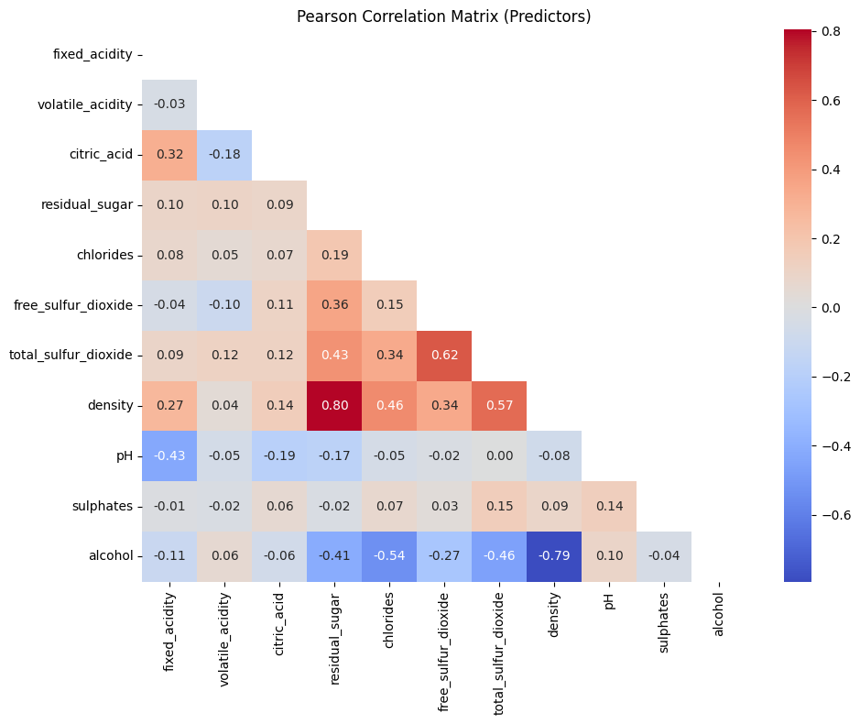
Figure 1 Multicollinearity
The correlation matrix indicates generally low interdependence among predictors, with a few strong and chemically intuitive correlations, most notably between residual sugar and density, alcohol and density, and free and total sulfur dioxide.

Objective 2
The intention is to identify potential physicochemical determinants of wine, but not causality. Figure 2 shows a direct and evidence-based analysis of the relationships between the physicochemical features and wine quality, using the Pearson correlation matrix, shown in heatmap.
It could be inferred that wine quality is influenced by a small number of dominant variables, while most attributes show weak or indirect effects. Alcohol exhibits the highest positive correlation with wine quality, of a rank of 0.46. This indicates that wines with higher alcohol content tend to receive higher quality ratings. Density is moderate and negatively correlated with quality, with a correlation coefficient of −0.36. Higher density is associated with residual sugar and lower alcohol, both of which reduce perceived quality in white wines. Lower-density wines are generally rated higher in quality. Chlorides show a noticeable negative relationship with quality (r = −0.32). Elevated chloride levels can introduce excessive salinity and harshness.
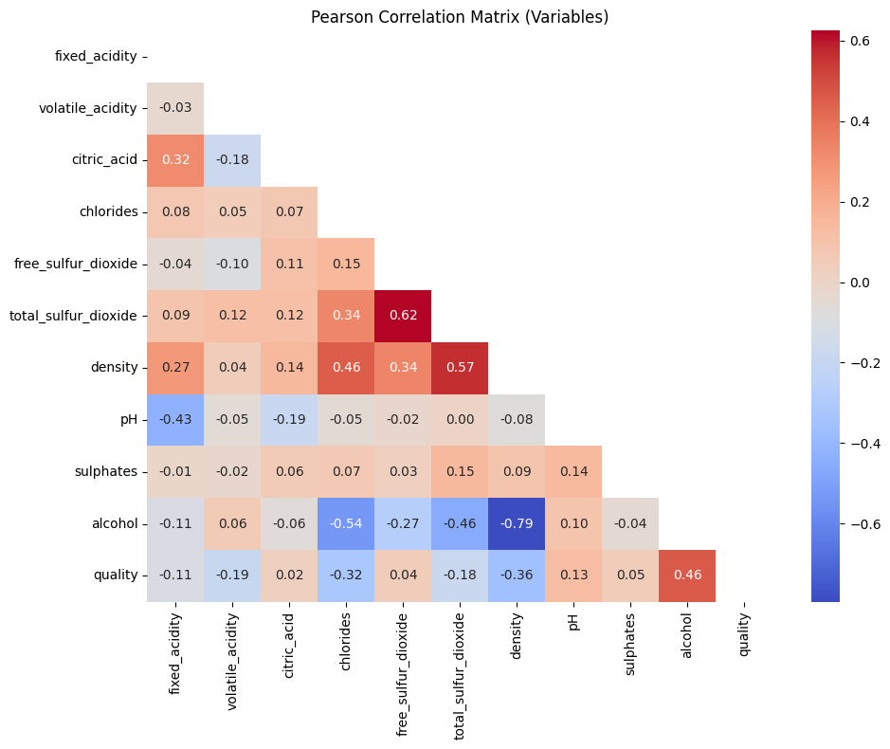
Figure 2 Correlation of Features with Quality
Overall, the Pearson correlation analysis reveals that wine quality is most strongly and positively associated with alcohol content, while density and chlorides exhibit moderate negative relationships. Most remaining physicochemical attributes display weak linear associations, indicating that wine quality arises from complex interactions rather than isolated effects.

Objective 3
Objective 3 aims to identify the most significant physicochemical determinants that impact wine quality, across different estimation models. This objective was addressed using a comparative modeling framework comprising OLS as the baseline model, Ridge, LASSO, Elastic Net, and Huber regression, as presented in Table 2. By evaluating the magnitude, direction and stability of coefficients across models, the analysis isolates physicochemical attributes with robust and economically meaningful effects on wine quality.
The results consistently identify alcohol content as the most significant determinant of wine quality, exhibiting the largest positive coefficients across all models and remaining robust under regularization and outlier-resistant estimation. This indicates that higher alcohol levels are strongly associated with higher quality ratings. Volatile acidity emerges as the most important negative determinant, with stable negative coefficients across all specifications, confirming its detrimental influence on sensory quality. Free sulfur dioxide shows a consistent positive effect, suggesting that appropriate preservative levels enhance perceived quality, while chlorides exert a moderate but stable negative impact.
Table 2. Coefficient Estimates of Features in Classical Regression Models
 | OLS | Ridge | LASSO | Elastic Net | Huber
Fixed Acidity | -0.03709 | -0.037002 | 0 | -0.01047 | -0.029533
Volatile Acidity | -0.14813 | -0.148026 | -0.11417 | -0.13204 | -0.135568
Citric Acid | 0.034518 | 0.034536 | 0 | 0.005219 | 0.033987
Chlorides | -0.06145 | -0.061538 | -0.03258 | -0.0535 | -0.064661
Fre Sulfur Dioxide | 0.156092 | 0.156006 | 0.071423 | 0.097982 | 0.154547
Total Sulfur Dioxide | -0.05727 | -0.057174 | 0 | 0 | -0.078297
Density | 0.043272 | 0.042819 | 0 | 0 | 0.051222
PH | 0.043927 | 0.043971 | 0.014821 | 0.029922 | 0.051136
Sulphates | 0.050086 | 0.050075 | 0.001263 | 0.023723 | 0.048896
Alcohol | 0.390127 | 0.389585 | 0.326014 | 0.337939 | 0.416842

Other variables such as pH and sulphates exhibit smaller yet consistent positive contributions, indicating secondary, fine-tuning roles in quality determination. In contrast, fixed acidity, citric acid, total sulfur dioxide, and density are either weak or redundant predictors, as evidenced by coefficient shrinkage to zero in LASSO and Elastic Net models.
Overall, the findings demonstrate that wine quality is driven by a parsimonious subset of physicochemical attributes, with alcohol, volatile acidity, free sulfur dioxide and chlorides accounting for the majority of systematic variation in quality scores.

Objective 4
Objective 4 attempts to develop and evaluate predictive models that use physicochemical attributes to classify or predict white wine quality. This objective was addressed by developing and comparing a suite of linear, regularized, robust and machine learning models, evaluated using multiple performance metrics (R², Adjusted R², RMSE, MAE, Maximum Error, and MAPE).
The results demonstrate that ensemble-based machine learning models outperform all other approaches. In particular, the Random Forest model achieved the highest predictive accuracy, explaining approximately 35% of the variance in wine quality (R² = 0.3547) and producing the lowest prediction errors across all metrics. LightGBM also performed strongly, confirming the effectiveness of boosted tree ensembles in capturing nonlinear relationships and feature interactions.
Traditional linear and regularized regression models (OLS, Ridge, LASSO, Elastic Net, and Huber) exhibited comparable but weaker performance, explaining roughly 25–26% of the variance in quality. While these models offer interpretability, their limited explanatory power indicates that linear assumptions are insufficient for fully modeling wine quality.
Table 3 Performance Evaluation of Models
 | R² | Adj. R² | RMSE | MAE | Max Error | MAPE
Random Forest | 0.3547 | 0.3464 | 0.6555 | 0.5273 | 2.26 | 0.0938
LightGBM | 0.3299 | 0.3213 | 0.668 | 0.5353 | 2.3743 | 0.095
Neural Network | 0.2748 | 0.2655 | 0.6949 | 0.5587 | 2.5192 | 0.0993
Decision Tree | 0.2645 | 0.2551 | 0.6998 | 0.56 | 2.5261 | 0.1
Huber | 0.2643 | 0.2549 | 0.6999 | 0.5585 | 2.4748 | 0.0998
Ridge | 0.2623 | 0.2529 | 0.7009 | 0.5611 | 2.342 | 0.1001
OLS | 0.2623 | 0.2528 | 0.7009 | 0.5611 | 2.3427 | 0.1001
XGBoost | 0.2556 | 0.246 | 0.7041 | 0.5603 | 2.3883 | 0.0994
ElasticNet | 0.2468 | 0.2372 | 0.7082 | 0.574 | 2.2841 | 0.1027
Lasso | 0.2183 | 0.2083 | 0.7215 | 0.5871 | 2.315 | 0.1053
SVR | -0.1238 | -0.1382 | 0.865 | 0.668 | 4.1121 | 0.1186

Neural Network and single Decision Tree models provided moderate improvements over linear baselines but remained inferior to ensemble methods. In contrast, Support Vector Regression (SVR) performed poorly, with negative R² values, indicating inadequate generalization in this context.
Overall, the findings confirm that predicting wine quality from physicochemical attributes is best achieved using nonlinear ensemble models, supporting the use of Random Forest and gradient boosting techniques as the preferred predictive frameworks for this study.

Figure 3 showcases a comparative evaluation of multiple predictive models using the R² score as the performance metric. The overall conclusion suggests that ensemble tree-based models (Random Forest and LightGBM) clearly outperform linear and single-tree approaches. The relatively modest R² values across all models indicate that wine quality is only partially explained by physicochemical properties, leaving room for unobserved factors including sensory attributes and winemaking practices. Linear models provide stable but limited performance, while SVR is unsuitable in its current configuration. From a modelling standpoint, Random Forest is earmarked as the preferred model, with LightGBM as a strong alternative, for predicting wine quality based on physicochemical attributes.
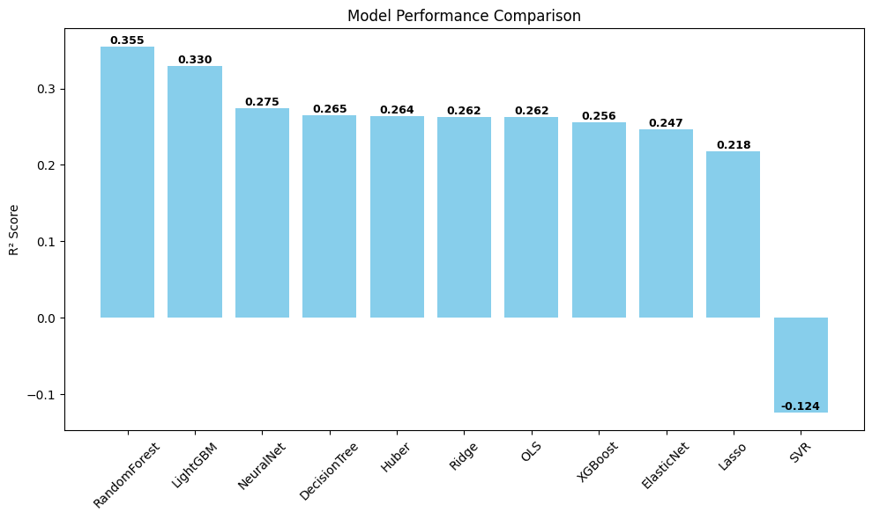
Figure 3 Model Performance Comparison of R²

Objective 5
The last objective investigates the extent to which individual features contribute to variations in best performing quality score model. It is inferred from Table 3 that, random forest is the best performing model, across different performance metrices. After establishing the best performing model, it becomes imperative to scrutinize the performances of the features, in the best performing model.

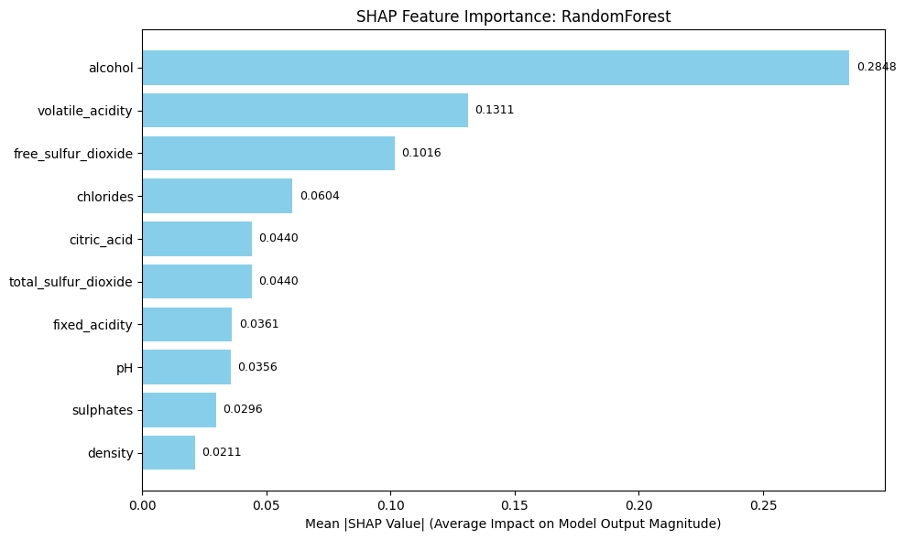
Figure 4 SHAP Feature Importance for Random Forest

This objective is directly supported by the Random Forest model combined with SHAP feature importance analysis, which provides both strong predictive performance and transparent model interpretability. The SHAP feature importance bar chart demonstrates that the Random Forest model bases its predictions primarily on a small subset of highly influential physicochemical variables.

The results show that alcohol content is the dominant predictor, contributing the largest average impact (0.284) on predicted wine quality, substantially exceeding all other variables. Volatile acidity emerges as the second most influential feature (0.13), confirming its critical role in shaping quality predictions. Free sulfur dioxide and chlorides provide meaningful but secondary contributions, while acidity-related variables (citric acid, fixed acidity and pH) and sulfur compounds contribute incrementally. Density exhibits minimal influence in the Random Forest predictions.

These findings indicate that the Random Forest model achieves its superior predictive accuracy by capturing nonlinear effects and interactions driven primarily by alcohol and acidity-related attributes, rather than relying on uniform contributions from all physicochemical variables. The concentration of predictive power among a limited number of features explains the model’s improved performance relative to linear and regularized regression approaches.

Overall, the SHAP-based interpretation confirms that the Random Forest model not only predicts wine quality more accurately but does so using an interpretable and theoretically consistent feature hierarchy.

Objective 6
Objective 6 verifies the directions and variabilities of the feature importance of the best performing model. This objective is explicitly addressed through the SHAP summary (beeswarm) plot, in Figure 6. Unlike aggregate importance measures, the SHAP beeswarm plot reveals both the magnitude and direction of each variable’s influence on predicted wine quality. The red/pin colour suggests high feature values, whiles blue colour suggests low feature values.
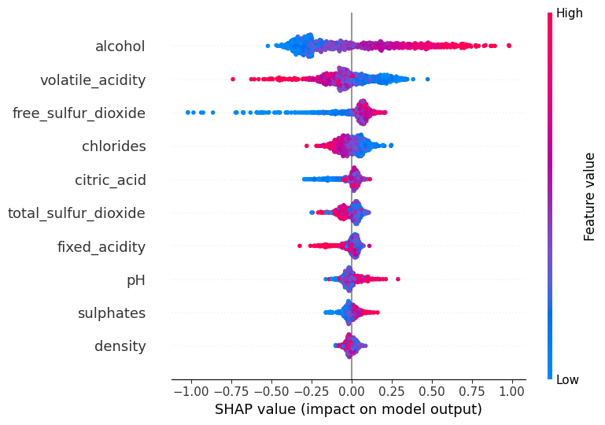
Figure 5 SHAP Beeswarm
The results show that alcohol content contributes the largest share of variation in quality scores, with high alcohol values consistently exerting strong positive effects (red) and low values (blue) driving predictions downward. This wide spread of SHAP values confirm alcohol as the dominant source of variability in predicted quality. Volatile acidity represents the most important negative contributor, where higher values systematically reduce predicted quality, explaining substantial downward variation in scores.
Free sulfur dioxide and chlorides contribute moderate but meaningful variability, exhibiting non-linear and asymmetric effects across observations. Acidity-related variables, including citric acid, fixed acidity, and pH display smaller, more localized contributions, suggesting that their effects on quality are conditional and interaction-dependent rather than dominant. Sulphates provide a minor positive contribution, while density shows negligible influence, with SHAP values clustered near zero.
Overall, the SHAP beeswarm analysis demonstrates that variation in wine quality predictions is driven primarily by alcohol and volatile acidity, with secondary variables introducing incremental adjustments rather than large shifts. By quantifying how each feature increases or decreases predicted quality across individual wines, this analysis directly fulfills Objective 6 by providing a transparent and granular explanation of how physicochemical attributes contribute to observed variations in wine quality scores.
Conclusion
This study provides a comprehensive, data-driven analysis of the relationship between physicochemical properties and wine quality. The findings show that wine quality is primarily driven by a small subset of key variables, with alcohol emerging as the strongest positive determinant and volatile acidity as the most important negative contributor. Other attributes, such as free sulfur dioxide and chlorides, play secondary roles, while several variables exhibit minimal or redundant effects.
Comparative modeling results indicate that nonlinear ensemble methods, particularly Random Forest, outperform linear and regularized regression models, demonstrating the importance of capturing nonlinearities and interactions in wine quality prediction. However, the relatively modest predictive power across all models suggests that physicochemical properties alone cannot fully explain perceived wine quality.
Finally, SHAP-based interpretability analyses confirm and extend these results by revealing both the magnitude and direction of individual feature effects at the observation level. Overall, the study shows that combining machine learning with explainable AI yields accurate and interpretable insights into wine quality determinants, while highlighting the continued relevance of unobserved sensory and process-related factors.

Rerferences
Cortez, P., Cerdeira, A., Almeida, F., Matos, T., & Reis, J. (2009). Modeling wine preferences by
data mining from physicochemical properties. Decision support systems, 47(4), 547-553.

Jackson, R. S. (2020). Wine Science: Principles and Applications (5th ed.). Academic Press. ISBN:
978-0123814687.

Ofoedu, C. E., Ofoedu, E. O., Chacha, J. S., Owuamanam, C. I., Efekalam, I. S., & Awuchi, C.
G. (2022). Comparative evaluation of physicochemical antioxidant, and sensory properties of red wine as markers of its quality and authenticity. International Journal of Food Science, 2022(1), 8368992.

Sui, X., Zhu, Z., Cheng, F., Sun, Y., & Jiang, X. (2024). Evaluation of physicochemical
properties, antioxidant capacity, and volatile flavor compounds during the wine fermentation of Mei (Prunus mume) fruit. LWT, 201, 116177.

Swiegers, J. H., & Pretorius, I. S. (2005). Yeast modulation of wine flavor. Advances in Applied
Microbiology, 57, 131–175.

