**Batch #1 (Anti-bias Task, Behavioral Assay)**

Animals: #148, #149, #150, #151

Strain: ???

**Protocol:** Mice were head-fixed in the tactile virtual reality setup. Mice were allowed to explore and collect reward in a single-choicepoint open (“unbiased”) maze in which reward was presented in both branches of the maze. The open maze allowed us to determine the animal’s preferred direction. In the subsequent three days, the mice were placed in a new (“anti-bias”) maze, in which the preferred side was stripped of reward and closed off by a dead end. Then, the mice were placed back into the original “unbiased” maze for two final days to gauge bias shift. Sessions were run for 20 minutes per day, for the 7 day protocol.

|  |
| --- |
| Prior to each batch of animals being enrolled in a task, they were given approximately 3-4 days of acclimatization to the ball by learning to run for water for ~2 days (via *scim_train.mat)*  and adjusting to walled tactile feedback for ~2 days (*randomCorridor.mat).* |

**Batch Performance:**

Overall: best batch of the summer

* Good runners (averaged ~102 trials per day)
* Robust learning: all animals had reversed bias to (near perfection)

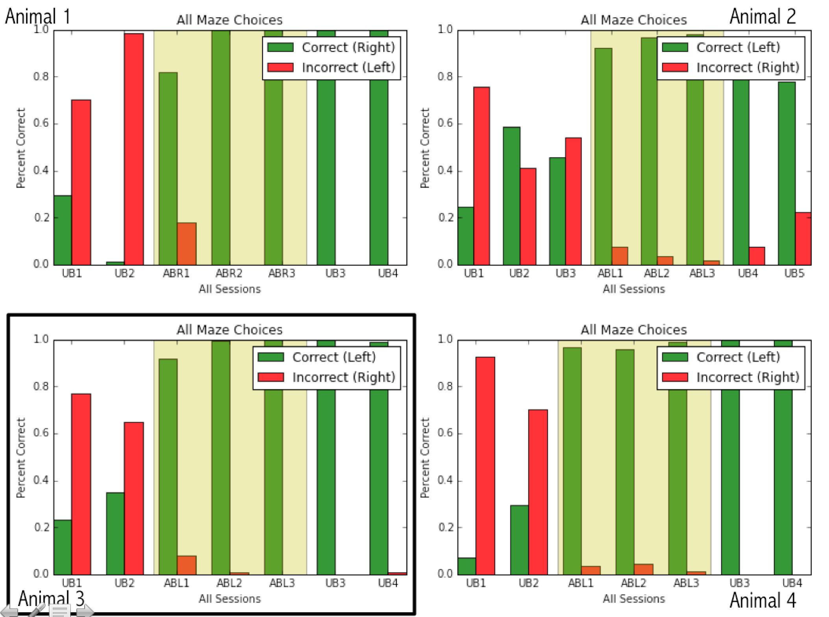

(see further figures produced in 148.ipynb, 149.ipynb, 150.ipynb, 151.ipynb, and batch1.ipynb)

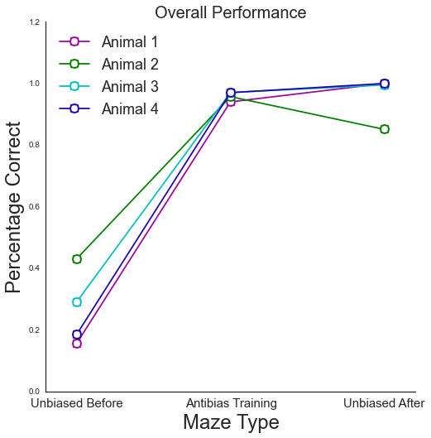

**Batch #1 (Pro-bias Task, Behavioral Assay)**

Animals: #149, #150 --- (#148, #151 excluded)

Strain: ???

**Protocol:** Following the “anti-bias” task, mice were placed into a new single-choice point maze in which the side of the newly adopted bias was now stripped of reward and blocked with a dead end, and the side of the original bias was now open and rewarded (essentially, the reverse of the “anti-bias” maze). Mice were trained in this maze for two day, for 20 minutes each day.

**Performance:**

* #149, #150 performed well, able to explore and learn new maze schematic
* #150 was also trained on another antibias day after probias (not shown here)

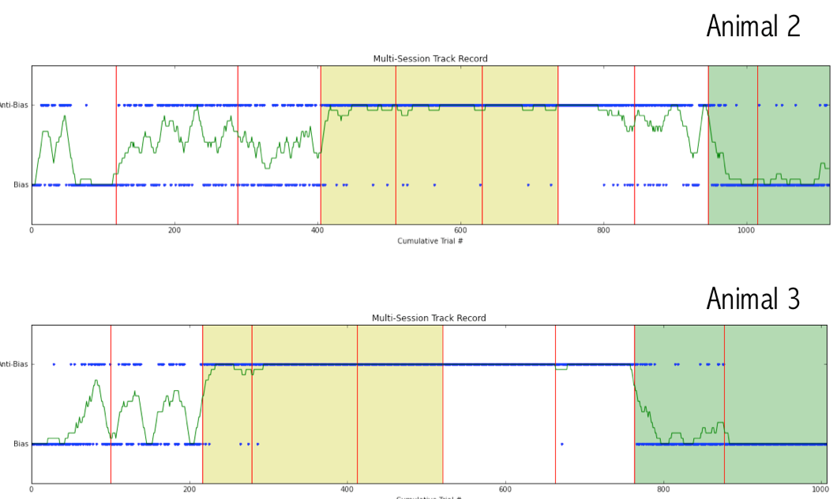

(see further figures produced in 149.ipynb, 150.ipynb)

**Failure Modes:**

* #148: Poor in ability to back out of new dead end, frequently times out by sitting in dead end.
* #151: begins running through front dead end wall.
* Initially, some mice needed to be trained with enlarged walls to make them receptive to tactile feedback and to keep their corridor position towards the center. Was done by taping taller card stock to the plastic walls. The walls were eventually removed or lost over the course of the protocol but mice only needed a few days to then achieve good corridor position with the normal walls

**Batch #1 (Switching Task, Behavioral Assay)**

Animals: #149, #150

Strain: ???

Upon noticing the relatively quick ability of mice to adapt to changing reward mazes, the switching task was designed to maximize the number of times a subject would have to adapt to new situation, in the hopes of elucidating more about vicarious trial-and-error behavior in mice. Vicarious trial-and-error (VTE) is characterized as the imagination of future trajectories and often manifests itself by rodents positioning their bodies or craning necks oriented toward the currently-pondered pathway.

**Protocol**: Mice were trained for three days in a flexible programmed “anti-bias” maze in which the the direction of the rewards and dead-ends were flipped after every 20 trials (in which ‘completion’ is defined by either the animal collecting reward and escaping the maze or the animal hits the 120-second timeout for maze completion). Sessions were run for 20 minutes each, which results in approximately 4-6 switches per session. Definitely the most demanding task of the summer. The first 20 sessions of each day were set to the most recent train, aka the “pro-bias” or initial bias side for #149 and an “antibias” side for #150

**Performance**: Surprisingly good?

* Problem 1: Seemed to fight an over-train bias. Mice faced correction biases in which it was easier to make corrections toward the side they had previously been trained to extensively.
  + #149 had been most recently trained on a day of “probias” (where reward was on the right) and also showed a higher percentage correct on the right
  + #150 had most recently been trained on one final post-probias “antibias” session (where reward was on the left) and therefore showed a higher percentage correct on the left

#149: #150:

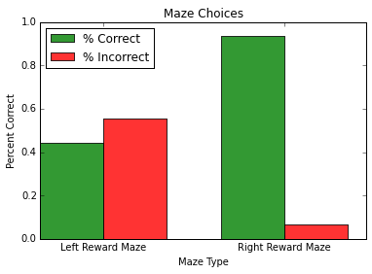 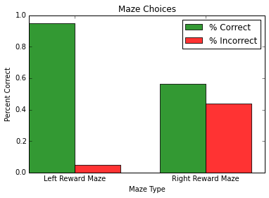

(see further performance dot plot figures at the end of 149.ipynb and 150.ipynb)

**Conclusions**:

* Mice can handle the task and adapt within 20 trials to new environments!
* Future hypothesis: well-trained naive mice should display a more even performance distribution regardless of side. ---time to replicate

**Batch #2 (Anti-bias Task, Behavior and Imaging)**

Animals: #146, #152, #5001, #5002

Strain: GP4.3 --check

The goal was to replicate the prior single choice point maze tasks and conduct calcium imaging to explore neural correlates in the posterior parietal cortex as well as retrosplenial cortex.

All 4 animals had large D-shaped windows installed over the left hemisphere.

**Acclimatization**: All mice trained for 1 day in running for water (scim_train.mat), and 2 days of 30 min sessions of random corridor running (*randomCorridor.mat).*

Note: 5001 was a very slow runner, and soon placed on QHA

**Protocol\***: Mice were allowed to explore and collect reward in a single-choicepoint open (“unbiased”) maze in which reward was presented in both branches of the maze. The open maze allowed us to determine the animal’s preferred direction. In the subsequent three days, the mice were placed in a new (“anti-bias”) maze, in which the preferred side was stripped of reward and closed off by a dead end. Then, the mice were placed into two days of switching task where the dead ends and reward sides flipped every 20 trials. The first 20 sessions of each day were set to the most recent training, in this case, the same as the antibias. The goal is to begin imaging on the switching tasks.

|  |
| --- |
| *Due to a number of failures, many mice were excluded over the course of the protocol leaving the protocol unfinished in all 4 animals. Protocol Completion below:* |

*Green = completed successfully | Orange = completed with error | x = not run*

|  |  |  |  |  |  |  |  |
| --- | --- | --- | --- | --- | --- | --- | --- |
| Animal | UB1 | UB2 | AB1 | AB2 | AB3 | S1 | S2 |
| #146 |  |  |  |  | x | Many incomplete | Many incomplete |
| #152 |  |  | Ran DE (1 trial) | Ran DE | x | x | x |
| #5001 |  |  |  | Ran DE | x | x | x |
| #5002 |  |  | Ran DE (1 trial) | Ran DE | x | x | x |

Note: On the second day of “antibias”: the timeout time was set to 30 seconds, easier and much much higher rates of incompletes. The timeout was lowered on the hypothesis that an increased number of approaches to the dead end. In addition, for all sessions in which mice ran dead ends, the session was aborted immediately.

Due to poor completion and a number of animal failures, imaging for switching tasks became nearly impossible, we instead ran imaging on a couple of animals during *randomCorridor.mat* sessions (5002 and 146). For #146, the corridor imaging was done between the “antibias” and switching days. For 5002, the corridor imaging was done as the final sessions after the “antibias” days. (Full protocol details for each animal can be found in *mvr_session_log.xlsx*)

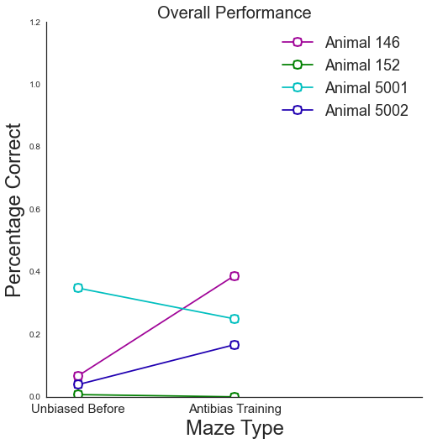

**Failure modes**:

* #146: best of the batch, fair number of incomplete trials however.
* #152: immediately ran dead ends
* #5001: was always a slow runner, began running dead ends on day 2 of “antibias”
* #5002: fast runner, but immediately ran dead ends

(see more figures in 146.ipynb, 152.ipynb, 5001.ipynb, 5002.ipynb, and batch2.ipynb)

**Batch #3 (Antibias and Open Water Task, Behavior)**

Animals: #153,#154, #155, #156

Strain: EMX1-CreX Rosa-LSL-H2B-GFP

After the failures of the imaging batch, we turned back to behavior to make our initial results more robust. Common failure modes we had met until now included mice running through dead ends and refusal to walk out of the dead end thus timing out the trial.

Initially we hoped to run this batch of mice again on the 2 day “unbias” -- 3 day “antibias -- 2 switching type of protocol. However, due to some mediocre performances during the antibias phase sessions, the protocol was modified to the following mid-protocol:

**Protocol**: The mice were placed in 1 day of unbiased to determine preferred direction, 3 days of antibias, and then 3 days of open water maze. The Open Water Maze is similar to and serves the same purpose of the antibias maze, except without the dead end. It looks like the unbiased maze with reward only present on the “antibias” side.

In the open water maze, it is very important that the animals are very water restricted now that there is no salient dead end to drive them away from the incorrect (biased) branch. Only the 0/1 presence of water drives the behavioral response. The open water maze thus at least eliminates the stress on the animal of being in the claustrophobic dead end space. The open water maze data was processed

Note: It might be worth it to explore the power of the maze as a navigational assay tool in a batch on its own. In these experiments, I was time crunched and wanted to get data for my poster to be honest, so I combined this test by implementing it after 3 days of antibias. While the performance could have been promising in this new maze, the results are confounded by any learning that occurred in the previous 3 days in an “antibias” maze that also involved dead ends.

**Performance**: (From top to bottom: #153, #154, #156)

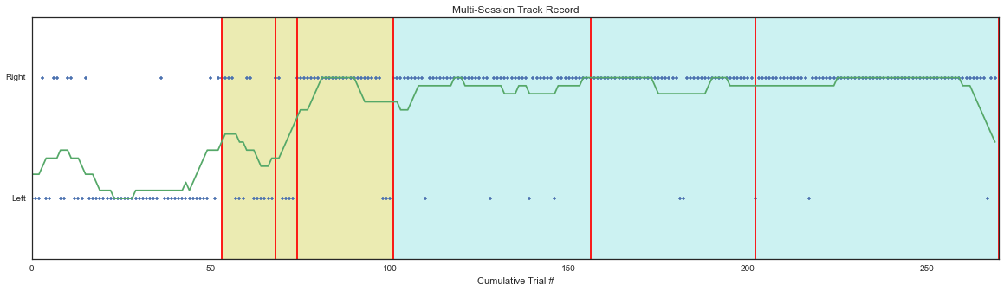

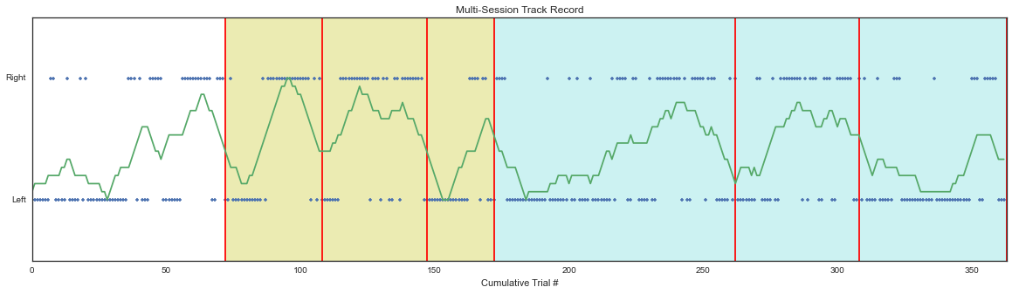

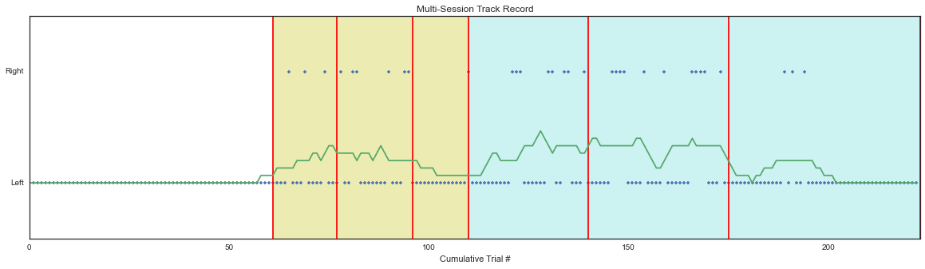

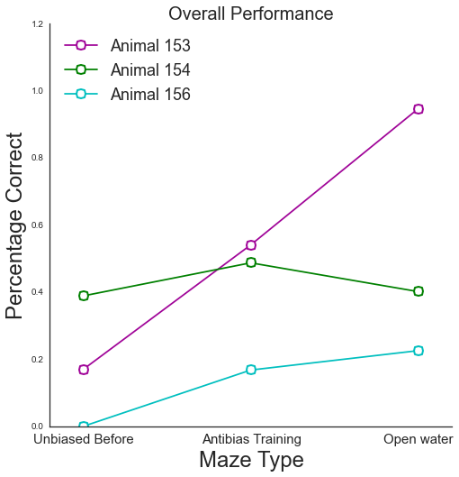

**Failure Modes**:

* #154, #156: both mice had difficulty backing out of dead ends. They were fairly slow mice, so they didn’t run through dead ends, but it seemed as though figured out the timeout, so they would often struggle a little bit in the dead ends and then sit and wait until the walls reset to the start point in the maze.
* In addition, #156 was 100% biased to one side during the unbiased day (see above), most of the correct trials seen in the data above were from manually guiding the treadmill ball toward reward, not independent decision. I also noticed that as the animal tried to run straight, it would be running slightly at an angle, and therefore automatically chooses one side much more easily than the other, and without a will to explore, will continue to stay running in one direction because it seems physically more natural,
* #155 lost a head cap on day one of corridor.
* #153 ran through dead ends during the antibias, although performed with high accuracy when the maze opened up, the learning however may have been established on the third “antibias” day.
* *RANDOM: These mice never ate the sunflower seed rewards after running in the rig. Even if I broke open the shell for them, there was no desire to eat the reward?*

**Batch #4**

Animals: #157, #158, +2 more

Strain: EMX1-CreX Rosa-LSL-H2B-GFP

This batch of animals was unfortunately never run. Likely due to surgical error, either in materials or performance, many of the head bars came off over the course of the following week. 1 animal was found dead in its cage on the second day of post-op care (cause of death unclear, though skull did not look infected). A second animal was euthanized by vet staff,a dnand autopsy revealed bloody matter in the intestines. The following two animals (#157 and #158) seemed to recover very well for a week. However, early I noticed that #157 had a tendency to scratch at the base of the head cap. We were later notified that the head bar had come off and the vet staff euthanized the animal. A similar warning was sent to us the next day about #158, and this animal was euthanized by us.

In all the animals that we euthanized, all head caps were ultimately salvaged and are currently stored in Nick’s acetone container. None of the skulls in these batch appeared infected (at least by visual inspection).

Pro tip: don’t use old Krazy Glue

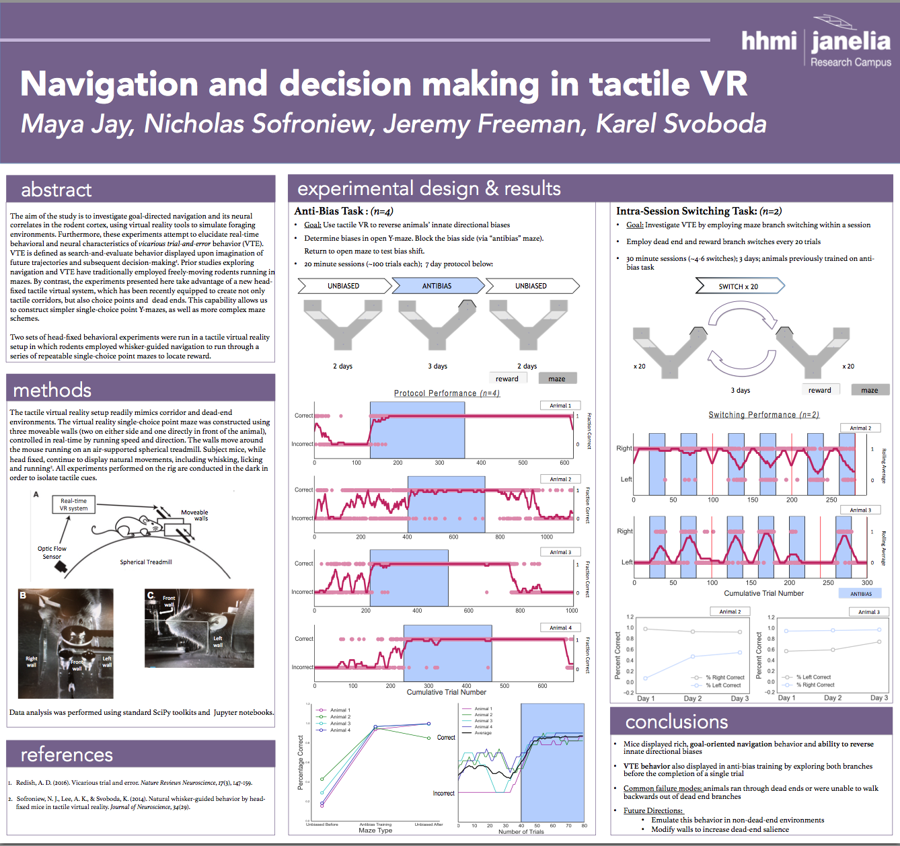

**Future Directions**

* Try the open water (waterR or waterL) maze on naive mice. Is the dead end really necessary for learning, or will simple thirst drive the animals sufficiently to mentally map the layout.
* Common failure model involved running through dead ends→ could a motorized block be placed on the ball such that the ball cannot move backward if the mouse is in the dead end, such that only forward motion (backward walking) is allowed. The inability to move the ball naturally may also serve as another salient feature for mice to learn to avoid the dead ends.
* Backwards walking: Another common failure was the inability of animals to walk backwards on the ball out of a dead end; part of this stems from the fact that walking in reverse is a highly unnatural form of locomotion for mice:
  + Could try some kind of backwards walking training on the rig?
  + Practice reverse walk in home cage (cover one end of play tube that is narrow enough such that the only way out is to walk backwards
* Karel’s suggestion: place textured surface (spikes/sandpaper) on front wall to attach further negative valence to dead end wall experience to avoid running through

Once we get the behavior more robust, other routes could include:

* Changing probabilities (i.e. 70/30% reward in either side, this would require fast mice that run lots of trials
* More choice points and complex mazes (two choice/ tripleY)
* Image successfully….

Thank you to Nick, Karel, Jeremy, and Jasmine for making this summer so memorable! Let me know if there’s any more info you need from me.

Maya Jay

774-208-4713

mayajay@mit.edu